Sts. Peter & Paul
Evangelical Lutheran Church
Lutheran Church-Missouri Synod
Founded-1917

December 4, 2022

699 Stambaugh Avenue
Sharon, Pennsylvania 16146

“I was glad when they said to me,
Let us go to the house of the LORD!”
Psalm 122:1
Sts. Peter & Paul Evangelical Lutheran Church, LC-MS
POPULUS ZION
December 4, 2022

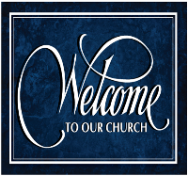
A special welcome to our guests this day! If you would like more information about The Lutheran Church - Missouri Synod, or this congregation, please speak with Pastor Deal or an Elder after the service.
Members & Guests: Don’t be embarrassed if your children make noise during the worship service, all children do. We encourage families to worship together but, if you feel the need, there are pews in the rear of the Church which are reserved for young families on both sides of the sanctuary. There is also a quiet room available to you during our service which is located down the hallway past the offices on the right side of the church as well as a children’s area in the Fellowship Hall where you are able to follow along with the service.

Today’s service includes the Sacrament of Holy Communion. If during this past year, you have not worshipped with us and been communed, we respectfully ask that you do not partake of this sacrament this day before first speaking with Pastor Deal.
If visiting from a sister congregation of the LC-MS and are in good standing, please inform Pastor Deal of your desire to commune prior to the service.
If wishing to receive a blessing during communion, please approach with your arms crossed.

CONTACT INFORMATION
Pastor Deal: pastordeal@saintspeterandpaul.net or 724-347-3620 (opt. 2)
Church Office: church@saintspeterandpaul.net or 724-347-3620 (opt. 3)

Silent prayer before worship: Heavenly Father, You sent John the Baptist to prepare the way for Your Son, Jesus Christ. Prepare my heart to receive Christ, that I may be certain of my salvation, and may honor him in all I do and say. In Jesus’ name. Amen.

Divine Service ~ Setting 1 ~ p. 151
Confession and Absolution

Opening Hymn: LSB #340 “Lift Up Your Heads, Ye Mighty Gates”

Stand

The sign of the cross may be made by all in remembrance of their Baptism.

Invocation
P In the name of the Father and of the T Son and of the Holy Spirit.
C Amen.

Exhortation LSB 151
P If we say we have no sin, we deceive ourselves, and the truth is not in us.
C But if we confess our sins, God, who is faithful and just, will forgive our sins and cleanse us from all unrighteousness.

Silence for reflection on God’s Word and for self-examination.

Confession of Sins LSB 151
P Let us then confess our sins to God our Father.
C Most merciful God, we confess that we are by nature sinful and unclean. We have sinned against You in thought, word, and deed, by what we have done and by what we have left undone. We have not loved You with our whole heart; we have not loved our neighbors as ourselves. We justly deserve Your present and eternal punishment. For the sake of Your Son, Jesus Christ, have mercy on us. Forgive us, renew us, and lead us, so that we may delight in Your will and walk in Your ways to the glory of Your holy name. Amen.

Absolution LSB 151
P Almighty God in His mercy has given His Son to die for you and for His sake forgives you all your sins. As a called and ordained servant of Christ, and by His authority, I therefore forgive you all your sins in the name of the Father and of the T Son and of the Holy Spirit.
C Amen.
Stand
Service of the Word

Introit Psalm 80:1, 3, 14, 17; antiphon: Isaiah 62:11b; 30:30, 29
Say to the daughter of | Zion,*
“Behold, your sal- | vation comes.”
The Lord will cause his majestic voice | to be heard,*
and you shall have glad- | ness of heart.
Give ear, O Shepherd of Israel, you who lead Joseph | like a flock!*
You who are enthroned upon the cherubim, | shine forth.
Restore us, | O God;*
let your face shine, that we | may be saved!
Turn again, O | God of hosts!*
Look down from | heaven, and see.
But let your hand be on the man of your | right hand,*
the son of man whom you have made strong | for yourself!
Say to the daughter of | Zion,*
“Behold, your sal- | vation comes.”
The Lord will cause his majestic voice | to be heard,*
and you shall have glad- | ness of heart.

Kyrie 152
P In peace let us pray to the Lord.
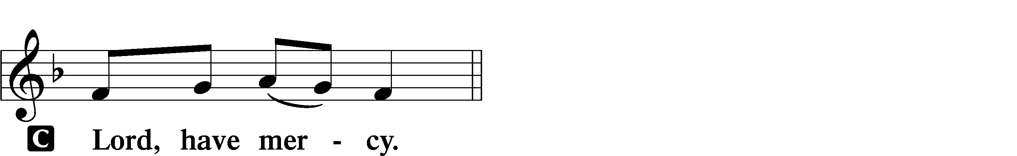

P For the peace from above and for our salvation let us pray to the Lord.
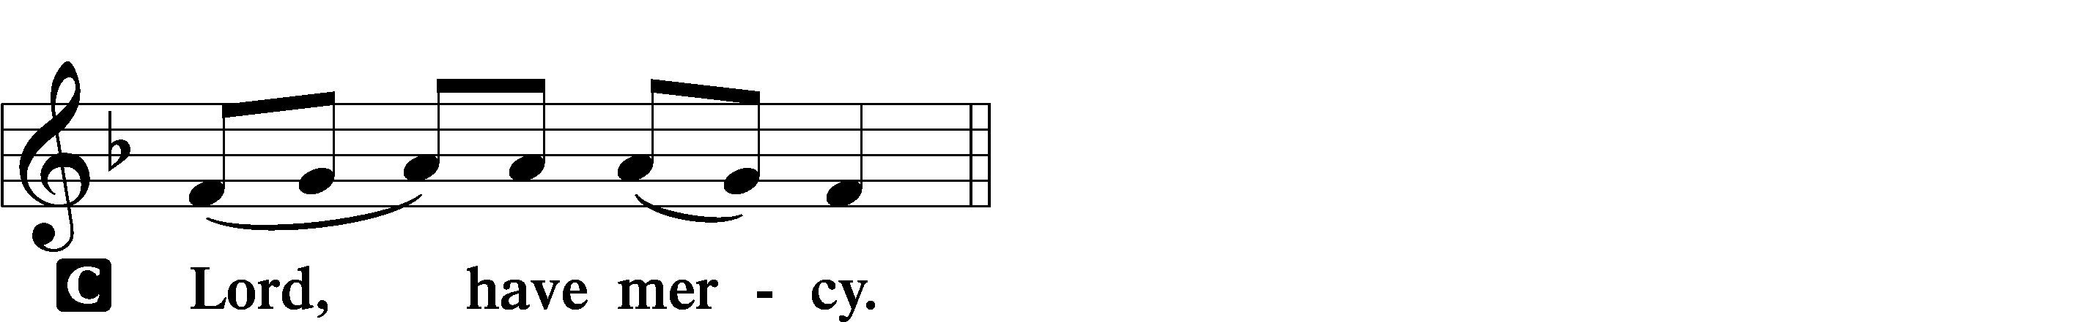
P For the peace of the whole world, for the well-being of the Church of God, and for the unity of all let us pray to the Lord.
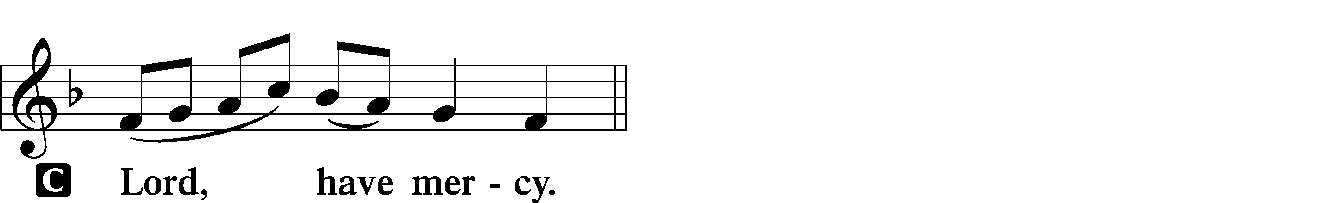

P For this holy house and for all who offer here their worship and praise let us pray to the Lord.
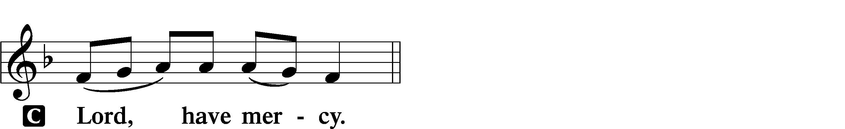

P Help, save, comfort, and defend us, gracious Lord.

Salutation and Collect of the Day: Populus Zion
P The Lord be with you.
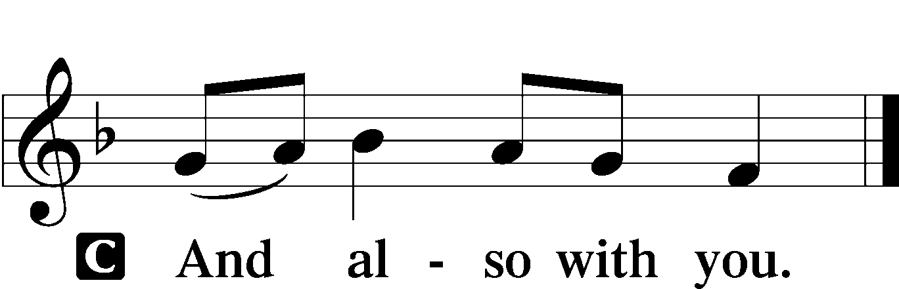

P Let us pray.
Stir up our hearts, O Lord, to make ready the way of Your only-begotten Son, that by His coming we may be enabled to serve You with pure minds; through the same Jesus Christ, our Lord, who lives and reigns with You and the Holy Spirit, one God, now and forever.

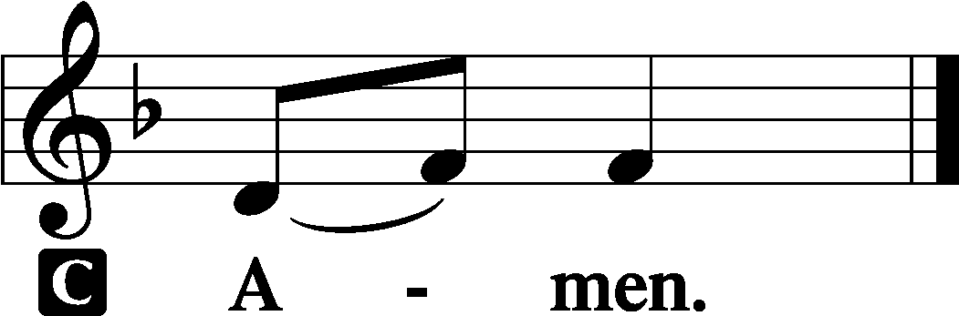

Sit

Prophecy: Song of Solomon 2:8b–14 (NKJV)
Behold, my beloved comes leaping upon the mountains, skipping upon the hills. My beloved is like a gazelle or a young stag. Behold, he stands behind our wall; he is looking through the windows, gazing through the lattice. My beloved spoke, and said to me: “Rise up, my love, my fair one, and come away. For lo, the winter is past, the rain is over and gone. The flowers appear on the earth; the time of singing has come, and the voice of the turtledove is heard in our land. The fig tree puts forth her green figs, and the vines with the tender grapes give a good smell. Rise up, my love, my fair one, and come away! O my dove, in the clefts of the rock, in the secret places of the cliff, let me see your face, let me hear your voice; for your voice is sweet, and your face is lovely.”

P This is the Word of the Lord.
C Thanks be to God.

Psalm: Psalm 50:1–15; antiphon: v. 15
The Mighty One, God the Lord,
speaks and summons the earth
from the rising of the sun to its setting.
Out of Zion, the perfection of beauty,
God shines forth.
Our God comes; he does not keep silence;
before him is a devouring fire,
around him a mighty tempest.
He calls to the heavens above
and to the earth, that he may judge his people:
“Gather to me my faithful ones,
who made a covenant with me by sacrifice!”
The heavens declare his righteousness,
for God himself is judge!
“Hear, O my people, and I will speak;
O Israel, I will testify against you.
I am God, your God.
Not for your sacrifices do I rebuke you;
your burnt offerings are continually before me.
I will not accept a bull from your house
or goats from your folds.
For every beast of the forest is mine,
the cattle on a thousand hills.
I know all the birds of the hills,
and all that moves in the field is mine.
“If I were hungry, I would not tell you,
for the world and its fullness are mine.
Do I eat the flesh of bulls
or drink the blood of goats?
Offer to God a sacrifice of thanksgiving,
and perform your vows to the Most High,
and call upon me in the day of trouble;
I will deliver you, and you shall glorify me.”

Epistle: Romans 15:4–13 (NKJV)
Brethren: Whatever things were written before were written for our learning, that we through the patience and comfort of the Scriptures might have hope. Now may the God of patience and comfort grant you to be like-minded toward one another, according to Christ Jesus, that you may with one mind and one mouth glorify the God and Father of our Lord Jesus Christ. Therefore receive one another, just as Christ also received us, to the glory of God. Now I say that Jesus Christ has become a servant to the circumcision for the truth of God, to confirm the promises made to the fathers, and that the Gentiles might glorify God for His mercy, as it is written: “For this reason I will confess to You among the Gentiles, and sing to Your name.” And again he says: “Rejoice, O Gentiles, with His people!” And again: “Praise the Lord, all you Gentiles! Laud Him, all you peoples!” And again, Isaiah says: “There shall be a root of Jesse; and He who shall rise to reign over the Gentiles, in Him the Gentiles shall hope.” Now may the God of hope fill you with all joy and peace in believing, that you may abound in hope by the power of the Holy Spirit.

P This is the Word of the Lord.
C Thanks be to God.

Stand

Alleluia and Verse LSB 156
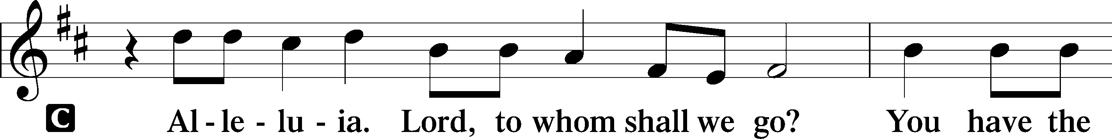
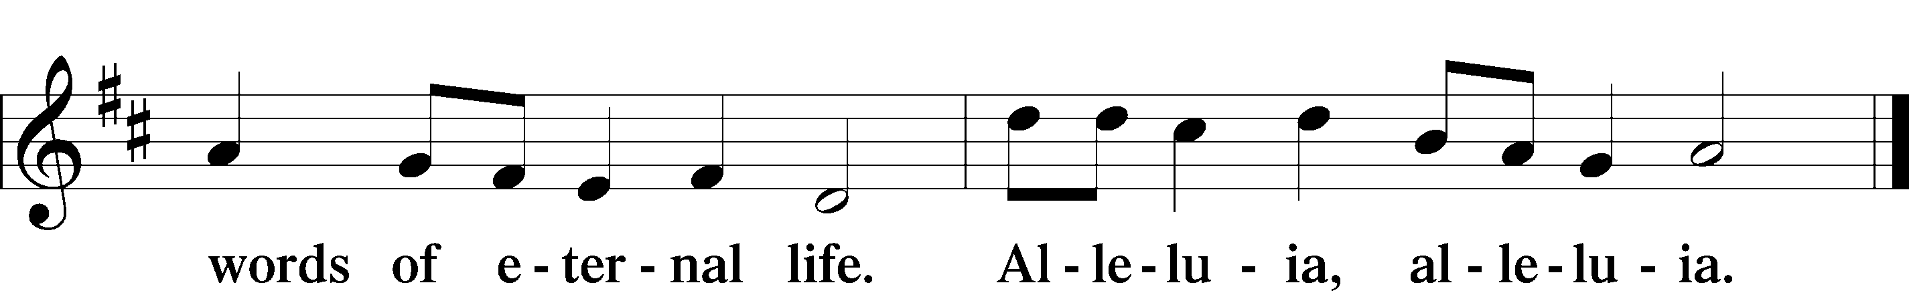

Holy Gospel: Luke 21:25–33 (NKJV)
P The Holy Gospel according to St. Luke, the twenty-first chapter.
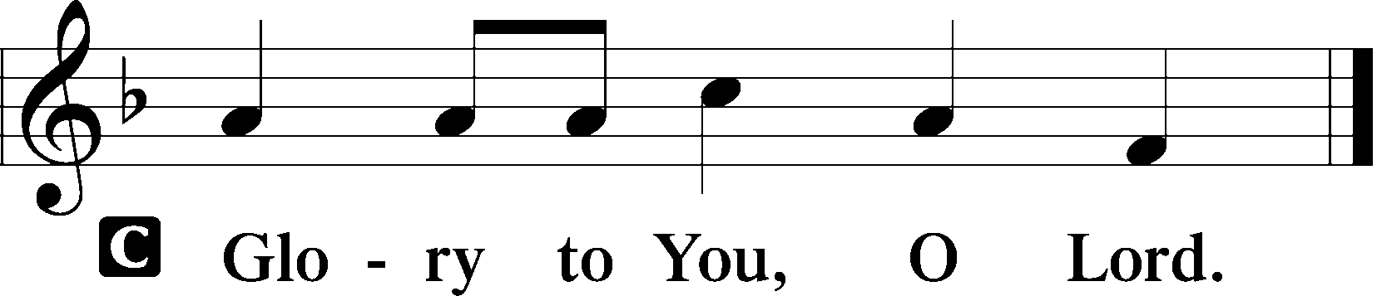

At that time Jesus said to His disciples: “There will be signs in the sun, in the moon, and in the stars; and on the earth distress of nations, with perplexity, the sea and the waves roaring; men’s hearts failing them from fear and the expectation of those things which are coming on the earth, for the powers of the heavens will be shaken. Then they will see the Son of Man coming in a cloud with power and great glory. Now when these things begin to happen, look up and lift up your heads, because your redemption draws near.” Then He spoke to them a parable: “Look at the fig tree, and all the trees. When they are already budding, you see and know for yourselves that summer is now near. So you also, when you see these things happening, know that the kingdom of God is near. Assuredly, I say to you, this generation will by no means pass away till all things take place. Heaven and earth will pass away, but My words will by no means pass away.”

P This is the Gospel of the Lord.
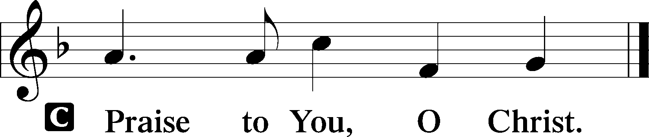

Nicene Creed
C I believe in one God,
the Father Almighty,
maker of heaven and earth
and of all things visible and invisible.

And in one Lord Jesus Christ,
the only-begotten Son of God,
begotten of His Father before all worlds,
God of God, Light of Light,
very God of very God,
begotten, not made,
being of one substance with the Father,
by whom all things were made;
who for us men and for our salvation came down from heaven
and was incarnate by the Holy Spirit of the virgin Mary
and was made man;
and was crucified also for us under Pontius Pilate.
He suffered and was buried.
And the third day He rose again according to the Scriptures
and ascended into heaven
and sits at the right hand of the Father.
And He will come again with glory to judge both the living and the dead,
whose kingdom will have no end.

And I believe in the Holy Spirit,
the Lord and giver of life,
who proceeds from the Father and the Son,
who with the Father and the Son together is worshiped and glorified,
who spoke by the prophets.
And I believe in one holy Christian and apostolic Church,
I acknowledge one Baptism for the remission of sins,
and I look for the resurrection of the dead
and the life T of the world to come. Amen.
Sit

Hymn of the Day: LSB #355 “O Savior, Rend the Heavens Wide”

Sermon

Stand

Prayer of the Church

Offertory LSB 159
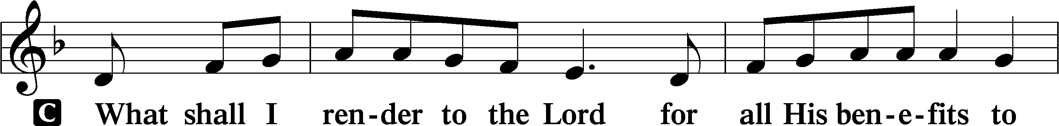
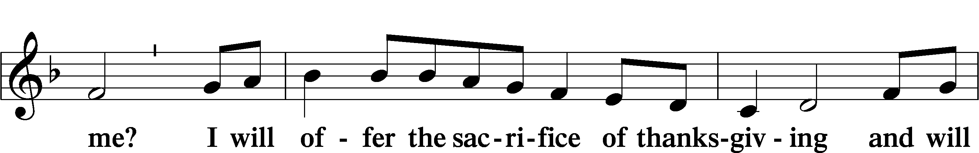
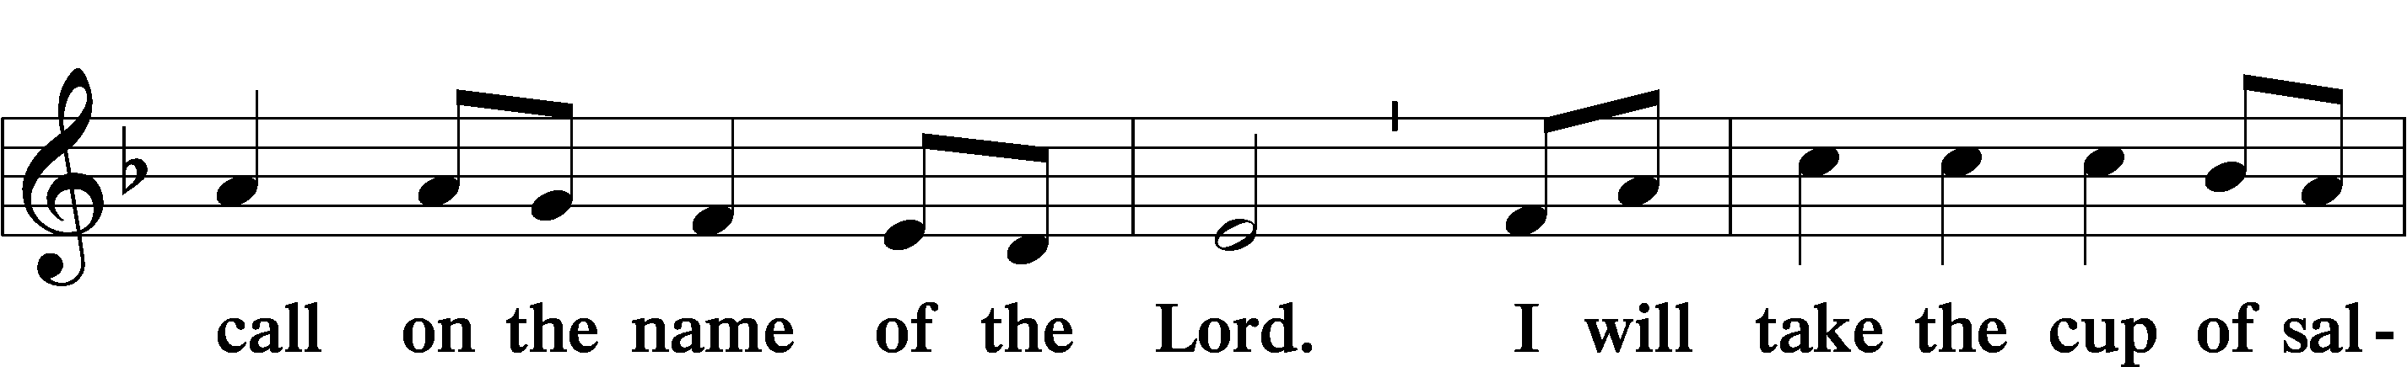
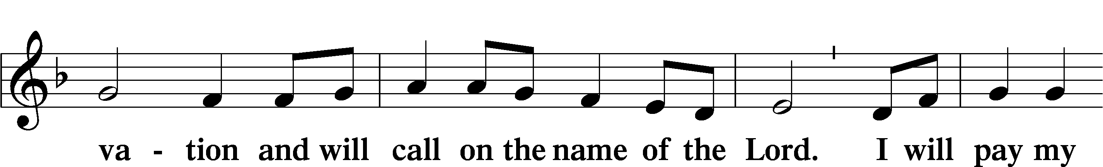
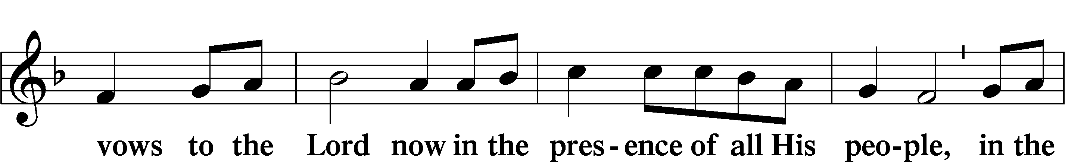
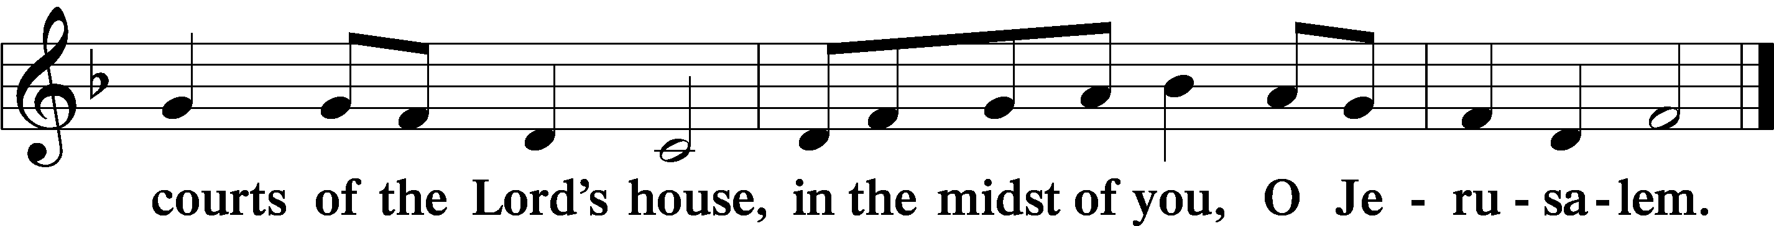

Preparatory Hymn: LSB #336 “Lo! He Comes with Clouds Descending”

Service of the Sacrament

Preface LSB 160
P The Lord be with you.
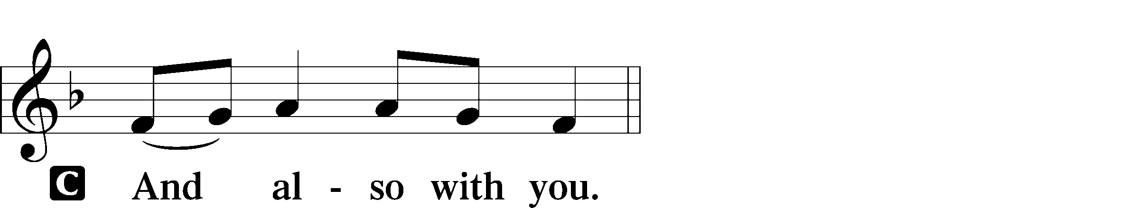

P Lift up your hearts.

P Let us give thanks to the Lord our God.
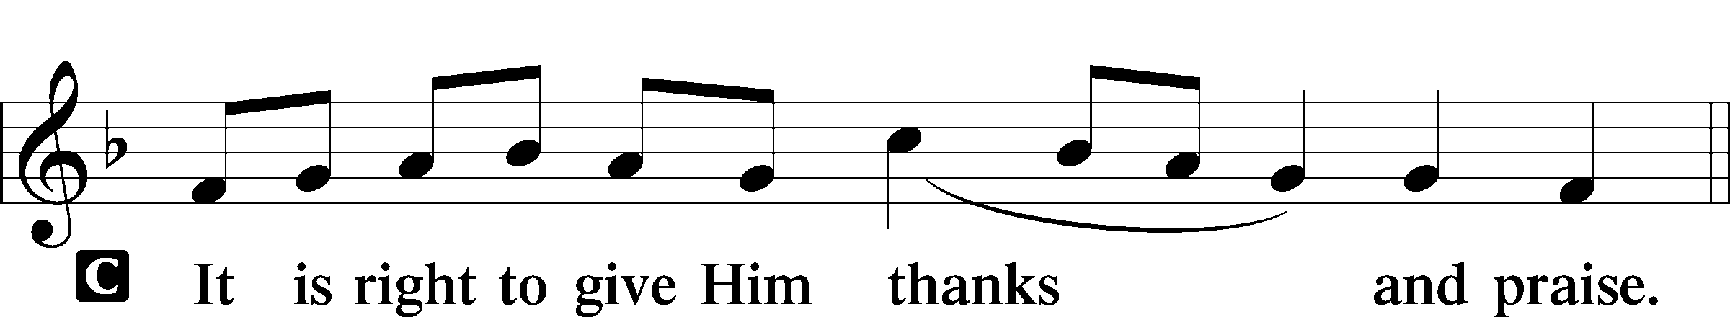

Proper Preface (Abbreviated) LSB 161
P It is truly good, right, and salutary . . . evermore praising You and saying:

Sanctus LSB 161
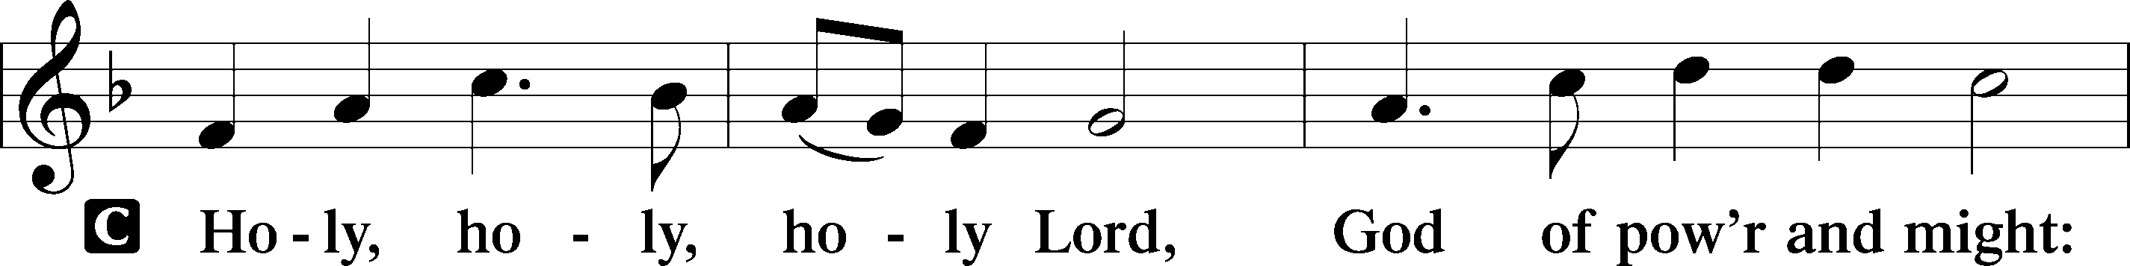
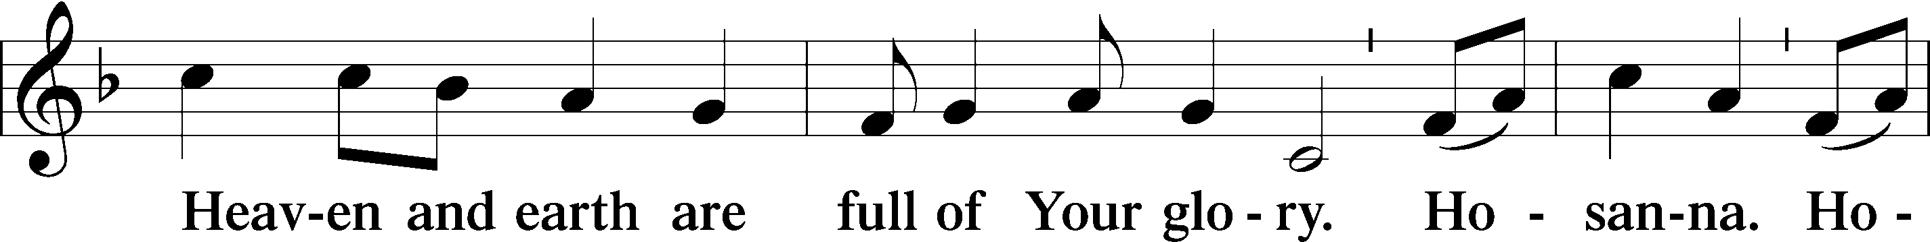
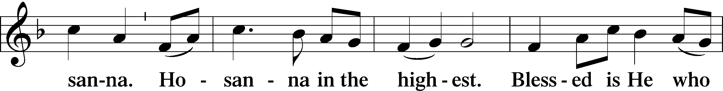
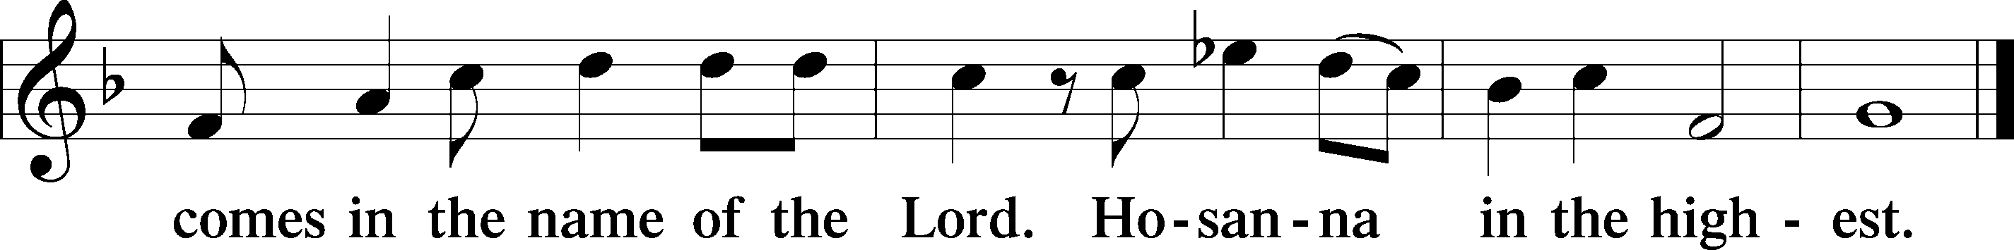

Prayer of Thanksgiving LSB 161
P Blessed are You, Lord of heaven and earth, for You have had mercy on those whom You created and sent Your only-begotten Son into our flesh to bear our sin and be our Savior. With repentant joy we receive the salvation accomplished for us by the all-availing sacrifice of His body and His blood on the cross.

Gathered in the name and the remembrance of Jesus, we beg You, O Lord, to forgive, renew, and strengthen us with Your Word and Spirit. Grant us faithfully to eat His body and drink His blood as He bids us do in His own testament. Gather us together, we pray, from the ends of the earth to celebrate with all the faithful the marriage feast of the Lamb in His kingdom, which has no end. Graciously receive our prayers; deliver and preserve us. To You alone, O Father, be all glory, honor, and worship, with the Son and the Holy Spirit, one God, now and forever.
C Amen.

Lord’s Prayer
C Our Father who art in heaven,
hallowed be Thy name,
Thy kingdom come,
Thy will be done on earth
as it is in heaven;
give us this day our daily bread;
and forgive us our trespasses
as we forgive those
who trespass against us;
and lead us not into temptation,
but deliver us from evil.
For Thine is the kingdom
and the power and the glory
forever and ever. Amen.

The Words of Our Lord Matthew 26:26-28; Mark 14:22-24; Luke 22:19-20; 1 Corinthians 11:23-25
P Our Lord Jesus Christ, on the night when He was betrayed, took bread, and when He had given thanks, He broke it and gave it to the disciples and said: “Take, eat; this is My T body, which is given for you. This do in remembrance of Me.”

In the same way also He took the cup after supper, and when He had given thanks, He gave it to them, saying: “Drink of it, all of you; this cup is the new testament in My T blood, which is shed for you for the forgiveness of sins. This do, as often as you drink it, in remembrance of Me.”

Pax Domini LSB 163
P The peace of the Lord be with you always.

Agnus Dei LSB 163
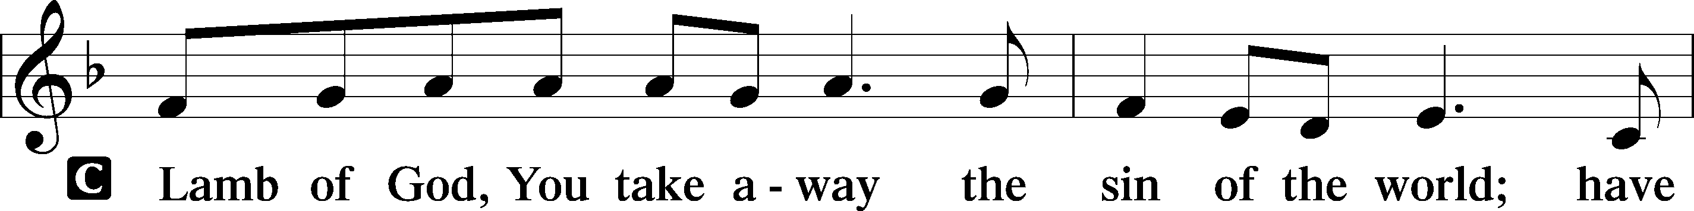
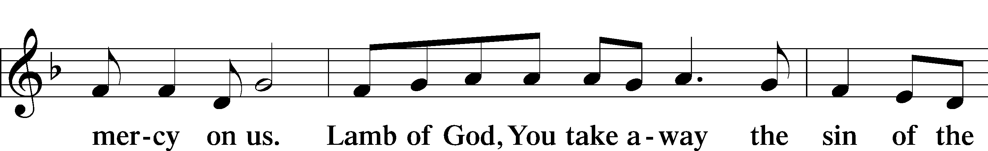
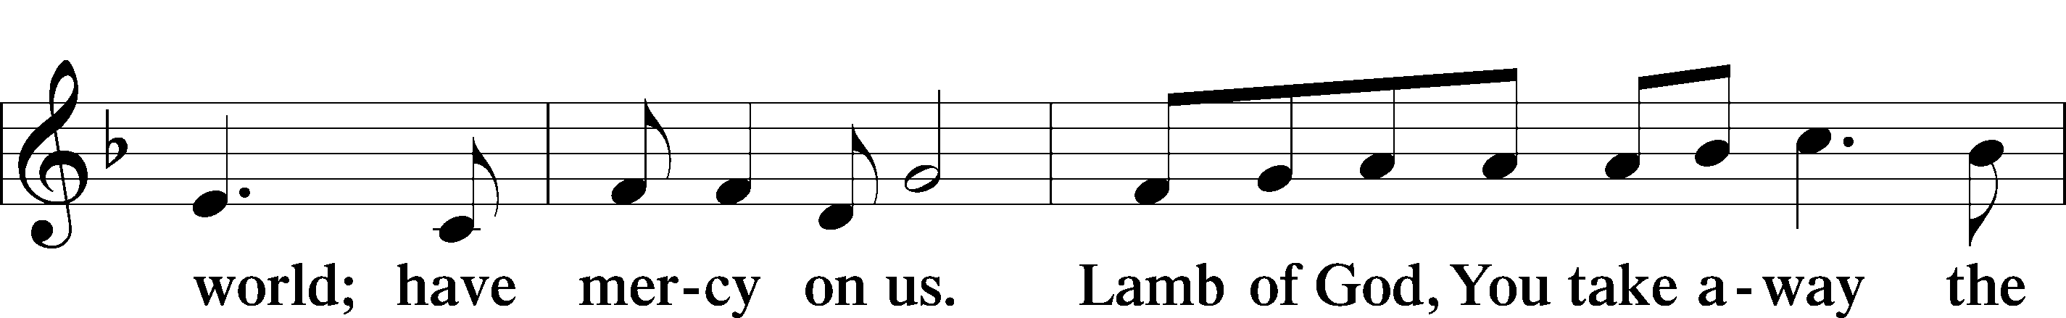
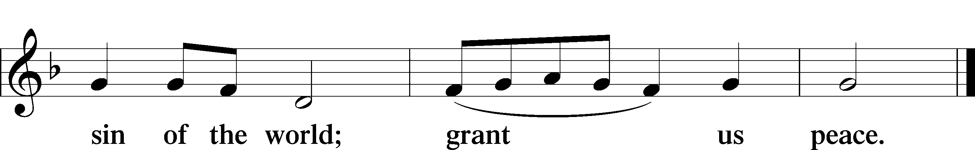
Sit

Distribution
The pastor and those who assist him receive the body and blood of Christ first and then distribute them to those who come to receive, saying:
Take, eat; this is the true body of our Lord and Savior Jesus Christ, given into death for your sins.
Amen.

Take, drink; this is the true blood of our Lord and Savior Jesus Christ, shed for the forgiveness of your sins.
Amen.

In dismissing the communicants, the following is said:
The Dismissal
P The body and blood of our Lord Jesus Christ strengthen and preserve you in body and soul to life everlasting. Depart T in peace.
C Amen.

Distribution Hymn: LSB #349 “Hark the Glad Sound”

Distribution Hymn: LSB #354 “Arise, O Christian People”

Distribution Hymn: LSB #672 “Jerusalem the Golden”

Stand

Nunc Dimittis LSB 165
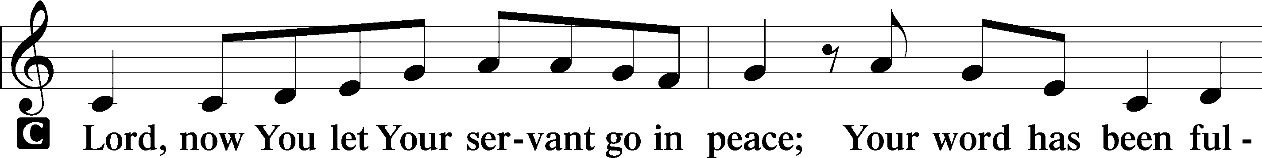
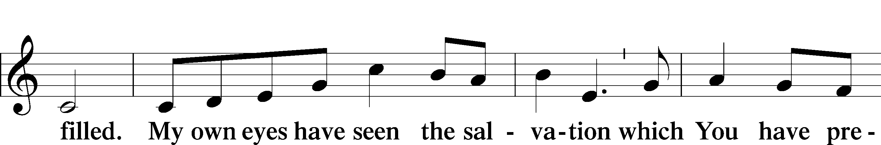
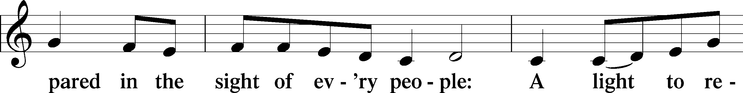
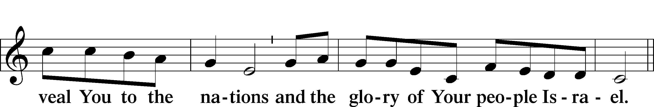
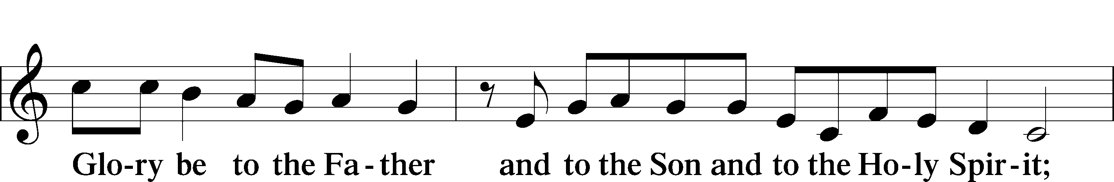
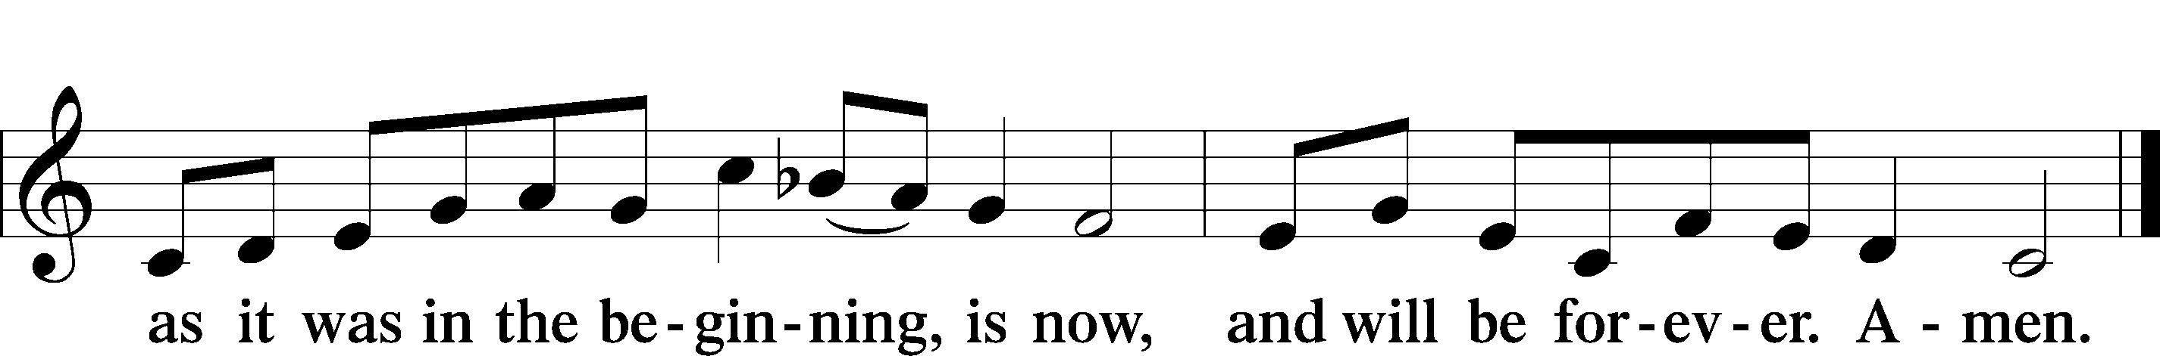

Post-Communion Collect
P Let us pray.
We give thanks to You, almighty God, that You have refreshed us through this salutary gift, and we implore You that of Your mercy You would strengthen us through the same in faith toward You and in fervent love toward one another; through Jesus Christ, Your Son, our Lord, who lives and reigns with You and the Holy Spirit, one God, now and forever.

Benediction LSB 166
P The Lord bless you and keep you.
The Lord make His face shine on you and be gracious to you.
The Lord look upon you with favor and T give you peace.

Closing Hymn: LSB #873 “Christ, Whose Glory Fills the Skies”

Silent prayer after worship: O God of grace and mercy, keep me mindful of the true meaning of Christmas throughout this Advent season. Fill my heart with joy and peace, and lead me to share the same with others. In Jesus’ name. Amen.
fffffffffffffffffffffffffffffffffff
Acknowledgments
Unless otherwise indicated, Scripture quotations are from the ESV® Bible (The Holy Bible, English Standard Version®), copyright © 2001 by Crossway, a publishing ministry of Good News Publishers. Used by permission. All rights reserved.
Created by Lutheran Service Builder © 2021 Concordia Publishing House.
fffffffffffffffffffffffffffffffffff
SCHEDULE THROUGH DECEMBER 11, 2022:

:

Today, 7 pm, Fellowship Hall: AA Meeting
Tuesday, 7-9 pm, Fellowship Hall: Penn-Ohio Singers
Wednesday, Noon, Sanctuary: Advent Service of Morning Prayer
5:30 pm: Sanctuary, Choir Rehearsal
7:00 pm, Sanctuary: Advent Vespers Service
7:30 pm, Downstairs: NA Meeting
Thursday, 9 am, Downstairs: Food Pantry
Next Sunday, 8 am, Fellowship Hall: Bible Study
9 am, Sanctuary: Divine Service
Following Worship, Fellowship Hall: Coffee & Christmas Cookies
7 pm, Fellowship Hall: AA Meeting
fffffffffffffffffffffffffffffffffff
Attendance: Sunday, November 27, 2022: 30
Wednesday, November 30, 2022: 20 (noon: 10; eve: 10 )
fffffffffffffffffffffffffffffffffff
Join us next Sunday, following worship, for Coffee & Christmas Cookies Fellowship sponsored by the Altar Guild. Members should drop off cookies in the kitchen prior to worship. Boxes will be available for anyone who wishes to take some home (while they last!).
The 2023 Coffee Fellowship sign-up sheet has been posted on the bulletin board in the narthex. Consider signing up to be a sponsor!
Our Stewardship of Treasures for the Lord:
In order to do the Lord’s work, we need $2,462.92 each week to meet our 2022 budget for general purposes and $80.00 for the SELC.
Online Figures: (11.25 & 11.28.22)
General Fund: $6,080.00
SELC: $200.00
Quarterly Missions: $100.00
Capital Campaign: $1,000.00
Figures for Wednesday, November 24, 2022
General Fund: $327.00
Capital Campaign: $40.00
Other: $13.10
Figures for Sunday, November 27, 2022:
General Fund: $1,329.00 Ahead for the week*: +$5,273.08
SELC: $35.00 Ahead for the week*: +$155.00
Quarterly Missions: $35.00 *Includes above figures.
Capital Campaign: $610.00
Other: $20.00

For online giving, check out https://www.saintspeterandpaul.net/online-giving.

fffffffffffffffffffffffffffffffffff
Concordia Youngstown will be distributing warm socks, gloves, coats, hats, and scarves during its Food Give-Away on December 17.
If you would like to help, please place your donations in the box in the church narthex by Sunday, December 11. Please direct any question concerning this to Matt Berent.
fffffffffffffffffffffffffffffffffff
Orders and payments for poinsettias to adorn our altar this Christmas are due TODAY. Extra order forms are available on the table in the narthex. Please speak with Diane if you should have any questions.
fffffffffffffffffffffffffffffffffff
THANK YOU FOR SERVING IN DECEMBER: Head Elder: Barry Nelson; Assisting Elder: Jonathan Baisch; Altarware: Marie Flaugher (12.25) and Diane Riefstahl
Remember the following in Prayer…
~The Hurting and Healing: Amy, Gerald Arthur, Ellen Baron^{CA}, Lois Bortner^{CA}, John Burdette, Bev & Joe Chlpka, Kathleen Coughenour, Kim, Anna Mae Daris, Susan Davies, Tim Dudash, Joseph Fleet, Eddy Furey, Tim Haenftling, Austin Hamilton, Anson Holcroft, Neil Huston, Darla Krajci, Barbara Kreske, Michelle Kelly^{CA}, Donna Kennedy, Gerald Krivosh, Jess Lavoie, Paul Lucas^{CA}, Sandy Marshall, Ernie Meszaros, David Nelson, Linda Parkany, Juanita Rentschler, Richard Reuning^{CA}, Nancy Robertson^{CA}, Viola Sakony, Marty Scott, Kara, Fred Tonty, Angela Weser^{CA}, and Ruth Wolf.
~The Homebound: Rudy & Jean Tomko, Betty Wolf, and Ed & Millie Zachar.
~Celebrating: Birthdays: Pastor Deal (12.04), Marie Flaugher (12.05), and Jennifer Voytik (12.05). Anniversary: Ralph & Judie Dorman (12.09).
~Serving in the Military: Curtis Sinewe and Joshua Solyan.
~Community & World Needs: Those suffering from or affected by the coronavirus; those suffering due to the conflict between Ukraine and Russia; those suffering from loss and dislocation because weather disasters; those suffering from addiction and their families; Local, State, and National Government Leaders; safety for all Police Officers, Firefighters, & First Responders; the unemployed; our Fourth Quarter Local Mission: Willow Women’s Center *CA represents cancer.
fffffffffffffffffffffffffffffffffff
Bible Memory Verses ~ Week of December 4th:
For Adults: If you confess with your mouth that Jesus is Lord and believe in your heart that God raised him from the dead, you will be saved. Romans 10:9

For Children: Raise your heads, because your redemption is drawing near.
Luke 21:28
fffffffffffffffffffffffffffffffffff
Minutes from the Nov. 20, 2022, Voters’ Assembly are available in the narthex along with the December issue of “The Rock and the Sword” newsletter.
fffffffffffffffffffffffffffffffffffNNext Sunday is “Food Pantry Sunday”! Your financial contributions will be greatly appreciated. Donations may be placed in a pew envelope. Please be certain to indicate your envelope number and designate “Food Pantry”.
CHOIr members are reminded of rehearsals Wednesday evenings at 5:30 through December 21st.
fffffffffffffffffffffffffffffffffff
Auditors will meet following worship December 18th for a monthly audit of deposits.
fffffffffffffffffffffffffffffffffff
Please consider joining us for Christmas Decorating Saturday, December 17th beginning at 10 am. Your help will be greatly appreciated!
fffffffffffffffffffffffffffffffffff
Midweek Advent Services will be held Wednesdays at noon and 7 pm. This year’s theme is “Come and See”. Corresponding daily devotionals are available on the sign-in table next to Pastor Deal’s office and on the table in the narthex.

fffffffffffffffffffffffffffffffffff

Here to Serve

Pastor………………………………………………...……………Rev. Jacob Deal
E-mail …………………………….……pastordeal@saintspeterandpaul.net
Phone Number……………………..…………………724-347-3620 (Option 2)
Church Office………………………..…………………724-347-3620 (Option 3)
Website …………………………………………www.saintspeterandpaul.net
Secretary…………………………………………………………Diane Riefstahl
E-mail ………………………………………church@saintspeterandpaul.net
Website …………………………………………www.saintspeterandpaul.net
Food Pantry: Please leave message……………724-347-3620 (Option 3)
AA Contact: Steve………………………………………………..…724-813-2358
NA Contact: Larry………………………………………………..724-977-8733
Choir Director………………………………………………………Chris Nelson
Congregation President……………………………………Jonathan Baisch
Elder Chairman…………………………………………...………Barry Nelson
fffffffffffffffffffffffffffffffffff
Please check the December newsletter for anticipated Church Office hours this month. If needing to get into the church building during the week, please phone first to make certain someone is here to let you in.

