Sts. Peter & Paul
Evangelical Lutheran Church
Lutheran Church-Missouri Synod
Founded-1917

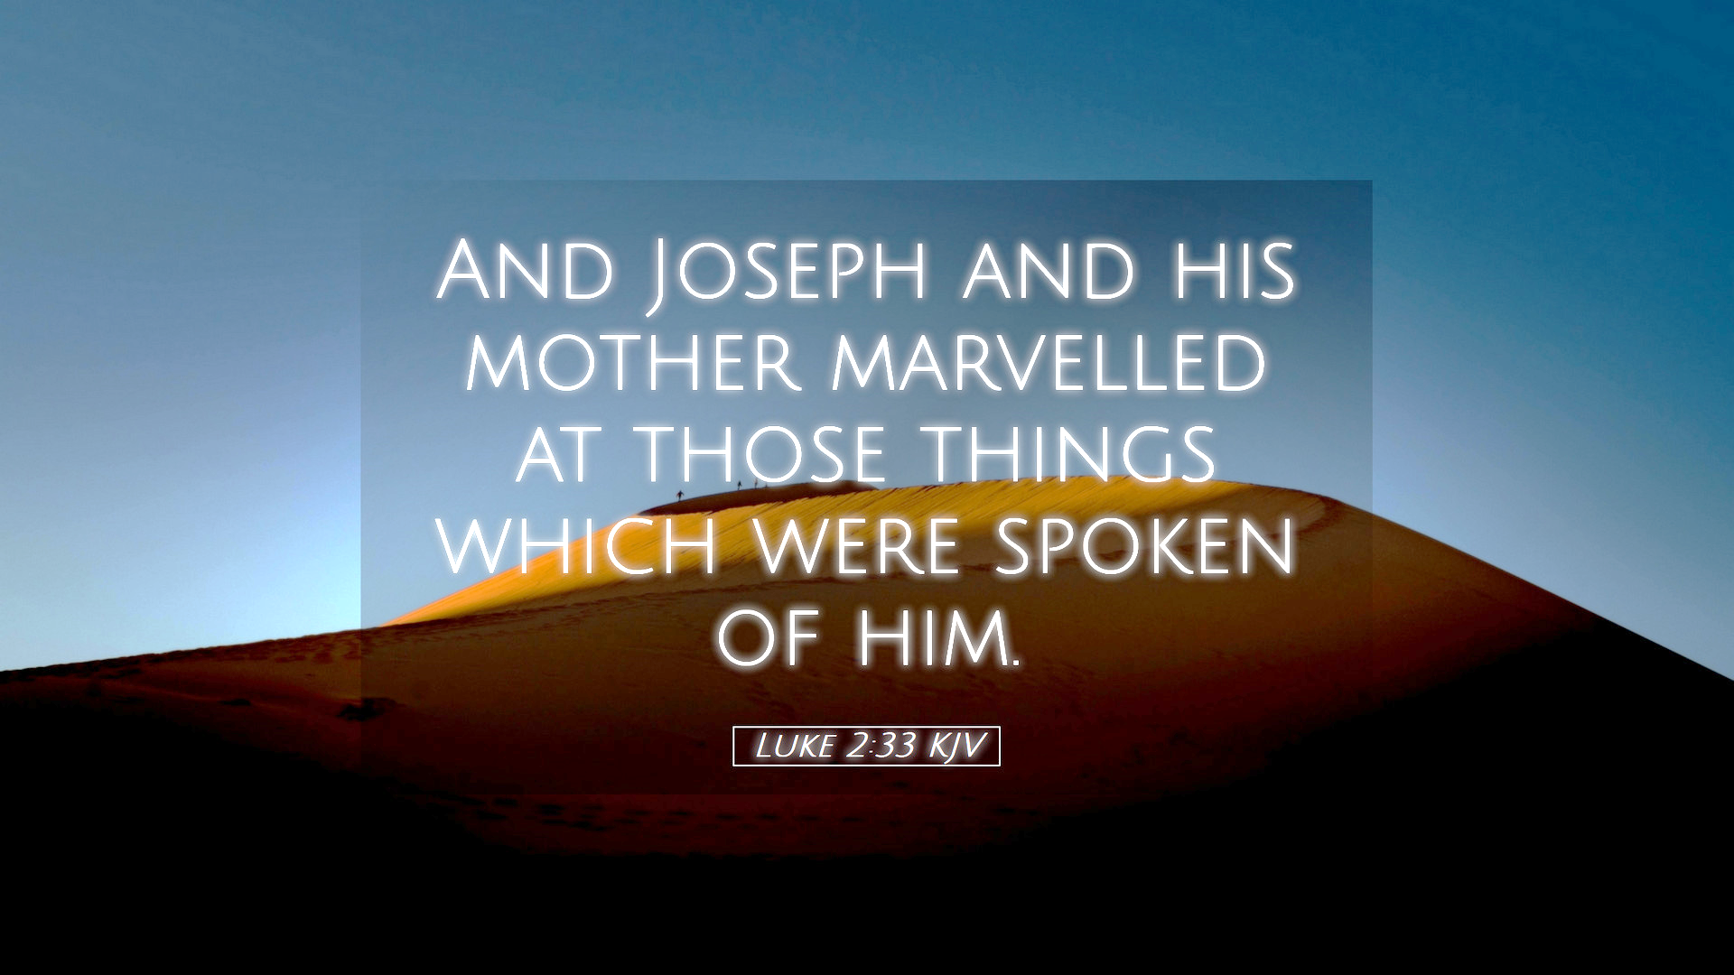

December 31, 2023

699 Stambaugh Ave.
Sharon, Pennsylvania 16146

“I was glad when they said to me,
Let us go to the house of the LORD!”
Psalm 122:1
Sts. Peter & Paul Evangelical Lutheran Church, LC-MS
FIRST SUNDAY AFTER CHRISTMAS
December 31, 2023

A special welcome to our guests this day! If you would like more information about The Lutheran Church - Missouri Synod, or this congregation, please speak with Pastor Deal or an Elder after the service.
Members & Guests: Don’t be embarrassed if your children make noise during the worship service, all children do. We encourage families to worship together but, if you feel the need, there are pews in the rear of the Church which are reserved for young families on both sides of the sanctuary. There is also a quiet room available to you, located next to the sanctuary (formerly the Pastor’s office), where you would be able to follow along with the service.

Today’s service includes the Sacrament of Holy Communion. If during this past year, you have not worshipped with us and been communed, we respectfully ask that you do not partake of this sacrament this day before first speaking with Pastor Deal.
If visiting from a sister congregation of the LC-MS and are in good standing, please inform Pastor Deal of your desire to commune prior to the service.
If wishing to receive a blessing during communion, please approach with your arms crossed.

CONTACT INFORMATION
Pastor Deal: pastordeal@saintspeterandpaul.net or 724-347-3620 (opt. 2)
Church Office: church@saintspeterandpaul.net or 724-347-3620 (opt. 3)
Secretary’s Office: The office will be open Tuesday (8:30 am-4:30 pm), Wednesday (8:30 am-1 pm), and Thursday (8:30-4).

Silent prayer before worship: Lord Jesus, the day of Christmas is now past, but the celebration of Your birth continues. Lead me to continually celebrate that You are with me always, and to worship You as my Savior and Lord. Amen.
Confession and Absolution

Opening Hymn: LSB #389 “Let All Together Praise Our God”

The sign of the cross may be made by all in remembrance of their Baptism.

Invocation
P In the name of the Father and of the T Son and of the Holy Spirit.
C Amen.

Exhortation Hebrews 10:22; Psalm 124:8; Psalm 32:5
P Beloved in the Lord! Let us draw near with a true heart and confess our sins unto God our Father, beseeching Him in the name of our Lord Jesus Christ to grant us forgiveness.

P Our help is in the name of the Lord,
C who made heaven and earth.
P I said, I will confess my transgressions unto the Lord,
C and You forgave the iniquity of my sin.

Silence for reflection on God’s Word and for self-examination.

Confession of Sins
P O almighty God, merciful Father,
C I, a poor, miserable sinner, confess unto You all my sins and iniquities with which I have ever offended You and justly deserved Your temporal and eternal punishment. But I am heartily sorry for them and sincerely repent of them, and I pray You of Your boundless mercy and for the sake of the holy, innocent, bitter sufferings and death of Your beloved Son, Jesus Christ, to be gracious and merciful to me, a poor, sinful being.

Absolution [John 20:19–23]
P Upon this your confession, I, by virtue of my office, as a called and ordained servant of the Word, announce the grace of God unto all of you, and in the stead and by the command of my Lord Jesus Christ I forgive you all your sins in the name of the Father and of the T Son and of the Holy Spirit.
C Amen.

Service of the Word
Introit Psalm 93:1, 3–4; antiphon: vv. 5, 2
Your decrees are very | trustworthy;*
holiness befits your house, O Lord, for- | evermore.
Your throne is established | from of old;*
you are from ever- | lasting.
The Lord reigns; he is robed in | majesty;*
the Lord is robed; he has put on strength | as his belt.
Yes, the world is es- | tablished;*
it shall nev- | er be moved.
The floods have lifted up, O Lord, the floods have lifted | up their voice;*
the floods lift up their | roaring.
Mightier than the thunders of many waters, mightier than the waves | of the sea,*
the Lord on high is | mighty!
Your decrees are very | trustworthy;*
holiness befits your house, O Lord, for- | evermore.
Your throne is established | from of old;*
you are from ever- | lasting.

Gloria Patri
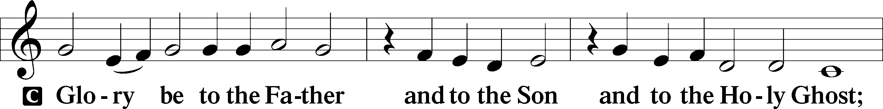
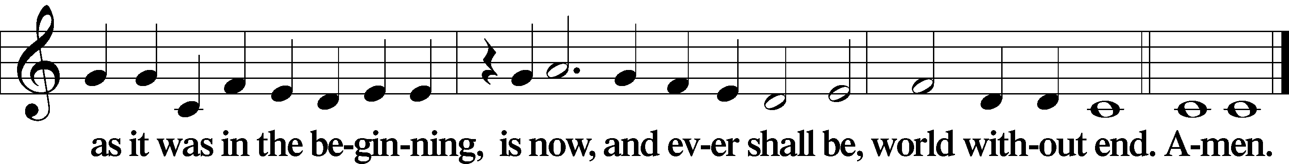

Kyrie Mark 10:47
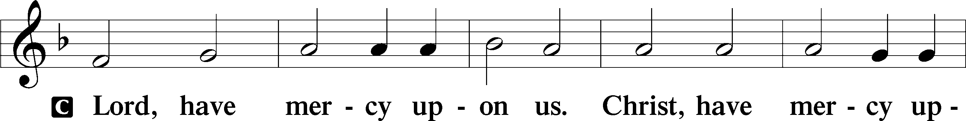
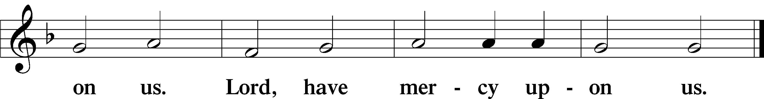

Gloria in Excelsis Luke 2:14; John 1:29
P Glory be to God on high:
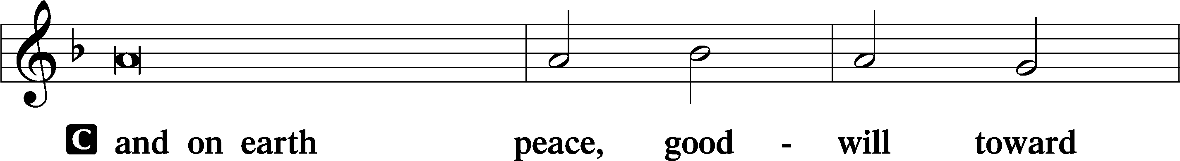
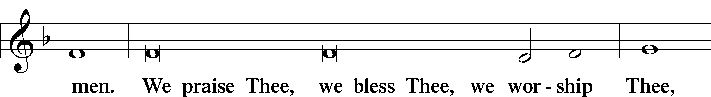
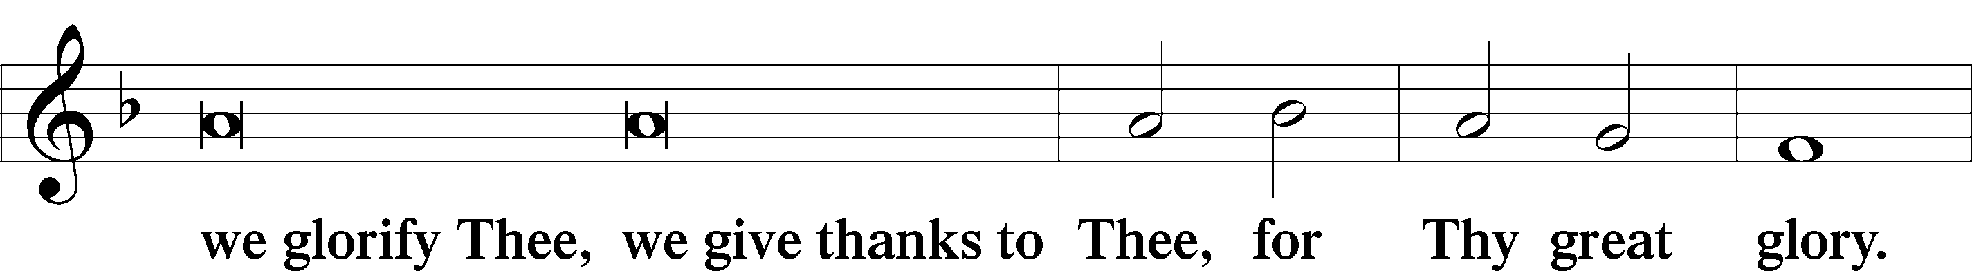
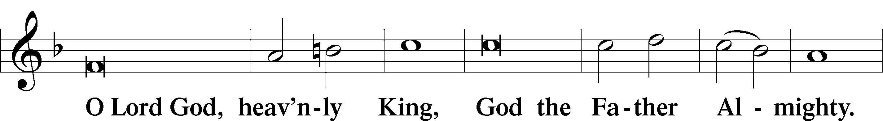
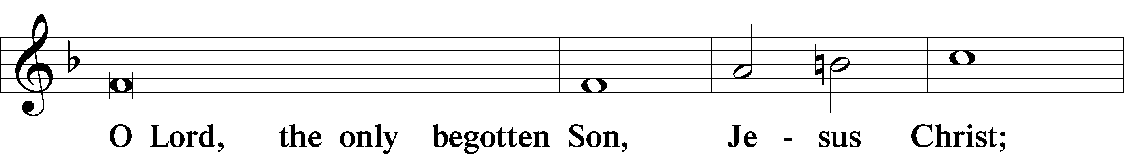
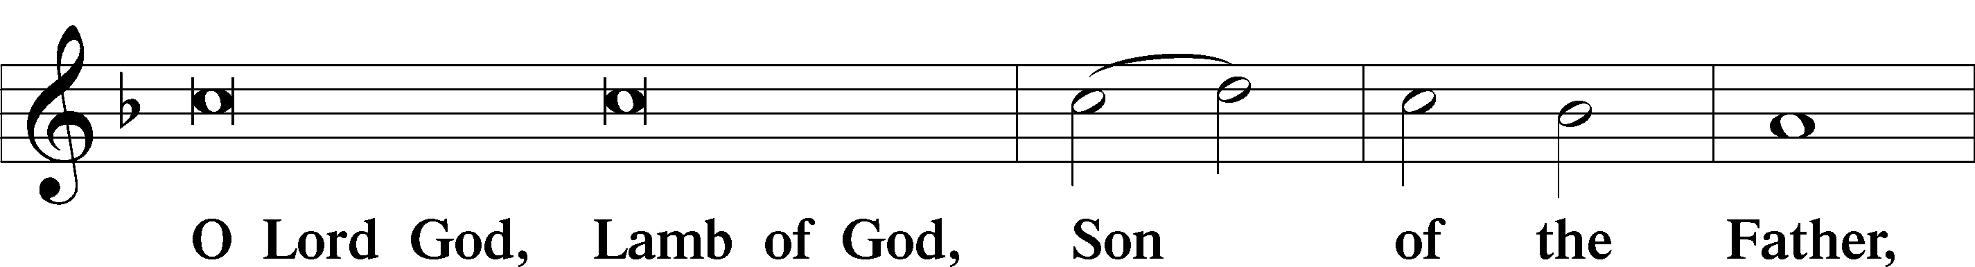
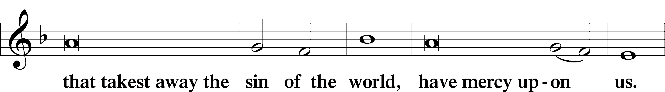
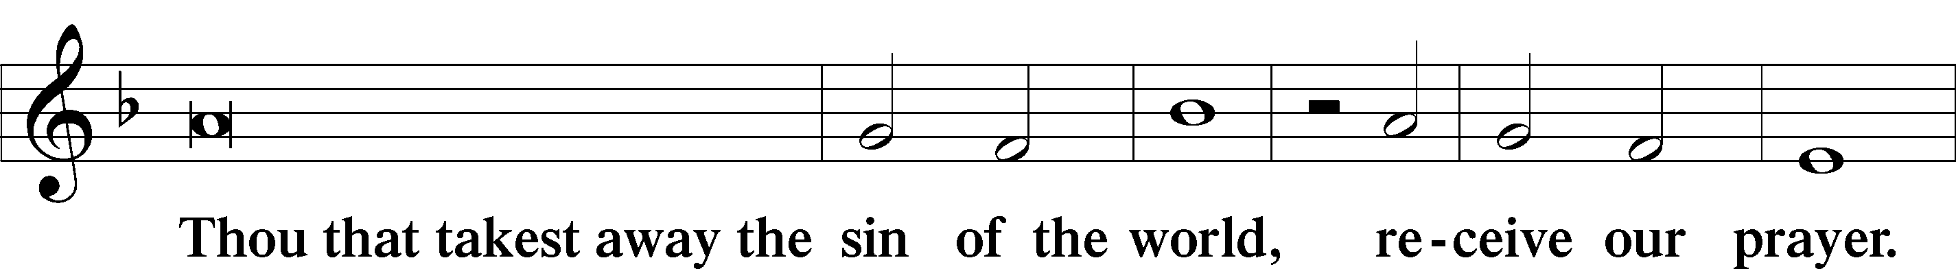
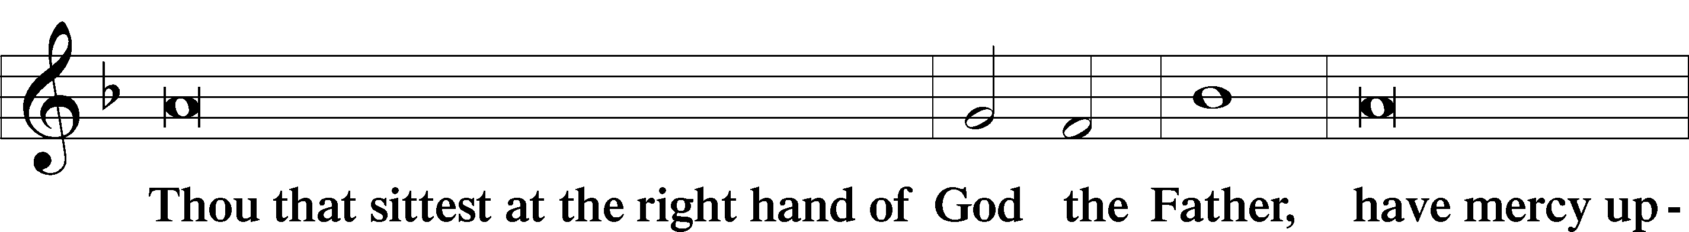
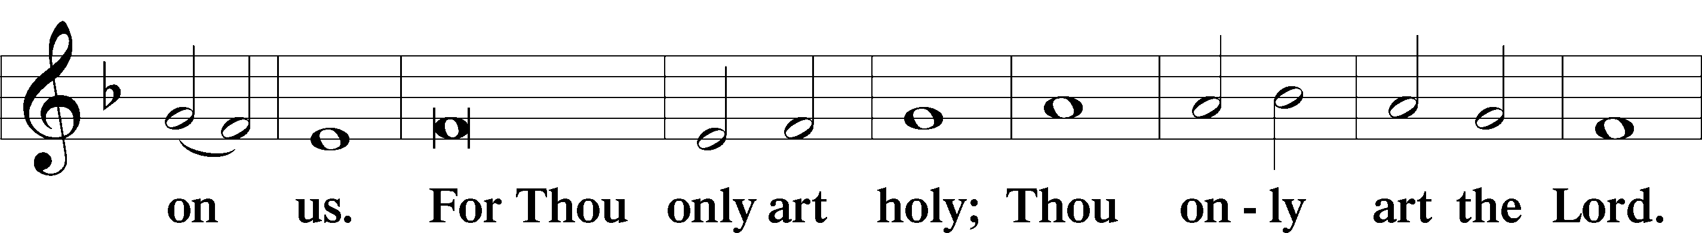
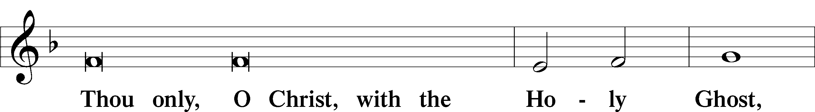
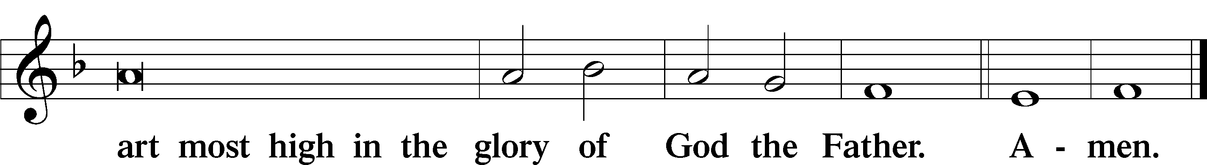

Salutation and Collect of the Day: First Sunday After Christmas
P The Lord be with you.
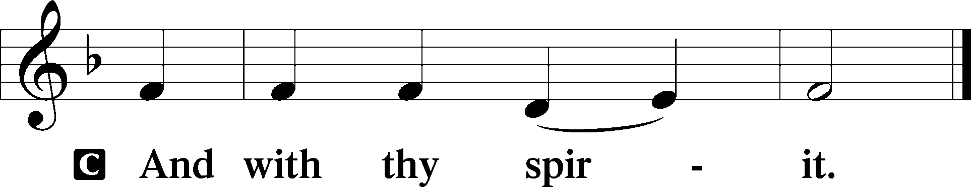

P Let us pray.
O God, our Maker and Redeemer, You wonderfully created us and in the incarnation of Your Son yet more wondrously restored our human nature. Grant that we may ever be alive in Him who made Himself to be like us; through Jesus Christ, our Lord, who lives and reigns with You and the Holy Spirit, one God, now and forever.
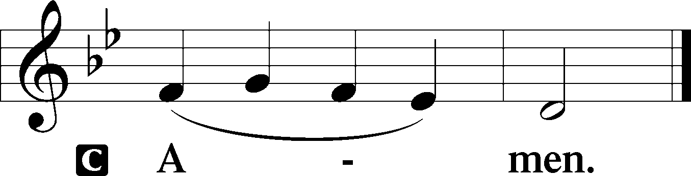
Sit
Prophecy: Jeremiah 31:31-34 (NKJV)
Thus says the Lord God: “Behold, the days are coming when I will make a new covenant with the house of Israel and with the house of Judah—not according to the covenant that I made with their fathers in the day that I took them by the hand to lead them out of the land of Egypt, My covenant which they broke, though I was a husband to them, says the Lord. But this is the covenant that I will make with the house of Israel after those days, says the Lord: I will put My law in their minds, and write it on their hearts; and I will be their God, and they shall be My people. No more shall every man teach his neighbor, and every man his brother, saying, ‘Know the Lord,’ for they all shall know Me, from the least of them to the greatest of them, says the Lord. For I will forgive their iniquity, and their sin I will remember no more,” says the Lord Almighty.

P This is the Word of the Lord.
C Thanks be to God.

Gradual Psalm 45:2a, 1b
You are the most handsome of the | sons of men;*
grace is poured up- | on your lips.
I address my verses | to the king;*
my tongue is like the pen of a | ready scribe.

Epistle: Galatians 4:1–7 (NKJV)
Brethren: The heir, as long as he is a child, does not differ at all from a slave, though he is master of all, but is under guardians and stewards until the time appointed by the father. Even so we, when we were children, were in bondage under the elements of the world. But when the fullness of the time had come, God sent forth His Son, born of a woman, born under the law, to redeem those who were under the law, that we might receive the adoption as sons. And because you are sons, God has sent forth the Spirit of His Son into your hearts, crying out, “Abba, Father!” Therefore you are no longer a slave but a son, and if a son, then an heir of God through Christ.

P This is the Word of the Lord.
C Thanks be to God.

Stand

Verse Psalm 93:1
Alleluia. The Lord reigns; he is robed in majesty; the Lord is robed; he has put on strength as his belt. Alleluia.

Alleluia
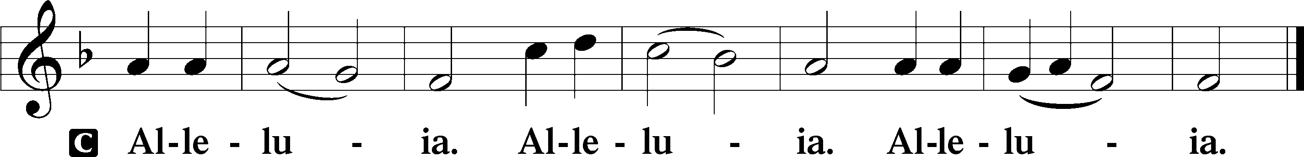

Holy Gospel: Luke 2:33–40 (NKJV)
P The Holy Gospel according to St. Luke, the second chapter.
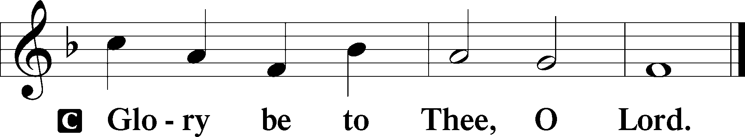

At that time: Joseph and Mary marveled at those things which were spoken of Jesus. Then Simeon blessed them, and said to Mary His mother, “Behold, this Child is destined for the fall and rising of many in Israel, and for a sign which will be spoken against (yes, a sword will pierce through your own soul also), that the thoughts of many hearts may be revealed.” Now there was one, Anna, a prophetess, the daughter of Phanuel, of the tribe of Asher. She was of a great age, and had lived with a husband seven years from her virginity; and this woman was a widow of about eighty-four years, who did not depart from the temple, but served God with fastings and prayers night and day. And coming in that instant she gave thanks to the Lord, and spoke of Him to all those who looked for redemption in Jerusalem. So when they had performed all things according to the law of the Lord, they returned to Galilee, to their own city, Nazareth. And the Child grew and became strong in spirit, filled with wisdom; and the grace of God was upon Him.

P This is the Gospel of the Lord.
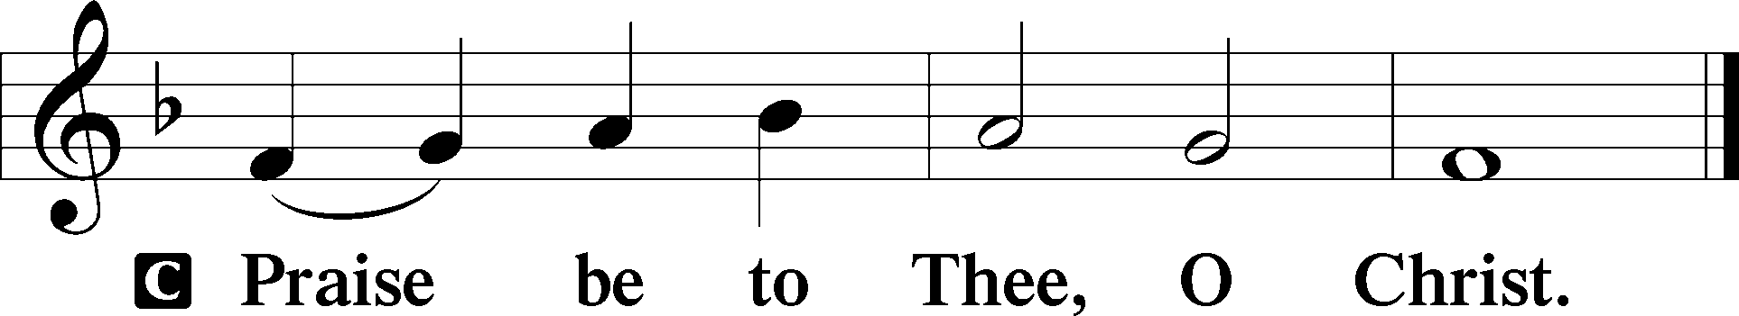

Nicene Creed
C I believe in one God,
the Father Almighty,
maker of heaven and earth
and of all things visible and invisible.

And in one Lord Jesus Christ,
the only-begotten Son of God,
begotten of His Father before all worlds,
God of God, Light of Light,
very God of very God,
begotten, not made,
being of one substance with the Father,
by whom all things were made;
who for us men and for our salvation came down from heaven
and was incarnate by the Holy Spirit of the virgin Mary
and was made man;
and was crucified also for us under Pontius Pilate.
He suffered and was buried.
And the third day He rose again according to the Scriptures
and ascended into heaven
and sits at the right hand of the Father.
And He will come again with glory to judge both the living and the dead,
whose kingdom will have no end.

And I believe in the Holy Spirit,
the Lord and giver of life,
who proceeds from the Father and the Son,
who with the Father and the Son together is worshiped and glorified,
who spoke by the prophets.
And I believe in one holy Christian and apostolic Church,
I acknowledge one Baptism for the remission of sins,
and I look for the resurrection of the dead
and the life T of the world to come. Amen.
Sit

Hymn of the Day: LSB #938 “In Peace and Joy I Now Depart”

Sermon

Stand

Offertory Psalm 51:10–12
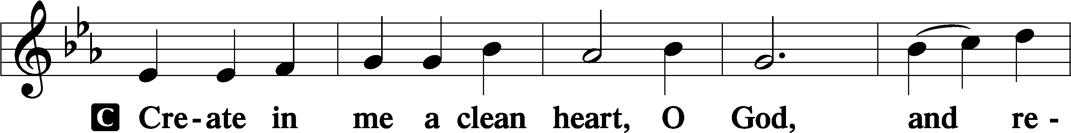
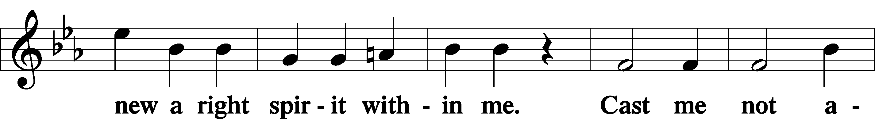
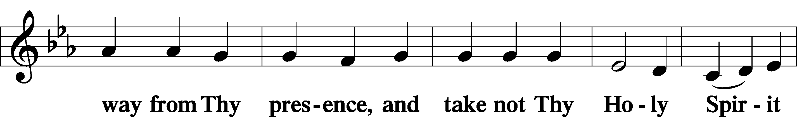
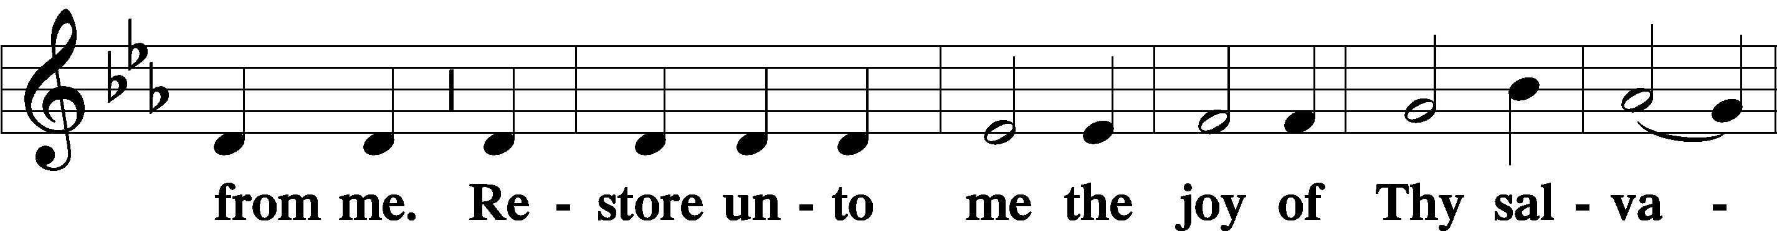
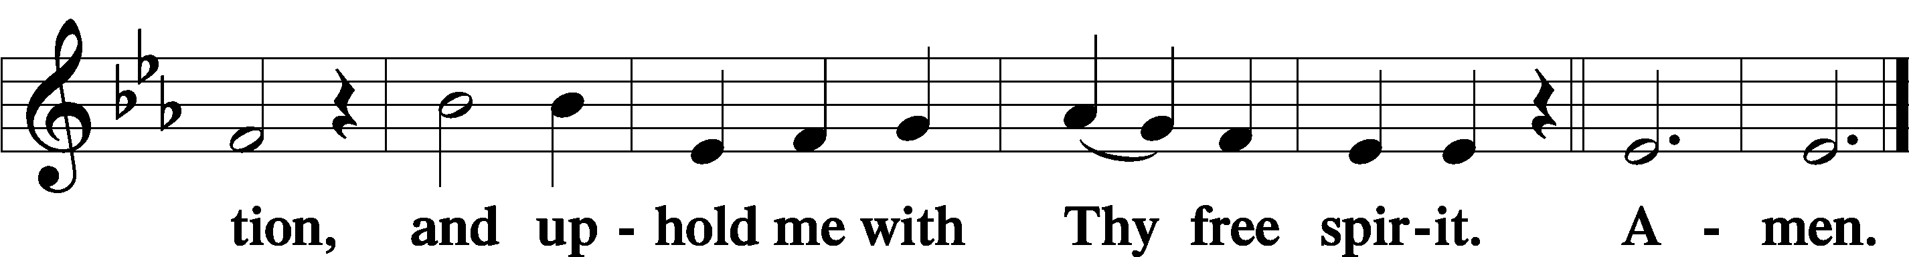

Prayer of the Church

Sit

Preparatory Hymn: LSB #519 “In His Temple Now Behold Him”

Stand
Service of the Sacrament

Preface 2 Timothy 4:22; Colossians 3:1 Psalm 136
P The Lord be with you.
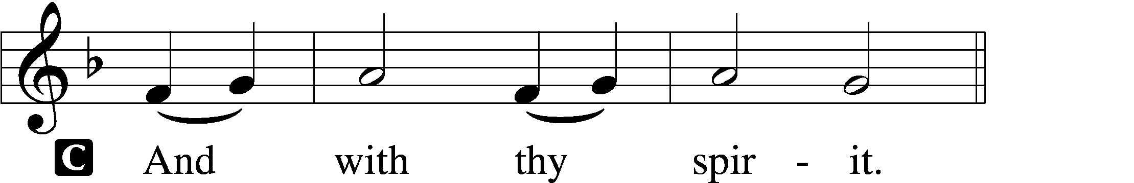

P Lift up your hearts.
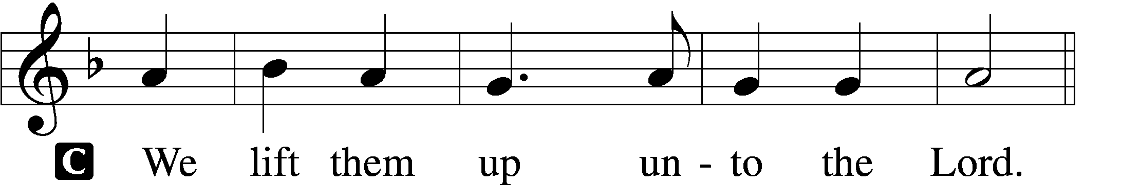

P Let us give thanks unto the Lord, our God.
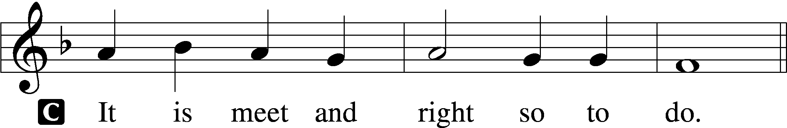

Proper Preface (Abbreviated) LSB 194
P It is truly meet, right, and salutary . . . evermore praising You and saying:

Sanctus Isaiah 6:3; Matthew 21:9
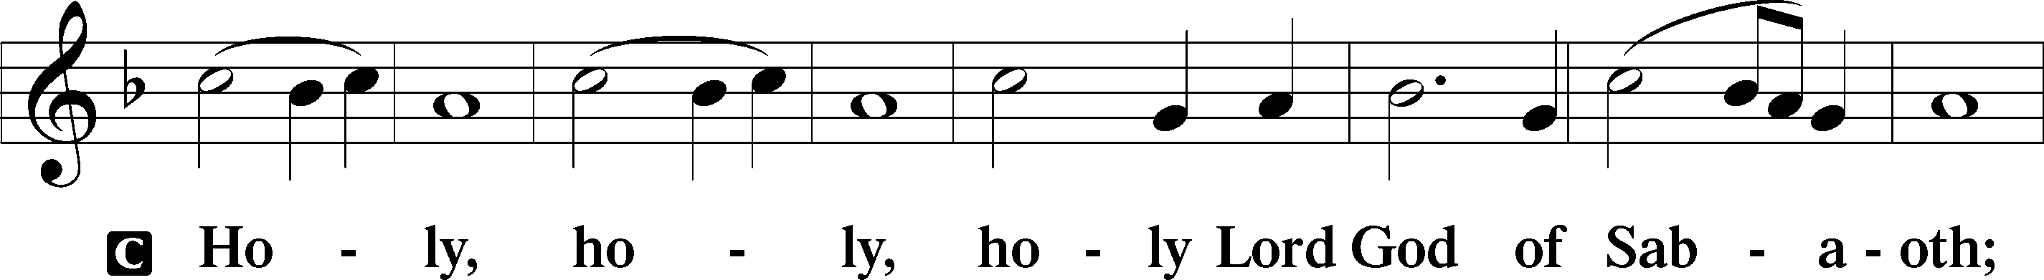
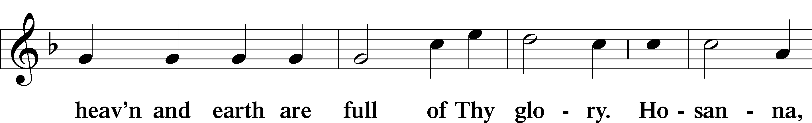
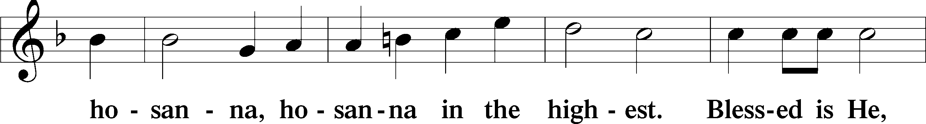
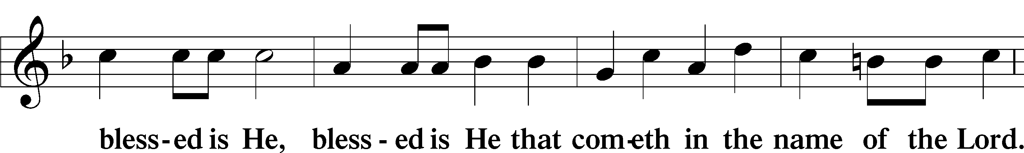
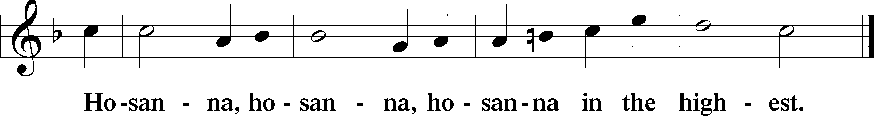

Lord’s Prayer The congregation is encouraged to silently pray the Lord’s Prayer as it is chanted. Matthew 6:9–13
P Our Father who art in heaven,
hallowed be Thy name,
Thy kingdom come,
Thy will be done on earth as it is in heaven;
give us this day our daily bread;
and forgive us our trespasses as we forgive those who trespass against us;
and lead us not into temptation,
but deliver us from evil.
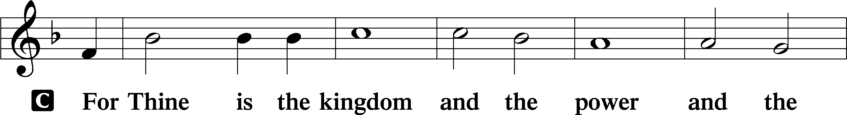
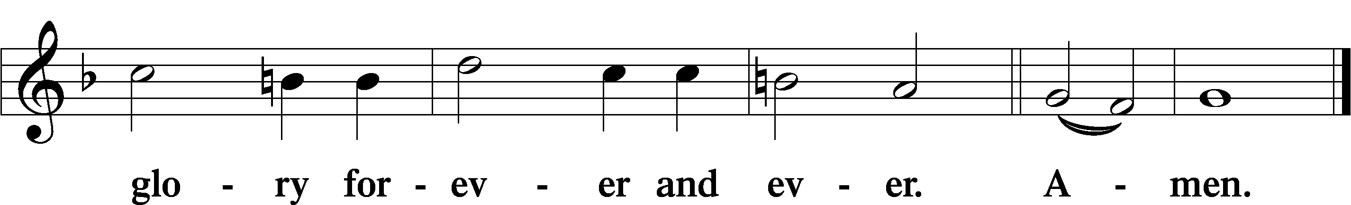

The Words of Our Lord Matthew 26:26–28; Mark 14:22–24; Luke 22:19–20; 1 Corinthians 11:23–25
P Our Lord Jesus Christ, on the night when He was betrayed, took bread, and when He had given thanks, He broke it and gave it to the disciples and said: “Take, eat; this is My T body, which is given for you. This do in remembrance of Me.”

In the same way also He took the cup after supper, and when He had given thanks, He gave it to them, saying: “Drink of it, all of you; this cup is the new testament in My T blood, which is shed for you for the forgiveness of sins. This do, as often as you drink it, in remembrance of Me.”

Pax Domini John 20:19
P The peace of the Lord be with you always.
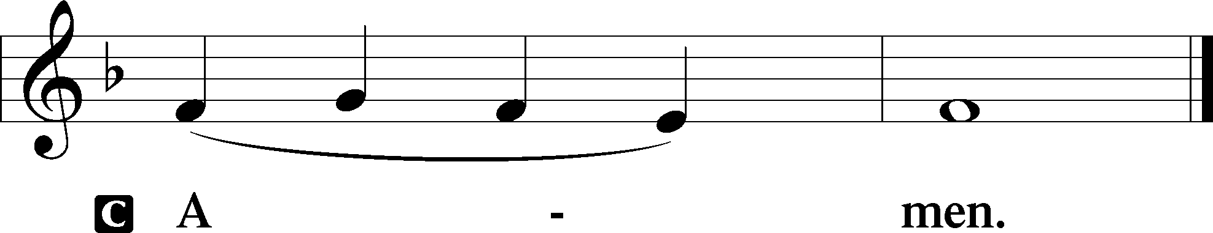

Agnus Dei John 1:29
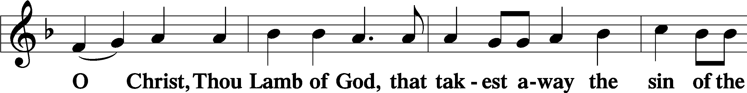
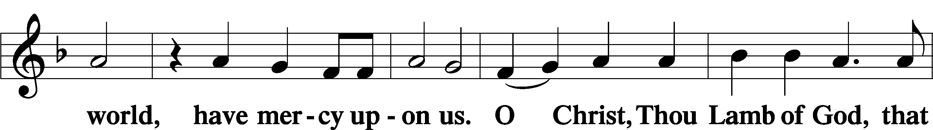
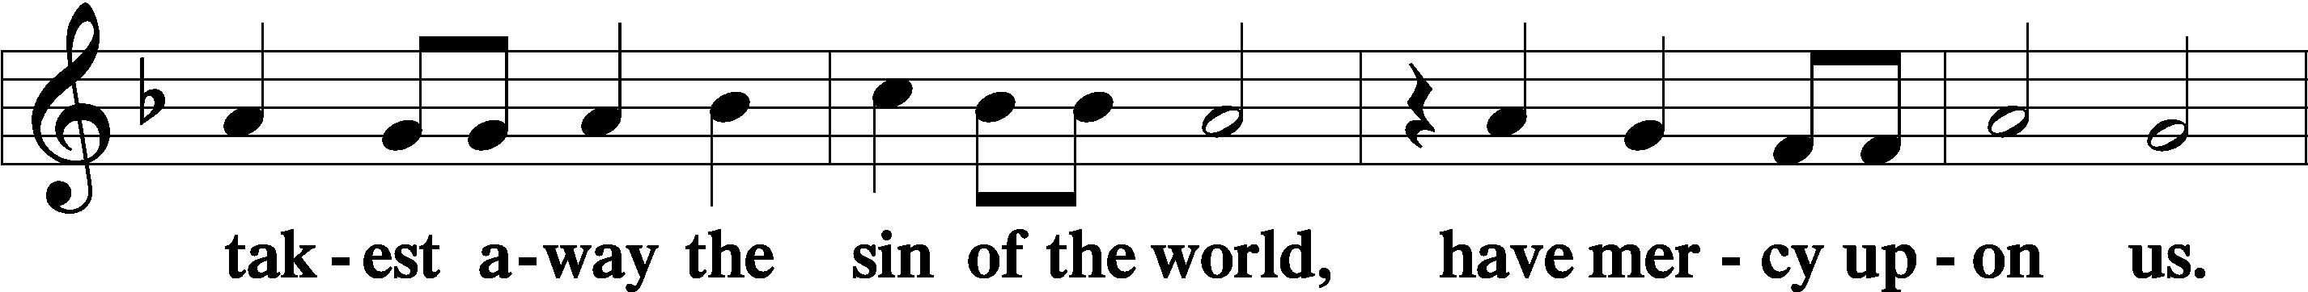
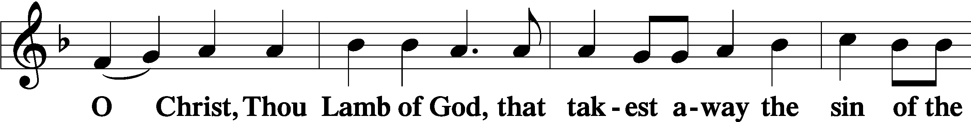
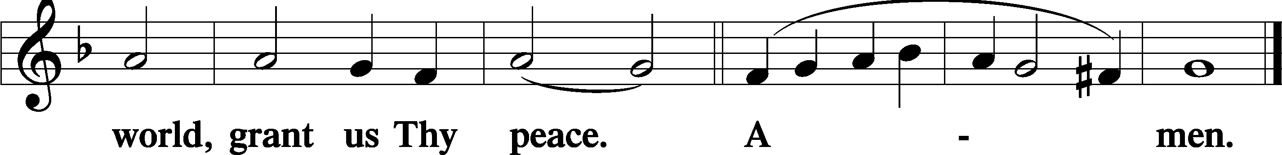
Sit

Distribution
The pastor and those who assist him receive the body and blood of Christ first and then distribute them to those who come to receive, saying:
Take, eat; this is the true body of our Lord and Savior Jesus Christ, given into death for your sins.
Amen.

Take, drink; this is the true blood of our Lord and Savior Jesus Christ, shed for the forgiveness of your sins.
Amen.

In dismissing the communicants, the following is said:
P The body and blood of our Lord Jesus Christ strengthen and preserve you in body and soul to life everlasting. Depart T in peace.
C Amen.

Distribution Hymn: LSB #371 “Let Our Gladness Banish Sadness”

Distribution Hymn: LSB #359 “Lo, How a Rose E’er Blooming”

Distribution Hymn: LSB #818 “In Thee Is Gladness”

Stand

Nunc Dimittis Luke 2:29–32
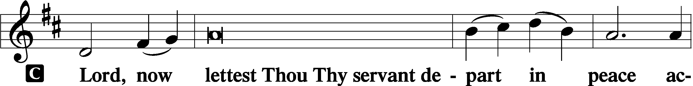
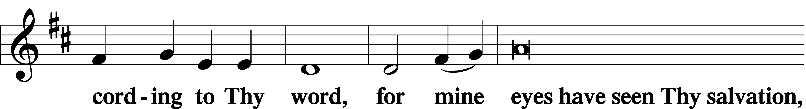
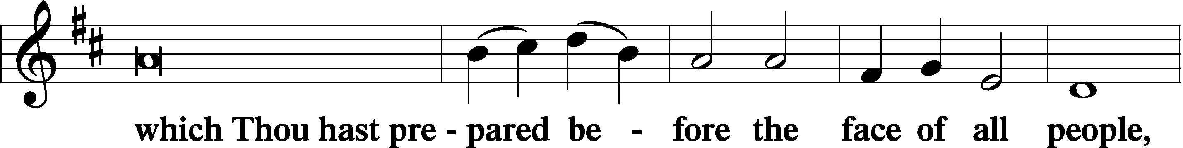
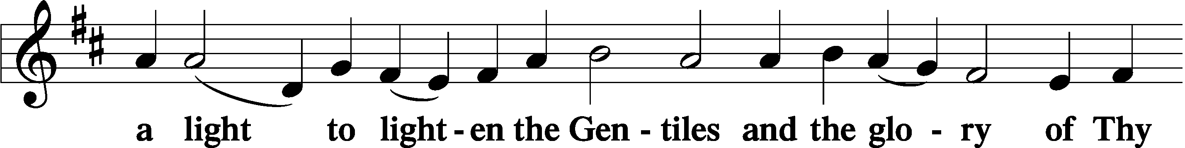
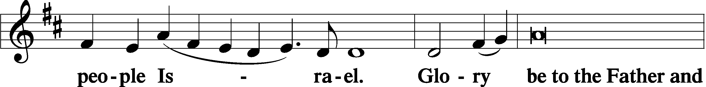
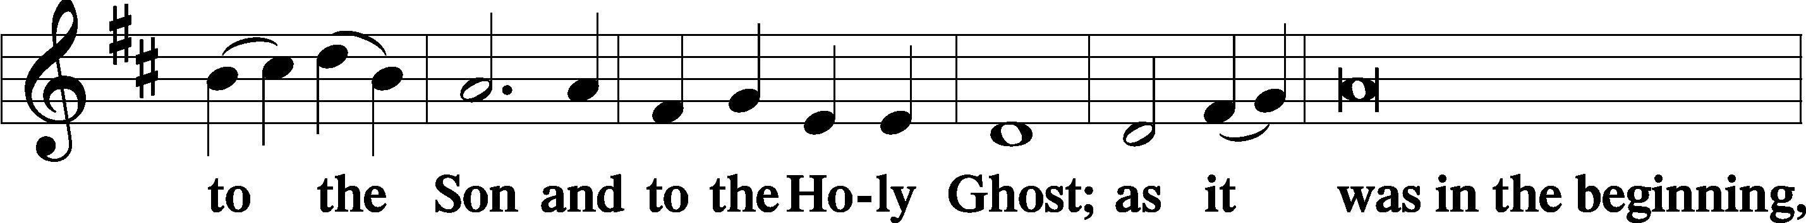
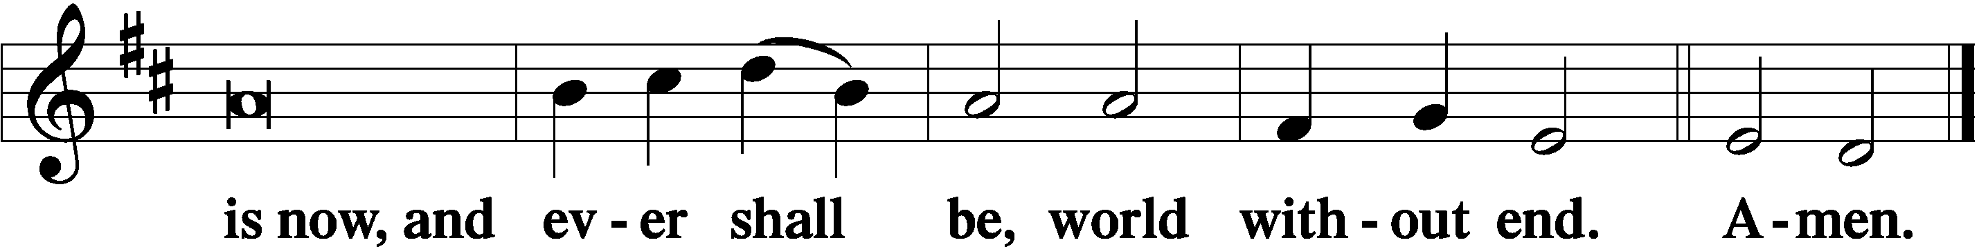

Thanksgiving Psalm 107:1
P O give thanks unto the Lord, for He is good,
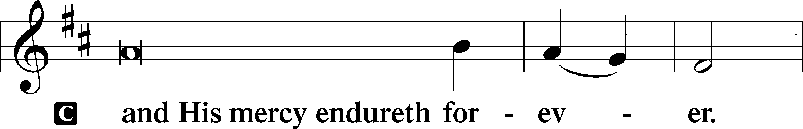

Post-Communion Collect
P Let us pray.
We give thanks to You, almighty God, that You have refreshed us through this salutary gift, and we implore You that of Your mercy You would strengthen us through the same in faith toward You and in fervent love toward one another; through Jesus Christ, Your Son, our Lord, who lives and reigns with You and the Holy Spirit, one God, now and forever.
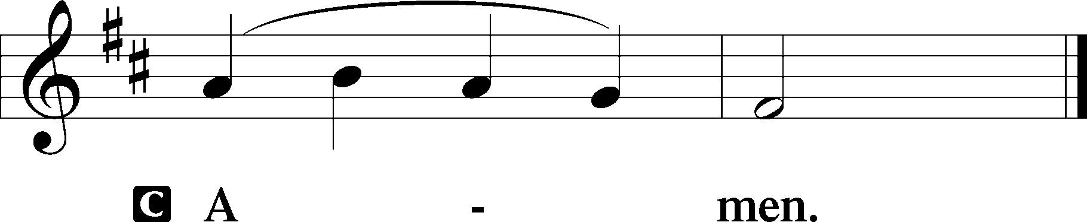

Salutation 2 Timothy 4:22
P The Lord be with you.
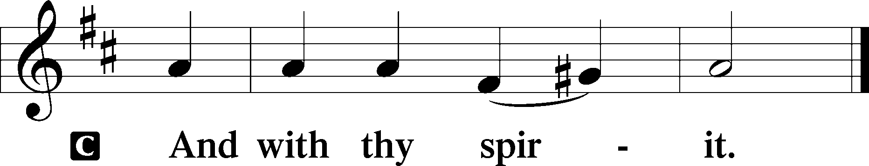

Benedicamus Psalm 103:1
P Bless we the Lord.
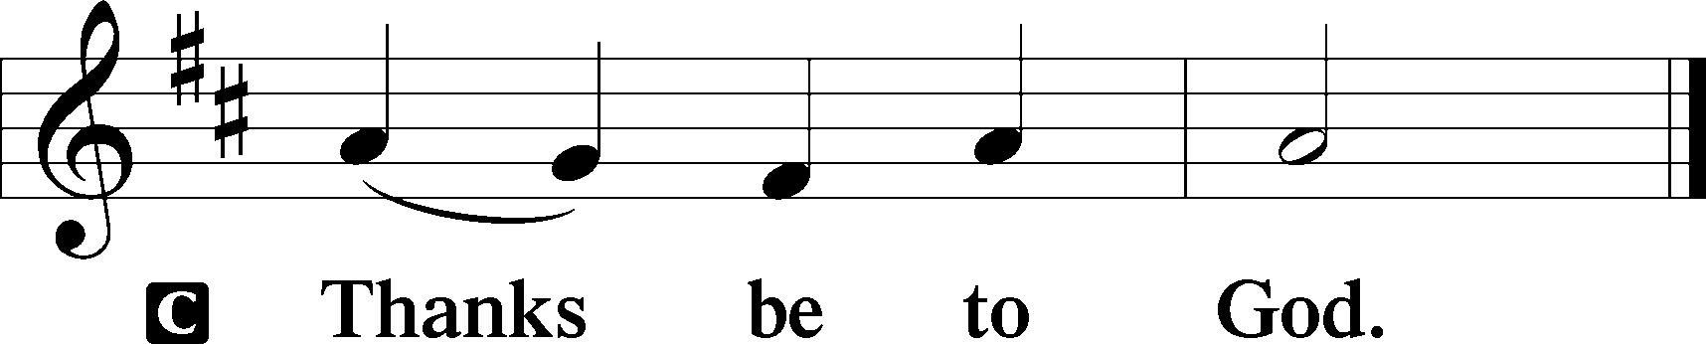

Benediction Numbers 6:24–26
P The Lord bless you and keep you.
The Lord make His face shine upon you and be gracious unto you.
The Lord lift up His countenance upon you and T give you peace.
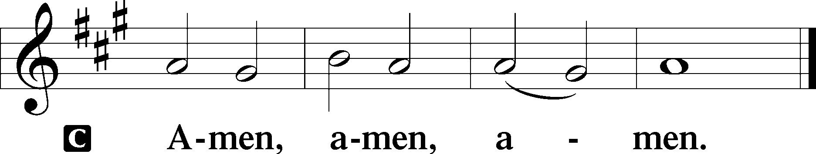

Closing Hymn: LSB #897 “O Rejoice, Ye Christians, Loudly”

Silent prayer after worship: Lord Jesus, let me never forget that You came to be my Wonderful Counselor, Mighty God, Everlasting Father and Prince of Peace every day of my life. Give me faith to trust in You always. Amen.

Acknowledgments: Unless otherwise indicated, Scripture quotations are from the ESV® Bible (The Holy Bible, English Standard Version®), copyright © 2001 by Crossway, a publishing ministry of Good News Publishers. Used by permission. All rights reserved. Created by Lutheran Service Builder © 2023 Concordia Publishing House.
fffffffffffffffffffffffffffffffffff
fffffffffffffffffffffffffffffffffff
In Loving Memory of My Cousin, Lori Colt Davis, on Her December Birthday: Linda Tomko.
In Loving Memory of Paul & Mildred Fabri, My Parents: Joani Rice (Piano Repair).
In Loving Memory of My Father, Paul, and My Uncles, Andy and Mike: Michael Petro (Capital Campaign).
In Loving Memory of Uncles Andy Petro and Uncle Mike Petro: Patty Parker (Capital Campaign).
In Loving Memory of Timith Riffle: Diane Riefstahl.
In Memory of All Loved Ones: Edeltraud Sulek (Capital Campaign).
fffffffffffffffffffffffffffffffffff
Sincere “thanks” goes out to those who graciously volunteered to provide food for this evening’s AA Sober New Year’s Eve party! Your generosity is greatly appreciated.
fffffffffffffffffffffffffffffffffff
SCHEDULE THROUGH JANUARY 7, 2024:

:

Today, 7 pm, Fellowship Hall: AA “New Year’s Eve” Party
Monday, 7 pm, Sanctuary: Vespers Service Celebrating the Circumcision and Name of Jesus
Tuesday, 7-9 pm, Fellowship Hall: Penn-Ohio Singers
Wednesday, 7 pm, Fellowship Hall: NA Meeting
Thursday, 10 am, Fellowship Hall: Women’s Bible Study
Saturday, 7 pm, Sanctuary: Divine Service Celebrating the Epiphany of Our Lord
Next Sunday, 9 am, Sanctuary: Divine Service
7 pm, Fellowship Hall: AA New Year’s Eve Celebration
fffffffffffffffffffffffffffffffffff
THANK YOU FOR SERVING IN DECEMBER: Elder: Jonathan Baisch; Ushers: Cheryl Fedele, Mike Flaugher, & Jesse Riffle; Altarware: Marie Flaugher (12.31).
fffffffffffffffffffffffffffffffffff
Bible Memory Verses ~ Week of December 31st:
For Adults: Come to me, all who labor and are heavy laden, and I will give you rest. Take my yoke upon you, and learn from me, for I am gentle and lowly in heart, and you will find rest for your souls. For my yoke is easy, and my burden is light. Matthew 11:28-30
For Children: Lord, now you are letting your servant depart in peace, according to your word; for my eyes have seen your salvation. Luke 2:29-30
fffffffffffffffffffffffffffffffffff
2024 Offering Envelopes are available in the church library. Please stop by and pick yours up!
fffffffffffffffffffffffffffffffffff
Additional Opportunities for Worship this Week: Join us tomorrow evening, January 1st, at 7 pm for a Vespers Service celebrating the Circumcision and Name of Jesus and this Saturday evening, January 6th, at 7 pm for a special Divine Service celebrating the Epiphany of Our Lord.
fffffffffffffffffffffffffffffffffff
Our Stewardship of Treasures for the Lord:
In order to do the Lord’s work, we need $2,553.63 each week to meet our 2023 budget for general purposes and $76.92 for the SELC.

Online Figures for December 20 & December 24, 2023
General Fund: $6,000.00
SELC: $100.00
Quarterly Missions: $25.00
Capital Campaign: $1,200.00
Figures for Wednesday, December 20, 2023
General Fund: $145.00
Capital Campaign: $180.00
Other: $500.00
Figures for Sunday, December 24, 2023
General Fund: $1,115.00
Capital Campaign: $35.00
Other: $200.00
Figures for Sunday, December 24, 2023
General Fund: $1,113.00
Figures for Monday, December 25, 2023
General Fund: $390.00

For online giving, check out https://www.saintspeterandpaul.net/online-giving.
fffffffffffffffffffffffffffffffffff
Attendance: Sunday, December 24, 2023: (am) 32; (pm) 49
Monday, December 25, 2023: 25
Tuesday, December 26, 2023: 4
Wednesday, December 27, 2023: 4
Thursday, December 28, 2023: 4
fffffffffffffffffffffffffffffffffff
The January issue of ”The Rock and the Sword” newsletter is available on the tables in the narthex and next to the nursery.
fffffffffffffffffffffffffffffffffff

Remember the following in Prayer…
~The Hurting and Healing: Amy, Mary Jane Anderson, Steve Antolovich, Ellen Baron^{CA}, Amy Blomenberg, Lois Bortner^{CA}, Sara Brubaker, Dee Bullock, Bev & Joe Chlpka, Susan Davies, Loretta Deal, Tim Dudash, Judith & Eddy Furey, Griffin, Austin Hamilton, Pastor Charles Henrickson, Joan, Keith Jozwiakowski, Rhyan Kirsch, Darla Krajci, Barbara Kreske, Jess Lavoie, Paul Lucas^{CA}, Sandy Marshall, Frank Niemeyer^{CA}, Juanita Rentschler, Richard Reuning^{CA}, Rosemary (Posey) Rice^{CA}, Nancy Robertson^{CA}, Kriss Svidro^{CA}, Rudy Tomko, Bob Usnarski, Joel & Peggy Wasson, Angela Weser^{CA}, and Ruth Wolf.
~The Homebound: Anna Mae Daris, Millie Elavsky, Jean Tomko, Betty Wolf, and Ed & Millie Zachar.
~Celebrating this Week: Birthday: Mike Flaugher (01.04).
~Serving in the Military: Alex (Sasha) Carr, Duncan Vaupel, Curtis Sinewe, and Joshua Solyan.
~Community & World Needs: Those suffering due to the conflicts in the Middle East and between Ukraine and Russia; those suffering from loss and dislocation because weather disasters; those suffering from addiction and their families; Local, State, and National Government Leaders; safety for all Police Officers, Firefighters, & First Responders; the unemployed; our Fourth Quarter Local Mission: Willow Women’s Center.
*CA represents cancer.
fffffffffffffffffffffffffffffffffff
Copies of the 1st Quarter “Portals of Prayer” for 2024 are available on the table in the narthex and next to the sign-in table by the nursery.
fffffffffffffffffffffffffffffffffff
THANK YOU FOR SERVING IN JANUARY: Elder: Jonathan Baisch; Ushers: Cheryl Fedele, Mike Flaugher, & Jesse Riffle; Altarware ~ Sundays: (prior) Elizabeth Haenftling (01.07), Marie Flaugher (01.14) & Diane Riefstahl (01.21 & 01.28); (after) Cheryl Fedele & Clara Krivosh; Special Divine Service: Diane Riefstahl (01.06).
fffffffffffffffffffffffffffffffffff
Here to Serve
Pastor………………………………………………...……………Rev. Jacob Deal
E-mail …………………………….……pastordeal@saintspeterandpaul.net
Phone Number……………………..…………………724-347-3620 (Option 2)
Church Office………………………..…………………724-347-3620 (Option 3)
Website …………………………………………www.saintspeterandpaul.net
Secretary…………………………………………………………Diane Riefstahl
E-mail ………………………………………church@saintspeterandpaul.net
Website …………………………………………www.saintspeterandpaul.net
Food Pantry (email): ……………foodpantry@saintspeterandpaul.net
Congregation President………………………………….…Jonathan Baisch
Church Elder …………………………………………...……. Jonathan Baisch
Organist………………………………………………..….…Rebecca Marquette
AA Contact: Steve………………………………………………...…724-813-2358
NA Contact: Larry……………………………………..…………..724-977-8733
fffffffffffffffffffffffffffffffffff
If needing to get into the church building during the week, please phone first to make certain someone is here to let you in.

