Sts. Peter & Paul
Evangelical Lutheran Church
Lutheran Church-Missouri Synod
Founded-1917

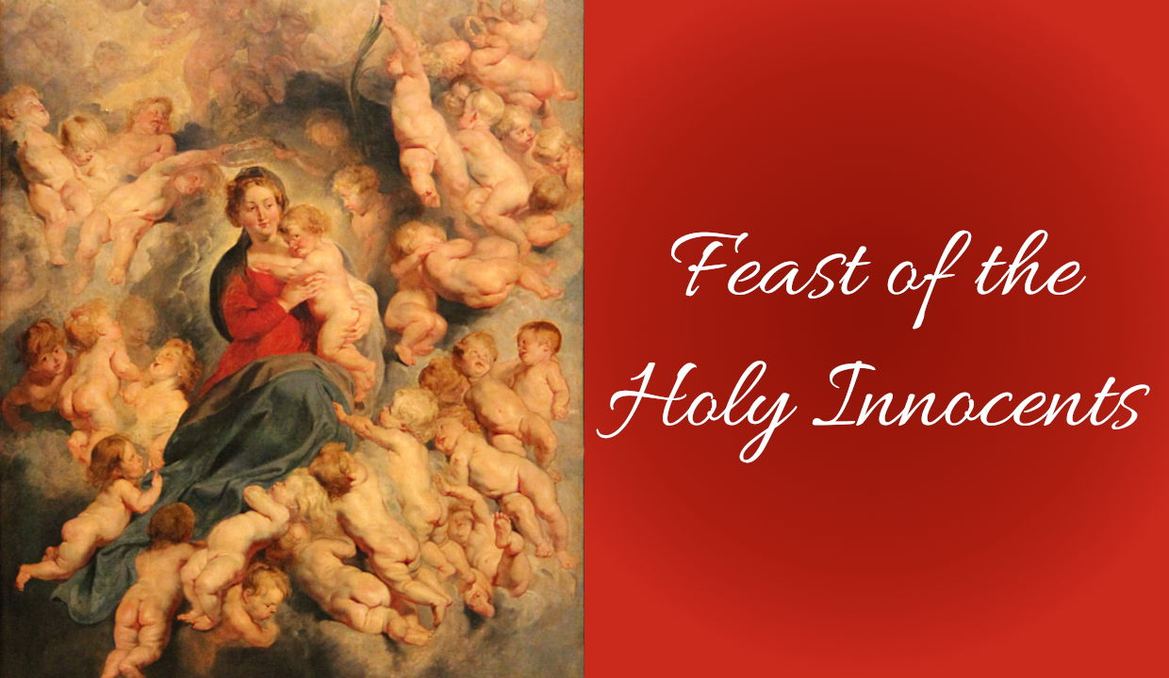

Feast of the Holy Innocents,
Martyrs
December 28, 2022

699 Stambaugh Avenue
Sharon, Pennsylvania 16146

“I was glad when they said to me,
Let us go to the house of the LORD!”
Psalm 122:1
Sts. Peter & Paul Evangelical Lutheran Church, LC-MS

FEAST OF THE HOLY INNOCENTS,
MARTYRS
December 28, 2022

A special welcome to our guests this day! If you would like more information about The Lutheran Church - Missouri Synod, or this congregation, please speak with Pastor Deal or an Elder after the service.
Members & Guests: Don’t be embarrassed if your children make noise during the worship service, all children do. We encourage families to worship together but, if you feel the need, there are pews in the rear of the Church which are reserved for young families on both sides of the sanctuary. There is also a quiet room available to you during our service which is located down the hallway past the offices on the right side of the church as well as a children’s area in the Fellowship Hall where you are able to follow along with the service.

CONTACT INFORMATION
Pastor Deal: pastordeal@saintspeterandpaul.net or 724-347-3620 (opt. 2)
Church Office: church@saintspeterandpaul.net or 724-347-3620 (opt. 3)

Silent prayer before worship: Dearest Lord Jesus, You have come to me as the Holy Child of Bethlehem. I come to You this hour to receive Your gifts peace, hope, love, joy and life. Help me to value these more than anything else. Amen.

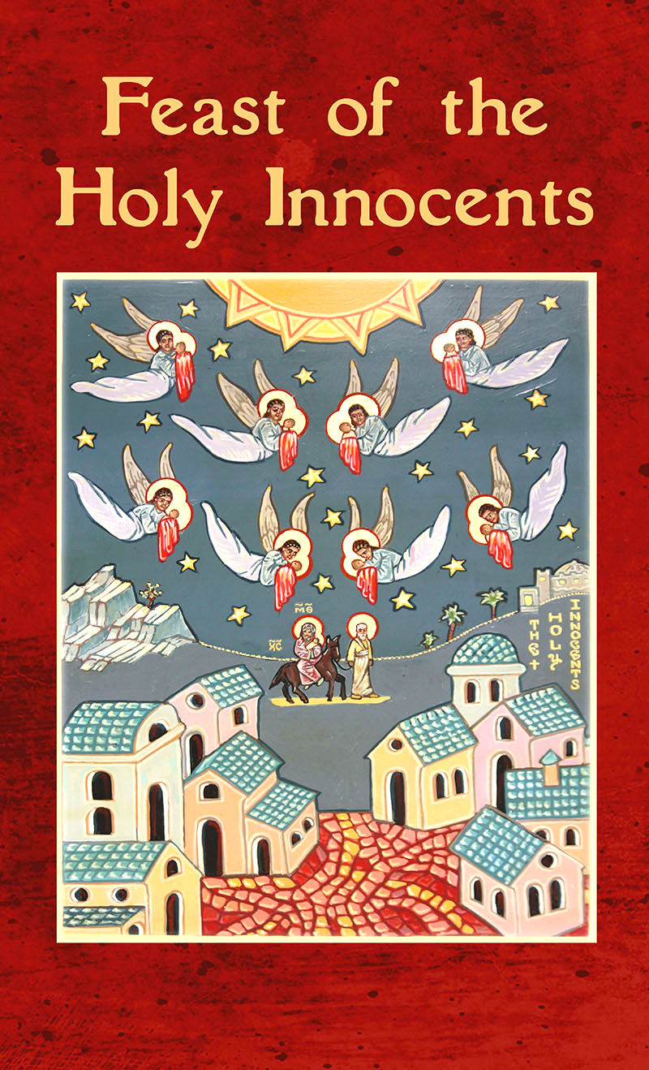
VESPERS

Opening Hymn: LSB #360 “All My Heart Again Rejoices”

Stand

Common Versicles LSB 229

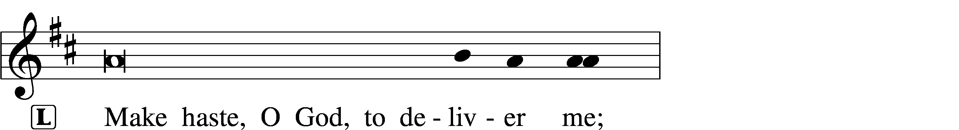
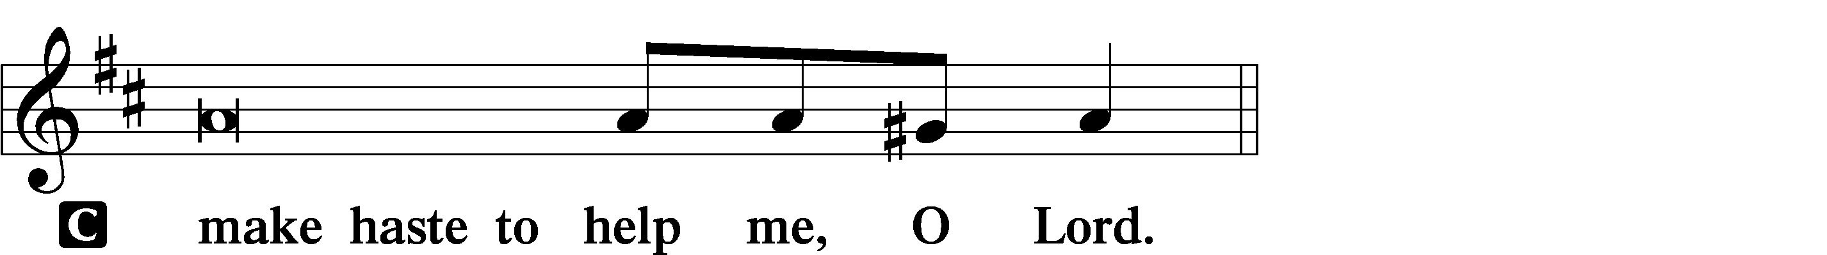

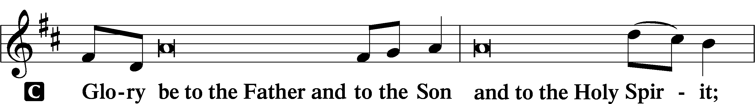
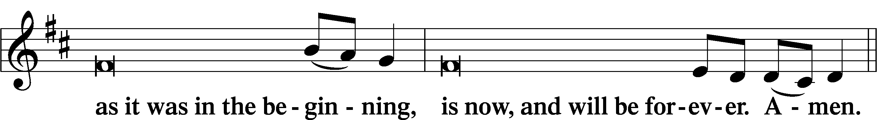
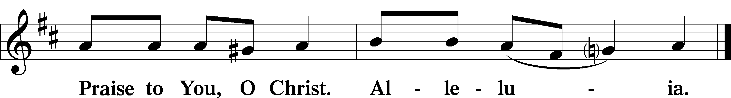

Psalmody

Psalm 54
O God, save me, by your name,
and vindicate me by your might.
O God, hear my prayer;
give ear to the words of my mouth.
For strangers have risen against me;
ruthless men seek my life;
they do not set God before themselves.
Behold, God is my helper;
the Lord is the upholder of my life.
He will return the evil to my enemies;
in your faithfulness put an end to them.
With a freewill offering I will sacrifice to you;
I will give thanks to your name, O Lord, for it is good.
For he has delivered me from every trouble,
and my eye has looked in triumph on my enemies.
Sit

Hymn of the Day: LSB #969 “Sweet Flowerets of the Martyr Band”
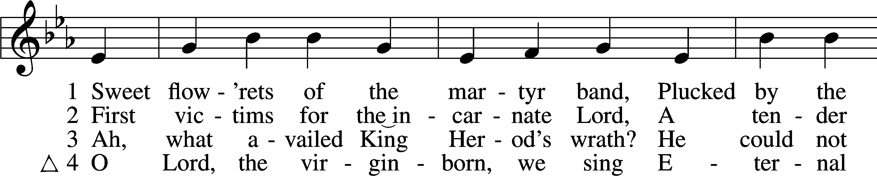
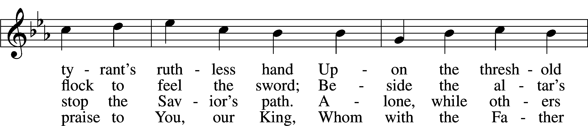
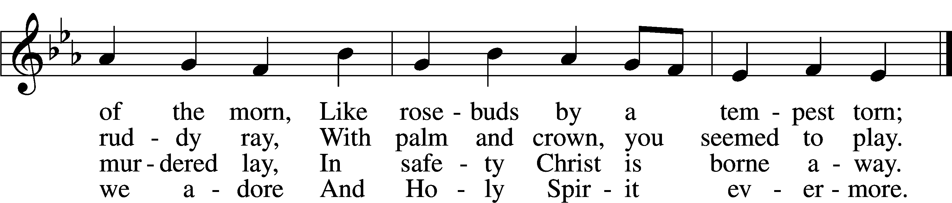
Text: Aurelius Prudentius Clemens, 348–c. 413; tr. Henry W. Baker, 1821–77, alt.
Tune: Daniel Vetter, d. 1721
Text and tune: Public domain

Readings

Prophecy: Exodus 1:8–22
In those days: There arose a new king over Egypt, who did not know Joseph. And he said to his people, “Look, the people of the children of Israel are more and mightier than we; come, let us deal shrewdly with them, lest they multiply, and it happen, in the event of war, that they also join our enemies and fight against us, and so go up out of the land.” Therefore they set taskmasters over them to afflict them with their burdens. And they built for Pharaoh supply cities, Pithom and Raamses. But the more they afflicted them, the more they multiplied and grew. And they were in dread of the children of Israel. So the Egyptians made the children of Israel serve with rigor. And they made their lives bitter with hard bondage—in mortar, in brick, and in all manner of service in the field. All their service in which they made them serve was with rigor. Then the king of Egypt spoke to the Hebrew midwives, of whom the name of one was Shiphrah and the name of the other Puah; and he said, “When you do the duties of a midwife for the Hebrew women, and see them on the birthstools, if it is a son, then you shall kill him; but if it is a daughter, then she shall live.” But the midwives feared God, and did not do as the king of Egypt commanded them, but saved the male children alive. So the king of Egypt called for the midwives and said to them, “Why have you done this thing, and saved the male children alive?” And the midwives said to Pharaoh, “Because the Hebrew women are not like the Egyptian women; for they are lively and give birth before the midwives come to them.” Therefore God dealt well with the midwives, and the people multiplied and grew very mighty. And so it was, because the midwives feared God, that He provided households for them. So Pharaoh commanded all his people, saying, “Every son who is born you shall cast into the river, and every daughter you shall save alive.”

P This is the Word of the Lord.
C Thanks be to God.

Epistle: Revelation 14:1–5
In those days: I looked, and behold, a Lamb standing on Mount Zion, and with Him one hundred and forty-four thousand, having His Father’s name written on their foreheads. And I heard a voice from heaven, like the voice of many waters, and like the voice of loud thunder. And I heard the sound of harpists playing their harps. They sang as it were a new song before the throne, before the four living creatures, and the elders; and no one could learn that song except the hundred and forty-four thousand who were redeemed from the earth. These are the ones who were not defiled with women, for they are virgins. These are the ones who follow the Lamb wherever He goes. These were redeemed from among men, being firstfruits to God and to the Lamb. And in their mouth was found no deceit, for they are without fault before the throne of God.

P This is the Word of the Lord.
C Thanks be to God.

Gospel: Matthew 2:13b–18
At that time: An angel of the Lord appeared to Joseph in a dream, saying, “Arise, take the young Child and His mother, flee to Egypt, and stay there until I bring you word; for Herod will seek the young Child to destroy Him.” When he arose, he took the young Child and His mother by night and departed for Egypt, and was there until the death of Herod, that it might be fulfilled which was spoken by the Lord through the prophet, saying, “Out of Egypt I called My Son.” Then Herod, when he saw that he was deceived by the wise men, was exceedingly angry; and he sent forth and put to death all the male children who were in Bethlehem and in all its districts, from two years old and under, according to the time which he had determined from the wise men. Then was fulfilled what was spoken by Jeremiah the prophet, saying: “A voice was heard in Ramah, lamentation, weeping, and great mourning, Rachel weeping for her children, refusing to be comforted, because they are no more.”

P This is the Word of the Lord.
C Thanks be to God.

Sermon

Canticle
Stand

Antiphon (Common) 231
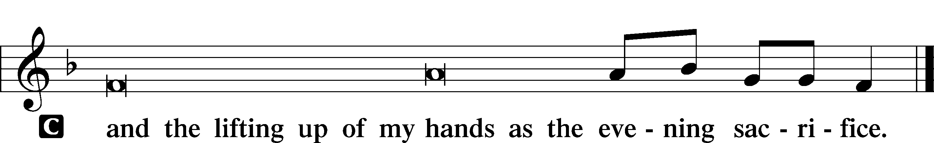

Magnificat 231
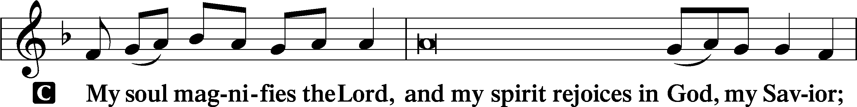
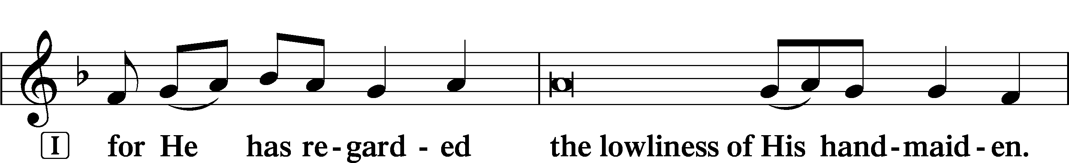
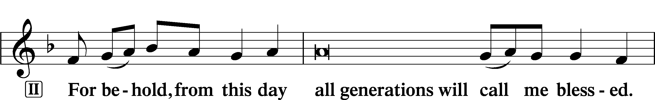
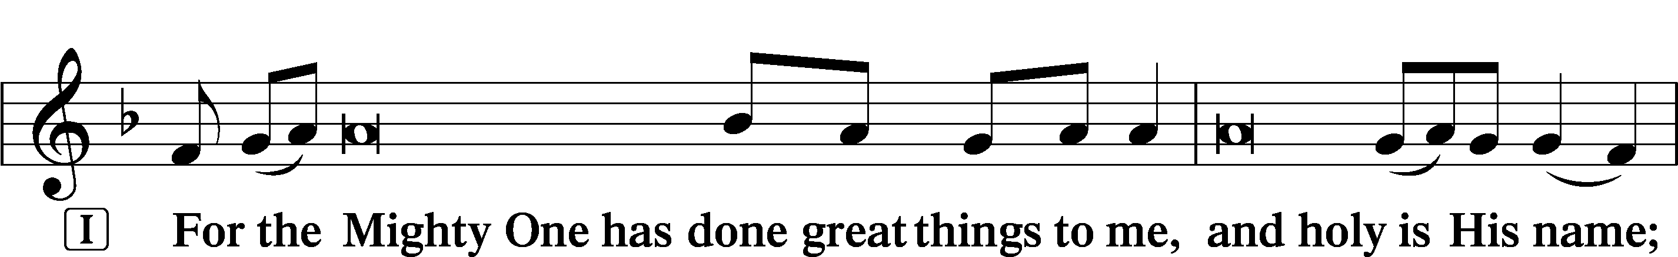
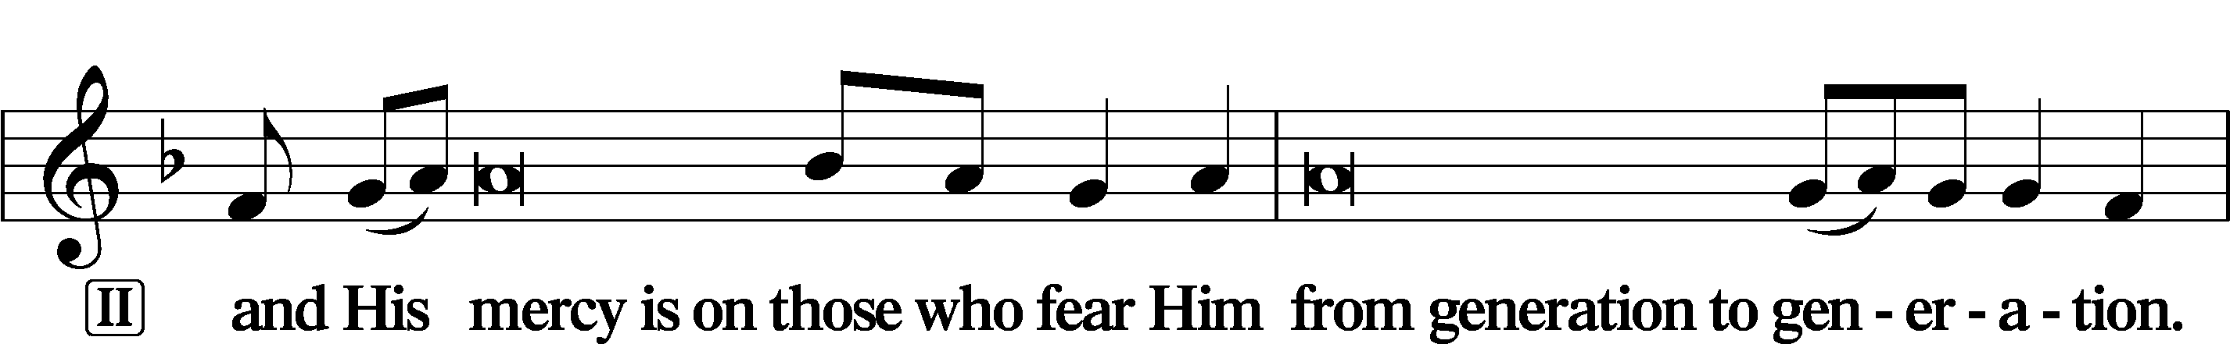
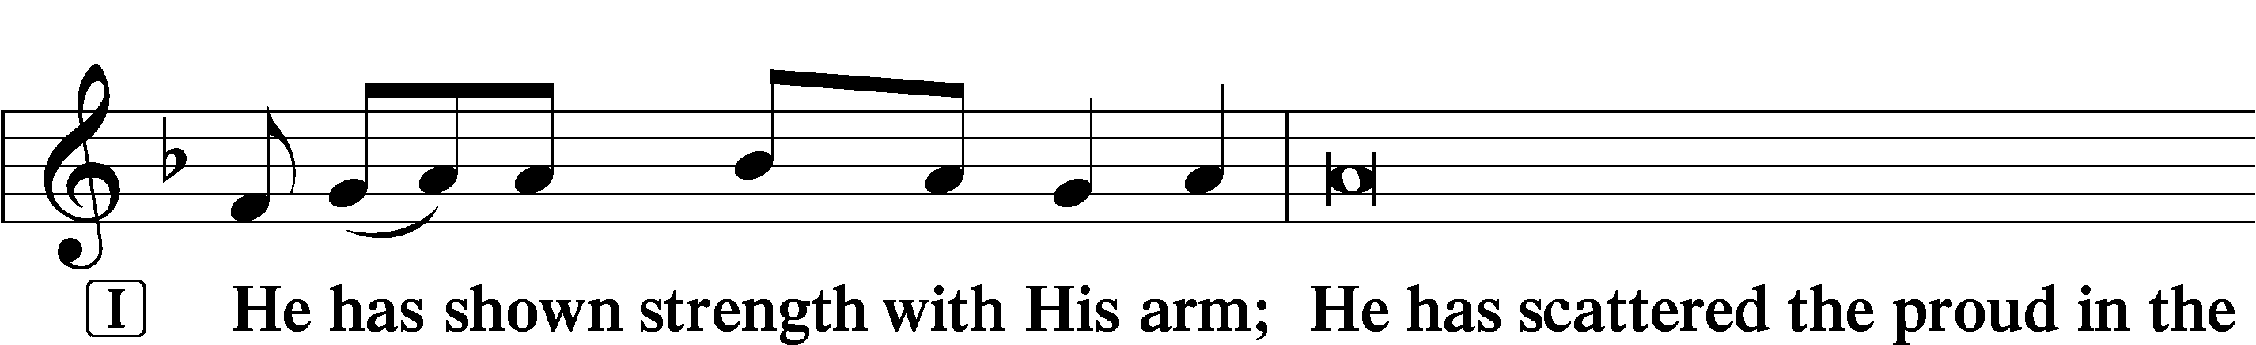
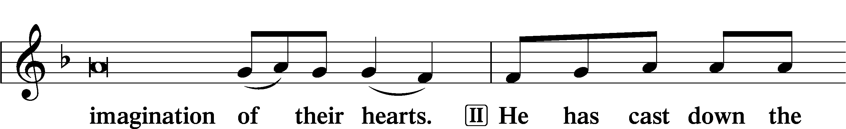
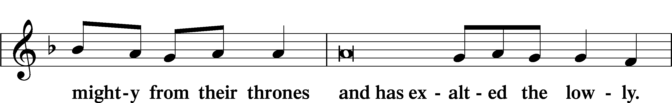
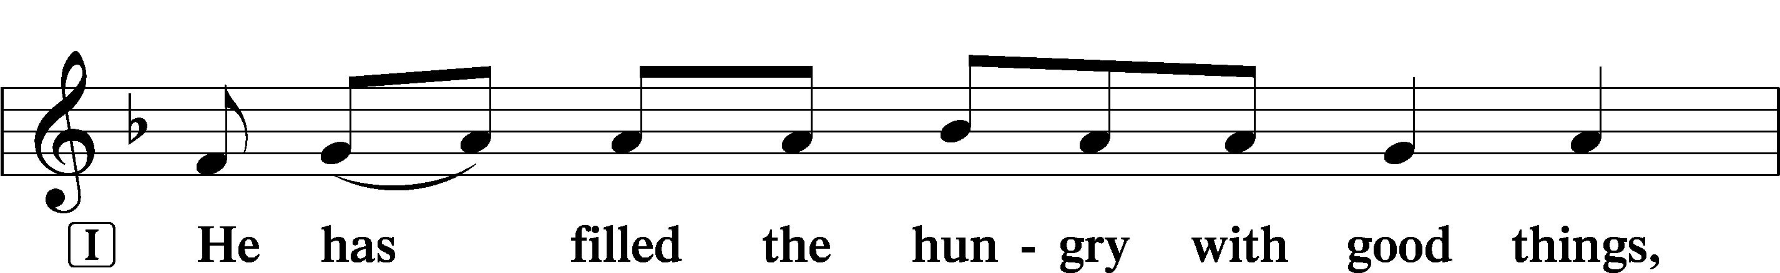
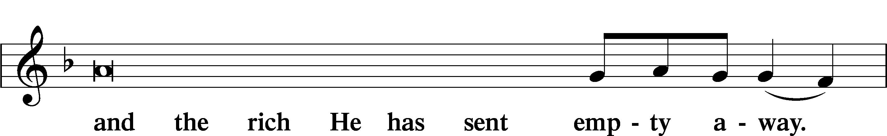
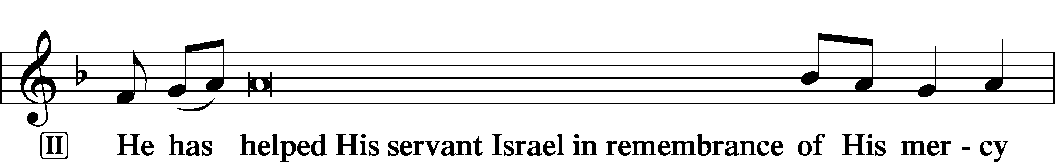
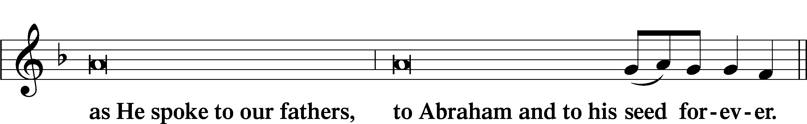
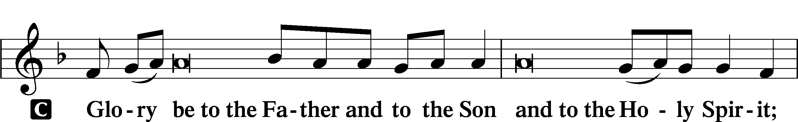
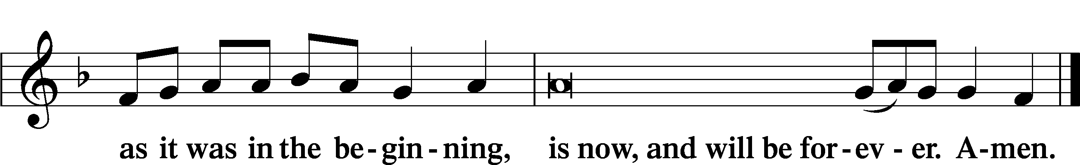
Prayer

Kyrie LSB 233
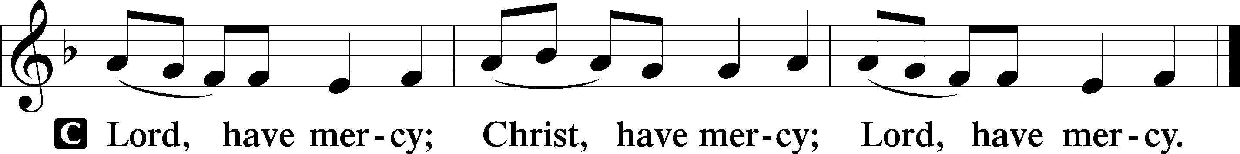

Lord’s Prayer
C Our Father who art in heaven,
hallowed be Thy name,
Thy kingdom come,
Thy will be done on earth
as it is in heaven;
give us this day our daily bread;
and forgive us our trespasses
as we forgive those
who trespass against us;
and lead us not into temptation,
but deliver us from evil.
For Thine is the kingdom
and the power and the glory
forever and ever. Amen.

Collects
Introduction to Collects LSB 233
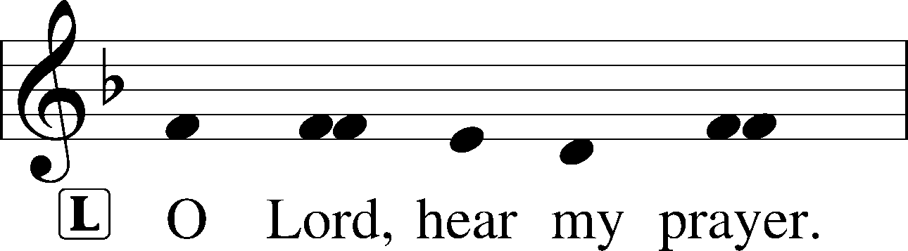
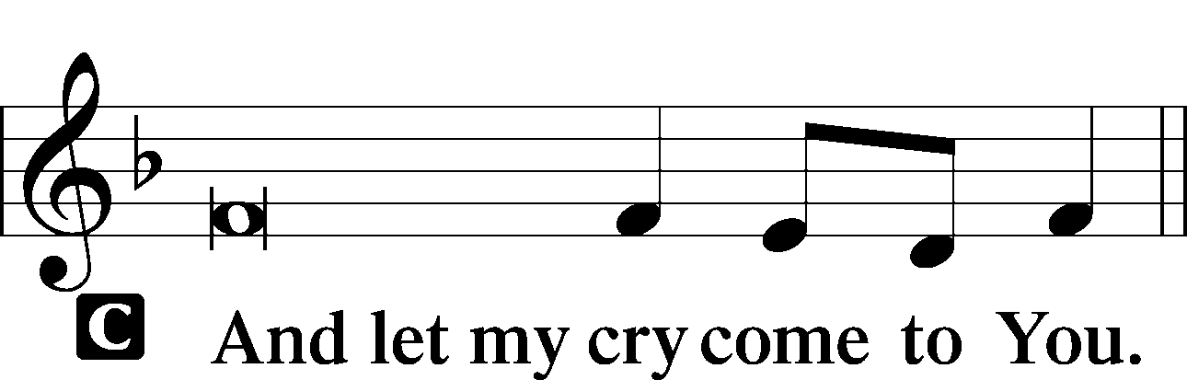

Collect of the Day: Holy Innocents
P Almighty God, the martyred innocents of Bethlehem showed forth Your praise not by speaking but by dying. Put to death in us all that is in conflict with Your will that our lives may bear witness to the faith we profess with our lips; through Jesus Christ, our Lord, who lives and reigns with You and the Holy Spirit, one God, now and forever.

Collect for Peace
P O God, from whom come all holy desires, all good counsels, and all just works, give to us, Your servants, that peace which the world cannot give, that our hearts may be set to obey Your commandments and also that we, being defended from the fear of our enemies, may live in peace and quietness; through Jesus Christ, Your Son, our Lord, who lives and reigns with You and the Holy Spirit, one God, now and forever.
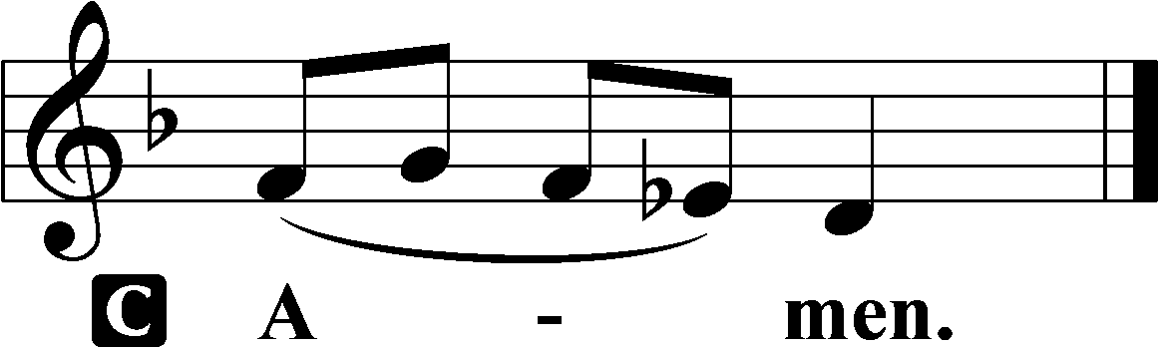

Benedicamus LSB 234
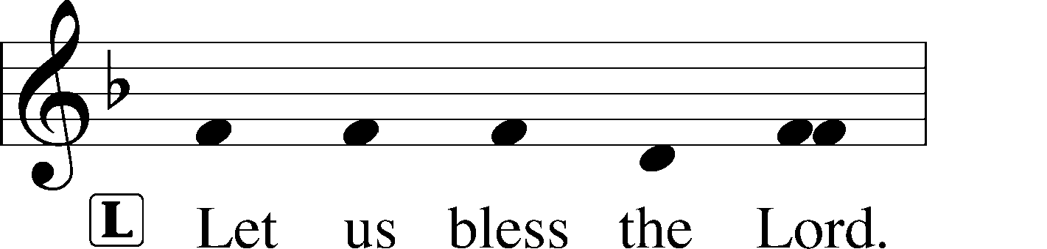
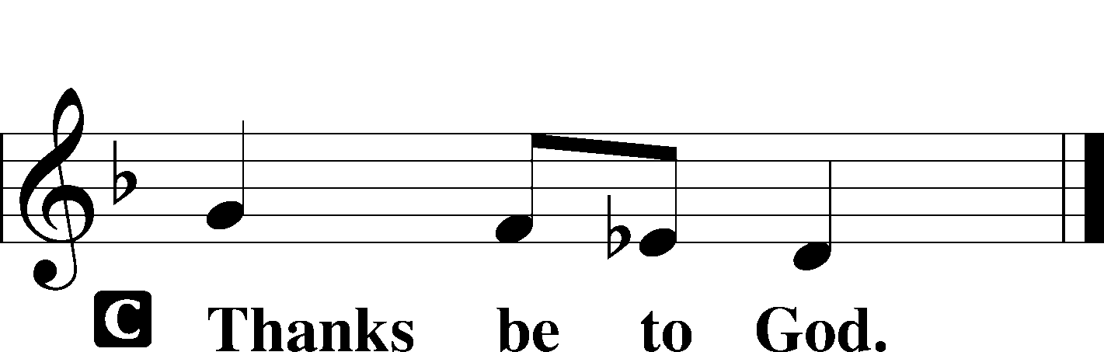

Benediction LSB 234
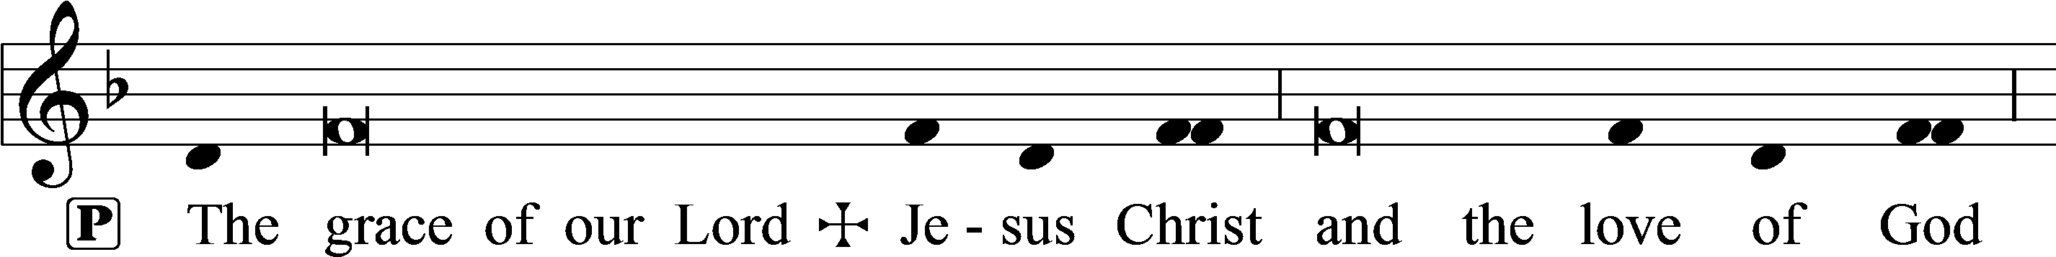
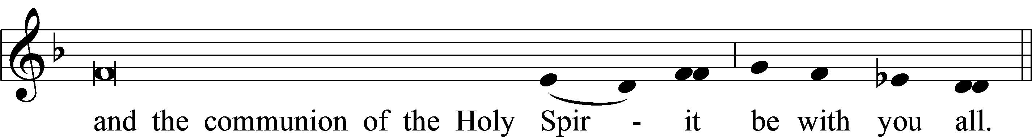

Closing Hymn: LSB #666 “O Little Flock, Fear Not the Foe”

Silent prayer after worship: Thank You, Lord Jesus, for leaving Your throne in heaven to come and be my Savior. Lead me to daily rejoice and give thanks for Your gift of salvation, and to share with others the good news of Your birth. Amen.
fffffffffffffffffffffffffffffffffff
Acknowledgments
Unless otherwise indicated, Scripture quotations are from the ESV® Bible (The Holy Bible, English Standard Version®), copyright © 2001 by Crossway, a publishing ministry of Good News Publishers. Used by permission. All rights reserved.
Created by Lutheran Service Builder © 2022 Concordia Publishing House.

Please consider joining us for the following upcoming services:

New Year’s Eve
4 pm, Vespers
Saturday, December 31, 2022

The Circumcision and Name of Jesus
9 am, Divine Service
Sunday, January 1, 2023

Here to Serve

Pastor………………………………………………...……………Rev. Jacob Deal
E-mail …………………………….……pastordeal@saintspeterandpaul.net
Phone Number……………………..…………………724-347-3620 (Option 2)
Church Office………………………..…………………724-347-3620 (Option 3)
Website …………………………………………www.saintspeterandpaul.net
Secretary…………………………………………………………Diane Riefstahl
E-mail ………………………………………church@saintspeterandpaul.net
Website …………………………………………www.saintspeterandpaul.net
Food Pantry: Please leave message……………724-347-3620 (Option 3)
AA Contact: Steve………………………………………………..…724-813-2358
NA Contact: Larry………………………………………………..724-977-8733
Choir Director………………………………………………………Chris Nelson
Congregation President……………………………………Jonathan Baisch
Elder Chairman…………………………………………...………Barry Nelson
fffffffffffffffffffffffffffffffffff
If needing to get into the church building during the week, please phone first to make certain someone is here to let you in.

