Sts. Peter & Paul
Evangelical Lutheran Church
Lutheran Church-Missouri Synod
Founded-1917
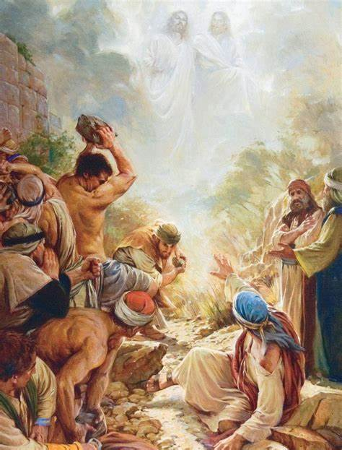

December 26, 2023

699 Stambaugh Avenue
Sharon, Pennsylvania 16146

“I was glad when they said to me,
Let us go to the house of the LORD!”
Psalm 122:1
Sts. Peter & Paul Evangelical Lutheran Church, LC-MS
FEAST OF SAINT STEPHEN, MARTYR
December 26, 2023

Silent prayer before worship: Dear heavenly Father, help me to remember that I am Your child. Give me a childlike faith, so I can trust that through Your Son Jesus I have life and hope always. In Jesus’ name. Amen.

VESPERS

Opening Hymn: #517 “By All Your Saints in Warfare” (sts. 1, 7, 3)
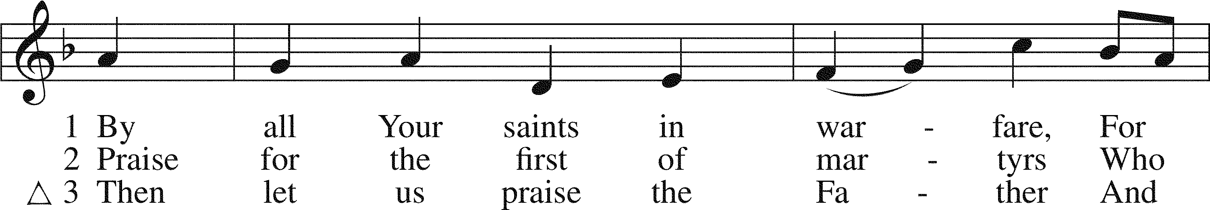
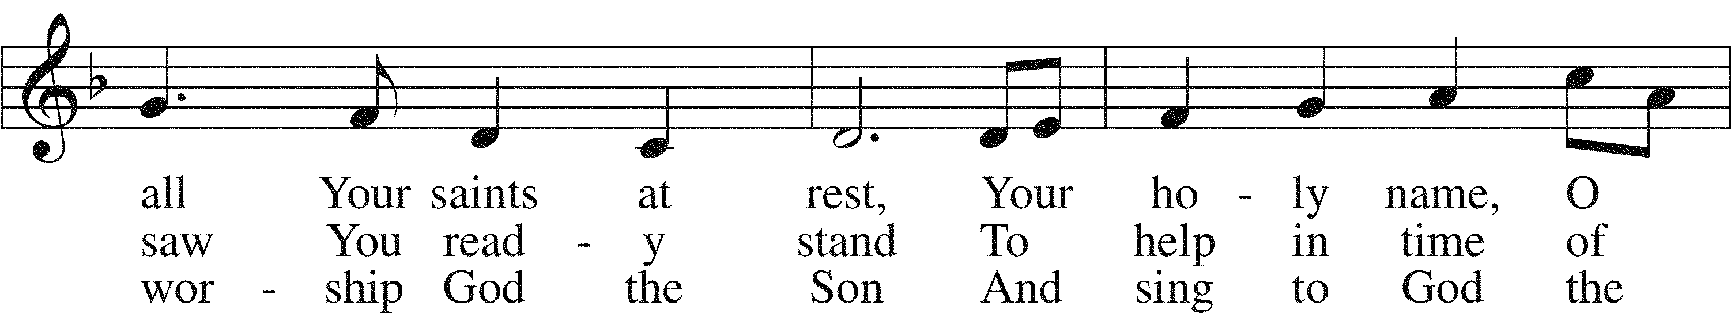
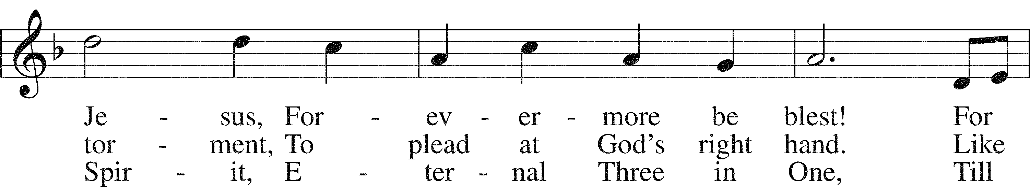
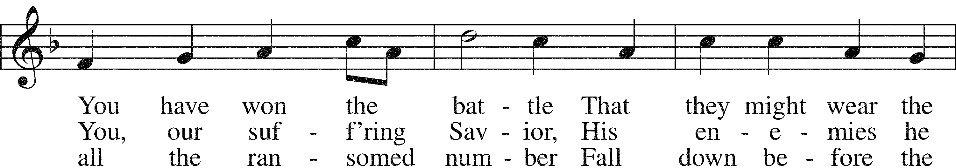
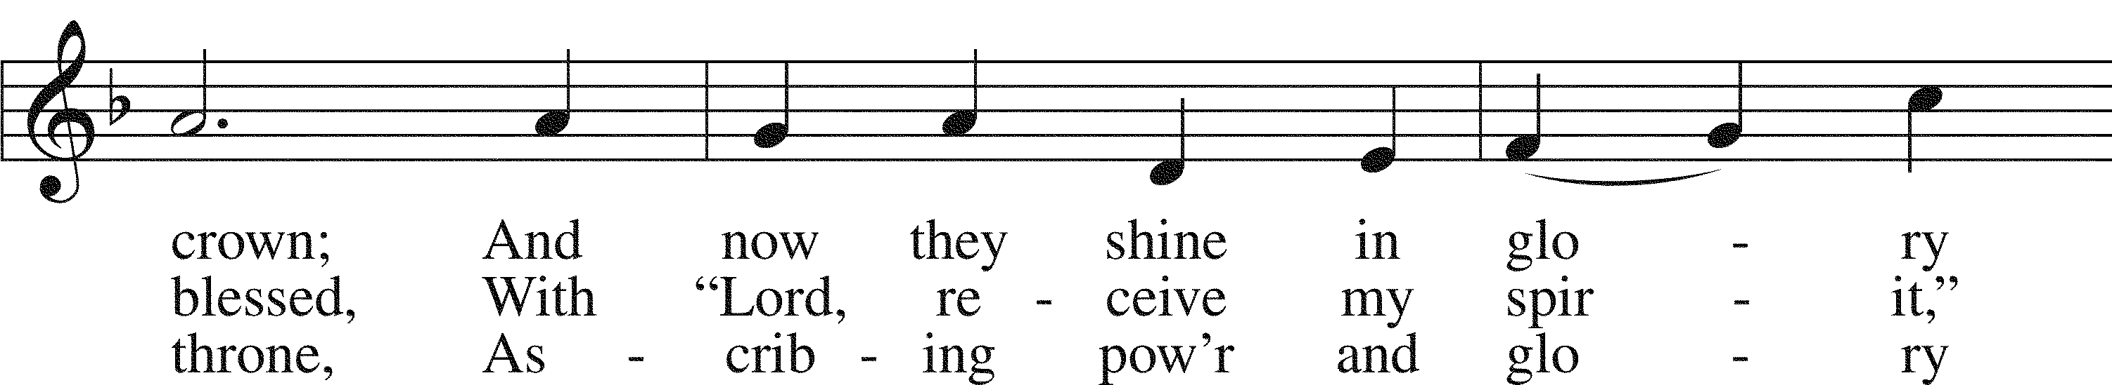
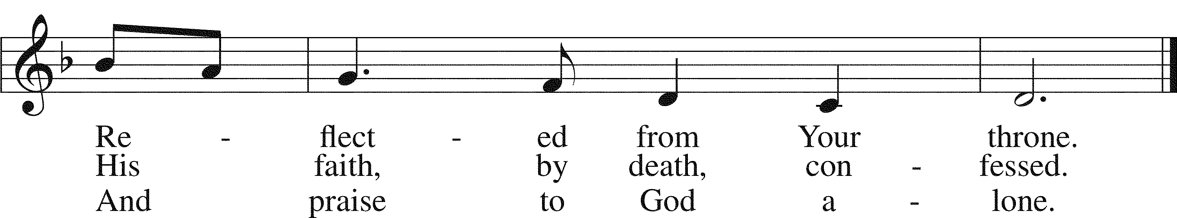

Text: Horatio Bolton Nelson, 1823–1913, alt. Tune: English; coll. and arr. Ralph Vaughan Williams, 1872–1958 Text: Public domain Tune: Public domain

Stand

Common Versicles LSB 229
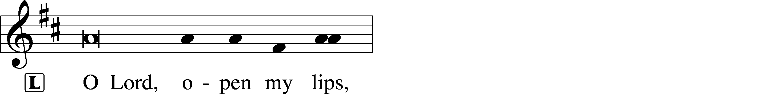
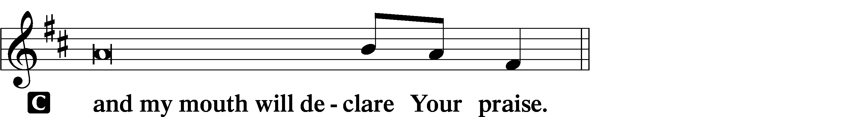

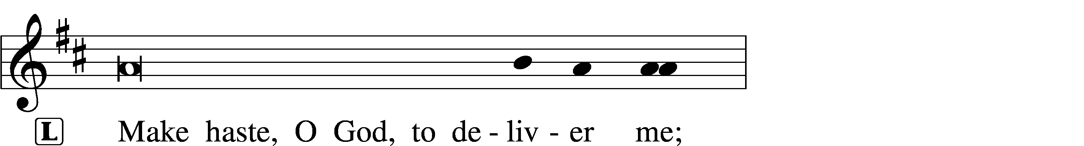
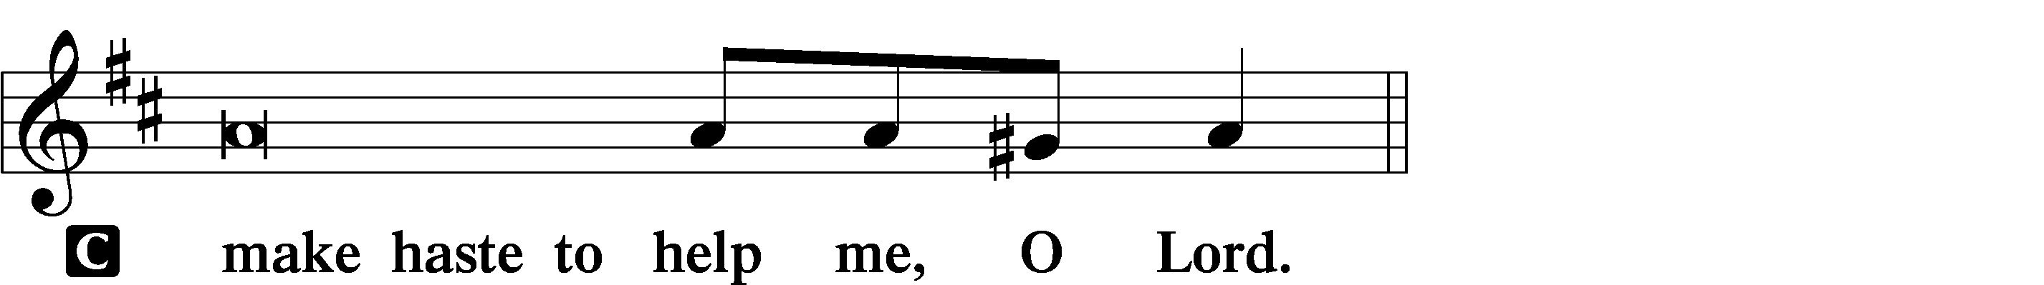

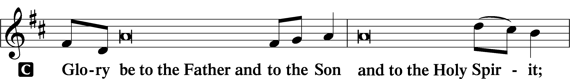
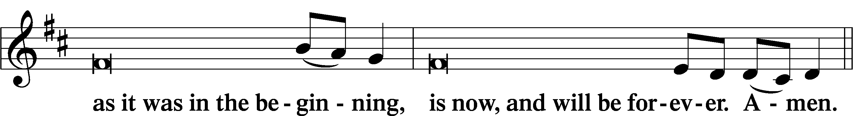
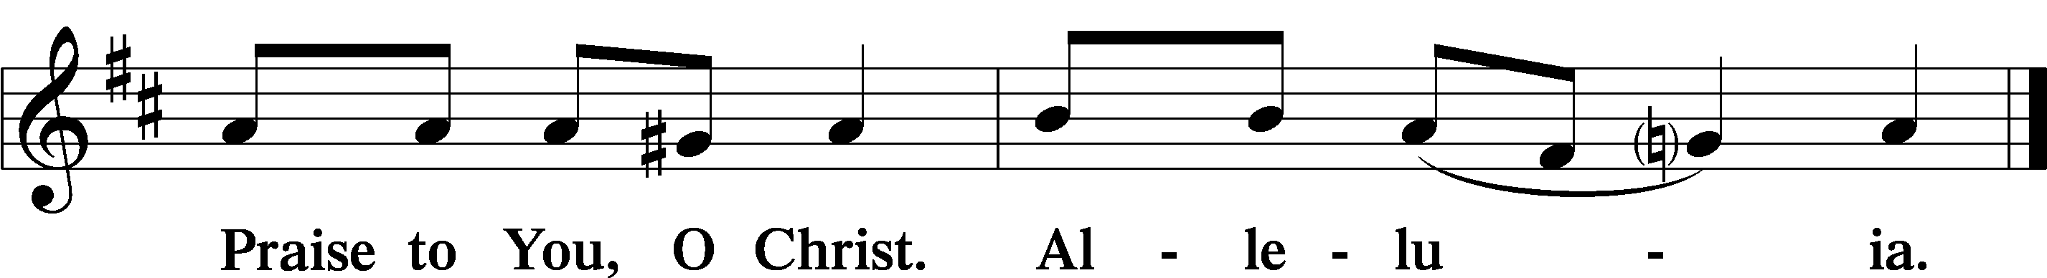

Psalmody

Psalm Reading: Psalm 119:137–144 (NKJV)
Righteous are You, O Lord,
And upright are Your judgments.
Your testimonies, which You have commanded,
Are righteous and very faithful.
My zeal has consumed me,
Because my enemies have forgotten Your words.
Your word is very pure;
Therefore Your servant loves it.
I am small and despised,
Yet I do not forget Your precepts.
Your righteousness is an everlasting righteousness,
And Your law is truth.
Trouble and anguish have overtaken me,
Yet Your commandments are my delights.
The righteousness of Your testimonies is everlasting;
Give me understanding, and I shall live.
Sit

Hymn of the Day: ELH #555 “Rise Again, Ye Lion-Hearted”
- Rise again, ye lion-hearted
Saints of early Christendom.
Whither is your strength departed,
Whither gone your martyrdom?
Lo, love’s light is on them,
Glory’s flame upon them,
And their will to die doth quell
E’en the lord and prince of hell.

- These the saints by fear unshaken
Facing danger dauntlessly;
These no witching lust hath taken,
Lust that lures to vanity.
Mid the roar and rattle
Of tumultuous battle
In desire they soar above
All that earth would have them love.

- Great of heart, they know no turning,
Honor, gold, they laugh to scorn,
Quench desires within them burning,
By no earthly passion torn.
Mid the lions roaring,
Songs of praise outpouring,
Joyously they take their stand
On th’arena’s bloody sand.

- Would to God that I might even
As the martyred saints of old,
With the helping hand of Heaven,
Steadfast stand in battle bold!
O my God, I pray Thee,
In the combat stay me.
Grant that I may ever be
Loyal, staunch, and true to Thee.

Readings

Prophecy: 2 Chronicles 24:17–22 (NKJV)
In those days: After the death of Jehoiada the priest, the leaders of Judah came and bowed down to the king. And the king listened to them. Therefore they left the house of the Lord God of their fathers, and served wooden images and idols; and wrath came upon Judah and Jerusalem because of their trespass. Yet He sent prophets to them, to bring them back to the Lord; and they testified against them, but they would not listen. Then the Spirit of God came upon Zechariah the son of Jehoiada the priest, who stood above the people, and said to them, “Thus says God: ‘Why do you transgress the commandments of the Lord, so that you cannot prosper? Because you have forsaken the Lord, He also has forsaken you.’ ” So they conspired against him, and at the command of the king they stoned him with stones in the court of the house of the Lord. Thus Joash the king did not remember the kindness which Jehoiada his father had done to him, but killed his son; and as he died, he said, “The Lord look on it, and repay!”

P This is the Word of the Lord.
C Thanks be to God.

Epistle: Acts 6:8–10, 7:54–60 (NKJV)
In those days: Stephen, full of faith and power, did great wonders and signs among the people. Then there arose some from what is called the Synagogue of the Freedmen (Cyrenians, Alexandrians, and those from Cilicia and Asia), disputing with Stephen. And they were not able to resist the wisdom and the Spirit by which he spoke. When they heard him they were cut to the heart, and they gnashed at him with their teeth. But he, being full of the Holy Spirit, gazed into heaven and saw the glory of God, and Jesus standing at the right hand of God, and said, “Look! I see the heavens opened and the Son of Man standing at the right hand of God!” Then they cried out with a loud voice, stopped their ears, and ran at him with one accord; and they cast him out of the city and stoned him. And the witnesses laid down their clothes at the feet of a young man named Saul. And they stoned Stephen as he was calling on God and saying, “Lord Jesus, receive my spirit.” Then he knelt down and cried out with a loud voice, “Lord, do not charge them with this sin.” And when he had said this, he fell asleep in the Lord.

P O Lord, have mercy on us.
C Thanks be to God.

Stand
Gospel: Matthew 23:34–39 (NKJV)
At that time Jesus said to the multitude of the Jews and the chief priests: “Therefore, indeed, I send you prophets, wise men, and scribes: some of them you will kill and crucify, and some of them you will scourge in your synagogues and persecute from city to city, that on you may come all the righteous blood shed on the earth, from the blood of righteous Abel to the blood of Zechariah, son of Berechiah, whom you murdered between the temple and the altar. Assuredly, I say to you, all these things will come upon this generation. O Jerusalem, Jerusalem, the one who kills the prophets and stones those who are sent to her! How often I wanted to gather your children together, as a hen gathers her chicks under her wings, but you were not willing! See! Your house is left to you desolate; for I say to you, you shall see Me no more till you say, ‘Blessed is He who comes in the name of the Lord!’ ”

P This is the Word of the Lord.
C Thanks be to God.

Responsory LSB 230
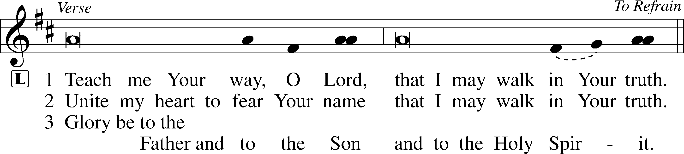
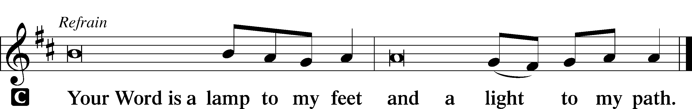

Sermon

Canticle

Stand

Antiphon (Common) 231
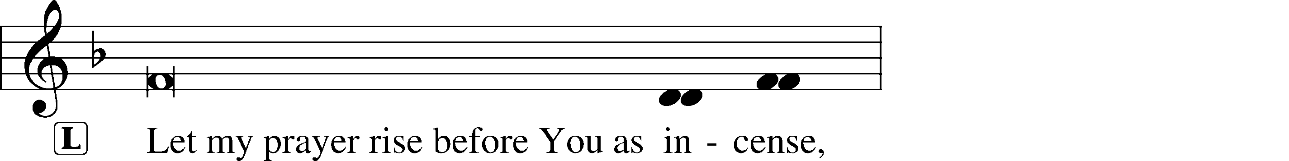
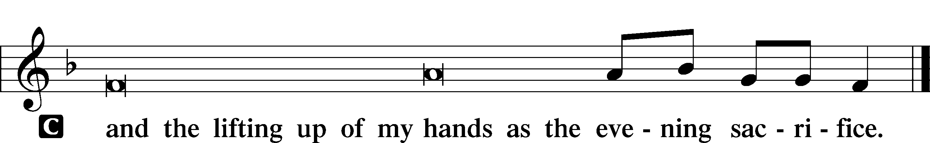

Magnificat 231
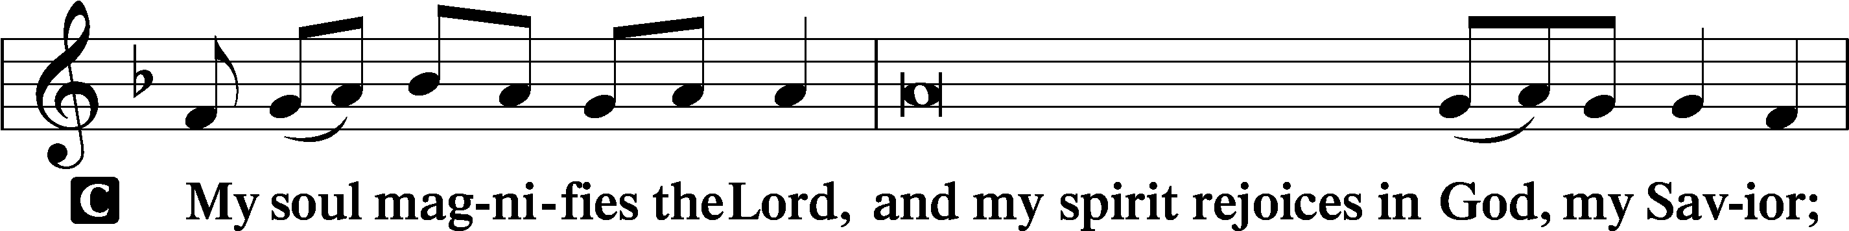
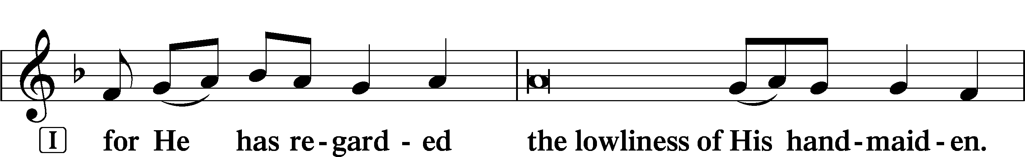
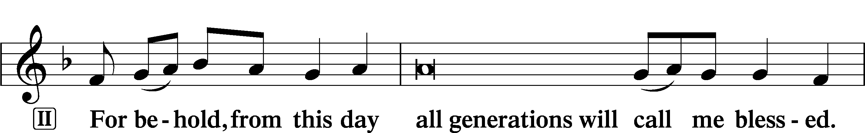
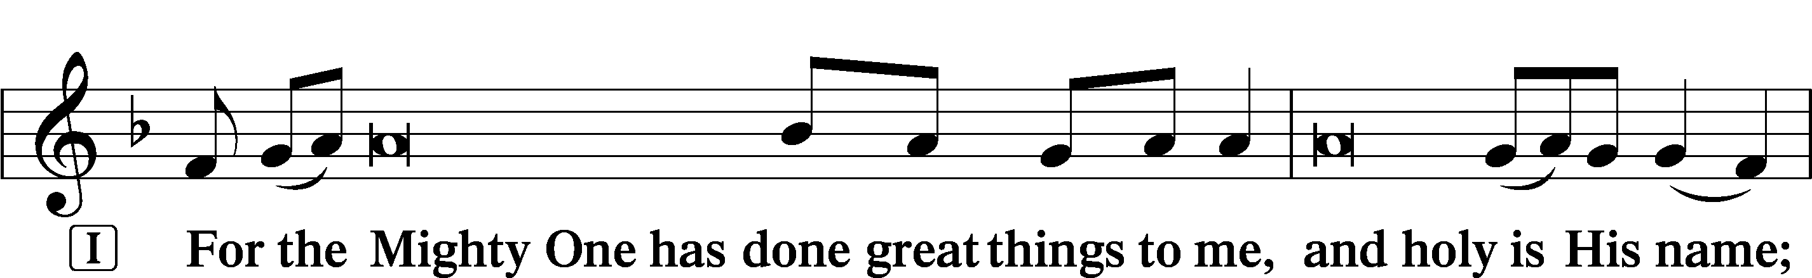
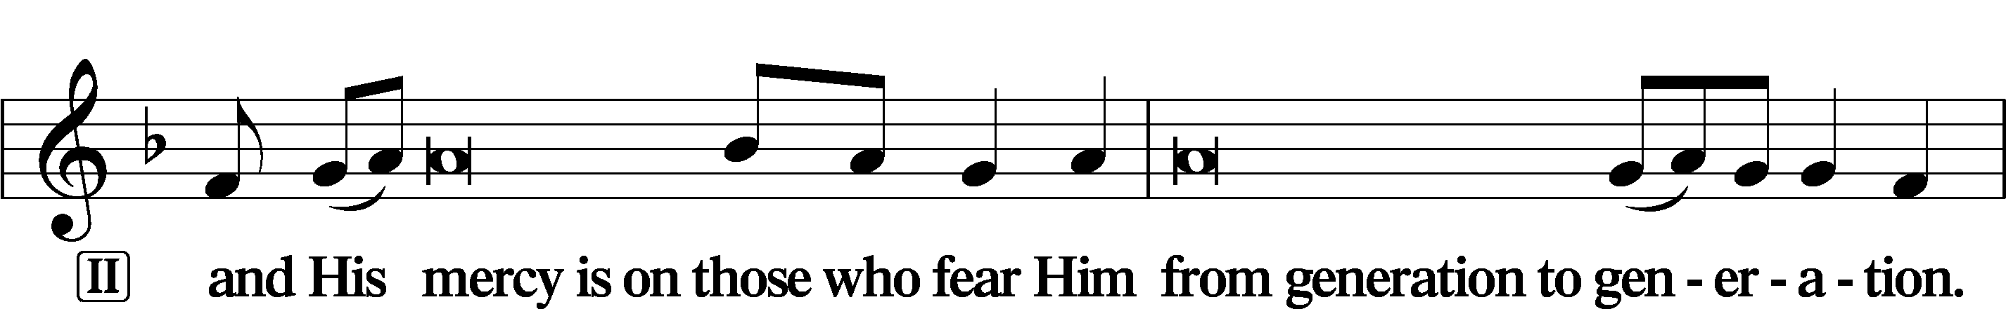
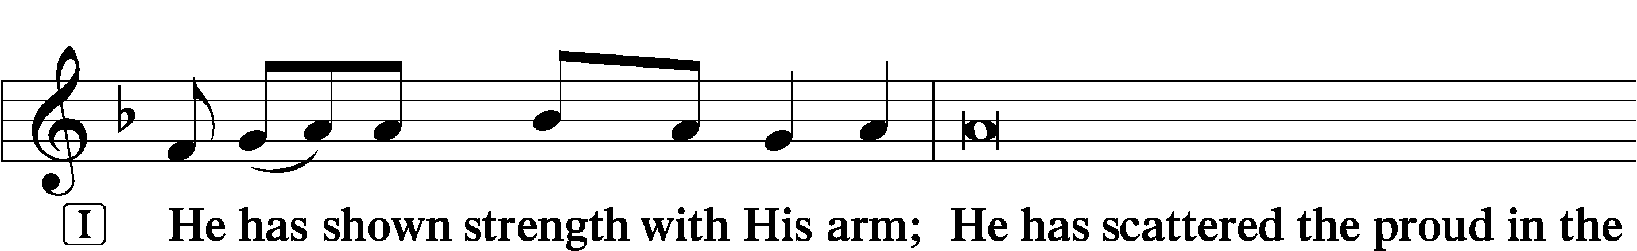
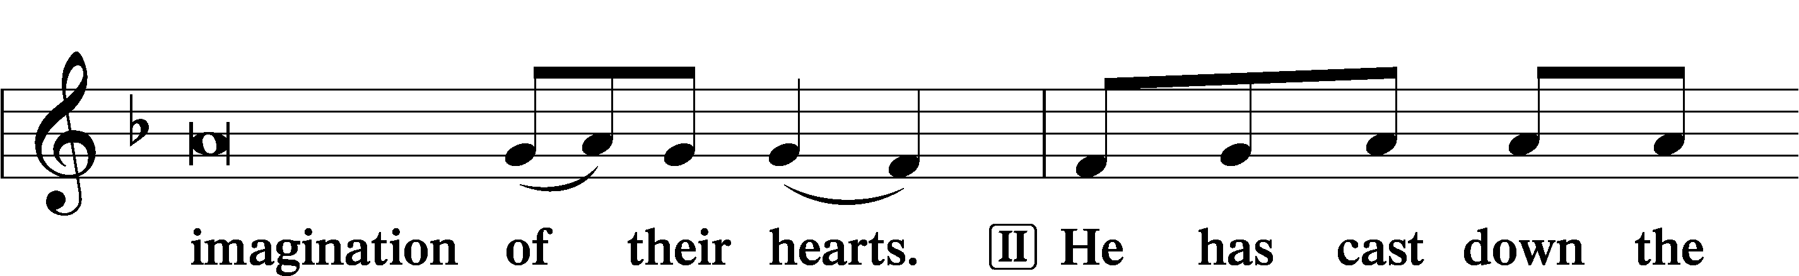
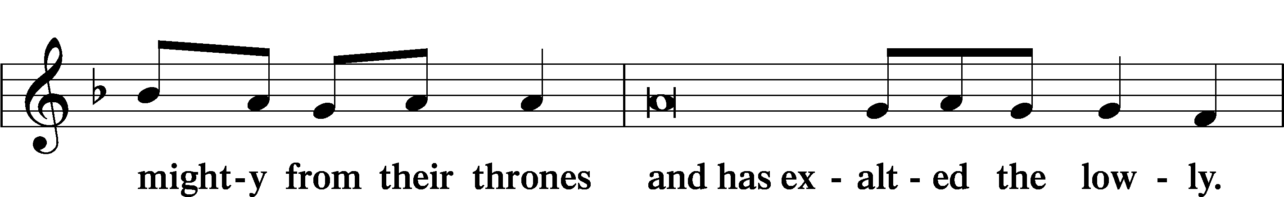
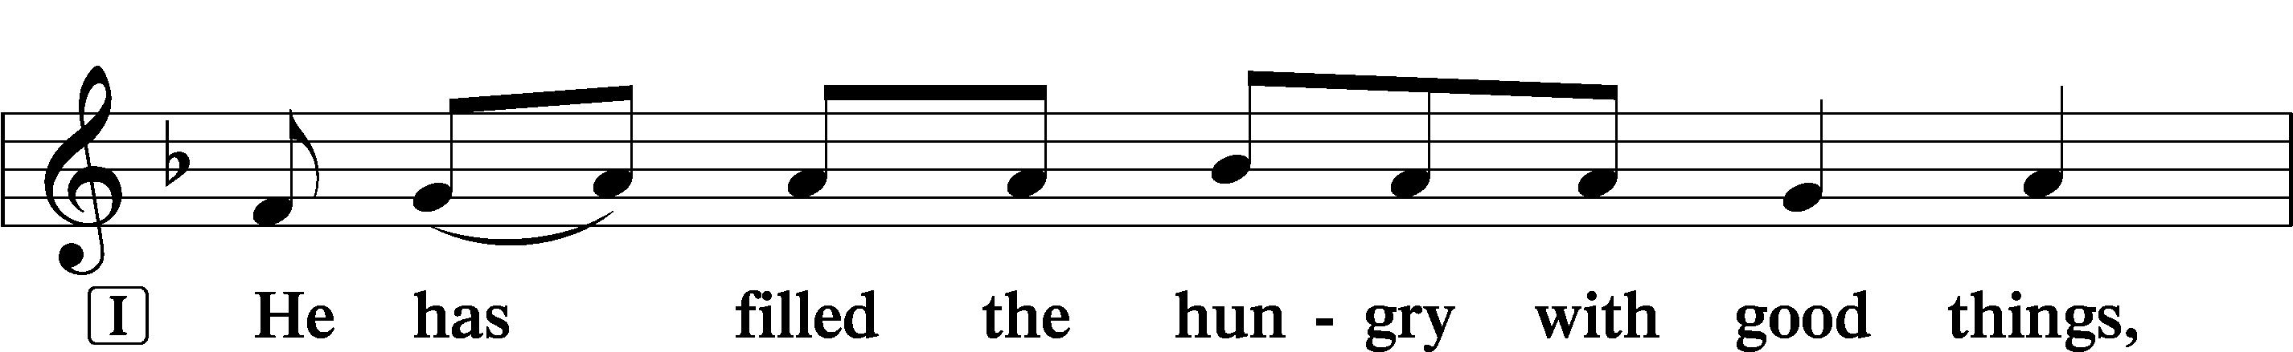
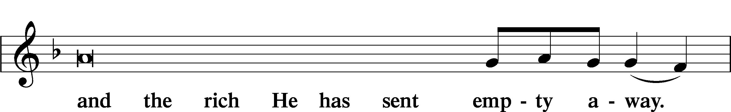
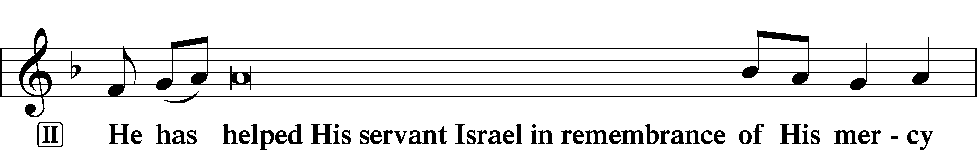
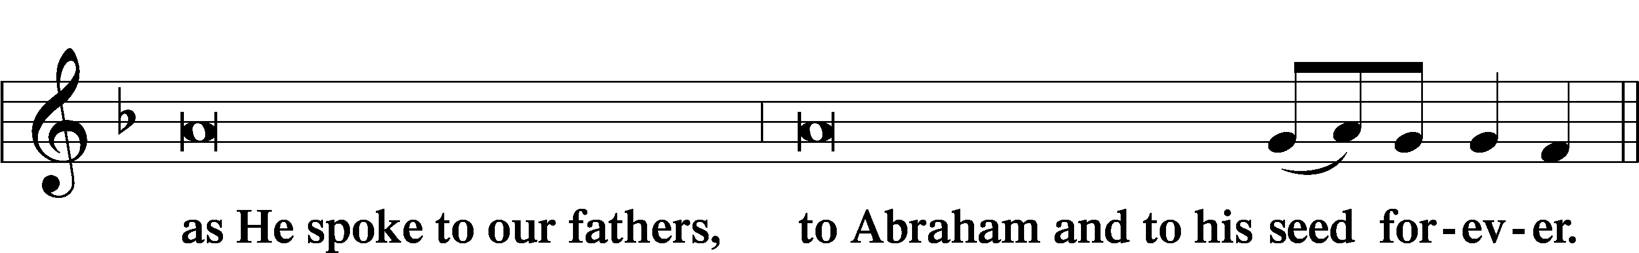
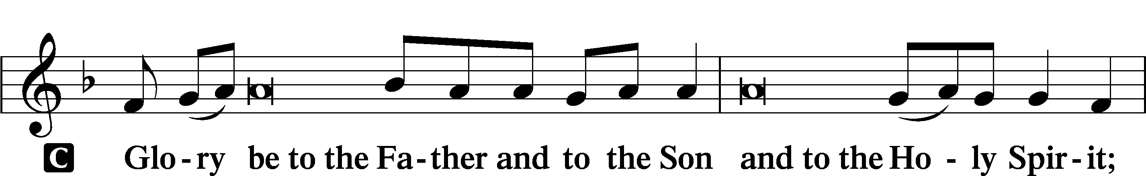
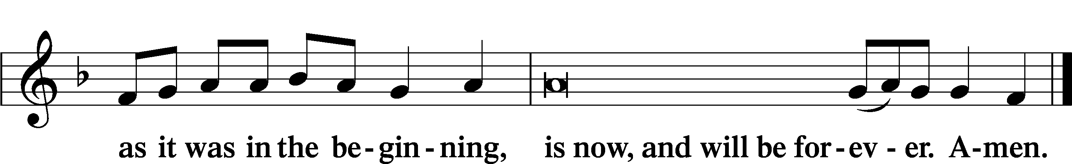

Prayer

Kyrie LSB 233
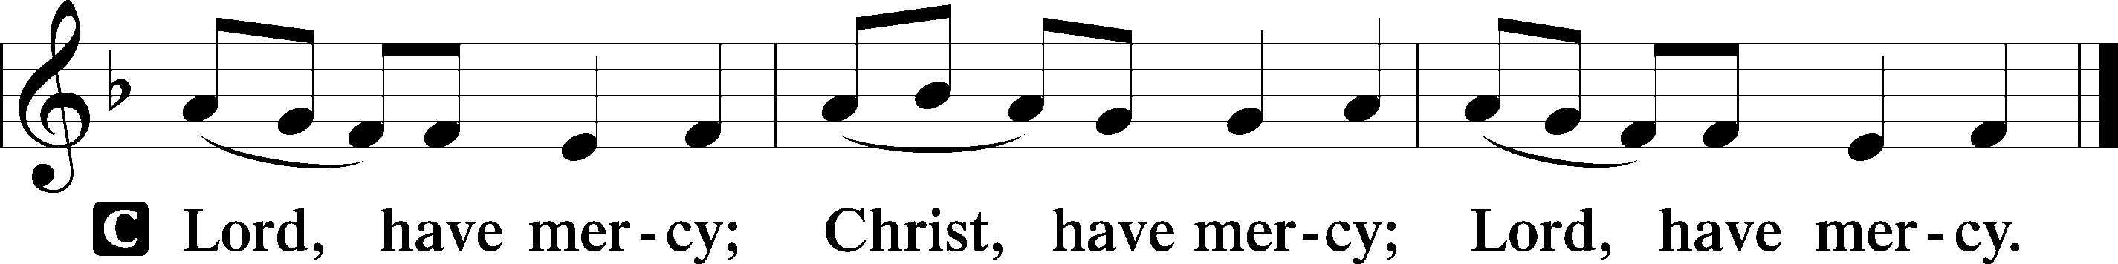
The Lord’s Prayer LSB 957
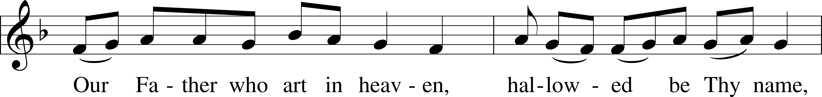
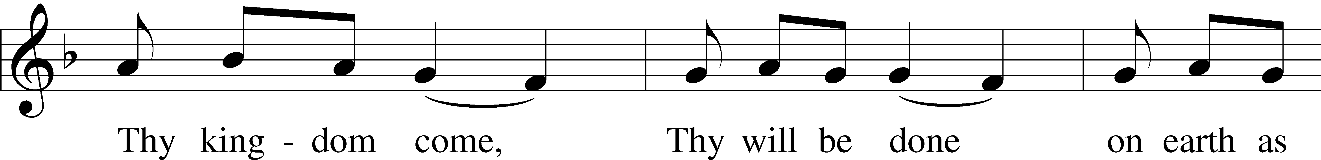
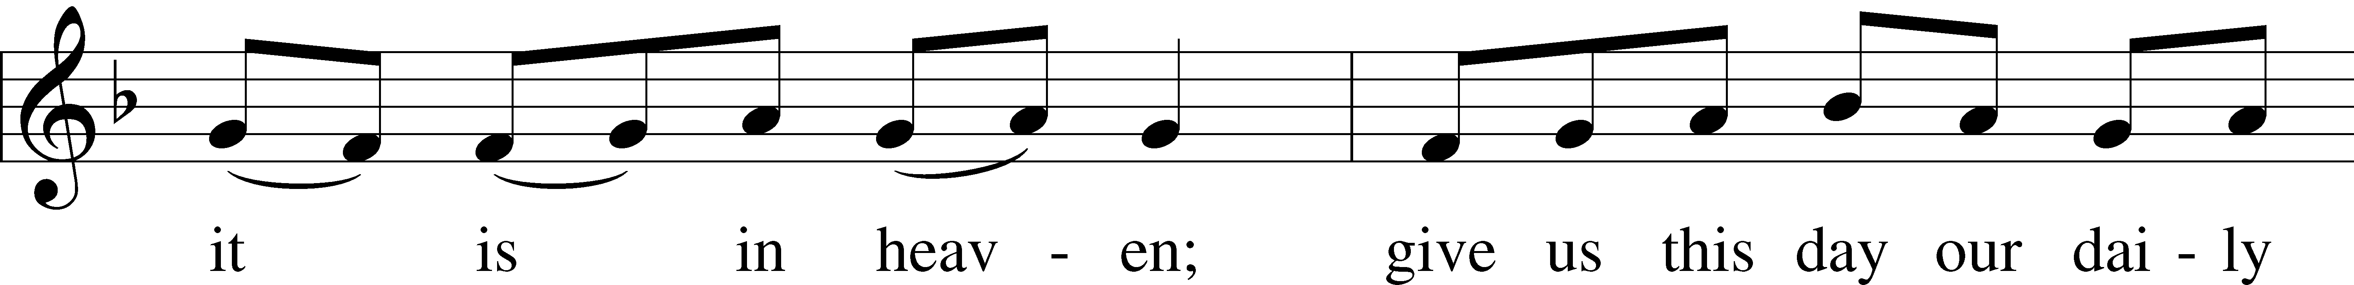
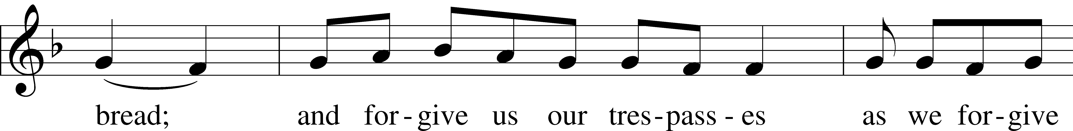
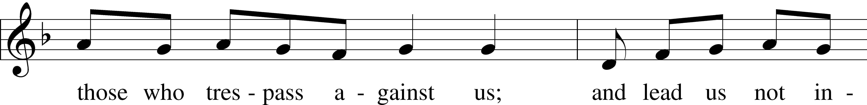
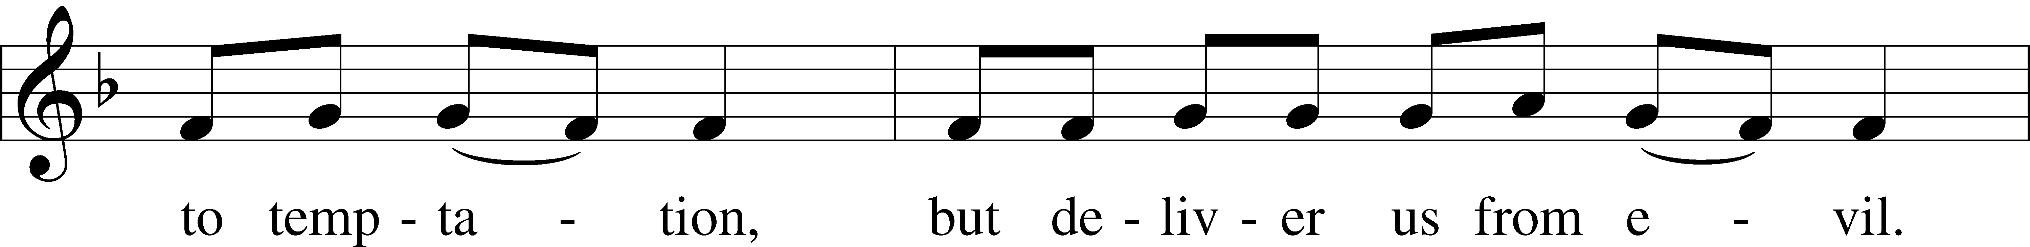
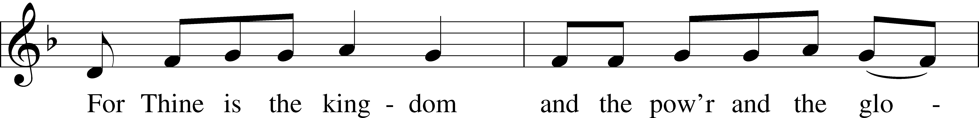
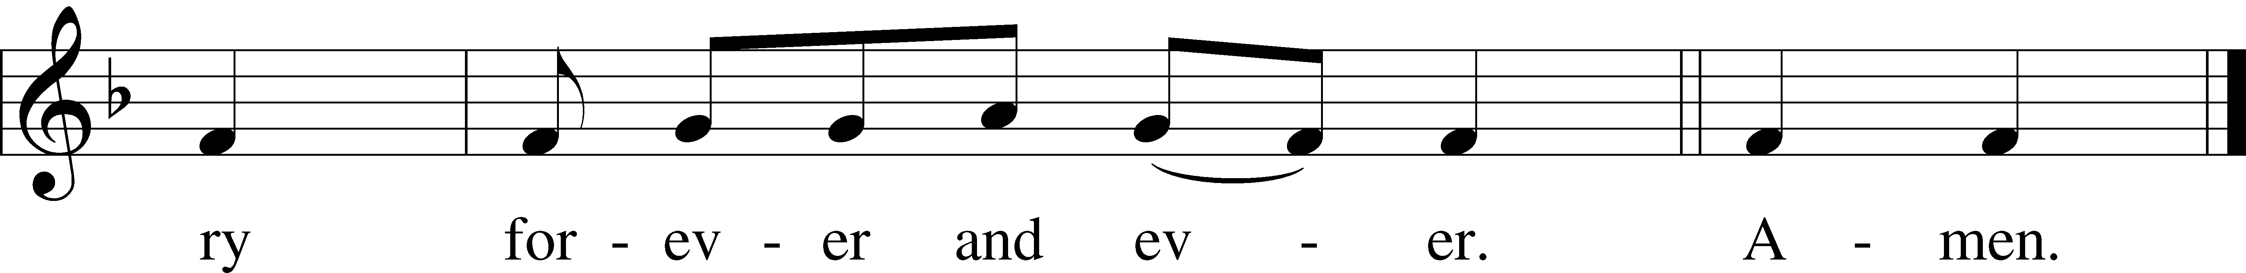

Collects

Introduction to Collects LSB 233
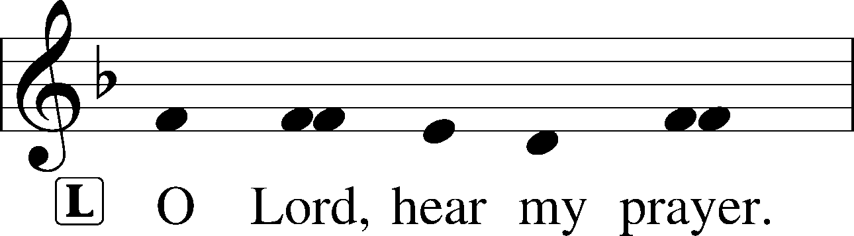
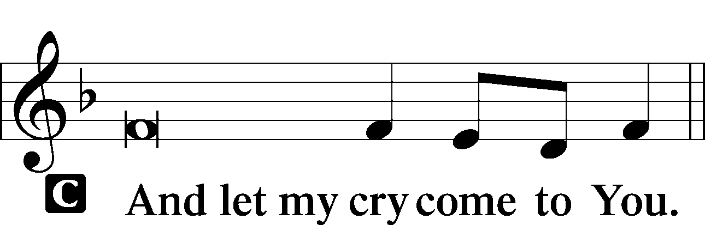

Collect of the Day: Saint Stephen
P Heavenly Father, in the midst of our sufferings for the sake of Christ grant us grace to follow the example of the first martyr, Stephen, that we also may look to the One who suffered and was crucified on our behalf and pray for those who do us wrong; through Jesus Christ, our Lord, who lives and reigns with You and the Holy Spirit, one God, now and forever.
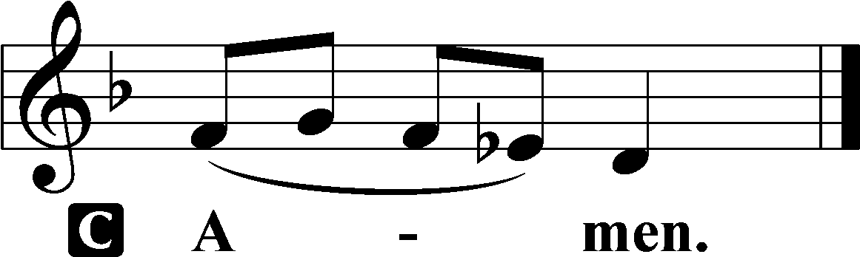

Collect for Peace
P O God, from whom come all holy desires, all good counsels, and all just works, give to us, Your servants, that peace which the world cannot give, that our hearts may be set to obey Your commandments and also that we, being defended from the fear of our enemies, may live in peace and quietness; through Jesus Christ, Your Son, our Lord, who lives and reigns with You and the Holy Spirit, one God, now and forever.

Benedicamus LSB 234
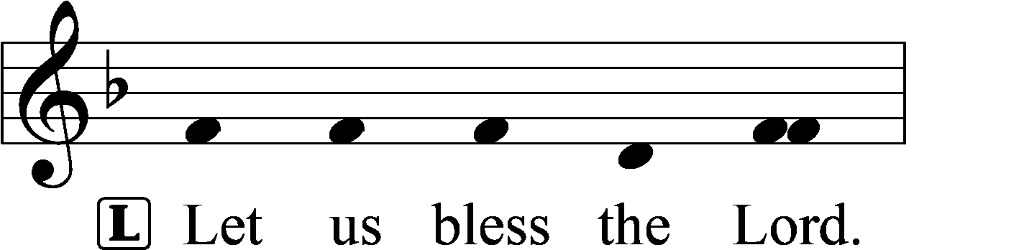
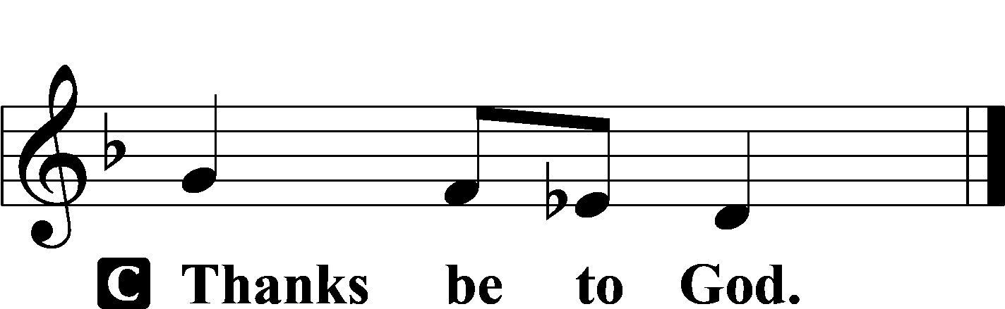

Benediction LSB 234
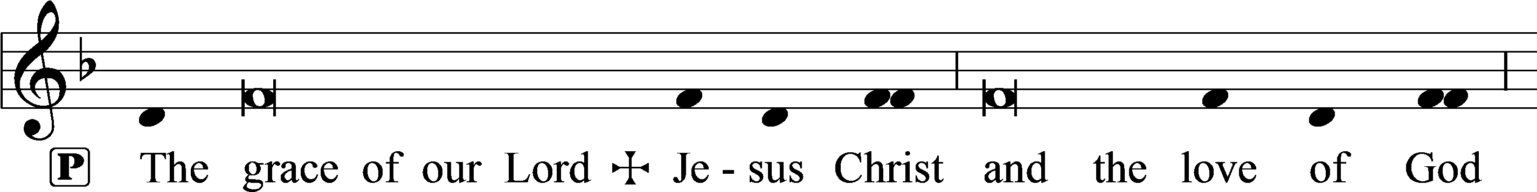
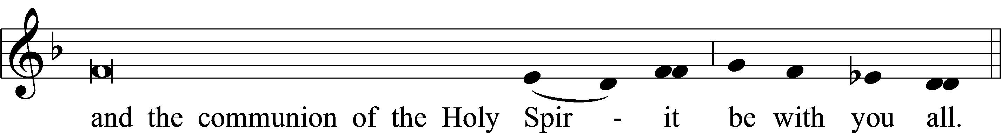

Closing Hymn: LSB #661 “The Son of God Goes Forth to War”
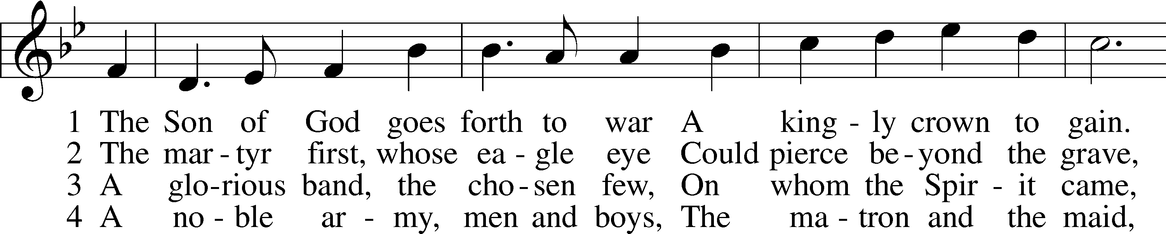
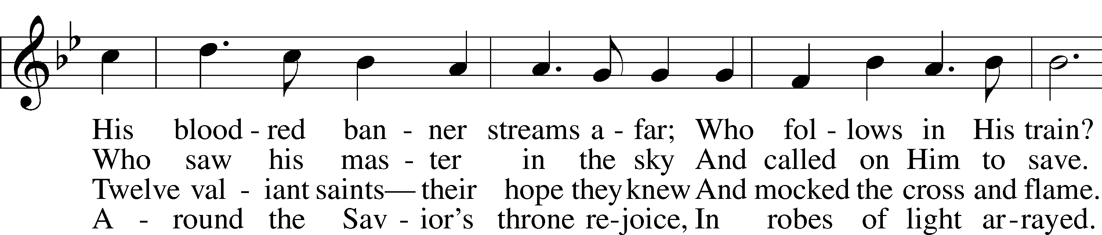
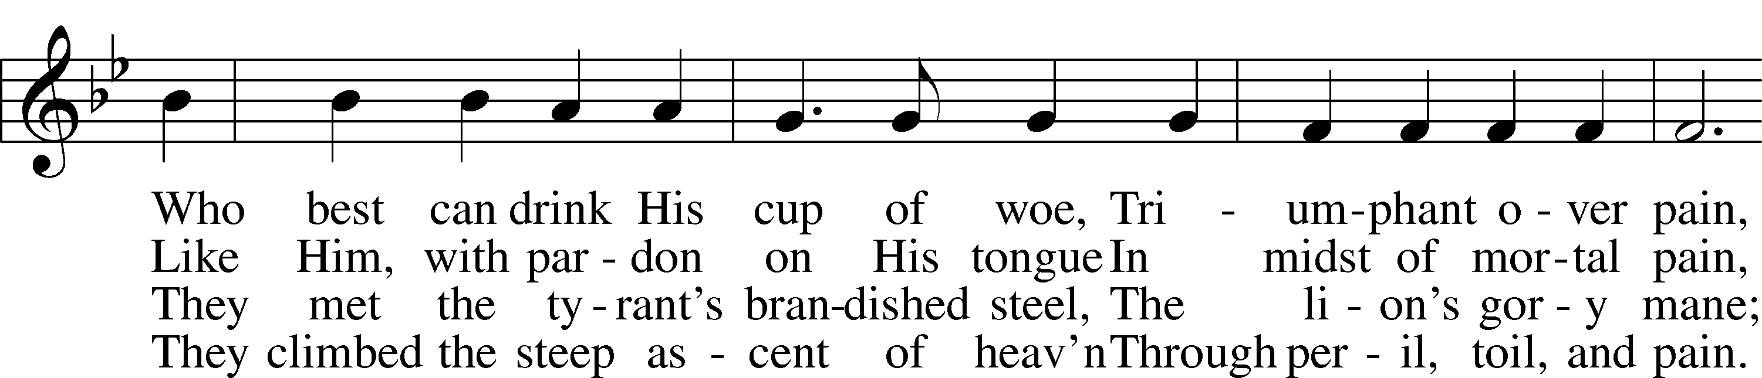
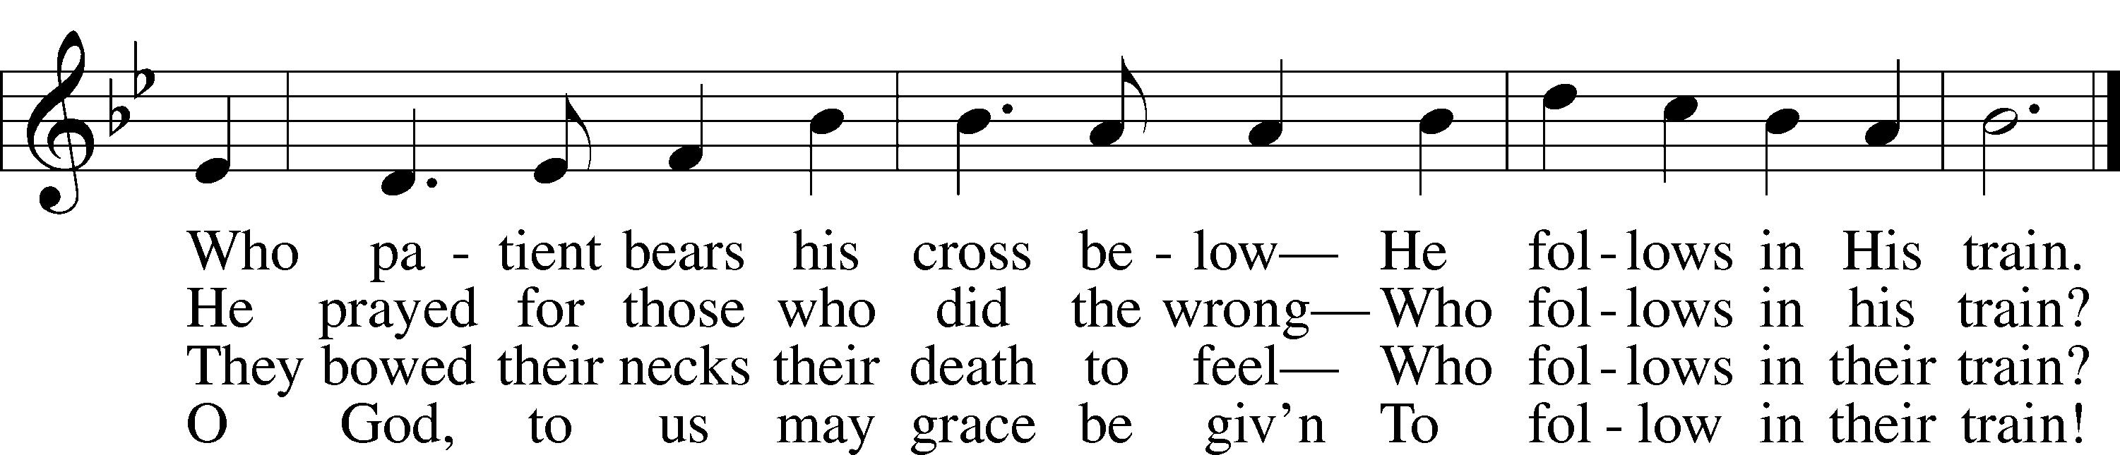

Text: Reginald Heber, 1783–1826, alt. Tune: Henry S. Cutler, 1824–1902 Text and tune: Public domain

Silent prayer after worship: Lord Jesus, let me not forget that You were born to be my Savior so that I can have forgiveness of sins, peace, hope and life everlasting. Fill me with Your love, and lead me to share that love always. Amen.

Acknowledgments
Unless otherwise indicated, Scripture quotations are from the ESV® Bible (The Holy Bible, English Standard Version®), copyright © 2001 by Crossway, a publishing ministry of Good News Publishers. Used by permission. All rights reserved.Created by Lutheran Service Builder © 2023 Concordia Publishing House.

