Sts. Peter & Paul
Evangelical Lutheran Church
Lutheran Church-Missouri Synod
Founded-1917

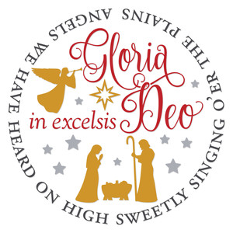

December 25, 2023

699 Stambaugh Ave.
Sharon, Pennsylvania 16146

“I was glad when they said to me,
Let us go to the house of the LORD!”
Psalm 122:1
Sts. Peter & Paul Evangelical Lutheran Church, LC-MS
CHRISTMAS DAY
December 25, 2023

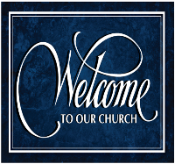
A special welcome to our guests this day! If you would like more information about The Lutheran Church - Missouri Synod, or this congregation, please speak with Pastor Deal or an Elder after the service.
Members & Guests: Don’t be embarrassed if your children make noise during the worship service, all children do. We encourage families to worship together but, if you feel the need, there are pews in the rear of the Church which are reserved for young families on both sides of the sanctuary. There is also a quiet room available to you, located next to the sanctuary (formerly the Pastor’s office), where you would be able to follow along with the service.

Today’s service includes the Sacrament of Holy Communion. If during this past year, you have not worshipped with us and been communed, we respectfully ask that you do not partake of this sacrament this day before first speaking with Pastor Deal.
If visiting from a sister congregation of the LC-MS and are in good standing, please inform Pastor Deal of your desire to commune prior to the service.
If wishing to receive a blessing during communion, please approach with your arms crossed.

CONTACT INFORMATION
Pastor Deal: pastordeal@saintspeterandpaul.net or 724-347-3620 (opt. 2)
Church Office: church@saintspeterandpaul.net or 724-347-3620 (opt. 3)
Secretary’s Office: The office will be open Tuesday & Wednesday (8:30 am-4:30 pm).

Silent prayer before worship: Dearest Lord Jesus, You have come to me as the Holy Child of Bethlehem. I come to You this hour to receive Your gifts peace, hope, love, joy and life. Help me to value these more than anything else. Amen.

Confession and Absolution

Opening Hymn: LSB #382 “We Praise You, Jesus, at Your Birth”

Stand

The sign of the cross may be made by all in remembrance of their Baptism.

Invocation
P In the name of the Father and of the T Son and of the Holy Spirit.
C Amen.

Exhortation Hebrews 10:22; Psalm 124:8; Psalm 32:5
P Beloved in the Lord! Let us draw near with a true heart and confess our sins unto God our Father, beseeching Him in the name of our Lord Jesus Christ to grant us forgiveness.

P Our help is in the name of the Lord,
C who made heaven and earth.
P I said, I will confess my transgressions unto the Lord,
C and You forgave the iniquity of my sin.

Silence for reflection on God’s Word and for self-examination.

Confession of Sins
P O almighty God, merciful Father,
C I, a poor, miserable sinner, confess unto You all my sins and iniquities with which I have ever offended You and justly deserved Your temporal and eternal punishment. But I am heartily sorry for them and sincerely repent of them, and I pray You of Your boundless mercy and for the sake of the holy, innocent, bitter sufferings and death of Your beloved Son, Jesus Christ, to be gracious and merciful to me, a poor, sinful being.
Absolution [John 20:19–23]
P Upon this your confession, I, by virtue of my office, as a called and ordained servant of the Word, announce the grace of God unto all of you, and in the stead and by the command of my Lord Jesus Christ I forgive you all your sins in the name of the Father and of the T Son and of the Holy Spirit.
C Amen.

Service of the Word

Introit Psalm 98:1–4; antiphon: Isaiah 9:6
For to us a child is born, to us a son is | given;*
and the government shall be upon his | shoulder,
and his name shall be called Wonderful | Counselor,*
Mighty God, Everlasting Father, | Prince of Peace.
Oh sing to the Lord a new song, for he has done | marvelous things!*
His right hand and his holy arm have worked salva- | tion for him.
The Lord has made known his sal- | vation;*
he has revealed his righteousness in the sight of the | nations.
He has remembered his steadfast love and faithfulness to the house of | Israel.*
All the ends of the earth have seen the salvation | of our God.
Make a joyful noise to the Lord, | all the earth;*
break forth into joyous song and sing | praises!
For to us a child is born, to us a son is | given;*
and the government shall be upon his | shoulder,
and his name shall be called Wonderful | Counselor,*
Mighty God, Everlasting Father, | Prince of Peace.

Gloria Patri
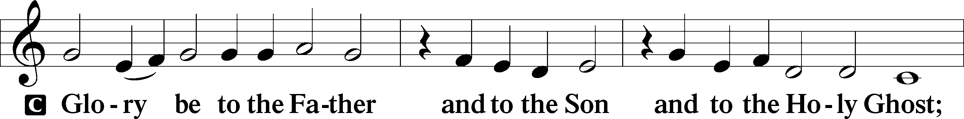
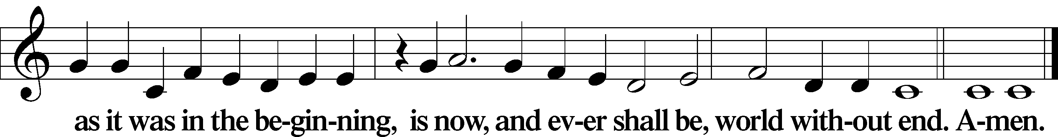

Kyrie Mark 10:47
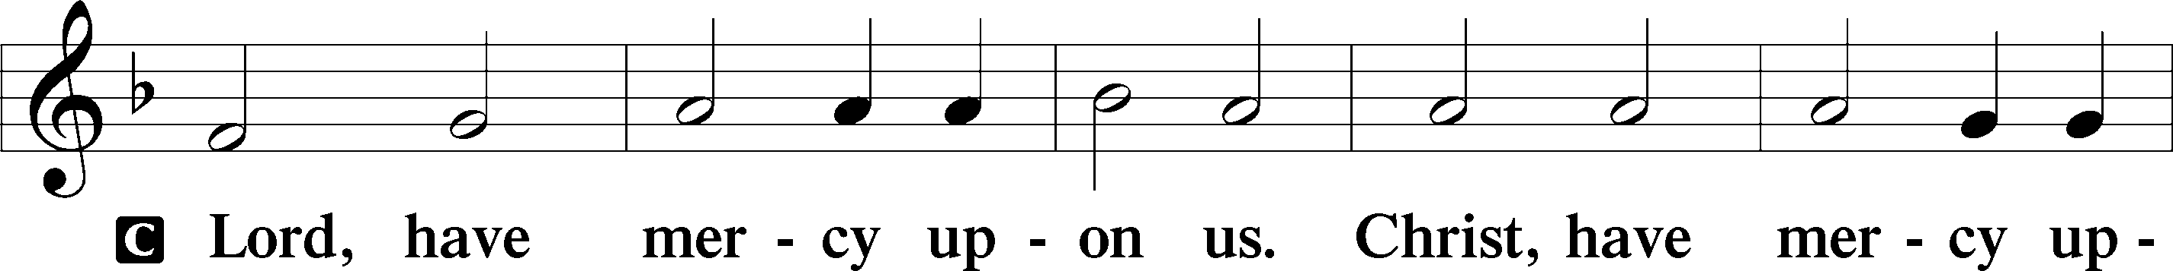
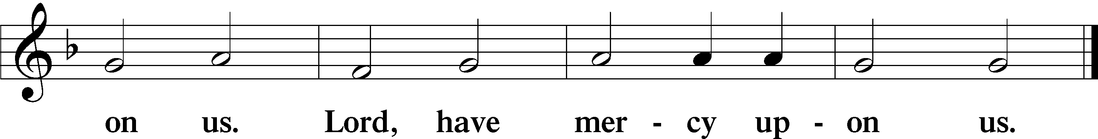

Gloria in Excelsis Luke 2:14; John 1:29
P Glory be to God on high:
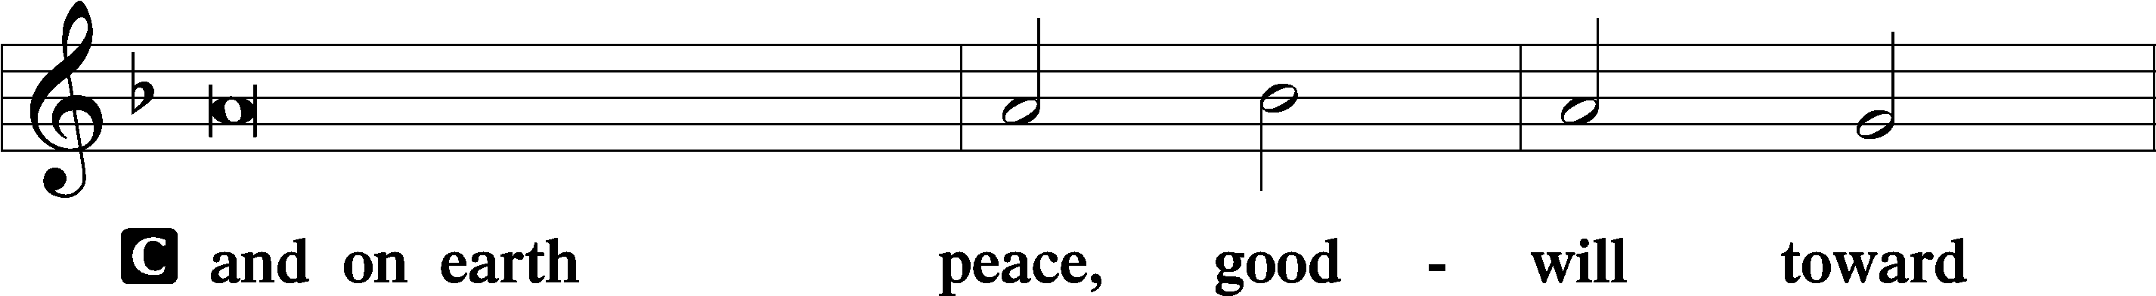
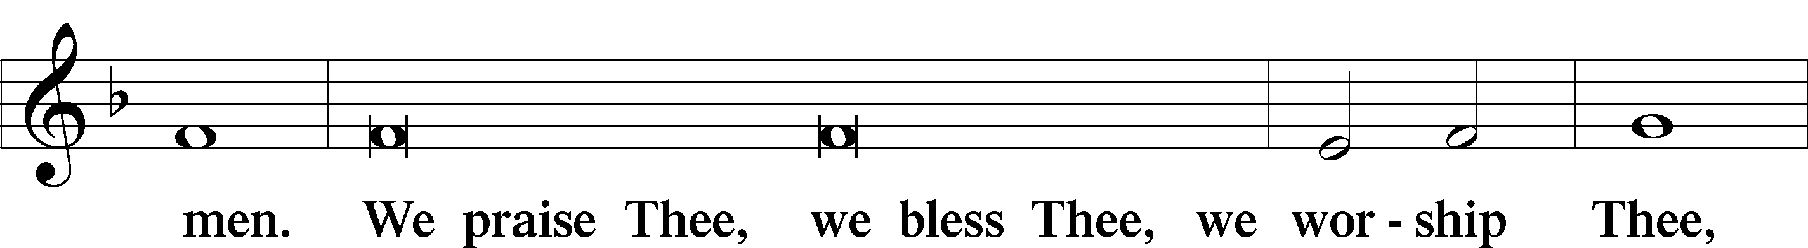
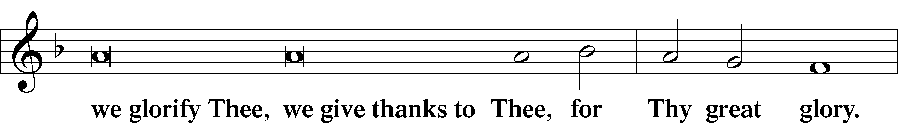
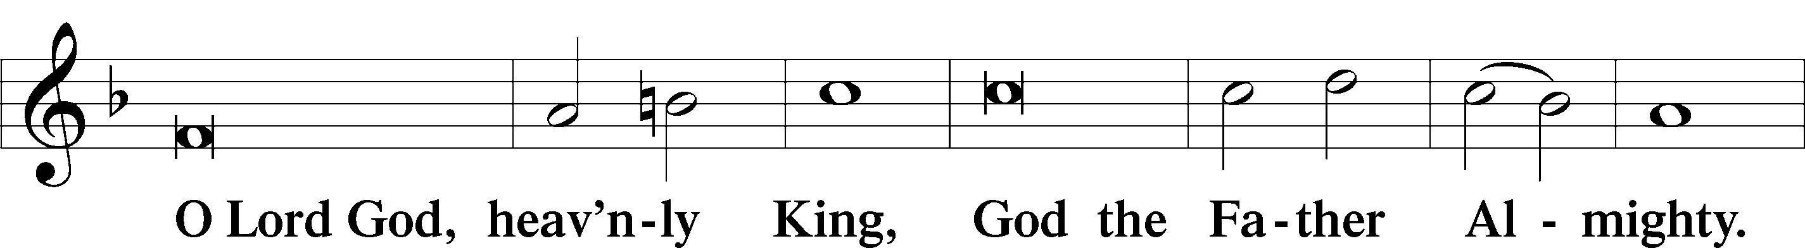
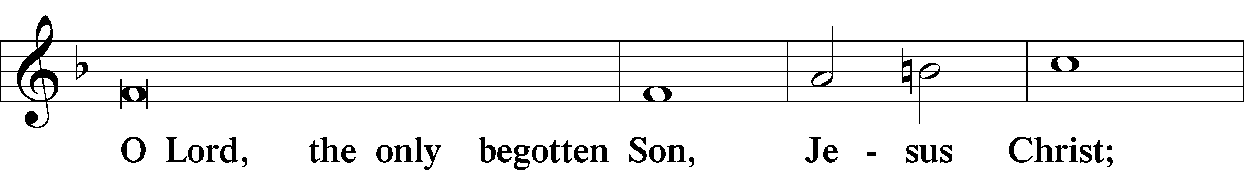
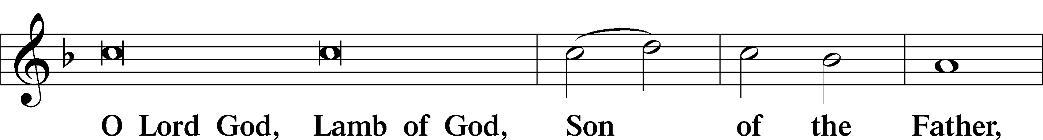
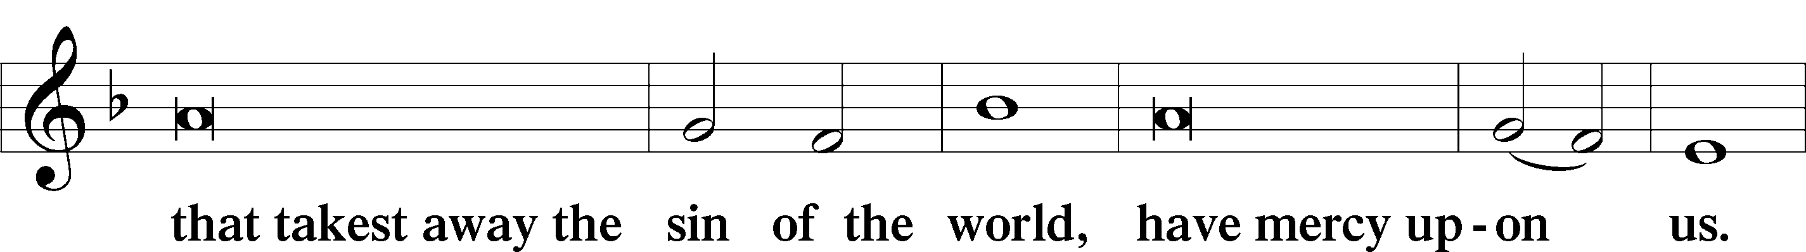
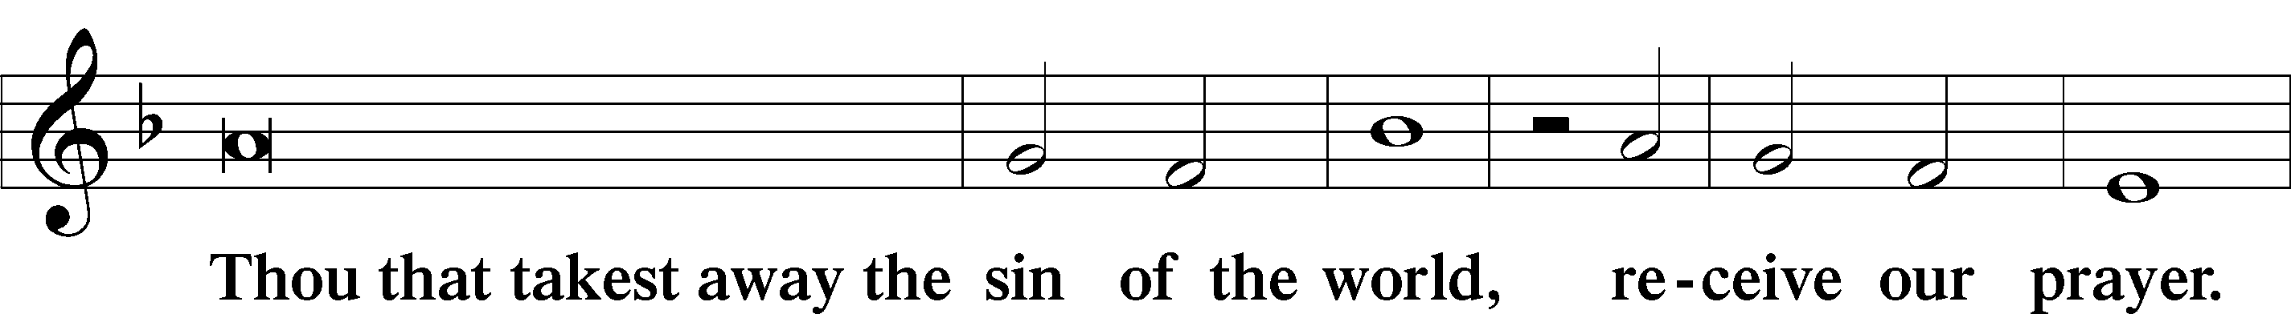
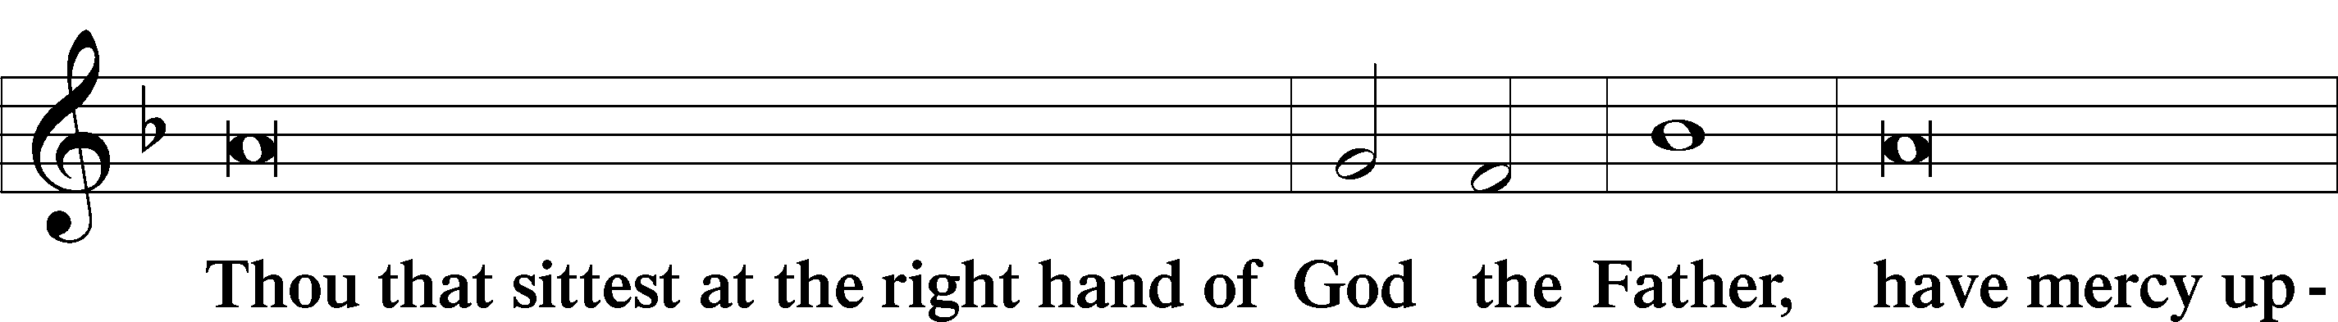
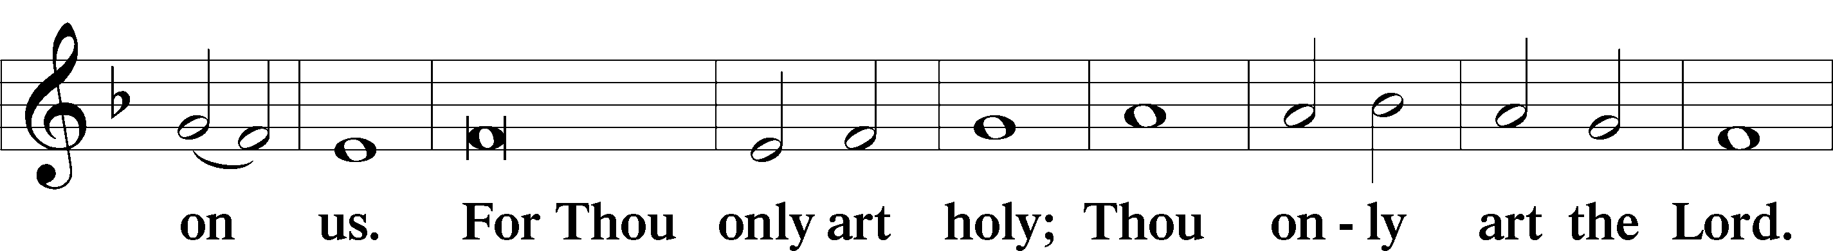
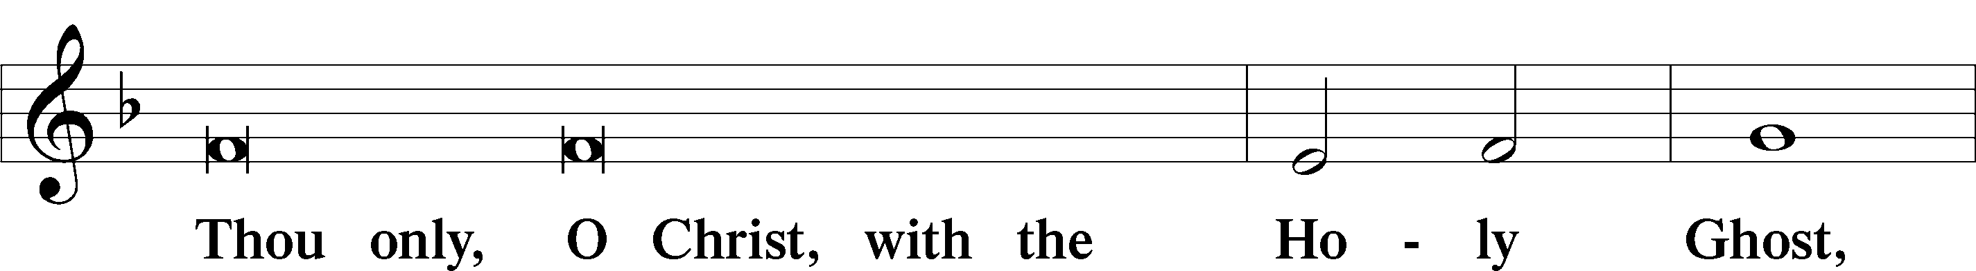
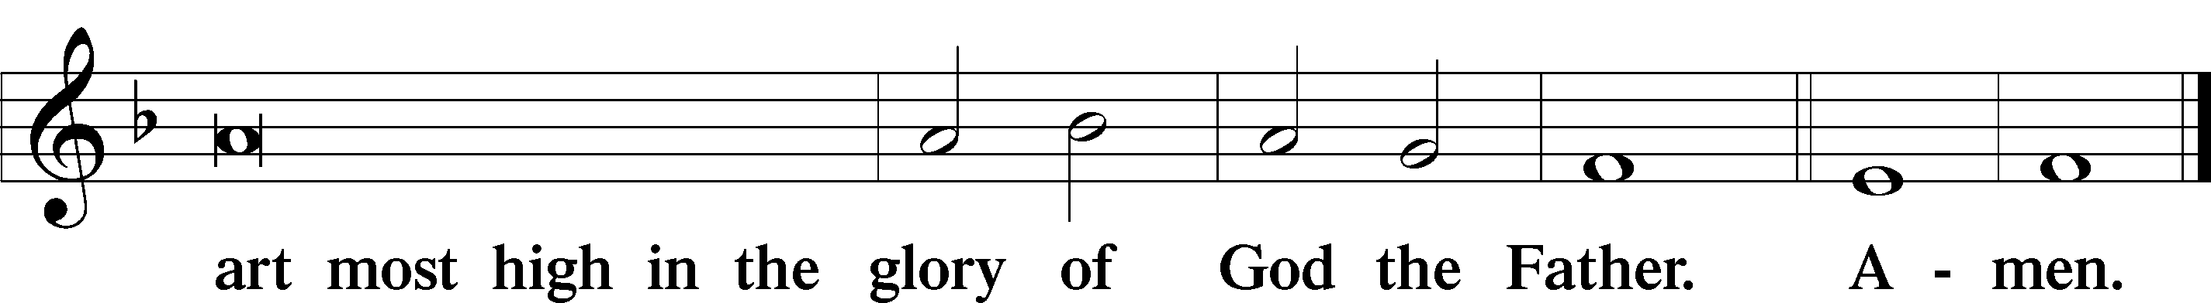

Salutation and Collect of the Day: Christmas Day
P The Lord be with you.
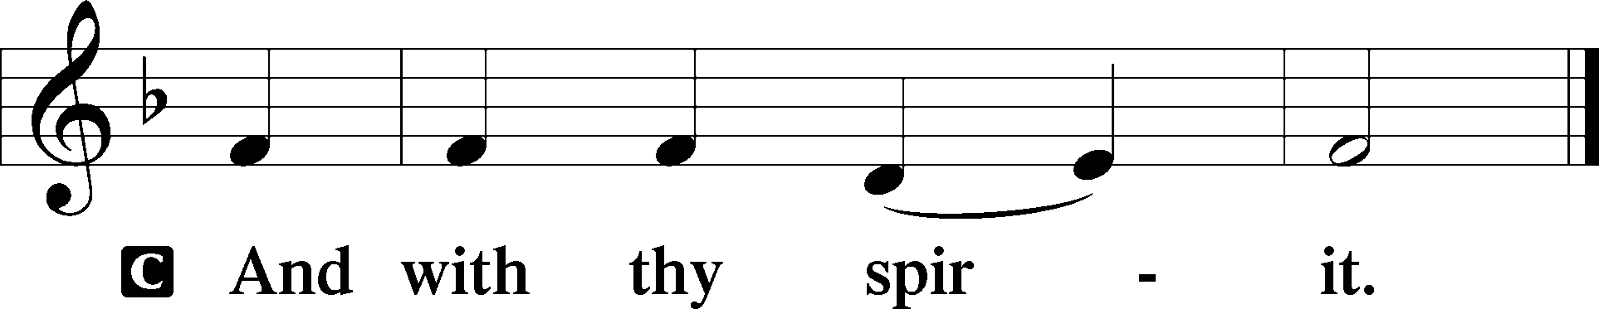

P Let us pray.
Almighty God, grant that the birth of Your only-begotten Son in the flesh may set us free from the bondage of sin; through Jesus Christ, Your Son, our Lord, who lives and reigns with You and the Holy Spirit, one God, now and forever.

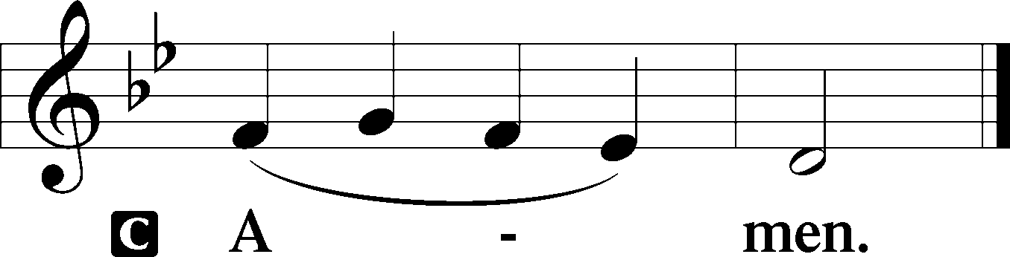
Sit

Prophecy: Isaiah 52:6-10 (NKJV)
Thus says the Lord God: “My people shall know My name; therefore they shall know in that day that I am He who speaks: ‘Behold, it is I.’ ” How beautiful upon the mountains are the feet of him who brings good news, who proclaims peace, who brings glad tidings of good things, who proclaims salvation, who says to Zion, “Your God reigns!” Your watchmen shall lift up their voices, with their voices they shall sing together; for they shall see eye to eye when the Lord brings back Zion. Break forth into joy, sing together, you waste places of Jerusalem! For the Lord has comforted His people, He has redeemed Jerusalem. The Lord has made bare His holy arm in the eyes of all the nations; and all the ends of the earth shall see the salvation of our God.

P This is the Word of the Lord.
C Thanks be to God.

Gradual Psalm 118:26a, 27a, 23
Blessèd is he who comes in the name | of the Lord!*
The Lord is God, and he has made his light to shine up- | on us.
This is the Lord’s | doing;*
it is marvelous | in our eyes.

Epistle: Hebrews 1:1-12 (NKJV)
Brethren: God, who at various times and in various ways spoke in time past to the fathers by the prophets, has in these last days spoken to us by His Son, whom He has appointed heir of all things, through whom also He made the worlds; who being the brightness of His glory and the express image of His person, and upholding all things by the word of His power, when He had by Himself purged our sins, sat down at the right hand of the Majesty on high, having become so much better than the angels, as He has by inheritance obtained a more excellent name than they. For to which of the angels did He ever say: “You are My Son, today I have begotten You”? And again: “I will be to Him a Father, and He shall be to Me a Son”? But when He again brings the firstborn into the world, He says: “Let all the angels of God worship Him.” And of the angels He says: “Who makes His angels spirits and His ministers a flame of fire.” But to the Son He says: “Your throne, O God, is forever and ever; a scepter of righteousness is the scepter of Your kingdom. You have loved righteousness and hated lawlessness; therefore God, Your God, has anointed You with the oil of gladness more than Your companions.” And: “You, Lord, in the beginning laid the foundation of the earth, and the heavens are the work of Your hands. They will perish, but You remain; and they will all grow old like a garment; like a cloak You will fold them up, and they will be changed. But You are the same, and Your years will not fail.”

P This is the Word of the Lord.
C Thanks be to God.

Stand

Verse Liturgical Text
Alleluia. A holy day has dawned upon us. Come, all you nations, and worship the Lord. Alleluia.

Alleluia
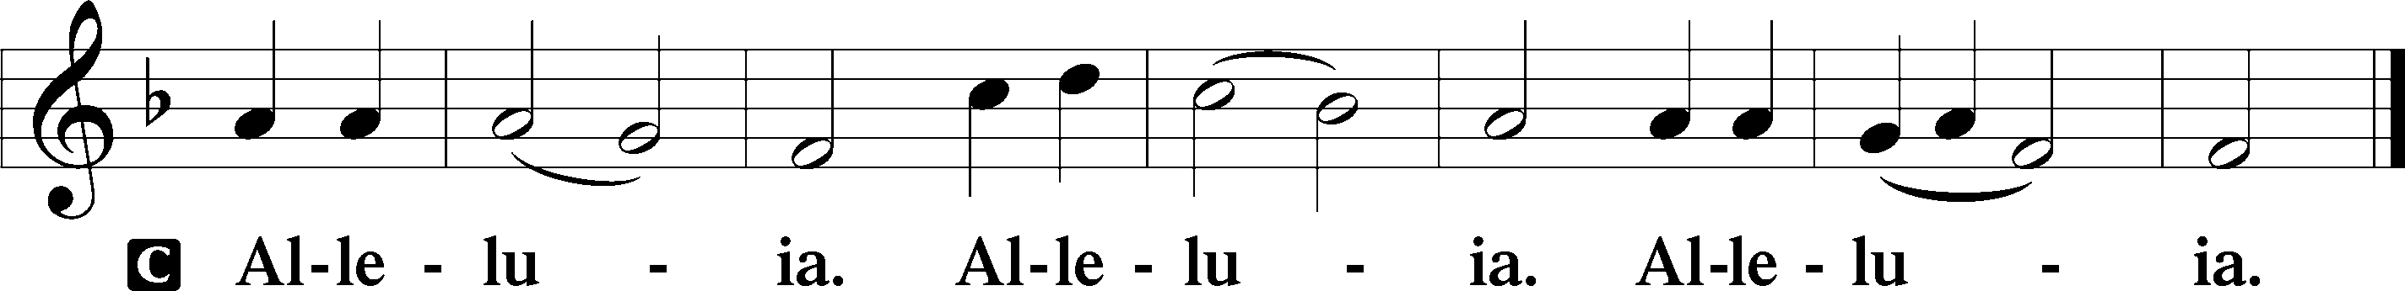

Holy Gospel: John 1:1–14 (NKJV)
P The Holy Gospel according to St. John, the first chapter.
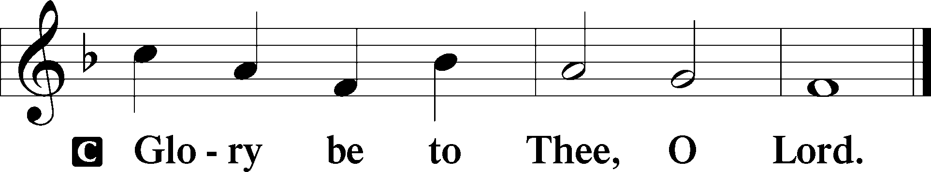

In the beginning was the Word, and the Word was with God, and the Word was God. He was in the beginning with God. All things were made through him, and without him was not any thing made that was made. In him was life, and the life was the light of men. The light shines in the darkness, and the darkness has not overcome it.
There was a man sent from God, whose name was John. He came as a witness, to bear witness about the light, that all might believe through him. He was not the light, but came to bear witness about the light.
The true light, which enlightens everyone, was coming into the world. He was in the world, and the world was made through him, yet the world did not know him. He came to his own, and his own people did not receive him. But to all who did receive him, who believed in his name, he gave the right to become children of God, who were born, not of blood nor of the will of the flesh nor of the will of man, but of God.
And the Word became flesh and dwelt among us, and we have seen his glory, glory as of the only Son from the Father, full of grace and truth. (John bore witness about him, and cried out, “This was he of whom I said, ‘He who comes after me ranks before me, because he was before me.’”) And from his fullness we have all received, grace upon grace. For the law was given through Moses; grace and truth came through Jesus Christ. No one has ever seen God; the only God, who is at the Father’s side, he has made him known.

P This is the Gospel of the Lord.
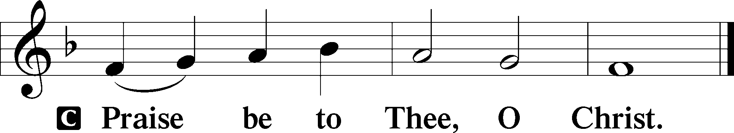

Nicene Creed
C I believe in one God,
the Father Almighty,
maker of heaven and earth
and of all things visible and invisible.

And in one Lord Jesus Christ,
the only-begotten Son of God,
begotten of His Father before all worlds,
God of God, Light of Light,
very God of very God,
begotten, not made,
being of one substance with the Father,
by whom all things were made;
who for us men and for our salvation came down from heaven
and was incarnate by the Holy Spirit of the virgin Mary
and was made man;
and was crucified also for us under Pontius Pilate.
He suffered and was buried.
And the third day He rose again according to the Scriptures
and ascended into heaven
and sits at the right hand of the Father.
And He will come again with glory to judge both the living and the dead,
whose kingdom will have no end.

And I believe in the Holy Spirit,
the Lord and giver of life,
who proceeds from the Father and the Son,
who with the Father and the Son together is worshiped and glorified,
who spoke by the prophets.
And I believe in one holy Christian and apostolic Church,
I acknowledge one Baptism for the remission of sins,
and I look for the resurrection of the dead
and the life T of the world to come. Amen.
Sit

Hymn of the Day: LSB #384 “Of the Father’s Love Begotten”

Sermon

Stand

Offertory Psalm 51:10–12
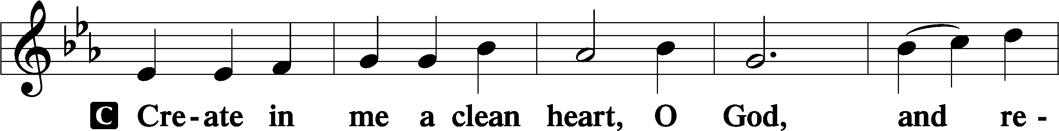
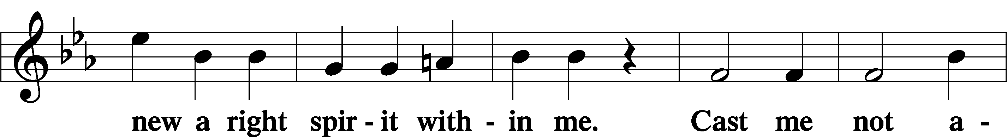
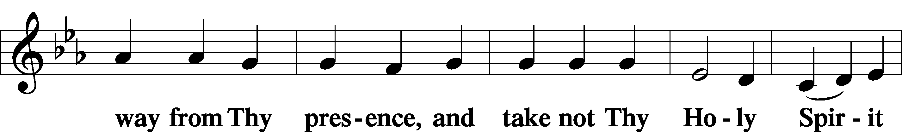
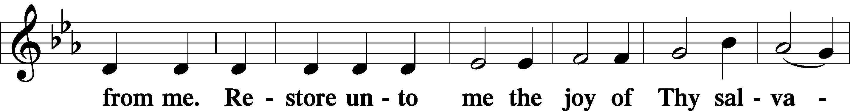
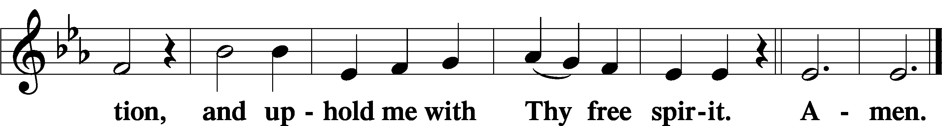

Prayer of the Church

Sit

Preparatory Hymn: LSB #368 “Angels We Have Heard on High”

Stand
Service of the Sacrament

Preface 2 Timothy 4:22; Colossians 3:1 Psalm 136
P The Lord be with you.
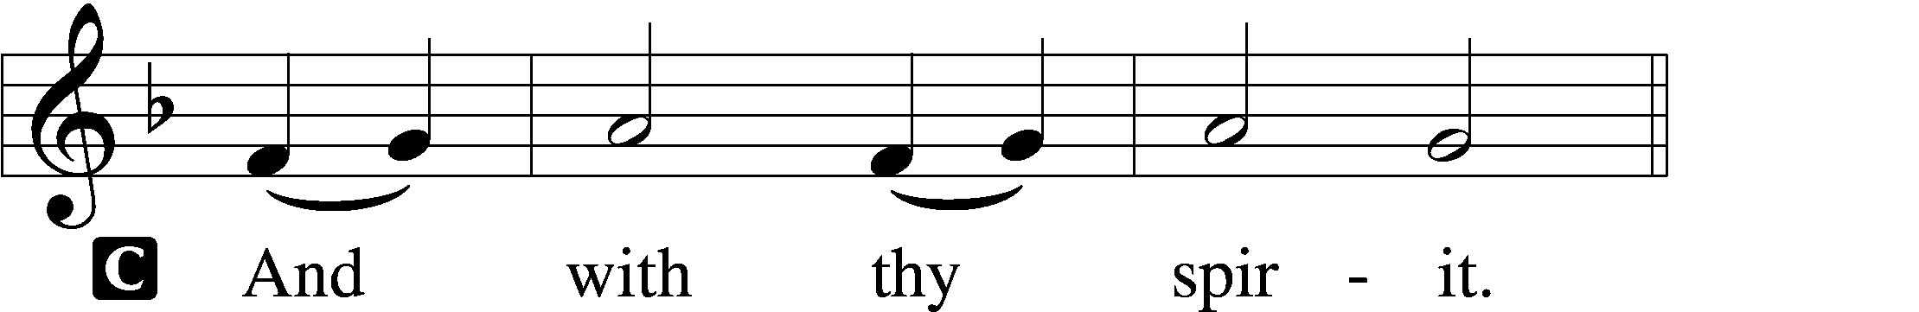

P Lift up your hearts.
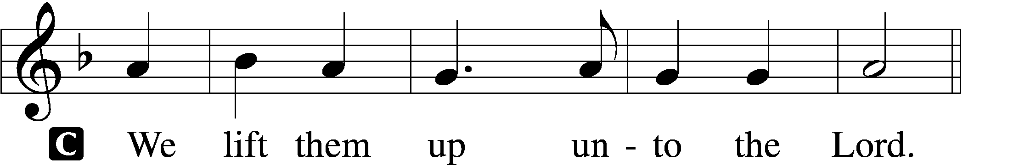

P Let us give thanks unto the Lord, our God.
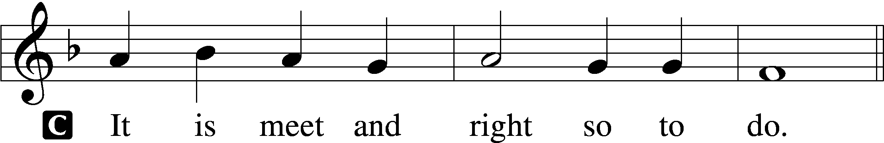

Proper Preface (Abbreviated) LSB 194
P It is truly meet, right, and salutary . . . evermore praising You and saying:

Sanctus Isaiah 6:3; Matthew 21:9
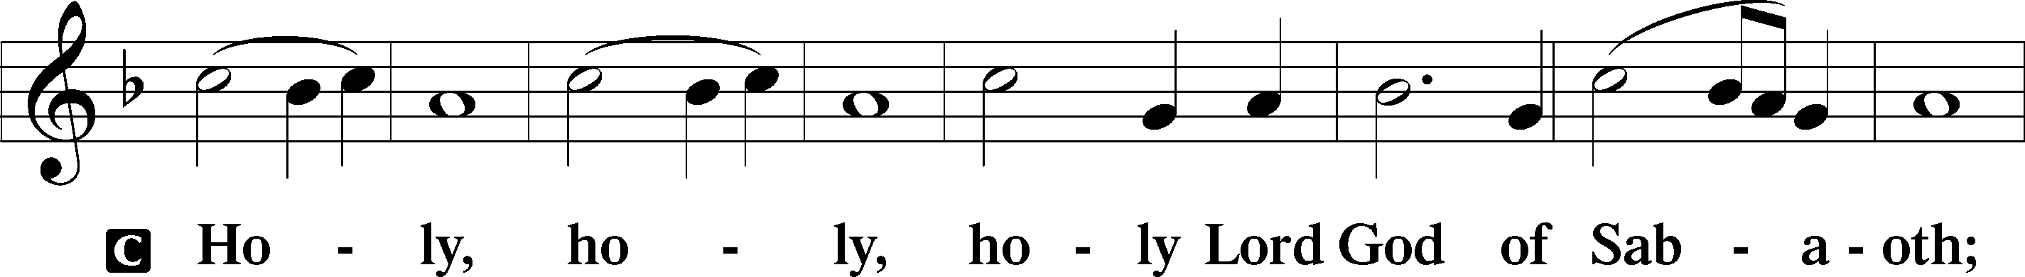
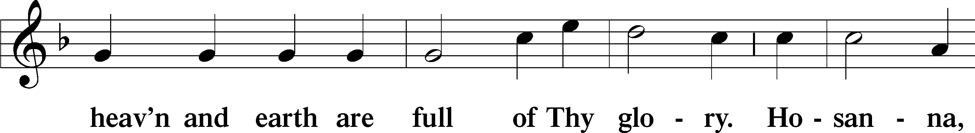
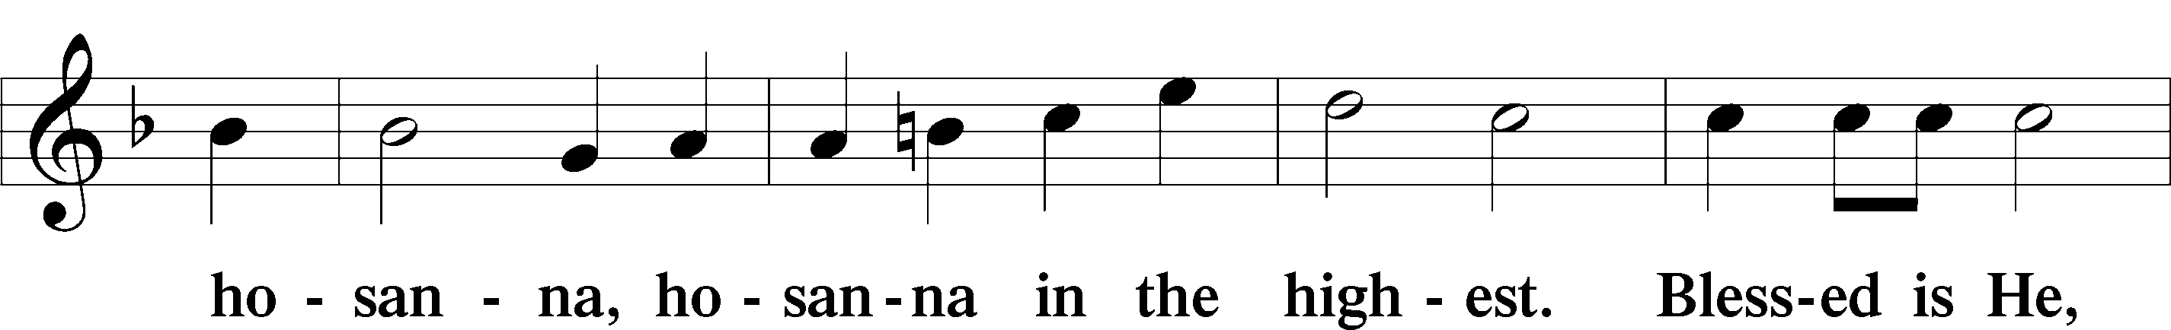
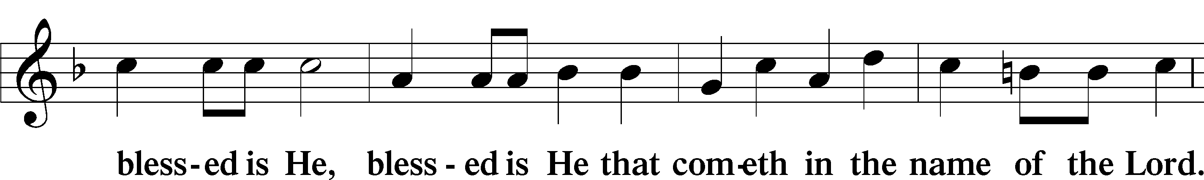
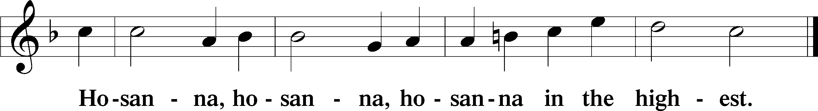

Lord’s Prayer The congregation is encouraged to silently pray the Lord’s Prayer as it is chanted. Matthew 6:9–13
P Our Father who art in heaven,
hallowed be Thy name,
Thy kingdom come,
Thy will be done on earth as it is in heaven;
give us this day our daily bread;
and forgive us our trespasses as we forgive those who trespass against us;
and lead us not into temptation,
but deliver us from evil.
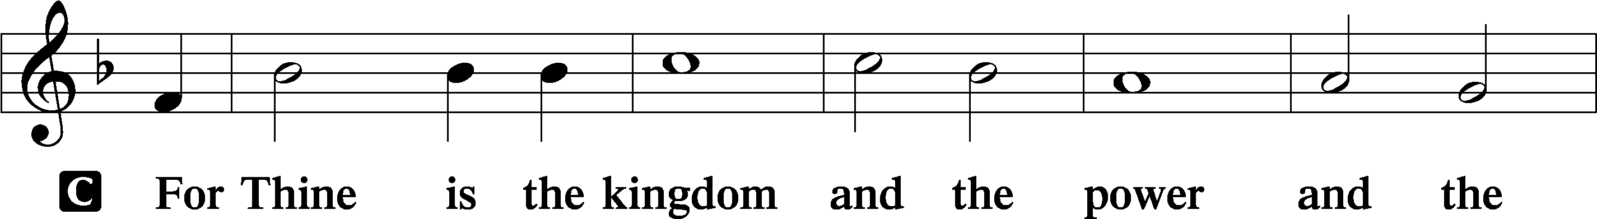
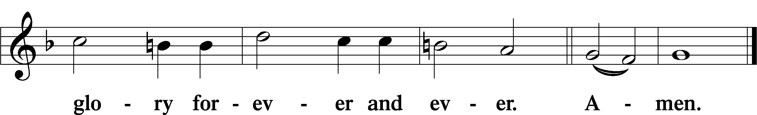

The Words of Our Lord Matthew 26:26–28; Mark 14:22–24; Luke 22:19–20; 1 Corinthians 11:23–25
P Our Lord Jesus Christ, on the night when He was betrayed, took bread, and when He had given thanks, He broke it and gave it to the disciples and said: “Take, eat; this is My T body, which is given for you. This do in remembrance of Me.”

In the same way also He took the cup after supper, and when He had given thanks, He gave it to them, saying: “Drink of it, all of you; this cup is the new testament in My T blood, which is shed for you for the forgiveness of sins. This do, as often as you drink it, in remembrance of Me.”

Pax Domini John 20:19
P The peace of the Lord be with you always.
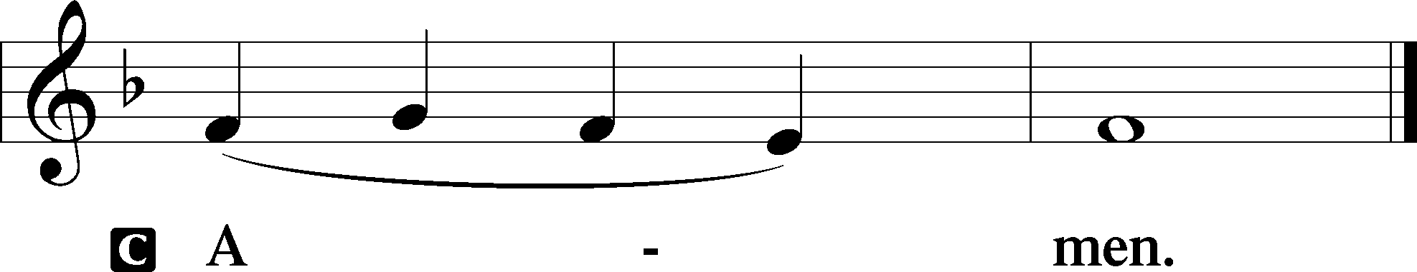

Agnus Dei John 1:29
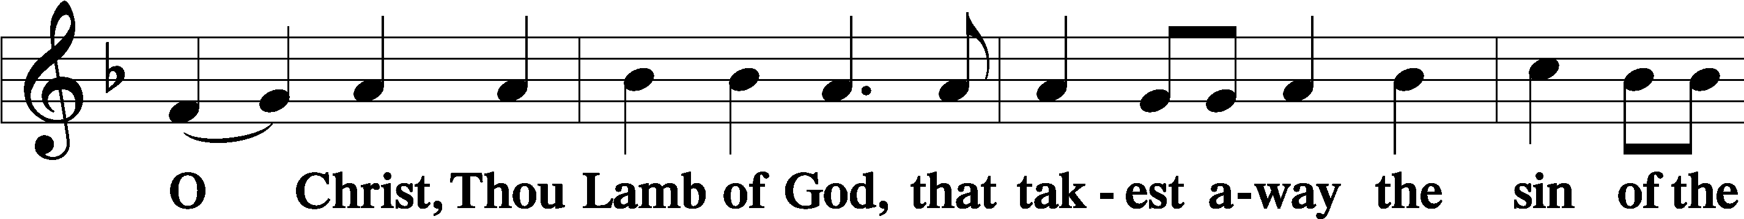
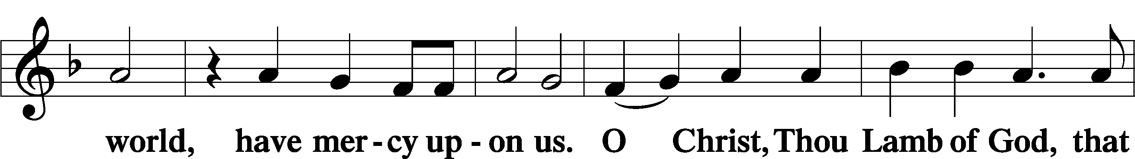
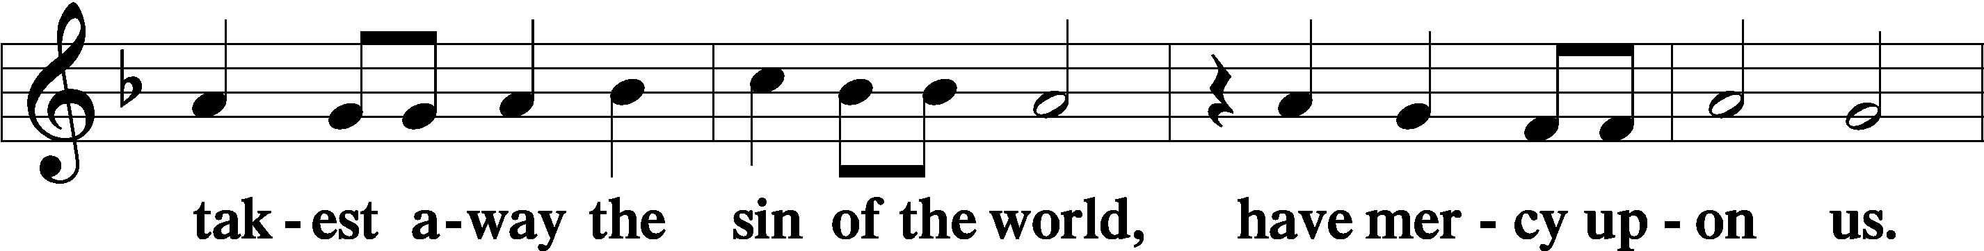
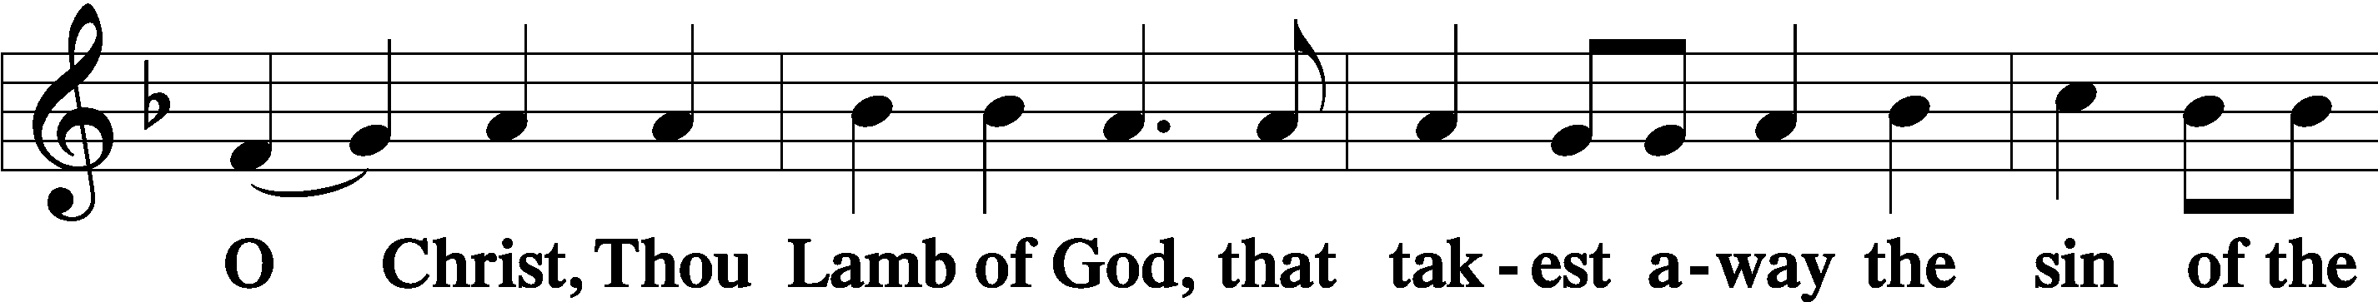
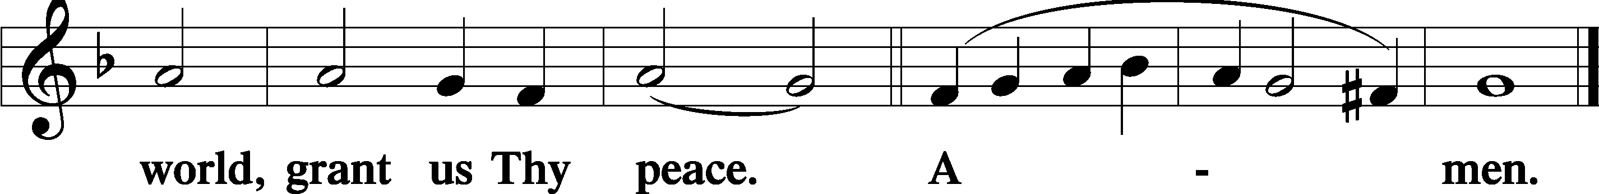
Sit

Distribution
The pastor and those who assist him receive the body and blood of Christ first and then distribute them to those who come to receive, saying:
Take, eat; this is the true body of our Lord and Savior Jesus Christ, given into death for your sins.
Amen.

Take, drink; this is the true blood of our Lord and Savior Jesus Christ, shed for the forgiveness of your sins.
Amen.

In dismissing the communicants, the following is said:
P The body and blood of our Lord Jesus Christ strengthen and preserve you in body and soul to life everlasting. Depart T in peace.
C Amen.

Distribution Hymn: LSB #360 “All My Heart Again Rejoices”

Distribution Hymn: LSB #370 “What Child Is This”

Distribution Hymn: LSB #386 “Now Sing We, Now Rejoice”

Stand

Nunc Dimittis Luke 2:29–32
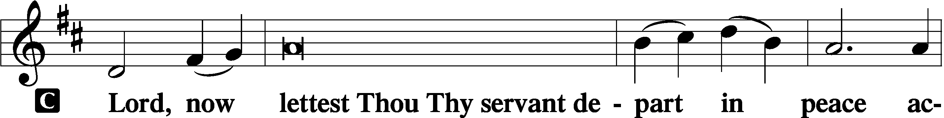
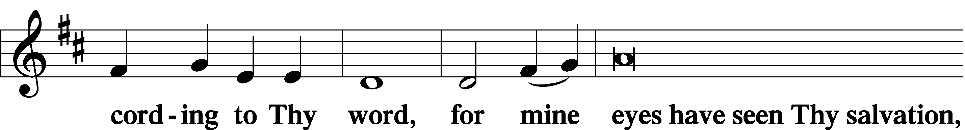
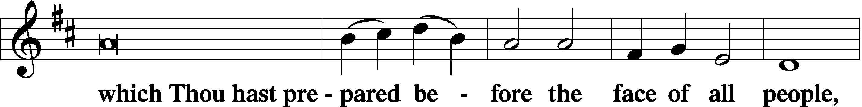
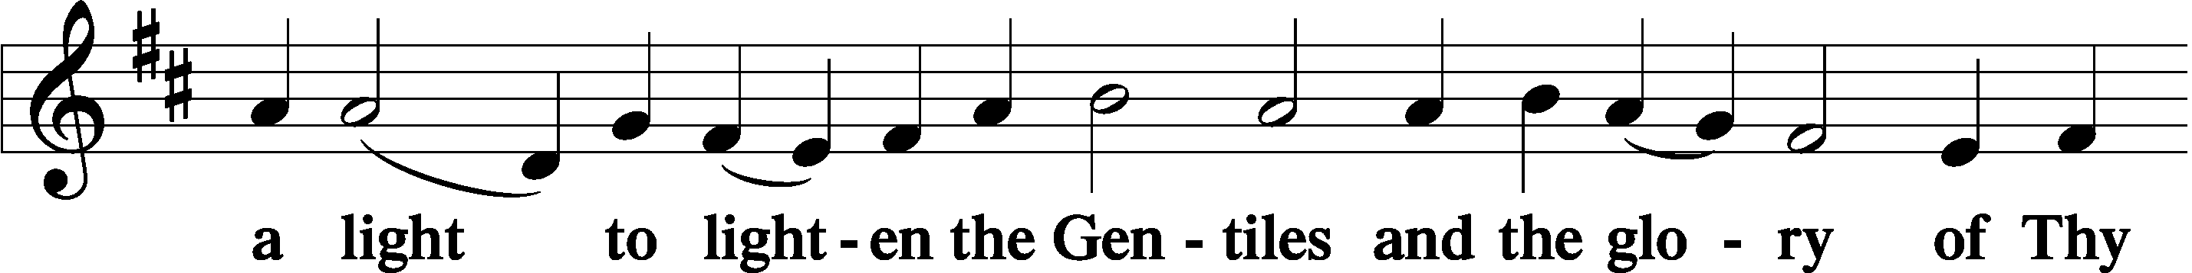
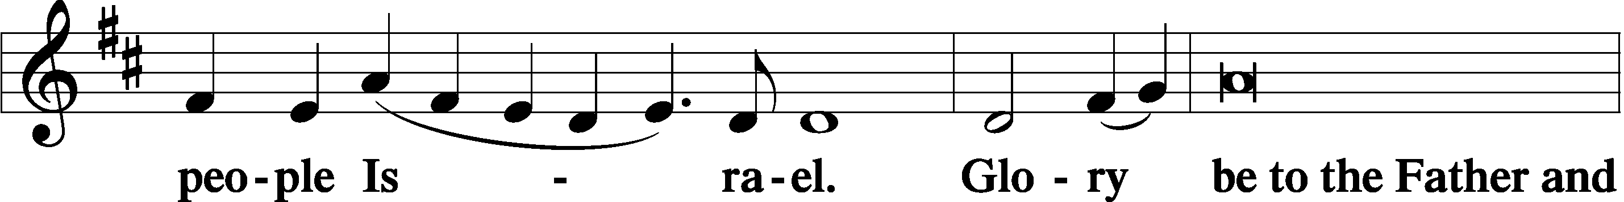
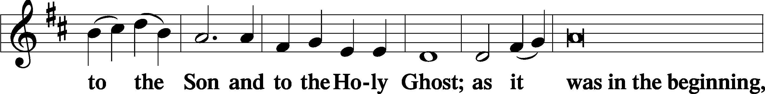
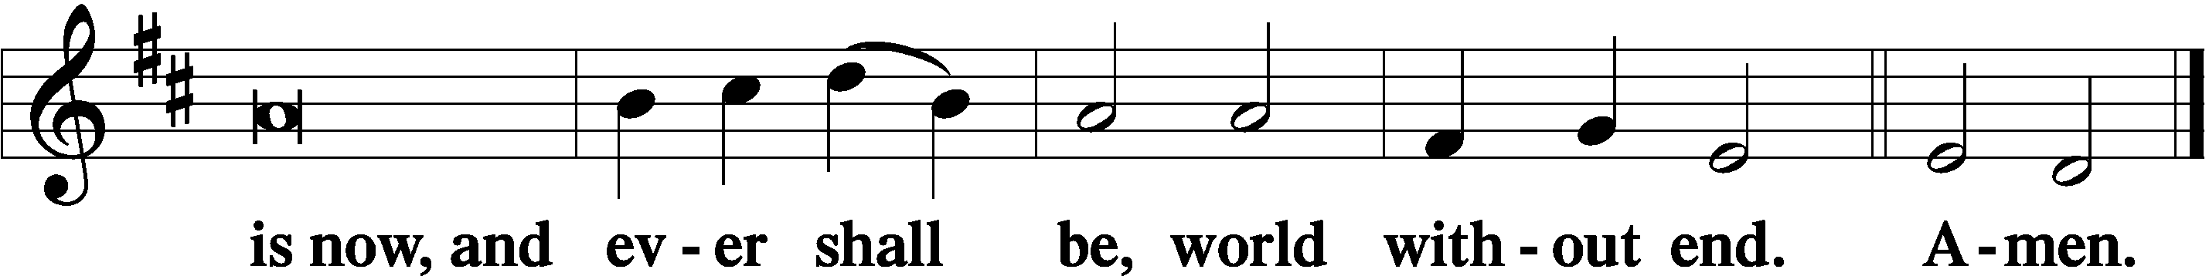

Thanksgiving Psalm 107:1
P O give thanks unto the Lord, for He is good,
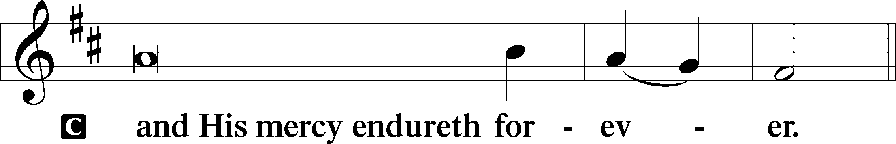

Post-Communion Collect
P Let us pray.
We give thanks to You, almighty God, that You have refreshed us through this salutary gift, and we implore You that of Your mercy You would strengthen us through the same in faith toward You and in fervent love toward one another; through Jesus Christ, Your Son, our Lord, who lives and reigns with You and the Holy Spirit, one God, now and forever.
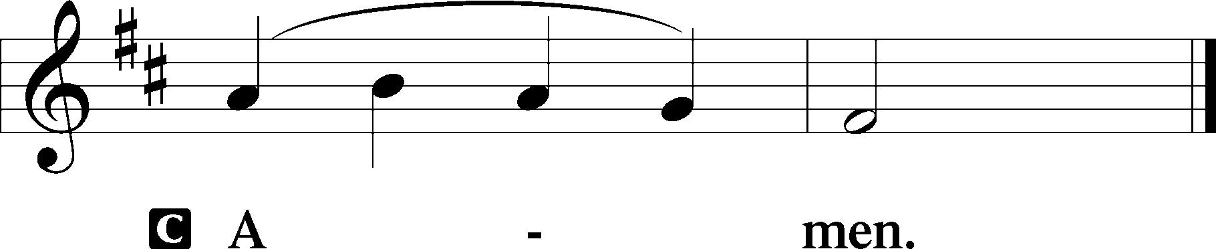

Salutation 2 Timothy 4:22
P The Lord be with you.
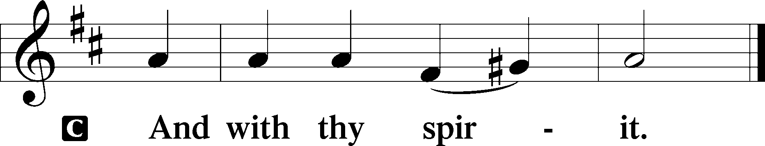

Benedicamus Psalm 103:1
P Bless we the Lord.
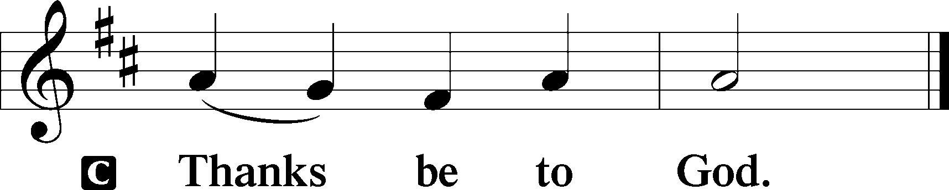

Benediction Numbers 6:24–26
P The Lord bless you and keep you.
The Lord make His face shine upon you and be gracious unto you.
The Lord lift up His countenance upon you and T give you peace.
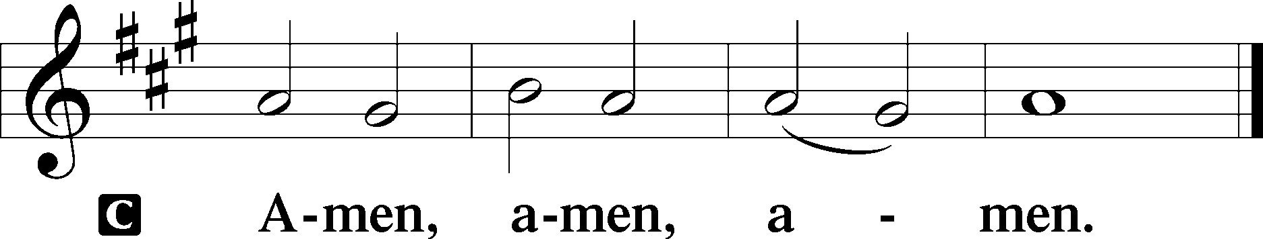

Closing Hymn: LSB #390 “Let Us All with Gladsome Voice”

Silent prayer after worship: Thank You, Lord Jesus, for leaving Your throne in heaven to come and be my Savior. Lead me to daily rejoice and give thanks for Your gift of salvation, and to share with others the good news of Your birth. Amen.

Acknowledgments
Unless otherwise indicated, Scripture quotations are from the ESV® Bible (The Holy Bible, English Standard Version®), copyright © 2001 by Crossway, a publishing ministry of Good News Publishers. Used by permission. All rights reserved.
Created by Lutheran Service Builder © 2023 Concordia Publishing House.

