Sts. Peter & Paul
Evangelical Lutheran Church
Lutheran Church-Missouri Synod
Founded-1917

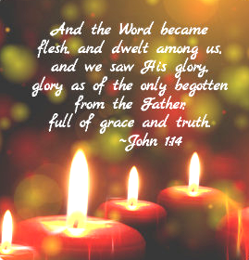

December 25, 2022

699 Stambaugh Avenue
Sharon, Pennsylvania 16146

“I was glad when they said to me,
Let us go to the house of the LORD!”
Psalm 122:1
Sts. Peter & Paul Evangelical Lutheran Church, LC-MS
THE NATIVITY OF OUR LORD
December 25, 2022

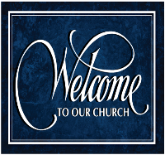
A special welcome to our guests this day! If you would like more information about The Lutheran Church - Missouri Synod, or this congregation, please speak with Pastor Deal or an Elder after the service.
Members & Guests: Don’t be embarrassed if your children make noise during the worship service, all children do. We encourage families to worship together but, if you feel the need, there are pews in the rear of the Church which are reserved for young families on both sides of the sanctuary. There is also a quiet room available to you during our service which is located down the hallway past the offices on the right side of the church as well as a children’s area in the Fellowship Hall where you are able to follow along with the service.

Today’s service includes the Sacrament of Holy Communion. If during this past year, you have not worshipped with us and been communed, we respectfully ask that you do not partake of this sacrament this day before first speaking with Pastor Deal.
If visiting from a sister congregation of the LC-MS and are in good standing, please inform Pastor Deal of your desire to commune prior to the service.
If wishing to receive a blessing during communion, please approach with your arms crossed.

CONTACT INFORMATION
Pastor Deal: pastordeal@saintspeterandpaul.net or 724-347-3620 (opt. 2)
Church Office: church@saintspeterandpaul.net or 724-347-3620 (opt. 3)

Silent prayer before worship: Dearest Lord Jesus, You have come to me as the Holy Child of Bethlehem. I come to You this hour to receive Your gifts peace, hope, love, joy and life. Help me to value these more than anything else. Amen.

Confession and Absolution

Opening Hymn: TLH #78 “Hail the Day So Rich in Cheer”

Stand

The sign of the cross may be made by all in remembrance of their Baptism.

Invocation
P In the name of the Father and of the T Son and of the Holy Spirit.
C Amen.

Exhortation Hebrews 10:22; Psalm 124:8; Psalm 32:5
P Beloved in the Lord! Let us draw near with a true heart and confess our sins unto God our Father, beseeching Him in the name of our Lord Jesus Christ to grant us forgiveness.

P Our help is in the name of the Lord,
C who made heaven and earth.
P I said, I will confess my transgressions unto the Lord,
C and You forgave the iniquity of my sin.

Silence for reflection on God’s Word and for self-examination.

Confession of Sins
P O almighty God, merciful Father,
C I, a poor, miserable sinner, confess unto You all my sins and iniquities with which I have ever offended You and justly deserved Your temporal and eternal punishment. But I am heartily sorry for them and sincerely repent of them, and I pray You of Your boundless mercy and for the sake of the holy, innocent, bitter sufferings and death of Your beloved Son, Jesus Christ, to be gracious and merciful to me, a poor, sinful being.

Absolution [John 20:19–23]
P Upon this your confession, I, by virtue of my office, as a called and ordained servant of the Word, announce the grace of God unto all of you, and in the stead and by the command of my Lord Jesus Christ I forgive you all your sins in the name of the Father and of the T Son and of the Holy Spirit.
C Amen.

Service of the Word

Introit Psalm 98:1–4; antiphon: Isaiah 9:6
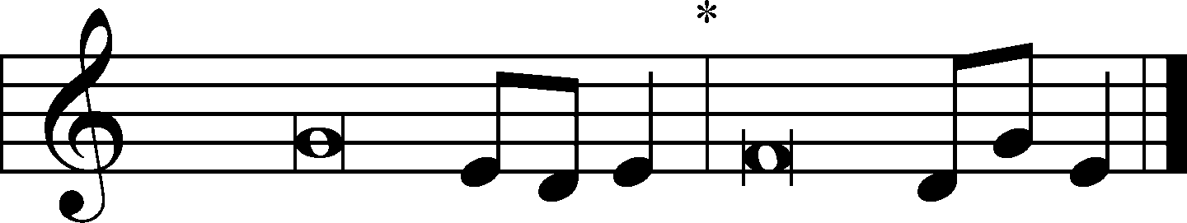
For to us a child is born, to us a son is | given;*
and the government shall be upon his | shoulder,
and his name shall be called Wonderful | Counselor,*
Mighty God, Everlasting Father, | Prince of Peace.
Oh sing to the Lord a new song, for he has done | marvelous things!*
His right hand and his holy arm have worked salva- | tion for him.
The Lord has made known his sal- | vation;*
he has revealed his righteousness in the sight of the | nations.
He has remembered his steadfast love and faithfulness to the house of | Israel.*
All the ends of the earth have seen the salvation | of our God.
Make a joyful noise to the Lord, | all the earth;*
break forth into joyous song and sing | praises!
For to us a child is born, to us a son is | given;*
and the government shall be upon his | shoulder,
and his name shall be called Wonderful | Counselor,*
Mighty God, Everlasting Father, | Prince of Peace.

Gloria Patri
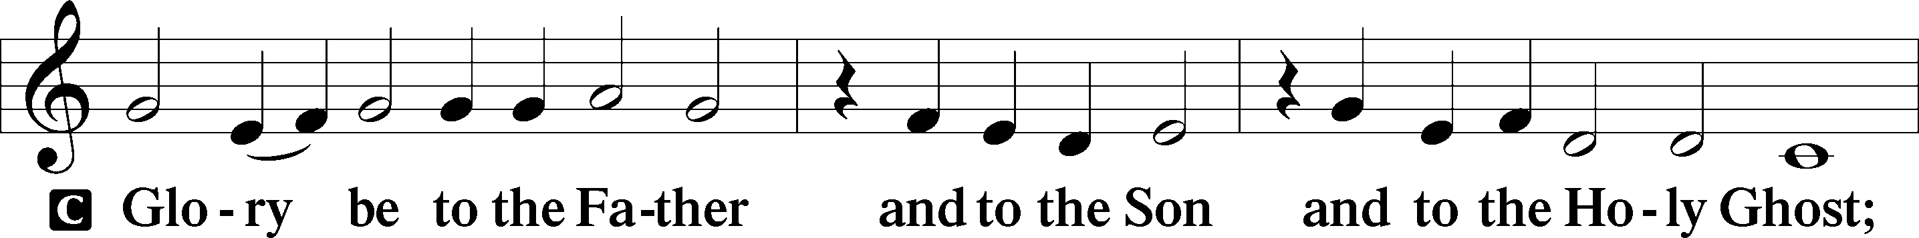
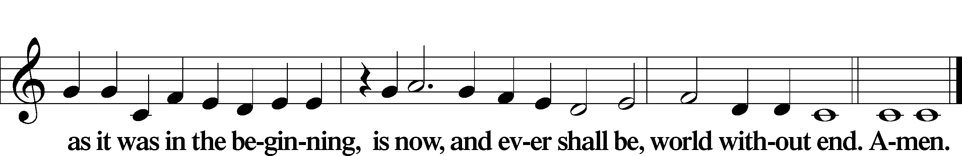

Kyrie Mark 10:47
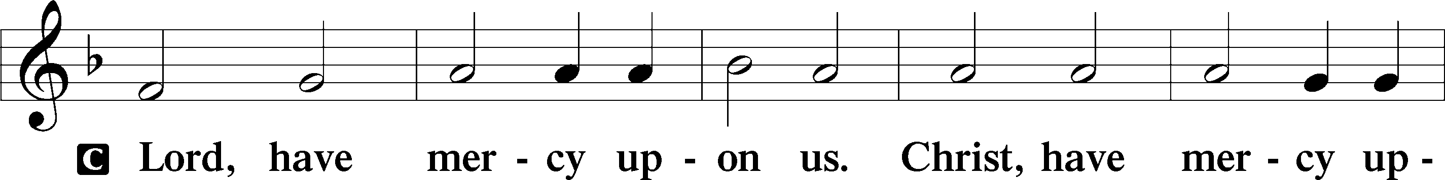
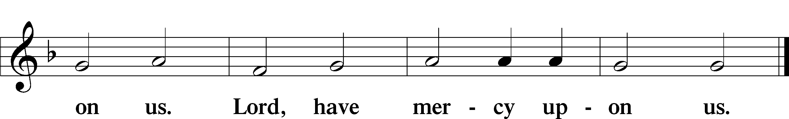

Gloria in Excelsis Luke 2:14; John 1:29
P Glory be to God on high:
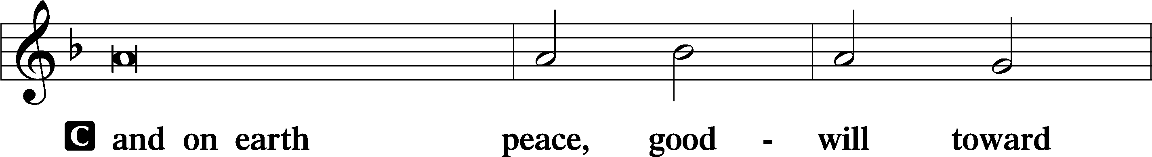
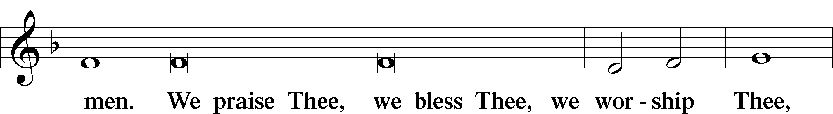
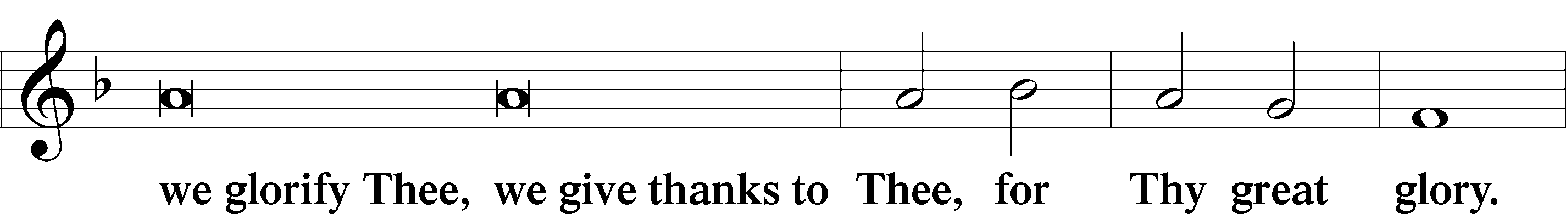
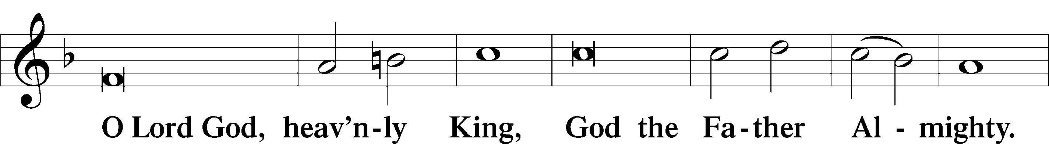
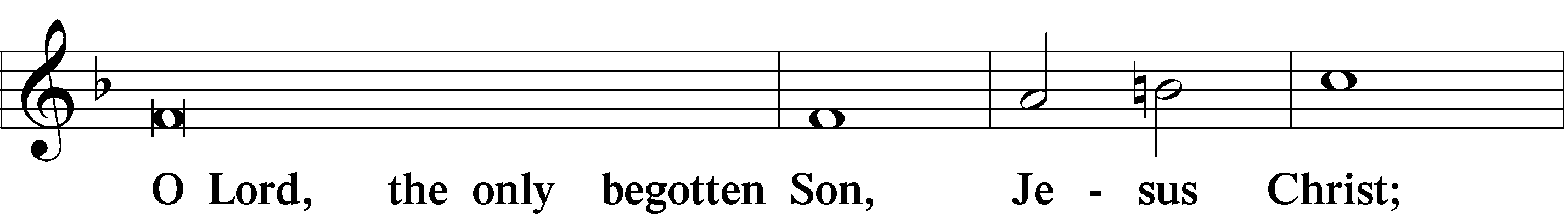
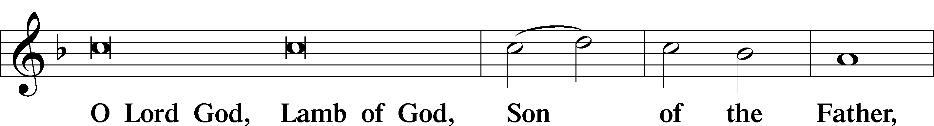
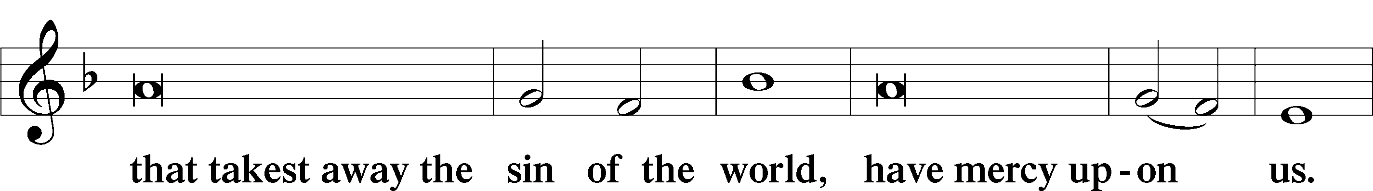
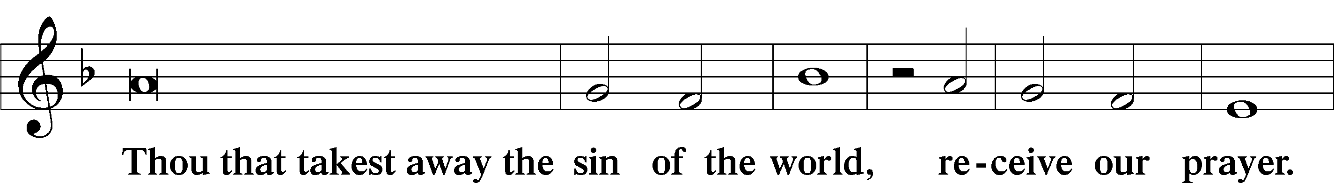
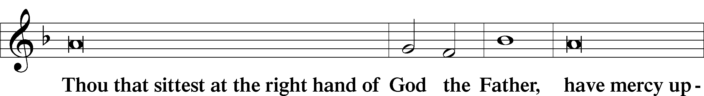
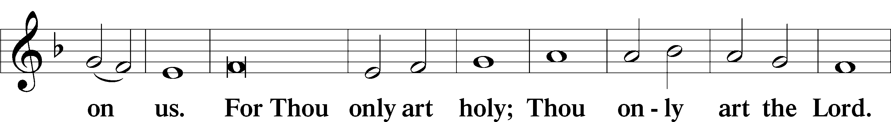
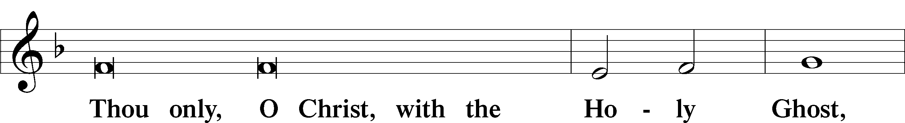
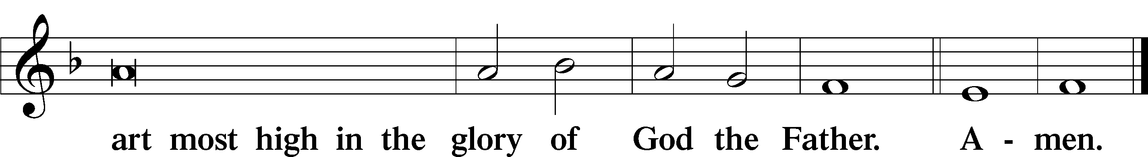

Salutation and Collect of the Day: Christmas Day
P The Lord be with you.
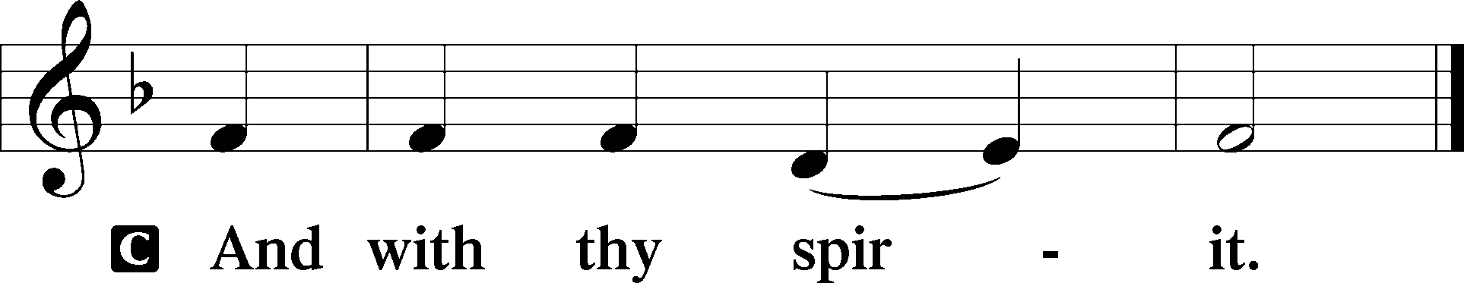

P Let us pray.
Almighty God, grant that the birth of Your only-begotten Son in the flesh may set us free from the bondage of sin; through Jesus Christ, Your Son, our Lord, who lives and reigns with You and the Holy Spirit, one God, now and forever.
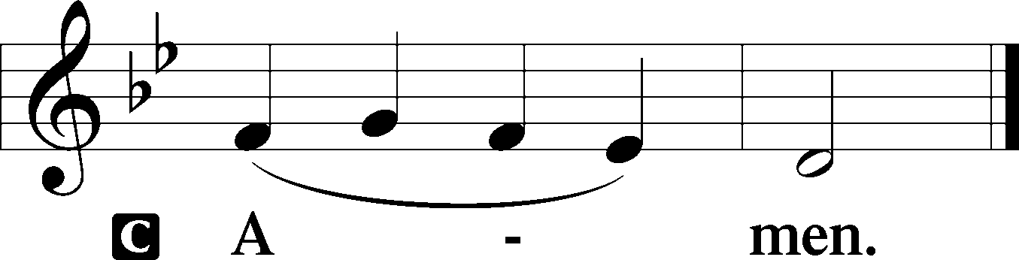
Sit

Prophecy: Isaiah 52:6-10
Thus says the Lord God: “My people shall know My name; therefore they shall know in that day that I am He who speaks: ‘Behold, it is I.’ ” How beautiful upon the mountains are the feet of him who brings good news, who proclaims peace, who brings glad tidings of good things, who proclaims salvation, who says to Zion, “Your God reigns!” Your watchmen shall lift up their voices, with their voices they shall sing together; for they shall see eye to eye when the Lord brings back Zion. Break forth into joy, sing together, you waste places of Jerusalem! For the Lord has comforted His people, He has redeemed Jerusalem. The Lord has made bare His holy arm in the eyes of all the nations; and all the ends of the earth shall see the salvation of our God.

P This is the Word of the Lord.
C Thanks be to God.

Gradual Psalm 118:26a, 27a, 23
Blessèd is he who comes in the name | of the Lord!*
The Lord is God, and he has made his light to shine up- | on us.
This is the Lord’s | doing;*
it is marvelous | in our eyes.

Epistle: Hebrews 1:1-12
Brethren: God, who at various times and in various ways spoke in time past to the fathers by the prophets, has in these last days spoken to us by His Son, whom He has appointed heir of all things, through whom also He made the worlds; who being the brightness of His glory and the express image of His person, and upholding all things by the word of His power, when He had by Himself purged our sins, sat down at the right hand of the Majesty on high, having become so much better than the angels, as He has by inheritance obtained a more excellent name than they. For to which of the angels did He ever say: “You are My Son, today I have begotten You”? And again: “I will be to Him a Father, and He shall be to Me a Son”? But when He again brings the firstborn into the world, He says: “Let all the angels of God worship Him.” And of the angels He says: “Who makes His angels spirits and His ministers a flame of fire.” But to the Son He says: “Your throne, O God, is forever and ever; a scepter of righteousness is the scepter of Your kingdom. You have loved righteousness and hated lawlessness; therefore God, Your God, has anointed You with the oil of gladness more than Your companions.” And: “You, Lord, in the beginning laid the foundation of the earth, and the heavens are the work of Your hands. They will perish, but You remain; and they will all grow old like a garment; like a cloak You will fold them up, and they will be changed. But You are the same, and Your years will not fail.”

P This is the Word of the Lord.
C Thanks be to God.

Stand

Verse Liturgical Text
Alleluia. A holy day has dawned upon us. Come, all you nations, and worship the Lord. Alleluia.

Alleluia
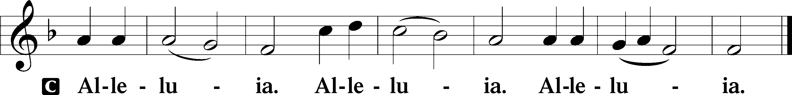

Holy Gospel: John 1:1–14
P The Holy Gospel according to St. John, the first chapter.
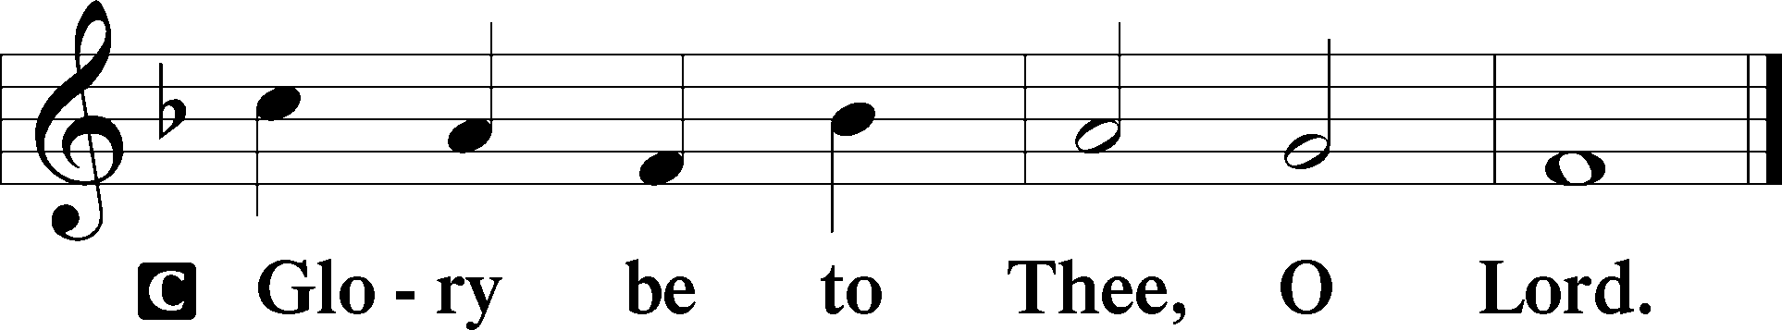

In the beginning was the Word, and the Word was with God, and the Word was God. He was in the beginning with God. All things were made through Him, and without Him nothing was made that was made. In Him was life, and the life was the light of men. And the light shines in the darkness, and the darkness did not comprehend it. There was a man sent from God, whose name was John. This man came for a witness, to bear witness of the Light, that all through him might believe. He was not that Light, but was sent to bear witness of that Light. That was the true Light which gives light to every man coming into the world. He was in the world, and the world was made through Him, and the world did not know Him. He came to His own, and His own did not receive Him. But as many as received Him, to them He gave the right to become children of God, to those who believe in His name: who were born, not of blood, nor of the will of the flesh, nor of the will of man, but of God. And the Word became flesh and dwelt among us, and we beheld His glory, the glory as of the only begotten of the Father, full of grace and truth.

P This is the Gospel of the Lord.
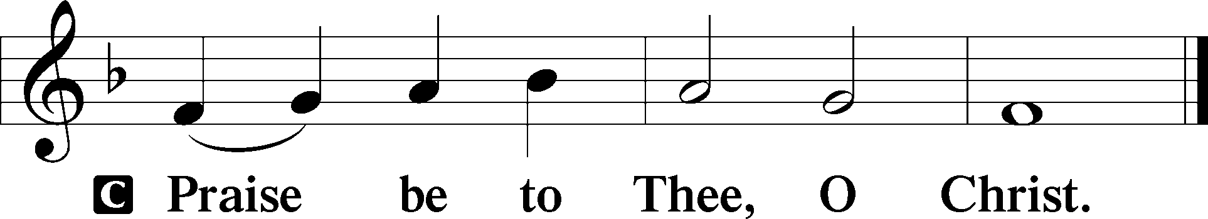

Nicene Creed
C I believe in one God,
the Father Almighty,
maker of heaven and earth
and of all things visible and invisible.

And in one Lord Jesus Christ,
the only-begotten Son of God,
begotten of His Father before all worlds,
God of God, Light of Light,
very God of very God,
begotten, not made,
being of one substance with the Father,
by whom all things were made;
who for us men and for our salvation came down from heaven
and was incarnate by the Holy Spirit of the virgin Mary
and was made man;
and was crucified also for us under Pontius Pilate.
He suffered and was buried.
And the third day He rose again according to the Scriptures
and ascended into heaven
and sits at the right hand of the Father.
And He will come again with glory to judge both the living and the dead,
whose kingdom will have no end.

And I believe in the Holy Spirit,
the Lord and giver of life,
who proceeds from the Father and the Son,
who with the Father and the Son together is worshiped and glorified,
who spoke by the prophets.
And I believe in one holy Christian and apostolic Church,
I acknowledge one Baptism for the remission of sins,
and I look for the resurrection of the dead
and the life T of the world to come. Amen.
Sit

Hymn of the Day: LSB #382 “We Praise You, Jesus, at Your Birth”

Sermon

Stand

Prayer of the Church

Offertory Psalm 51:10–12
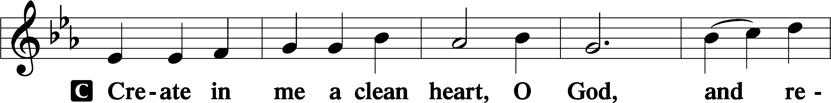
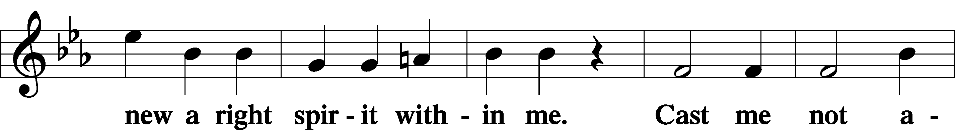
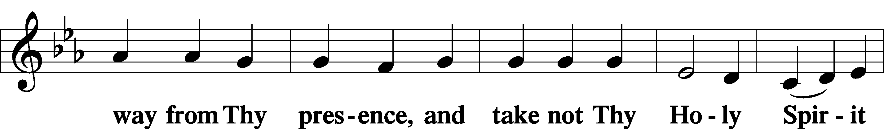
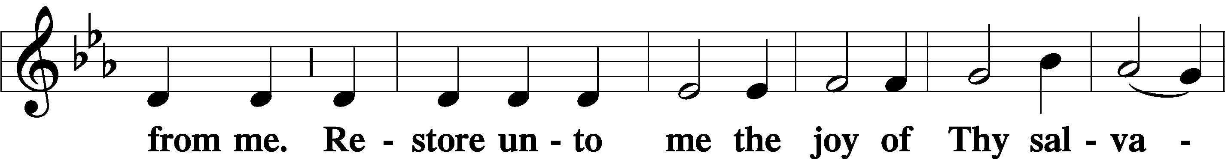
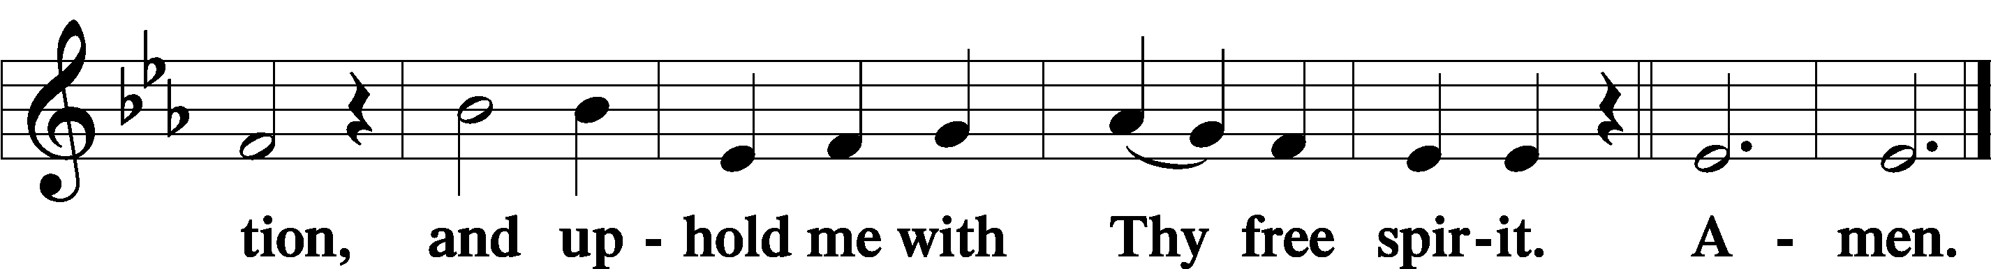
Sit

Preparatory Hymn: LSB #368 “Angels We Have Heard on High”

Stand
Service of the Sacrament

Preface 2 Timothy 4:22; Colossians 3:1 Psalm 136
P The Lord be with you.
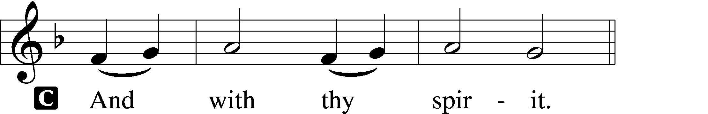

P Lift up your hearts.
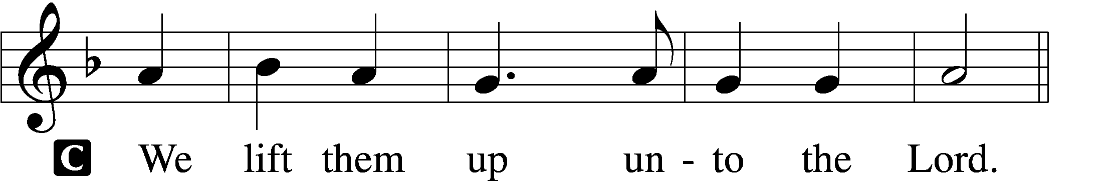

P Let us give thanks unto the Lord, our God.
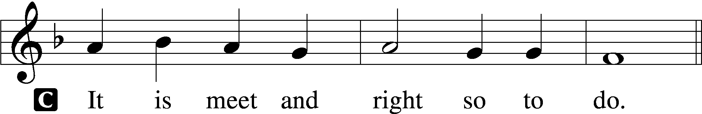

Proper Preface (Abbreviated) LSB 194
P It is truly meet, right, and salutary . . . evermore praising You and saying:

Sanctus Isaiah 6:3; Matthew 21:9
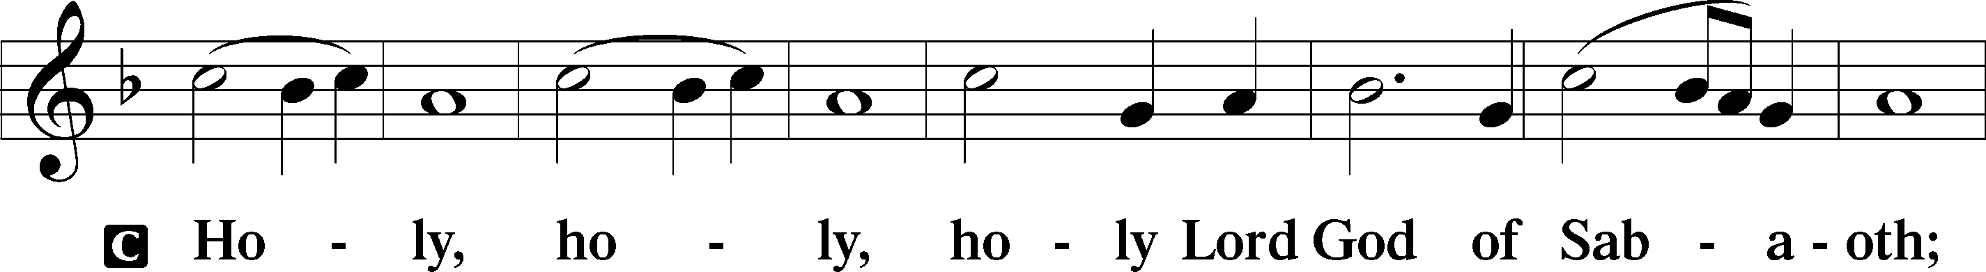
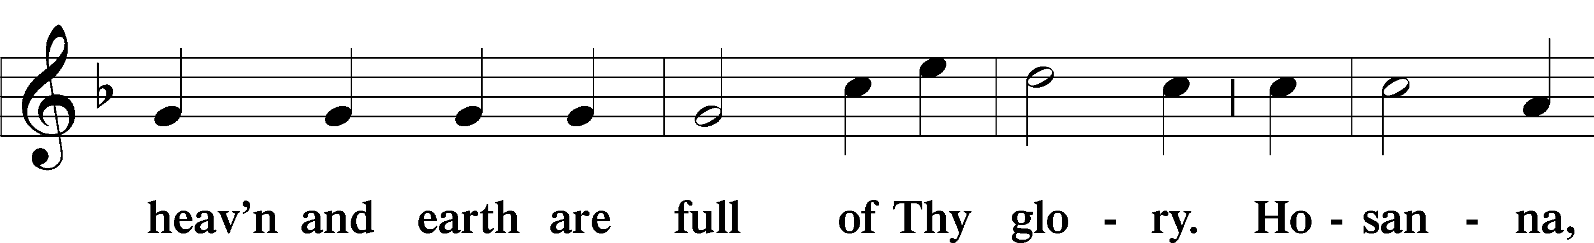
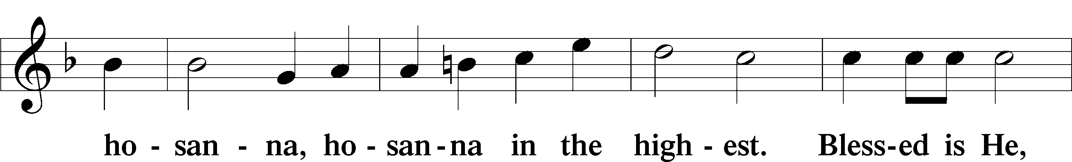
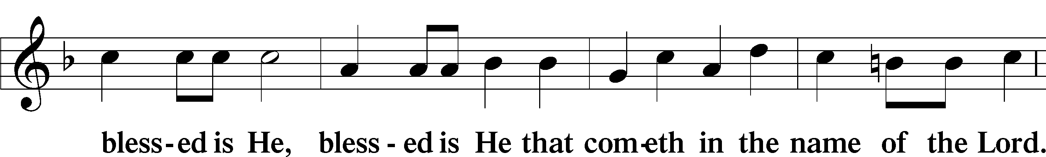
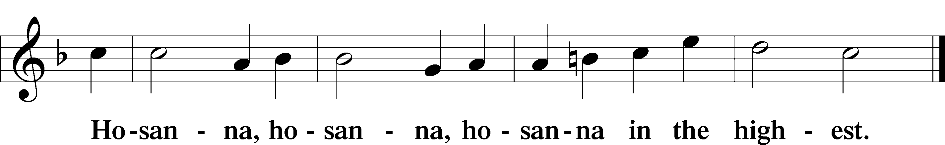

Lord’s Prayer Matthew 6:9–13
C Our Father who art in heaven,
hallowed be Thy name,
Thy kingdom come,
Thy will be done on earth as it is in heaven;
give us this day our daily bread;
and forgive us our trespasses as we forgive those who trespass against us;
and lead us not into temptation,
but deliver us from evil.
For Thine is the kingdom and the power and the glory forever and ever. Amen.

The Words of Our Lord Matthew 26:26–28; Mark 14:22–24; Luke 22:19–20; 1 Corinthians 11:23–25
P Our Lord Jesus Christ, on the night when He was betrayed, took bread, and when He had given thanks, He broke it and gave it to the disciples and said: “Take, eat; this is My T body, which is given for you. This do in remembrance of Me.”

In the same way also He took the cup after supper, and when He had given thanks, He gave it to them, saying: “Drink of it, all of you; this cup is the new testament in My T blood, which is shed for you for the forgiveness of sins. This do, as often as you drink it, in remembrance of Me.”

Pax Domini John 20:19
P The peace of the Lord be with you always.
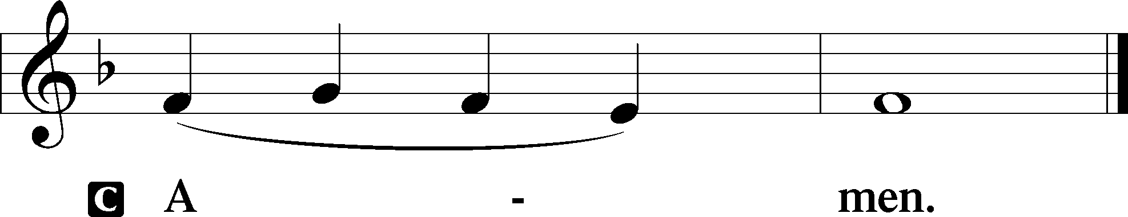

Agnus Dei John 1:29
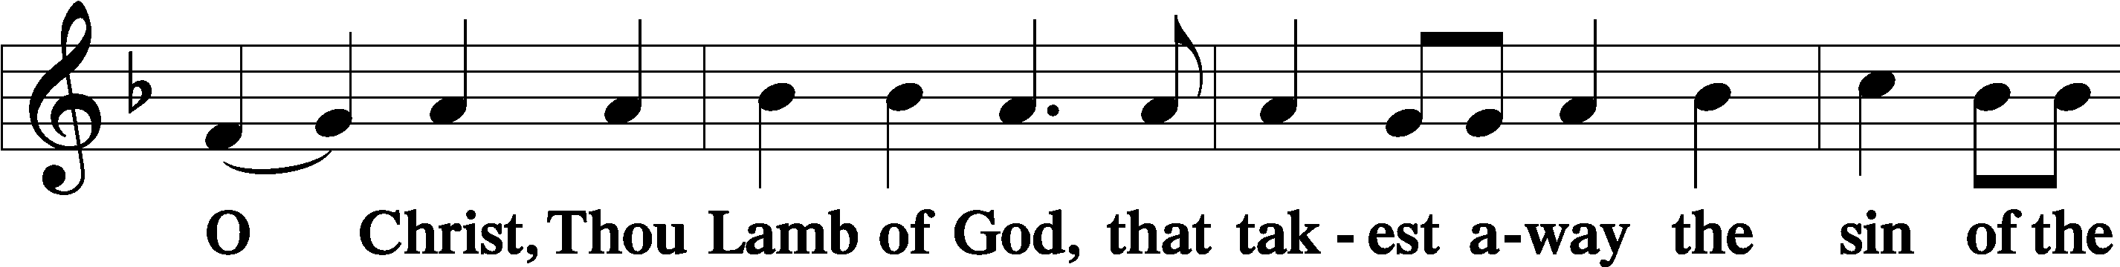
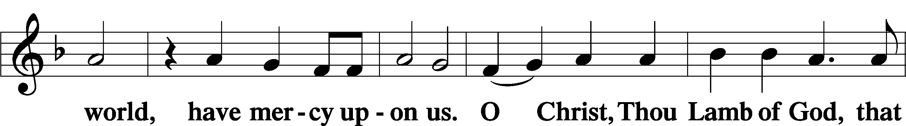
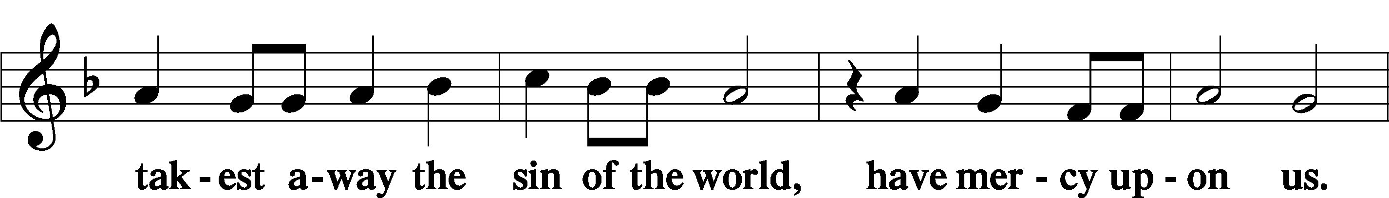
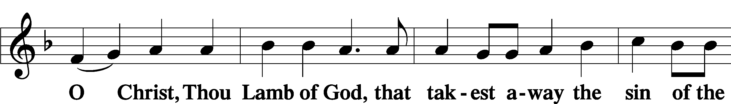
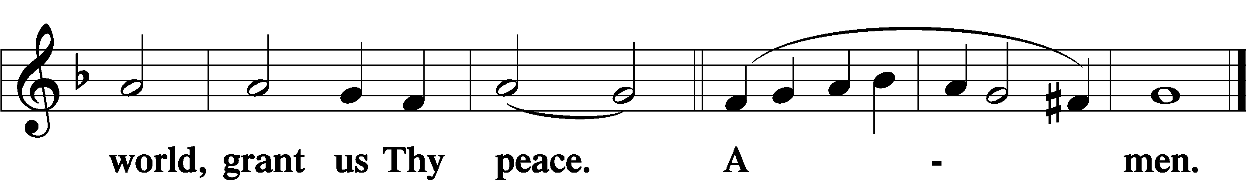
Sit

Distribution
The pastor and those who assist him receive the body and blood of Christ first and then distribute them to those who come to receive, saying:
Take, eat; this is the true body of our Lord and Savior Jesus Christ, given into death for your sins.
Amen.

Take, drink; this is the true blood of our Lord and Savior Jesus Christ, shed for the forgiveness of your sins.
Amen.

In dismissing the communicants, the following is said:
The Dismissal
P The body and blood of our Lord Jesus Christ strengthen and preserve you in body and soul to life everlasting. Depart T in peace.
C Amen.

Distribution Hymn: LSB #375 “Come, Your Hearts and Voices Raising”

Distribution Hymn: LSB #370 “What Child Is This”

Distribution List: LSB #386 “Now Sing We, Now Rejoice”

Distribution Hymn: LSB #387 “Joy to the World”

Stand

Nunc Dimittis Luke 2:29–32
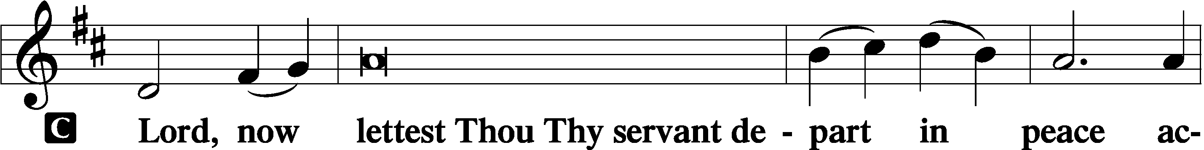
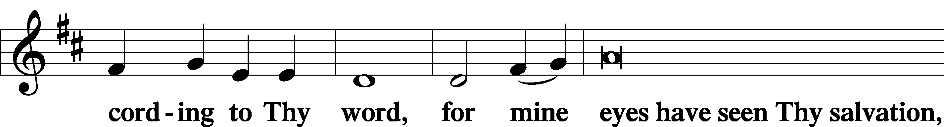
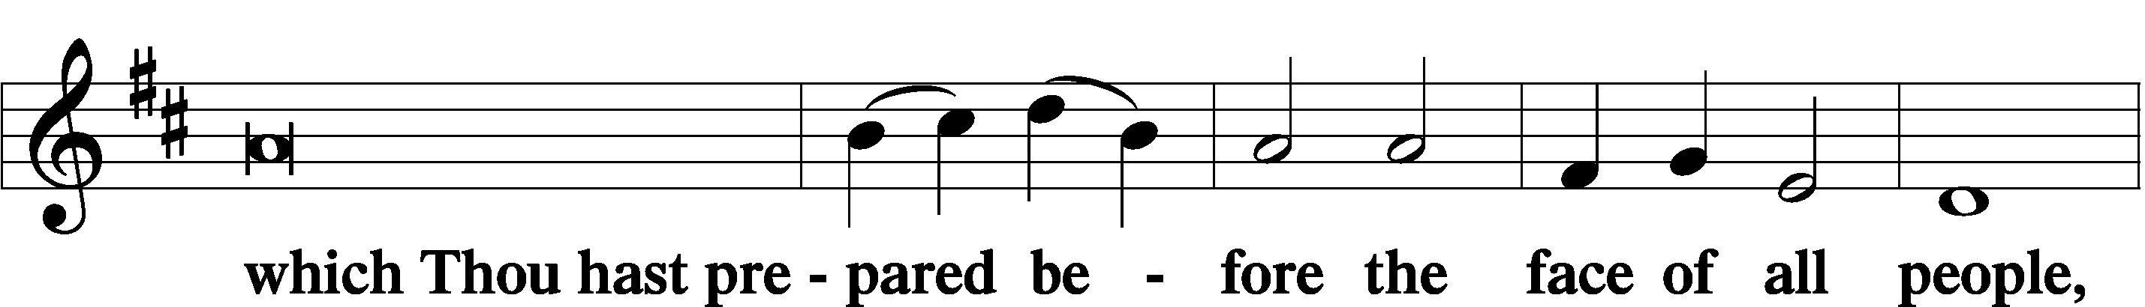
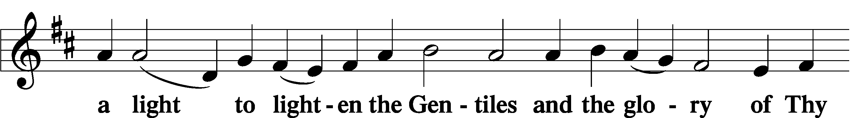
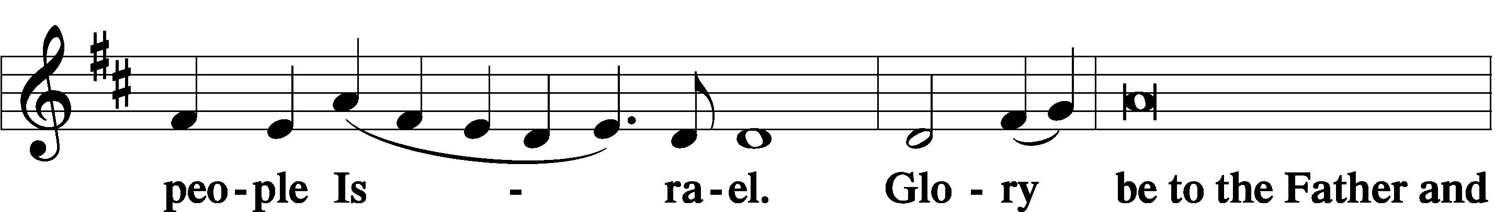
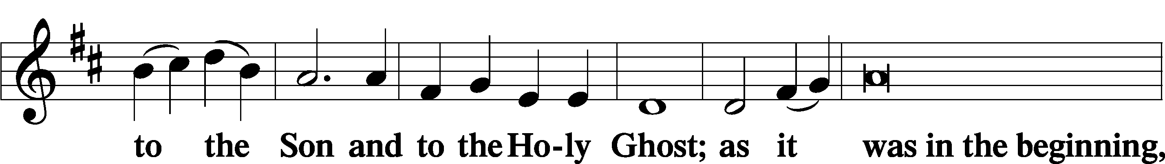
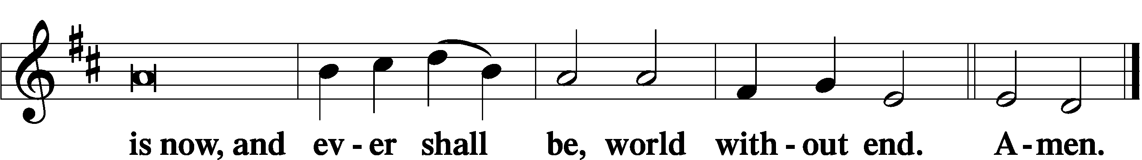

Thanksgiving Psalm 107:1
P O give thanks unto the Lord, for He is good,
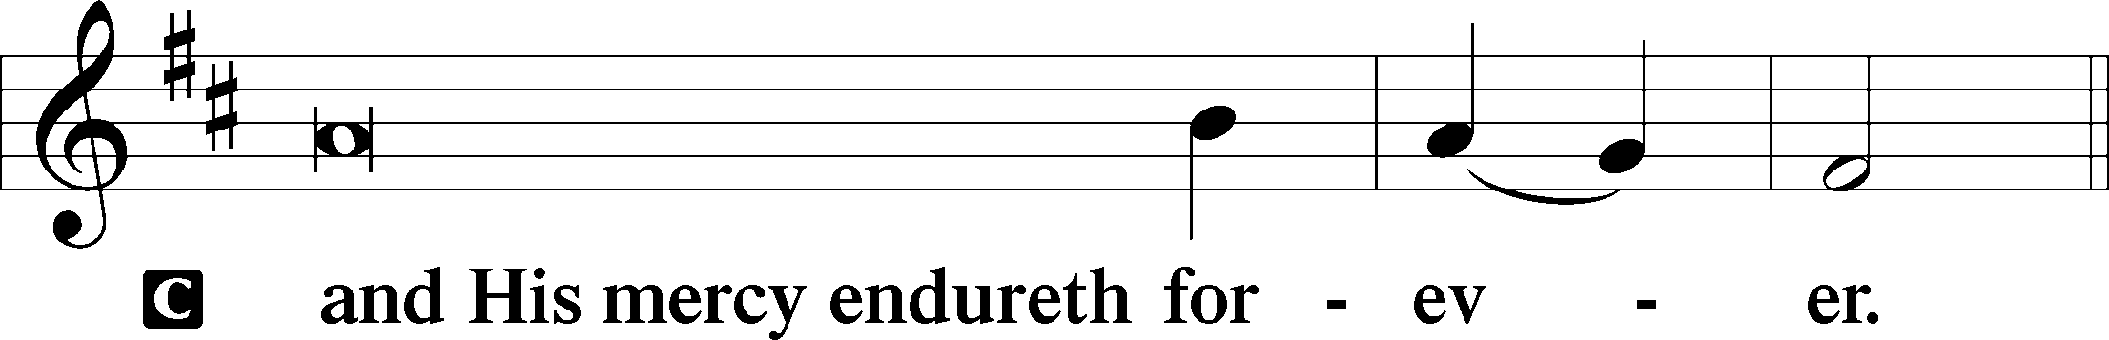

Post-Communion Collect
P Let us pray.
We give thanks to You, almighty God, that You have refreshed us through this salutary gift, and we implore You that of Your mercy You would strengthen us through the same in faith toward You and in fervent love toward one another; through Jesus Christ, Your Son, our Lord, who lives and reigns with You and the Holy Spirit, one God, now and forever.
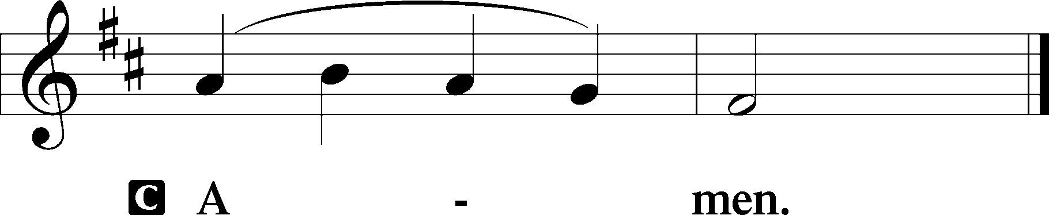

Salutation 2 Timothy 4:22
P The Lord be with you.
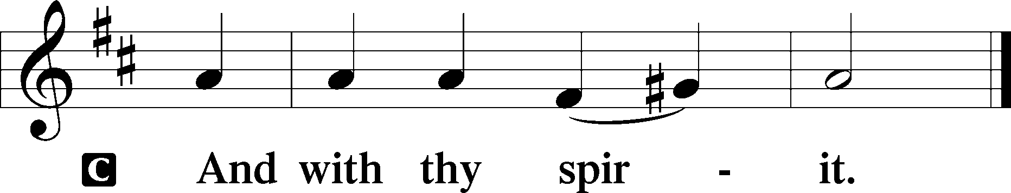

Benedicamus Psalm 103:1
P Bless we the Lord.
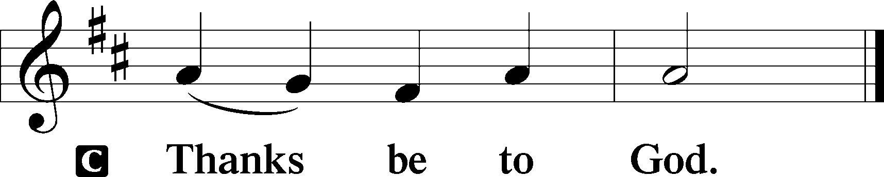

Benediction Numbers 6:24–26
P The Lord bless you and keep you.
The Lord make His face shine upon you and be gracious unto you.
The Lord lift up His countenance upon you and T give you peace.
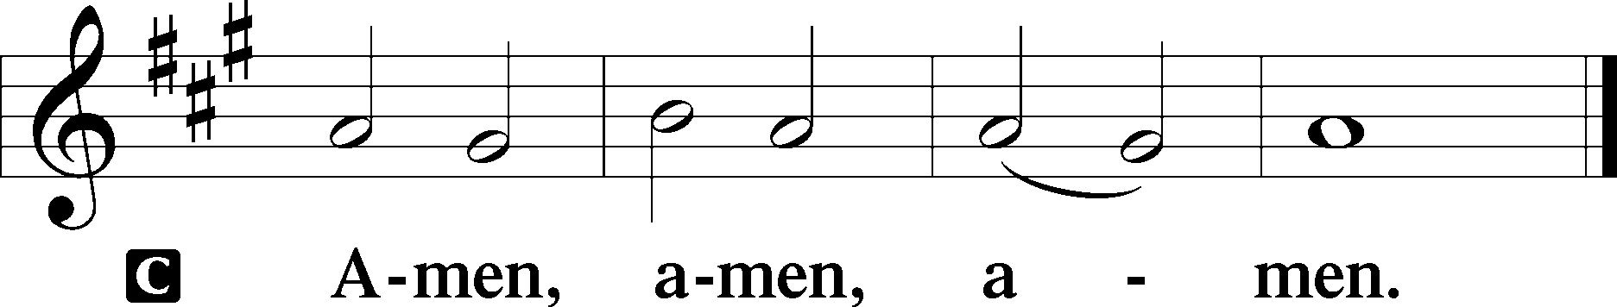

Closing Hymn: LSB #390 “Let Us All with Gladsome Voice”

Silent prayer after worship: Thank You, Lord Jesus, for leaving Your throne in heaven to come and be my Savior. Lead me to daily rejoice and give thanks for Your gift of salvation, and to share with others the good news of Your birth. Amen.
fffffffffffffffffffffffffffffffffff
Acknowledgments
Unless otherwise indicated, Scripture quotations are from the ESV® Bible (The Holy Bible, English Standard Version®), copyright © 2001 by Crossway, a publishing ministry of Good News Publishers. Used by permission. All rights reserved.
Created by Lutheran Service Builder © 2021 Concordia Publishing House.
fffffffffffffffffffffffffffffffffff
In Honor of our Wedding Anniversary: Anson & Hank Holcroft (Capital Campaign).
fffffffffffffffffffffffffffffffffff
SCHEDULE THROUGH JANUARY 1, 2023:

:

Today, 7 pm, Fellowship Hall: AA Meeting
Monday, 7 pm, Sanctuary: Festival of St. Stephen, Martyr (Vespers)
Tuesday, 7 pm, Sanctuary: Festival of St. John, Apostle and Evangelist (Vespers)
7-9 pm, Fellowship Hall: Penn-Ohio Singers
Wednesday, 7:00 pm, Sanctuary: Festival of the Holy Innocents (Vespers)
7:30 pm, Downstairs: NA Meeting
Saturday, 4 pm, Sanctuary: New Year’s Eve Service (Vespers)
Next Sunday, 9 am, Sanctuary: Divine Service
7 pm, Fellowship Hall: AA Meeting
fffffffffffffffffffffffffffffffffff
Attendance: Wednesday, December 14, 2022: 24 (noon: 12; eve: 12)
Sunday, December 18, 2022: 29
fffffffffffffffffffffffffffffffffff The 2023 Coffee Fellowship sign-up sheet has been posted on the bulletin board in the narthex along with the 2023 Altar Flower Sponsorship sheet. Consider signing up to be a sponsor!
fffffffffffffffffffffffffffffffffff
THANK YOU FOR SERVING IN DECEMBER: Head Elder: Barry Nelson; Assisting Elder: Jonathan Baisch; Altarware: Marie Flaugher and Altar Guild Volunteers
fffffffffffffffffffffffffffffffffff
REMINDER: The installation of 2023 Church Officers and Boards will take place during the Divine Service January 8, 2023. We will also be recognizing past servants of the church that day. Your attendance that day will be greatly appreciated.
Our Stewardship of Treasures for the Lord:
In order to do the Lord’s work, we need $2,462.92 each week to meet our 2022 budget for general purposes and $80.00 for the SELC.
Figures for Wednesday, December 14, 2022
General Fund: $390.00
SELC: $5.00
Capital Campaign: $660.00
Other: $16.00
Figures for Sunday, December 18, 2022:
General Fund: $1179.00 Behind for the week*: -$893.92
SELC: $5.00 Behind for the week*: -$70.00
Capital Campaign: $825.00 *Includes above figures.

For online giving, check out https://www.saintspeterandpaul.net/online-giving.

fffffffffffffffffffffffffffffffffff
Remember the following in Prayer…
~The Hurting and Healing: Amy, Gerald Arthur, Evelyn Baisch, Ellen Baron^{CA}, Lois Bortner^{CA}, John Burdette, Bev & Joe Chlpka, Kathleen Coughenour, Kim, Anna Mae Daris, Susan Davies, Tim Dudash, Joseph Fleet, Eddy Furey, Tim Haenftling, Austin Hamilton, Anson Holcroft, Neil Huston, Darla Krajci, Barbara Kreske, Michelle Kelly^{CA}, Donna Kennedy, Gerald Krivosh, Jess Lavoie, Paul Lucas^{CA}, Sandy Marshall, Ernie Meszaros, David Nelson, Linda Parkany, Juanita Rentschler, Richard Reuning^{CA}, Nancy Robertson^{CA}, Viola Sakony, Marty Scott, Kara, Fred Tonty, Angela Weser^{CA}, and Ruth Wolf.
~The Homebound: Rudy & Jean Tomko, Betty Wolf, and Ed & Millie Zachar.
~Celebrating: Birthday: Jean Tomko (12.28).
~Serving in the Military: Curtis Sinewe and Joshua Solyan.
~Community & World Needs: Those suffering from or affected by the coronavirus; those suffering due to the conflict between Ukraine and Russia; those suffering from loss and dislocation because weather disasters; those suffering from addiction and their families; Local, State, and National Government Leaders; safety for all Police Officers, Firefighters, & First Responders; the unemployed; our Fourth Quarter Local Mission: Willow Women’s Center *CA represents cancer.
Bible Memory Verses ~ Week of December 25th:
For Adults: And we know that for those who love God all things work together for good, for those who are called according to his purpose. Romans 8:28

For Children: The Word became flesh and dwelt among us. John 1:14
fffffffffffffffffffffffffffffffffff
Submissions for an abbreviated January newsletter are due to the church office by 9 am Wednesday, December 28th. Please be certain to submit any meeting dates and times for the January calendar. Thank you!
fffffffffffffffffffffffffffffffffff
It’s time to prepare for the 2022 Annual Report! Copies of 2021 submissions have been placed in library mailboxes to use as a reference. Please email 2022 information to church@saintspeterandpaul.net on or before Monday, January 9th. Material will be formatted for you. See Diane with any questions.

ADDITIONAL UP-COMING SERVICES

Festival of St. Stephen, Martyr
Monday, December 26, 2022 at 7 pm
Vespers Service

Festival of St. John, Apostle & Evangelist
Tuesday, December 27, 2022 at 7 pm
Vespers Service

Festival of the Holy Innocents, Martyrs
Wednesday, December 28, 2022 at 7 pm
Vespers Service

New Year’s Eve Service
Saturday, December 3`, 2022 at 4 pm
Vespers Service
The poinsettias adorning our Sanctuary have been
donated by the following church members:
Rev. Art & Mrs. Evelyn Baisch: To the Glory of God (1 white plant)

Mike & Marie Flaugher: In Honor of Our Church (3 red plants)

Judith A. Furey: In Loving Memory of Judith Elizabeth Boal and Dorothy Shoenberger (2 large white plants)

Mark Gabriel: In Loving Memory of Parents, Peter & Anne Gabriel, and Brother, Denny A. Gabriel (1 large red/white/pink plant)

Elizabeth Loughan: In Loving Memory of Bill Loughan and Iris & James Reigelman (2 large red/white/pink plants)

Ruth Meszaros: In Loving Memory of Mom and Dad, Millie & Paul Fabri (1 white plant)

Barry & Chris Nelson and Family: In Loving Memory of Bill & Margie Nelson, John & Mary Ann Krajci; John G. Krajci; Olivia Lynn Sovesky; and All Loved Ones (1 red plant and 1 large red/white/pink plant)

Diane Riefstahl: In Loving Memory of Parents, Donald L. & Lucile M. Riefstahl, and Brother, Donald C. Riefstahl (2 white plants and 1 large red plant)

Mrs. Robert Sulek: In Loving Memory of Husband, Robert Sulek, and Brother, Richard Dorfi (2 red plants)

Linda Tomko: In Loving Memory of Parents, Paul & Lillian Tomko, and Grandparents, Aunts, Uncles, and Cousins (2 large red/white/pink plants)

