Sts. Peter & Paul
Evangelical Lutheran Church
Lutheran Church-Missouri Synod
Founded-1917

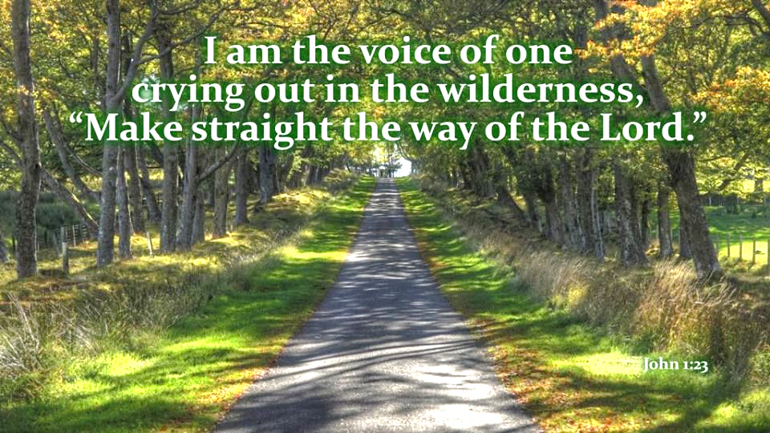

December 18, 2022

699 Stambaugh Avenue
Sharon, Pennsylvania 16146

“I was glad when they said to me,
Let us go to the house of the LORD!”
Psalm 122:1
Sts. Peter & Paul Evangelical Lutheran Church, LC-MS
RORATE COELI
December 18, 2022

A special welcome to our guests this day! If you would like more information about The Lutheran Church - Missouri Synod, or this congregation, please speak with Pastor Deal or an Elder after the service.
Members & Guests: Don’t be embarrassed if your children make noise during the worship service, all children do. We encourage families to worship together but, if you feel the need, there are pews in the rear of the Church which are reserved for young families on both sides of the sanctuary. There is also a quiet room available to you during our service which is located down the hallway past the offices on the right side of the church as well as a children’s area in the Fellowship Hall where you are able to follow along with the service.

Today’s service includes the Sacrament of Holy Communion. If during this past year, you have not worshipped with us and been communed, we respectfully ask that you do not partake of this sacrament this day before first speaking with Pastor Deal.
If visiting from a sister congregation of the LC-MS and are in good standing, please inform Pastor Deal of your desire to commune prior to the service.
If wishing to receive a blessing during communion, please approach with your arms crossed.

CONTACT INFORMATION
Pastor Deal: pastordeal@saintspeterandpaul.net or 724-347-3620 (opt. 2)
Church Office: church@saintspeterandpaul.net or 724-347-3620 (opt. 3)

Silent prayer before worship: Dear heavenly Father, help me to remember that I am Your child. Give me a childlike faith, so I can trust that through Your Son Jesus I have life and hope always. In Jesus’ name. Amen.

Divine Service ~ Setting 1 ~ p. 151
Confession and Absolution

Opening Hymn: LSB #334 “O Lord, How Shall I Meet You”

Stand

The sign of the cross may be made by all in remembrance of their Baptism.

Invocation
P In the name of the Father and of the T Son and of the Holy Spirit.
C Amen.

Exhortation LSB 151
P If we say we have no sin, we deceive ourselves, and the truth is not in us.
C But if we confess our sins, God, who is faithful and just, will forgive our sins and cleanse us from all unrighteousness.

Silence for reflection on God’s Word and for self-examination.

Confession of Sins LSB 151
P Let us then confess our sins to God our Father.
C Most merciful God, we confess that we are by nature sinful and unclean. We have sinned against You in thought, word, and deed, by what we have done and by what we have left undone. We have not loved You with our whole heart; we have not loved our neighbors as ourselves. We justly deserve Your present and eternal punishment. For the sake of Your Son, Jesus Christ, have mercy on us. Forgive us, renew us, and lead us, so that we may delight in Your will and walk in Your ways to the glory of Your holy name. Amen.

Absolution LSB 151
P Almighty God in His mercy has given His Son to die for you and for His sake forgives you all your sins. As a called and ordained servant of Christ, and by His authority, I therefore forgive you all your sins in the name of the Father and of the T Son and of the Holy Spirit.
C Amen.

Stand
Service of the Word

Introit Psalm 19:1, 4–6; antiphon: Isaiah 45:8a
Shower, O heavens, | from above,*
and let the clouds rain down | righteousness;
let the earth open, that salvation and righteousness may | bear fruit;*
let the earth cause them | both to sprout.
The heavens declare the glo- | ry of God,*
and the sky above proclaims his | handiwork.
Their measuring line goes out through all the earth, and their words to the end | of the world.*
In them he has set a tent | for the sun,
which comes out like a bridegroom leaving his | chamber,*
and, like a strong man, runs its | course with joy.
Its rising is from the end of the heavens, and its circuit to the | end of them,*
and there is nothing hidden | from its heat.
Shower, O heavens, | from above,*
and let the clouds rain down | righteousness;
let the earth open, that salvation and righteousness may | bear fruit;*
let the earth cause them | both to sprout.

Kyrie 152
P In peace let us pray to the Lord.
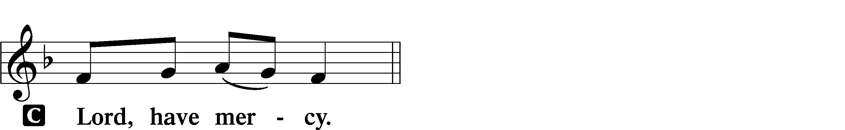

P For the peace from above and for our salvation let us pray to the Lord.
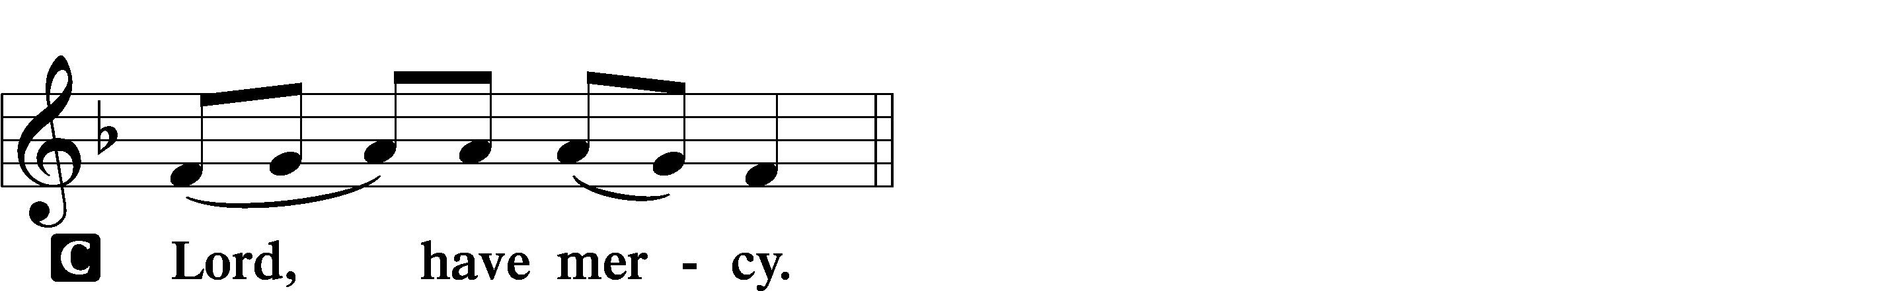

P For the peace of the whole world, for the well-being of the Church of God, and for the unity of all let us pray to the Lord.
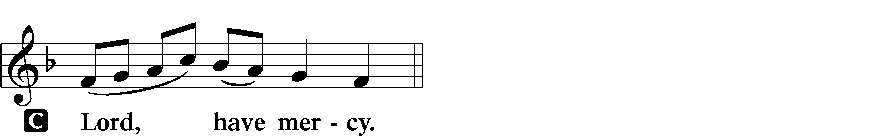

P For this holy house and for all who offer here their worship and praise let us pray to the Lord.
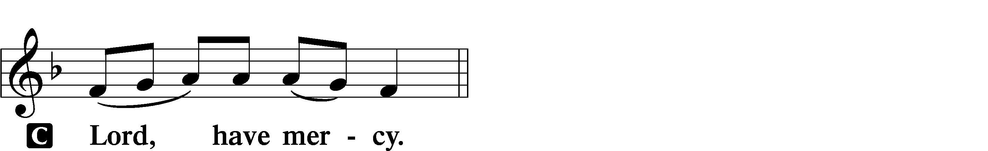

P Help, save, comfort, and defend us, gracious Lord.

Salutation and Collect of the Day: Rorate Coeli
P The Lord be with you.
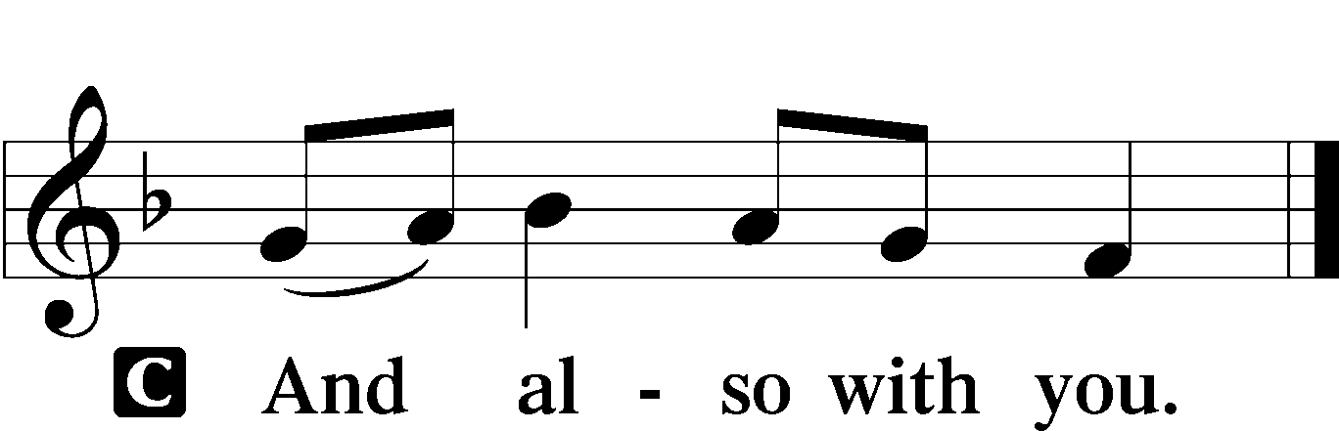

P Let us pray.
Stir up Your power, O Lord, and come and help us by Your might, that the sins which weigh us down may be quickly lifted by Your grace and mercy; for You live and reign with the Father and the Holy Spirit, one God, now and forever.
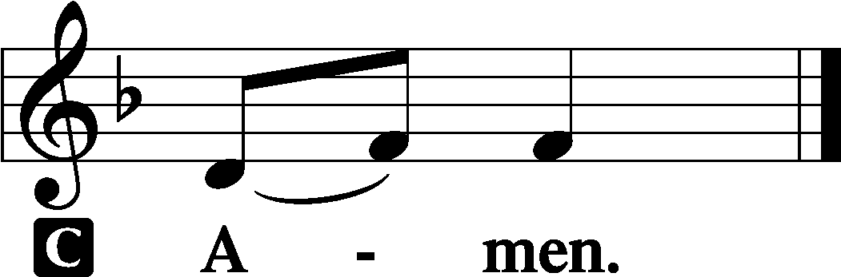
Sit

Prophecy: Deuteronomy 18:15–19
In those days Moses spoke to the children of Israel, saying: “The Lord your God will raise up for you a Prophet like me from your midst, from your brethren. Him you shall hear, according to all you desired of the Lord your God in Horeb in the day of the assembly, saying, ‘Let me not hear again the voice of the Lord my God, nor let me see this great fire anymore, lest I die.’ And the Lord said to me: ‘What they have spoken is good. I will raise up for them a Prophet like you from among their brethren, and will put My words in His mouth, and He shall speak to them all that I command Him. And it shall be that whoever will not hear My words, which He speaks in My name, I will require it of him.’ ”

P This is the Word of the Lord.
C Thanks be to God.

Psalm: Psalm 111; antiphon: v. 9
Praise the Lord!
I will give thanks to the Lord with my whole heart,
in the company of the upright, in the congregation.
Great are the works of the Lord,
studied by all who delight in them.
Full of splendor and majesty is his work,
and his righteousness endures forever.
He has caused his wondrous works to be remembered;
the Lord is gracious and merciful.
He provides food for those who fear him;
he remembers his covenant forever.
He has shown his people the power of his works,
in giving them the inheritance of the nations.
The works of his hands are faithful and just;
all his precepts are trustworthy;
they are established forever and ever,
to be performed with faithfulness and uprightness.
He sent redemption to his people;
he has commanded his covenant forever.
Holy and awesome is his name!
The fear of the Lord is the beginning of wisdom;
all those who practice it have a good understanding.
His praise endures forever!

Epistle: Philippians 4:4–7
Brethren: Rejoice in the Lord always. Again I will say, rejoice! Let your gentleness be known to all men. The Lord is at hand. Be anxious for nothing, but in everything by prayer and supplication, with thanksgiving, let your requests be made known to God; and the peace of God, which surpasses all understanding, will guard your hearts and minds through Christ Jesus our Lord.

P This is the Word of the Lord.
C Thanks be to God.

Stand
Alleluia and Verse LSB 156
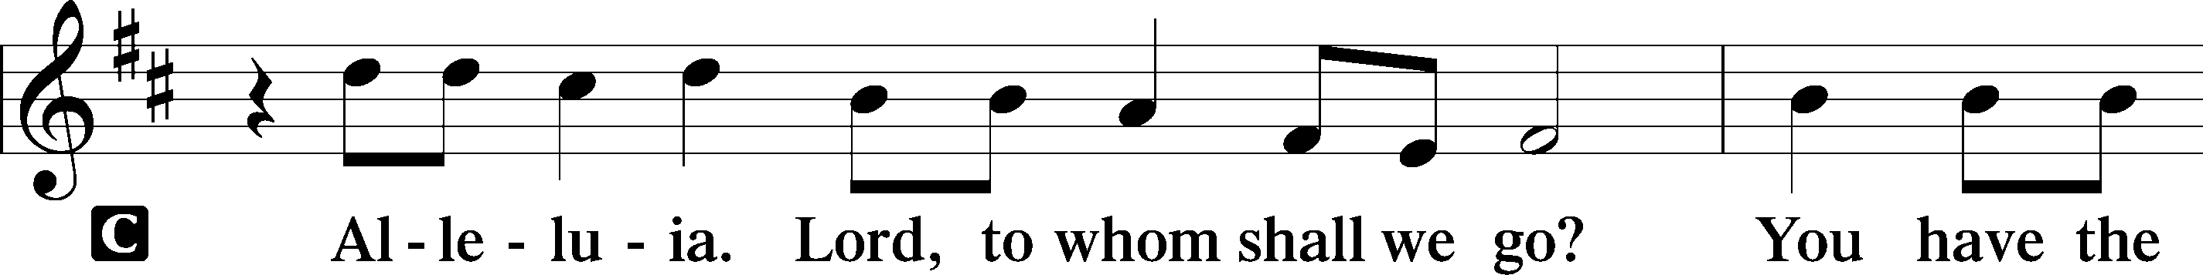
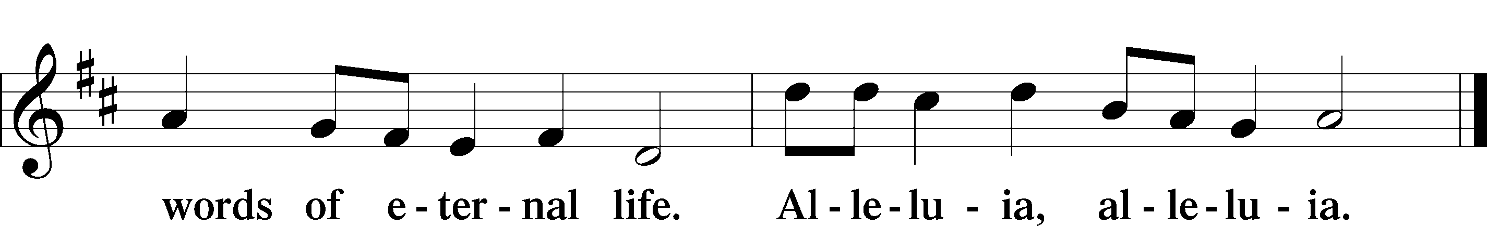

Holy Gospel: John 1:19b–28
P The Holy Gospel according to St. John, the first chapter.
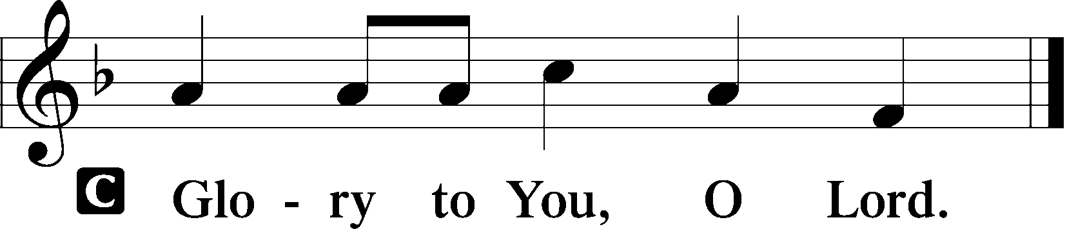

At that time: When the Jews sent priests and Levites from Jerusalem to ask John, “Who are you?” he confessed, and did not deny, but confessed, “I am not the Christ.” And they asked him, “What then? Are you Elijah?” He said, “I am not.” “Are you the Prophet?” And he answered, “No.” Then they said to him, “Who are you, that we may give an answer to those who sent us? What do you say about yourself?” He said: “I am ‘The voice of one crying in the wilderness: “Make straight the way of the Lord,” ’ as the prophet Isaiah said.” Now those who were sent were from the Pharisees. And they asked him, saying, “Why then do you baptize if you are not the Christ, nor Elijah, nor the Prophet?” John answered them, saying, “I baptize with water, but there stands One among you whom you do not know. It is He who, coming after me, is preferred before me, whose sandal strap I am not worthy to loose.” These things were done in Bethabara beyond the Jordan, where John was baptizing.

P This is the Gospel of the Lord.
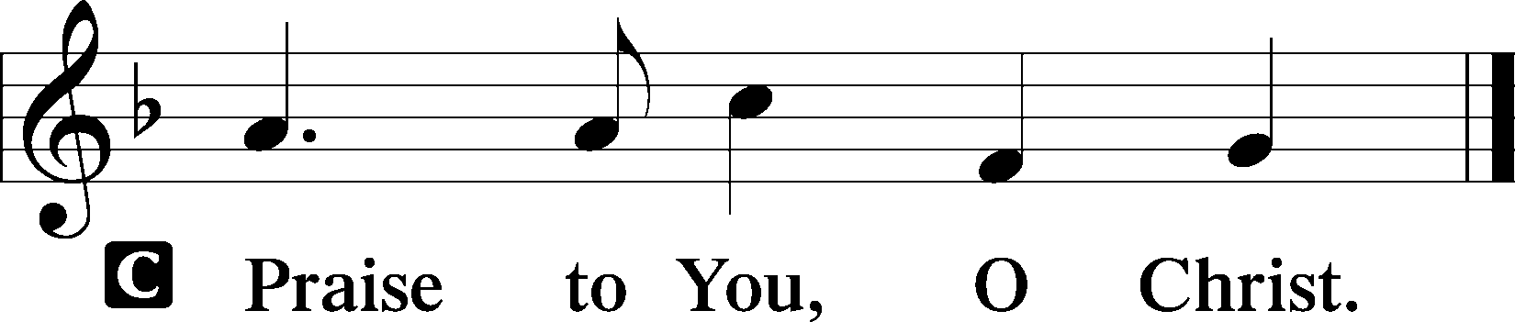

Nicene Creed
C I believe in one God,
the Father Almighty,
maker of heaven and earth
and of all things visible and invisible.

And in one Lord Jesus Christ,
the only-begotten Son of God,
begotten of His Father before all worlds,
God of God, Light of Light,
very God of very God,
begotten, not made,
being of one substance with the Father,
by whom all things were made;
who for us men and for our salvation came down from heaven
and was incarnate by the Holy Spirit of the virgin Mary
and was made man;
and was crucified also for us under Pontius Pilate.
He suffered and was buried.
And the third day He rose again according to the Scriptures
and ascended into heaven
and sits at the right hand of the Father.
And He will come again with glory to judge both the living and the dead,
whose kingdom will have no end.

And I believe in the Holy Spirit,
the Lord and giver of life,
who proceeds from the Father and the Son,
who with the Father and the Son together is worshiped and glorified,
who spoke by the prophets.
And I believe in one holy Christian and apostolic Church,
I acknowledge one Baptism for the remission of sins,
and I look for the resurrection of the dead
and the life T of the world to come. Amen.
Sit

Hymn of the Day: LSB #347 “Comfort, Comfort Ye My People”

Sermon

Stand

Prayer of the Church

Offertory LSB 159
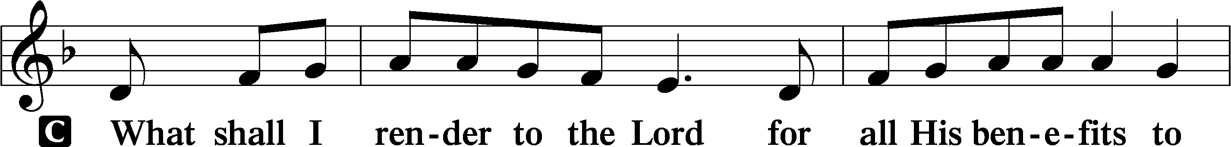
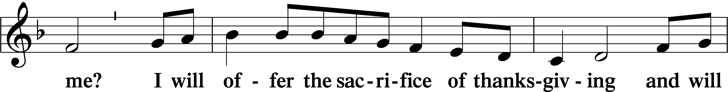
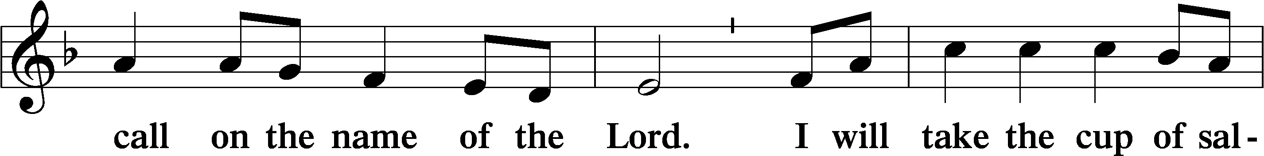
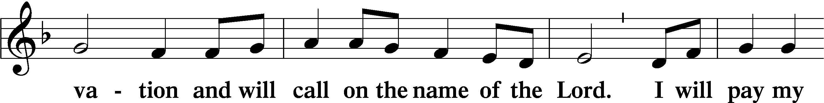
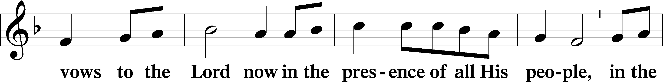
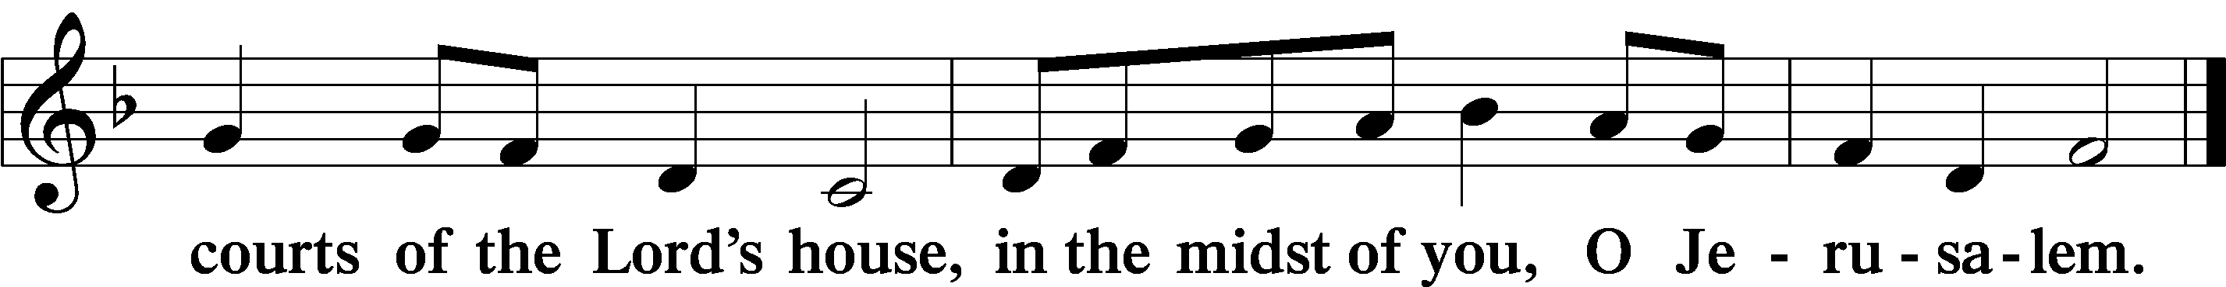

Preparatory Hymn: LSB #357 “O Come, O Come, Emmanuel”

Service of the Sacrament

Preface LSB 160
P The Lord be with you.

P Lift up your hearts.

P Let us give thanks to the Lord our God.
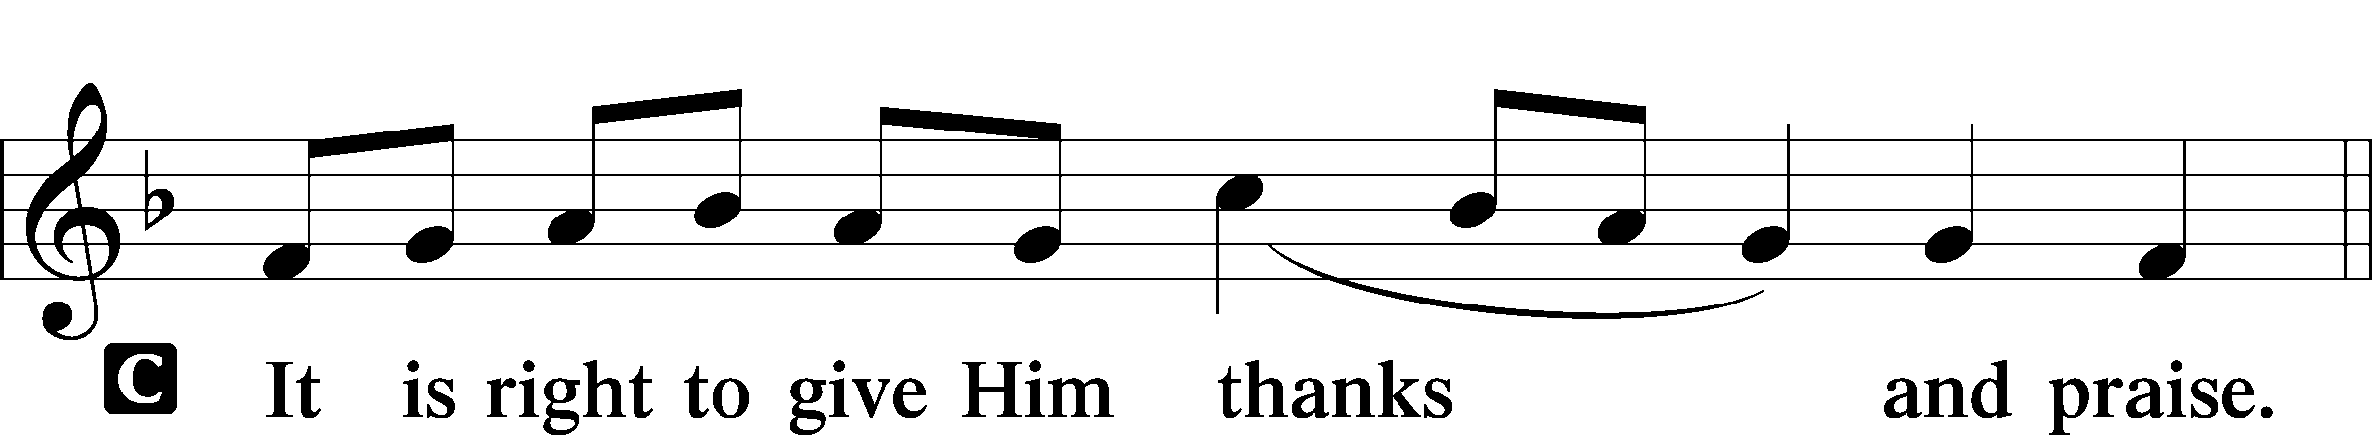

Proper Preface (Abbreviated)
P It is truly good, right, and salutary that we should at all times and in all places give thanks to You, holy Lord, almighty Father, everlasting God, through Jesus Christ, our Lord, … Therefore with angels and archangels and with all the company of heaven we laud and magnify Your glorious name, evermore praising You and saying:

Sanctus LSB 161
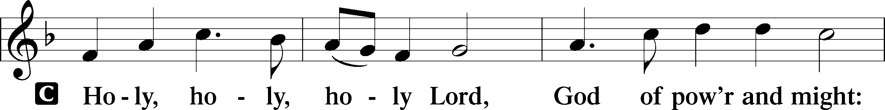
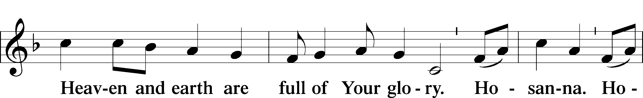
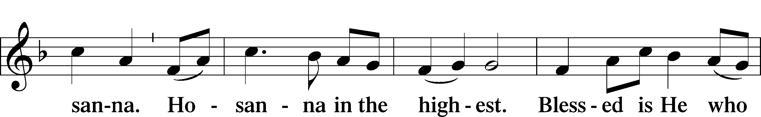
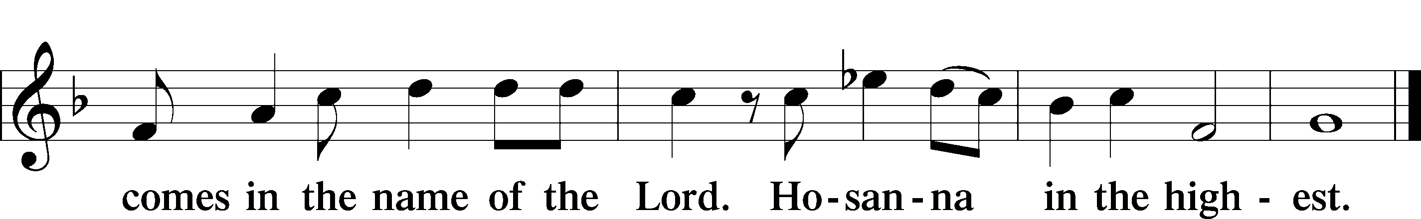

Prayer of Thanksgiving LSB 161
P Blessed are You, Lord of heaven and earth, for You have had mercy on those whom You created and sent Your only-begotten Son into our flesh to bear our sin and be our Savior. With repentant joy we receive the salvation accomplished for us by the all-availing sacrifice of His body and His blood on the cross.

Gathered in the name and the remembrance of Jesus, we beg You, O Lord, to forgive, renew, and strengthen us with Your Word and Spirit. Grant us faithfully to eat His body and drink His blood as He bids us do in His own testament. Gather us together, we pray, from the ends of the earth to celebrate with all the faithful the marriage feast of the Lamb in His kingdom, which has no end. Graciously receive our prayers; deliver and preserve us. To You alone, O Father, be all glory, honor, and worship, with the Son and the Holy Spirit, one God, now and forever.
C Amen.

Lord’s Prayer
C Our Father who art in heaven,
hallowed be Thy name,
Thy kingdom come,
Thy will be done on earth
as it is in heaven;
give us this day our daily bread;
and forgive us our trespasses
as we forgive those
who trespass against us;
and lead us not into temptation,
but deliver us from evil.
For Thine is the kingdom
and the power and the glory
forever and ever. Amen.

The Words of Our Lord Matthew 26:26-28; Mark 14:22-24; Luke 22:19-20; 1 Corinthians 11:23-25
P Our Lord Jesus Christ, on the night when He was betrayed, took bread, and when He had given thanks, He broke it and gave it to the disciples and said: “Take, eat; this is My T body, which is given for you. This do in remembrance of Me.”

In the same way also He took the cup after supper, and when He had given thanks, He gave it to them, saying: “Drink of it, all of you; this cup is the new testament in My T blood, which is shed for you for the forgiveness of sins. This do, as often as you drink it, in remembrance of Me.”

Pax Domini LSB 163
P The peace of the Lord be with you always.

Agnus Dei LSB 163
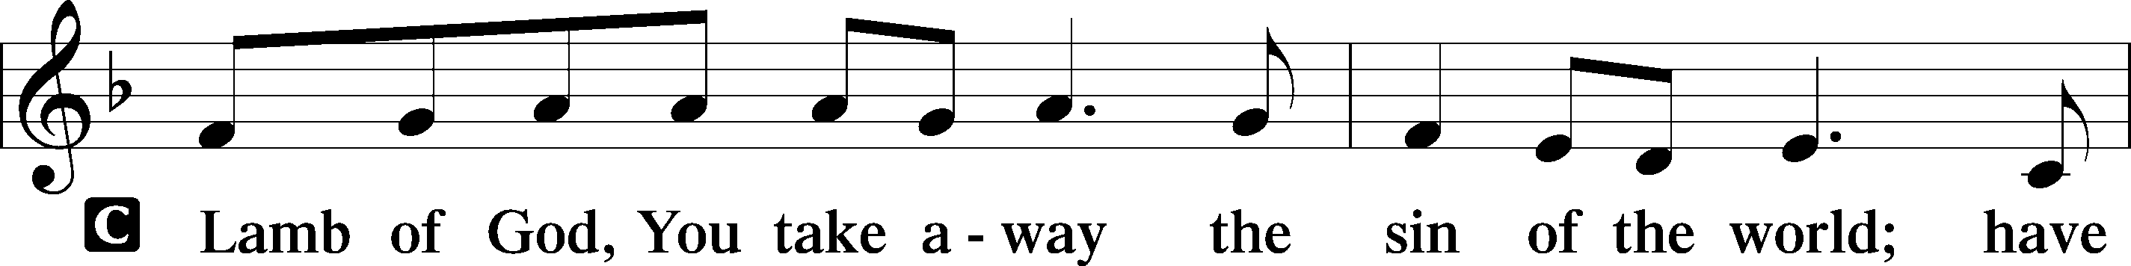
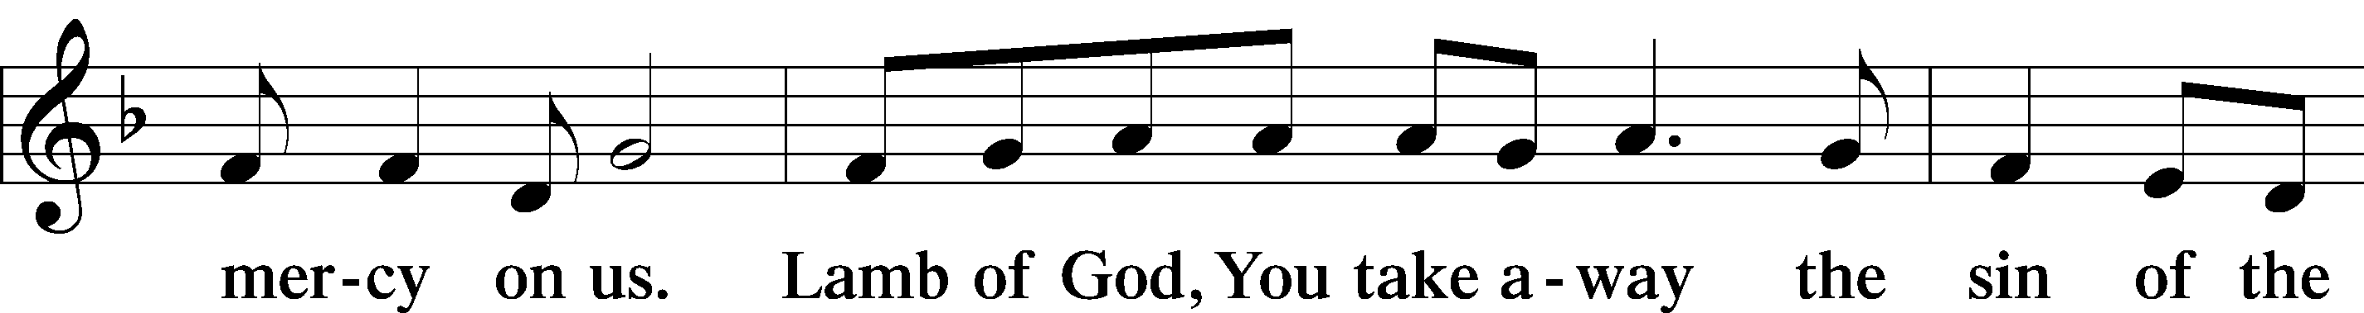
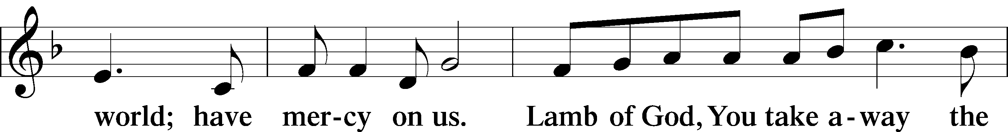
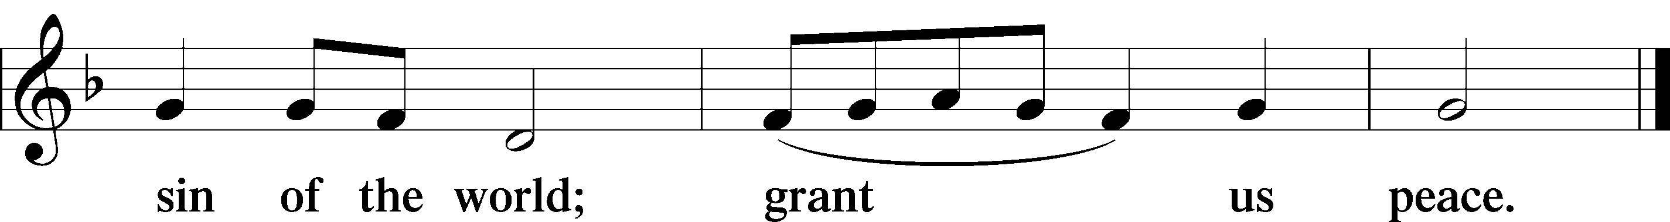
Sit

Distribution
The pastor and those who assist him receive the body and blood of Christ first and then distribute them to those who come to receive, saying:
Take, eat; this is the true body of our Lord and Savior Jesus Christ, given into death for your sins.
Amen.

Take, drink; this is the true blood of our Lord and Savior Jesus Christ, shed for the forgiveness of your sins.
Amen.

In dismissing the communicants, the following is said:
The Dismissal
P The body and blood of our Lord Jesus Christ strengthen and preserve you in body and soul to life everlasting. Depart T in peace.
C Amen.

Distribution Hymn: LSB #803 “Joyful, Joyful We Adore Thee”

Distribution Hymn: LSB #622 “Lord Jesus Christ, You Have Prepared”

Distribution Hymn: LSB #642 “O Living Bread from Heaven”

Stand
Nunc Dimittis LSB 165
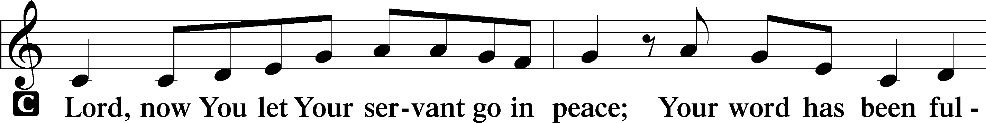
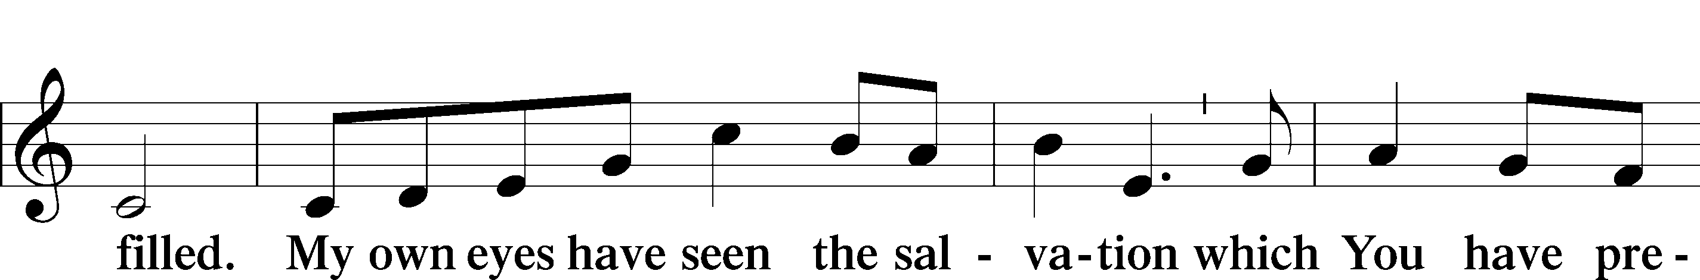
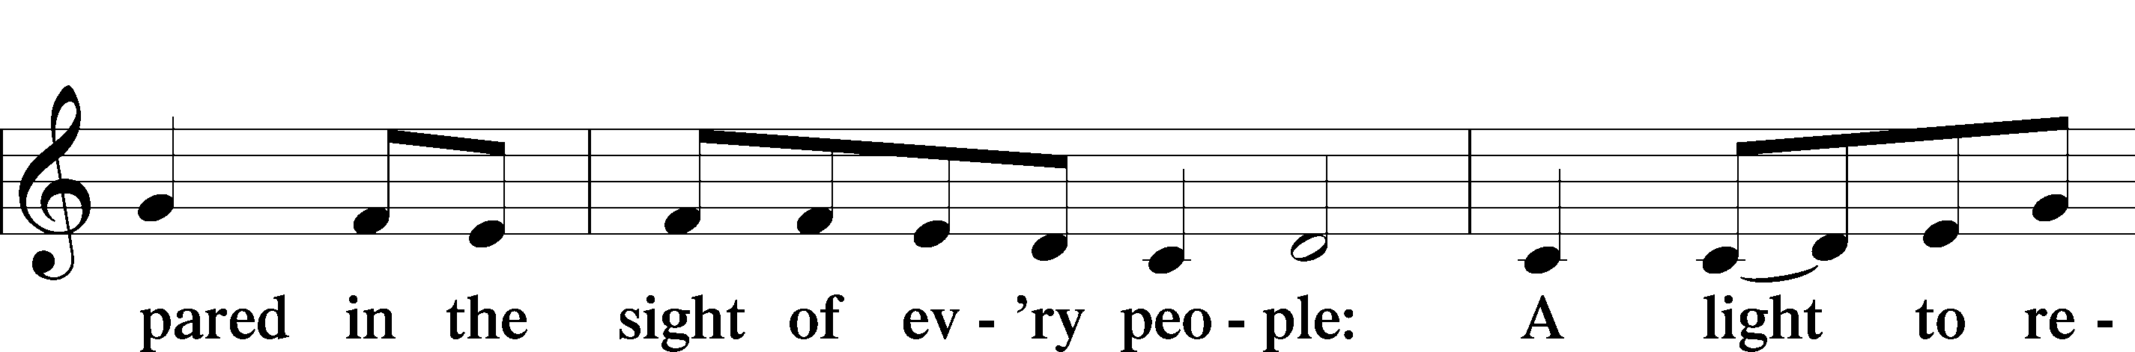
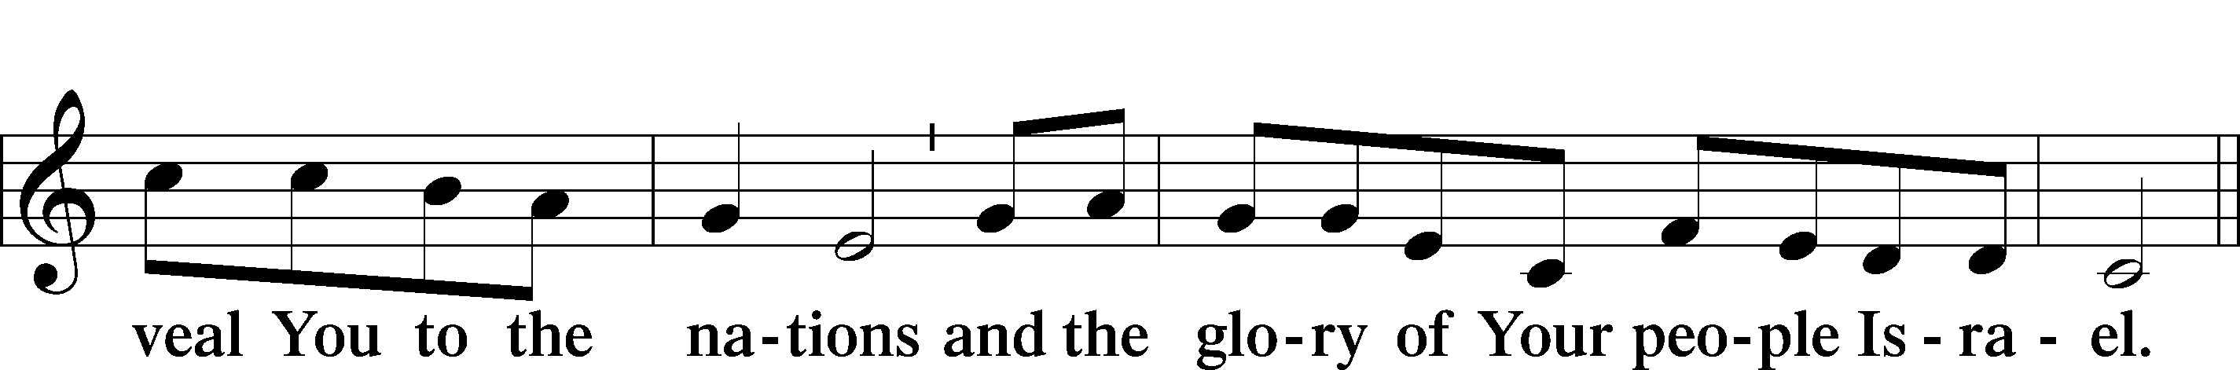
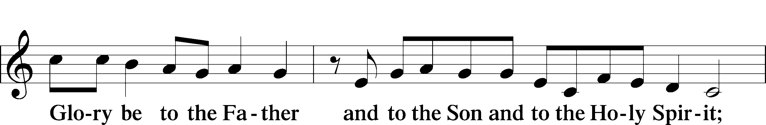
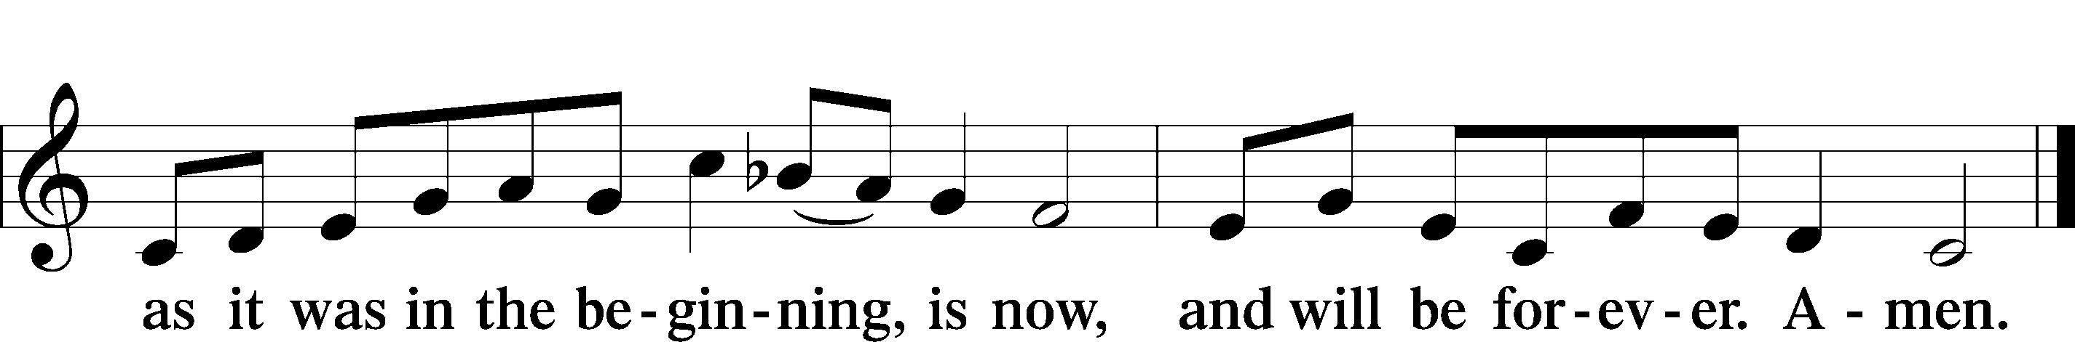
Post-Communion Collect
P Let us pray.
We give thanks to You, almighty God, that You have refreshed us through this salutary gift, and we implore You that of Your mercy You would strengthen us through the same in faith toward You and in fervent love toward one another; through Jesus Christ, Your Son, our Lord, who lives and reigns with You and the Holy Spirit, one God, now and forever.

Benediction LSB 166
P The Lord bless you and keep you.
The Lord make His face shine on you and be gracious to you.
The Lord look upon you with favor and T give you peace.

Closing Hymn: LSB #332 “Savior of the Nations, Come”

Silent prayer after worship: Lord Jesus, let me not forget that You were born to be my Savior so that I can have forgiveness of sins, peace, hope and life everlasting. Fill me with Your love, and lead me to share that love always. Amen.
fffffffffffffffffffffffffffffffffff
Acknowledgments
Unless otherwise indicated, Scripture quotations are from the ESV® Bible (The Holy Bible, English Standard Version®), copyright © 2001 by Crossway, a publishing ministry of Good News Publishers. Used by permission. All rights reserved.
Created by Lutheran Service Builder © 2021 Concordia Publishing House.
fffffffffffffffffffffffffffffffffff
Attendance: Sunday, December 4, 2022: 34
Wednesday, December 7, 2022: 27 (noon: 12; eve: 15)
Sunday, December 11, 2022: 34

fffffffffffffffffffffffffffffffffff
In Loving Memory of Karen Arthur: Gerald Arthur (Major Repairs).
In Loving Memory of Sister, Betty Hardell (December 19, 1945 to August 16, 2021) and Father, Paul Petro (February 25, 1911 to December 22, 2008) and in Honor of Viola Sakony on her 93rd Birthday December 19th: Patty Parker (Capital Campaign).
In Loving Memory of Father, Paul Petro: Michael Petro (Capital Campaign).
fffffffffffffffffffffffffffffffffff
SCHEDULE THROUGH DECEMBER 25, 2022:

:

Today, following Worship: Audit of Deposits
7 pm, Fellowship Hall: AA Meeting
Tuesday, 7-9 pm, Fellowship Hall: Penn-Ohio Singers
Wednesday, Noon, Sanctuary: Advent Service of Morning Prayer
5:30 pm: Sanctuary, Choir Rehearsal
7:00 pm, Sanctuary: Advent Vespers Service
7:30 pm, Downstairs: NA Meeting
Thursday, 9 am, Downstairs: Food Pantry
Saturday, 8 pm, Sanctuary: Christmas Eve Service
Next Sunday, 9 am, Sanctuary: Christmas Day Divine Service
7 pm, Fellowship Hall: AA Meeting
fffffffffffffffffffffffffffffffffff
The 2023 Coffee Fellowship sign-up sheet has been posted on the bulletin board in the narthex along with the 2023 Altar Flower Sponsorship sheet. Consider signing up to be a sponsor!
fffffffffffffffffffffffffffffffffff
THANK YOU FOR SERVING IN DECEMBER: Head Elder: Barry Nelson; Assisting Elder: Jonathan Baisch; Altarware: Marie Flaugher and Altar Guild Volunteers
fffffffffffffffffffffffffffffffffff

Our Stewardship of Treasures for the Lord:
In order to do the Lord’s work, we need $2,462.92 each week to meet our 2022 budget for general purposes and $80.00 for the SELC.
Figures for Wednesday, November 30, 2022
General Fund: $120.00
SELC: $25.00
Figures for Sunday, December 4, 2022:
General Fund: $2,375.15 Ahead for the week*: +$2.23
SELC: $75.00 Ahead for the week*: +$20.00
Food Pantry: $50.00
Quarterly Missions: $1000.00 *Includes above figures.
Capital Campaign: $660.00
Other: $970.00
Online Figures: (12/05, 12/08, & 12/13.22)
General Fund: $6,080.00
SELC: $100.00
Food Pantry: $100.00
Capital Campaign: $200.00
Figures for Wednesday, December 7, 2022
General Fund: $520.00
SELC: $30.00
Quarterly Missions: $250.00
Figures for Sunday, December 11, 2022:
General Fund: $891.00 Ahead for the week*: +$5,028.08
SELC: $65.00 Ahead for the week*: +$115.00
Food Pantry: $80.00
Quarterly Missions: $25.00 *Includes above figures.
Capital Campaign: $320.00
Other: $700.00

For online giving, check out https://www.saintspeterandpaul.net/online-giving.

fffffffffffffffffffffffffffffffffff

Remember the following in Prayer…
~The Hurting and Healing: Friends and Family of Donald C. Riefstahl, brother of Diane, who passed away December 7, 2022; also, Amy, Gerald Arthur, Evelyn Baisch (recovering from surgery), Ellen Baron^{CA}, Lois Bortner^{CA}, John Burdette, Bev & Joe Chlpka, Kathleen Coughenour, Kim, Anna Mae Daris, Susan Davies, Tim Dudash, Joseph Fleet, Eddy Furey, Tim Haenftling, Austin Hamilton, Anson Holcroft, Neil Huston, Darla Krajci, Barbara Kreske, Michelle Kelly^{CA}, Donna Kennedy, Gerald Krivosh, Jess Lavoie, Paul Lucas^{CA}, Sandy Marshall, Ernie Meszaros, David Nelson, Linda Parkany, Juanita Rentschler, Richard Reuning^{CA}, Nancy Robertson^{CA}, Viola Sakony, Marty Scott, Kara, Fred Tonty, Angela Weser^{CA}, and Ruth Wolf.
~The Homebound: Rudy & Jean Tomko, Betty Wolf, and Ed & Millie Zachar.
~Celebrating: Birthdays: Rebekah Baisch (12.13), Rev. Ed Kucera (12.13), Joan Rice (12.16), Bill Wolf (12.16), Debbie Zurawsky (12.17), Viola Sakony (12.19), and Titus Deal (12.23). Anniversary: Anson & Hank Holcroft (12.18).
~Serving in the Military: Curtis Sinewe and Joshua Solyan.
~Community & World Needs: Those suffering from or affected by the coronavirus; those suffering due to the conflict between Ukraine and Russia; those suffering from loss and dislocation because weather disasters; those suffering from addiction and their families; Local, State, and National Government Leaders; safety for all Police Officers, Firefighters, & First Responders; the unemployed; our Fourth Quarter Local Mission: Willow Women’s Center *CA represents cancer.
fffffffffffffffffffffffffffffffffff
Bible Memory Verses ~ Week of December 11th:
For Adults: For by grace you have been saved through faith. And this is not your own doing; it is the gift of God, not a result of works, so that no one may boast.
Ephesians 2:8-9
For Children: Prepare the way of the Lord; behold, the Lord God comes with might. Isaiah 40:3, 10
Bible Memory Verses ~ Week of December 18th:
For Adults: Therefore, if anyone is in Christ, he is a new creation. The old has passed away; behold, the new has come. 2 Corinthians 5:17
For Children: My soul magnifies the Lord, and my spirit rejoices in God my Savior.
Luke 1:46-47
Auditors will meet following worship this morning for a monthly audit of deposits.
fffffffffffffffffffffffffffffffffff
This season’s final Midweek Advent Services will be held Wednesday at noon and 7 pm. Please join us as we prepare to “Come and See”.
fffffffffffffffffffffffffffffffffff

ADDITIONAL UP-COMING SERVICES

Christmas Eve Service of Lessons and Carols
Saturday, December 24, 2022 at 8 pm

Christmas Day Divine Service
Sunday, December 25, 2022 at 9 am
No Bible Study that morning.

Festival of St. Stephen, Martyr
Monday, December 26, 2022 at 7 pm
Vespers Service

Festival of St. John, Apostle & Evangelist
Tuesday, December 27, 2022 at 7 pm
Vespers Service

Festival of the Holy Innocents, Martyrs
Wednesday, December 28, 2022 at 7 pm
Vespers Service

New Year’s Eve Service
Saturday, December 3`, 2022 at 4 pm
Vespers Service

fffffffffffffffffffffffffffffffffff

Here to Serve

Pastor………………………………………………...……………Rev. Jacob Deal
E-mail …………………………….……pastordeal@saintspeterandpaul.net
Phone Number……………………..…………………724-347-3620 (Option 2)
Church Office………………………..…………………724-347-3620 (Option 3)
Website …………………………………………www.saintspeterandpaul.net
Secretary…………………………………………………………Diane Riefstahl
E-mail ………………………………………church@saintspeterandpaul.net
Website …………………………………………www.saintspeterandpaul.net
Food Pantry: Please leave message……………724-347-3620 (Option 3)
AA Contact: Steve………………………………………………..…724-813-2358
NA Contact: Larry………………………………………………..724-977-8733
Choir Director………………………………………………………Chris Nelson
Congregation President……………………………………Jonathan Baisch
Elder Chairman…………………………………………...………Barry Nelson
fffffffffffffffffffffffffffffffffff
If needing to get into the church building during the week, please phone first to make certain someone is here to let you in.

