Sts. Peter & Paul
Evangelical Lutheran Church
Lutheran Church-Missouri Synod
Founded-1917

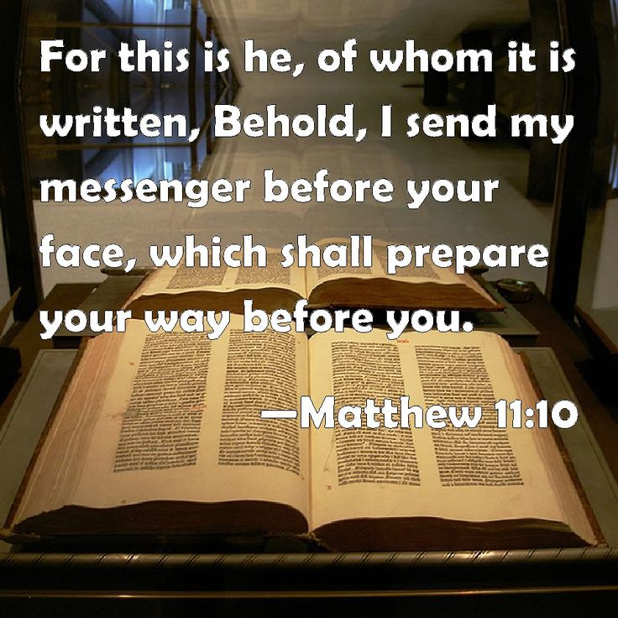
DECEMBER 16, 2018

699 Stambaugh Avenue
Sharon, Pennsylvania 16146

“I was glad when they said to me,
Let us go to the house of the LORD!”
Psalm 122:1
Sts. Peter & Paul Evangelical Lutheran Church, LC-MS

GAUDETE
December 16, 2018

Silent prayer before worship: Lord Jesus, You came as the Wonderful Counselor, Mighty God, Everlasting Father, and Prince of Peace. Lead me to read and study the Scriptures, that You may bless me with Your counsel, strength, love, and peace. Amen.
CONFESSION AND ABSOLUTION
Opening Hymn: LSB #346 “When All the World Was Cursed”
Stand

The sign of the cross may be made by all in remembrance of their Baptism.

P In the name of the Father and of the T Son and of the Holy Spirit.
C Amen. Matthew 28: 19b; (18:20)

P Beloved in the Lord! Let us draw near with a true heart and confess our sins unto God our Father, beseeching Him in the name of our Lord Jesus Christ to grant us forgiveness. [Hebrews 10:22]

P Our help is in the name of the Lord,
C who made heaven and earth. Psalm 124: 8
P I said, I will confess my transgressions unto the Lord,
C and You forgave the iniquity of my sin. Psalm 32: 5

Silence for reflection on God's Word and for self-examination.

P O almighty God, merciful Father,
C I, a poor, miserable sinner, confess unto You all my sins and iniquities with which I have ever offended You and justly deserved Your temporal and eternal punishment. But I am heartily sorry for them and sincerely repent of them, and I pray You of Your boundless mercy and for the sake of the holy, innocent, bitter sufferings and death of Your beloved Son, Jesus Christ, to be gracious and merciful to me, a poor, sinful being.

P Upon this your confession, I, by virtue of my office, as a called and ordained servant of the Word, announce the grace of God unto all of you, and in the stead and by the command of my Lord Jesus Christ I forgive you all your sins in the name of the Father and of the T Son and of the Holy Spirit.
[John 20: 19-23]
C Amen.

Passing of the Peace.
SERVICE OF THE WORD
Introit: Ps. 85:1–2, 6, 8; antiphon: Phil. 4:4–5
Rejoice in the Lord | always;*
again I will | say, Rejoice.
Let your reasonableness be known to | everyone.*
The Lord | is at hand.
Lord, you were favorable | to your land;*
you restored the fortunes of | Jacob.
You forgave the iniquity of your | people;*
you covered | all their sin.
Will you not revive | us again,*
that your people may re- | joice in you?
Let me hear what God the | Lord will speak,*
for he will speak peace to his people, to his saints; but let them not turn back to | folly.

Gloria Patri
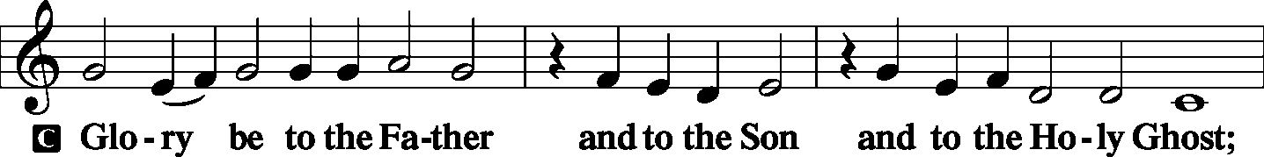
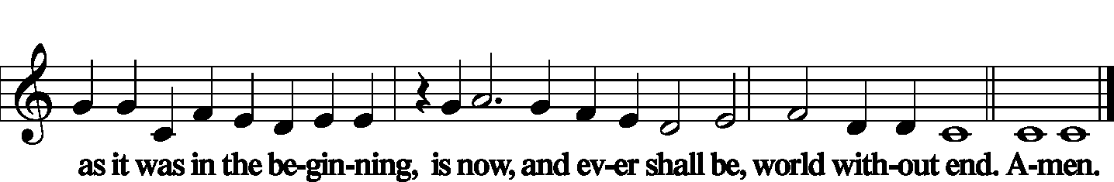

Kyrie Mark 10:47
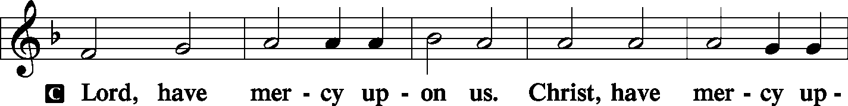
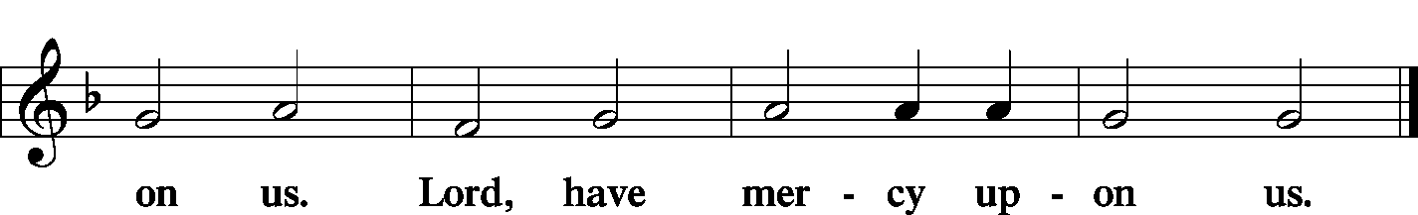

Salutation and Collect of the Day
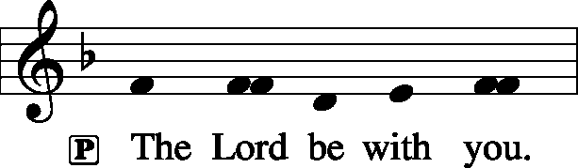 2 Timothy 4: 22
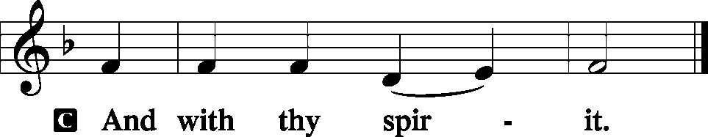

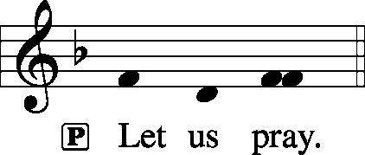

P Lord Jesus Christ, we implore You to hear our prayers and to lighten the darkness of our hearts by Your gracious visitation; for You live and reign with the Father and the Holy Spirit, one God, now and forever.
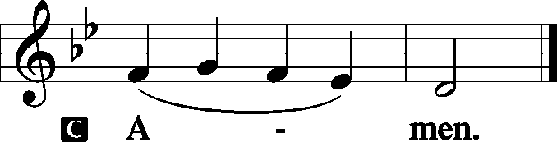

Sit

Old Testament Reading: Isaiah 40:1–8
Comfort, comfort my people, says your God.
Speak tenderly to Jerusalem,
and cry to her
that her warfare is ended,
that her iniquity is pardoned,
that she has received from the Lord’s hand
double for all her sins.
A voice cries:
“In the wilderness prepare the way of the Lord;
make straight in the desert a highway for our God.
Every valley shall be lifted up,
and every mountain and hill be made low;
the uneven ground shall become level,
and the rough places a plain.
And the glory of the Lord shall be revealed,
and all flesh shall see it together,
for the mouth of the Lord has spoken.”
A voice says, “Cry!”
And I said, “What shall I cry?”
All flesh is grass,
and all its beauty is like the flower of the field.
The grass withers, the flower fades
when the breath of the Lord blows on it;
surely the people are grass.
The grass withers, the flower fades,
but the word of our God will stand forever.

P This is the Word of the Lord.
C Thanks be to God.
Gradual: Ps. 80:1–2
You who are enthroned upon the cherubim, shine forth.
Stir up your might and come to save us!
Give ear, O Shepherd of Israel,
you who lead Joseph like a flock!

Epistle: 1 Corinthians 4:1–5
This is how one should regard us, as servants of Christ and stewards of the mysteries of God. Moreover, it is required of stewards that they be found trustworthy. But with me it is a very small thing that I should be judged by you or by any human court. In fact, I do not even judge myself. I am not aware of anything against myself, but I am not thereby acquitted. It is the Lord who judges me. Therefore do not pronounce judgment before the time, before the Lord comes, who will bring to light the things now hidden in darkness and will disclose the purposes of the heart. Then each one will receive his commendation from God.

P This is the Word of the Lord.
C Thanks be to God.

Stand
Alleluia Verse and Alleluia
P Alleluia. Stir up your might and come to save us. Alleluia.

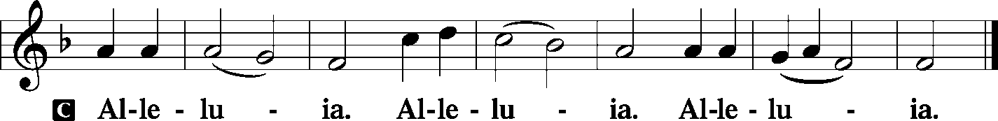

Holy Gospel: Matthew 11:2–10
P The Holy Gospel according to St. Matthew, the eleventh chapter.

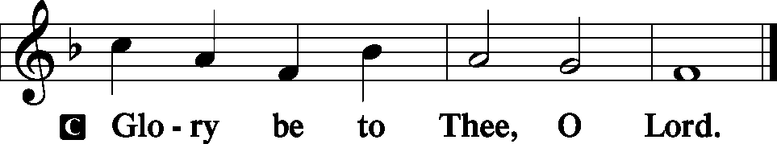

Now when John heard in prison about the deeds of the Christ, he sent word by his disciples and said to him, “Are you the one who is to come, or shall we look for another?” And Jesus answered them, “Go and tell John what you hear and see: the blind receive their sight and the lame walk, lepers are cleansed and the deaf hear, and the dead are raised up, and the poor have good news preached to them. And blessed is the one who is not offended by me.”
As they went away, Jesus began to speak to the crowds concerning John: “What did you go out into the wilderness to see? A reed shaken by the wind? What then did you go out to see? A man dressed in soft clothing? Behold, those who wear soft clothing are in kings’ houses. What then did you go out to see? A prophet? Yes, I tell you, and more than a prophet. This is he of whom it is written,
“‘Behold, I send my messenger before your face,
who will prepare your way before you.’
P This is the Gospel of the Lord.

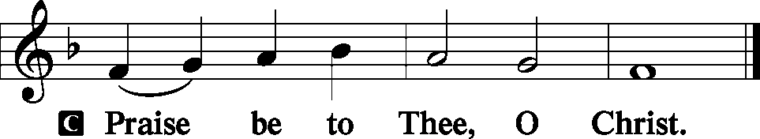

Nicene Creed
C I believe in one God,
the Father Almighty,
maker of heaven and earth
and of all things visible and invisible.
And in one Lord Jesus Christ,
the only-begotten Son of God,
begotten of His Father before all worlds,
God of God, Light of Light,
very God of very God,
begotten, not made,
being of one substance with the Father,
by whom all things were made;
who for us men and for our salvation came down from heaven
and was incarnate by the Holy Spirit of the virgin Mary
and was made man;
and was crucified also for us under Pontius Pilate.
He suffered and was buried.
And the third day He rose again according to the Scriptures
and ascended into heaven
and sits at the right hand of the Father.
And He will come again with glory to judge both the living and the dead,
whose kingdom will have no end.

And I believe in the Holy Spirit,
the Lord and giver of life,
who proceeds from the Father and the Son,
who with the Father and the Son together is worshiped and glorified,
who spoke by the prophets.
And I believe in one holy Christian and apostolic Church,
I acknowledge one Baptism for the remission of sins,
and I look for the resurrection of the dead
and the life T of the world to come. Amen.
Sit

Hymn of the Day: LSB #345 “Hark! A Thrilling Voice Is Sounding”

Sermon
Stand

P The peace of God, which passes all understanding, keep your hearts and minds in Christ Jesus. Philippians 4: 7
C Amen.

Prayer of the Church [Timothy 2: 1-4]
Sit

Offertory Psalm 51: 10-12
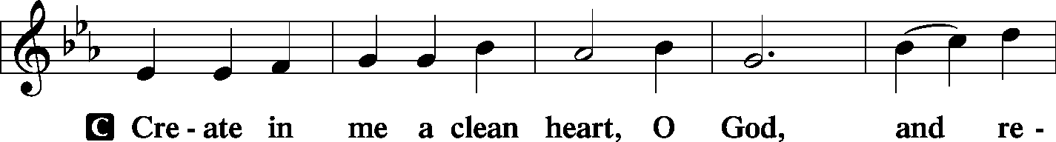
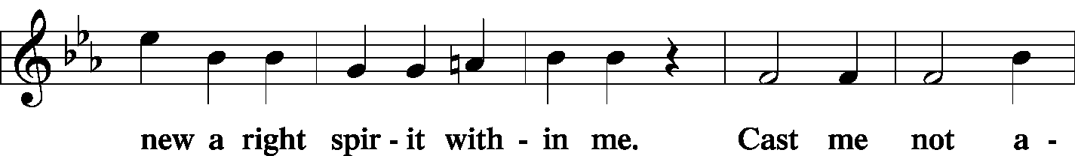
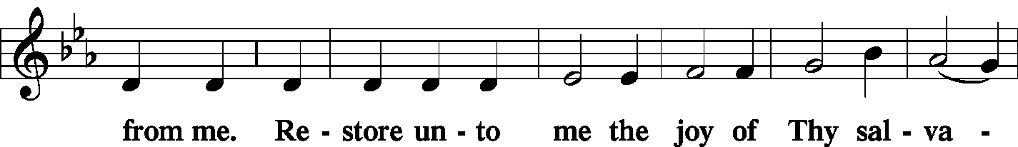
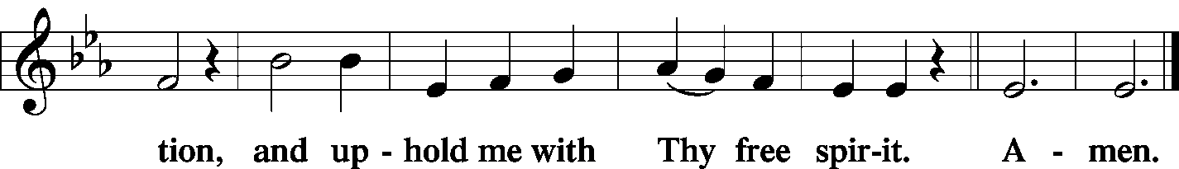

Offering/Offering Hymn: LSB #333 “Once He Came in Blessing”
Stand
SERVICE OF THE SACRAMENT
Preface
2 Timothy 4: 22
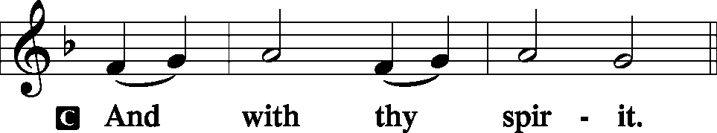
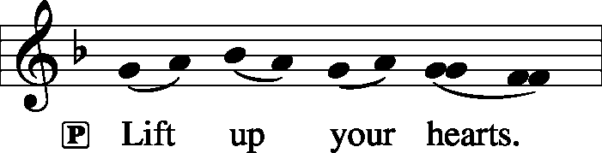 [Colossians 3:1]

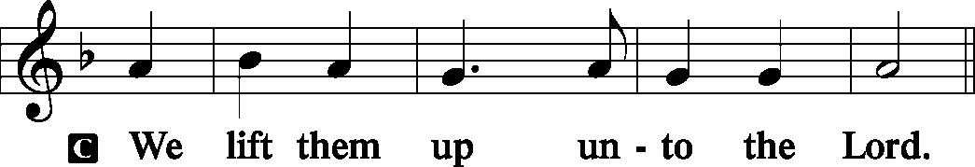

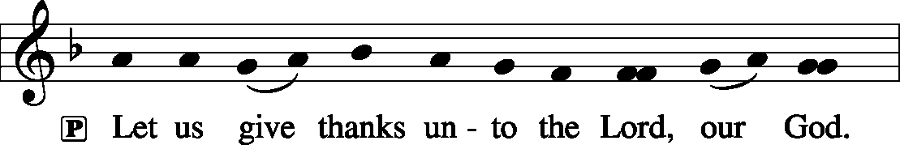 [Psalm 136]

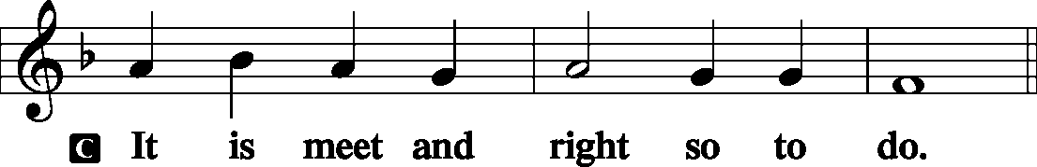

P It is truly meet, right, and salutary . . . evermore praising You and saying:
Sanctus Isaiah 6: 3; Matthew 21: 9
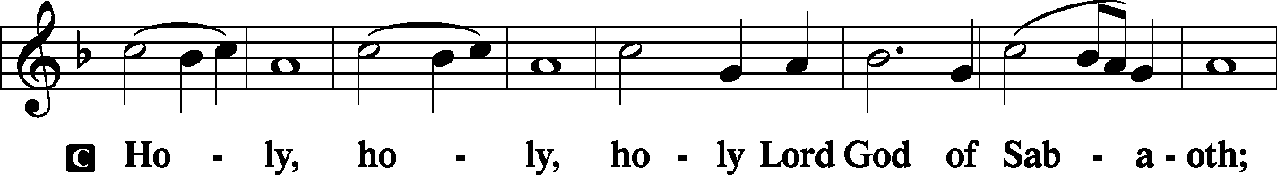
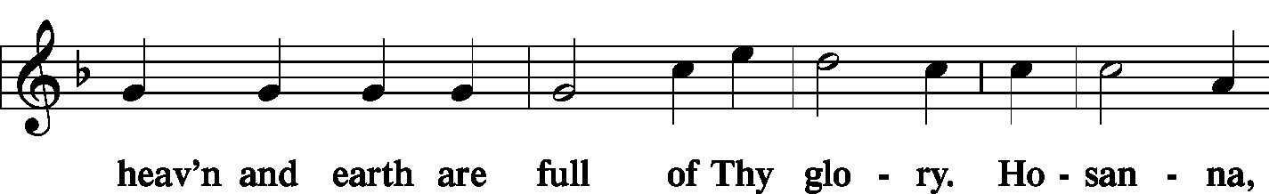
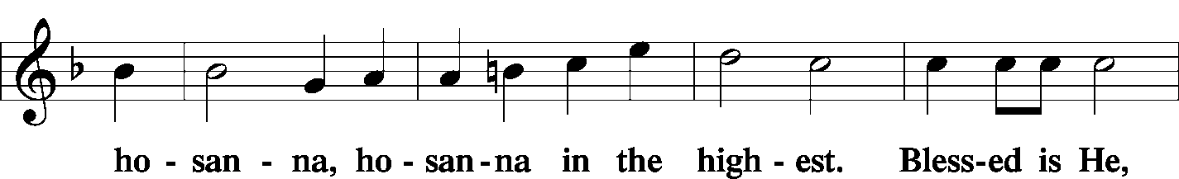
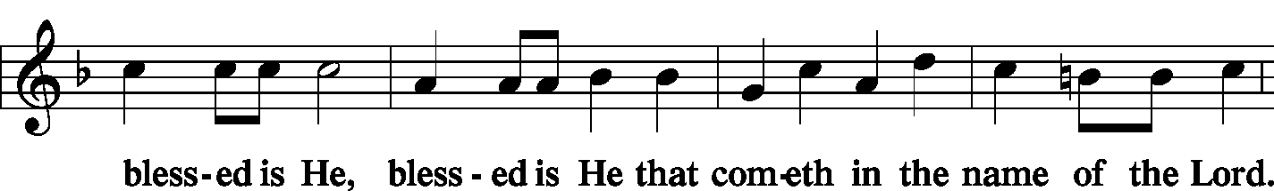
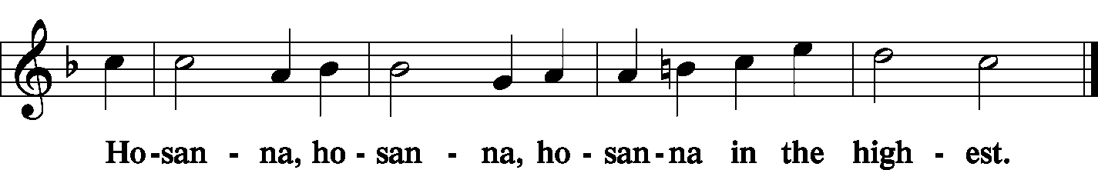

Lord's Prayer Matthew 6: 9-13
P Lord, remember us in Your kingdom and teach us to pray:
C Our Father who art in heaven,
hallowed be Thy name,
Thy kingdom come,
Thy will be done on earth as it is in heaven;
give us this day our daily bread;
and forgive us our trespasses as we forgive those who trespass against us;
and lead us not into temptation,
but deliver us from evil.
For Thine is the kingdom and the power and the glory forever and ever. Amen.

The Words of Our Lord Matthew 26: 26-28; Mark 14: 22-24
Luke 22: 19-20; 1 Corinthians 11: 23-25
P Our Lord Jesus Christ, on the night when He was betrayed, took bread, and when He had given thanks, He broke it and gave it to the disciples and said: “Take, eat; this is My T body, which is given for you. This do in remembrance of Me.”

P In the same way also He took the cup after supper, and when He had given thanks, He gave it to them, saying: “Drink of it, all of you; this cup is the new testament in My T blood, which is shed for you for the forgiveness of sins. This do, as often as you drink it, in remembrance of Me.”
Pax Domini John 20: 19
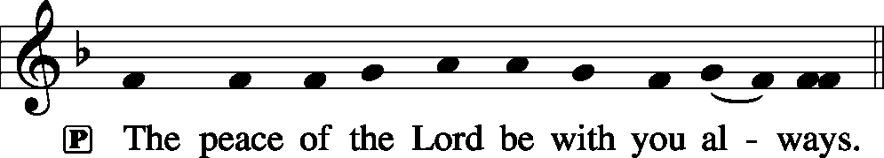

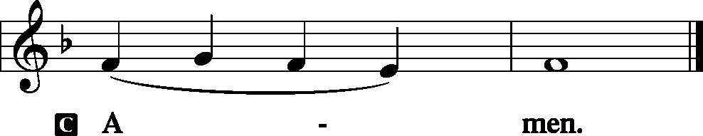

Agnus Dei John 1: 29
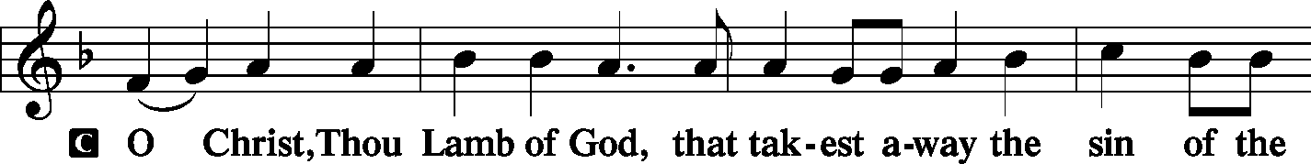
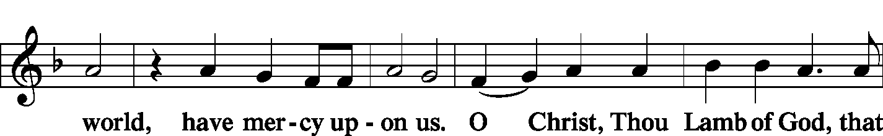
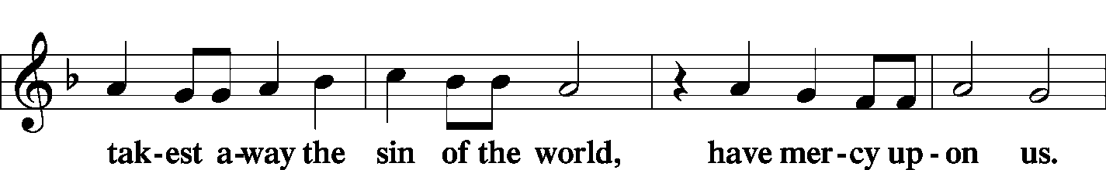
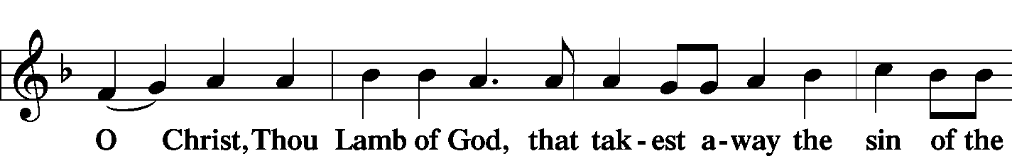
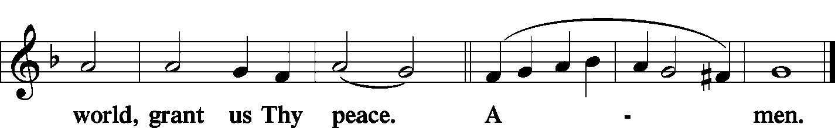
Sit

Distribution
The pastor and those who assist him receive the body and blood of Christ first and then distribute them to those who come to receive, saying:

Take, eat; this is the true body of our Lord and Savior Jesus Christ, given into death for your sins.
Amen.

Take, drink; this is the true blood of our Lord and Savior Jesus Christ, shed for the forgiveness of your sins.
Amen.

In dismissing the communicants, the following is said:
P The body and blood of our Lord Jesus Christ strengthen and preserve you in body and soul to life everlasting. Depart T in peace.
C Amen.

Distribution Hymn: LSB #354 “Arise, O Christian People”
Stand

Post-Communion Canticle: Nunc Dimittis Luke 2: 29-32
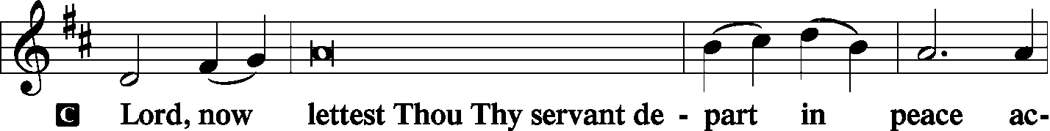
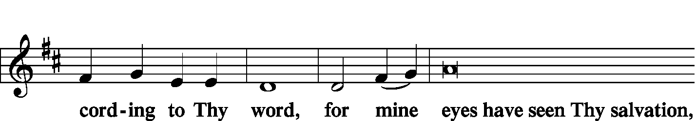
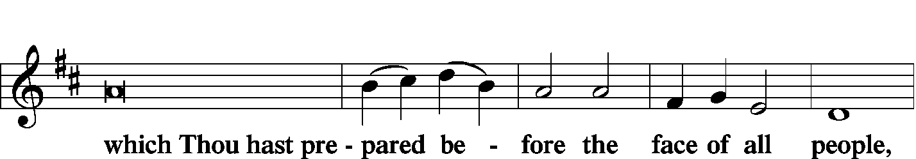
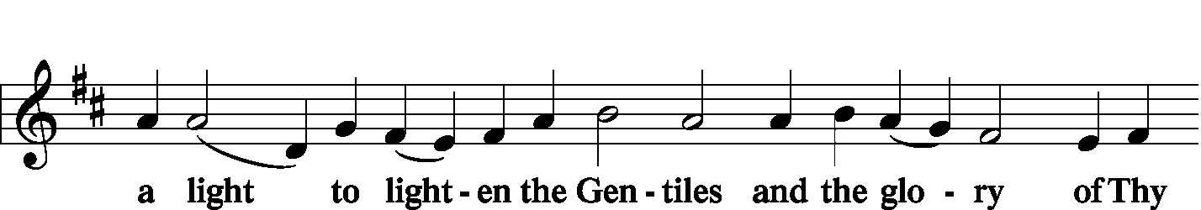
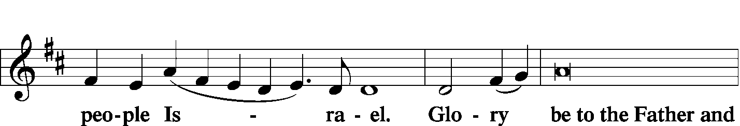
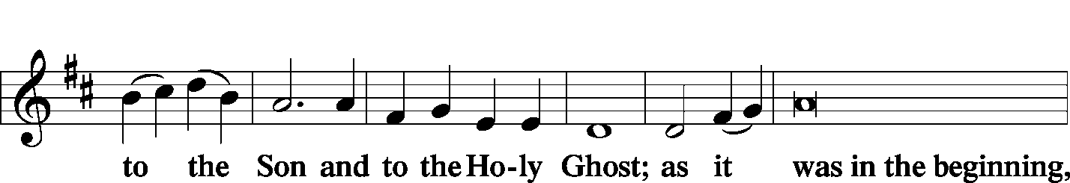
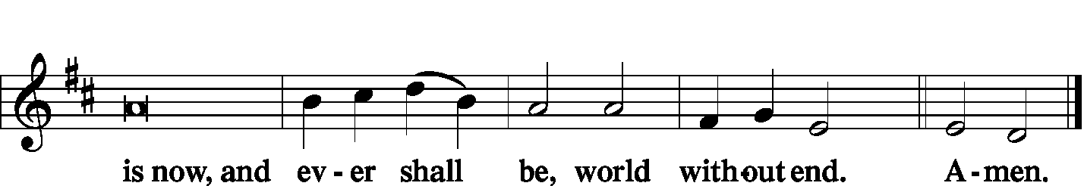

Thanksgiving Psalm 107: 1
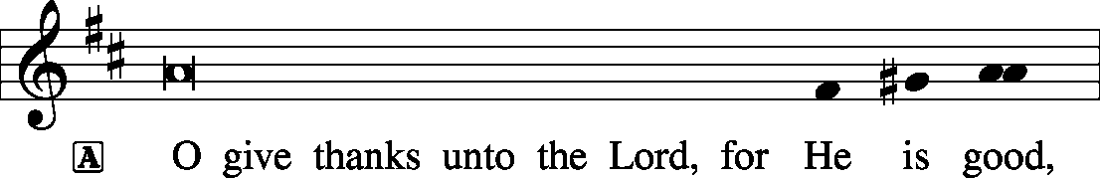
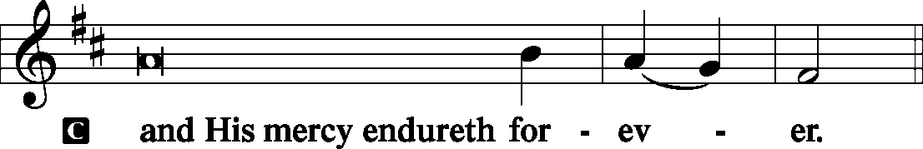

P Let us pray.
We give thanks to You, almighty God, that You have refreshed us through this salutary gift, and we implore You that of Your mercy You would strengthen us through the same in faith toward You and fervent love toward one another; through Jesus Christ, Your Son, our Lord, who lives and reigns with You and the Holy Spirit, one God, now and forever.
Salutation and Benedicamus
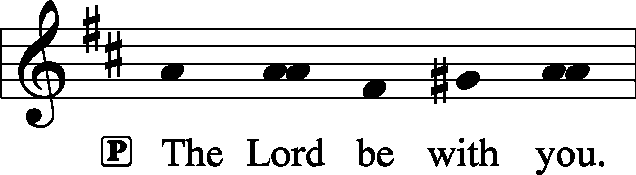 2 Timothy 4: 22

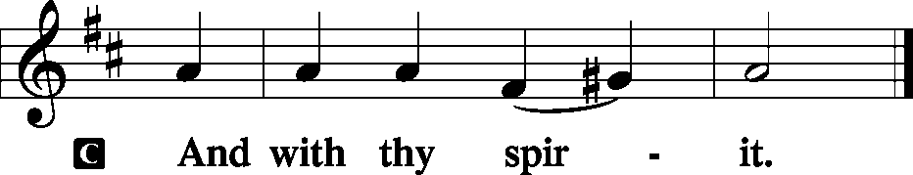
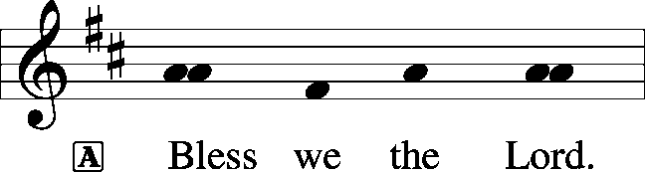 [Psalm 103: 1]

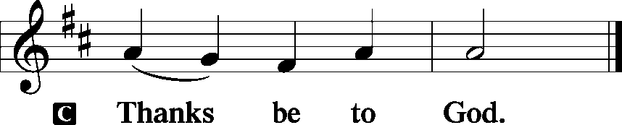

Benediction Numbers 6: 24-26
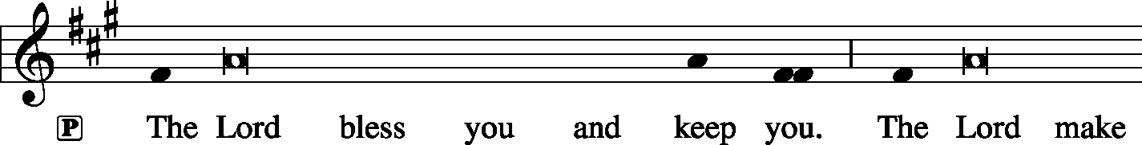
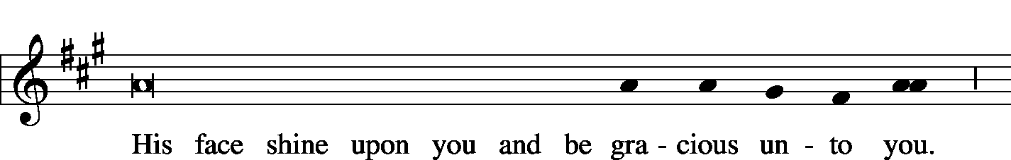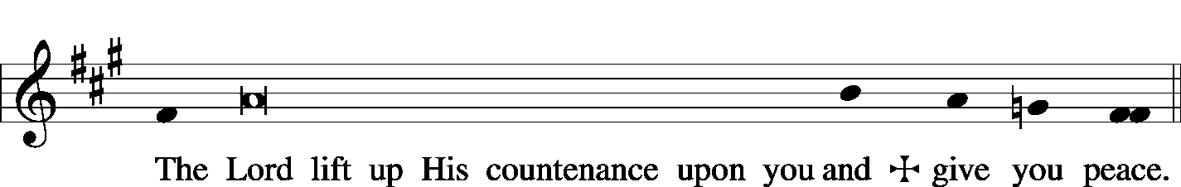

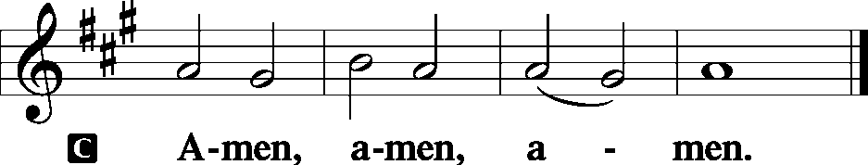

Closing Hymn: LSB #737 “Rejoice, My Heart, Be Glad and Sing”
Silent prayer after worship: Almighty God, be with me and be near me always. Bless me with the Holy Spirit, who works through Your Word, so that the true spirit of Christmas may fill me and show itself in my life. In Jesus’ name. Amen.

Acknowledgments: Divine Service, Setting Three from Lutheran Service Book Unless otherwise indicated, all scripture quotations are from The Holy Bible, English Standard Version, copyright © 2001 by Crossway Bibles, a division of Good News Publishers. Used by permission. All rights reserved. Created by Lutheran Service Builder © 2006 Concordia Publishing House. CCLI License #3029-446


In Loving Memory of Mother, Matilda Weisenborn: Martin & Marilyn Weisenborn.
In Loving Memory of Dennis Gabriel, Anne Gabriel, Frank Gabriel: Liz Shreffler, Elizabeth Campbell & Family.
In Honor of Rev. Kucera’s 90th Birthday: Diane Riefstahl (Food Pantry).
In Remembrance of Our Wedding Anniversary December 18th: Anson & Hank Holcroft.
SCHEDULE FOR TODAY THROUGH DEC. 23rd:
:

:

Today, following Worship, Downstairs……….…Light Lunch & Christmas Caroling
7 pm, Downstairs….…………………..….……………………………..…..……AA Meeting
Monday, 6:30 pm………………………………………………….…Preschool Christmas Program
Wednesday, noon & 7 pm, Sanctuary…………………..………..Mid-week Advent Service
Next Sunday, 8:45 am, Downstairs………………………….…………….…………….Bible Study
10 am, Sanctuary…......................................................................Divine Service
7 pm, Downstairs………………………………………………………..…....……AA Meeting

Word of Hope: 1-888-217-8679
The only 24/7 CONFIDENTIAL Hotline that is distinctly Lutheran, bringing healing found in Christ, to those whose hearts have been broken by abortion.

Thank You for Serving in December:
Today’s Greeters: Cheryl Fedele & Clara Krivosh. Assisting Elders: Ralph Dorman & John Dyll. Ushers: John Dyll, Ed Zachar, Barry Nelson, Jerome Thomas, Gary Burns. Altarware: Cheryl Fedele & Traudi Sulek.
December Greeters: 23~Matt & Cathy Berent; 24~Anson & Henrietta Holcroft;
25~Dolores Fee & Diane Riefstahl; 30~Jeff & Stacy Brandes; 31~Gary & Eileen Burns.

Attendance:
Sunday, December 9, 2018…………………………………………………………48
Advent, Midweek Service, Wednesday, December 12, 2018…………… 7 pm: 22

Sincere thanks are extended to those who assisted with the decoration of the church and church property yesterday. A very special thanks goes out to our anonymous donors for their generous donation of artificial Christmas trees which now adorn our sanctuary.
Also, many thanks to those who helped clean up from last Sunday’s luncheon.
Remember the following in Prayer…
~The Hurting and Healing: Tony³, Lois Bortner^{CA}, Jeff Brandes², Richard Brandes², Eileen Burns², Ed Colt¹, John Dyll², Norma Ferringer⁴, Anson Holcroft³, Betty Knauff^{CA}, Regis Knauff³, Jess Lavoie², Paul Lucas^{CA}, Barry Nelson⁴, David Nelson⁴,Tom Mulligan^{CA}, Iona Oltman^{CA}, Rudy Pinal^{CA}, Richard Reuning^{CA}, Viola Sakony¹, Scott^{CA}, and Angela Weser^{CA}.
~Our Homebound: Helen Bender, Dan Davis, Edna Krajci, Mary Ann Krajci, Sophie Mihm, Marion & Gene Roberts, Barbara Vasconi, and Joanne Wolfe.
~Those Celebrating: Birthdays~Joan Rice (12.16); Bill Wolf (12.16); Debbie Zurawsky (12.17); Viola Sakony (12.19); Robin Hawthorne (12.22). Anniversary~Anson & Henrietta Holcroft (12.18).
~Serving in the Military: Clayton Drnek, Curtis Sinewe, and Joshua Solyan.
~Community & World Needs: Victims of violence and terrorism; those suffering from loss and dislocation because weather disasters; those suffering from addiction and their families; safety for teachers, staff, and students; Local, State, and National Government Leaders; Safety for all Police Officers, Firefighters, & First Responders; the unemployed; our Fourth Quarter Local Mission: Willow Women’s Center.
*CA represents cancer; number after other names represents weeks on the prayer list. After 4 weeks names may be resubmitted. This helps us to remember people’s specific needs and reminds us that God is providing healing as people get better and no longer need our prayers. Please submit prayer requests in writing to the church office.
Please keep those listed above in your prayers.

Our Stewardship of Treasures for the Lord:
In order to do the Lord’s work, we need $2,843.00* each week to meet our 2018 budget for general purposes and $99.00 for missions.
Sunday, December 9, 2018:
General Offering:…..…..………...................................................$1,977.00
Behind this week*^: -$41.00
SELC Missions:……….………..…..…….............................................$65.00
Behind this week: ^ -$14.00
Preschool Tuition Payments…………………….............................…$615.00
Other Offerings:………….…….…….....................………..…………$167.00
Wednesday, December 5, 2018:
General Offering:…..…..………......................................................$210.00
SELC Missions:……….………..…..…….............................................$20.00

*Includes preschool tuition; ^Includes Wednesday’s figures.

Those participating in caroling to our shut-ins this afteroon are asked to join us downstairs following worship for a light luncheon. We hope to leave to begin caroling within the half hour.

Bible Memory Verses:
For Children: Prepare the way of the Lord; behold, the Lord God comes with might.
Isaiah 40:3, 10
For Adults: For by grace you have been saved through faith. And this is not your own doing; it is the gift of God, not a result of works, so that no one may boast.
Ephesians 2:8-9

Mid-week Advent Services continue this Wednesday.
- The noon service will follow the “Prayer and Preaching” worship service.
- The 7 pm service will follow Divine Service setting three and will include the Lord’s Supper.
- Both services will emphasize the 10 Commandments, Apostles’ Creed, and Lord’s Prayer and correlate with the 2018 Advent Devotions.
We hope you join us! Bring a friend!

Sign-up sheets for 2019 coffee & donut and altar flower sponsorships are posted on the bulletin board in the narthex.

December is the final month to donate to our Fourth Quarter Local Mission, Willow Women’s Center. Your support will be greatly appreciated.

Be Still Before the Lord…
Wait Patiently for Him

You may have noticed these words on the Advent banner adorning our sanctuary. They remind us that Advent, like Lent, is a time of reflection and a time of preparation. Soon, the fulfillment of what was spoken by the prophets will come to fruition. We need to prepare our hearts to receive Him.
Too often, our world wishes to thrust its version of Christmas upon us. Stores begin blasting Christmas music right after Halloween has ended, everyone is in a hurry to buy the perfect present, put up the Christmas tree, and begin baking treats. Although this may be how the world celebrates the holiday, as the church we show patience. We need to ready ourselves. We need to be still.
So, what will this look like in our church? Although we will begin our physical preparations for Christmas, we will allow things to “unfold” accordingly. Trees will not be lit during services until Christmas Eve nor will the altar be adorned with flowers; the Christ child will not take His place in the manger until then and the Three Kings will not make their appearance until Epiphany.
Let’s not rush Christmas. Let’s allow our hearts and minds to reflect on what it is that we are waiting for. Let’s be still and wait patiently.

MARK YOUR CALENDARS!
Monday, December 17th: Tuesday, December 25th:
Preschool Christmas program Christmas Day Divine Service
6:30 PM 10 AM

Monday, December 24th: Monday, December 31st:
Christmas Eve candlelight service New Year’s Eve Service
8 PM 4 PM
Here to Serve You…

Pastor………………………………………………….………..…Rev. Jacob Deal
E-mail ……….…………………….…..pastordeal@saintspeterandpaul.net
Phone Number…………..……………………………724-347-3620 (Option 2)
Church Office………………………………….………724-347-3620 (Option 3)
Website ……….………………….……...…….www.saintspeterandpaul.net
Secretary………………………………………………….……. Diane Riefstahl
E-mail ……….…………………….…….…church@saintspeterandpaul.net
Food Pantry: John Dyll…………….……………………..…..…724-347-1779
Little People Preschool…………….……………….724-347-3620 (Option 4)
Teacher: Paula Ostheimer………….………………….…….....724-981-5846
Email ……….………….…………………….paula@saintspeterandpaul.net
AA Contact: Steve……………………….…………..……...……. 724-813-2358
Organist……………………………………………………..…Carrie Yasnowski
Choir Director……………..…………….…………..….….………Chris Nelson
Congregational President……………………..…..….…………Jeff Brandes

During Advent, the Secretary’s office hours will be Monday and Wednesday (8:30-5:00) and Thursdays/Fridays, as needed. Pastor Deal will be in the office Monday through Thursday unless ministering off-site. If you need to enter the Church, please call ahead to be sure someone is here to let you in. Thank you.

