Sts. Peter & Paul
Evangelical Lutheran Church
Lutheran Church-Missouri Synod
Founded-1917

December 10, 2023

699 Stambaugh Ave.
Sharon, Pennsylvania 16146

“I was glad when they said to me,
Let us go to the house of the LORD!”
Psalm 122:1
Sts. Peter & Paul Evangelical Lutheran Church, LC-MS
POPULUS ZION
December 10, 2023

A special welcome to our guests this day! If you would like more information about The Lutheran Church - Missouri Synod, or this congregation, please speak with Pastor Deal or an Elder after the service.
Members & Guests: Don’t be embarrassed if your children make noise during the worship service, all children do. We encourage families to worship together but, if you feel the need, there are pews in the rear of the Church which are reserved for young families on both sides of the sanctuary. There is also a quiet room available to you, located next to the sanctuary (formerly the Pastor’s office), where you would be able to follow along with the service.

Today’s service includes the Sacrament of Holy Communion. If during this past year, you have not worshipped with us and been communed, we respectfully ask that you do not partake of this sacrament this day before first speaking with Pastor Deal.
If visiting from a sister congregation of the LC-MS and are in good standing, please inform Pastor Deal of your desire to commune prior to the service.
If wishing to receive a blessing during communion, please approach with your arms crossed.

CONTACT INFORMATION
Pastor Deal: pastordeal@saintspeterandpaul.net or 724-347-3620 (opt. 2)
Church Office: church@saintspeterandpaul.net or 724-347-3620 (opt. 3)
Secretary’s Office: The office will be open Monday (8:30-5:00). & Wednesday (8:30-10:00; 10:45-5:00).

Silent prayer before worship: Heavenly Father, You sent John the Baptist to prepare the way for Your Son, Jesus Christ. Prepare my heart to receive Christ, that I may be certain of my salvation, and may honor him in all I do and say. In Jesus’ name. Amen.
Confession and Absolution

Opening Hymn: LSB #345 “Hark! A Thrilling Voice Is Sounding”

The sign of the cross may be made by all in remembrance of their Baptism.

Invocation
P In the name of the Father and of the T Son and of the Holy Spirit.
C Amen.

Exhortation Hebrews 10:22; Psalm 124:8; Psalm 32:5
P Beloved in the Lord! Let us draw near with a true heart and confess our sins unto God our Father, beseeching Him in the name of our Lord Jesus Christ to grant us forgiveness.

P Our help is in the name of the Lord,
C who made heaven and earth.
P I said, I will confess my transgressions unto the Lord,
C and You forgave the iniquity of my sin.

Silence for reflection on God’s Word and for self-examination.

Confession of Sins
P O almighty God, merciful Father,
C I, a poor, miserable sinner, confess unto You all my sins and iniquities with which I have ever offended You and justly deserved Your temporal and eternal punishment. But I am heartily sorry for them and sincerely repent of them, and I pray You of Your boundless mercy and for the sake of the holy, innocent, bitter sufferings and death of Your beloved Son, Jesus Christ, to be gracious and merciful to me, a poor, sinful being.

Absolution [John 20:19–23]
P Upon this your confession, I, by virtue of my office, as a called and ordained servant of the Word, announce the grace of God unto all of you, and in the stead and by the command of my Lord Jesus Christ I forgive you all your sins in the name of the Father and of the T Son and of the Holy Spirit.
C Amen.
Service of the Word

Introit Psalm 80:1, 3, 14, 17; antiphon: Isaiah 62:11b; 30:30, 29
Say to the daughter of | Zion,*
“Behold, your sal- | vation comes.”
The Lord will cause his majestic voice | to be heard,*
and you shall have glad- | ness of heart.
Give ear, O Shepherd of Israel, you who lead Joseph | like a flock!*
You who are enthroned upon the cherubim, | shine forth.
Restore us, | O God;*
let your face shine, that we | may be saved!
Turn again, O | God of hosts!*
Look down from | heaven, and see.
But let your hand be on the man of your | right hand,*
the son of man whom you have made strong | for yourself!
Say to the daughter of | Zion,*
“Behold, your sal- | vation comes.”
The Lord will cause his majestic voice | to be heard,*
and you shall have glad- | ness of heart.

Gloria Patri
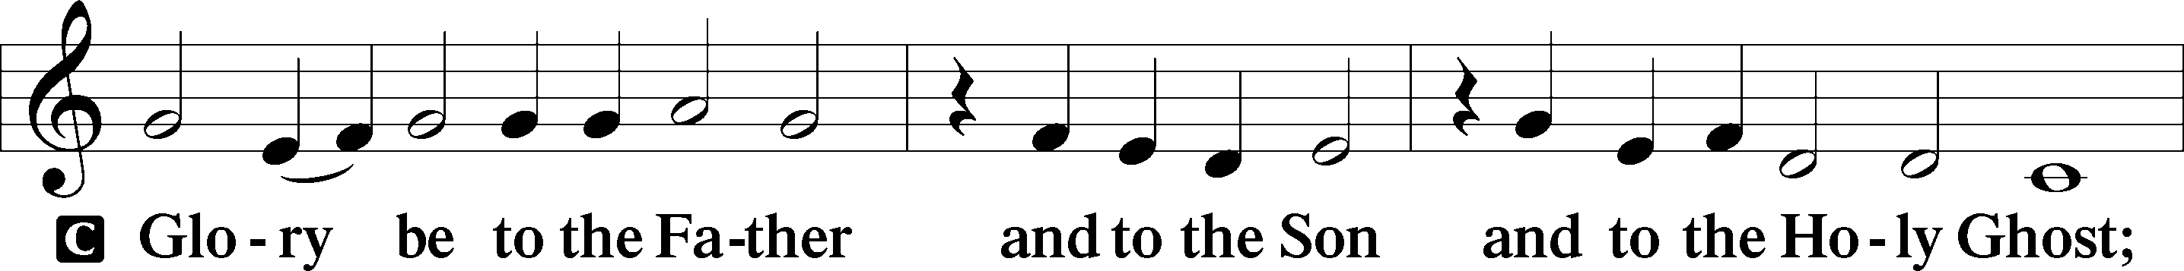
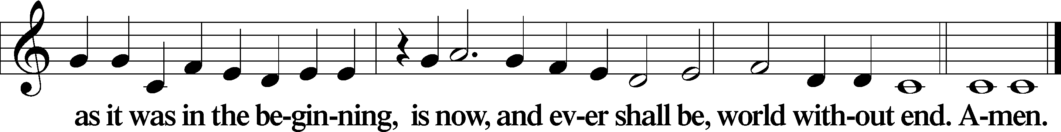
Kyrie Mark 10:47
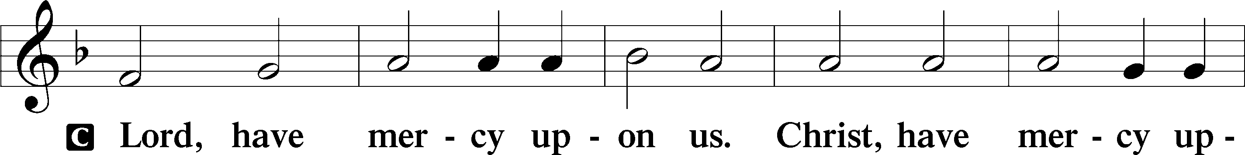
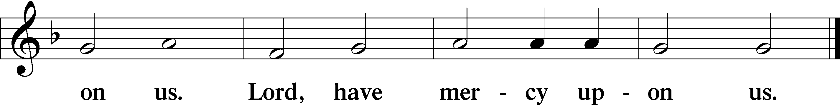

Salutation and Collect of the Day: Populus Zion
P The Lord be with you.
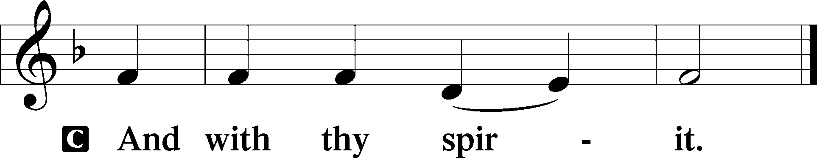

P Let us pray.
Stir up our hearts, O Lord, to make ready the way of Your only-begotten Son, that by His coming we may be enabled to serve You with pure minds; through the same Jesus Christ, our Lord, who lives and reigns with You and the Holy Spirit, one God, now and forever.
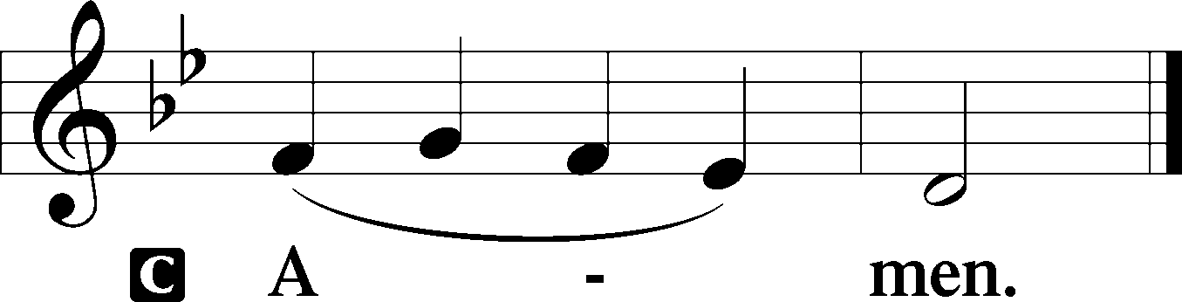
Sit

Prophecy: Song of Solomon 2: 8b-14 (NKJV)
Behold, my beloved comes leaping upon the mountains, skipping upon the hills. My beloved is like a gazelle or a young stag. Behold, he stands behind our wall; he is looking through the windows, gazing through the lattice. My beloved spoke, and said to me: “Rise up, my love, my fair one, and come away. For lo, the winter is past, the rain is over and gone. The flowers appear on the earth; the time of singing has come, and the voice of the turtledove is heard in our land. The fig tree puts forth her green figs, and the vines with the tender grapes give a good smell. Rise up, my love, my fair one, and come away! O my dove, in the clefts of the rock, in the secret places of the cliff, let me see your face, let me hear your voice; for your voice is sweet, and your face is lovely.”
P This is the Word of the Lord.
C Thanks be to God.

Gradual Psalm 50:2–3a, 5
Out of Zion, the perfection of beauty, God | shines forth.*
Our God comes; he does not keep | silence;
“Gather to me my | faithful ones,*
who made a covenant with me by | sacrifice!”

Epistle: Romans 15:4–13 (NKJV)
Brethren: Whatever things were written before were written for our learning, that we through the patience and comfort of the Scriptures might have hope. Now may the God of patience and comfort grant you to be like-minded toward one another, according to Christ Jesus, that you may with one mind and one mouth glorify the God and Father of our Lord Jesus Christ. Therefore receive one another, just as Christ also received us, to the glory of God. Now I say that Jesus Christ has become a servant to the circumcision for the truth of God, to confirm the promises made to the fathers, and that the Gentiles might glorify God for His mercy, as it is written: “For this reason I will confess to You among the Gentiles, and sing to Your name.” And again he says: “Rejoice, O Gentiles, with His people!” And again: “Praise the Lord, all you Gentiles! Laud Him, all you peoples!” And again, Isaiah says: “There shall be a root of Jesse; and He who shall rise to reign over the Gentiles, in Him the Gentiles shall hope.” Now may the God of hope fill you with all joy and peace in believing, that you may abound in hope by the power of the Holy Spirit.

P This is the Word of the Lord.
C Thanks be to God.

Stand

Verse Luke 21:26b–27
Alleluia. The powers of the heavens will be shaken, and then they will see the Son of Man coming in a cloud with power and great glory. Alleluia.

Alleluia
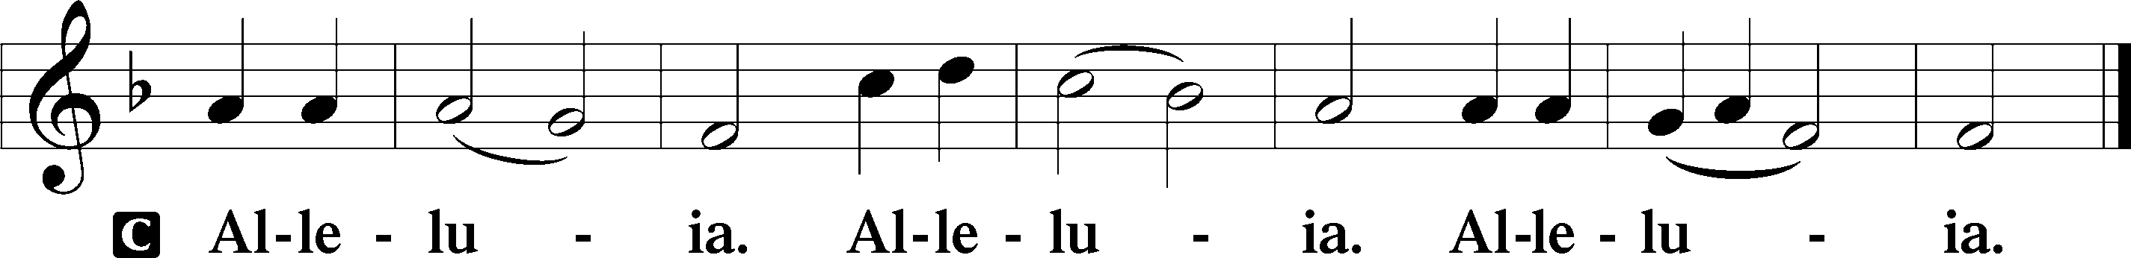

Holy Gospel: Luke 21:25–33 (NKJV)
P The Holy Gospel according to St. Luke, the twenty-first chapter.
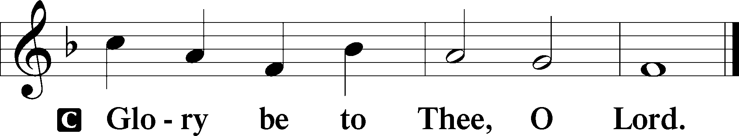

At that time Jesus said to His disciples: “There will be signs in the sun, in the moon, and in the stars; and on the earth distress of nations, with perplexity, the sea and the waves roaring; men’s hearts failing them from fear and the expectation of those things which are coming on the earth, for the powers of the heavens will be shaken. Then they will see the Son of Man coming in a cloud with power and great glory. Now when these things begin to happen, look up and lift up your heads, because your redemption draws near.” Then He spoke to them a parable: “Look at the fig tree, and all the trees. When they are already budding, you see and know for yourselves that summer is now near. So you also, when you see these things happening, know that the kingdom of God is near. Assuredly, I say to you, this generation will by no means pass away till all things take place. Heaven and earth will pass away, but My words will by no means pass away.”

P This is the Gospel of the Lord.
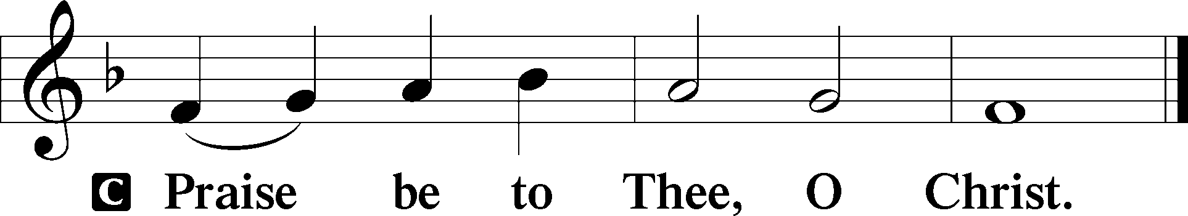

Nicene Creed
C I believe in one God,
the Father Almighty,
maker of heaven and earth
and of all things visible and invisible.

And in one Lord Jesus Christ,
the only-begotten Son of God,
begotten of His Father before all worlds,
God of God, Light of Light,
very God of very God,
begotten, not made,
being of one substance with the Father,
by whom all things were made;
who for us men and for our salvation came down from heaven
and was incarnate by the Holy Spirit of the virgin Mary
and was made man;
and was crucified also for us under Pontius Pilate.
He suffered and was buried.
And the third day He rose again according to the Scriptures
and ascended into heaven
and sits at the right hand of the Father.
And He will come again with glory to judge both the living and the dead,
whose kingdom will have no end.

And I believe in the Holy Spirit,
the Lord and giver of life,
who proceeds from the Father and the Son,
who with the Father and the Son together is worshiped and glorified,
who spoke by the prophets.
And I believe in one holy Christian and apostolic Church,
I acknowledge one Baptism for the remission of sins,
and I look for the resurrection of the dead
and the life T of the world to come. Amen.
Sit

Hymn of the Day: LSB #355 “O Savior, Rend the Heavens Wide”

Sermon

Stand

Offertory Psalm 51:10–12
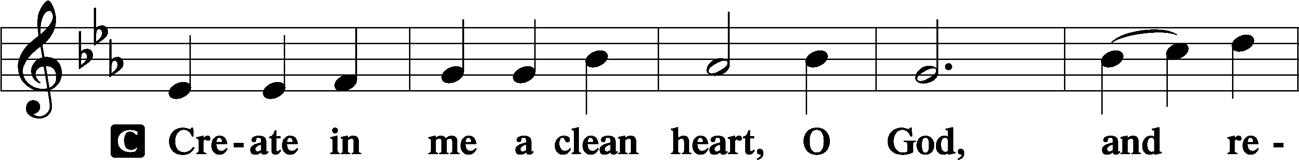
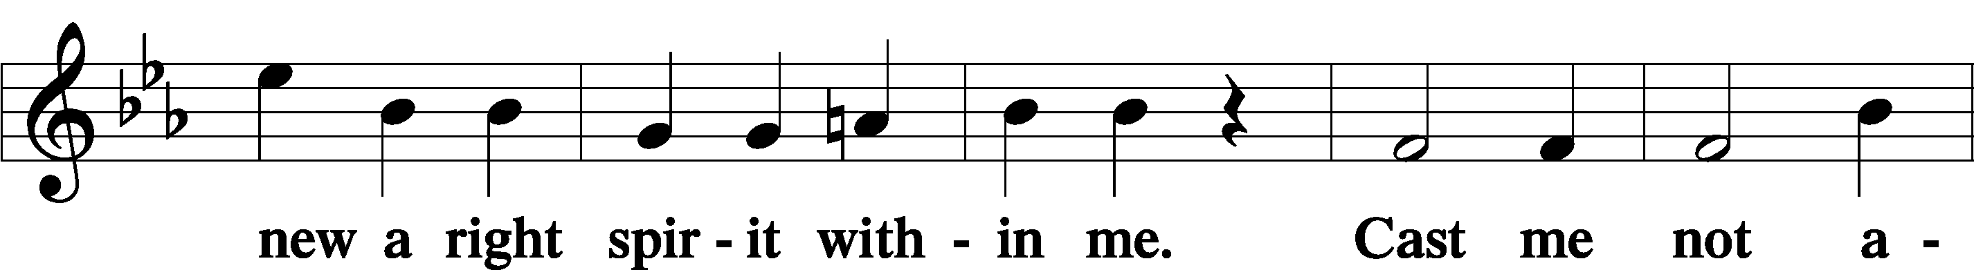
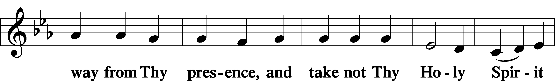
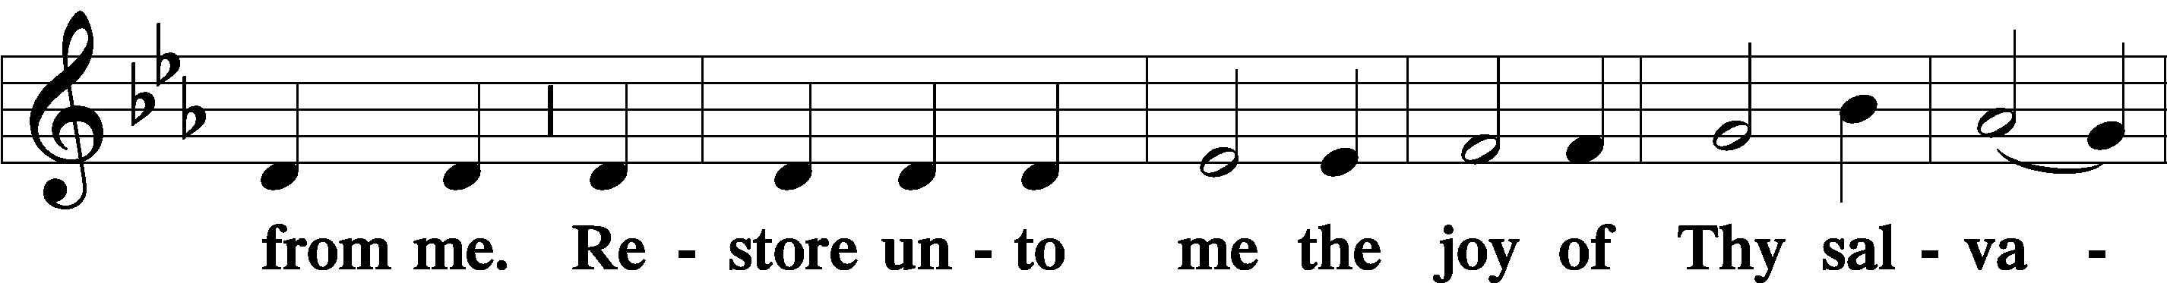
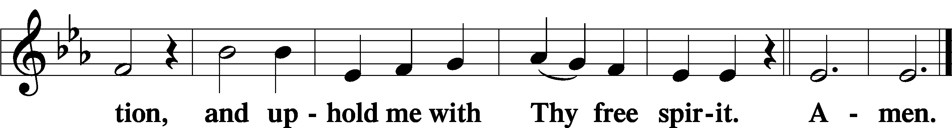

Prayer of the Church

Sit

Preparatory Hymn: LSB #513 “The Clouds of Judgment Gather”

Stand

Service of the Sacrament

Preface 2 Timothy 4:22; Colossians 3:1 Psalm 136
P The Lord be with you.
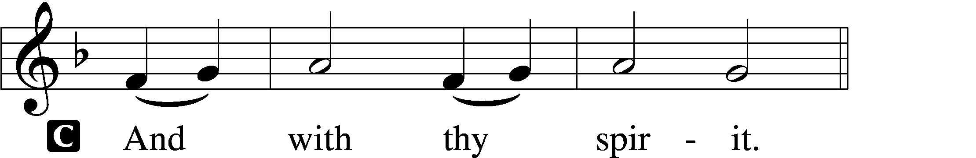

P Lift up your hearts.
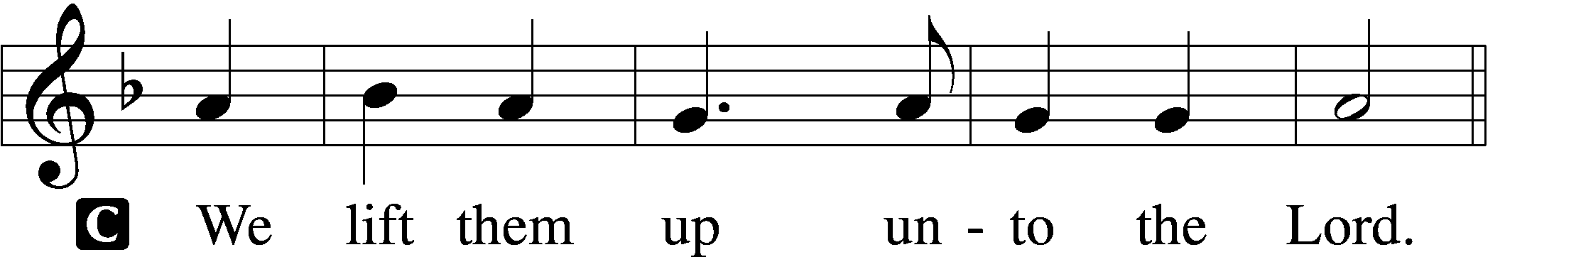

P Let us give thanks unto the Lord, our God.
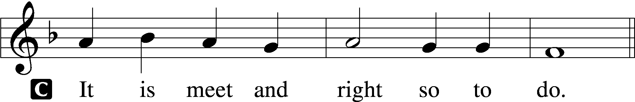

Proper Preface (Abbreviated) LSB 194
P It is truly meet, right, and salutary . . . evermore praising You and saying:

Sanctus Isaiah 6:3; Matthew 21:9
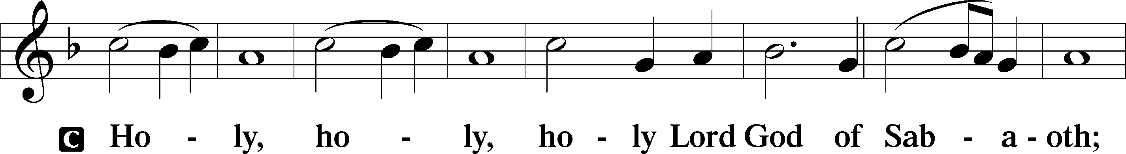
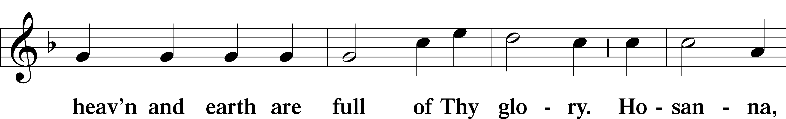
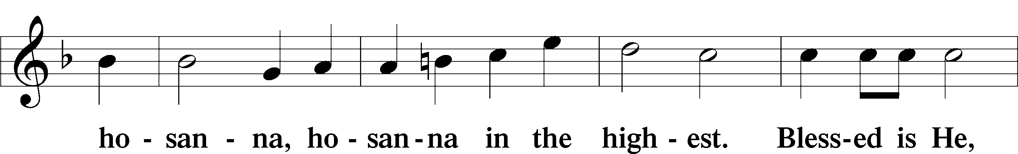
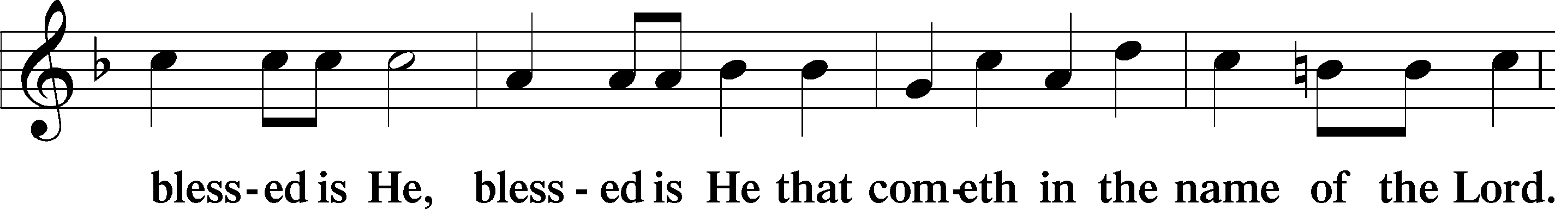
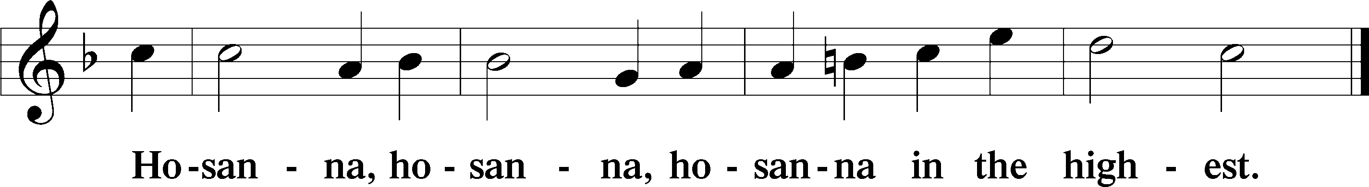

Lord’s Prayer The congregation is encouraged to silently pray the Lord’s Prayer as it is chanted. Matthew 6:9–13
P Our Father who art in heaven,
hallowed be Thy name,
Thy kingdom come,
Thy will be done on earth as it is in heaven;
give us this day our daily bread;
and forgive us our trespasses as we forgive those who trespass against us;
and lead us not into temptation,
but deliver us from evil.
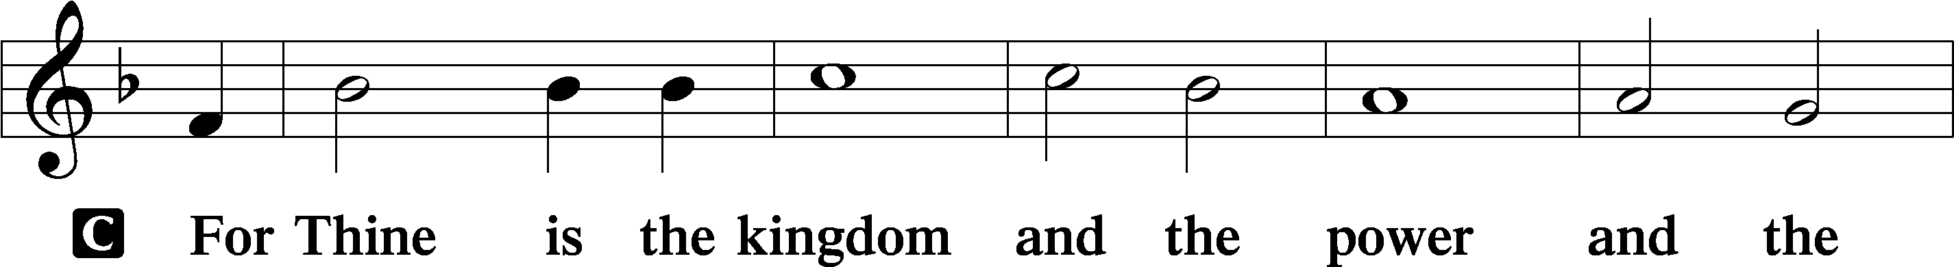
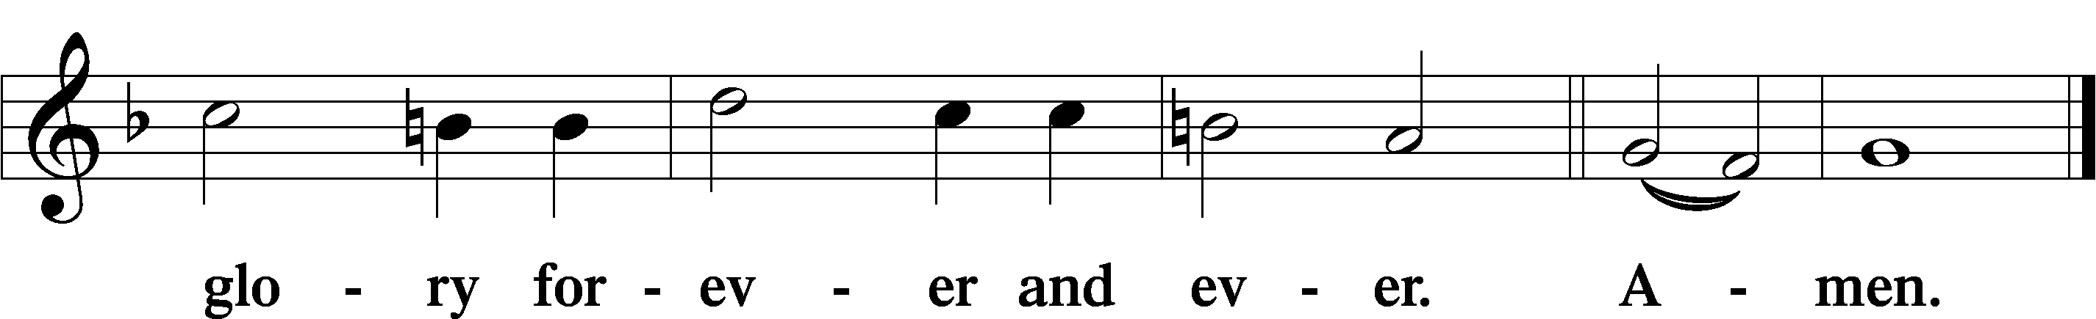

The Words of Our Lord Matthew 26:26–28; Mark 14:22–24; Luke 22:19–20; 1 Corinthians 11:23–25
P Our Lord Jesus Christ, on the night when He was betrayed, took bread, and when He had given thanks, He broke it and gave it to the disciples and said: “Take, eat; this is My T body, which is given for you. This do in remembrance of Me.”

In the same way also He took the cup after supper, and when He had given thanks, He gave it to them, saying: “Drink of it, all of you; this cup is the new testament in My T blood, which is shed for you for the forgiveness of sins. This do, as often as you drink it, in remembrance of Me.”

Pax Domini John 20:19
P The peace of the Lord be with you always.
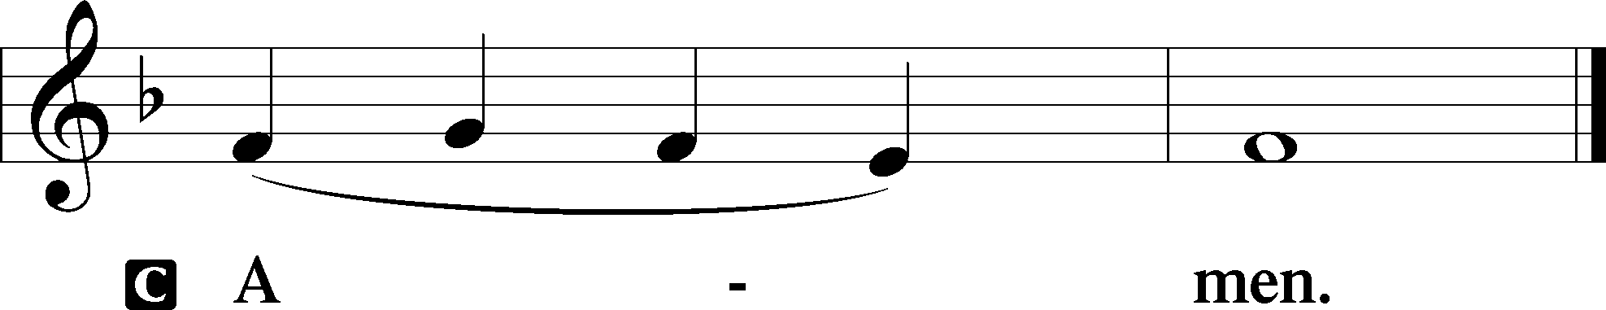

Agnus Dei John 1:29
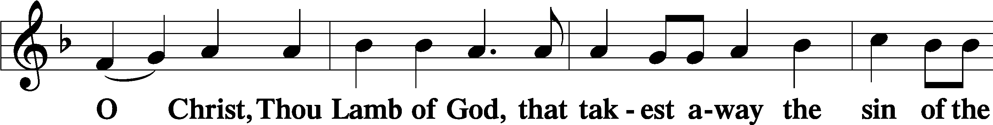
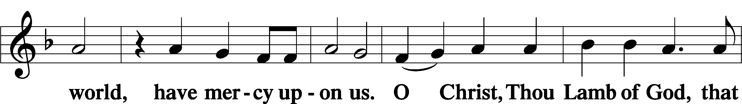
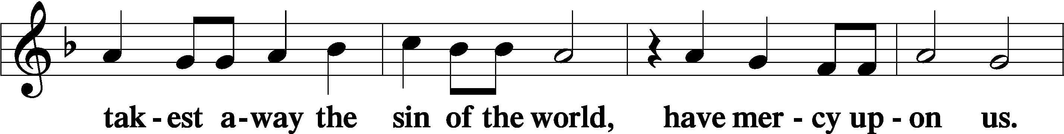
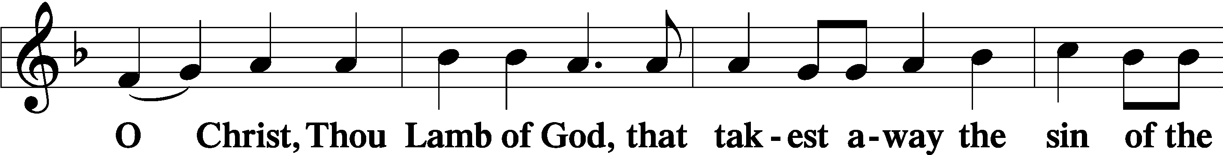
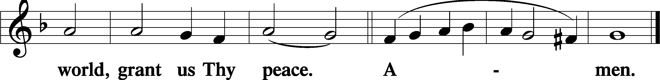
Sit

Distribution
The pastor and those who assist him receive the body and blood of Christ first and then distribute them to those who come to receive, saying:
Take, eat; this is the true body of our Lord and Savior Jesus Christ, given into death for your sins.
Amen.

Take, drink; this is the true blood of our Lord and Savior Jesus Christ, shed for the forgiveness of your sins.
Amen.

In dismissing the communicants, the following is said:
P The body and blood of our Lord Jesus Christ strengthen and preserve you in body and soul to life everlasting. Depart T in peace.
C Amen.

Distribution Hymn: LSB #510 “A Multitude Comes from the East and the West”

Distribution Hymn: LSB #336 “Lo! He Comes with Clouds Descending”

Distribution Hymn: LSB #515 “Rejoice, Rejoice, Believers”

Stand

Nunc Dimittis Luke 2:29–32
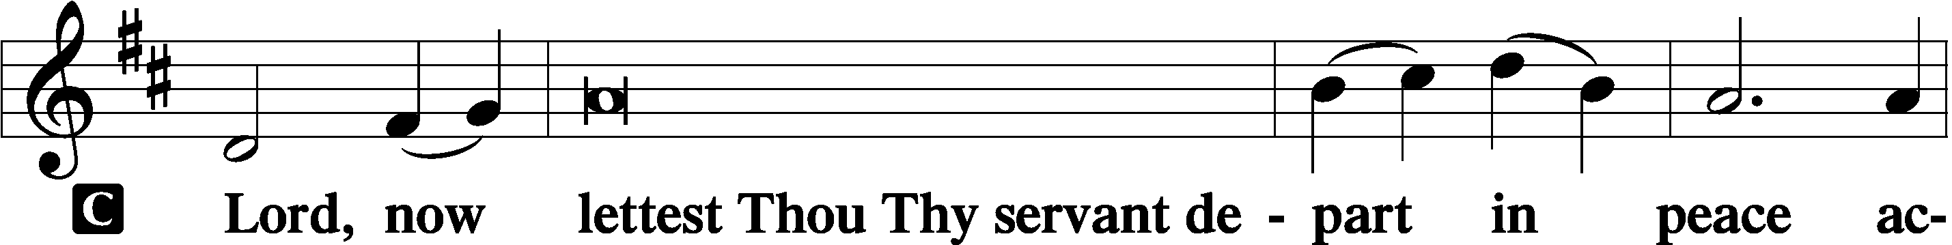
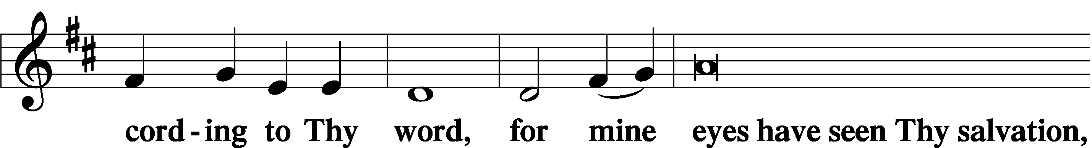
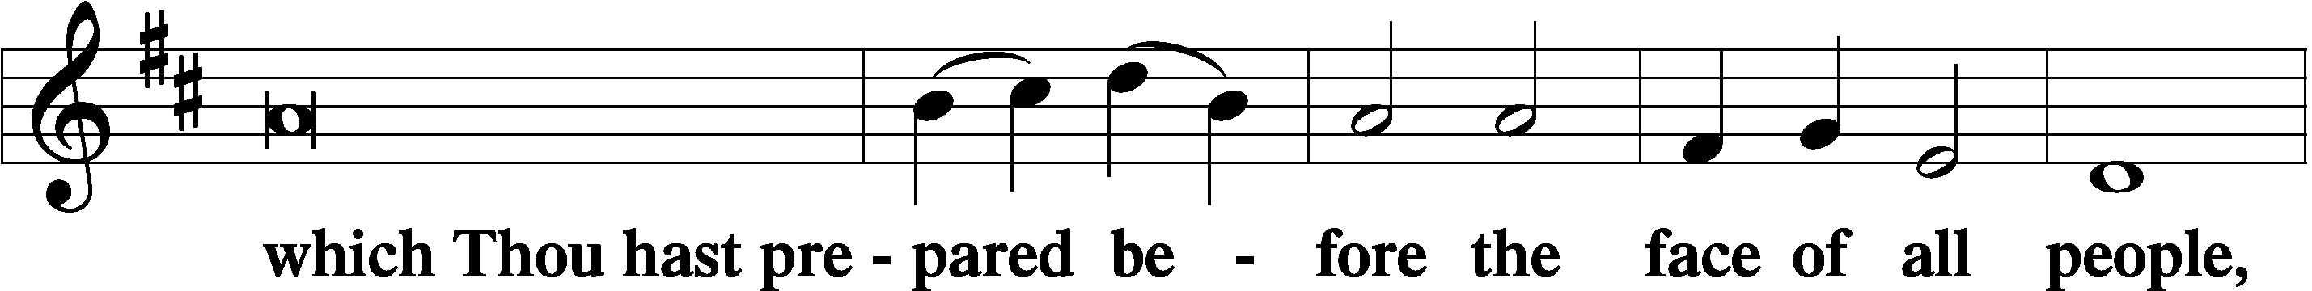
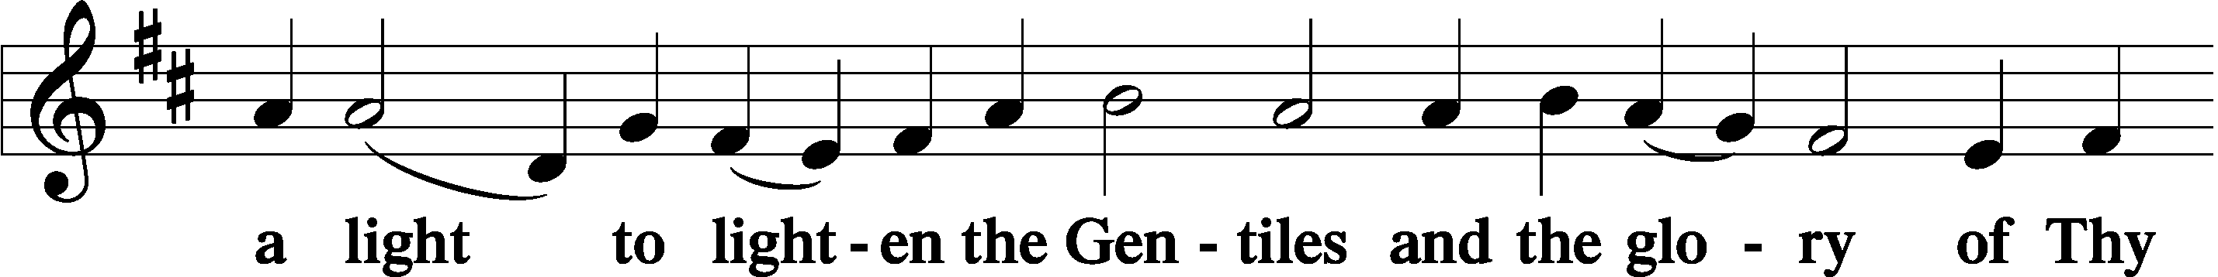
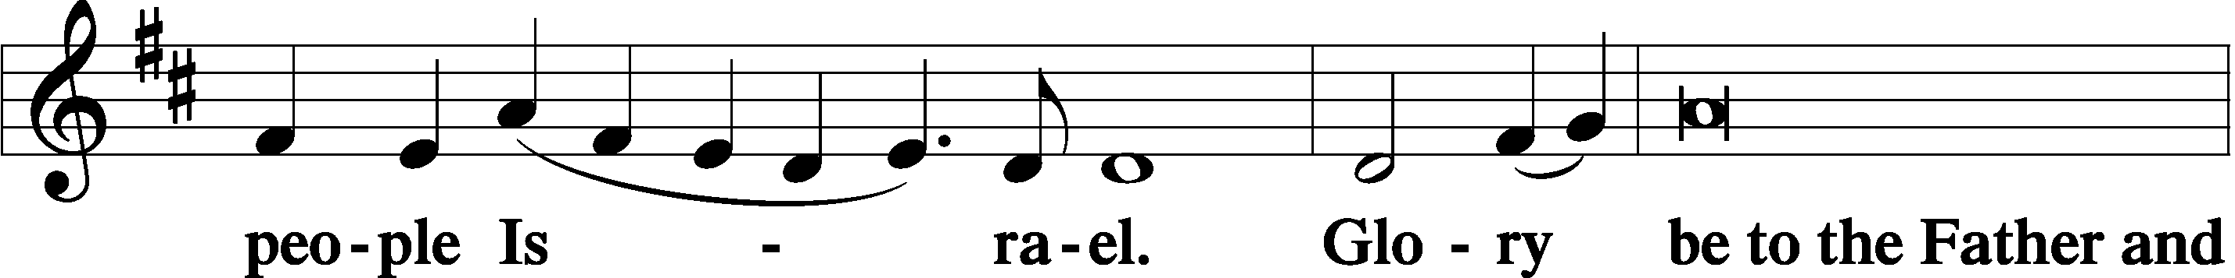
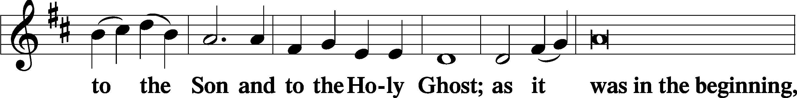
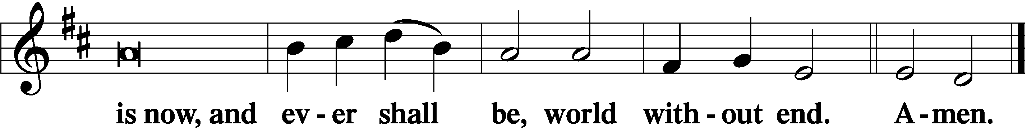

Thanksgiving Psalm 107:1
P O give thanks unto the Lord, for He is good,
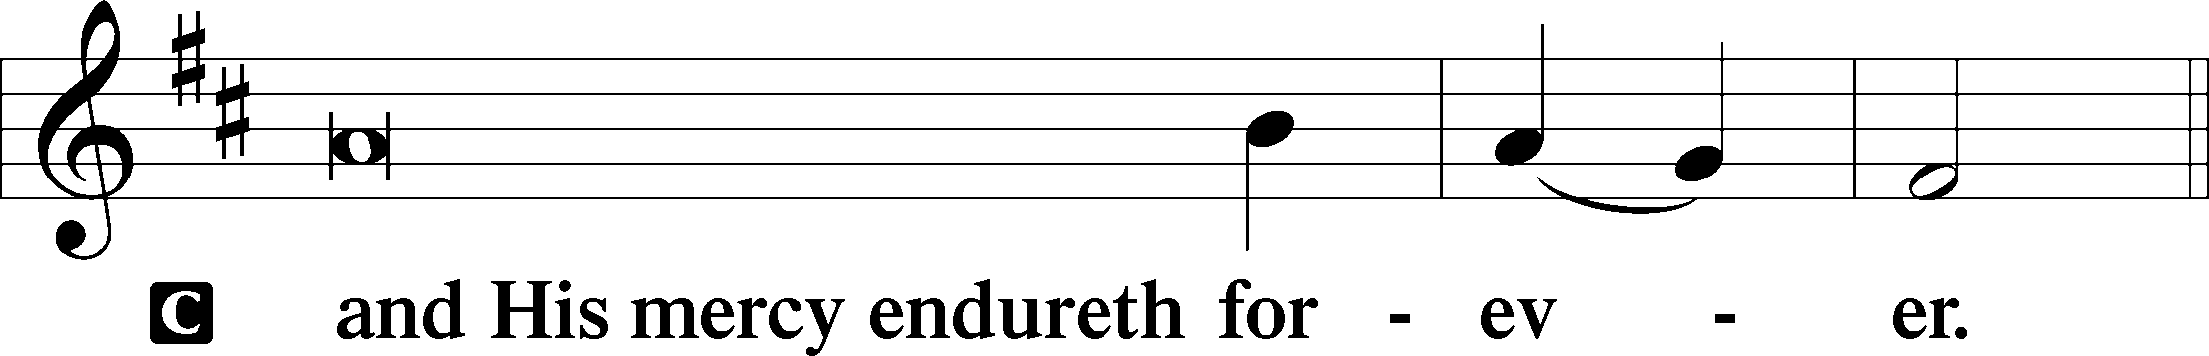

Post-Communion Collect
P Let us pray.
We give thanks to You, almighty God, that You have refreshed us through this salutary gift, and we implore You that of Your mercy You would strengthen us through the same in faith toward You and in fervent love toward one another; through Jesus Christ, Your Son, our Lord, who lives and reigns with You and the Holy Spirit, one God, now and forever.
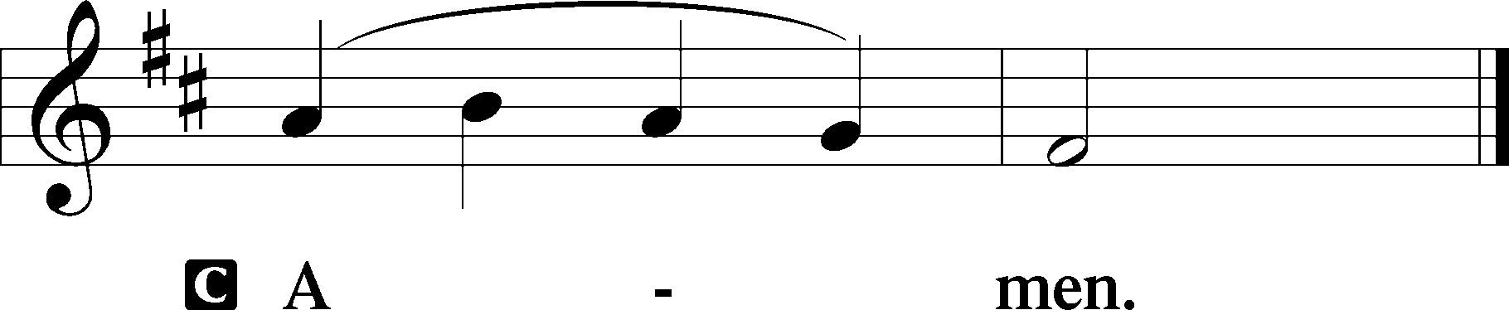

Salutation 2 Timothy 4:22
P The Lord be with you.
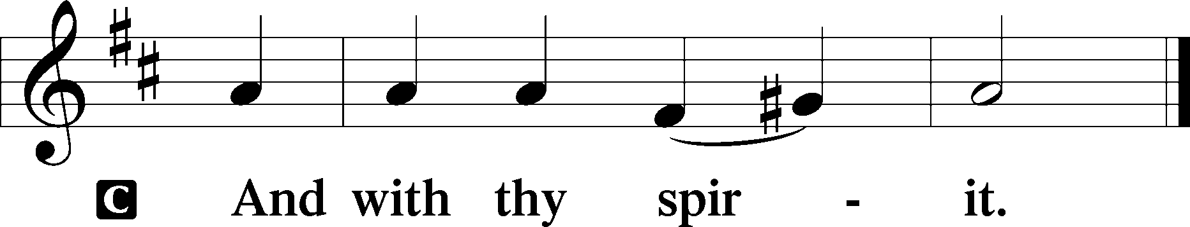

Benedicamus Psalm 103:1
P Bless we the Lord.
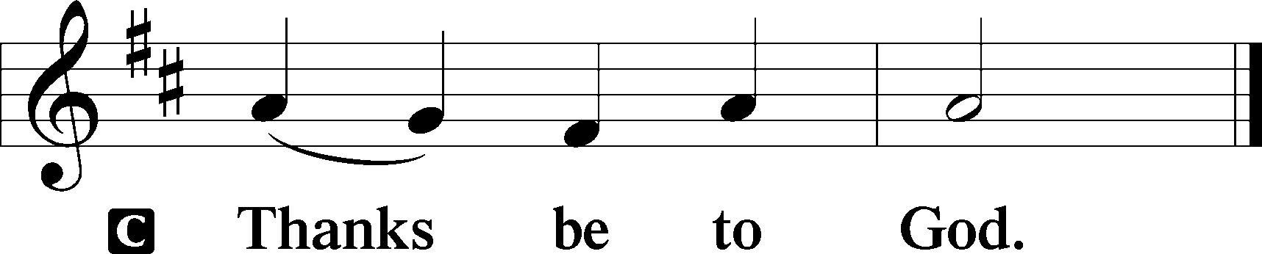

Benediction Numbers 6:24–26
P The Lord bless you and keep you.
The Lord make His face shine upon you and be gracious unto you.
The Lord lift up His countenance upon you and T give you peace.
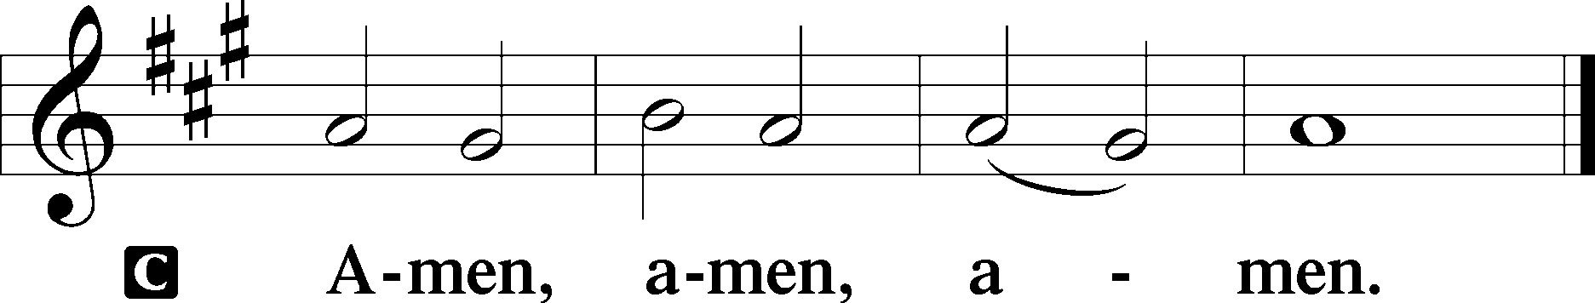

Closing Hymn: LSB #514 “The Bridegroom Soon Will Call Us”

Silent prayer after worship: O God of grace and mercy, keep me mindful of the true meaning of Christmas throughout this Advent season. Fill my heart with joy and peace, and lead me to share the same with others. In Jesus’ name. Amen.

Acknowledgments
Unless otherwise indicated, Scripture quotations are from the ESV® Bible (The Holy Bible, English Standard Version®), copyright © 2001 by Crossway, a publishing ministry of Good News Publishers. Used by permission. All rights reserved.
Created by Lutheran Service Builder © 2023 Concordia Publishing House.
fffffffffffffffffffffffffffffffffff
fffffffffffffffffffffffffffffffffff
In Loving Memory of my Brother, Donald C. Riefstahl (11.21.1949 – 12.07.2022): Diane Riefstahl
fffffffffffffffffffffffffffffffffff

SCHEDULE THROUGH DECEMBER 17, 2023:

:

Today, following Worship, Fellowship Hall: Coffee & Cookies Fellowship
7 pm, Fellowship Hall: AA Meeting
Tuesday, 7-9 pm, Fellowship Hall: Penn-Ohio Singers
Wednesday, 10 am, Sanctuary: Advent Midweek Matins Service Week 2
7 pm, Sanctuary: Advent Midweek Vespers Service Week 2
7:30 pm, Fellowship Hall: NA Meeting
Thursday, 9 am, Downstairs: Food Pantry
Next Sunday, 9 am, Sanctuary: Divine Service
Following Worship, Library: Audit of Deposits
7 pm, Fellowship Hall: AA Meeting
fffffffffffffffffffffffffffffffffff
THANK YOU FOR SERVING IN DECEMBER: Elder: Jonathan Baisch; Ushers: Cheryl Fedele, Mike Flaugher, & Jesse Riffle; Altarware ~ Sundays: (prior) Marie Flaugher (12.10 & 12.31) & Diane Riefstahl; (after) Marie Flaugher (12.10 & 12.31) & Elizabeth Haenftling (12.17, & 12.24); Special Divine Service: December 25th ~ Diane Riefstahl.
fffffffffffffffffffffffffffffffffff
Attendance: Thursday, November 30, 2023: 13
Sunday, December 3, 2023: 42
Wednesday, December 6, 2023: 9 (10 am); 13 (7 pm)
fffffffffffffffffffffffffffffffffff
NEW! Shelves have been placed in front of the secretary’s office for copies of items generally found in the narthex (seasonal devotionals, Church Council/Voters’ Assembly agendas & minutes, etc.) Items will now be available in both locations for your convenience.
fffffffffffffffffffffffffffffffffff
The minutes from the December 3, 2023 Voters’ Assembly are available this morning.
fffffffffffffffffffffffffffffffffff
Please join us downstairs this morning following worship for Coffee & Christmas Cookies Fellowship sponsored by the Altar Guild. Take out containers are available!
fffffffffffffffffffffffffffffffffff
Christmas cards for our shut-ins will be available at this morning’s Coffee Fellowship for you to sign and add good wishes.
fffffffffffffffffffffffffffffffffff
Bible Memory Verses ~ Week of December 10th:
For Adults: If you confess with your mouth that Jesus is Lord and believe in your heart that God raised him from the dead, you will be saved.
Romans 10:9

For Children: Raise your heads, because your redemption is drawing near.
Luke 21:28
fffffffffffffffffffffffffffffffffff
Auditors will meet next Sunday following worship for an audit of deposits.
Our Stewardship of Treasures for the Lord:
In order to do the Lord’s work, we need $2,553.63 each week to meet our 2023 budget for general purposes and $76.92 for the SELC.

Online Figures for November 29, December 3, and December 4, 2023
General Fund: $2,200.00
Capital Campaign: $100.00
Figures for Thursday, November 30, 2023
General Fund: $785.00
SELC: $35.00
Quarterly Missions: $35.00
Other: $8.50
Figures for Sunday, December 3, 2023
General Fund: $2,380.00
SELC: $100.00
Capital Campaign: $270.00
Other: $91.00

For online giving, check out https://www.saintspeterandpaul.net/online-giving.
fffffffffffffffffffffffffffffffffff
Advent Midweek Services continue this Wednesday, December 13th. Two services are offered this year: a 10 am Matins Service and a 7 pm Vesper Service. This year’s theme will focus on Christ in the Old Testament, “The Seen Yahweh”.
fffffffffffffffffffffffffffffffffff
This morning is “Stock the Food Pantry” Sunday. Although financial donations are always welcomed, this month we are seeking donations of paper products (toilet tissue, paper towels, and face tissue) to share with our clients. Please set your donations on the pew by the secretary’s office and they will be taken to the food pantry are for you. Thanks” in advance for your participation in this outreach mission.
fffffffffffffffffffffffffffffffffff
Please note the following new address: The Suttons, 268 Mitchell Rd., West Middlesex, PA 16159.
fffffffffffffffffffffffffffffffffff

Remember the following in Prayer…
~The Hurting and Healing: Amy, Mary Jane Anderson, Steve Antolovich, Ellen Baron^{CA}, Amy Blomenberg, Lois Bortner^{CA}, Sara Brubaker, Dee Bullock, Bev & Joe Chlpka, Susan Davies, Loretta Deal, Tim Dudash, Judith & Eddy Furey, Griffin, Austin Hamilton, Pastor Charles Henrickson, Joan, Keith Jozwiakowski, Darla Krajci, Barbara Kreske, Jess Lavoie, Paul Lucas^{CA}, Sandy Marshall, Frank Niemeyer^{CA}, Juanita Rentschler, Richard Reuning^{CA}, Tim Riffle, Nancy Robertson^{CA}, Kriss Svidro^{CA}, Rudy Tomko, Joel & Peggy Wasson, Angela Weser^{CA}, and Ruth Wolf.
~The Homebound: Anna Mae Daris, Millie Elavsky, Jean Tomko, Betty Wolf, and Ed & Millie Zachar.
~Celebrating this Week: Birthdays: Rebekah Baisch (12.13), Rev. Edward Kucera (12.13), Joan Rice (12.16), and Bill Wolf (12.16).
~Serving in the Military: Alex (Sasha) Carr, Duncan Vaupel, Curtis Sinewe, and Joshua Solyan.
~Community & World Needs: Those suffering due to the conflicts in the Middle East and between Ukraine and Russia; those suffering from loss and dislocation because weather disasters; those suffering from addiction and their families; Local, State, and National Government Leaders; safety for all Police Officers, Firefighters, & First Responders; the unemployed; our Fourth Quarter Local Mission: Willow Women’s Center.
*CA represents cancer.
fffffffffffffffffffffffffffffffffff
Congratulations to Alex (Sasha) Carr who graduated this past Thursday from his second phase of military training in Virginia. Sasha will soon be moving to Kentucky where he will be stationed for the next two years.
If wishing to send Sasha notes or cards during this time of transition, please send them to his mother’s address (2449 Romar Dr., Hermitage, PA 16148). She will make certain that he gets them!
fffffffffffffffffffffffffffffffffff

December 2023 Worship Services

Sunday, December 10 9 am Divine Service ~ Populus Zion

Wednesday, December 13 10 am Matins Service ~ Advent Midweek 2
7 pm Vespers Service ~ Advent Midweek 2

Sunday, December 17 9 am Divine Service ~ Gaudete

Wednesday, December 20 10 am Matins Service ~ Advent Midweek 3
7 pm Vespers Service ~ Advent Midweek 3

Sunday, December 24 9 am Divine Service ~ Rorate Coeli
8 pm Christmas Eve Service

Monday, December 25 9 am Divine Service ~ Christmas Day

Tuesday, December 26 7 pm Vespers Service
Feast of St. Stephen, Martyr

Wednesday, December 27 7 pm Vespers Service
Feast of St. John, Apostle & Evangelist

Thursday, December 28 7 pm Vespers Service
Feast of the Holy Innocents, Martyrs

Sunday, December 31 9 am Divine Service ~ First Sunday after
Christmas

Here to Serve
Pastor………………………………………………...……………Rev. Jacob Deal
E-mail …………………………….……pastordeal@saintspeterandpaul.net
Phone Number……………………..…………………724-347-3620 (Option 2)
Church Office………………………..…………………724-347-3620 (Option 3)
Website …………………………………………www.saintspeterandpaul.net
Secretary…………………………………………………………Diane Riefstahl
E-mail ………………………………………church@saintspeterandpaul.net
Website …………………………………………www.saintspeterandpaul.net
Food Pantry (email): ……………foodpantry@saintspeterandpaul.net
Congregation President………………………………….…Jonathan Baisch
Church Elder …………………………………………...……. Jonathan Baisch
Organist………………………………………………..….…Rebecca Marquette
AA Contact: Steve………………………………………………...…724-813-2358
NA Contact: Larry……………………………………..…………..724-977-8733
fffffffffffffffffffffffffffffffffff
If needing to get into the church building during the week, please phone first to make certain someone is here to let you in.

