Sts. Peter & Paul
Evangelical Lutheran Church
Lutheran Church-Missouri Synod
Founded-1917

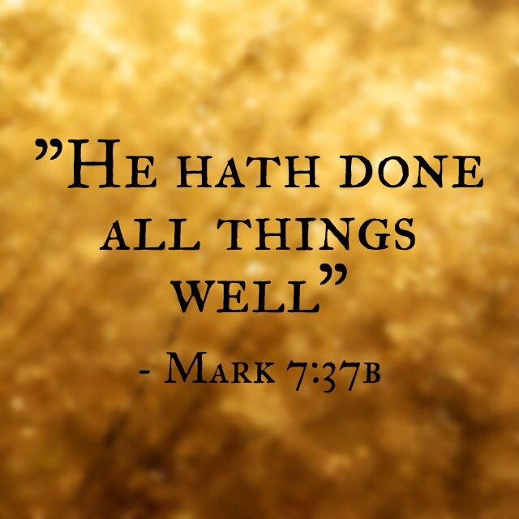

August 27, 2023

699 Stambaugh Ave.
Sharon, Pennsylvania 16146

“I was glad when they said to me,
Let us go to the house of the LORD!”
Psalm 122:1
Sts. Peter & Paul Evangelical Lutheran Church, LC-MS
THE TWELFTH SUNDAY AFTER TRINITY
August 27, 2023
A special welcome to our guests this day! If you would like more information about The Lutheran Church - Missouri Synod, or this congregation, please speak with Pastor Deal or an Elder after the service.
Members & Guests: Don’t be embarrassed if your children make noise during the worship service, all children do. We encourage families to worship together but, if you feel the need, there are pews in the rear of the Church which are reserved for young families on both sides of the sanctuary. There is also a quiet room available to you, located next to the sanctuary (formerly the Pastor’s office), where you would be able to follow along with the service.

Today’s service includes the Sacrament of Holy Communion. If during this past year, you have not worshipped with us and been communed, we respectfully ask that you do not partake of this sacrament this day before first speaking with Pastor Deal.
If visiting from a sister congregation of the LC-MS and are in good standing, please inform Pastor Deal of your desire to commune prior to the service.
If wishing to receive a blessing during communion, please approach with your arms crossed.

CONTACT INFORMATION
Pastor Deal: pastordeal@saintspeterandpaul.net or 724-347-3620 (opt. 2)
Church Office: church@saintspeterandpaul.net or 724-347-3620 (opt. 3)
Secretary’s Office will be open Monday (8:30-4:30) and Thursday (as needed) this week.

Silent prayer before worship Almighty God and Father, You have invited me to join with all the saints and angels in worshiping You today. Lead me to worship You with my heart as well as my lips to Your glory. In Jesus’ name. Amen.

Confession and Absolution

Opening Hymn: LSB #797 “Praise the Almighty”

The sign of the cross may be made by all in remembrance of their Baptism.

Invocation
P In the name of the Father and of the T Son and of the Holy Spirit.
C Amen.

Exhortation Hebrews 10:22; Psalm 124:8; Psalm 32:5
P Beloved in the Lord! Let us draw near with a true heart and confess our sins unto God our Father, beseeching Him in the name of our Lord Jesus Christ to grant us forgiveness.

P Our help is in the name of the Lord,
C who made heaven and earth.
P I said, I will confess my transgressions unto the Lord,
C and You forgave the iniquity of my sin.

Silence for reflection on God’s Word and for self-examination.

Confession of Sins
P O almighty God, merciful Father,
C I, a poor, miserable sinner, confess unto You all my sins and iniquities with which I have ever offended You and justly deserved Your temporal and eternal punishment. But I am heartily sorry for them and sincerely repent of them, and I pray You of Your boundless mercy and for the sake of the holy, innocent, bitter sufferings and death of Your beloved Son, Jesus Christ, to be gracious and merciful to me, a poor, sinful being.

Absolution [John 20:19–23]
P Upon this your confession, I, by virtue of my office, as a called and ordained servant of the Word, announce the grace of God unto all of you, and in the stead and by the command of my Lord Jesus Christ I forgive you all your sins in the name of the Father and of the T Son and of the Holy Spirit.
C Amen.
Service of the Word

Introit Psalm 70:2b, 4a, 5b; antiphon: vv. 1–2a
Make haste, O God, to de- | liver me!*
O Lord, make haste to | help me!
Let them be put to shame and con- | fusion*
who | seek my life!
Let them be | turned back*
and brought to dishonor who de- | sire my hurt!
May all who seek | you rejoice*
and be | glad in you!
You are my help and my de- | liverer;*
O Lord, do | not delay!
Make haste, O God, to de- | liver me!*
O Lord, make haste to | help me!
Let them be put to shame and con- | fusion*
who | seek my life!

Gloria Patri
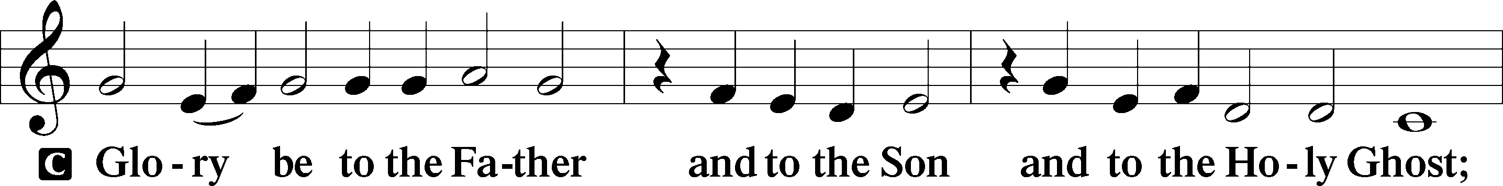
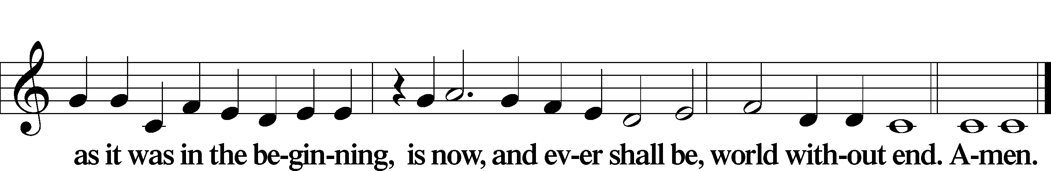

Kyrie Mark 10:47
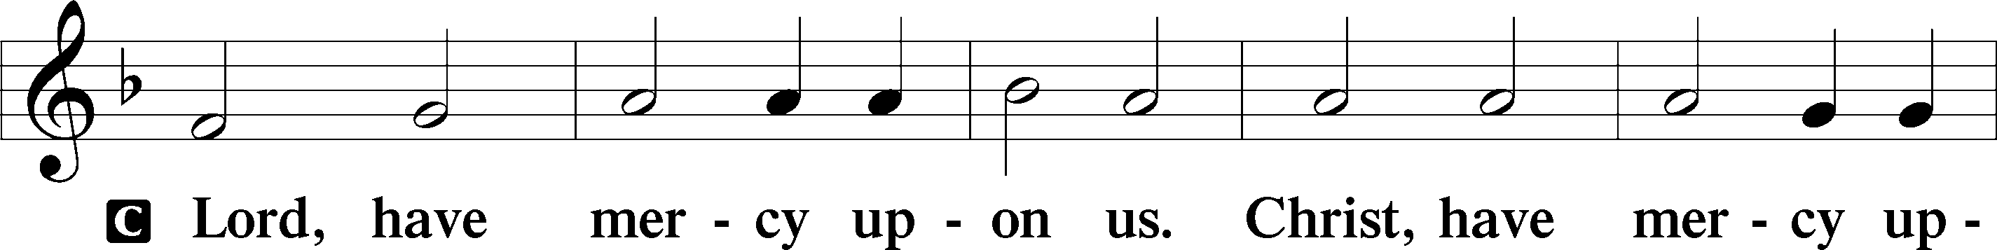
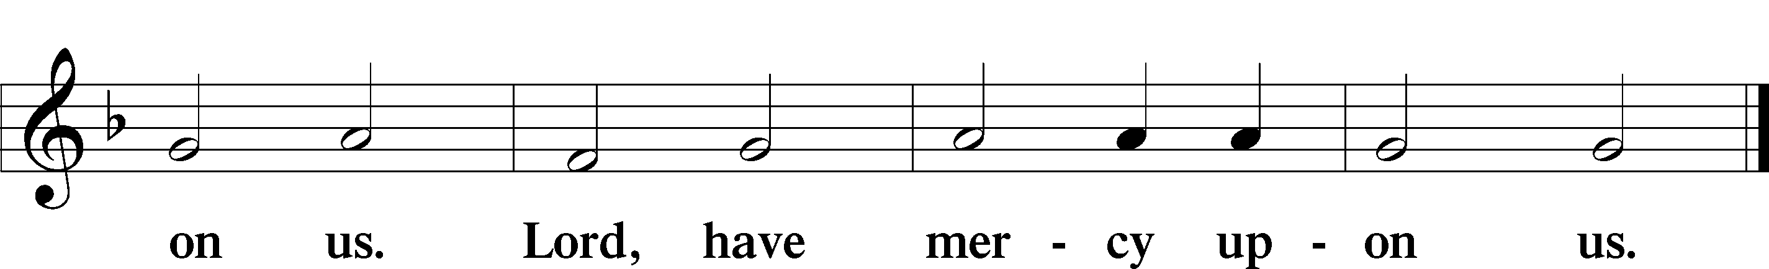

Gloria in Excelsis Luke 2:14; John 1:29
P Glory be to God on high:
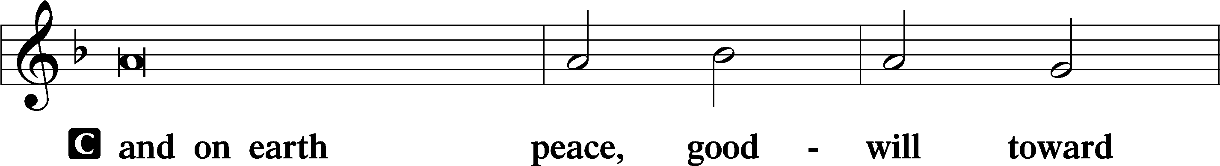
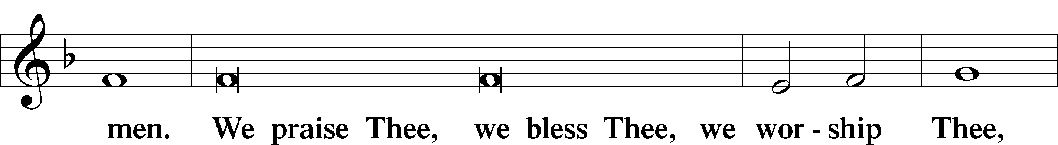
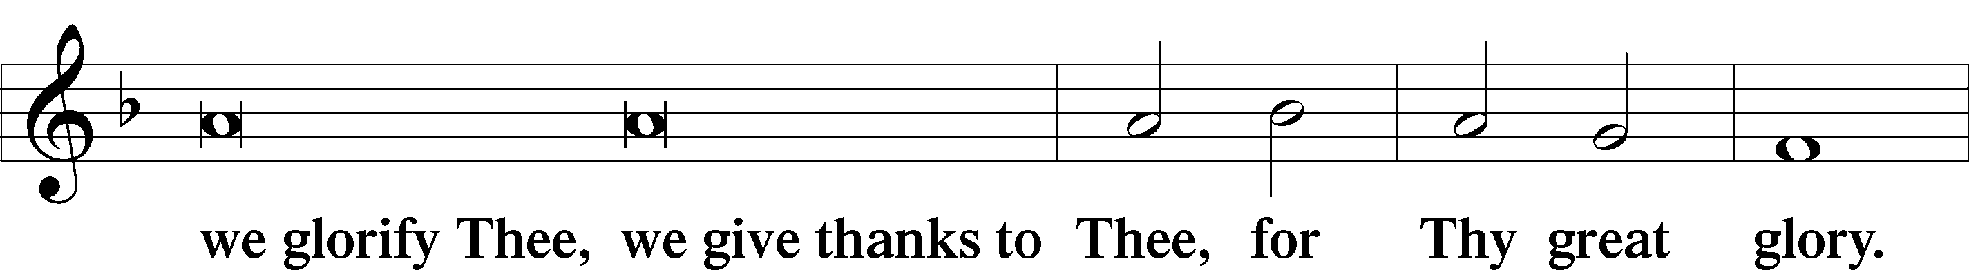
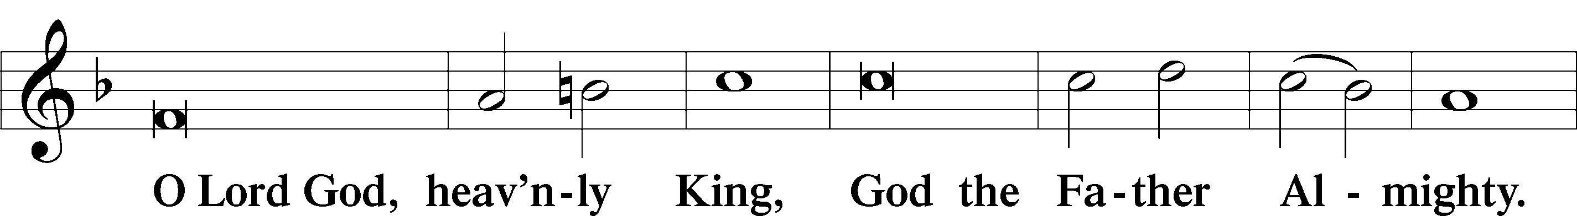
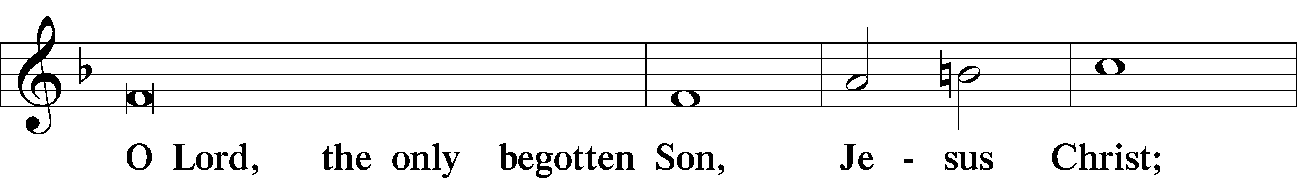
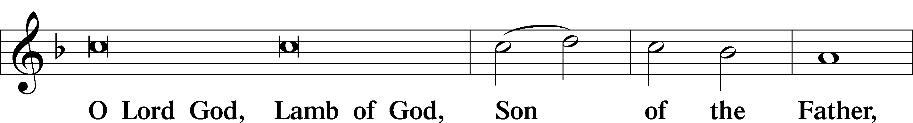
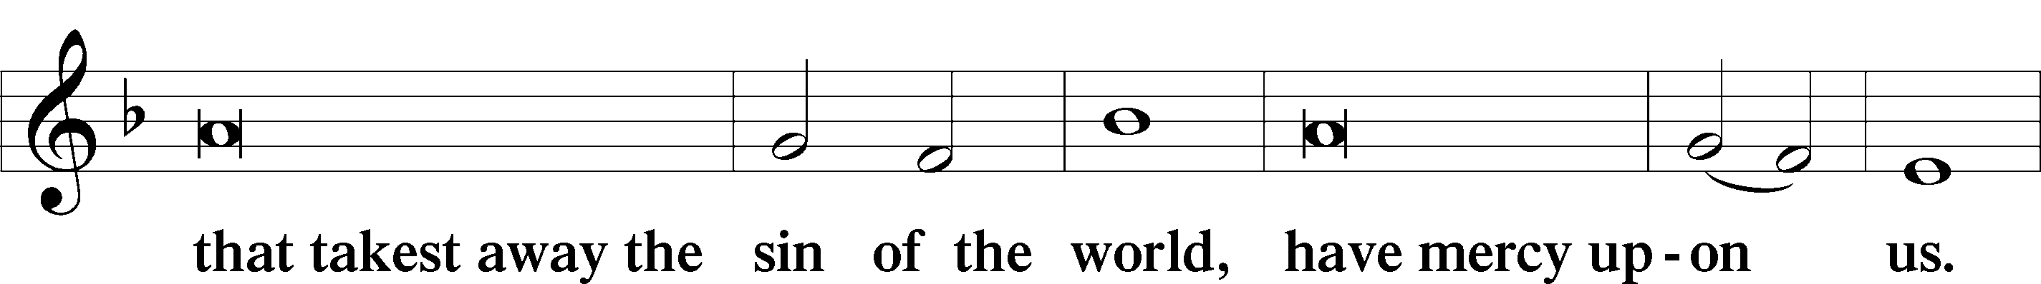
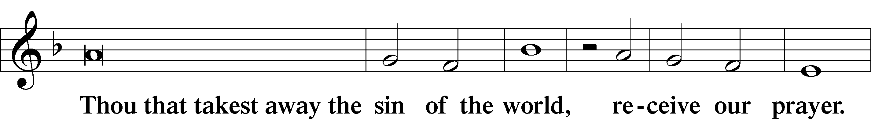
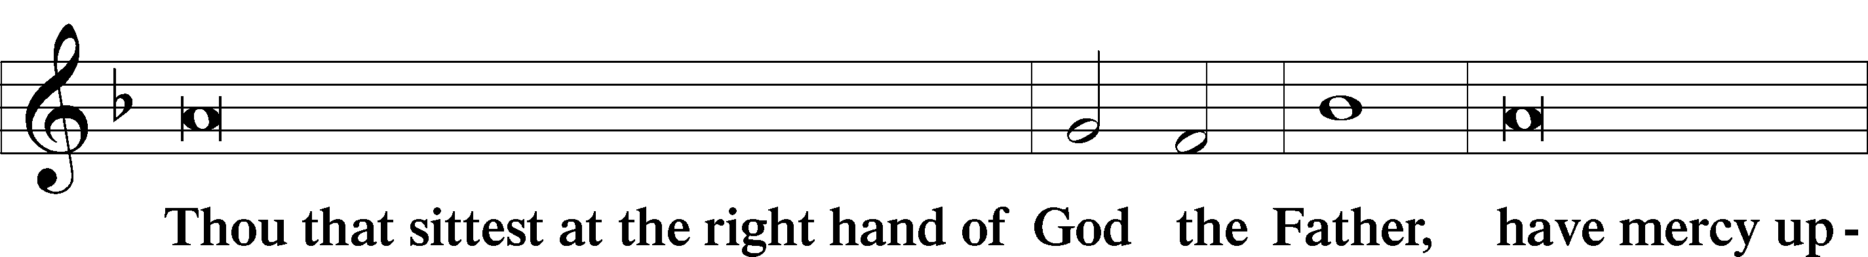
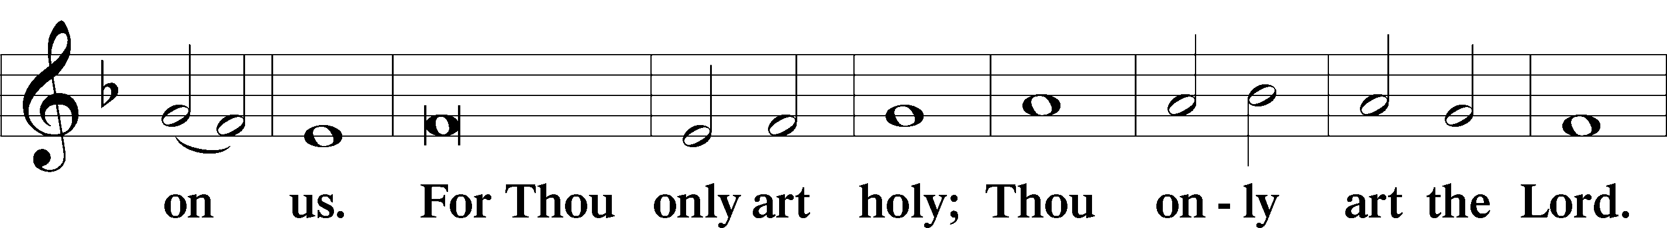
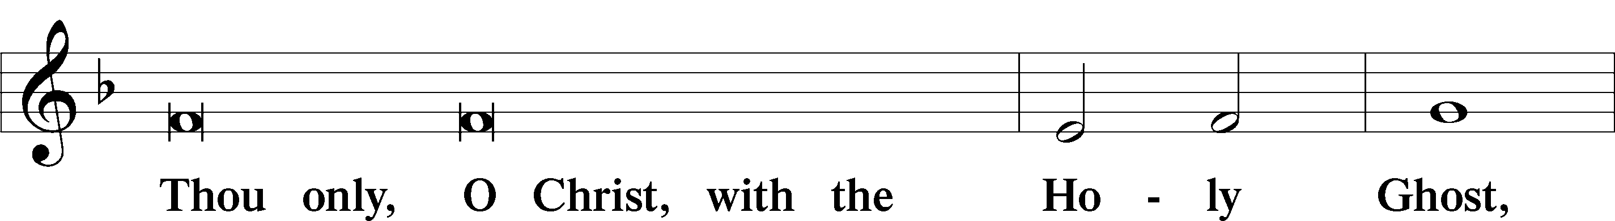
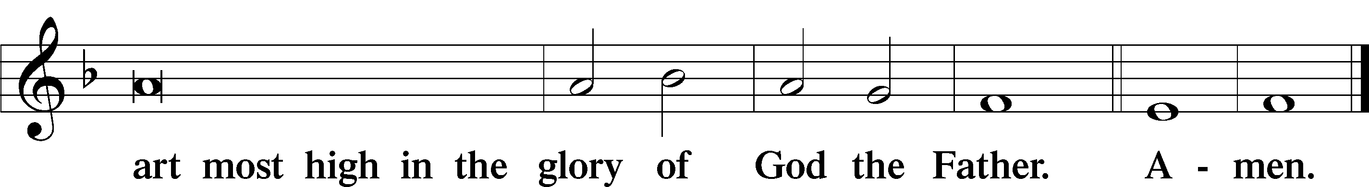

Salutation and Collect of the Day: Trinity 12
P The Lord be with you.
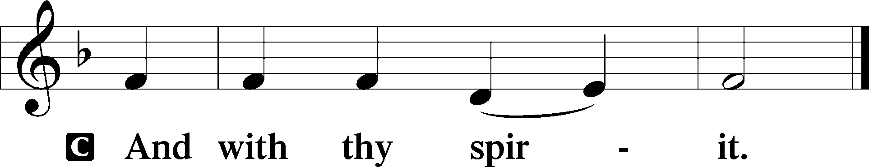

P Let us pray.
Almighty and merciful God, by Your gift alone Your faithful people render true and laudable service. Help us steadfastly to live in this life according to Your promises and finally attain Your heavenly glory; through Jesus Christ, Your Son, our Lord, who lives and reigns with You and the Holy Spirit, one God, now and forever.
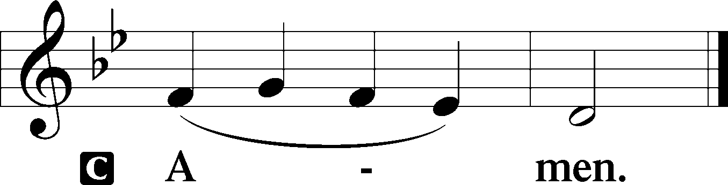
Sit

Prophecy: Isaiah 29:17–24 (NKJV)
Thus says the Lord God: Is it not yet a very little while till Lebanon shall be turned into a fruitful field, and the fruitful field be esteemed as a forest? In that day the deaf shall hear the words of the book, and the eyes of the blind shall see out of obscurity and out of darkness. The humble also shall increase their joy in the Lord, and the poor among men shall rejoice in the Holy One of Israel. For the terrible one is brought to nothing, the scornful one is consumed, and all who watch for iniquity are cut off—who make a man an offender by a word, and lay a snare for him who reproves in the gate, and turn aside the just by empty words. Therefore thus says the Lord, who redeemed Abraham, concerning the house of Jacob: “Jacob shall not now be ashamed, nor shall his face now grow pale; but when he sees his children, the work of My hands, in his midst, they will hallow My name, and hallow the Holy One of Jacob, and fear the God of Israel. These also who erred in spirit will come to understanding, and those who complained will learn doctrine,” says the Lord Almighty.

P This is the Word of the Lord.
C Thanks be to God.

Gradual Psalm 34:1–2
I will bless the Lord at | all times;*
his praise shall continually be | in my mouth.
My soul makes its boast | in the Lord;*
let the humble hear | and be glad.

Epistle: 2 Corinthians 3:4–11 (NKJV)
Brethren: We have such trust through Christ toward God. Not that we are sufficient of ourselves to think of anything as being from ourselves, but our sufficiency is from God, who also made us sufficient as ministers of the new covenant, not of the letter but of the Spirit; for the letter kills, but the Spirit gives life. But if the ministry of death, written and engraved on stones, was glorious, so that the children of Israel could not look steadily at the face of Moses because of the glory of his countenance, which glory was passing away, how will the ministry of the Spirit not be more glorious? For if the ministry of condemnation had glory, the ministry of righteousness exceeds much more in glory. For even what was made glorious had no glory in this respect, because of the glory that excels. For if what is passing away was glorious, what remains is much more glorious.

P This is the Word of the Lord.
C Thanks be to God.

Stand

Verse Psalm 81:1
Alleluia. Sing aloud to God our strength; shout for joy to the God of Jacob. Alleluia.

Alleluia
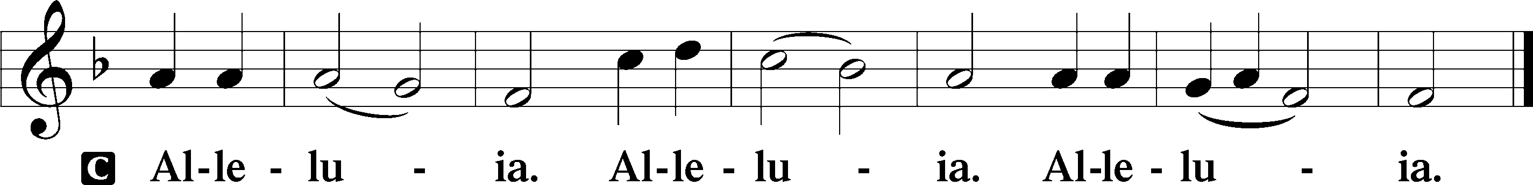

Holy Gospel: Mark 7:31–37 (NKJV)
P The Holy Gospel according to St. Mark, the seventh chapter.
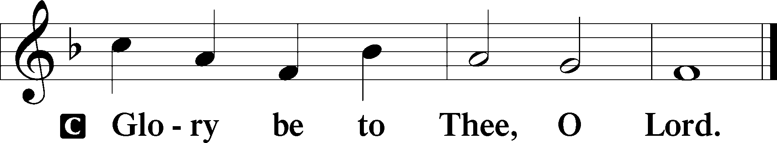

At that time: Departing from the region of Tyre and Sidon, Jesus came through the midst of the region of Decapolis to the Sea of Galilee. Then they brought to Him one who was deaf and had an impediment in his speech, and they begged Him to put His hand on him. And He took him aside from the multitude, and put His fingers in his ears, and He spat and touched his tongue. Then, looking up to heaven, He sighed, and said to him, “Ephphatha,” that is, “Be opened.” Immediately his ears were opened, and the impediment of his tongue was loosed, and he spoke plainly. Then He commanded them that they should tell no one; but the more He commanded them, the more widely they proclaimed it. And they were astonished beyond measure, saying, “He has done all things well. He makes both the deaf to hear and the mute to speak.”

P This is the Gospel of the Lord.
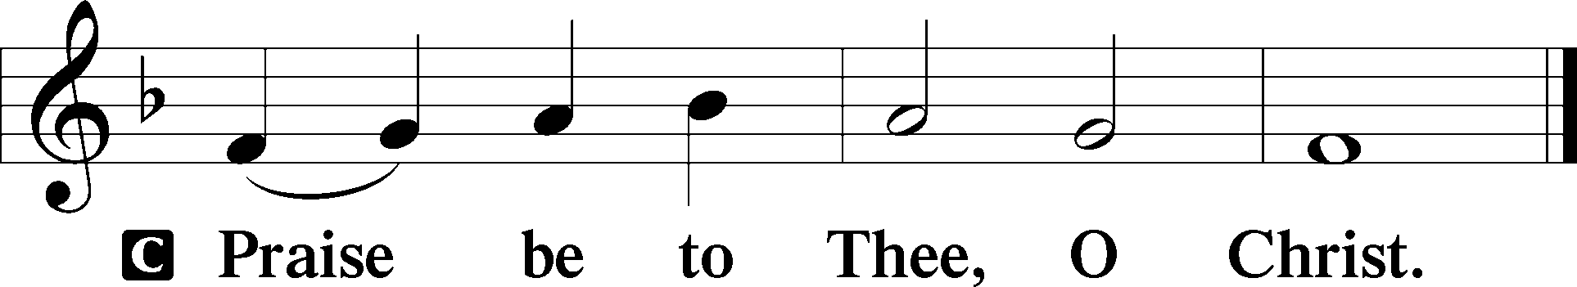

Nicene Creed
C I believe in one God,
the Father Almighty,
maker of heaven and earth
and of all things visible and invisible.

And in one Lord Jesus Christ,
the only-begotten Son of God,
begotten of His Father before all worlds,
God of God, Light of Light,
very God of very God,
begotten, not made,
being of one substance with the Father,
by whom all things were made;
who for us men and for our salvation came down from heaven
and was incarnate by the Holy Spirit of the virgin Mary
and was made man;
and was crucified also for us under Pontius Pilate.
He suffered and was buried.
And the third day He rose again according to the Scriptures
and ascended into heaven
and sits at the right hand of the Father.
And He will come again with glory to judge both the living and the dead,
whose kingdom will have no end.
And I believe in the Holy Spirit,
the Lord and giver of life,
who proceeds from the Father and the Son,
who with the Father and the Son together is worshiped and glorified,
who spoke by the prophets.
And I believe in one holy Christian and apostolic Church,
I acknowledge one Baptism for the remission of sins,
and I look for the resurrection of the dead
and the life T of the world to come. Amen.
Sit

Hymn of the Day: LSB #820 “My Soul, Now Praise Your Maker”

Sermon

Stand

Offertory Psalm 51:10–12
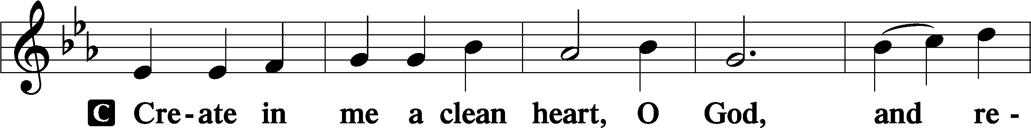
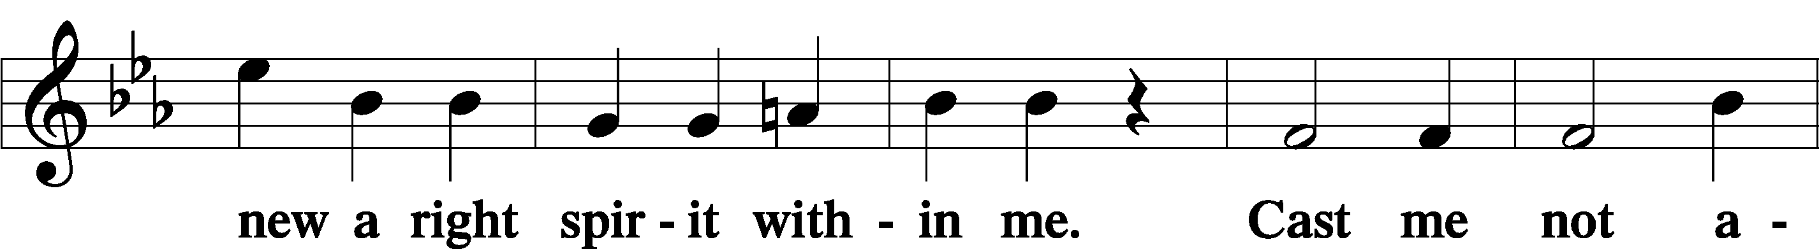
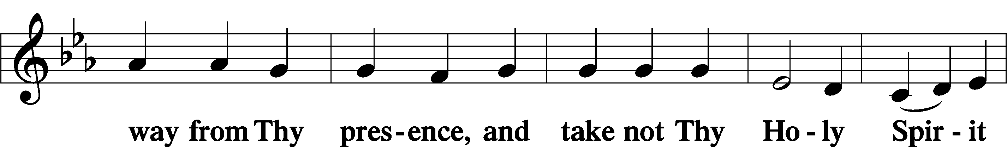
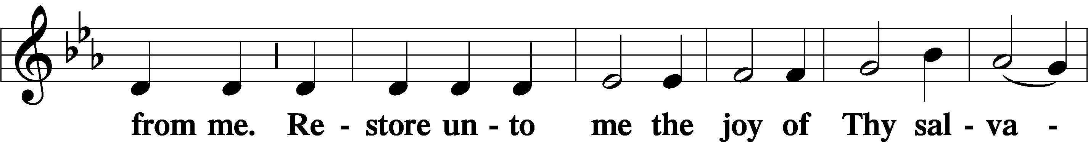
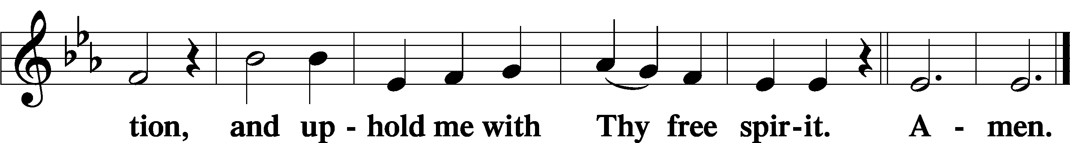

Prayer of the Church

Sit

Preparatory Hymn: LSB #790 “Praise to the Lord, the Almighty”

Stand
Service of the Sacrament

Preface 2 Timothy 4:22; Colossians 3:1 Psalm 136
P The Lord be with you.
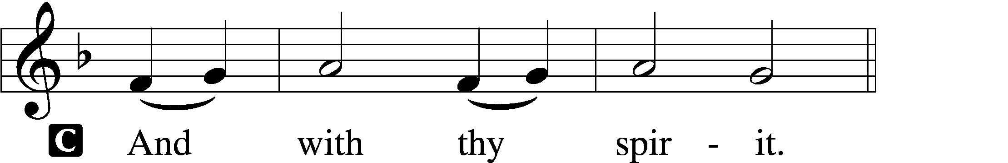

P Lift up your hearts.
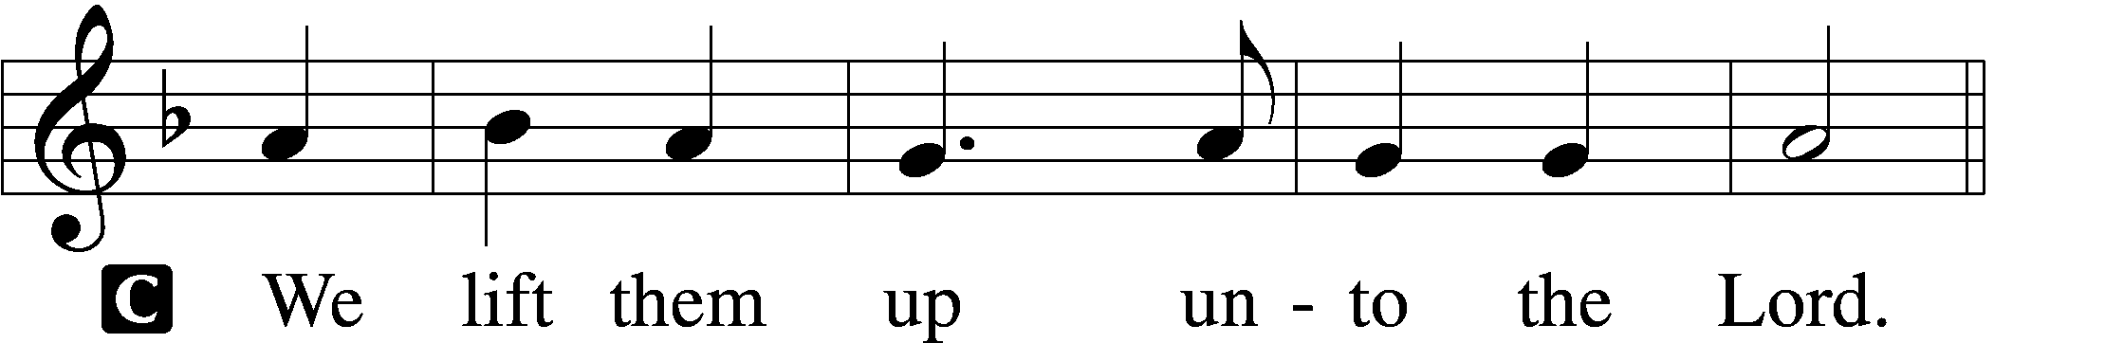

P Let us give thanks unto the Lord, our God.
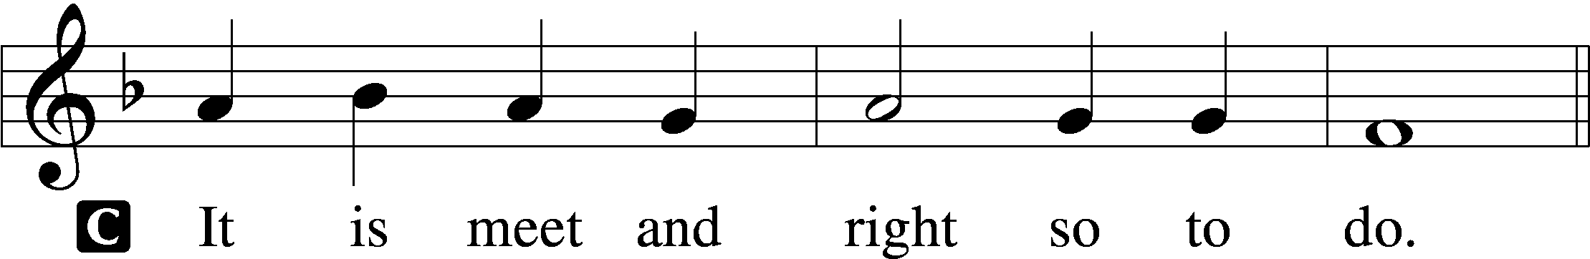

Proper Preface (Abbreviated) LSB 194
P It is truly meet, right, and salutary . . . evermore praising You and saying:

Sanctus Isaiah 6:3; Matthew 21:9
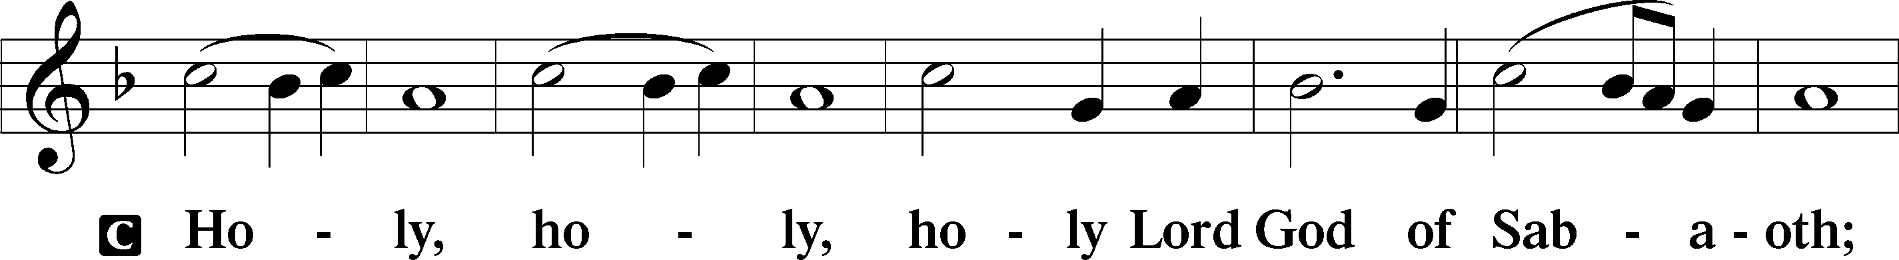
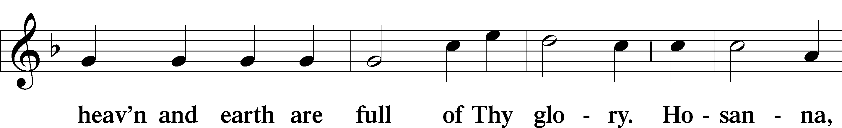
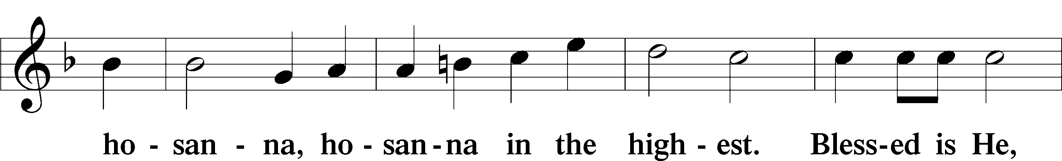
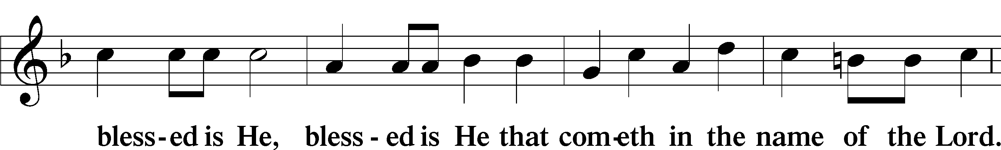
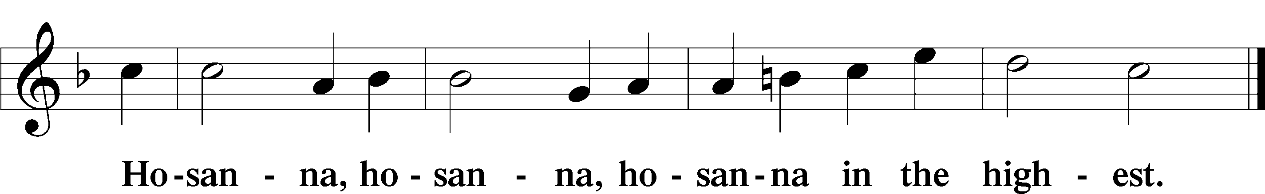

Lord’s Prayer Matthew 6:9–13
C Our Father who art in heaven,
hallowed be Thy name,
Thy kingdom come,
Thy will be done on earth as it is in heaven;
give us this day our daily bread;
and forgive us our trespasses as we forgive those who trespass against us;
and lead us not into temptation,
but deliver us from evil.
For Thine is the kingdom and the power and the glory forever and ever. Amen.

The Words of Our Lord Matthew 26:26–28; Mark 14:22–24; Luke 22:19–20; 1 Corinthians 11:23–25
P Our Lord Jesus Christ, on the night when He was betrayed, took bread, and when He had given thanks, He broke it and gave it to the disciples and said: “Take, eat; this is My T body, which is given for you. This do in remembrance of Me.”

In the same way also He took the cup after supper, and when He had given thanks, He gave it to them, saying: “Drink of it, all of you; this cup is the new testament in My T blood, which is shed for you for the forgiveness of sins. This do, as often as you drink it, in remembrance of Me.”
Pax Domini John 20:19
P The peace of the Lord be with you always.
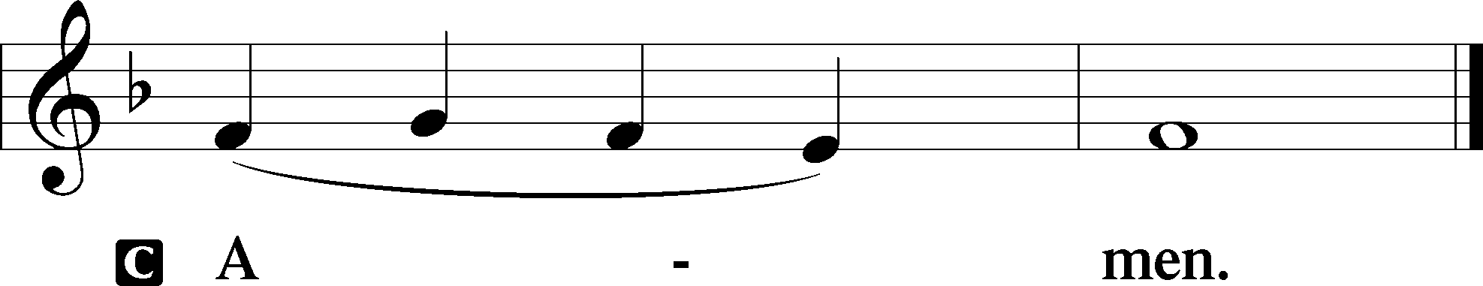

Agnus Dei John 1:29
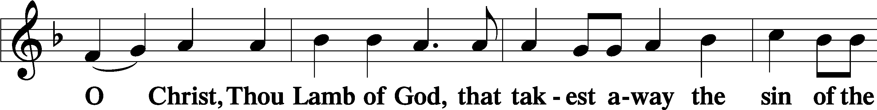
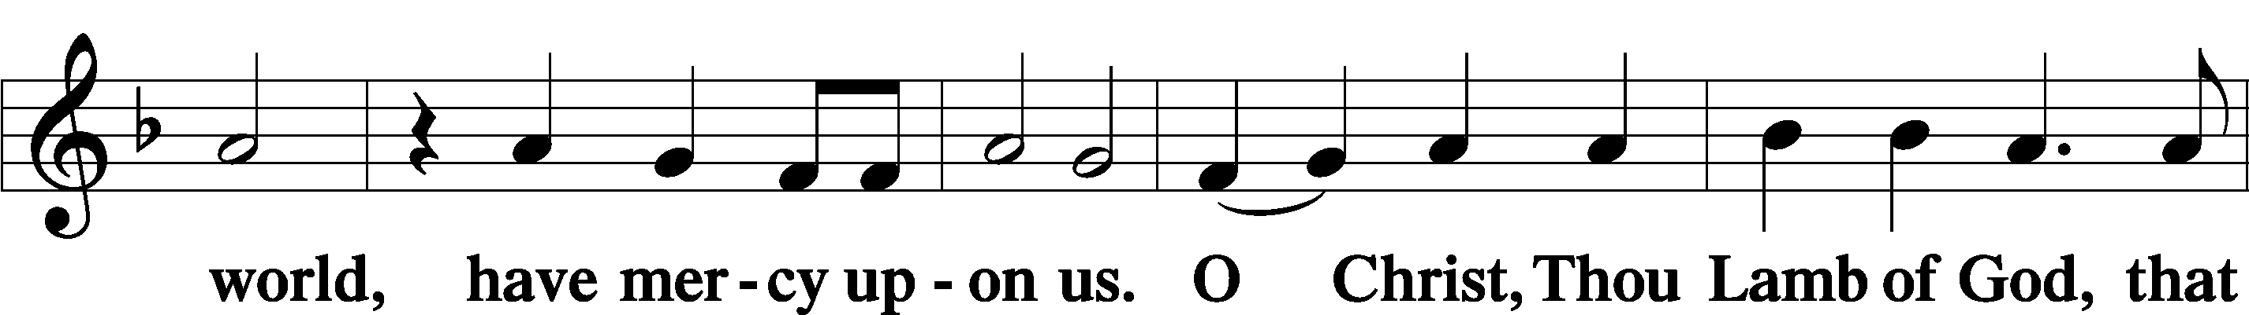
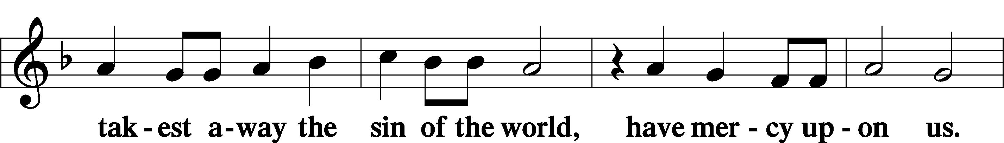
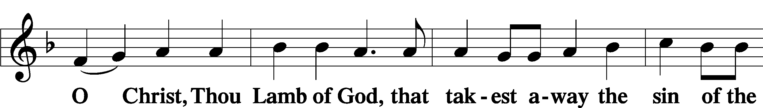
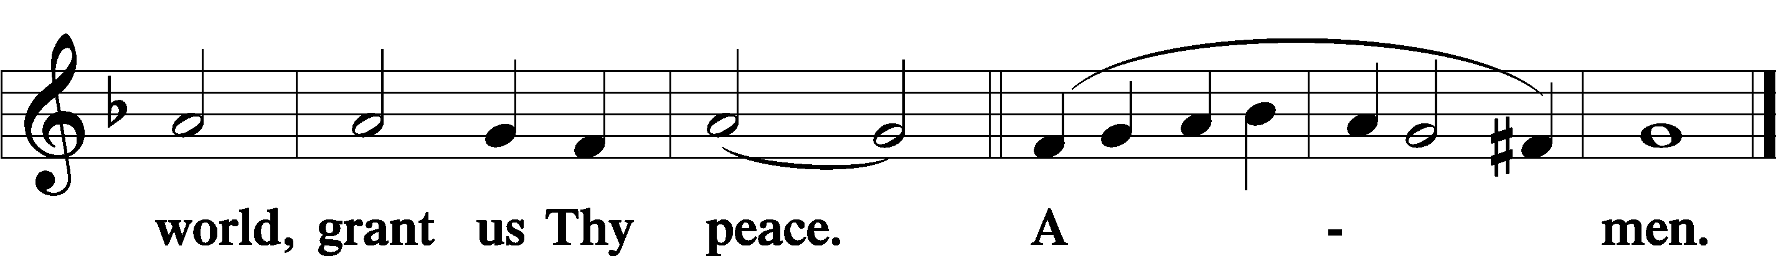
Sit

Distribution
The pastor and those who assist him receive the body and blood of Christ first and then distribute them to those who come to receive, saying:
Take, eat; this is the true body of our Lord and Savior Jesus Christ, given into death for your sins.
Amen.

Take, drink; this is the true blood of our Lord and Savior Jesus Christ, shed for the forgiveness of your sins.
Amen.

In dismissing the communicants, the following is said:
The Dismissal
P The body and blood of our Lord Jesus Christ strengthen and preserve you in body and soul to life everlasting. Depart T in peace.
C Amen.

Distribution Hymn: LSB #402 “The Only Son from Heaven”

Distribution Hymn: LSB #545 “Word of God, Come Down on Earth”

Distribution Hymn: LSB #630 “Now, My Tongue, the Mystery Telling”

Nunc Dimittis Luke 2:29–32
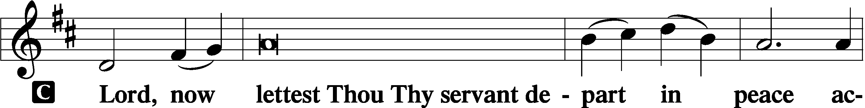
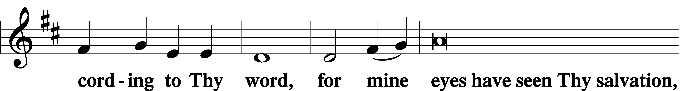
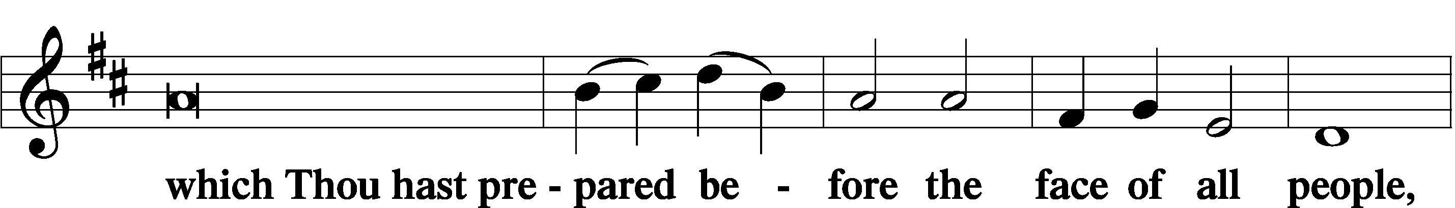
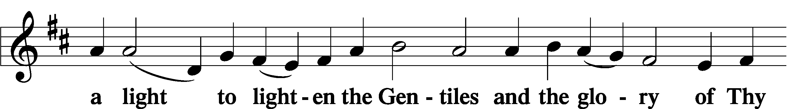
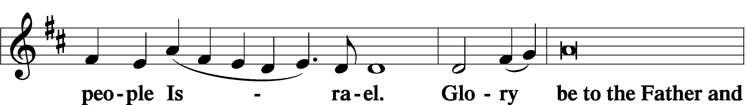
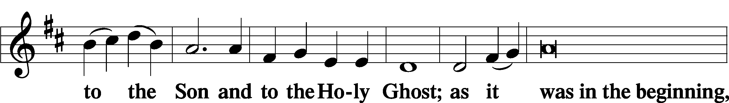
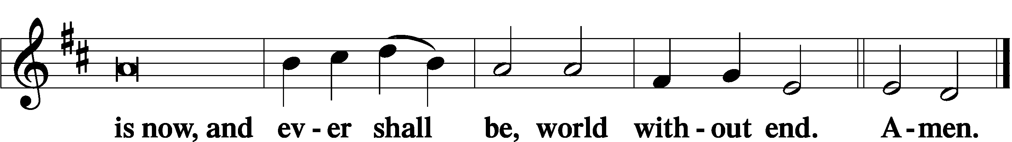

Thanksgiving Psalm 107:1
P O give thanks unto the Lord, for He is good,
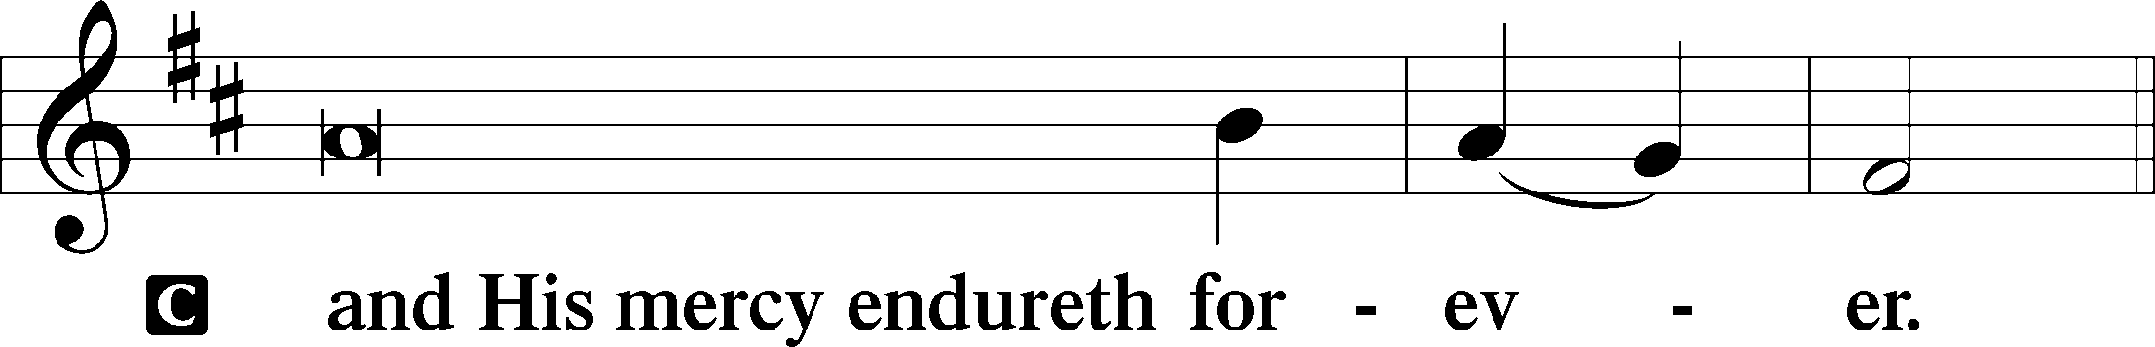

Post-Communion Collect
P Let us pray.
We give thanks to You, almighty God, that You have refreshed us through this salutary gift, and we implore You that of Your mercy You would strengthen us through the same in faith toward You and in fervent love toward one another; through Jesus Christ, Your Son, our Lord, who lives and reigns with You and the Holy Spirit, one God, now and forever.
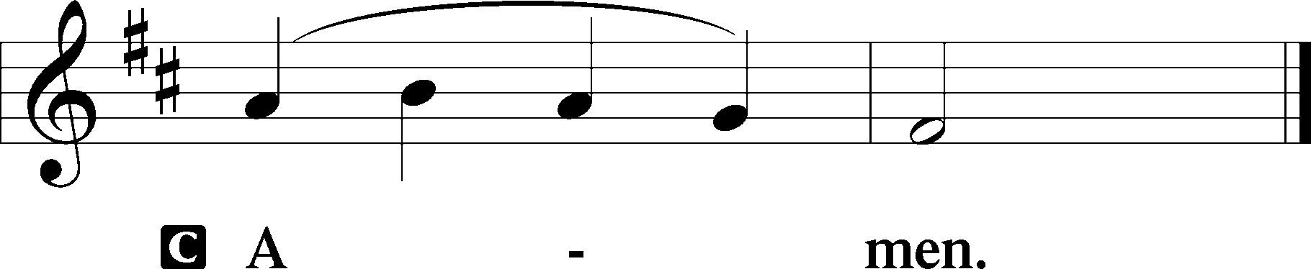

Salutation 2 Timothy 4:22
P The Lord be with you.
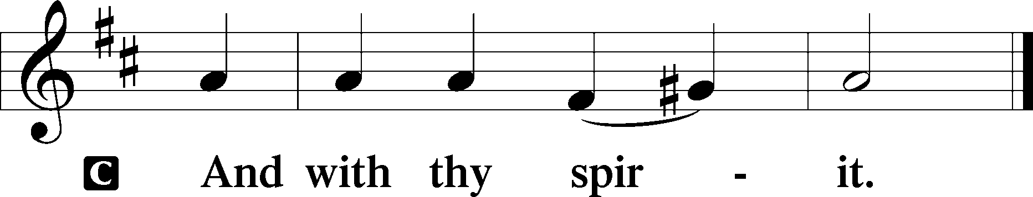

Benedicamus Psalm 103:1
P Bless we the Lord.
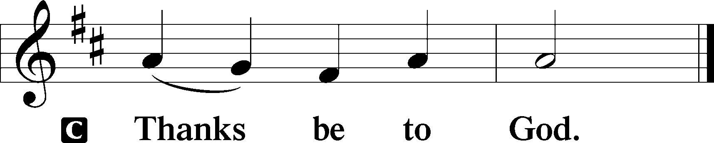

Benediction Numbers 6:24–26
P The Lord bless you and keep you.
The Lord make His face shine upon you and be gracious unto you.
The Lord lift up His countenance upon you and T give you peace.
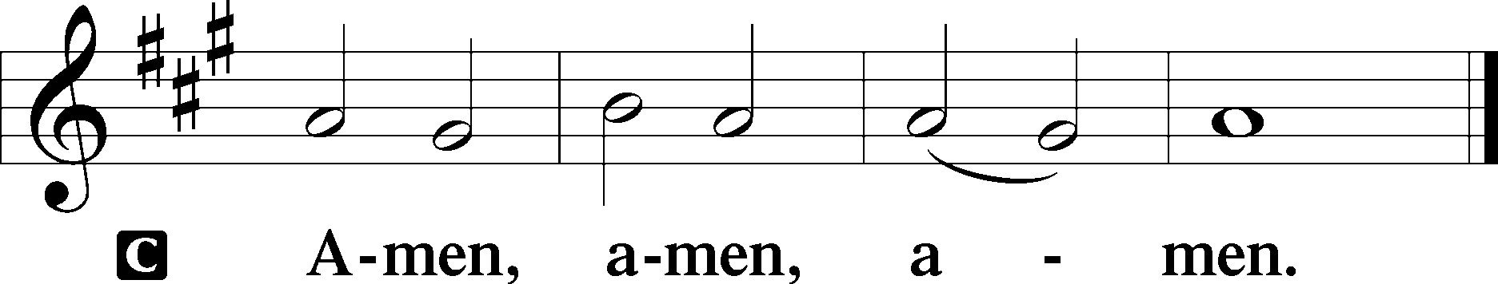

Closing Hymn: LSB #533 “Jesus Has Come and Brings Pleasure”

Silent prayer after worship: Dear Jesus, You have prepared a place for me in heaven. Lead me to faithfully follow You and to be in Your Word always that I may not lose my faith, but may one day see You in all Your glory at the Father’s side. Amen.
fffffffffffffffffffffffffffffffffff
Acknowledgments
Unless otherwise indicated, Scripture quotations are from the ESV® Bible (The Holy Bible, English Standard Version®), copyright © 2001 by Crossway, a publishing ministry of Good News Publishers. Used by permission. All rights reserved.
Created by Lutheran Service Builder © 2023 Concordia Publishing House.
fffffffffffffffffffffffffffffffffff

SCHEDULE THROUGH SEPTEMBER 3, 2023:

:

Today, following Worship, Library: Audit of Deposits
7 pm, Fellowship Hall: AA Meeting
Tuesday, 7-9 pm, Fellowship Hall: Penn-Ohio Singers
Wednesday, 7:30 pm, Fellowship Hall: NA Meeting
Next Sunday, 8 am, Fellowship Hall: Bible Study
9 am, Sanctuary: Divine Service
7 pm, Fellowship Hall: AA Meeting
fffffffffffffffffffffffffffffffffff
Attendance: Sunday, August 20, 2023: 32
fffffffffffffffffffffffffffffffffff
We are sincerely grateful to Pastor Arthur Baisch who is filling in for Pastor Deal during his time off.
Pastor Deal continues to be on vacation through August 28. If in need of pastoral care during this time, please contact either Pastor Baisch (501-253-8292) or Elder Jonathan Baisch (724-816-6866).
fffffffffffffffffffffffffffffffffff

Our Stewardship of Treasures for the Lord:
In order to do the Lord’s work, we need $2,553.63 each week to meet our 2023 budget for general purposes and $76.92 for the SELC.
Figures for Sunday, August 20, 2023
General Fund: $1,080.00 Behind for the week: -$1,473.63
SELC: $0.00 Behind for the week: -$76.92
Food Pantry: $60.00
Capital Campaign: $70.00
Other: $28.00

For online giving, check out https://www.saintspeterandpaul.net/online-giving.
fffffffffffffffffffffffffffffffffff
THANK YOU FOR SERVING IN AUGUST: Elder: Jonathan Baisch; Ushers: Cheryl Fedele, Mike Flaugher, & Jesse Riffle; Altarware: (prior) Diane Riefstahl & Marie Flaugher (08/13); (after) Hank Holcroft & Kati Laird.
fffffffffffffffffffffffffffffffffff
Bible Memory Verses ~ Week of August 27th:
For Adults: You are Peter, and on this rock I will build my church, and the gates of hell shall not prevail against it. Matthew 16:18
For Children: A bruised reed he will not break, and a smoldering wick he will not quench. Matthew 12:20
fffffffffffffffffffffffffffffffffff
Available this morning:
- Copies of the September issue of “The Rock and the Sword” newsletter (narthex and table near nursery).
fffffffffffffffffffffffffffffffffff
THANK YOU FOR SERVING IN SEPTEMBER: Elder: Jonathan Baisch; Ushers: Mark Kleindienst, Jerry Krivosh, & Gordon Marquette; Altarware: (prior) Diane Riefstahl; (after) Arlene Sutton (09.10), Kati Laird (09.03, 09.17, and 09/24), and Hank Holcroft (all).
fffffffffffffffffffffffffffffffffff
Sunday Morning Bible Study resumes next Sunday, September 3. We will continue our study of the minor prophets. All are welcome to join!
fffffffffffffffffffffffffffffffffff
Remember the following in Prayer…
~The Hurting and Healing: Amy, Steve Antolovich, Ellen Baron^{CA}, Amy Blomenberg, Lois Bortner^{CA}, Sara Brubaker, Dee Bullock, Bev & Joe Chlpka, Susan Davies, Loretta Deal, Tim Dudash, Judith & Eddy Furey, Griffin, Austin Hamilton, Pastor Charles Henrickson, Joan, Keith Jozwiakowski, Darla Krajci, Barbara Kreske, Pastor Ed Kucera, Jess Lavoie, Elizabeth Loughan, Paul Lucas^{CA}, Sandy Marshall, Gene Moore, Frank Niemeyer^{CA}, Juanita Rentschler, Richard Reuning^{CA}, Nancy Robertson^{CA}, Landon Sargent, Kriss Svidro^{CA}, Joel & Peggy Wasson, Angela Weser^{CA}, and Ruth Wolf.
~The Homebound: Anna Mae Daris, Millie Elavsky, Rudy & Jean Tomko, Betty Wolf, and Ed & Millie Zachar.
~Celebrating this Week: Birthdays: Alex (Sasha) Carr (08.28) and Elizabeth Loughan (08.30).
~Serving in the Military: Alex (Sasha) Carr, Curtis Sinewe, and Joshua Solyan.
~Community & World Needs: Those suffering from or affected by the coronavirus; those suffering due to the conflict between Ukraine and Russia; those suffering from loss and dislocation because weather disasters; those suffering from addiction and their families; Local, State, and National Government Leaders; safety for all Police Officers, Firefighters, & First Responders; the unemployed; our Third Quarter Local Mission: Luther Classical College.
*CA represents cancer.
fffffffffffffffffffffffffffffffffff
Our prayer list has been updated. If you would like someone’s name added or deleted from our Prayer List, please put a note in the secretary’s mail slot or email the church office. Thank you!
fffffffffffffffffffffffffffffffffff

Here to Serve
Pastor………………………………………………...……………Rev. Jacob Deal
E-mail …………………………….……pastordeal@saintspeterandpaul.net
Phone Number……………………..…………………724-347-3620 (Option 2)
Church Office………………………..…………………724-347-3620 (Option 3)
Website …………………………………………www.saintspeterandpaul.net
Secretary…………………………………………………………Diane Riefstahl
E-mail ………………………………………church@saintspeterandpaul.net
Website …………………………………………www.saintspeterandpaul.net
Food Pantry (email): ……………foodpantry@saintspeterandpaul.net
Congregation President………………………………….…Jonathan Baisch
Church Elder …………………………………………...……. Jonathan Baisch
Organist………………………………………………..….…Rebecca Marquette
Choir Director…………………………………………………….…Chris Nelson
AA Contact: Steve………………………………………………...…724-813-2358
NA Contact: Larry……………………………………..…………..724-977-8733
fffffffffffffffffffffffffffffffffff
If needing to get into the church building during the week, please phone first to make certain someone is here to let you in.

