Sts. Peter & Paul
Evangelical Lutheran Church
Lutheran Church-Missouri Synod
Founded-1917

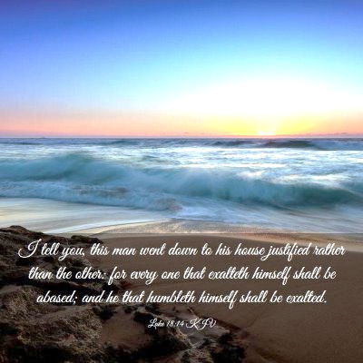

August 20, 2023

699 Stambaugh Ave.
Sharon, Pennsylvania 16146

“I was glad when they said to me,
Let us go to the house of the LORD!”
Psalm 122:1
Sts. Peter & Paul Evangelical Lutheran Church, LC-MS
THE ELEVENTH SUNDAY AFTER TRINITY
August 20, 2023
A special welcome to our guests this day! If you would like more information about The Lutheran Church - Missouri Synod, or this congregation, please speak with Pastor Deal or an Elder after the service.
Members & Guests: Don’t be embarrassed if your children make noise during the worship service, all children do. We encourage families to worship together but, if you feel the need, there are pews in the rear of the Church which are reserved for young families on both sides of the sanctuary. There is also a quiet room available to you, located next to the sanctuary (formerly the Pastor’s office), where you would be able to follow along with the service.

Today’s service includes the Sacrament of Holy Communion. If during this past year, you have not worshipped with us and been communed, we respectfully ask that you do not partake of this sacrament this day before first speaking with Pastor Deal.
If visiting from a sister congregation of the LC-MS and are in good standing, please inform Pastor Deal of your desire to commune prior to the service.
If wishing to receive a blessing during communion, please approach with your arms crossed.

CONTACT INFORMATION
Pastor Deal: pastordeal@saintspeterandpaul.net or 724-347-3620 (opt. 2)
Church Office: church@saintspeterandpaul.net or 724-347-3620 (opt. 3)
Secretary’s Office will be open Monday (8:30-4:30) and Thursday (as needed) this week.

Silent prayer before worship: Almighty God, open my eyes that I may see wonderful things in Your Word. Open my ears and my heart to hear Your voice through Holy Scriptures. Cause the light of Your love to shine forth from me so others may know You. In Jesus’ name. Amen.

Confession and Absolution

Opening Hymn: LSB #559 “Oh, How Great Is Your Compassion”

Stand

The sign of the cross may be made by all in remembrance of their Baptism.

Invocation
P In the name of the Father and of the T Son and of the Holy Spirit.
C Amen.

Exhortation Hebrews 10:22; Psalm 124:8; Psalm 32:5
P Beloved in the Lord! Let us draw near with a true heart and confess our sins unto God our Father, beseeching Him in the name of our Lord Jesus Christ to grant us forgiveness.

P Our help is in the name of the Lord,
C who made heaven and earth.
P I said, I will confess my transgressions unto the Lord,
C and You forgave the iniquity of my sin.

Silence for reflection on God’s Word and for self-examination.

Confession of Sins
P O almighty God, merciful Father,
C I, a poor, miserable sinner, confess unto You all my sins and iniquities with which I have ever offended You and justly deserved Your temporal and eternal punishment. But I am heartily sorry for them and sincerely repent of them, and I pray You of Your boundless mercy and for the sake of the holy, innocent, bitter sufferings and death of Your beloved Son, Jesus Christ, to be gracious and merciful to me, a poor, sinful being.

Absolution [John 20:19–23]
P Upon this your confession, I, by virtue of my office, as a called and ordained servant of the Word, announce the grace of God unto all of you, and in the stead and by the command of my Lord Jesus Christ I forgive you all your sins in the name of the Father and of the T Son and of the Holy Spirit.
C Amen.
Service of the Word

Introit Psalm 68:1, 3, 7a, 10b, 19; antiphon: vv. 5b, 6a, 35b
God is in his holy habi- | tation;*
[he] settles the solitary | in a home.
The God of Israel—he | is the one*
who gives power and strength to his | people.
God shall arise, his enemies shall be | scattered;*
and those who hate him shall flee be- | fore him!
But the righteous shall be glad; they shall exult be- | fore God;*
they shall be jubilant | with joy!
O God, when you went out before your | people,*
in your goodness, O God, you provided for the | needy.
Blessèd be the Lord, who daily | bears us up;*
God is our sal- | vation.
God is in his holy habi- | tation;*
[he] settles the solitary | in a home.
The God of Israel—he | is the one*
who gives power and strength to his | people.

Gloria Patri
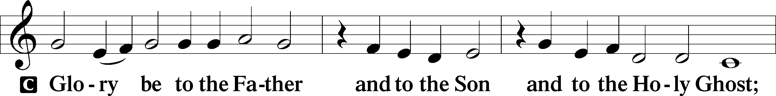
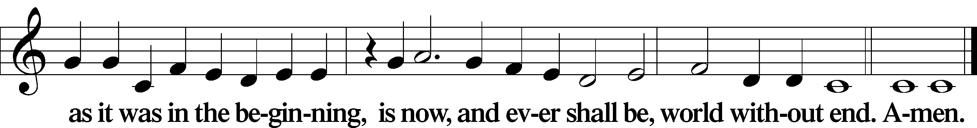

Kyrie Mark 10:47
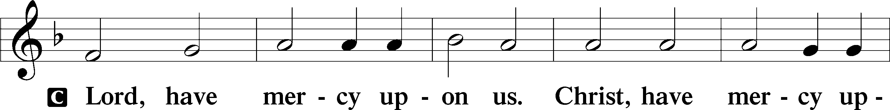
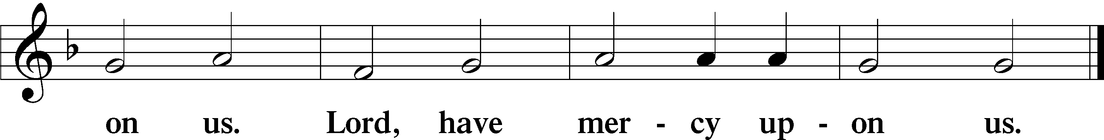

Gloria in Excelsis Luke 2:14; John 1:29
P Glory be to God on high:
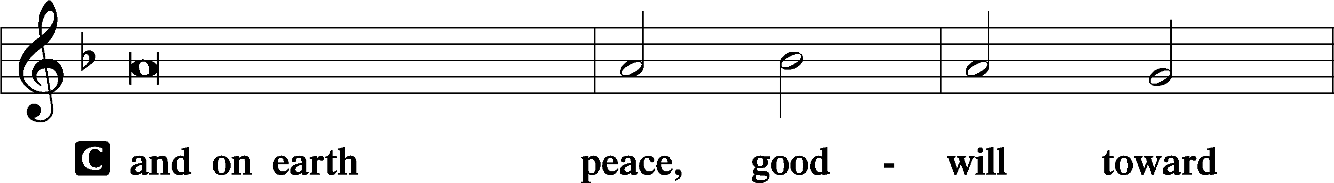
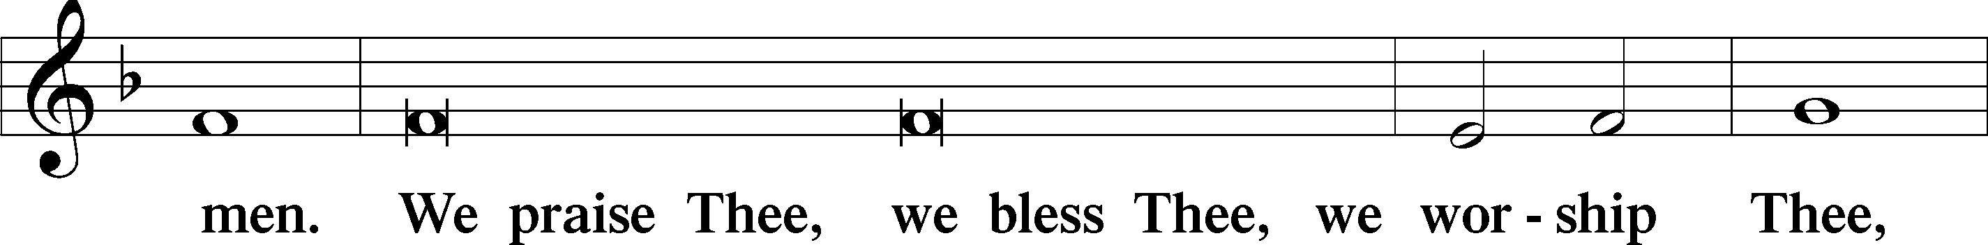
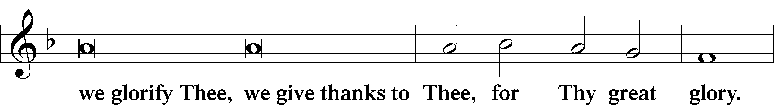
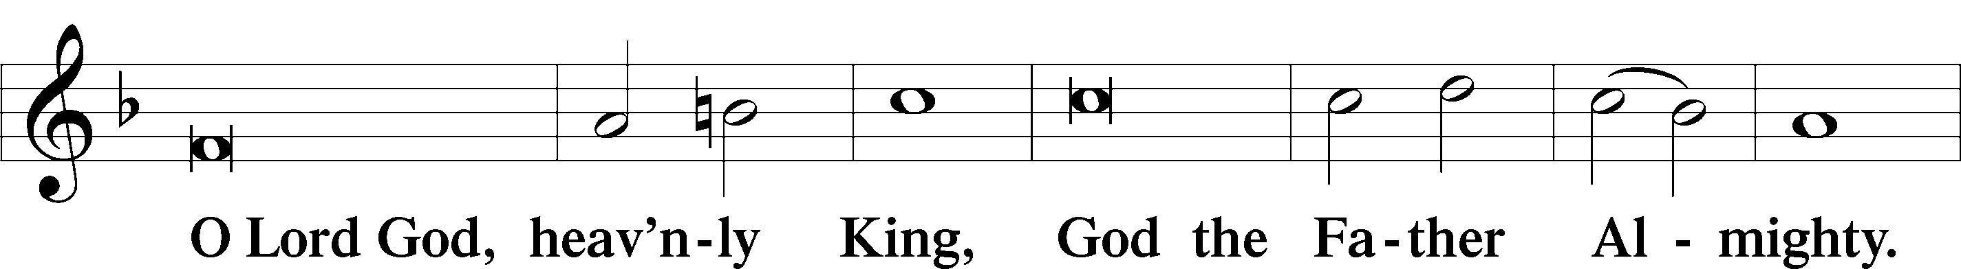
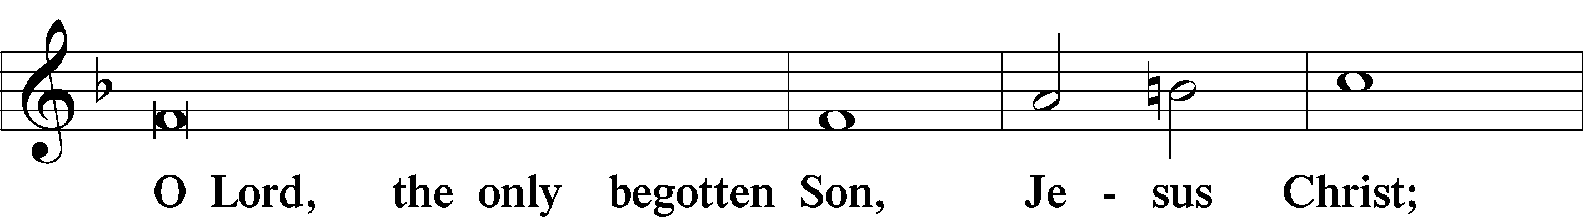
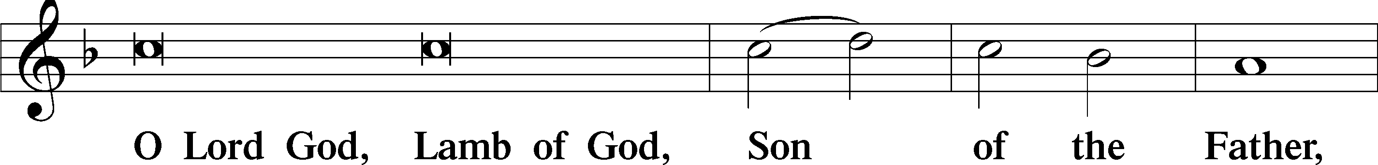
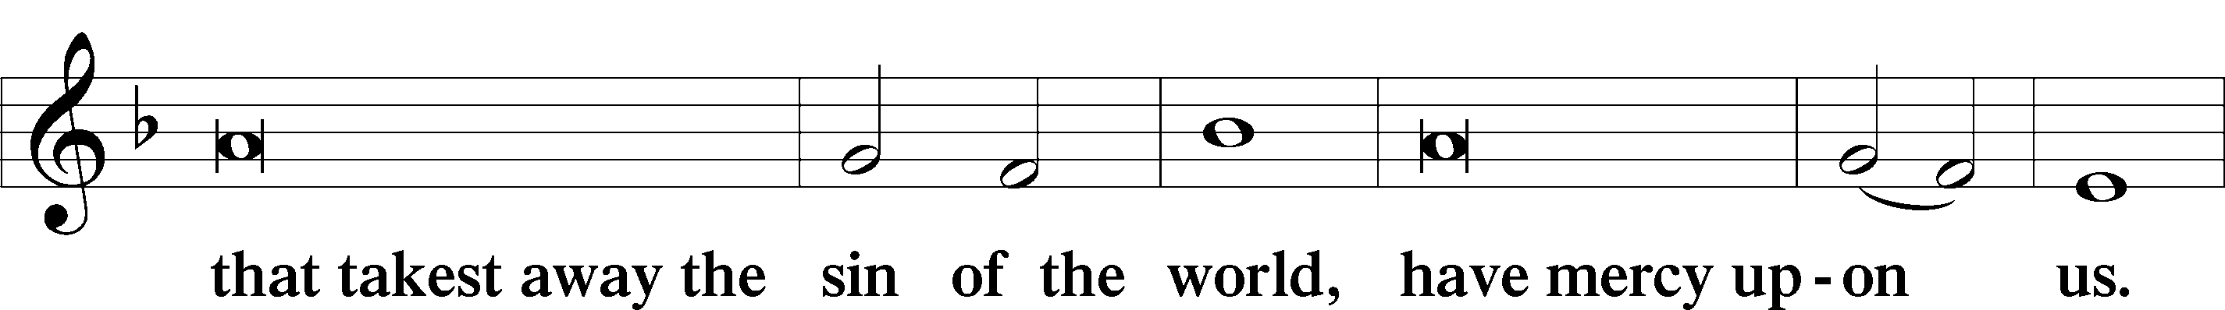
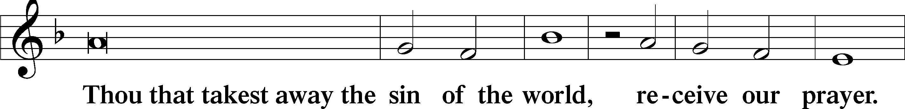
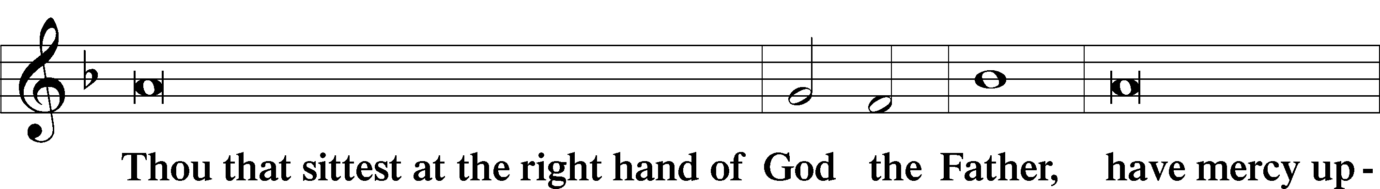
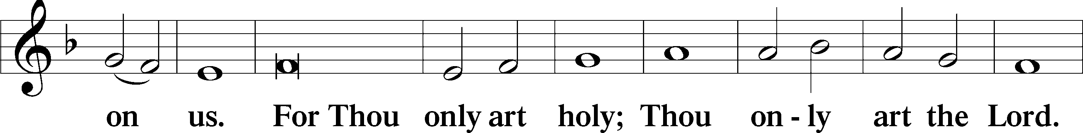
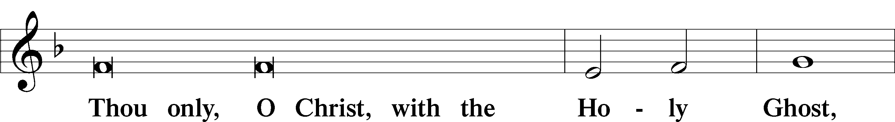
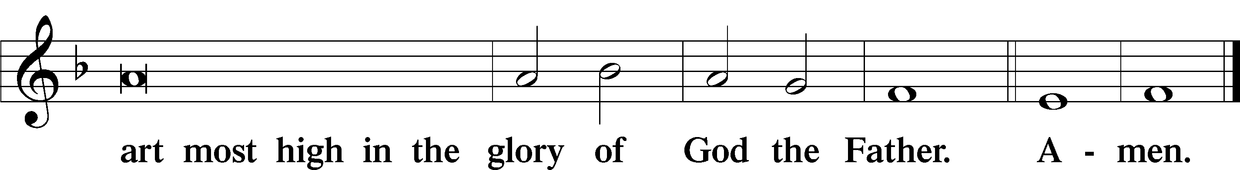

Salutation and Collect of the Day: Trinity 11
P The Lord be with you.
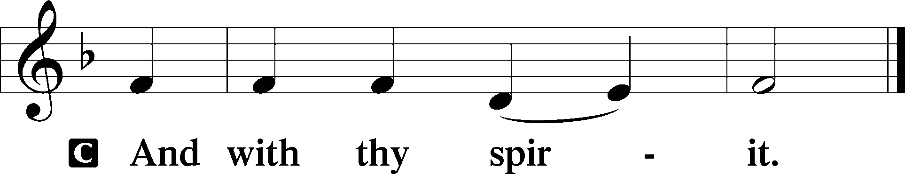

P Let us pray.
Almighty and everlasting God, always more ready to hear than we to pray and to give more than we either desire or deserve, pour down upon us the abundance of Your mercy, forgiving those things of which our conscience is afraid and giving us those good things that we are not worthy to ask, except through the merits and mediation of Christ, our Lord, who lives and reigns with You and the Holy Spirit, one God, now and forever.
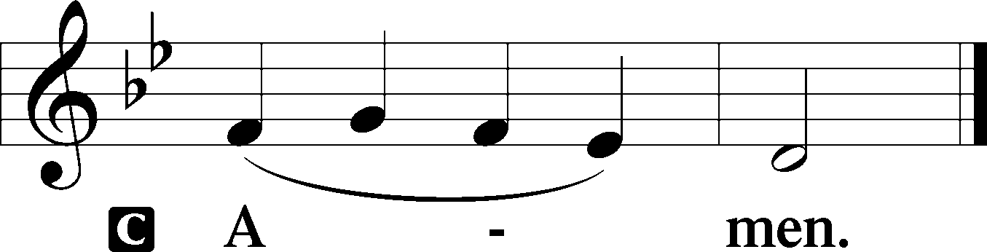
Sit
Prophecy: Genesis 4:1–15 (NKJV)
In those days: Adam knew Eve his wife, and she conceived and bore Cain, and said, “I have acquired a man from the Lord.” Then she bore again, this time his brother Abel. Now Abel was a keeper of sheep, but Cain was a tiller of the ground. And in the process of time it came to pass that Cain brought an offering of the fruit of the ground to the Lord. Abel also brought of the firstborn of his flock and of their fat. And the Lord respected Abel and his offering, but He did not respect Cain and his offering. And Cain was very angry, and his countenance fell. So the Lord said to Cain, “Why are you angry? And why has your countenance fallen? If you do well, will you not be accepted? And if you do not do well, sin lies at the door. And its desire is for you, but you should rule over it.” Now Cain talked with Abel his brother; and it came to pass, when they were in the field, that Cain rose up against Abel his brother and killed him. Then the Lord said to Cain, “Where is Abel your brother?” He said, “I do not know. Am I my brother’s keeper?” And He said, “What have you done? The voice of your brother’s blood cries out to Me from the ground. So now you are cursed from the earth, which has opened its mouth to receive your brother’s blood from your hand. When you till the ground, it shall no longer yield its strength to you. A fugitive and a vagabond you shall be on the earth.” And Cain said to the Lord, “My punishment is greater than I can bear! Surely You have driven me out this day from the face of the ground; I shall be hidden from Your face; I shall be a fugitive and a vagabond on the earth, and it will happen that anyone who finds me will kill me.” And the Lord said to him, “Therefore, whoever kills Cain, vengeance shall be taken on him sevenfold.” And the Lord set a mark on Cain, lest anyone finding him should kill him.

P This is the Word of the Lord.
C Thanks be to God.

Gradual Psalm 28:7b, 1a, 2a
In [God] my heart trusts, and | I am helped;*
my heart exults, and with my song I give | thanks to him.
To you, O Lord, I call; my rock, be not | deaf to me,*
hear the voice of my pleas for mercy, when I cry to | you for help.

Epistle: 1 Corinthians 15:1–10 (NKJV)
Brethren: I declare to you the gospel which I preached to you, which also you received and in which you stand, by which also you are saved, if you hold fast that word which I preached to you—unless you believed in vain. For I delivered to you first of all that which I also received: that Christ died for our sins according to the Scriptures, and that He was buried, and that He rose again the third day according to the Scriptures, and that He was seen by Cephas, then by the twelve. After that He was seen by over five hundred brethren at once, of whom the greater part remain to the present, but some have fallen asleep. After that He was seen by James, then by all the apostles. Then last of all He was seen by me also, as by one born out of due time. For I am the least of the apostles, who am not worthy to be called an apostle, because I persecuted the church of God. But by the grace of God I am what I am, and His grace toward me was not in vain; but I labored more abundantly than they all, yet not I, but the grace of God which was with me.

P This is the Word of the Lord.
C Thanks be to God.

Stand

Verse Psalm 90:1
Alleluia. Lord, you have been our dwelling place in all generations. Alleluia.

Alleluia
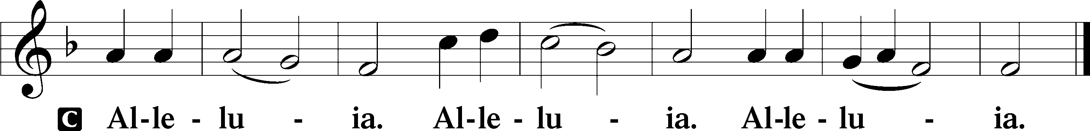

Holy Gospel: Luke 18:9–14 (NKJV)
P The Holy Gospel according to St. Luke, the eighteenth chapter.
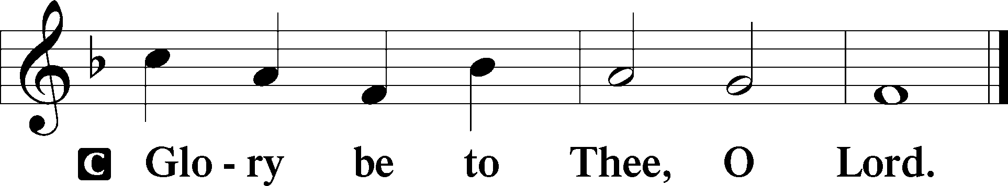

At that time: Jesus spoke this parable to some who trusted in themselves that they were righteous, and despised others: “Two men went up to the temple to pray, one a Pharisee and the other a tax collector. The Pharisee stood and prayed thus with himself, ‘God, I thank You that I am not like other men—extortioners, unjust, adulterers, or even as this tax collector. I fast twice a week; I give tithes of all that I possess.’ And the tax collector, standing afar off, would not so much as raise his eyes to heaven, but beat his breast, saying, ‘God, be merciful to me a sinner!’ I tell you, this man went down to his house justified rather than the other; for everyone who exalts himself will be humbled, and he who humbles himself will be exalted.”

P This is the Gospel of the Lord.
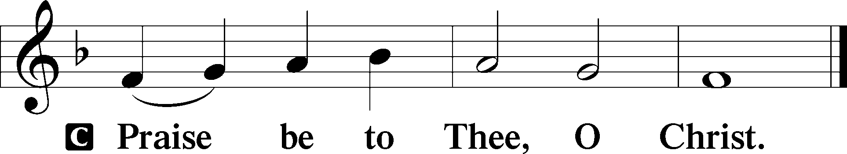

Nicene Creed
C I believe in one God,
the Father Almighty,
maker of heaven and earth
and of all things visible and invisible.

And in one Lord Jesus Christ,
the only-begotten Son of God,
begotten of His Father before all worlds,
God of God, Light of Light,
very God of very God,
begotten, not made,
being of one substance with the Father,
by whom all things were made;
who for us men and for our salvation came down from heaven
and was incarnate by the Holy Spirit of the virgin Mary
and was made man;
and was crucified also for us under Pontius Pilate.
He suffered and was buried.
And the third day He rose again according to the Scriptures
and ascended into heaven
and sits at the right hand of the Father.
And He will come again with glory to judge both the living and the dead,
whose kingdom will have no end.

And I believe in the Holy Spirit,
the Lord and giver of life,
who proceeds from the Father and the Son,
who with the Father and the Son together is worshiped and glorified,
who spoke by the prophets.
And I believe in one holy Christian and apostolic Church,
I acknowledge one Baptism for the remission of sins,
and I look for the resurrection of the dead
and the life T of the world to come. Amen.
Sit

Hymn of the Day: LSB #614 “’As Surely as I Live,’ God Said”

Sermon

Stand
Offertory Psalm 51:10–12
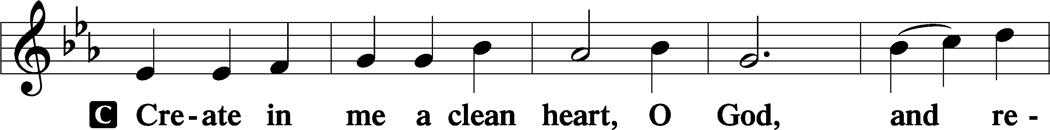
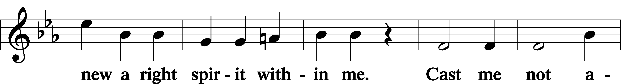
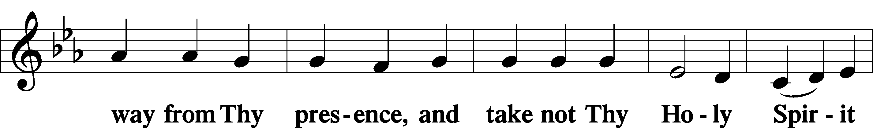
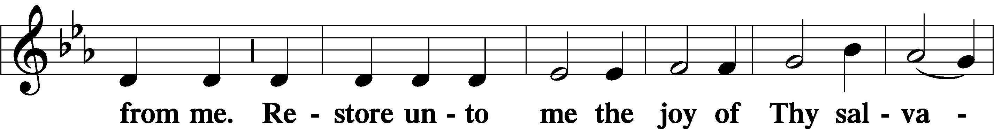
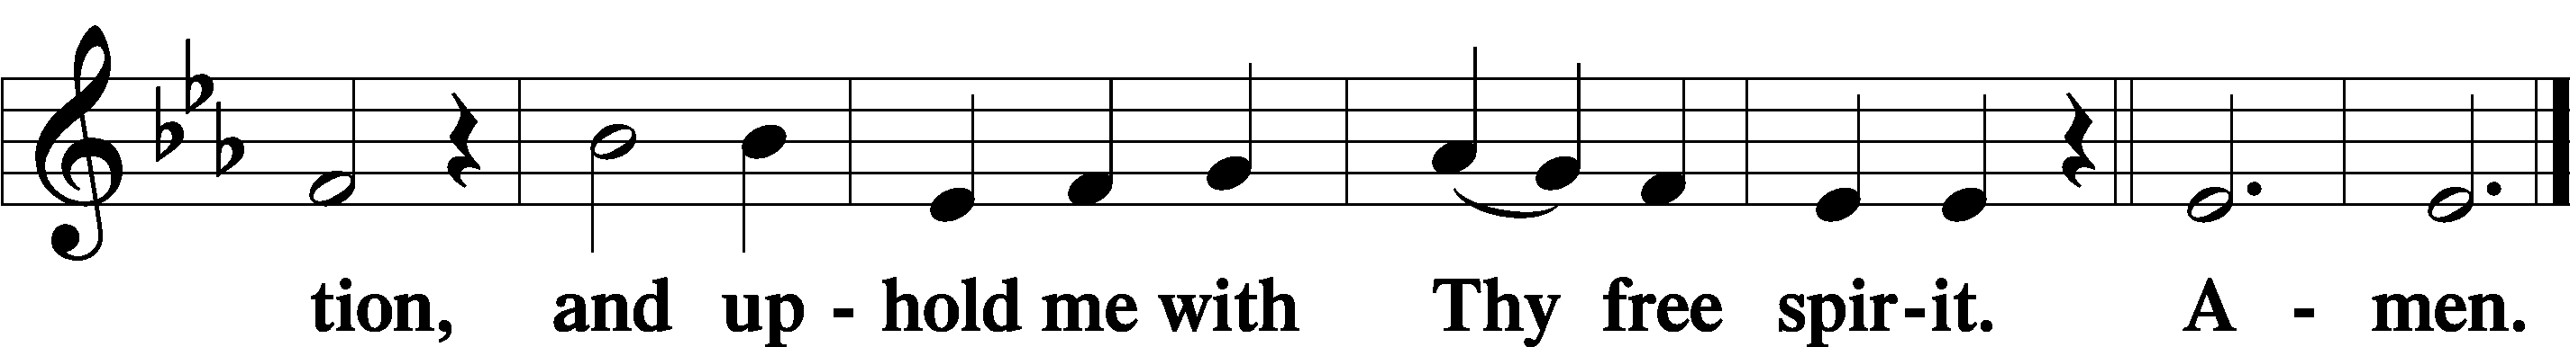

Prayer of the Church

Sit

Preparatory Hymn: LSB #815 “All Praise to Thee, for Thou, O King Divine”

Stand
Service of the Sacrament

Preface 2 Timothy 4:22; Colossians 3:1 Psalm 136
P The Lord be with you.

P Lift up your hearts.
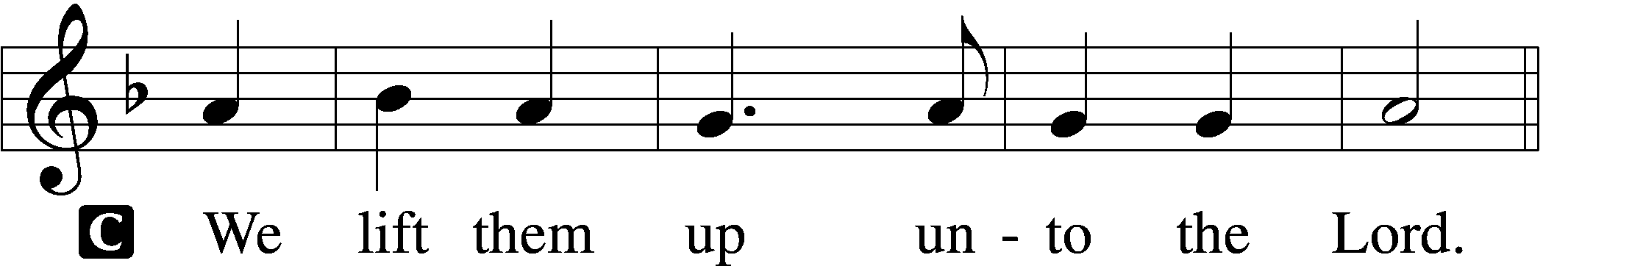
P Let us give thanks unto the Lord, our God.
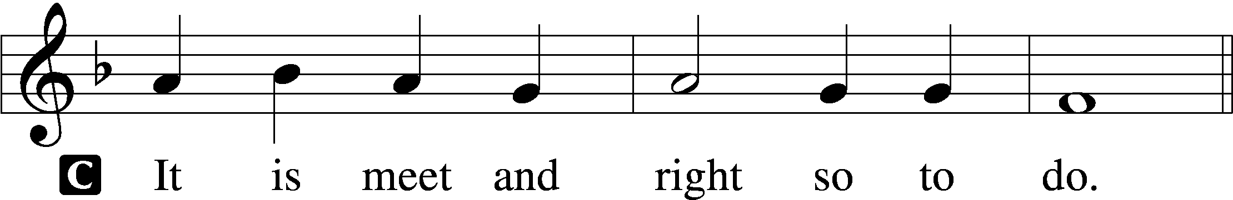

Proper Preface (Abbreviated) LSB 194
P It is truly meet, right, and salutary . . . evermore praising You and saying:

Sanctus Isaiah 6:3; Matthew 21:9
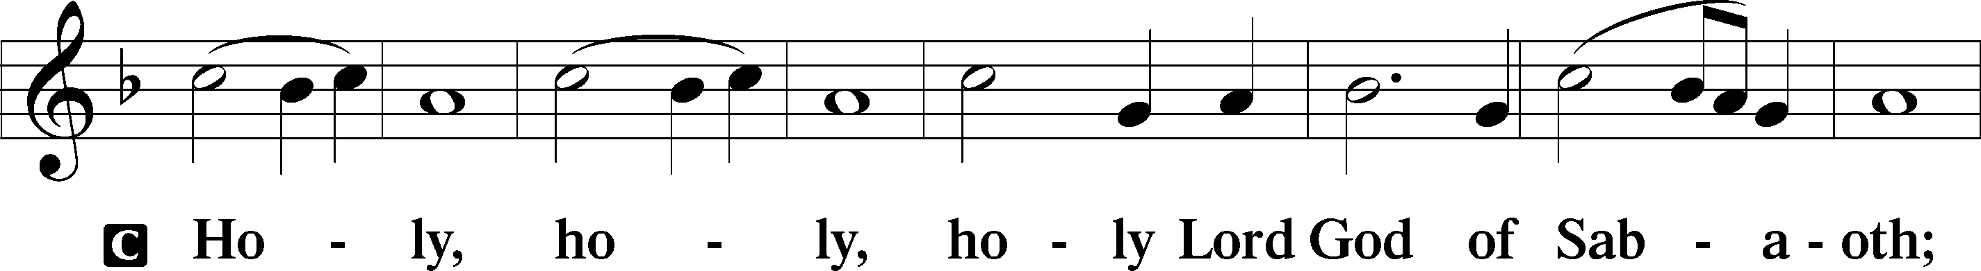
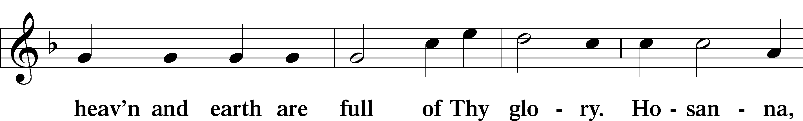
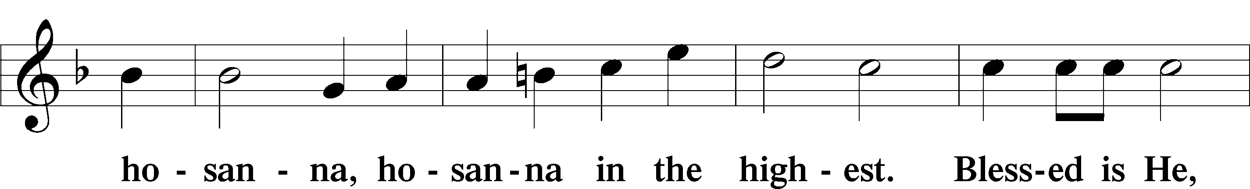
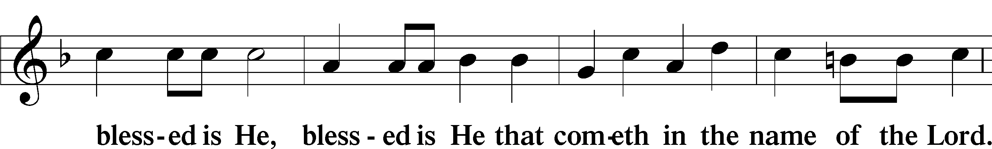
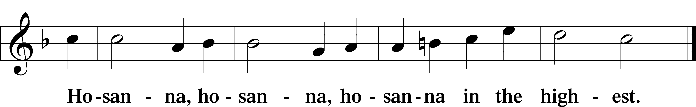

Lord’s Prayer Matthew 6:9–13
C Our Father who art in heaven,
hallowed be Thy name,
Thy kingdom come,
Thy will be done on earth as it is in heaven;
give us this day our daily bread;
and forgive us our trespasses as we forgive those who trespass against us;
and lead us not into temptation,
but deliver us from evil.
For Thine is the kingdom and the power and the glory forever and ever. Amen.

The Words of Our Lord Matthew 26:26–28; Mark 14:22–24; Luke 22:19–20; 1 Corinthians 11:23–25
P Our Lord Jesus Christ, on the night when He was betrayed, took bread, and when He had given thanks, He broke it and gave it to the disciples and said: “Take, eat; this is My T body, which is given for you. This do in remembrance of Me.”

In the same way also He took the cup after supper, and when He had given thanks, He gave it to them, saying: “Drink of it, all of you; this cup is the new testament in My T blood, which is shed for you for the forgiveness of sins. This do, as often as you drink it, in remembrance of Me.”

Pax Domini John 20:19
P The peace of the Lord be with you always.
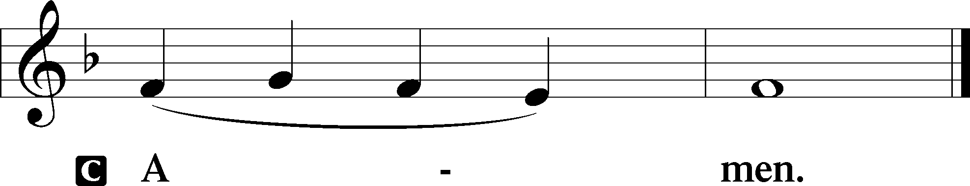

Agnus Dei John 1:29
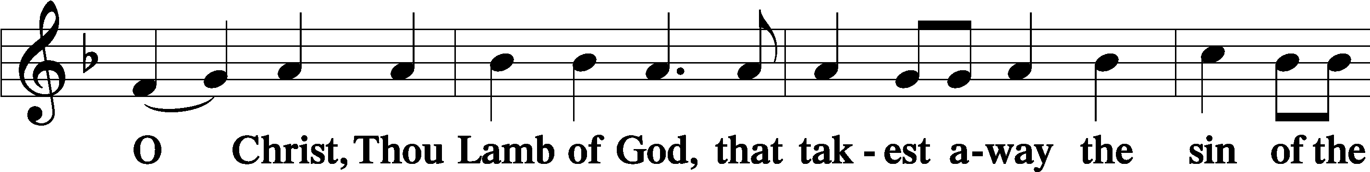
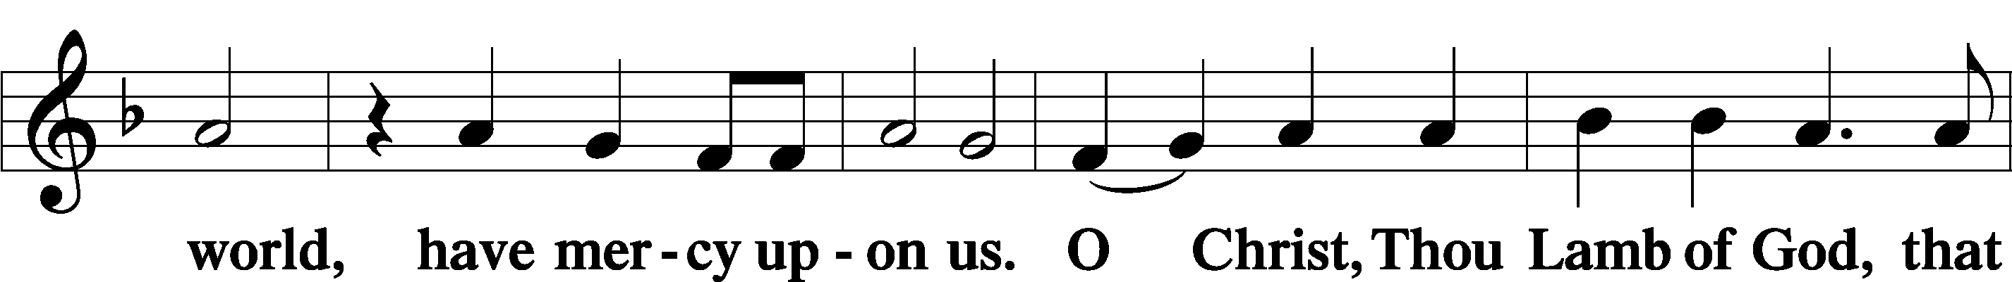
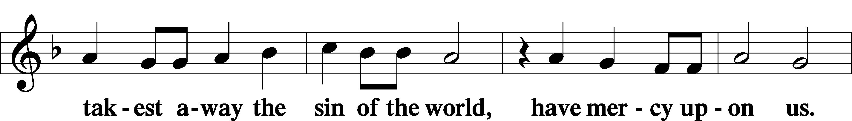
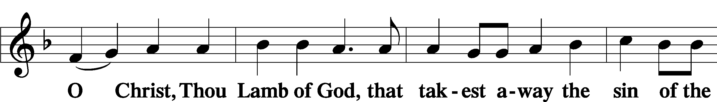
Sit

Distribution
The pastor and those who assist him receive the body and blood of Christ first and then distribute them to those who come to receive, saying:
Take, eat; this is the true body of our Lord and Savior Jesus Christ, given into death for your sins.
Amen.

Take, drink; this is the true blood of our Lord and Savior Jesus Christ, shed for the forgiveness of your sins.
Amen.

In dismissing the communicants, the following is said:
The Dismissal
P The body and blood of our Lord Jesus Christ strengthen and preserve you in body and soul to life everlasting. Depart T in peace.
C Amen.

Distribution Hymn: LSB #611 “Chief of Sinners Though I Be”

Distribution Hymn: LSB #617 “O Lord, We Praise Thee”

Distribution Hymn: LSB #615 “When in the Hour of Deepest Need”

Stand

Nunc Dimittis Luke 2:29–32
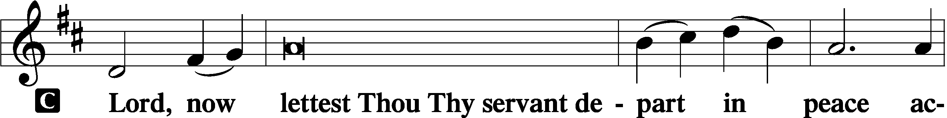
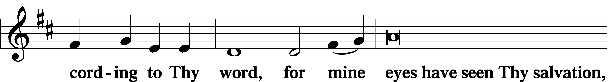
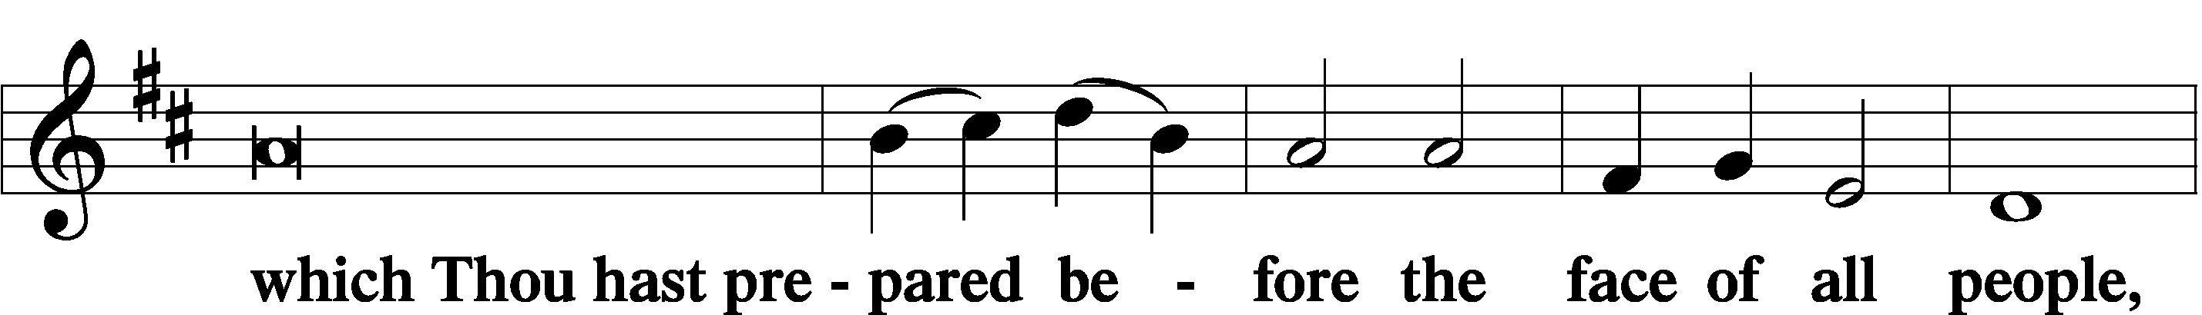
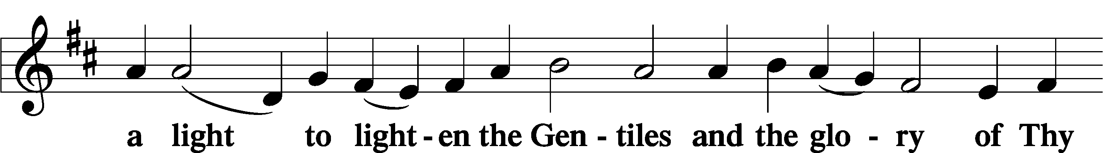
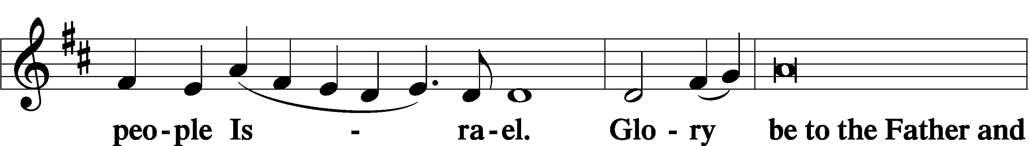
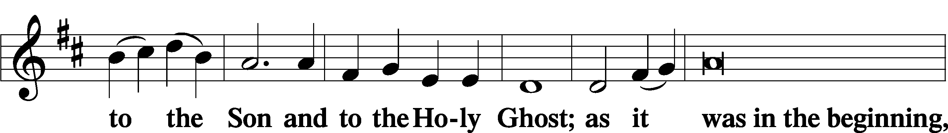
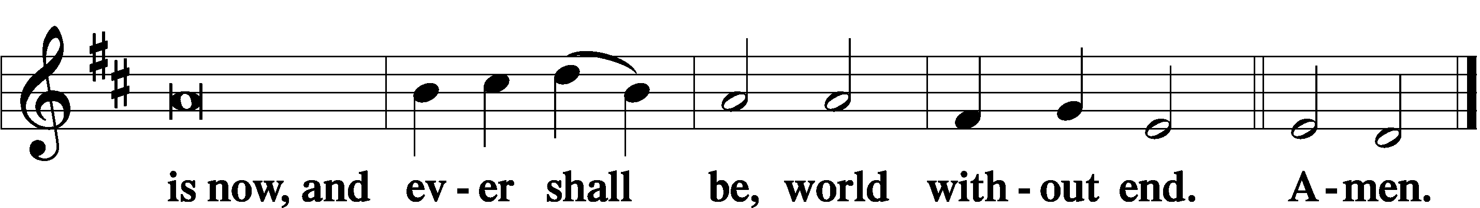

Thanksgiving Psalm 107:1
P O give thanks unto the Lord, for He is good,
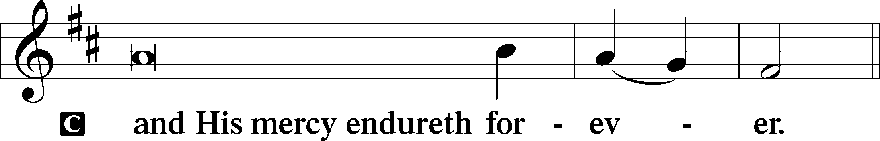

Post-Communion Collect
P Let us pray.
We give thanks to You, almighty God, that You have refreshed us through this salutary gift, and we implore You that of Your mercy You would strengthen us through the same in faith toward You and in fervent love toward one another; through Jesus Christ, Your Son, our Lord, who lives and reigns with You and the Holy Spirit, one God, now and forever.
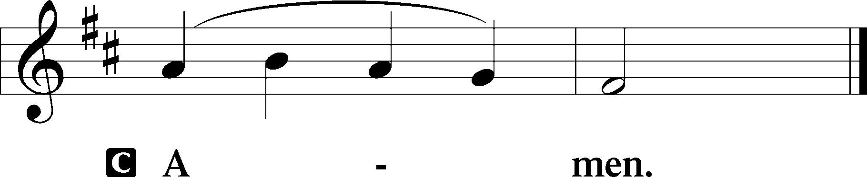

Salutation 2 Timothy 4:22
P The Lord be with you.
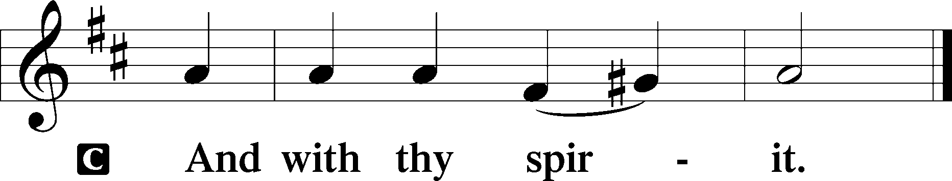

Benedicamus Psalm 103:1
P Bless we the Lord.
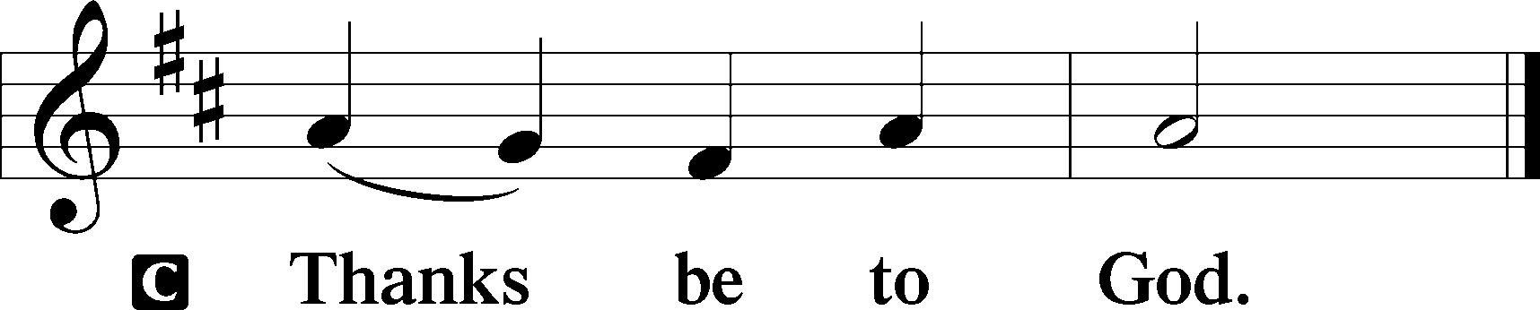

Benediction Numbers 6:24–26
P The Lord bless you and keep you.
The Lord make His face shine upon you and be gracious unto you.
The Lord lift up His countenance upon you and T give you peace.
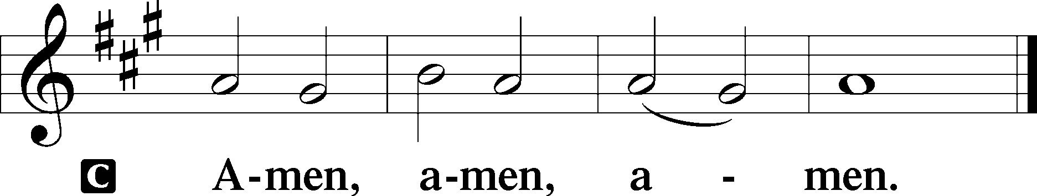

Closing Hymn: LSB #745 “In God, My Faithful God”

Silent prayer after worship: Heavenly Father, by the light of Your word, lead me around all spiritual dangers and temptations. Grant me Your strength and comfort, and remind me that You will never leave me nor forsake me. In Jesus’ name. Amen.
fffffffffffffffffffffffffffffffffff
Acknowledgments
Unless otherwise indicated, Scripture quotations are from the ESV® Bible (The Holy Bible, English Standard Version®), copyright © 2001 by Crossway, a publishing ministry of Good News Publishers. Used by permission. All rights reserved.
Created by Lutheran Service Builder © 2023 Concordia Publishing House.
fffffffffffffffffffffffffffffffffff
In Loving Memory of Martin Anderson: Jay & Judy Maher (Food Pantry)
In Loving Memory of Mother, Lillian Tomko, on her August birthday: Linda Tomko.
With Prayers for our Son-in-Law, Keith Jozwiakowski: Joe & Beverly Chlpka (Food Pantry).
fffffffffffffffffffffffffffffffffff
The Altar Flowers this morning are given by Ruth Meszaros & Joani Rice in Loving Memory of their Parents’, Paul & Millie Fabri’s, Wedding Anniversary, August 21, 1937. We are greatly appreciative of this gift.
fffffffffffffffffffffffffffffffffff

SCHEDULE THROUGH AUGUST 27, 2023:

:

Today, following Worship, Fellowship Hall: Voters’ Assembly
7 pm, Fellowship Hall: AA Meeting
Tuesday, 7-9 pm, Fellowship Hall: Penn-Ohio Singers
Wednesday, 7:30 pm, Fellowship Hall: NA Meeting
Thursday, 9 am, Downstairs: Food Pantry
Next Sunday, 9 am, Sanctuary: Divine Service
Following Worship, Library: Audit of Deposits
7 pm, Fellowship Hall: AA Meeting
fffffffffffffffffffffffffffffffffff
Attendance: Sunday, August 13, 2023: 47
fffffffffffffffffffffffffffffffffff
We are sincerely grateful to Pastor Arthur Baisch who will be filling in for Pastor Deal during his time off.
Pastor Deal continues to be on vacation through August 28. If in need of pastoral care during this time, please contact either Pastor Baisch (501-253-8292) or Elder Jonathan Baisch (724-816-6866).
fffffffffffffffffffffffffffffffffff
Our Stewardship of Treasures for the Lord:
In order to do the Lord’s work, we need $2,553.63 each week to meet our 2023 budget for general purposes and $76.92 for the SELC.
Figures for Sunday, August 13, 2023
General Fund: $2,455.00 Behind for the week: -$98.63
SELC: $78.00 Ahead for the week: +$1.08
Food Pantry: $115.00
Capital Campaign: $656.00
Other: $820.00

For online giving, check out https://www.saintspeterandpaul.net/online-giving.
fffffffffffffffffffffffffffffffffff
THANK YOU FOR SERVING IN AUGUST: Elder: Jonathan Baisch; Ushers: Cheryl Fedele, Mike Flaugher, & Jesse Riffle; Altarware: (prior) Diane Riefstahl & Marie Flaugher (08/13); (after) Hank Holcroft & Kati Laird.
fffffffffffffffffffffffffffffffffff
There will be a Voters’ Assembly held this morning in the Fellowship Hall ten minutes following the conclusion of the Divine Service. Your attendance will be greatly appreciated. Tentative agendas for the meeting are available on the table in the narthex.
fffffffffffffffffffffffffffffffffff
REMINDER: Items for the September calendar and newsletter are due to Diane by noon, tomorrow, August 21st.
fffffffffffffffffffffffffffffffffff
Information about the Barry Nelson Charitable Foundation and how you can donate is available on the tables in the narthex and by the nursery.
fffffffffffffffffffffffffffffffffff
Bible Memory Verses ~ Week of August 20th:
For Adults: Do not fear those who kill the body but cannot kill the soul. Rather fear him who can destroy both soul and body in hell. Matthew 10:28

For Children: God opposes the proud but gives grace to the humble.
1 Peter 5:5
fffffffffffffffffffffffffffffffffff

Remember the following in Prayer…
~The Hurting and Healing: Amy, Steve Antolovich, Ellen Baron^{CA}, Lois Bortner^{CA}, Dee Bullock, Bev & Joe Chlpka, Susan Davies, Loretta Deal, Tim Dudash, Judith & Eddy Furey, Griffin, Austin Hamilton, Pastor Charles Henrickson, Joan, Keith Jozwiakowski, Darla Krajci, Barbara Kreske, Pastor Ed Kucera, Jess Lavoie, Elizabeth Loughan, Paul Lucas^{CA}, Sandy Marshall, Gene Moore, Frank Niemeyer^{CA}, Juanita Rentschler, Richard Reuning^{CA}, Nancy Robertson^{CA}, Landon Sargent, Joel & Peggy Wasson, Angela Weser^{CA}, and Ruth Wolf.
~The Homebound: Anna Mae Daris, Millie Elavsky, Rudy & Jean Tomko, Betty Wolf, and Ed & Millie Zachar.
~Celebrating this Week: Anniversary: Rudy & Jean Tomko (08.20).
~Serving in the Military: Alex (Sasha) Carr, Curtis Sinewe, and Joshua Solyan.
~Community & World Needs: Those suffering from or affected by the coronavirus; those suffering due to the conflict between Ukraine and Russia; those suffering from loss and dislocation because weather disasters; those suffering from addiction and their families; Local, State, and National Government Leaders; safety for all Police Officers, Firefighters, & First Responders; the unemployed; our Third Quarter Local Mission: Luther Classical College.
*CA represents cancer.
fffffffffffffffffffffffffffffffffff
Our prayer list has been updated. If you would like someone’s name added or deleted from our Prayer List, please put a note in the secretary’s mail slot or email the church office. Thank you!
fffffffffffffffffffffffffffffffffff

Here to Serve
Pastor………………………………………………...……………Rev. Jacob Deal
E-mail …………………………….……pastordeal@saintspeterandpaul.net
Phone Number……………………..…………………724-347-3620 (Option 2)
Church Office………………………..…………………724-347-3620 (Option 3)
Website …………………………………………www.saintspeterandpaul.net
Secretary…………………………………………………………Diane Riefstahl
E-mail ………………………………………church@saintspeterandpaul.net
Website …………………………………………www.saintspeterandpaul.net
Food Pantry (email): ……………foodpantry@saintspeterandpaul.net
Congregation President………………………………….…Jonathan Baisch
Church Elder …………………………………………...……. Jonathan Baisch
Organist………………………………………………..….…Rebecca Marquette
Choir Director…………………………………………………….…Chris Nelson
AA Contact: Steve………………………………………………...…724-813-2358
NA Contact: Larry……………………………………..…………..724-977-8733
fffffffffffffffffffffffffffffffffff
If needing to get into the church building during the week, please phone first to make certain someone is here to let you in.

