Sts. Peter & Paul
Evangelical Lutheran Church
Lutheran Church-Missouri Synod
Founded-1917

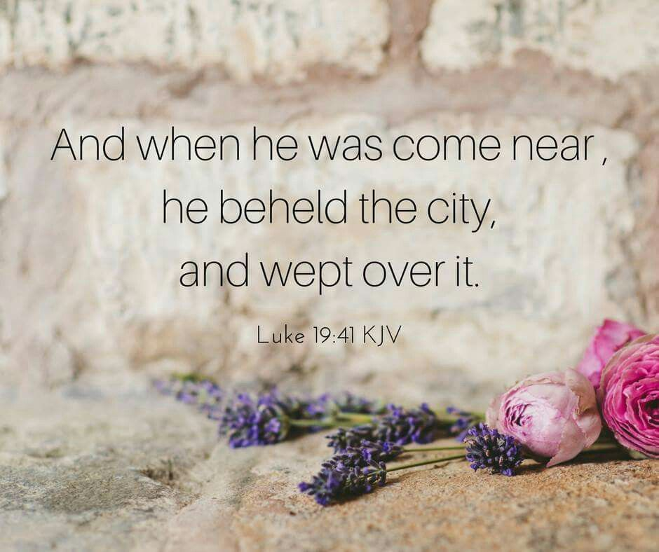

August 13, 2023

699 Stambaugh Ave.
Sharon, Pennsylvania 16146

“I was glad when they said to me,
Let us go to the house of the LORD!”
Psalm 122:1
Sts. Peter & Paul Evangelical Lutheran Church, LC-MS
THE TENTH SUNDAY AFTER TRINITY
August 13, 2023
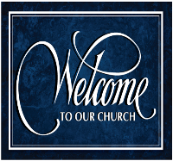
A special welcome to our guests this day! If you would like more information about The Lutheran Church - Missouri Synod, or this congregation, please speak with Pastor Deal or an Elder after the service.
Members & Guests: Don’t be embarrassed if your children make noise during the worship service, all children do. We encourage families to worship together but, if you feel the need, there are pews in the rear of the Church which are reserved for young families on both sides of the sanctuary. There is also a quiet room available to you, located next to the sanctuary (formerly the Pastor’s office), where you would be able to follow along with the service.

Today’s service includes the Sacrament of Holy Communion. If during this past year, you have not worshipped with us and been communed, we respectfully ask that you do not partake of this sacrament this day before first speaking with Pastor Deal.
If visiting from a sister congregation of the LC-MS and are in good standing, please inform Pastor Deal of your desire to commune prior to the service.
If wishing to receive a blessing during communion, please approach with your arms crossed.

CONTACT INFORMATION
Pastor Deal: pastordeal@saintspeterandpaul.net or 724-347-3620 (opt. 2)
Church Office: church@saintspeterandpaul.net or 724-347-3620 (opt. 3)
Secretary’s Office will be open Monday (8:30-4:30) and Thursday (as needed) this week.

Silent prayer before worship: Heavenly Father, You made me Your child in Jesus Christ, and You graciously fill my life with blessings. Accept the praise and thanksgiving I offer You in this worship service. In Jesus’ name. Amen.

Confession and Absolution

Opening Hymn: LSB #674 “Jerusalem, O City Fair and High”

Stand

The sign of the cross may be made by all in remembrance of their Baptism.

Invocation
P In the name of the Father and of the T Son and of the Holy Spirit.
C Amen.

Exhortation Hebrews 10:22; Psalm 124:8; Psalm 32:5
P Beloved in the Lord! Let us draw near with a true heart and confess our sins unto God our Father, beseeching Him in the name of our Lord Jesus Christ to grant us forgiveness.

P Our help is in the name of the Lord,
C who made heaven and earth.
P I said, I will confess my transgressions unto the Lord,
C and You forgave the iniquity of my sin.

Silence for reflection on God’s Word and for self-examination.

Confession of Sins
P O almighty God, merciful Father,
C I, a poor, miserable sinner, confess unto You all my sins and iniquities with which I have ever offended You and justly deserved Your temporal and eternal punishment. But I am heartily sorry for them and sincerely repent of them, and I pray You of Your boundless mercy and for the sake of the holy, innocent, bitter sufferings and death of Your beloved Son, Jesus Christ, to be gracious and merciful to me, a poor, sinful being.

Absolution [John 20:19–23]
P Upon this your confession, I, by virtue of my office, as a called and ordained servant of the Word, announce the grace of God unto all of you, and in the stead and by the command of my Lord Jesus Christ I forgive you all your sins in the name of the Father and of the T Son and of the Holy Spirit.
C Amen.

Service of the Word

Introit Psalm 55:1, 4–5, 16; antiphon: vv. 16a, 17b, 18a, 22a
I call to God, and he | hears my voice;*
he redeems my soul in | safety.
Cast your burden | on the Lord,*
and he will sus- | tain you.
Give ear to my prayer, | O God,*
and hide not yourself from my plea for | mercy!
My heart is in anguish with- | in me;*
the terrors of death have fallen up- | on me.
Fear and trembling come up- | on me,*
and horror over- | whelms me.
But I | call to God,*
and the Lord will | save me.
I call to God, and he | hears my voice;*
he redeems my soul in | safety.
Cast your burden | on the Lord,*
and he will sus- | tain you.

Gloria Patri
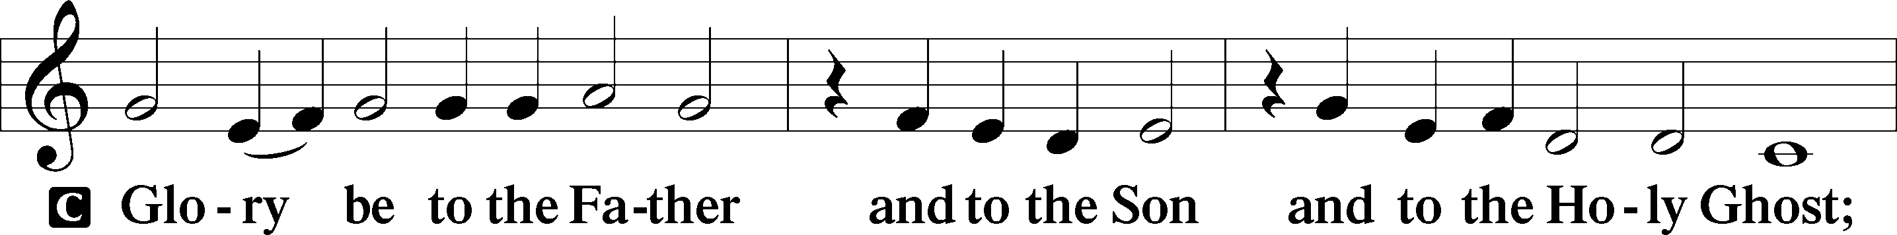
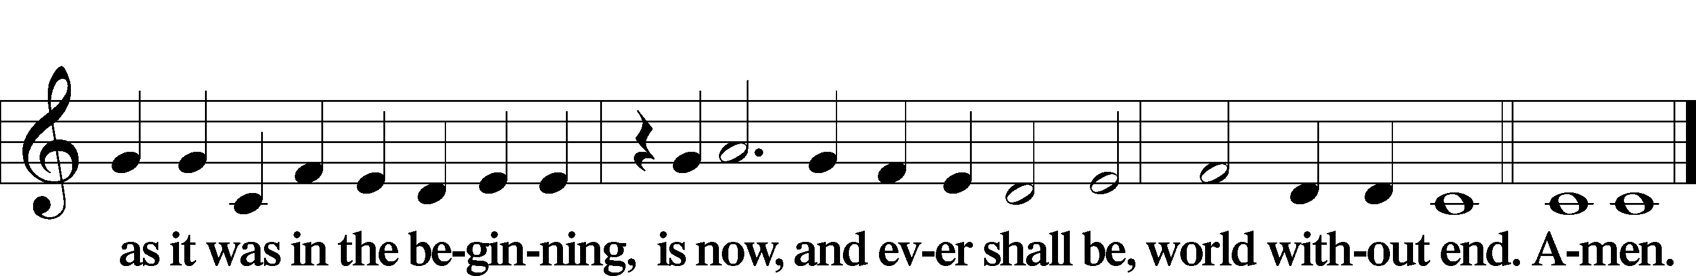

Kyrie Mark 10:47
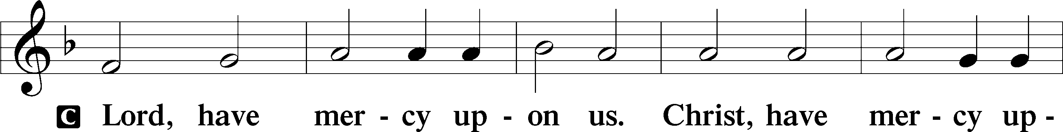
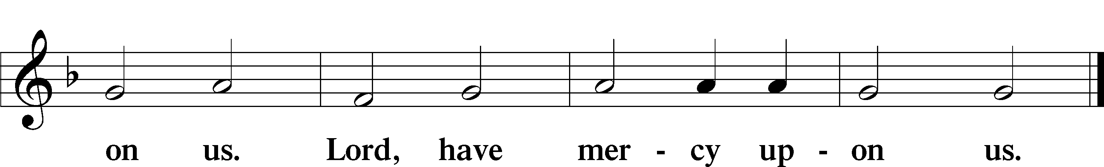

Gloria in Excelsis Luke 2:14; John 1:29
P Glory be to God on high:
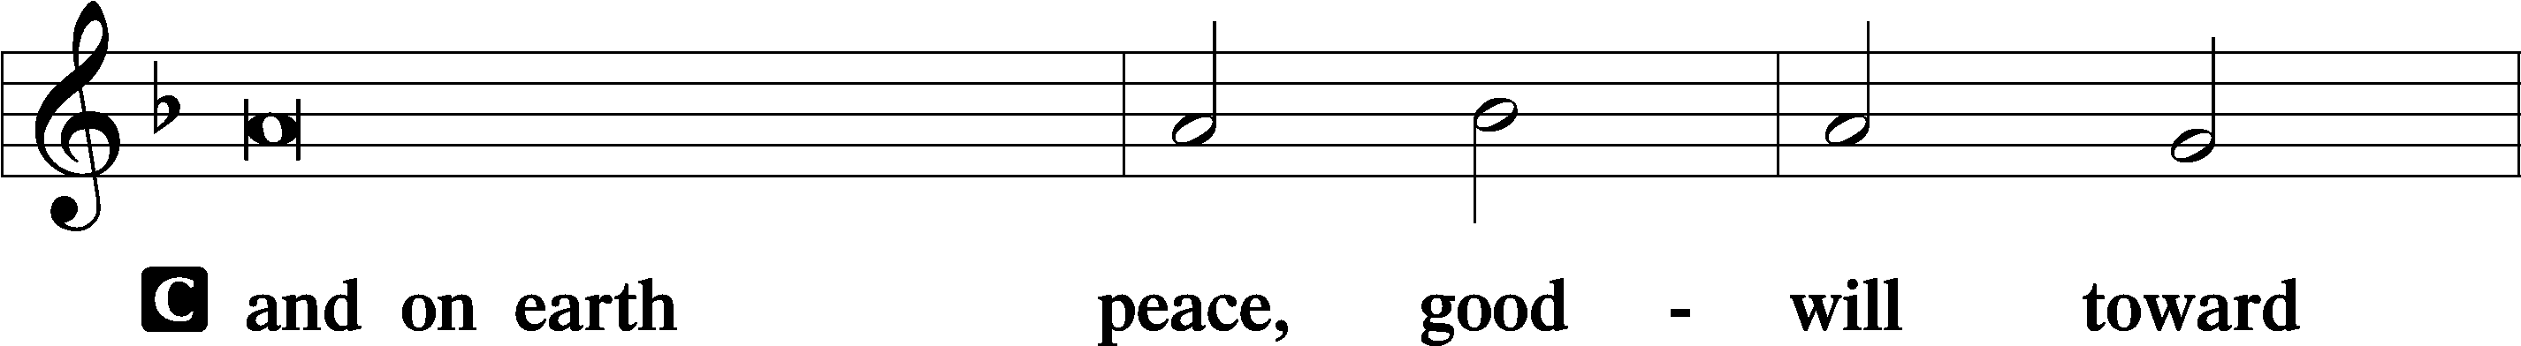
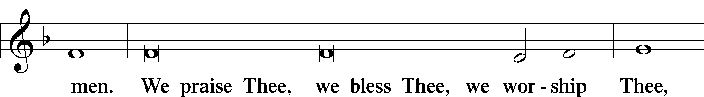
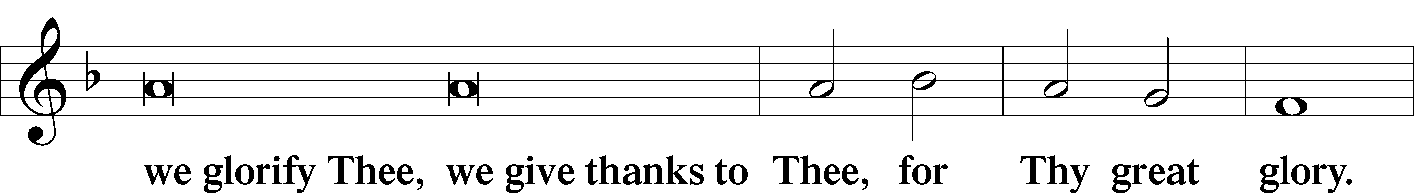
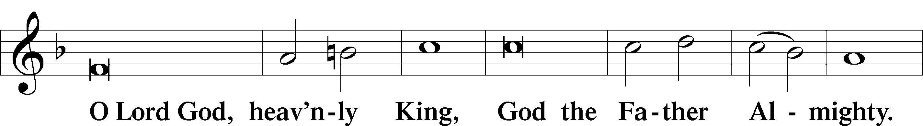
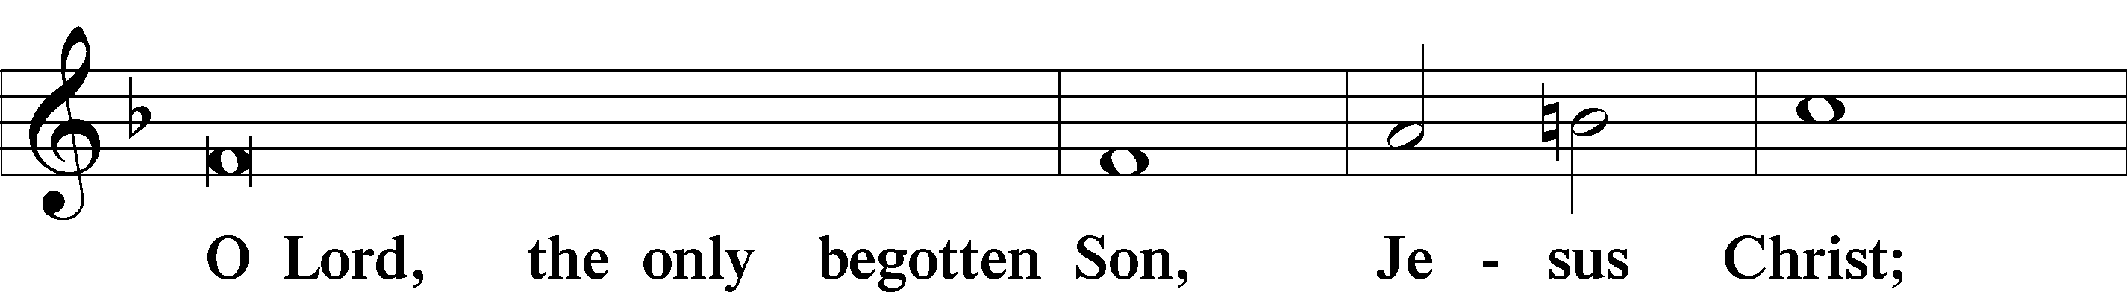
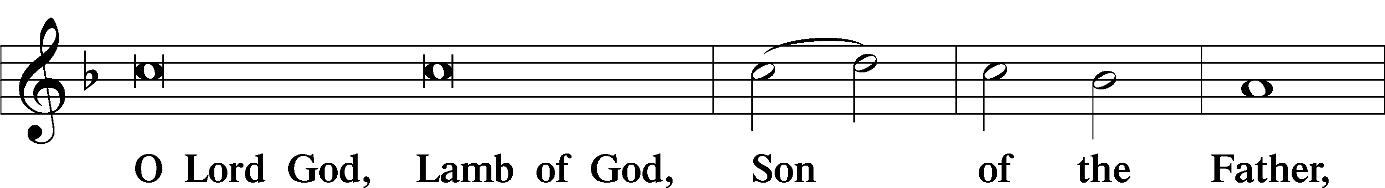
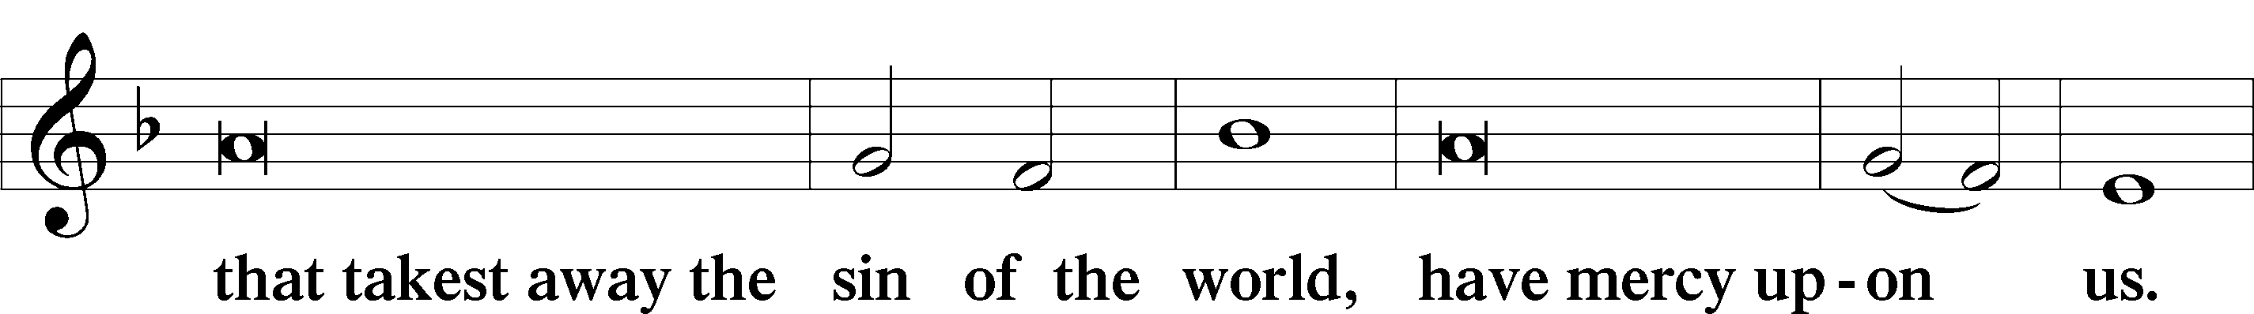
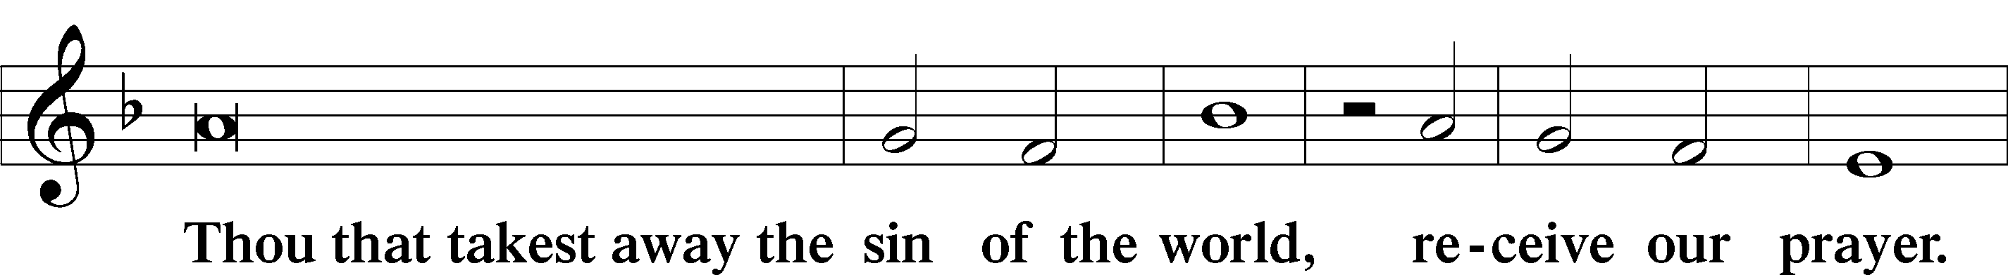
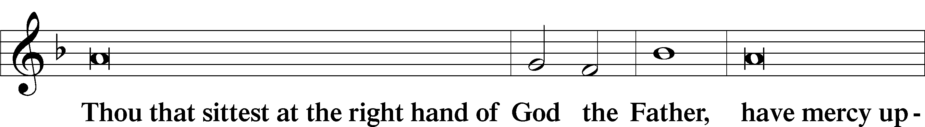
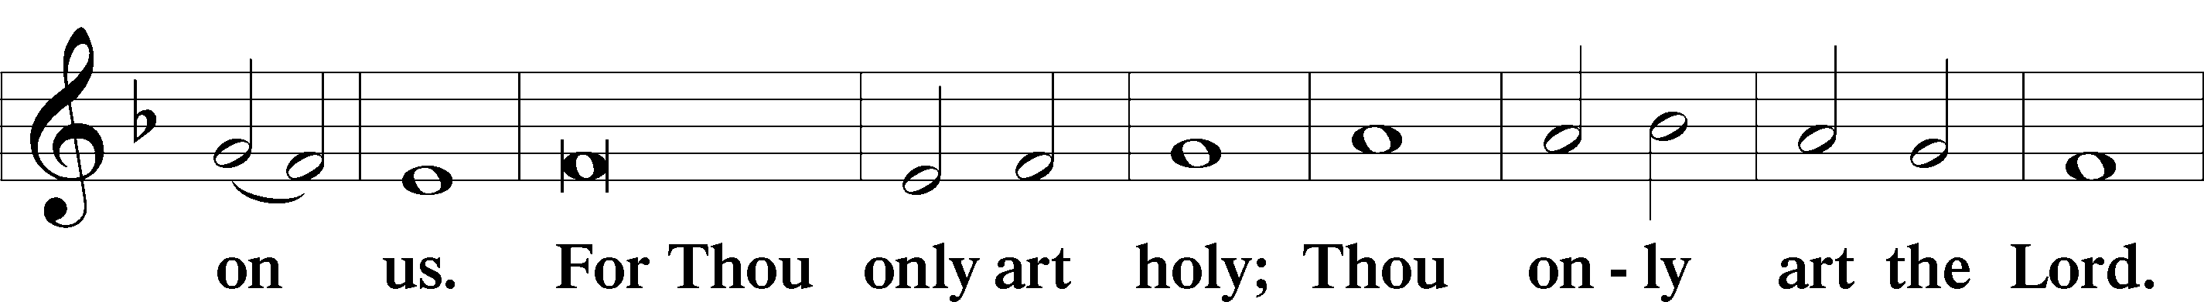
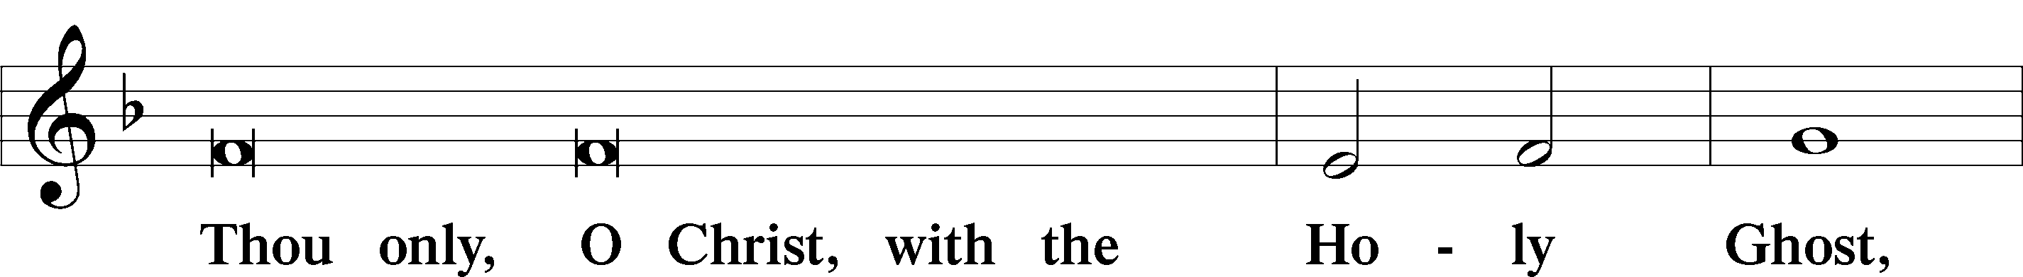
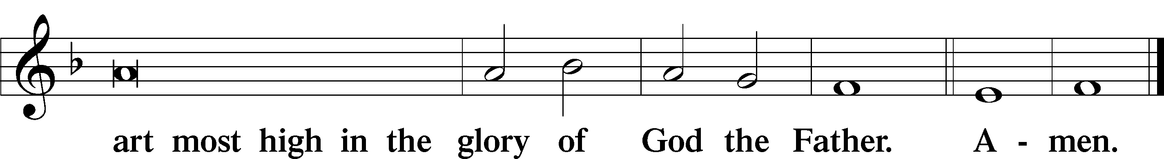

Salutation and Collect of the Day: Trinity 10
P The Lord be with you.
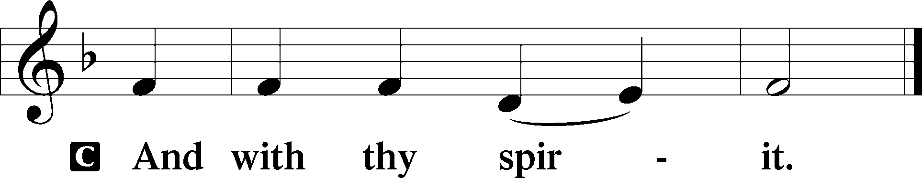

P Let us pray.
O God, who declarest Thine almighty power most chiefly in showing mercy and pity, give unto us abundantly Thy grace, that we, running to Thy promises, may be made partakers of Thy heavenly treasure; through Jesus Christ, our Lord, who lives and reigns with You and the Holy Spirit, one God, now and forever.
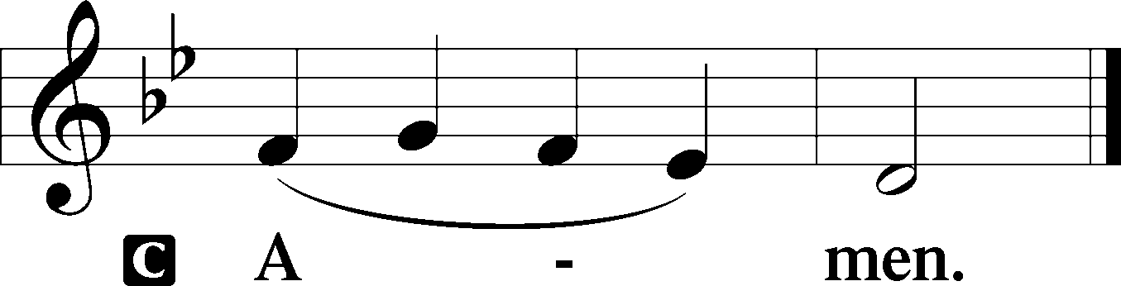
Sit

Prophecy: Jeremiah 7:1–11 (NKJV)
In those days the word of the Lord came to me, saying: “Stand in the gate of the Lord’s house, and proclaim there this word, and say, ‘Hear the word of the Lord, all you of Judah who enter in at these gates to worship the Lord! Thus says the Lord of hosts, the God of Israel: “Amend your ways and your doings, and I will cause you to dwell in this place. Do not trust in these lying words, saying, ‘The temple of the Lord, the temple of the Lord, the temple of the Lord are these.’ For if you thoroughly amend your ways and your doings, if you thoroughly execute judgment between a man and his neighbor, if you do not oppress the stranger, the fatherless, and the widow, and do not shed innocent blood in this place, or walk after other gods to your hurt, then I will cause you to dwell in this place, in the land that I gave to your fathers forever and ever. Behold, you trust in lying words that cannot profit. Will you steal, murder, commit adultery, swear falsely, burn incense to Baal, and walk after other gods whom you do not know, and then come and stand before Me in this house which is called by My name, and say, ‘We are delivered to do all these abominations’? Has this house, which is called by My name, become a den of thieves in your eyes? Behold, I, even I, have seen it,” says the Lord Almighty.’ ”

P This is the Word of the Lord.
C Thanks be to God.

Gradual Psalm 17:8, 2
Keep me as the apple | of your eye;*
hide me in the shadow | of your wings.
From your presence let my vindi- | cation come!*
Let your eyes be- | hold the right!
Epistle: Corinthians 12:2-11 (NKJV)
Brethren: You know that you were Gentiles, carried away to these dumb idols, however you were led. Therefore I make known to you that no one speaking by the Spirit of God calls Jesus accursed, and no one can say that Jesus is Lord except by the Holy Spirit. There are diversities of gifts, but the same Spirit. There are differences of ministries, but the same Lord. And there are diversities of activities, but it is the same God who works all in all. But the manifestation of the Spirit is given to each one for the profit of all: for to one is given the word of wisdom through the Spirit, to another the word of knowledge through the same Spirit, to another faith by the same Spirit, to another gifts of healings by the same Spirit, to another the working of miracles, to another prophecy, to another discerning of spirits, to another different kinds of tongues, to another the interpretation of tongues. But one and the same Spirit works all these things, distributing to each one individually as He wills.

P This is the Word of the Lord.
C Thanks be to God.

Stand

Verse Psalm 88:1
Alleluia. O Lord, God of my salvation; I cry out day and night before you. Alleluia.

Alleluia
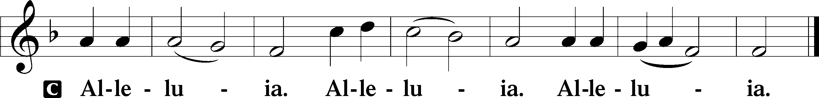

Holy Gospel: Luke 19:41–48 (NKJV)
P The Holy Gospel according to St. Luke, the nineteenth chapter.
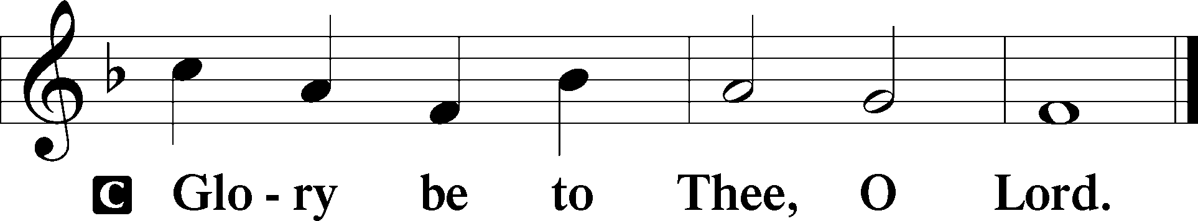

At that time: As Jesus drew near Jerusalem, He saw the city and wept over it, saying, “If you had known, even you, especially in this your day, the things that make for your peace! But now they are hidden from your eyes. For days will come upon you when your enemies will build an embankment around you, surround you and close you in on every side, and level you, and your children within you, to the ground; and they will not leave in you one stone upon another, because you did not know the time of your visitation.” Then He went into the temple and began to drive out those who bought and sold in it, saying to them, “It is written, ‘My house is a house of prayer,’ but you have made it a ‘den of thieves.’ ” And He was teaching daily in the temple. But the chief priests, the scribes, and the leaders of the people sought to destroy Him, and were unable to do anything; for all the people were very attentive to hear Him.

P This is the Gospel of the Lord.
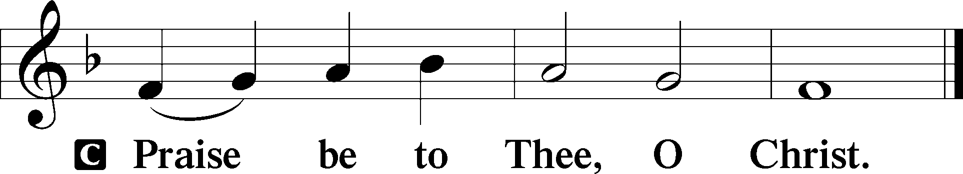

Nicene Creed
C I believe in one God,
the Father Almighty,
maker of heaven and earth
and of all things visible and invisible.

And in one Lord Jesus Christ,
the only-begotten Son of God,
begotten of His Father before all worlds,
God of God, Light of Light,
very God of very God,
begotten, not made,
being of one substance with the Father,
by whom all things were made;
who for us men and for our salvation came down from heaven
and was incarnate by the Holy Spirit of the virgin Mary
and was made man;
and was crucified also for us under Pontius Pilate.
He suffered and was buried.
And the third day He rose again according to the Scriptures
and ascended into heaven
and sits at the right hand of the Father.
And He will come again with glory to judge both the living and the dead,
whose kingdom will have no end.

And I believe in the Holy Spirit,
the Lord and giver of life,
who proceeds from the Father and the Son,
who with the Father and the Son together is worshiped and glorified,
who spoke by the prophets.
And I believe in one holy Christian and apostolic Church,
I acknowledge one Baptism for the remission of sins,
and I look for the resurrection of the dead
and the life T of the world to come. Amen.
Sit

Hymn of the Day: LSB #608 “Lord, to You I Make Confession”

Sermon

Stand

Offertory Psalm 51:10–12
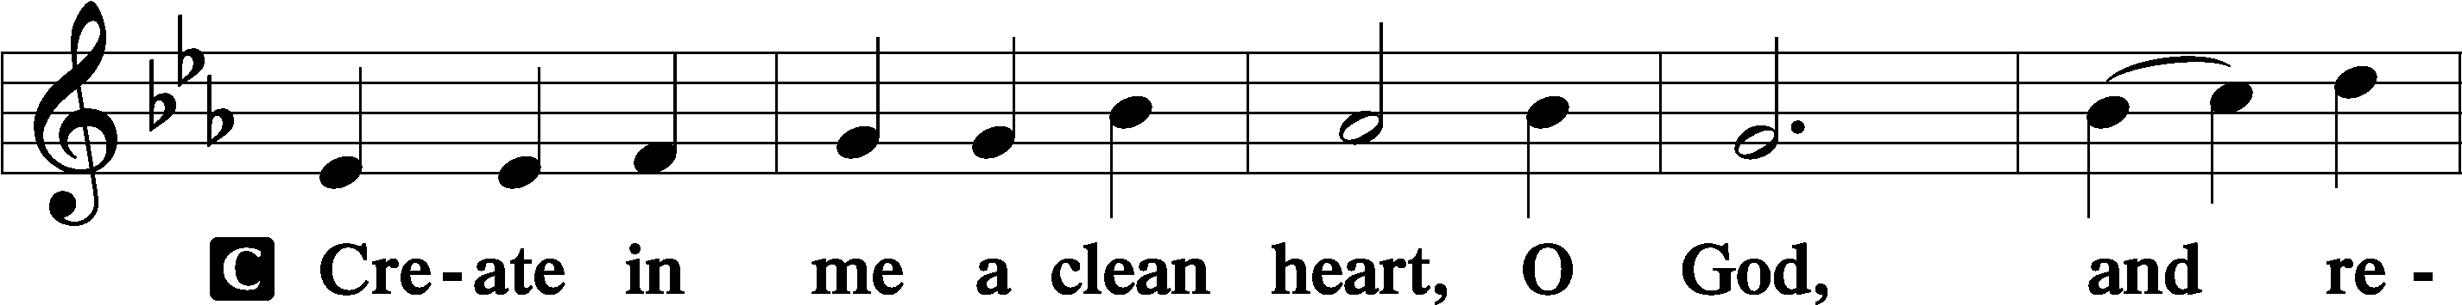
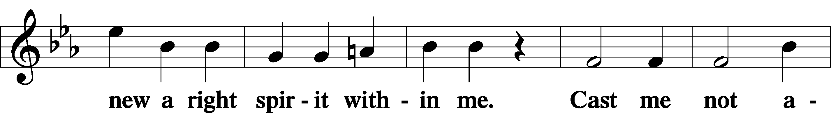
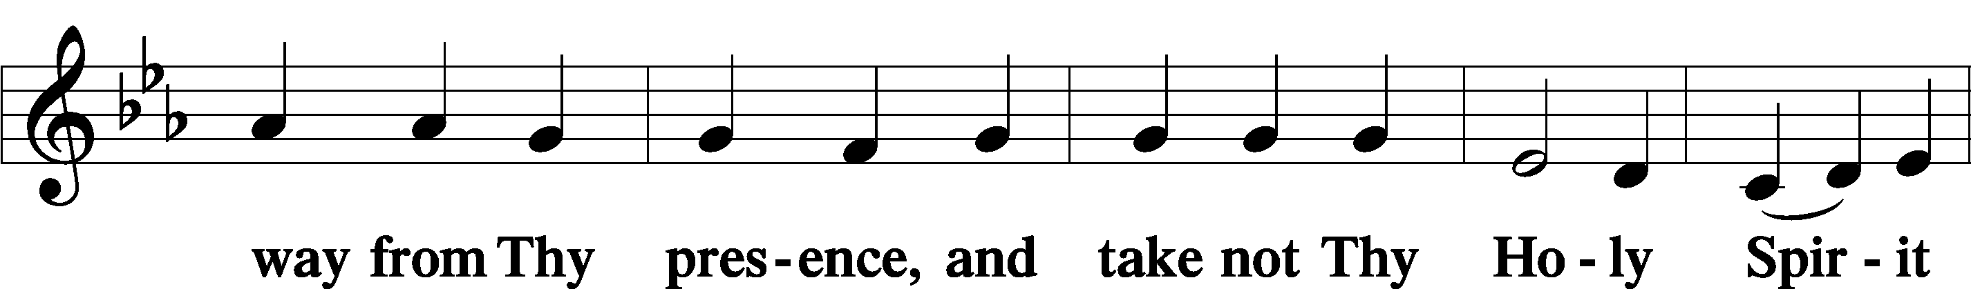
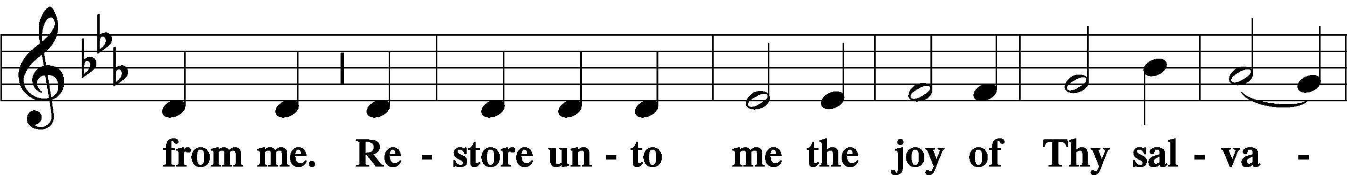
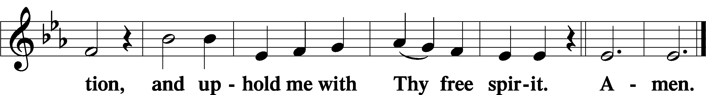
Prayer of the Church

Sit

Preparatory Hymn: LSB #508 “The Day Is Surely Drawing Near”

Stand
Service of the Sacrament

Preface 2 Timothy 4:22; Colossians 3:1 Psalm 136
P The Lord be with you.
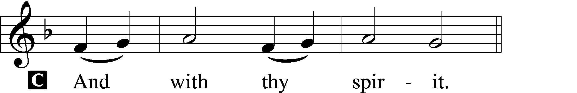

P Lift up your hearts.
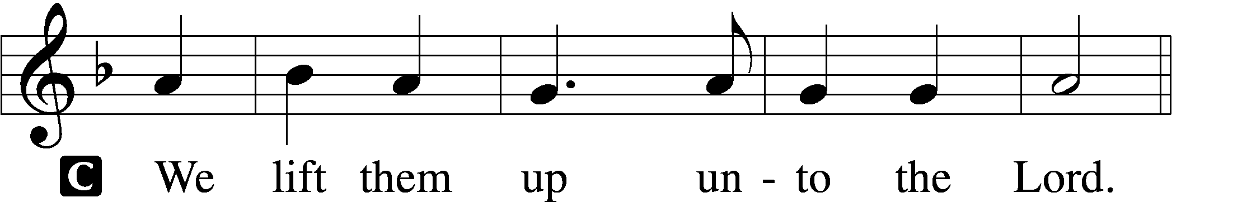

P Let us give thanks unto the Lord, our God.
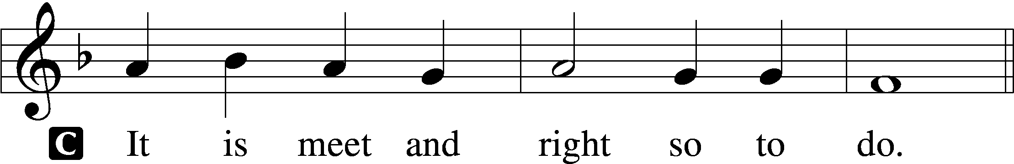

Proper Preface (Abbreviated) LSB 194
P It is truly meet, right, and salutary . . . evermore praising You and saying:

Sanctus Isaiah 6:3; Matthew 21:9
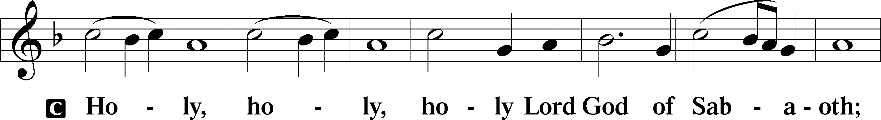
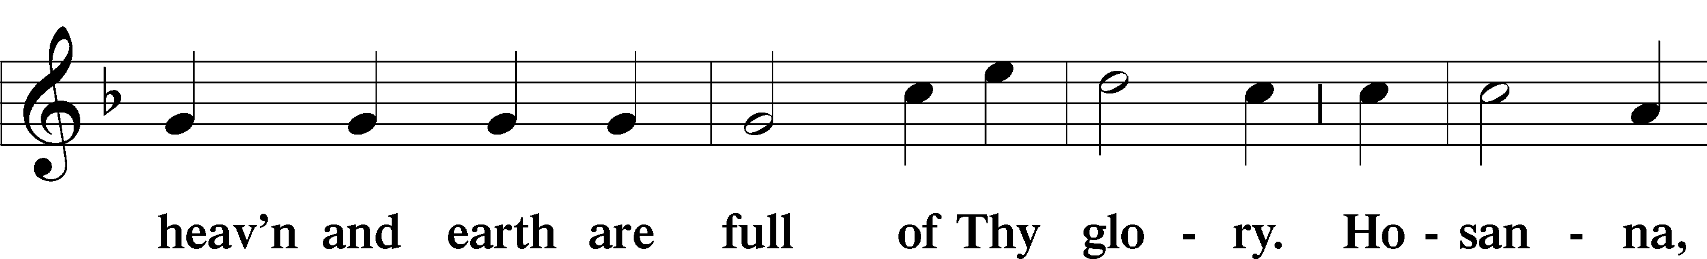
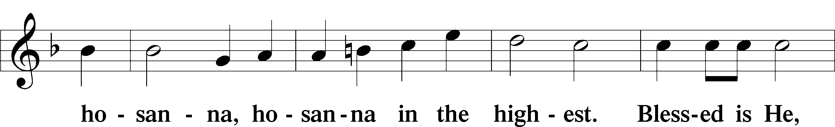
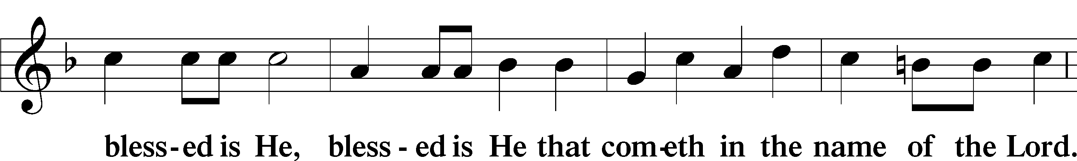
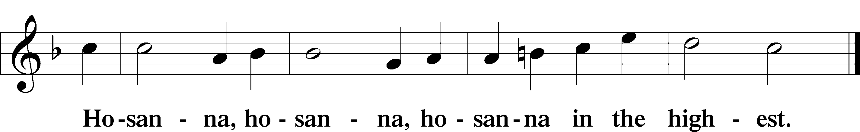

Lord’s Prayer Matthew 6:9–13
C Our Father who art in heaven,
hallowed be Thy name,
Thy kingdom come,
Thy will be done on earth as it is in heaven;
give us this day our daily bread;
and forgive us our trespasses as we forgive those who trespass against us;
and lead us not into temptation,
but deliver us from evil.
For Thine is the kingdom and the power and the glory forever and ever. Amen.
The Words of Our Lord Matthew 26:26–28; Mark 14:22–24; Luke 22:19–20; 1 Corinthians 11:23–25
P Our Lord Jesus Christ, on the night when He was betrayed, took bread, and when He had given thanks, He broke it and gave it to the disciples and said: “Take, eat; this is My T body, which is given for you. This do in remembrance of Me.”

In the same way also He took the cup after supper, and when He had given thanks, He gave it to them, saying: “Drink of it, all of you; this cup is the new testament in My T blood, which is shed for you for the forgiveness of sins. This do, as often as you drink it, in remembrance of Me.”

Pax Domini John 20:19
P The peace of the Lord be with you always.
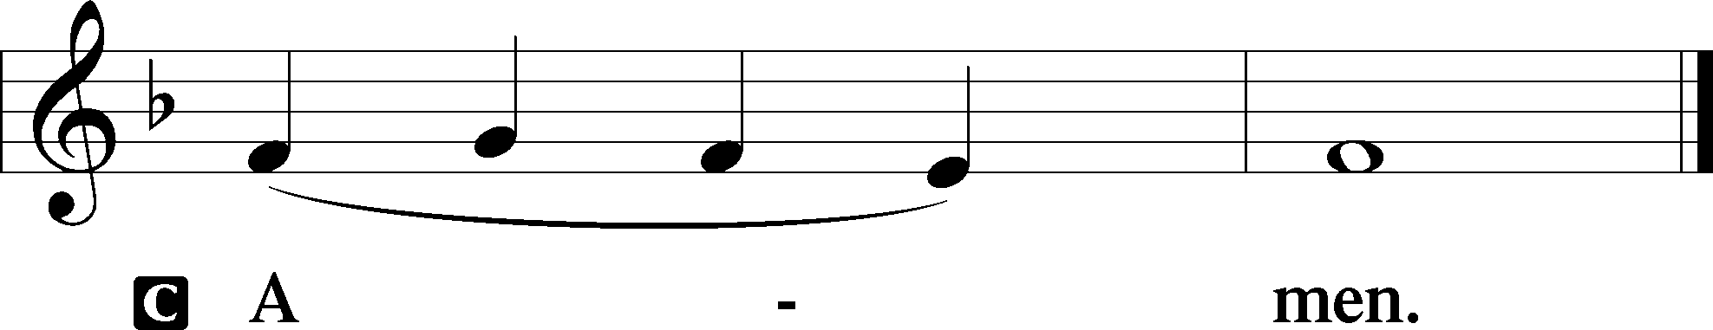

Agnus Dei John 1:29
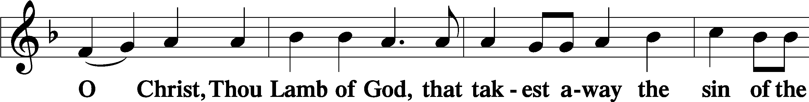
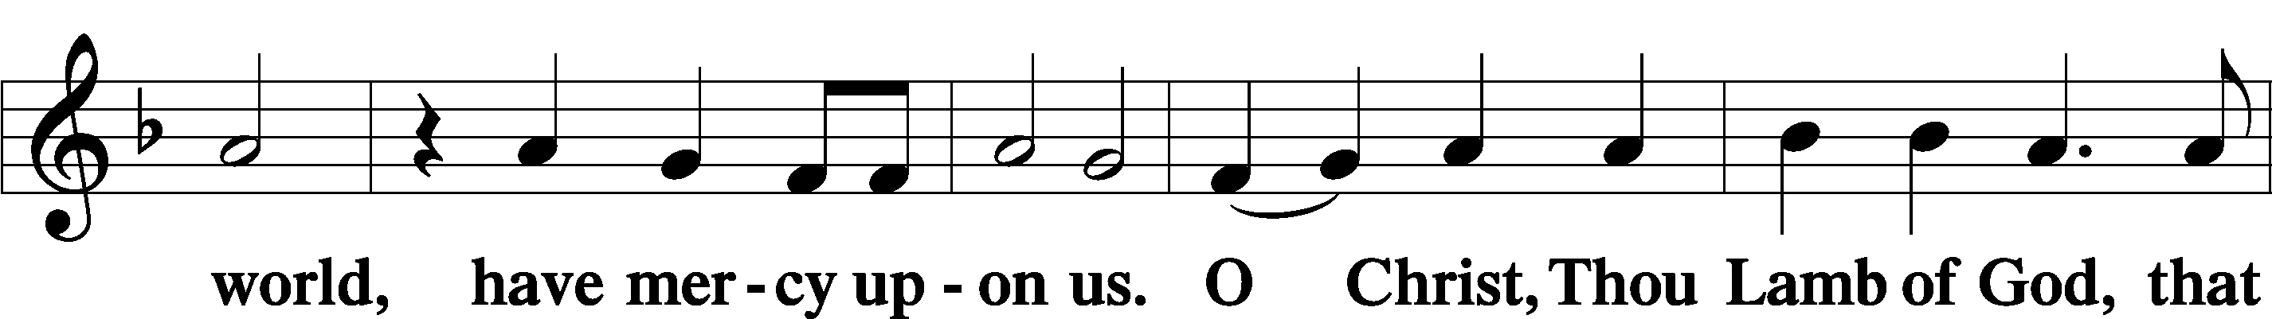
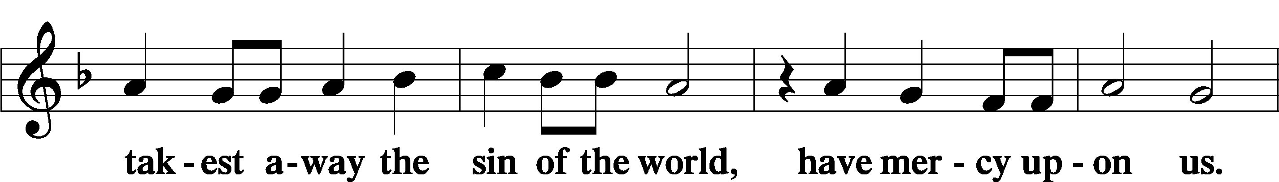
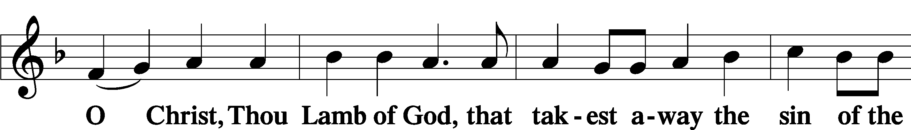
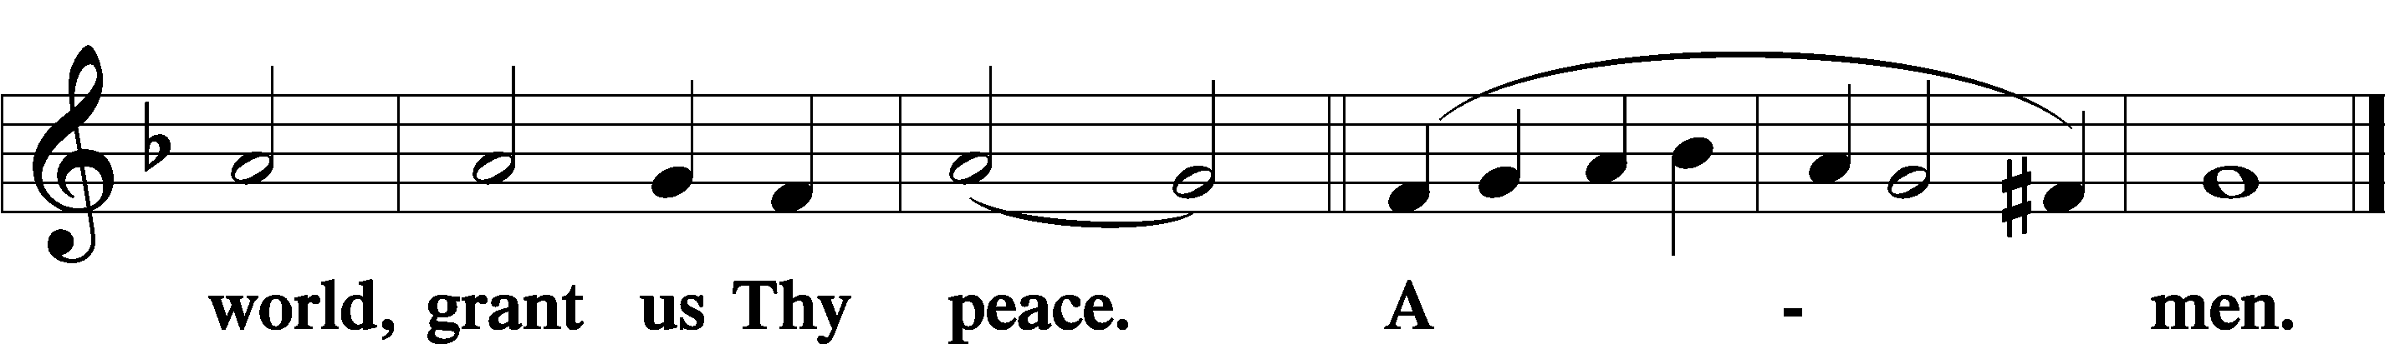
Sit
Distribution
The pastor and those who assist him receive the body and blood of Christ first and then distribute them to those who come to receive, saying:
Take, eat; this is the true body of our Lord and Savior Jesus Christ, given into death for your sins.
Amen.

Take, drink; this is the true blood of our Lord and Savior Jesus Christ, shed for the forgiveness of your sins.
Amen.

In dismissing the communicants, the following is said:
The Dismissal
P The body and blood of our Lord Jesus Christ strengthen and preserve you in body and soul to life everlasting. Depart T in peace.
C Amen.

Distribution Hymn: LSB #618 “I Come, O Savior, to Thy Table”

Distribution Hymn: LSB #607 “From Depths of Woe I Cry to Thee”

Distribution Hymn: LSB #659 “Lord of Our Life”

Stand

Nunc Dimittis Luke 2:29–32
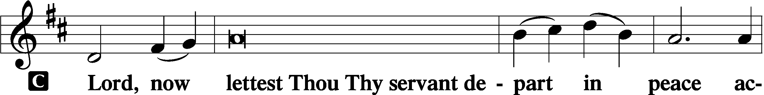
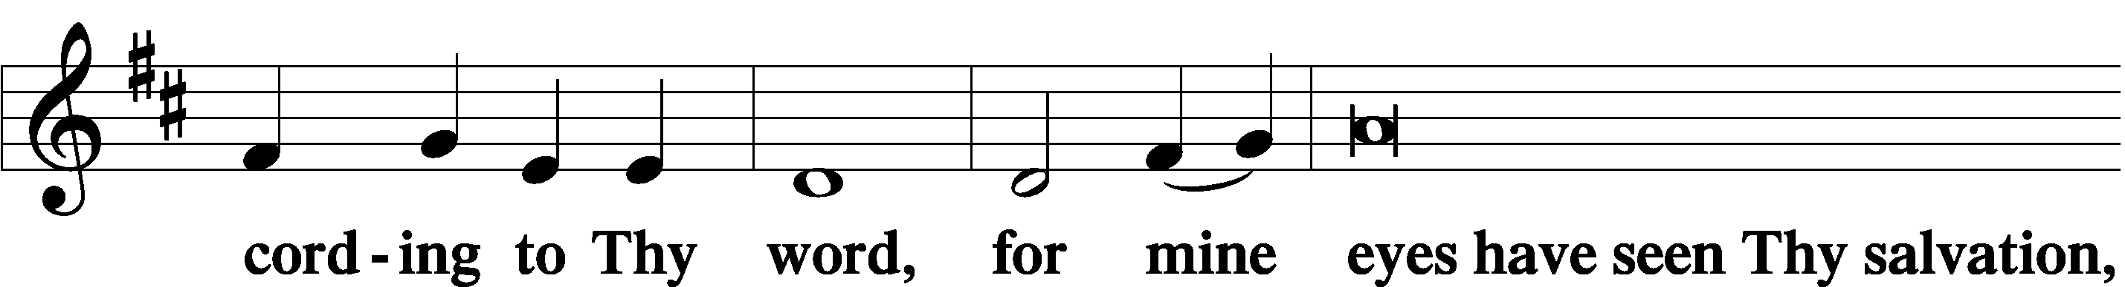
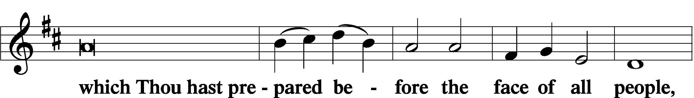
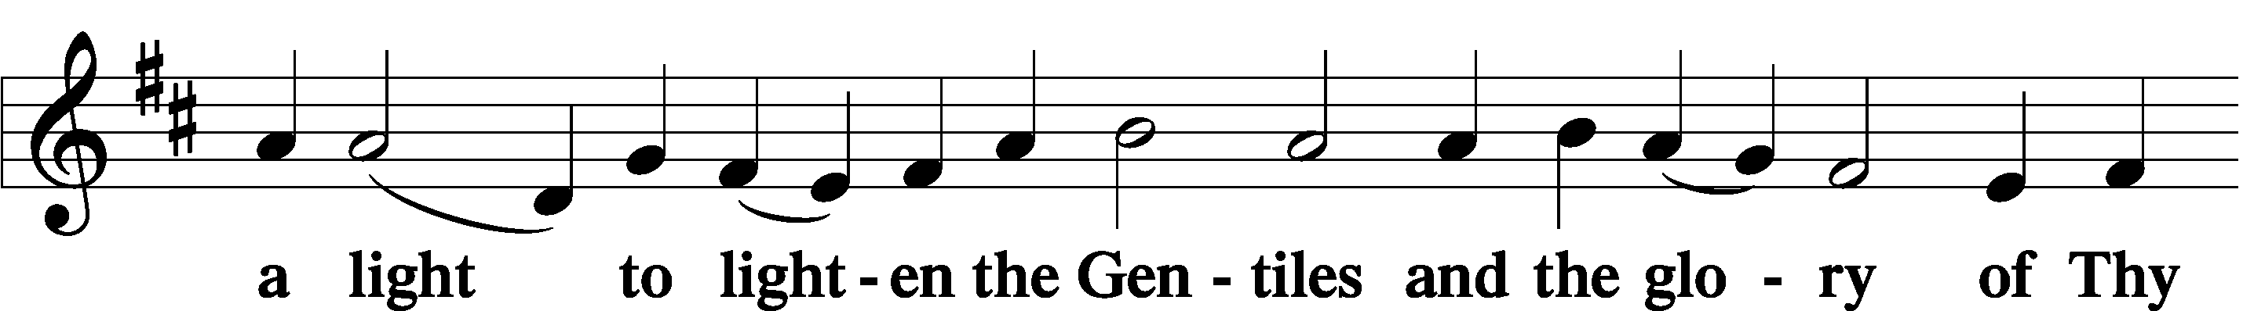
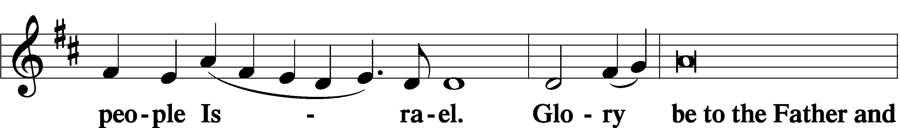
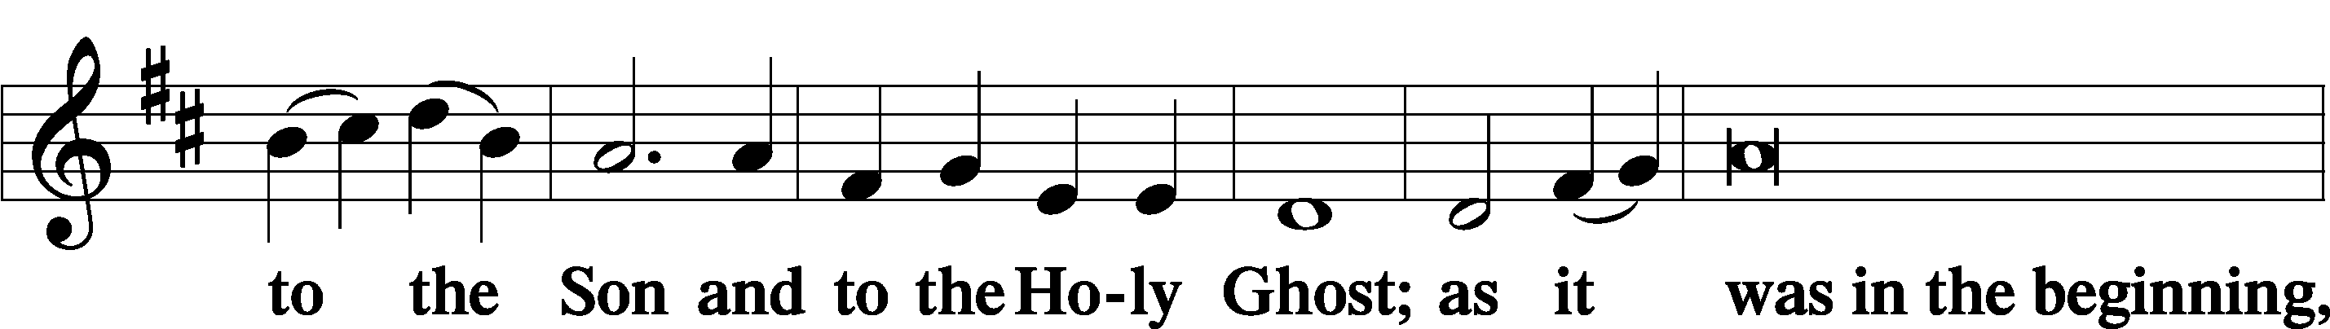
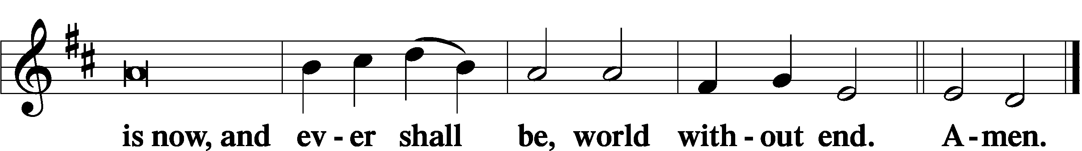

Thanksgiving Psalm 107:1
P O give thanks unto the Lord, for He is good,
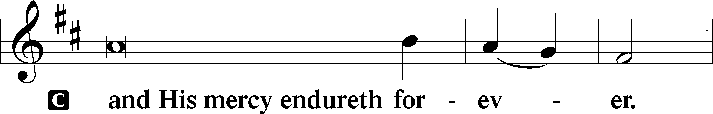

Post-Communion Collect
P Let us pray.
We give thanks to You, almighty God, that You have refreshed us through this salutary gift, and we implore You that of Your mercy You would strengthen us through the same in faith toward You and in fervent love toward one another; through Jesus Christ, Your Son, our Lord, who lives and reigns with You and the Holy Spirit, one God, now and forever.
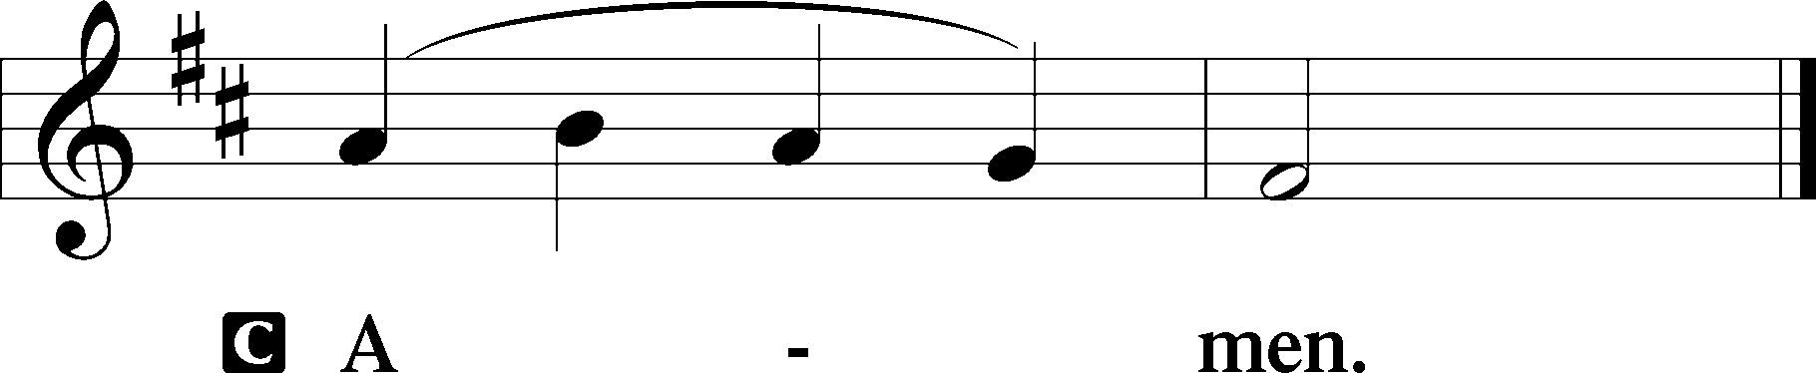

Salutation 2 Timothy 4:22
P The Lord be with you.
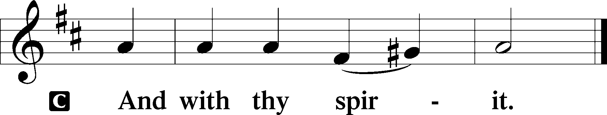

Benedicamus Psalm 103:1
P Bless we the Lord.
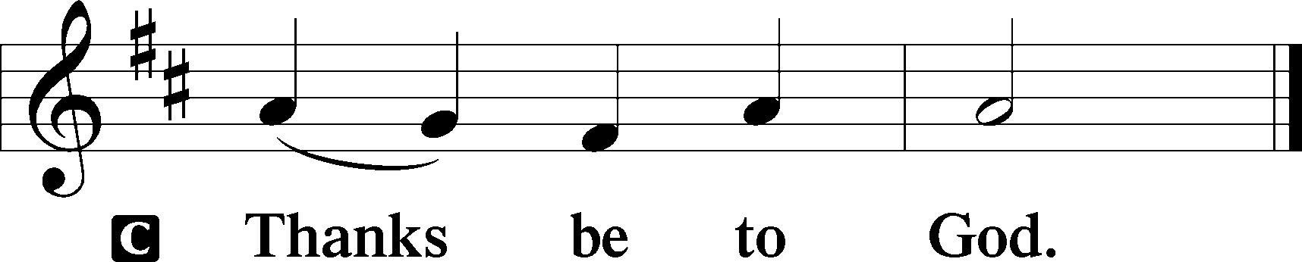

Benediction Numbers 6:24–26
P The Lord bless you and keep you.
The Lord make His face shine upon you and be gracious unto you.
The Lord lift up His countenance upon you and T give you peace.
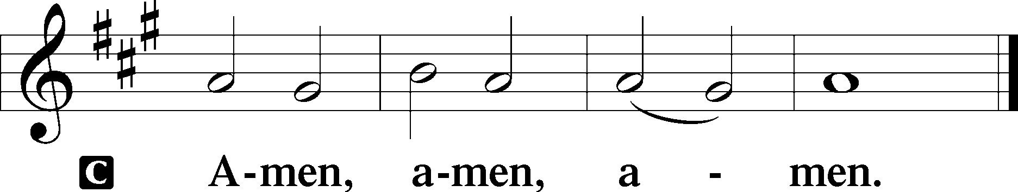

Closing Hymn: LSB #909 “Christ Is Made the Sure Foundation”

Silent prayer after worship: Father of mercy and might, give me the faith to gladly live as Your child in Christ. Lead me to live my life to Your glory and as a witness to Your love. In Jesus’ name. Amen.
fffffffffffffffffffffffffffffffffff
Acknowledgments
Unless otherwise indicated, Scripture quotations are from the ESV® Bible (The Holy Bible, English Standard Version®), copyright © 2001 by Crossway, a publishing ministry of Good News Publishers. Used by permission. All rights reserved.
Created by Lutheran Service Builder © 2023 Concordia Publishing House.
fffffffffffffffffffffffffffffffffff
fffffffffffffffffffffffffffffffffff
In Loving Memory of Father, Michael Dorfi: Edeltraud Sulek (Capital Campaign).
fffffffffffffffffffffffffffffffffff
SCHEDULE THROUGH AUGUST 20, 2023:

:

Today, following Worship, Fellowship Hall: Coffee Fellowship
7 pm, Fellowship Hall: AA Meeting
Tuesday, 7-9 pm, Fellowship Hall: Penn-Ohio Singers
Wednesday, 7 pm, Library: Trustees’ Meeting
7:30 pm, Fellowship Hall: NA Meeting
Saturday, 4 pm, All Saints Lutheran Church, Slippery Rock: Men’s Bible Study
Next Sunday, 9 am, Sanctuary: Divine Service
Following Worship, Fellowship Hall: Voters’ Assembly
7 pm, Fellowship Hall: AA Meeting
fffffffffffffffffffffffffffffffffff
Attendance: Sunday, August 6, 2023: 34
fffffffffffffffffffffffffffffffffff
Our Stewardship of Treasures for the Lord:
In order to do the Lord’s work, we need $2,553.63 each week to meet our 2023 budget for general purposes and $76.92 for the SELC.
Figures for Sunday, August 6, 2023
General Fund: $1,865.00 Behind for the week: -$688.63
SELC: $60.00 Behind for the week: -$16.92
Capital Campaign: $520.00

For online giving, check out https://www.saintspeterandpaul.net/online-giving.
fffffffffffffffffffffffffffffffffff
THANK YOU FOR SERVING IN AUGUST: Elder: Jonathan Baisch; Ushers: Cheryl Fedele, Mike Flaugher, & Jesse Riffle; Altarware: (prior) Diane Riefstahl & Marie Flaugher (08/13); (after) Hank Holcroft & Kati Laird.
fffffffffffffffffffffffffffffffffff
The next Voters’ Assembly will take place following worship next Sunday, August 20th. Your attendance will be greatly appreciated.
fffffffffffffffffffffffffffffffffff
Reminder: Items for the September calendar and newsletter are due to Diane by noon, Monday, August 21st.
fffffffffffffffffffffffffffffffffff
Remember the following in Prayer…
~The Hurting and Healing: Amy, Steve Antolovich, Ellen Baron^{CA}, Lois Bortner^{CA}, Dee Bullock, Bev & Joe Chlpka, Susan Davies, Loretta Deal, Tim Dudash, Judith & Eddy Furey, Griffin, Austin Hamilton, Pastor Charles Henrickson, Joan, Darla Krajci, Barbara Kreske, Pastor Ed Kucera, Jess Lavoie, Elizabeth Loughan, Paul Lucas^{CA}, Sandy Marshall, Gene Moore, Frank Niemeyer^{CA}, Juanita Rentschler, Richard Reuning^{CA}, Nancy Robertson^{CA}, Landon Sargent, Joel & Peggy Wasson, Angela Weser^{CA}, and Ruth Wolf.
~The Homebound: Anna Mae Daris, Millie Elavsky, Rudy & Jean Tomko, Betty Wolf, and Ed & Millie Zachar.
~Celebrating this Week: Anniversaries: Rev. Arthur & Evelyn Baisch (08.17) and David & Debbie Zurawsky (08.18).
~Serving in the Military: Alex (Sasha) Carr, Curtis Sinewe, and Joshua Solyan.
~Community & World Needs: Those suffering from or affected by the coronavirus; those suffering due to the conflict between Ukraine and Russia; those suffering from loss and dislocation because weather disasters; those suffering from addiction and their families; Local, State, and National Government Leaders; safety for all Police Officers, Firefighters, & First Responders; the unemployed; our Third Quarter Local Mission: Luther Classical College.
*CA represents cancer.
fffffffffffffffffffffffffffffffffff
Our prayer list has been updated. If you would like someone’s name added or deleted from our Prayer List, please put a note in the secretary’s mail slot or email the church office. Thank you!
fffffffffffffffffffffffffffffffffff
Available this morning in the narthex and on tables adjacent to the nursery.
- August issue of “The Rock and the Sword” newsletter.
- Minutes from the July 24th Church Council meeting.
- Tentative agenda for the August 20th Voters’ Assembly.
- Information concerning how to donate to the Barry Nelson Charitable Foundation.
fffffffffffffffffffffffffffffffffff
Bible Memory Verses ~ Week of August 13th:
For Adults: All who desire to live a godly life in Christ Jesus will be persecuted.
2 Timothy 3:12
For Children: Righteousness exalts a nation, but sin is a reproach to any people.
Proverbs 14:34
fffffffffffffffffffffffffffffffffff
CHANGE IN DATE: Trustees will meet this Wednesday, August 16th at 7 pm in the library.
fffffffffffffffffffffffffffffffffff
This morning is “Stock the Food Pantry” Sunday. Your financial donations will be greatly appreciated.
fffffffffffffffffffffffffffffffffff
Join us downstairs following worship this morning for Coffee Fellowship. This month’s sponsors are Mike & Marie Flaugher.
Coffee Fellowship sponsors are still needed for October and November this year. If interested, please sign the sheet posted in the narthex. Speak with Diane if you should have any questions.
fffffffffffffffffffffffffffffffffff
Men’s Bible Study this month will be held this Saturday at 4 pm at All Saints Lutheran Church in Slippery Rock.
fffffffffffffffffffffffffffffffffff
Pastor Deal will be on vacation August 14-28. If in need of pastoral care during this time, please contact Pastor Baisch (501-253-8292) or Elder Jonathan Baisch (724-816-6866).
fffffffffffffffffffffffffffffffffff

Here to Serve
Pastor………………………………………………...……………Rev. Jacob Deal
E-mail …………………………….……pastordeal@saintspeterandpaul.net
Phone Number……………………..…………………724-347-3620 (Option 2)
Church Office………………………..…………………724-347-3620 (Option 3)
Website …………………………………………www.saintspeterandpaul.net
Secretary…………………………………………………………Diane Riefstahl
E-mail ………………………………………church@saintspeterandpaul.net
Website …………………………………………www.saintspeterandpaul.net
Food Pantry (email): ……………foodpantry@saintspeterandpaul.net
Congregation President………………………………….…Jonathan Baisch
Church Elder …………………………………………...……. Jonathan Baisch
Organist………………………………………………..….…Rebecca Marquette
Choir Director…………………………………………………….…Chris Nelson
AA Contact: Steve………………………………………………...…724-813-2358
NA Contact: Larry……………………………………..…………..724-977-8733
fffffffffffffffffffffffffffffffffff
If needing to get into the church building during the week, please phone first to make certain someone is here to let you in.

