Sts. Peter & Paul
Evangelical Lutheran Church
Lutheran Church-Missouri Synod
Founded-1917

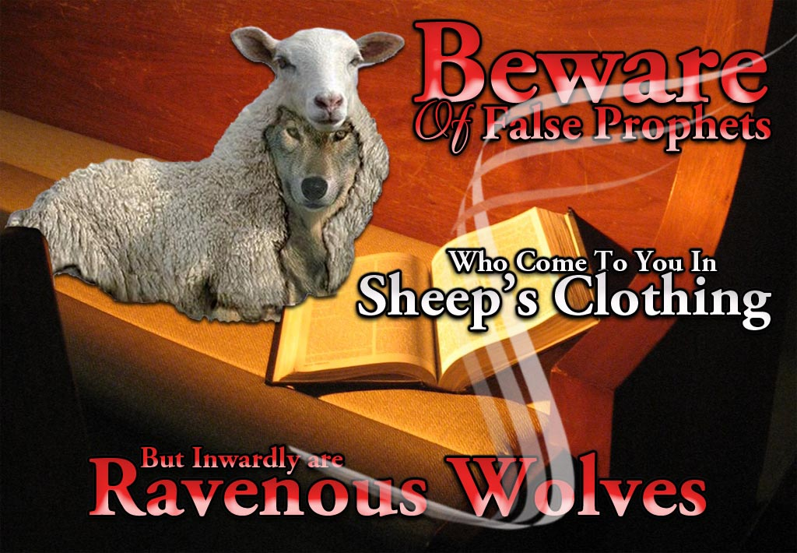

AUGUST 11, 2019

699 Stambaugh Avenue
Sharon, Pennsylvania 16146

“I was glad when they said to me,
Let us go to the house of the LORD!”
Psalm 122:1
Sts. Peter & Paul Evangelical Lutheran Church, LC-MS
EIGHTH SUNDAY AFTER TRINITY
AUGUST 11, 2019

Silent prayer before worship: Dear Lord, cast away the darkness of indifference and shine the light of Your love in my heart. Lead me to be in Your Word and in prayer daily, that I may grow in my faith and to share my faith with others. In Jesus’ name. Amen.

Please read Communion Statement found inside the Friendship Booklet prior to taking part in Holy Communion.
CONFESSION AND ABSOLUTION
Opening Hymn: LSB #693 “O Holy Spirit, Grant Us Grace”

Stand
The sign of the cross may be made by all in remembrance of their Baptism.

P In the name of the Father and of the T Son and of the Holy Spirit.
C Amen. Matthew 28: 19b; [18:20]

P If we say we have no sin, we deceive ourselves, and the truth is not in us.
C But if we confess our sins, God, who is faithful and just, will forgive our sins and cleanse us from all unrighteousness.

Silence for reflection on God's Word and for self-examination.

P Let us then confess our sins to God our Father.
C Most merciful God, we confess that we are by nature sinful and unclean. We have sinned against You in thought, word, and deed, by what we have done and by what we have left undone. We have not loved You with our whole heart; we have not loved our neighbors as ourselves. We justly deserve Your present and eternal punishment. For the sake of Your Son, Jesus Christ, have mercy on us. Forgive us, renew us, and lead us, so that we may delight in Your will and walk in Your ways to the glory of Your holy name. Amen.
P Almighty God in His mercy has given His Son to die for you and for His sake forgives you all your sins. As a called and ordained servant of Christ, and by His authority, I therefore forgive you all your sins in the name of the Father and of the T Son and of the Holy Spirit. [John 20: 19-23]
C Amen.

Passing of the Peace.

SERVICE OF THE WORD

Introit: Ps. 48:1, 3, 11, 14; antiphon: Ps. 48:9–10
We have thought on your steadfast love, | O God,*
in the midst of your | temple.
As your name, O God, so your praise reaches to the ends | of the earth.*
Your right hand is filled with | righteousness.
Great is the Lord and greatly | to be praised*
in the city of our God, his holy | mountain.
Within her | citadels*
God has made himself known as a | fortress.
Let Mount Zion | be glad!*
Let the daughters of Judah rejoice because of your | judgments!
This is God, our God forever and | ever.*
He will guide us for- | ever.
Glory be to the Father and | to the Son*
and to the Holy | Spirit;
as it was in the be- | ginning,*
is now, and will be forever. | Amen.
We have thought on your steadfast love, | O God,*
in the midst of your | temple.
As your name, O God, so your praise reaches to the ends | of the earth.*
Your right hand is filled with | righteousness.

Kyrie Mark 10:47
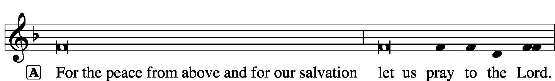
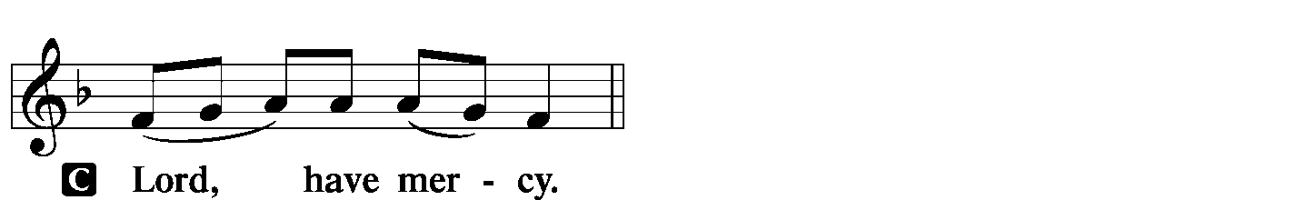
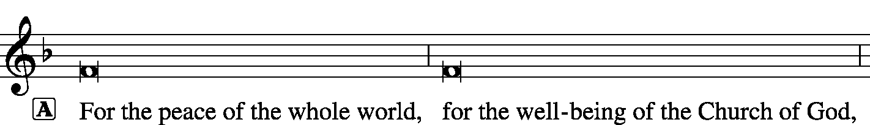
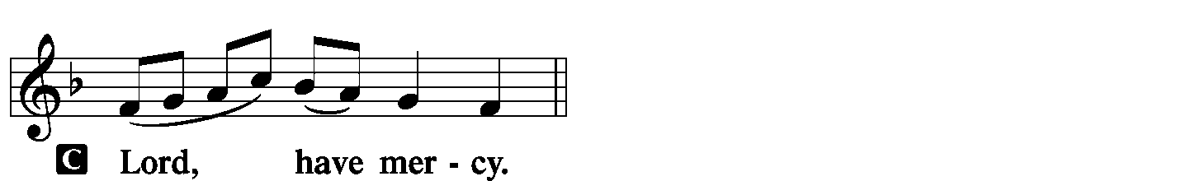
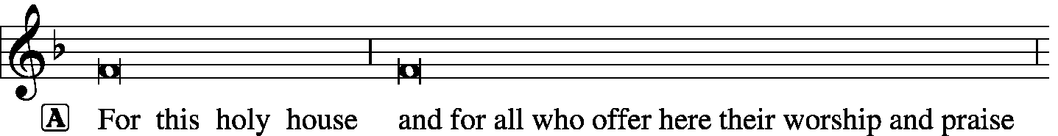
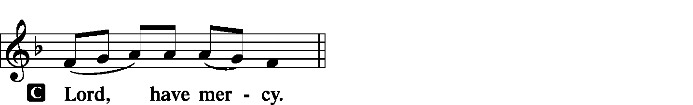
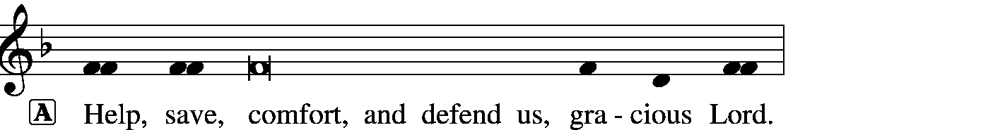

Gloria in Excelsis Luke 2: 14; John 1: 29
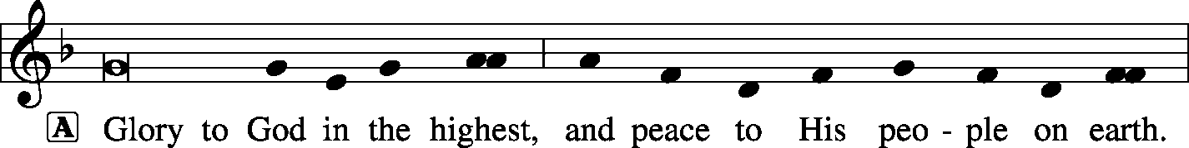
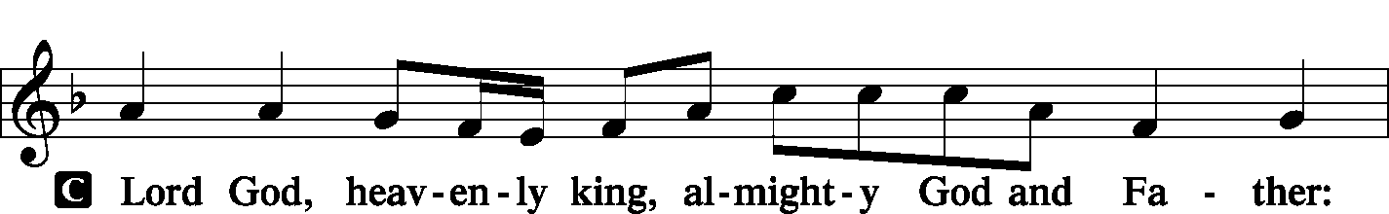
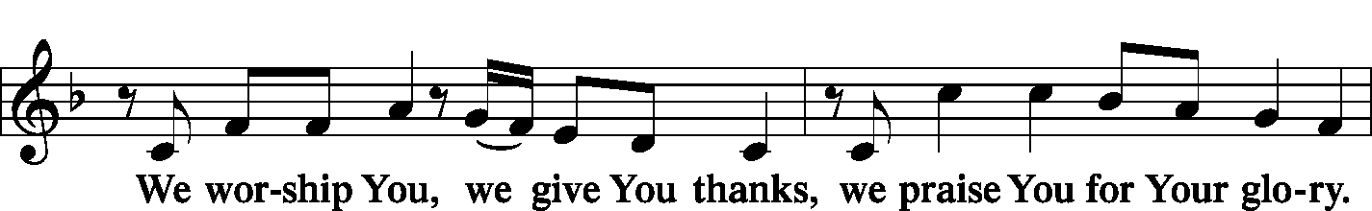
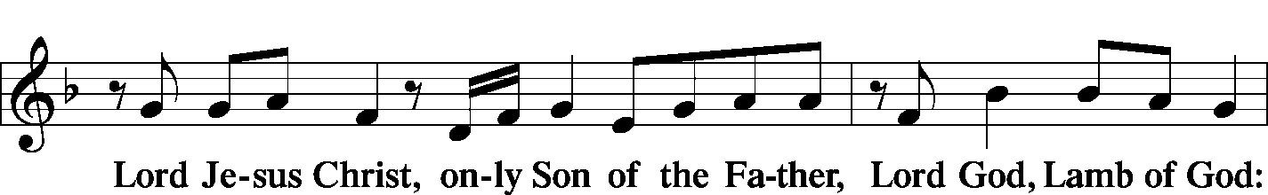
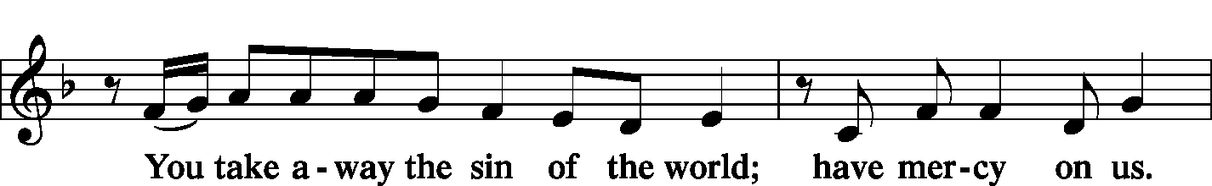
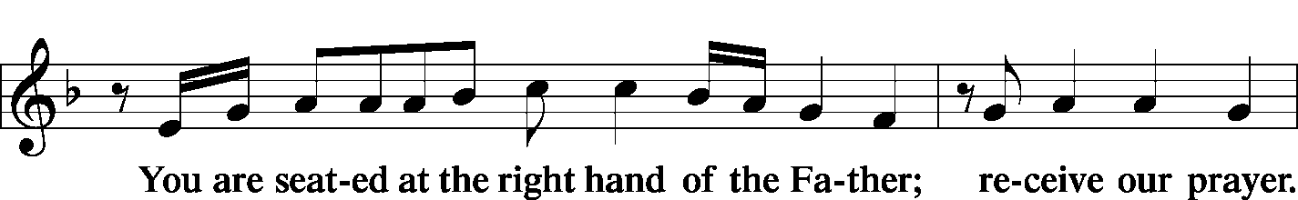
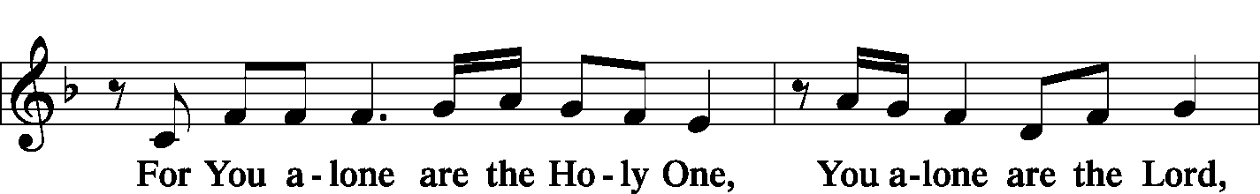
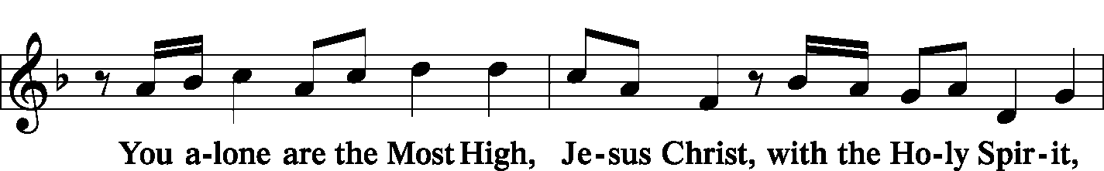
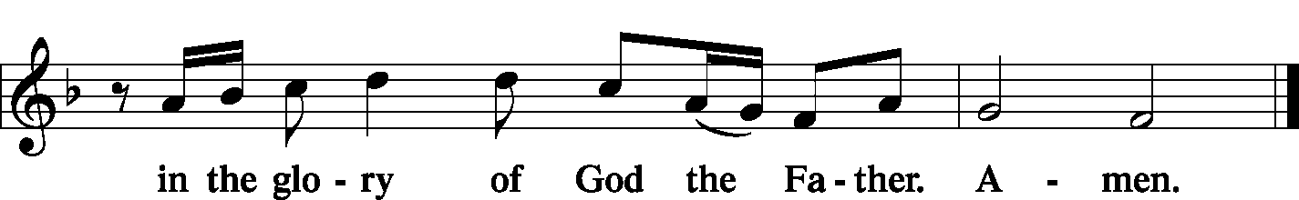

Salutation and Collect of the Day 2 Timothy 4: 22
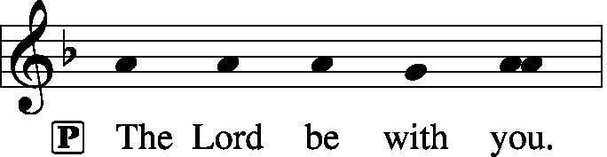
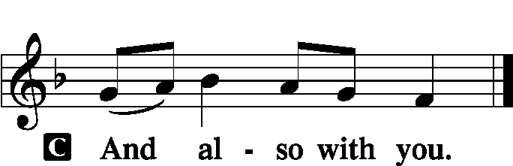

P Let us pray.
Grant to us, Lord, the Spirit to think and do always such things as are right, that we, who cannot do anything that is good without You, may be enabled by You to live according to Your will; through Jesus Christ, Your Son, our Lord, who lives and reigns with You and the Holy Spirit, one God, now and forever.

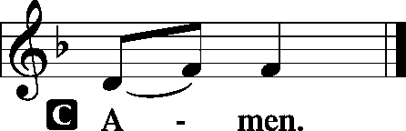

Sit

Old Testament Reading: Jeremiah 23:16–29
Thus says the Lord of hosts: “Do not listen to the words of the prophets who prophesy to you, filling you with vain hopes. They speak visions of their own minds, not from the mouth of the Lord. They say continually to those who despise the word of the Lord, ‘It shall be well with you’; and to everyone who stubbornly follows his own heart, they say, ‘No disaster shall come upon you.’”
For who among them has stood in the council of the Lord
to see and to hear his word,
or who has paid attention to his word and listened?
Behold, the storm of the Lord!
Wrath has gone forth,
a whirling tempest;
it will burst upon the head of the wicked.
The anger of the Lord will not turn back
until he has executed and accomplished
the intents of his heart.
In the latter days you will understand it clearly.
“I did not send the prophets,
yet they ran;
I did not speak to them,
yet they prophesied.
But if they had stood in my council,
then they would have proclaimed my words to my people,
and they would have turned them from their evil way,
and from the evil of their deeds.
“Am I a God at hand, declares the Lord, and not a God afar off? Can a man hide himself in secret places so that I cannot see him? declares the Lord. Do I not fill heaven and earth? declares the Lord. I have heard what the prophets have said who prophesy lies in my name, saying, ‘I have dreamed, I have dreamed!’ How long shall there be lies in the heart of the prophets who prophesy lies, and who prophesy the deceit of their own heart, who think to make my people forget my name by their dreams that they tell one another, even as their fathers forgot my name for Baal? Let the prophet who has a dream tell the dream, but let him who has my word speak my word faithfully. What has straw in common with wheat? declares the Lord.
Is not my word like fire, declares the Lord, and like a hammer that breaks the rock in pieces?”

P This is the Word of the Lord.
C Thanks be to God.

Gradual: : Ps. 31:2b, 1a
Be a rock of refuge for me,
a strong fortress to save me!
In you, O Lord, do I take refuge;
let me never be put to shame.

Second Reading: Acts 20:27–38
for I did not shrink from declaring to you the whole counsel of God. Pay careful attention to yourselves and to all the flock, in which the Holy Spirit has made you overseers, to care for the church of God, which he obtained with his own blood. I know that after my departure fierce wolves will come in among you, not sparing the flock; and from among your own selves will arise men speaking twisted things, to draw away the disciples after them. Therefore be alert, remembering that for three years I did not cease night or day to admonish everyone with tears. And now I commend you to God and to the word of his grace, which is able to build you up and to give you the inheritance among all those who are sanctified. I coveted no one’s silver or gold or apparel. You yourselves know that these hands ministered to my necessities and to those who were with me. In all things I have shown you that by working hard in this way we must help the weak and remember the words of the Lord Jesus, how he himself said, ‘It is more blessed to give than to receive.’”
And when he had said these things, he knelt down and prayed with them all. And there was much weeping on the part of all; they embraced Paul and kissed him, being sorrowful most of all because of the word he had spoken, that they would not see his face again. And they accompanied him to the ship.

P This is the Word of the Lord.
C Thanks be to God.

Stand

Verse of the Day: Ps. 78:1
Alleluia. Give ear, O my people, to my teaching; incline your ears to the words of my mouth! Alleluia.

Common Alleluia
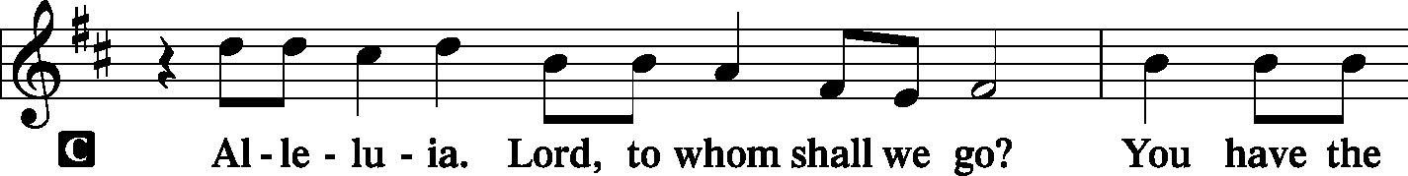
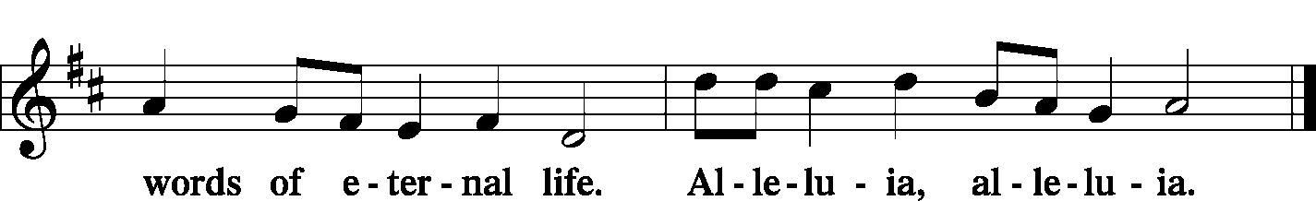

Holy Gospel: Matthew 7:15–23
P The Holy Gospel according to St. Matthew, the seventh chapter.

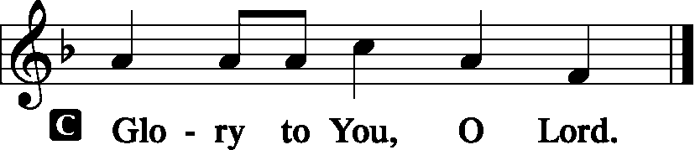

[Jesus said:] “Beware of false prophets, who come to you in sheep’s clothing but inwardly are ravenous wolves.
You will recognize them by their fruits. Are grapes gathered from thornbushes, or figs from thistles?
So, every healthy tree bears good fruit, but the diseased tree bears bad fruit. A healthy tree cannot bear bad fruit, nor can a diseased tree bear good fruit. Every tree that does not bear good fruit is cut down and thrown into the fire. Thus you will recognize them by their fruits.
“Not everyone who says to me, ‘Lord, Lord,’ will enter the kingdom of heaven, but the one who does the will of my Father who is in heaven. On that day many will say to me, ‘Lord, Lord, did we not prophesy in your name, and cast out demons in your name, and do many mighty works in your name?’ And then will I declare to them, ‘I never knew you; depart from me, you workers of lawlessness.’

P This is the Gospel of the Lord.
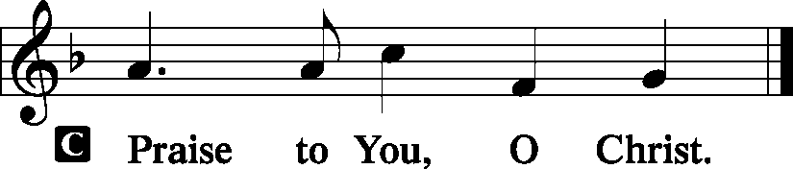

Nicene Creed
C I believe in one God,
the Father Almighty,
maker of heaven and earth
and of all things visible and invisible.
And in one Lord Jesus Christ,
the only-begotten Son of God,
begotten of His Father before all worlds,
God of God, Light of Light,
very God of very God,
begotten, not made,
being of one substance with the Father,
by whom all things were made;
who for us men and for our salvation came down from heaven
and was incarnate by the Holy Spirit of the virgin Mary
and was made man;
and was crucified also for us under Pontius Pilate.
He suffered and was buried.
And the third day He rose again according to the Scriptures
and ascended into heaven
and sits at the right hand of the Father.
And He will come again with glory to judge both the living and the dead,
whose kingdom will have no end.
And I believe in the Holy Spirit,
the Lord and giver of life,
who proceeds from the Father and the Son,
who with the Father and the Son together is worshiped and glorified,
who spoke by the prophets.
And I believe in one holy Christian and apostolic Church,
I acknowledge one Baptism for the remission of sins,
and I look for the resurrection of the dead
and the life T of the world to come. Amen.
Sit

Hymn of the Day: LSB #745 “In God, My Faithful God”

Sermon
Stand
Prayer of the Church [Timothy 2: 1-4]
Sit

Offertory Psalm 116: 12-13, 17-19
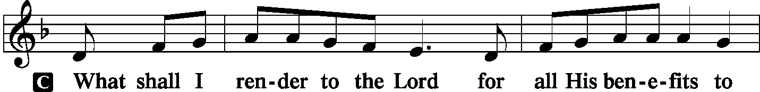
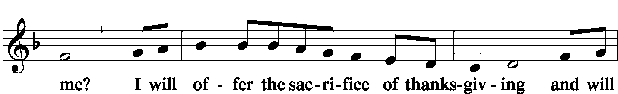
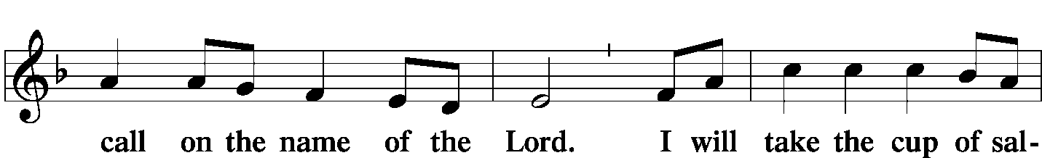
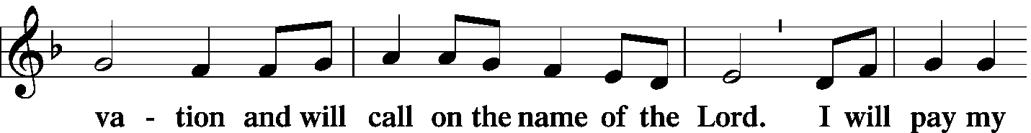
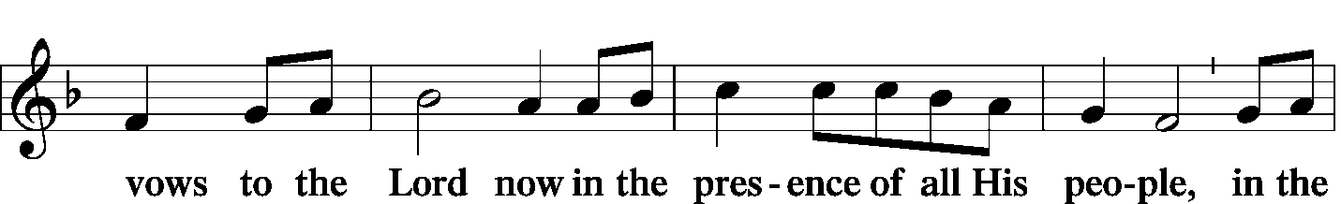
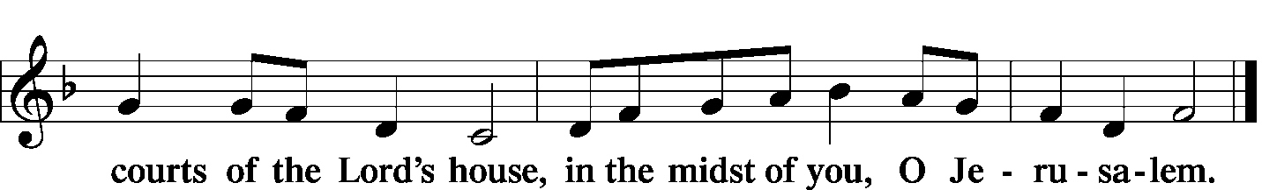

Offering/Offering Hymn: LSB #625 “Lord Jesus Christ, Life-Giving Bread”

Stand
SERVICE OF THE SACRAMENT
Preface
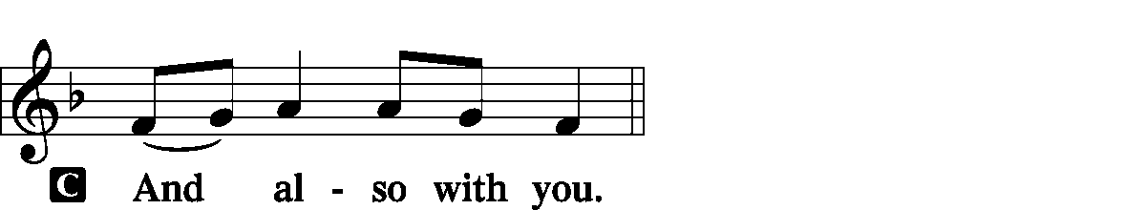
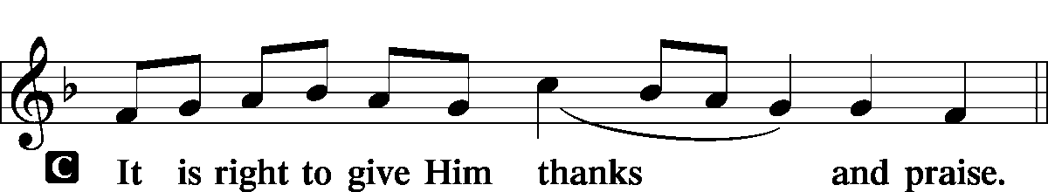

P It is truly good, right, and salutary … evermore praising You and saying:

Sanctus
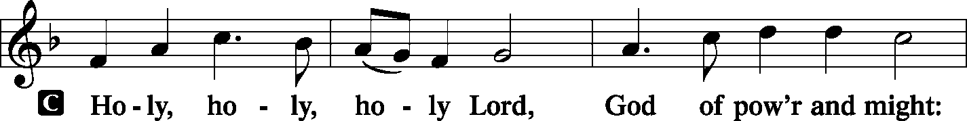
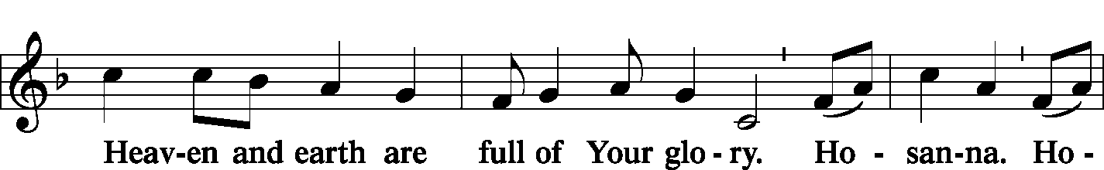
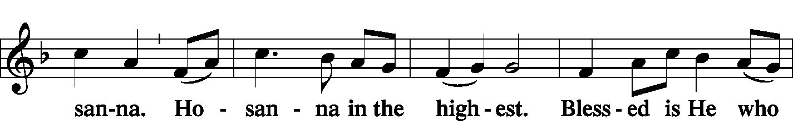
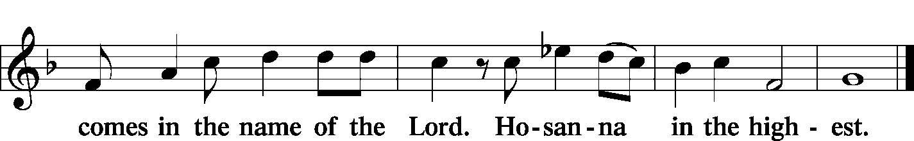

Lord's Prayer Matthew 6: 9-13
P Lord, remember us in Your kingdom and teach us to pray:
C Our Father who art in heaven,
hallowed be Thy name,
Thy kingdom come,
Thy will be done on earth as it is in heaven;
give us this day our daily bread;
and forgive us our trespasses as we forgive those who trespass against us;
and lead us not into temptation,
but deliver us from evil.
For Thine is the kingdom and the power and the glory forever and ever. Amen.

The Words of Our Lord Matthew 26: 26-28; Mark 14: 22-24
Luke 22: 19-20; 1 Corinthians 11: 23-25
P Our Lord Jesus Christ, on the night when He was betrayed, took bread, and when He had given thanks, He broke it and gave it to the disciples and said: “Take, eat; this is My T body, which is given for you. This do in remembrance of Me.”

P In the same way also He took the cup after supper, and when He had given thanks, He gave it to them, saying: “Drink of it, all of you; this cup is the new testament in My T blood, which is shed for you for the forgiveness of sins. This do, as often as you drink it, in remembrance of Me.”

Pax Domini John 20: 19
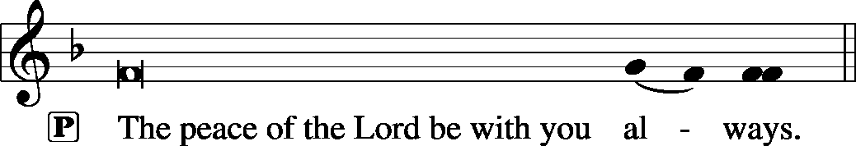

Agnus Dei John 1: 29
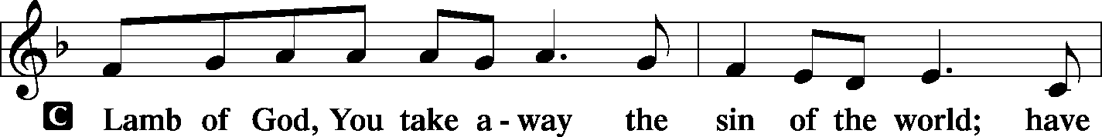
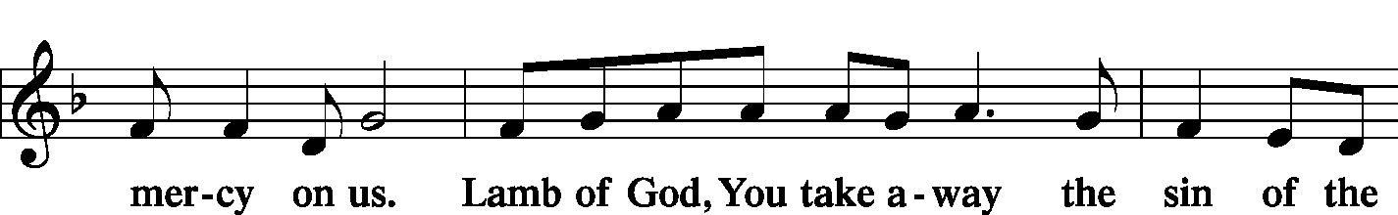
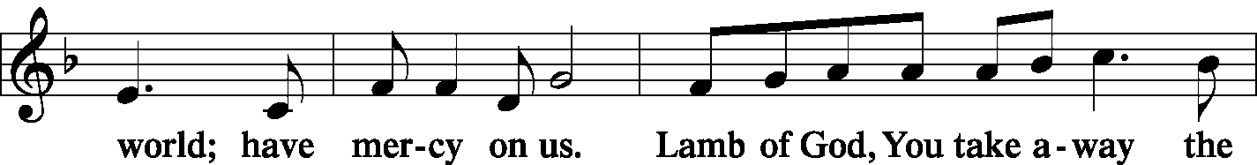
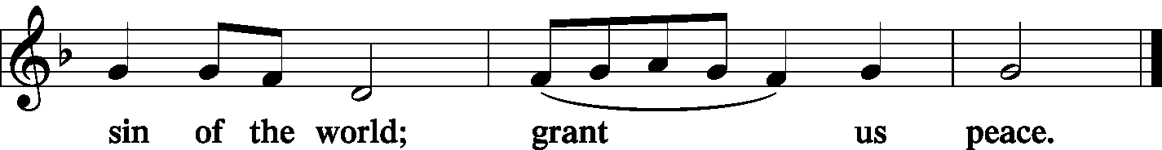

Sit
Distribution
The pastor and those who assist him receive the body and blood of Christ first and then distribute them to those who come to receive, saying:
Take, eat; this is the true body of our Lord and Savior Jesus Christ, given into death for your sins.
Amen.

Take, drink; this is the true blood of our Lord and Savior Jesus Christ, shed for the forgiveness of your sins.
Amen.
In dismissing the communicants, the following is said:
P The body and blood of our Lord Jesus Christ strengthen and preserve you in body and soul to life everlasting. Depart T in peace.
C Amen.

Distribution Hymn: LSB #617 “O Lord, We Praise Thee”
Distribution Hymn: LSB #693 “O Holy Spirit, Grant Us Grace”

Stand

Nunc Dimittis Luke 2: 29-32
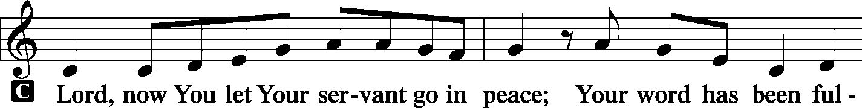
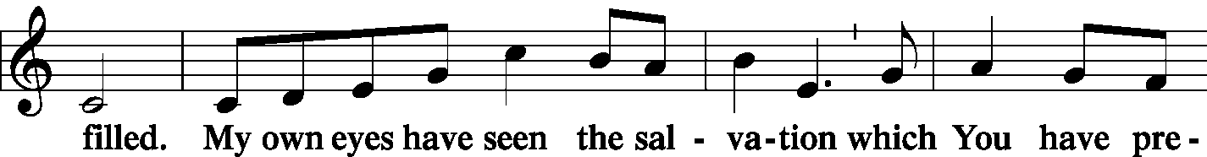
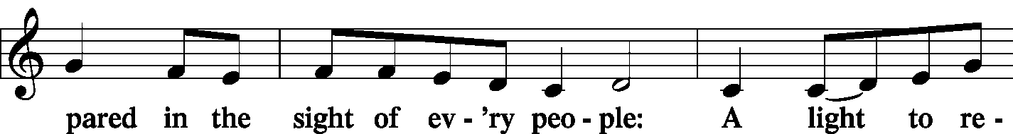
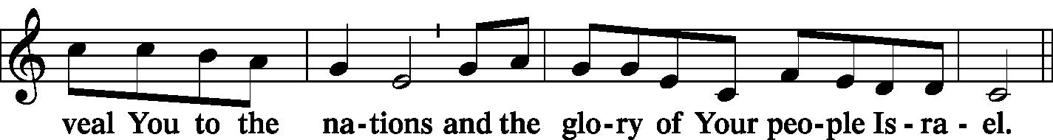
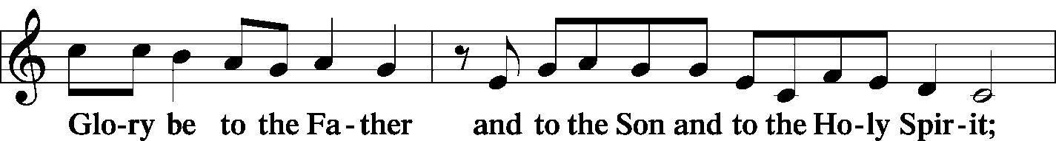
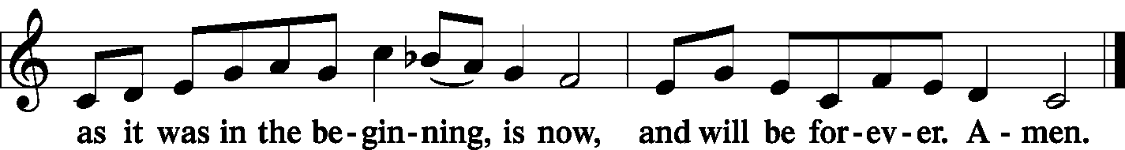

Post-Communion Collect Let us pray…

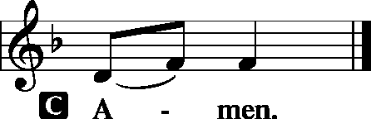

Benediction Numbers 6: 24-26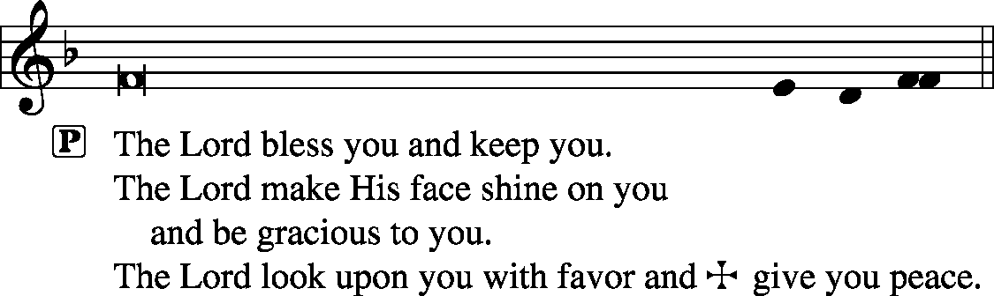
Closing Hymn: TLH #267 “If God Had Not Been on Our Side”, sung to the tune of LSB #899
- If God had not been on our side And had not come to aid us, The foes with all their pow’r and pride Would surely have dismayed us; For we, His flock, would have to fear The threat of men both far and near Who rise in might against us.
- Their furious wrath, did God permit, Would surely have consumed us And as a deep and yawning pit With life and limb entombed us. Like men o’er whom dark waters roll Their wrath would have engulfed our soul And, like a flood, o’er-whelmed us.
- Blest be the Lord, who foiled their threat That they could not devour us; Our souls, like birds, escaped their net, They could not overpow’r us. The snare is broken—we are free! Our help is ever, Lord, in Thee, Who madest earth and heaven. Amen.
Silent prayer after worship: Heavenly Father, give me a spirit that longs to have Your Word dwell in my heart, that I may have peace, hope and strength to meet all the trials and challenges of life, and may live according to Your will. In Jesus’ name. Amen.

Acknowledgments: Divine Service, Setting One from Lutheran Service Book Unless otherwise indicated, all scripture quotations are from The Holy Bible, English Standard Version, copyright © 2001 by Crossway Bibles, a division of Good News Publishers. Used by permission. All rights reserved. Created by Lutheran Service Builder © 2006 Concordia Publishing House. CCLI License #3029-446

The Altar Flowers this morning are given in Loving Memory of Father, Paul A. Fabri, and in Remembrance of Parents, Paul & Millie Fabri’s, Anniversary August 21, 1937, by Ruth Meszaros & Joani Rice. We sincerely appreciate this generous gift!


In Loving Memory of Departed Loved Ones: Betty Ann Wolf (Missions).
In Loving Memory of Mrs. Mary Kapusta: Mr. & Mrs. Edward Zachar.
In Memory of Our Loving Aunt Sophia Mihm: Kathryn, Dan, Daniel, Devin, & Julianna James (Food Pantry).
In Loving Memory of Paul Stewart, Paula Ostheimer’s Father: Mr. & Mrs. Robert Sulek (Preschool).
In Loving Memory of Mrs. Mary Zachar: Mr. & Mrs. Edward Zachar.

Minutes from the August 5, 2019, Church Council Meeting are available in the narthex.
SCHEDULE FOR TODAY THROUGH AUG. 18th :
:

:

Today, following Worship, Downstairs…….………………...Coffee & Donuts Fellowship
7 pm, Downstairs….…………….…………………..………………….……...……AA Meeting
Monday, 4:30 pm, Offices………………………………………………………New Members’ Class
Thursday, 8 pm…………………………………………………………..……Young Adult Bible Study
Saturday, 5 pm, Chapel……………………………..……………………………………..Divine Service
Next Sunday, 8:45 am, Downstairs……………………………………………..…………Bible Study
10 am, Sanctuary…...........................................................................Divine Service
7 pm, Downstairs…………………………………………..…………………......…AA Meeting

Our Stewardship of Treasures for the Lord:
In order to do the Lord’s work, we need $2,882.02* each week to meet our 2019 budget for general purposes and $38.46 for missions.
Wednesday, July 31 & Sunday, August 4, 2019:
General Offering: $1,705.00 Behind this week*: -$1,177.02
SELC Missions: $210.00 Ahead this week: +$171 .54
Local Missions: $0.00 Preschool Tuition: $0.00
Other Offerings: $166.00 *Includes preschool tuition.
Thank You for Serving in August:
Today’s Greeters: Jeff & Stacy Brandes. Assisting Elders: Bob Sulek & Barry Nelson. Ushers: Ralph Dorman, Jonathan Baisch, Matt Berent, Mark Gabriel, & John Dyll (alternate). Altarware: Clara Krivosh & Cheryl Fedele.
August Greeters: 18 ~ Gary & Eileen Burns; 25 ~ Barry & Chris Nelson.

Bible Memory Verses: For the week of August 11th:
For Children: Walk as children of light, for the fruit of light is found in all that is good and right and true. Eph. 5:8-9
For Adults: For our sake he made him to be sin who knew no sin, so that in him we might become the righteousness of God. 2 Corinthians 5:21

Attendance: Wednesday, July 31 and Sunday, August 4, 2019: 41
Please sign the Friendship Book and give your sheet to an usher after the offering.

Up-Coming Events!
~Sunday, August 25th. Voters’ Assembly meeting following the Divine Service.
~Wednesday, October 2nd or Thursday, October 3rd. Willow Women’s Center’s annual fall banquet hosted at the Avalon at Buhl. Phone 330-503-6512 or email rsvp@willowwomenscenter.com to reserve your spot for either date.

Remember the following in Prayer…
~The Hurting and Healing: Tony³, Lois Bortner^{CA}, Richard Brandes², Eileen Burns², Beverly Chlpka³, Kim³, Tim Dudash³, John Dyll², Jennifer Hilliard², Anson Holcroft², Betty Knauff^{CA}, Regis Knauff³, Clara Krivosh⁴, Jess Lavoie¹, Paul Lucas^{CA}, Rhonda Moats^{CA}, Barry Nelson³, David Nelson⁴,Tom Mulligan^{CA}, Iona Oltman^{CA}, Rudy Pinal^{CA}, Don Voytik², Angela Weser^{CA}, and Ken White^{CA}.
~Our Homebound: Helen Bender, Dan Davis, Edna Krajci, Mary Ann Krajci, Marion Roberts, Barbara Vasconi, and Joanne Wolfe.
~Celebrating: Birthdays: Sarah Chlpka (08.12).
~Serving in the Military: Clayton Drnek, Curtis Sinewe, and Joshua Solyan.
~Community & World Needs: Victims of violence and terrorism; those suffering from loss and dislocation because weather disasters; those suffering from addiction and their families; Local, State, and National Government Leaders; Safety for all Police Officers, Firefighters, & First Responders; the unemployed; our Third Quarter Local Mission: MERP (Medical Equipment Recycling Program).
*CA represents cancer; number after other names represents weeks on the prayer list. After 4 weeks names may be resubmitted. This helps us to remember people’s specific needs and reminds us that God is providing healing as people get better and no longer need our prayers. Please submit prayer requests in writing to the church office.

HELP NEEDED! Buhl Day Halushky Sale is right around the corner! Volunteers will be needed for…
- Fri., Aug. 30th: prepping cabbage
- Sat., Aug. 31st: cutting/cooking cabbage
- Sun., Sept. 1st: setting up at park
- Mon., Sept. 2nd: cooking noodles, heating cabbage, mixing halushky, delivering to park, manning our booth, tear down and clean-up at church and park.
Speak with Jesse Riffle or Diane Riefstahl if able to help!

Here to Serve You…

Pastor………………………………………………….………..…Rev. Jacob Deal
E-mail ……….…………………….…..pastordeal@saintspeterandpaul.net
Phone Number…………..……………………………724-347-3620 (Option 2)
Church Office………………………………….………724-347-3620 (Option 3)
Website ……….………………….……...…….www.saintspeterandpaul.net
Secretary………………………………………………….……. Diane Riefstahl
E-mail ……….…………………….…….…church@saintspeterandpaul.net
Food Pantry: John Dyll…………….……………………..…..…724-347-1779
Little People Preschool…………….……………….724-347-3620 (Option 4)
Teacher: Paula Ostheimer………….………………….…….....724-981-5846
Email ……….………….…………………….paula@saintspeterandpaul.net
AA Contact: Steve……………………….…………..……...……. 724-813-2358
Organist……………………………………………………..…Carrie Yasnowski
Choir Director……………..…………….…………..….….………Chris Nelson
Congregation President…………………………………………Jeff Brandes
 In general, the secretary’s office is open Monday and Thursdays from 8:30 am -4:30 pm. Pastor Deal is here throughout the week, except Fridays or when ministering offsite. If you need to enter the Church, please call ahead to be sure someone is here to let you in. Thank you.

