Sts. Peter & Paul
Evangelical Lutheran Church
Lutheran Church-Missouri Synod
Founded-1917

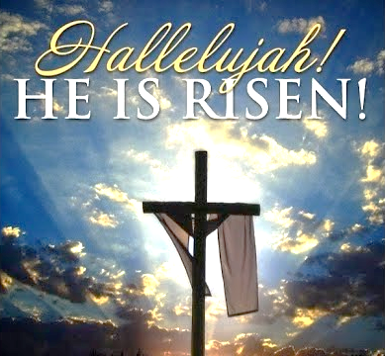

April 9, 2023

699 Stambaugh Ave.
Sharon, Pennsylvania 16146

“I was glad when they said to me,
Let us go to the house of the LORD!”
Psalm 122:1
Sts. Peter & Paul Evangelical Lutheran Church, LC-MS
EASTER
April 9, 2023

A special welcome to our guests this day! If you would like more information about The Lutheran Church - Missouri Synod, or this congregation, please speak with Pastor Deal or an Elder after the service.
Members & Guests: Don’t be embarrassed if your children make noise during the worship service, all children do. We encourage families to worship together but, if you feel the need, there are pews in the rear of the Church which are reserved for young families on both sides of the sanctuary. There is also a quiet room available to you during our service which is located down the hallway past the offices on the right side of the church as well as a children’s area in the Fellowship Hall where you are able to follow along with the service.

Today’s service includes the Sacrament of Holy Communion. If during this past year, you have not worshipped with us and been communed, we respectfully ask that you do not partake of this sacrament this day before first speaking with Pastor Deal.
If visiting from a sister congregation of the LC-MS and are in good standing, please inform Pastor Deal of your desire to commune prior to the service.
If wishing to receive a blessing during communion, please approach with your arms crossed.

CONTACT INFORMATION
Pastor Deal: pastordeal@saintspeterandpaul.net or 724-347-3620 (opt. 2)
Church Office: church@saintspeterandpaul.net or 724-347-3620 (opt. 3)

Silent prayer before worship: Heavenly Father, give me confidence to trust that through our living Savior Jesus I have a new and eternal life. Fill my heart with a joyful desire to share the wonderful news that Christ is risen. Amen.

Confession and Absolution

Processional Hymn: LSB #457 “Jesus Christ Is Risen Today”

The sign of the cross may be made by all in remembrance of their Baptism.

Invocation
P In the name of the Father and of the T Son and of the Holy Spirit.
C Amen.

Exhortation Hebrews 10:22; Psalm 124:8; Psalm 32:5
P Beloved in the Lord! Let us draw near with a true heart and confess our sins unto God our Father, beseeching Him in the name of our Lord Jesus Christ to grant us forgiveness.

P Our help is in the name of the Lord,
C who made heaven and earth.
P I said, I will confess my transgressions unto the Lord,
C and You forgave the iniquity of my sin.

Silence for reflection on God’s Word and for self-examination.

Confession of Sins
P O almighty God, merciful Father,
C I, a poor, miserable sinner, confess unto You all my sins and iniquities with which I have ever offended You and justly deserved Your temporal and eternal punishment. But I am heartily sorry for them and sincerely repent of them, and I pray You of Your boundless mercy and for the sake of the holy, innocent, bitter sufferings and death of Your beloved Son, Jesus Christ, to be gracious and merciful to me, a poor, sinful being.

Absolution [John 20:19–23]
P Upon this your confession, I, by virtue of my office, as a called and ordained servant of the Word, announce the grace of God unto all of you, and in the stead and by the command of my Lord Jesus Christ I forgive you all your sins in the name of the Father and of the T Son and of the Holy Spirit.
C Amen.

Service of the Word

Introit Psalm 8:1, 5–6, 9; antiphon: Luke 24:5b–6b
He is risen! Alle- | luia!*
Why do you seek the living among the dead? Alle- | luia!
Remember how he told you, Alle- | luia,*
that the Son of Man must be crucified and on the third day rise. Alle- | luia!
O Lord, our Lord, how majestic is your name in | all the earth!*
You have set your glory above the | heavens.
Yet you have made him a little lower than the heavenly | beings*
and crowned him with glory and | honor.
You have given him dominion over the works | of your hands;*
you have put all things under | his feet.
O | Lord, our Lord,*
how majestic is your name in | all the earth!
He is risen! Alle- | luia!*
Why do you seek the living among the dead? Alle- | luia!
Remember how he told you, Alle- | luia,*
that the Son of Man must be crucified and on the third day rise. Alle- | luia!

Gloria Patri
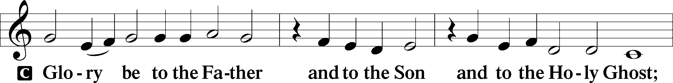
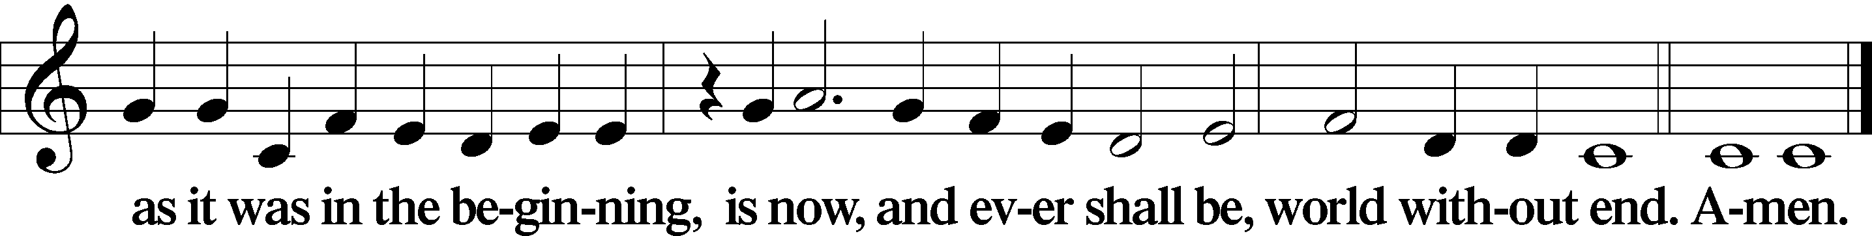

Kyrie Mark 10:47
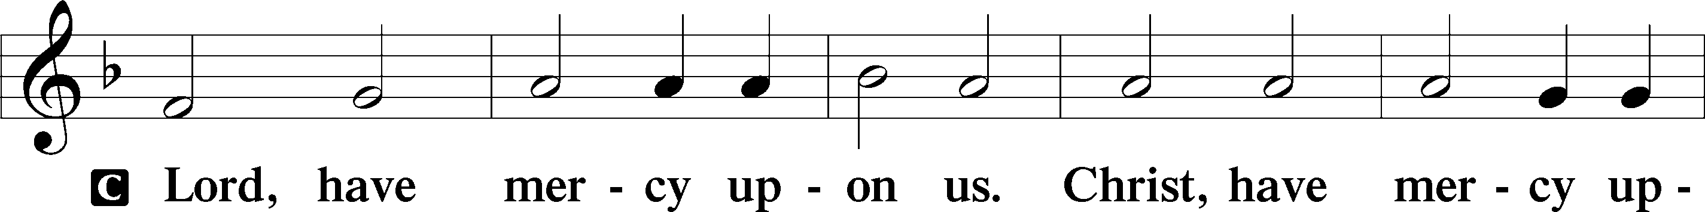
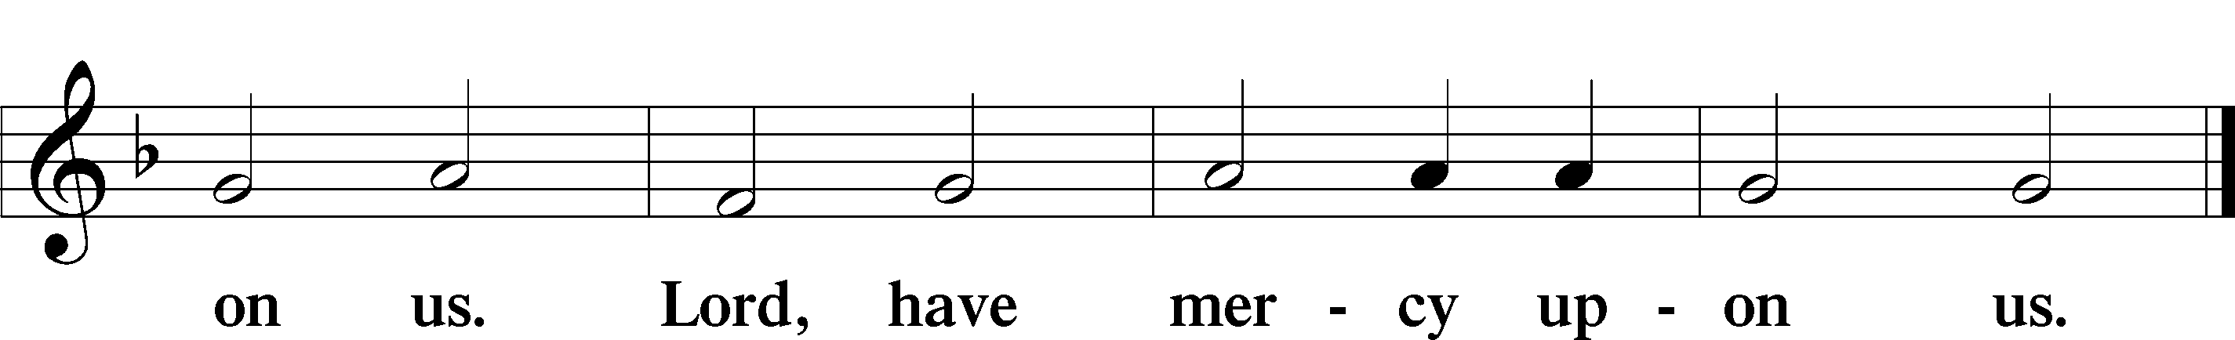

Gloria in Excelsis Luke 2:14; John 1:29
P Glory be to God on high:
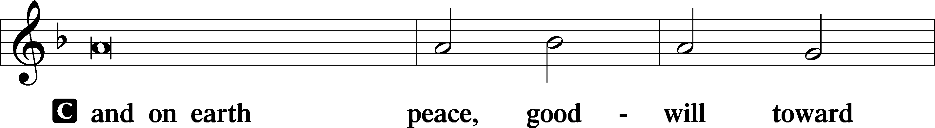
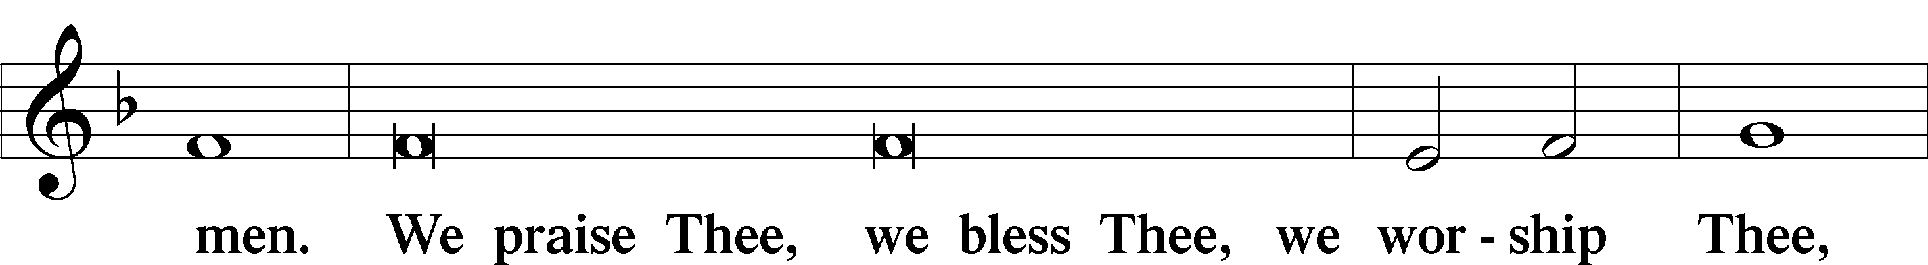
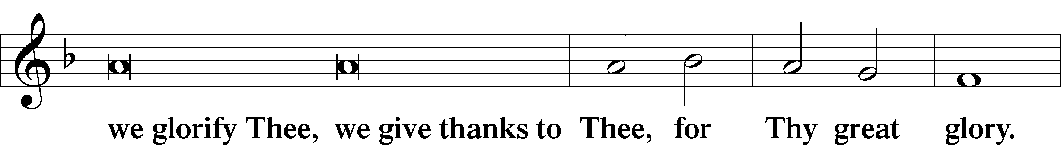
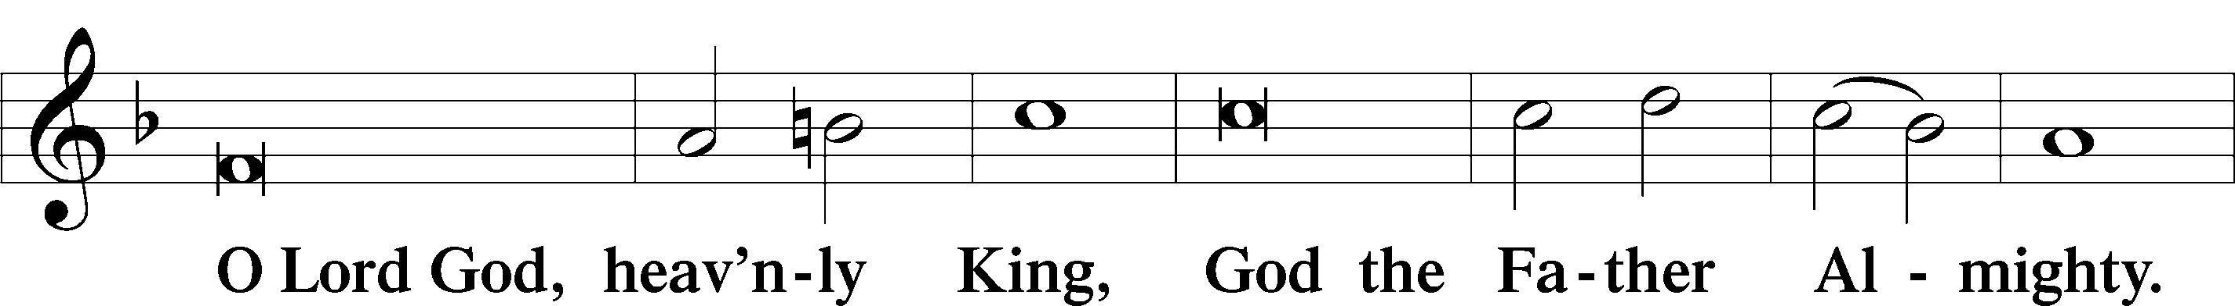
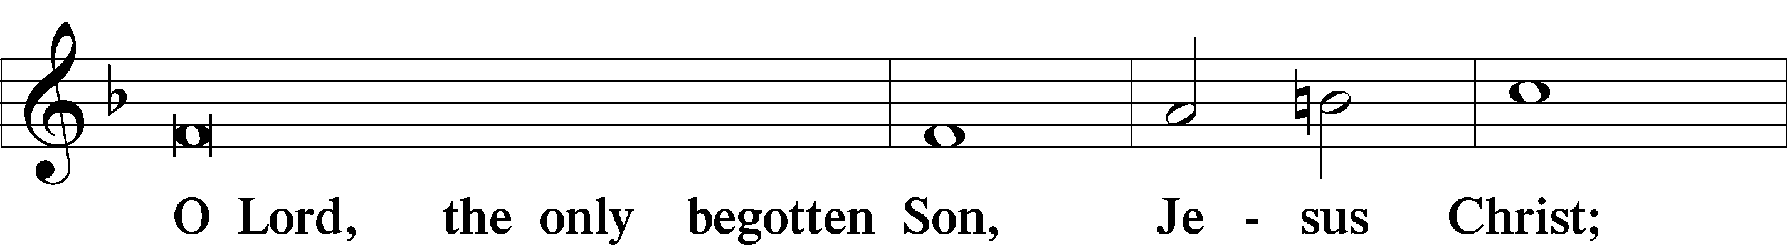
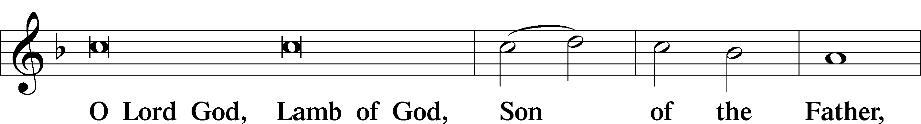
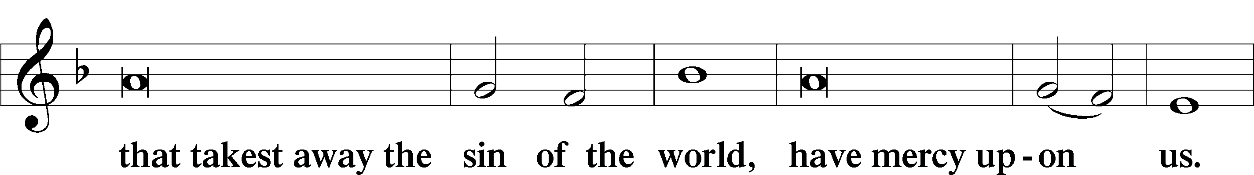
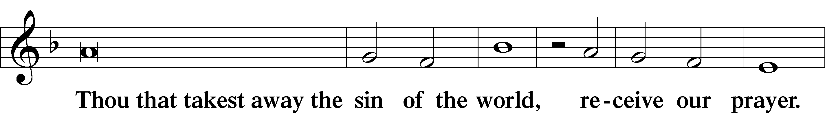
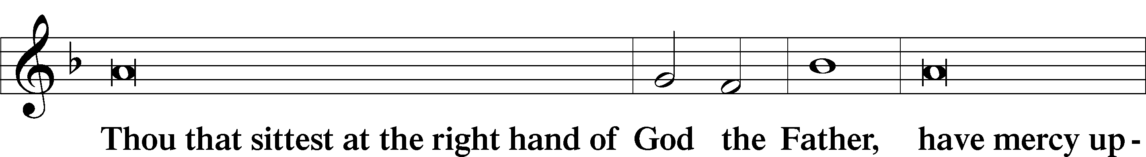
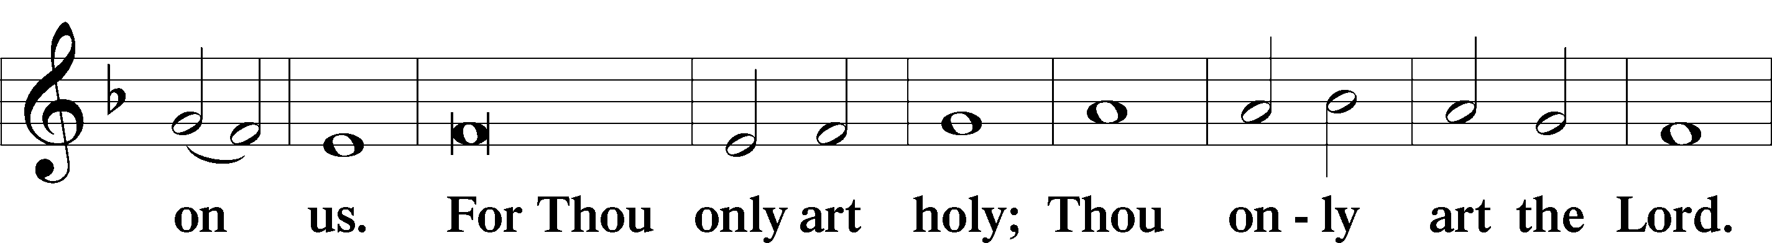
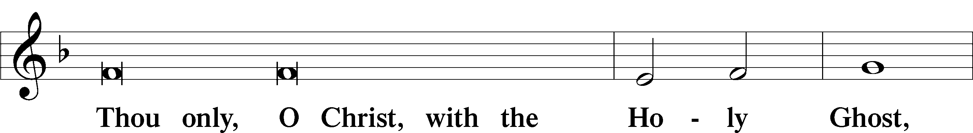
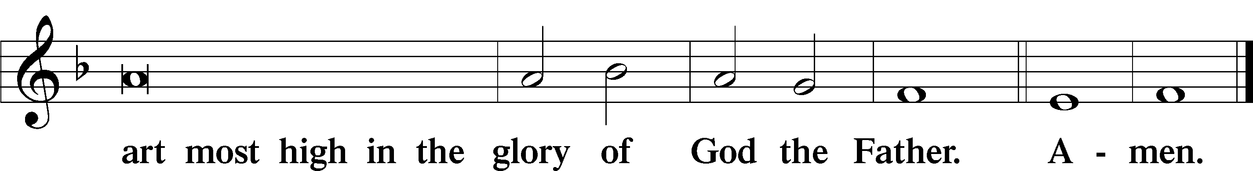

Salutation and Collect of the Day: Easter Day
P The Lord be with you.
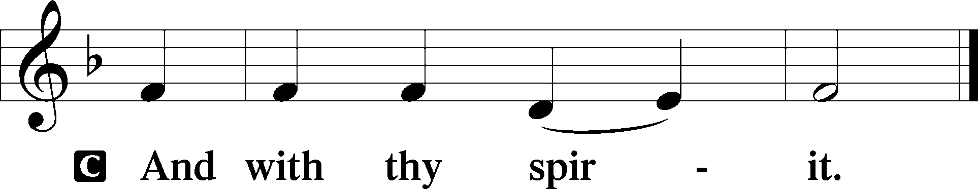

P Let us pray.
Almighty God the Father, through Your only-begotten Son, Jesus Christ, You have overcome death and opened the gate of everlasting life to us. Grant that we, who celebrate with joy the day of our Lord’s resurrection, may be raised from the death of sin by Your life-giving Spirit; through Jesus Christ, our Lord, who lives and reigns with You and the Holy Spirit, one God, now and forever.
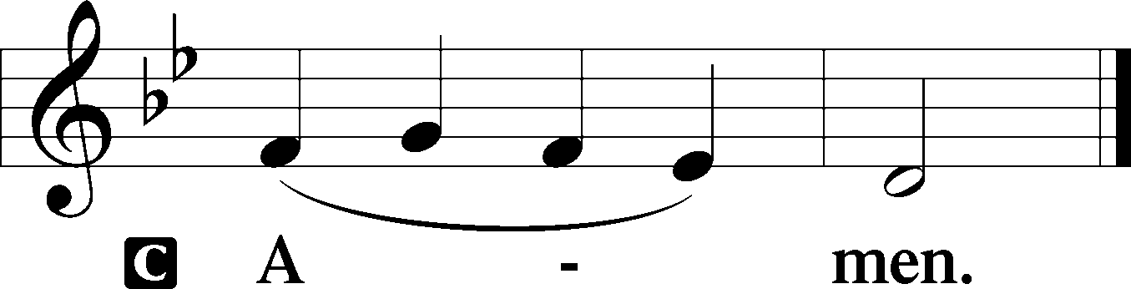
Sit

Prophecy: Job 19:23–27 (NKJV)
In those days the prophet Job spoke, saying: “Oh, that my words were written! Oh, that they were inscribed in a book! That they were engraved on a rock with an iron pen and lead, forever! For I know that my Redeemer lives, and He shall stand at last on the earth; and after my skin is destroyed, this I know, that in my flesh I shall see God, whom I shall see for myself, and my eyes shall behold, and not another. How my heart yearns within me!”

P This is the Word of the Lord.
C Thanks be to God.

Gradual Psalm 118:24, 1
This is the day that the | Lord has made;*
let us rejoice and be | glad in it.
Oh give thanks to the Lord, for | he is good;*
for his steadfast love endures for- | ever!

Choir: “Let the Alleluias Ring”

Epistle: 1 Corinthians 5:7–8 (NKJV)
Brethren: Purge out the old leaven, that you may be a new lump, since you truly are unleavened. For indeed Christ, our Passover, was sacrificed for us. Therefore let us keep the feast, not with old leaven, nor with the leaven of malice and wickedness, but with the unleavened bread of sincerity and truth.

P This is the Word of the Lord.
C Thanks be to God.

Stand

Verse 1 Corinthians 5:7b–8a, c
Alleluia. Christ, our Passover lamb, has been sacrificed. Let us therefore celebrate the festival with the unleavened bread of sincerity and truth. Alleluia.

Alleluia
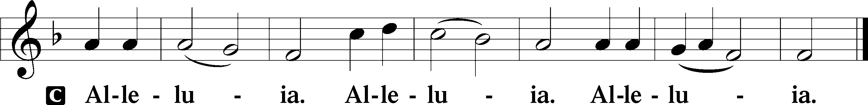

Holy Gospel: Mark 16:1–8 (NKJV)
P The Holy Gospel according to St. Mark, the sixteenth chapter.
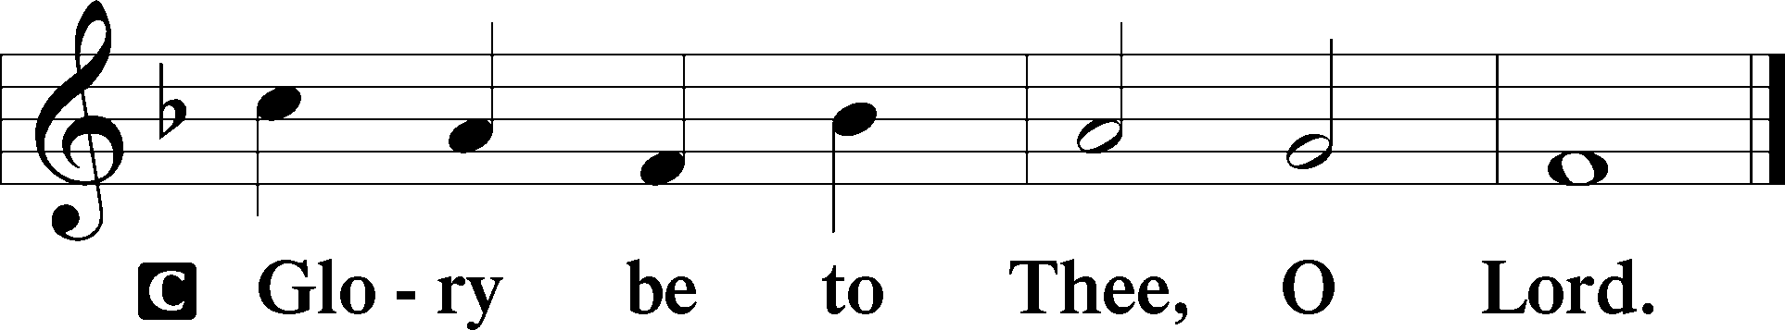

At that time: Mary Magdalene, Mary the mother of James, and Salome bought spices, that they might come and anoint Jesus. Very early in the morning, on the first day of the week, they came to the tomb when the sun had risen. And they said among themselves, “Who will roll away the stone from the door of the tomb for us?” But when they looked up, they saw that the stone had been rolled away—for it was very large. And entering the tomb, they saw a young man clothed in a long white robe sitting on the right side; and they were alarmed. But he said to them, “Do not be alarmed. You seek Jesus of Nazareth, who was crucified. He is risen! He is not here. See the place where they laid Him. But go, tell His disciples—and Peter—that He is going before you into Galilee; there you will see Him, as He said to you.” So they went out quickly and fled from the tomb, for they trembled and were amazed. And they said nothing to anyone, for they were afraid.

P This is the Gospel of the Lord.
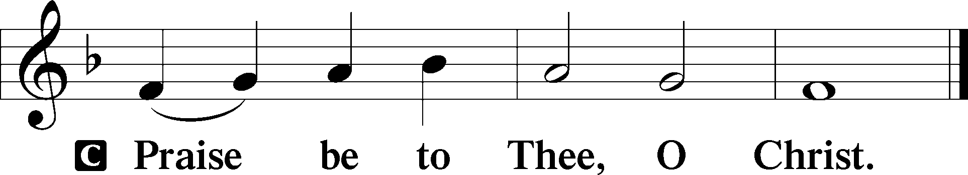

Nicene Creed
C I believe in one God,
the Father Almighty,
maker of heaven and earth
and of all things visible and invisible.

And in one Lord Jesus Christ,
the only-begotten Son of God,
begotten of His Father before all worlds,
God of God, Light of Light,
very God of very God,
begotten, not made,
being of one substance with the Father,
by whom all things were made;
who for us men and for our salvation came down from heaven
and was incarnate by the Holy Spirit of the virgin Mary
and was made man;
and was crucified also for us under Pontius Pilate.
He suffered and was buried.
And the third day He rose again according to the Scriptures
and ascended into heaven
and sits at the right hand of the Father.
And He will come again with glory to judge both the living and the dead,
whose kingdom will have no end.

And I believe in the Holy Spirit,
the Lord and giver of life,
who proceeds from the Father and the Son,
who with the Father and the Son together is worshiped and glorified,
who spoke by the prophets.
And I believe in one holy Christian and apostolic Church,
I acknowledge one Baptism for the remission of sins,
and I look for the resurrection of the dead
and the life T of the world to come. Amen.
Sit

Hymn of the Day: LSB #458 “Christ Jesus Lay in Death’s Strong Bands”

Sermon

Stand

Prayer of the Church

Offertory Psalm 51:10–12
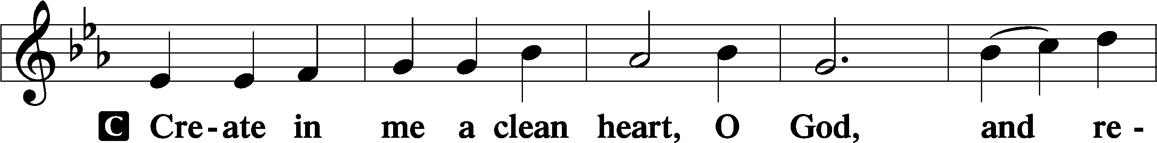
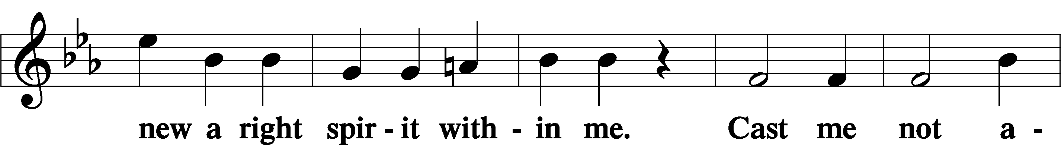
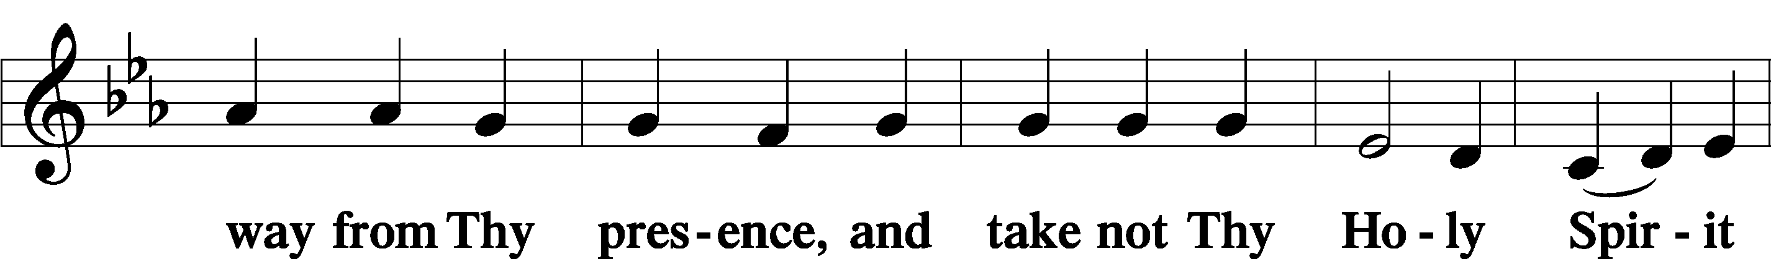
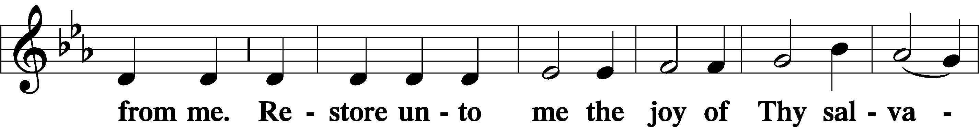
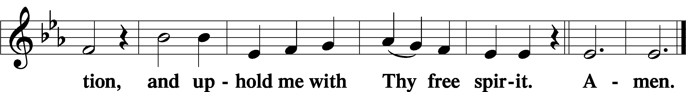

Sit
Preparatory Hymn: LSB #633 “At the Lamb’s High Feast We Sing”

Service of the Sacrament

Preface 2 Timothy 4:22; Colossians 3:1 Psalm 136
P The Lord be with you.
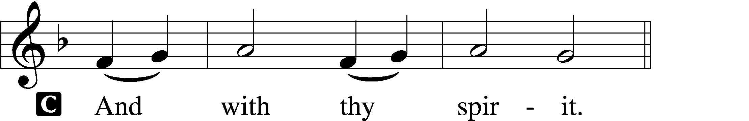

P Lift up your hearts.
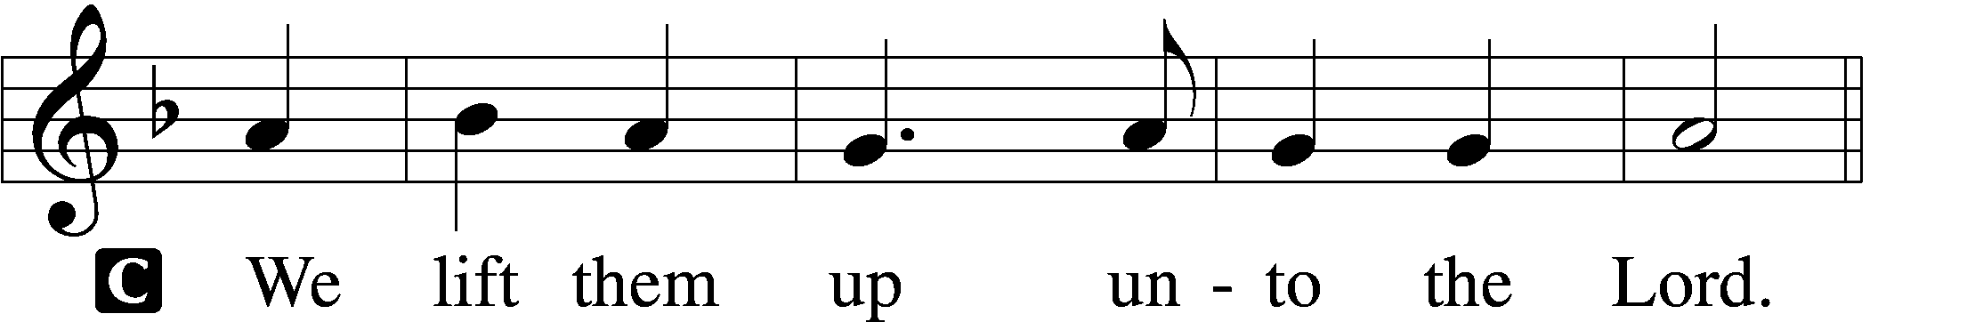

P Let us give thanks unto the Lord, our God.
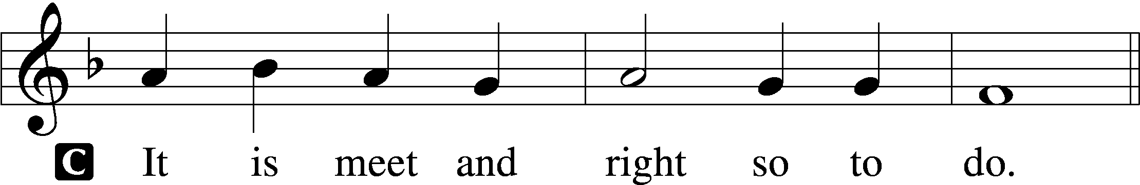

Proper Preface (Abbreviated) LSB 194
P It is truly meet, right, and salutary . . . evermore praising You and saying:

Sanctus Isaiah 6:3; Matthew 21:9
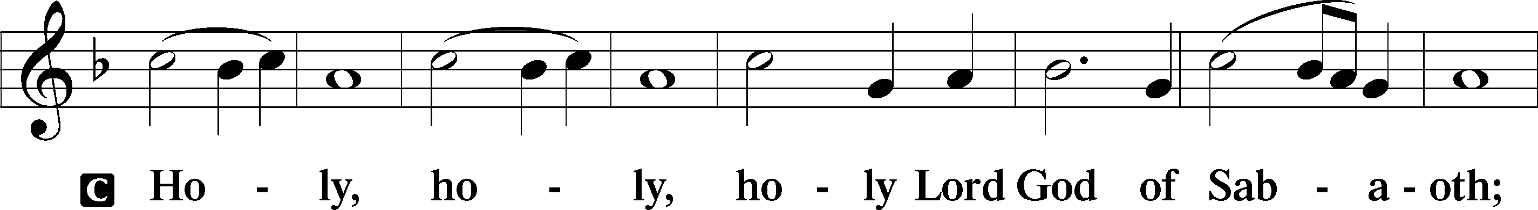
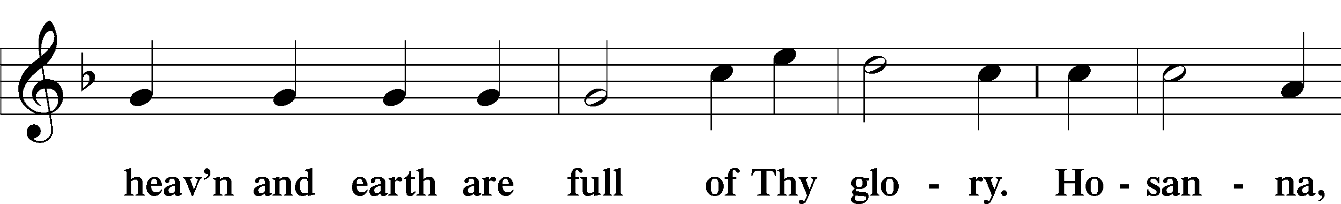
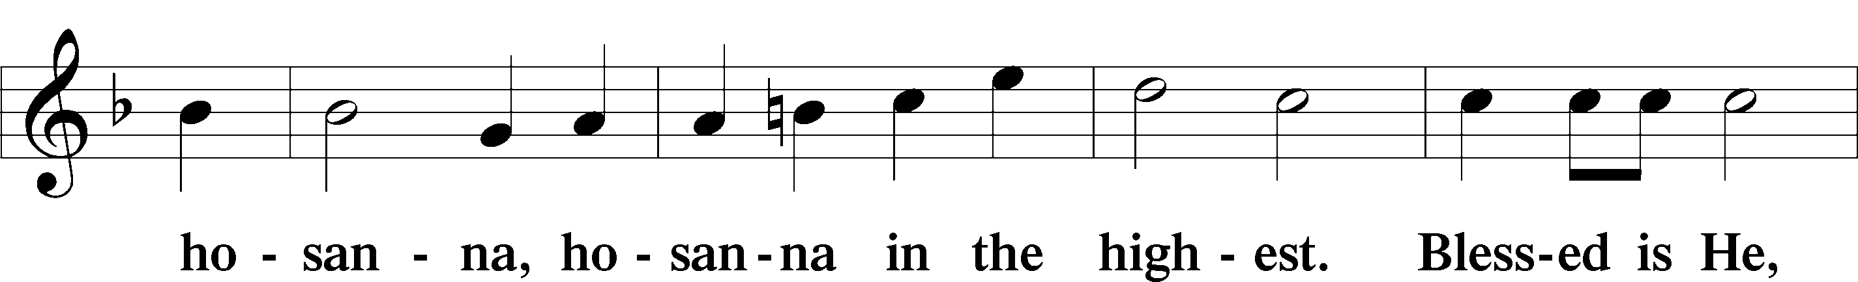
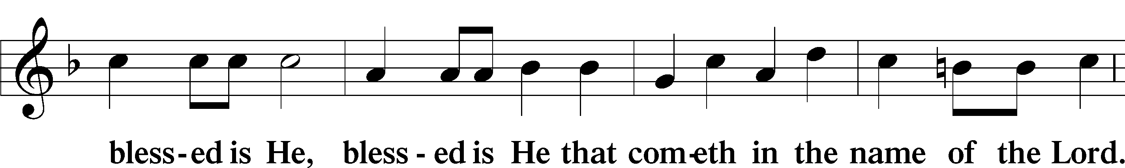
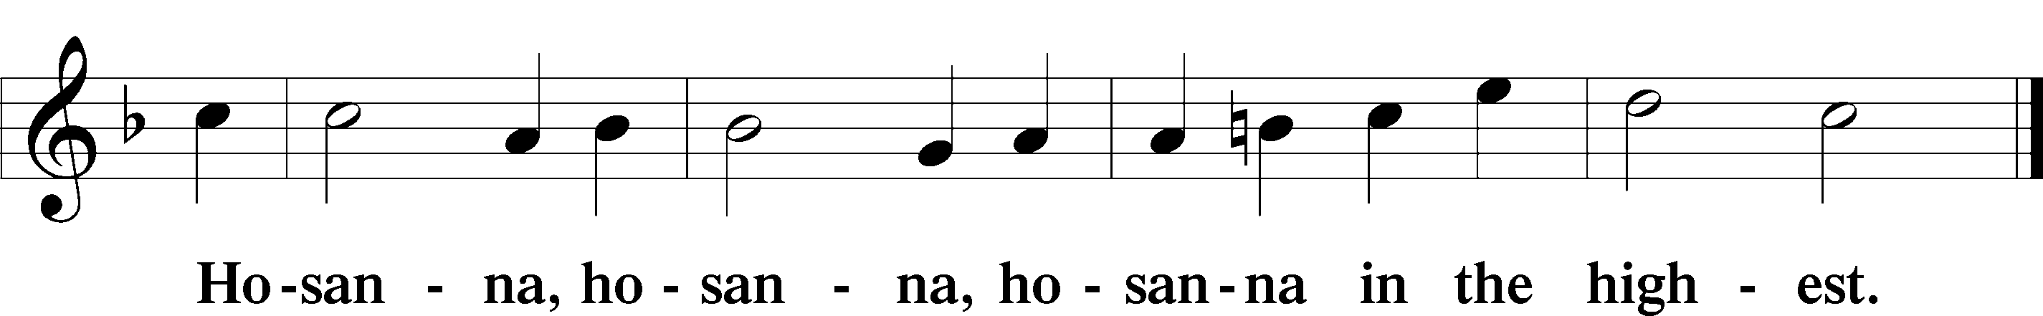

Lord’s Prayer Matthew 6:9–13
C Our Father who art in heaven,
hallowed be Thy name,
Thy kingdom come,
Thy will be done on earth as it is in heaven;
give us this day our daily bread;
and forgive us our trespasses as we forgive those who trespass against us;
and lead us not into temptation,
but deliver us from evil.
For Thine is the kingdom and the power and the glory forever and ever. Amen.

The Words of Our Lord Matthew 26:26–28; Mark 14:22–24; Luke 22:19–20; 1 Corinthians 11:23–25
P Our Lord Jesus Christ, on the night when He was betrayed, took bread, and when He had given thanks, He broke it and gave it to the disciples and said: “Take, eat; this is My T body, which is given for you. This do in remembrance of Me.”

In the same way also He took the cup after supper, and when He had given thanks, He gave it to them, saying: “Drink of it, all of you; this cup is the new testament in My T blood, which is shed for you for the forgiveness of sins. This do, as often as you drink it, in remembrance of Me.”

Pax Domini John 20:19
P The peace of the Lord be with you always.
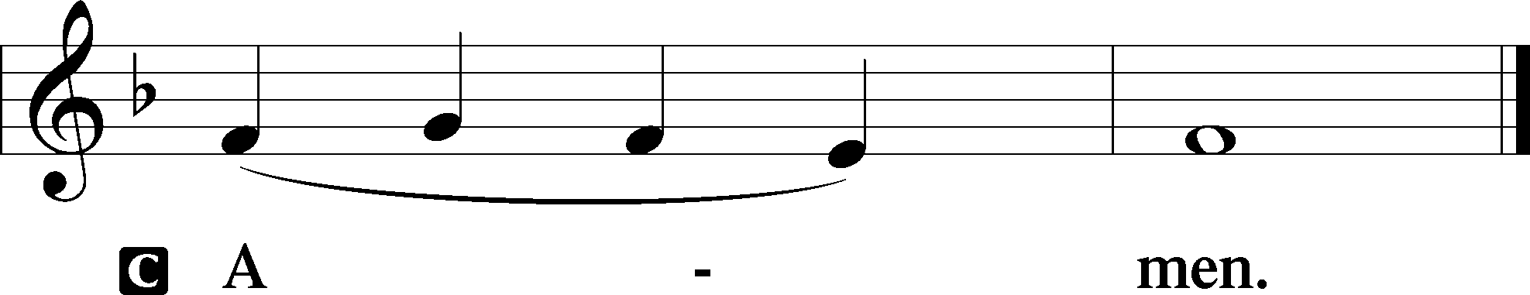

Agnus Dei John 1:29
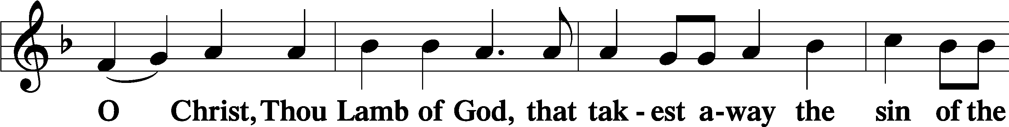
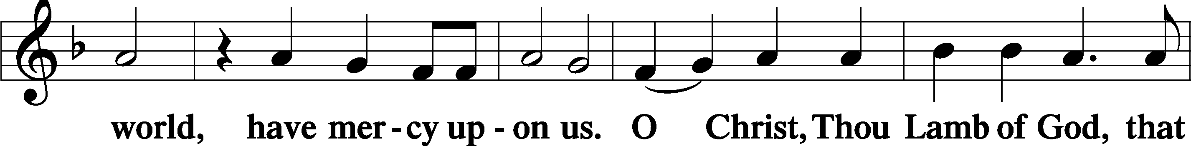
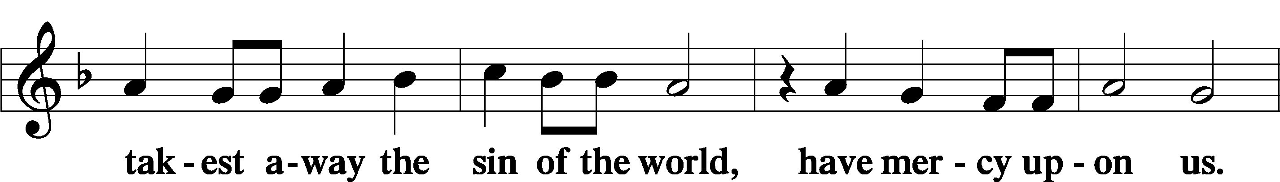
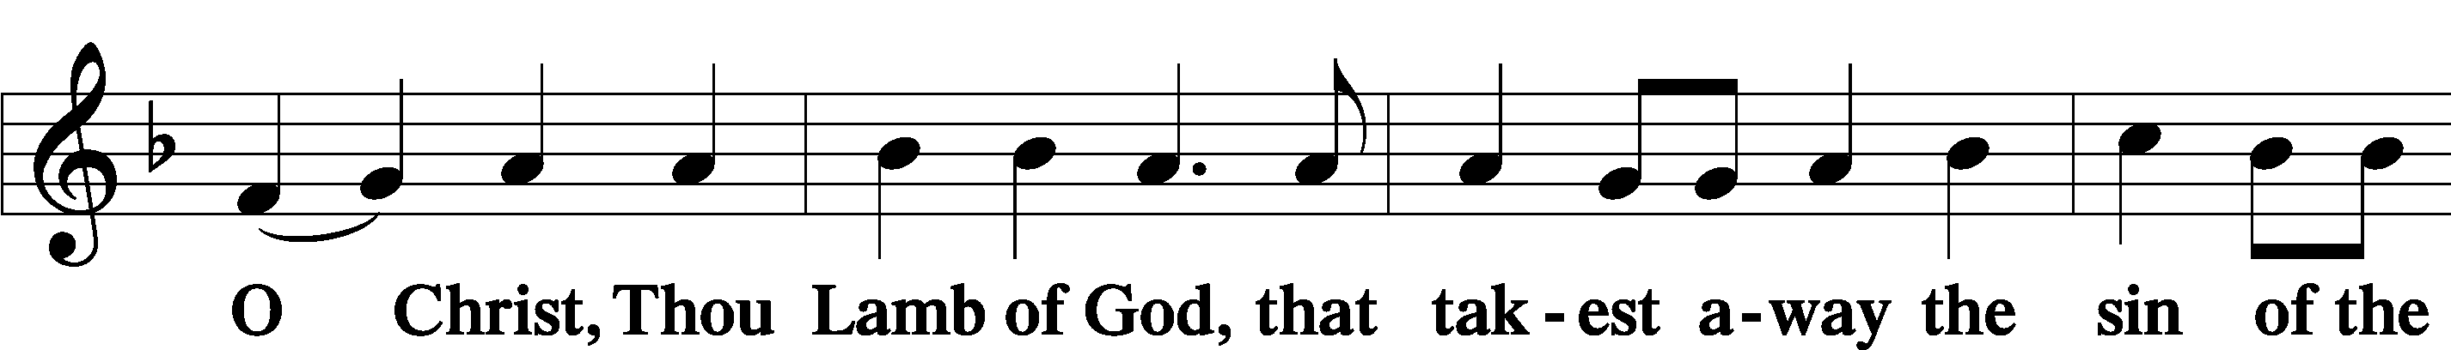
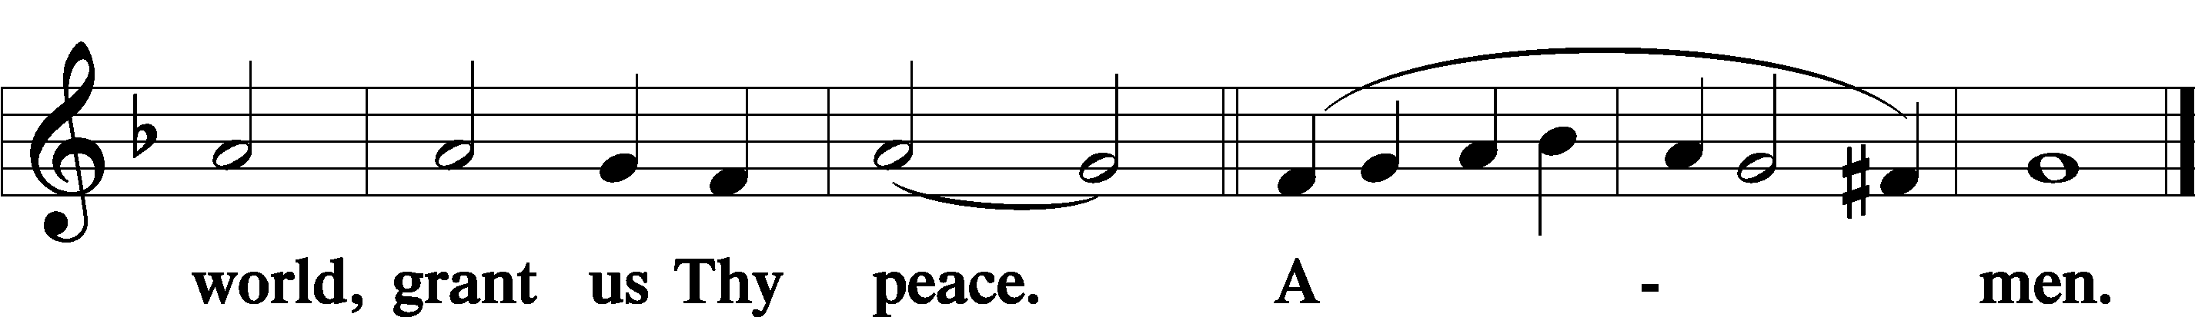
Sit

Distribution
The pastor and those who assist him receive the body and blood of Christ first and then distribute them to those who come to receive, saying:
Take, eat; this is the true body of our Lord and Savior Jesus Christ, given into death for your sins.
Amen.

Take, drink; this is the true blood of our Lord and Savior Jesus Christ, shed for the forgiveness of your sins.
Amen.

In dismissing the communicants, the following is said:
The Dismissal
P The body and blood of our Lord Jesus Christ strengthen and preserve you in body and soul to life everlasting. Depart T in peace.
C Amen.

Distribution Hymn: LSB #461 “I Know That My Redeemer Lives”

Distribution Hymn: LSB #487 “Come, You Faithful, Raise the Strain”

Distribution Hymn: LSB #464 “The Strife Is O’er, the Battle Done”

Stand

Nunc Dimittis Luke 2:29–32
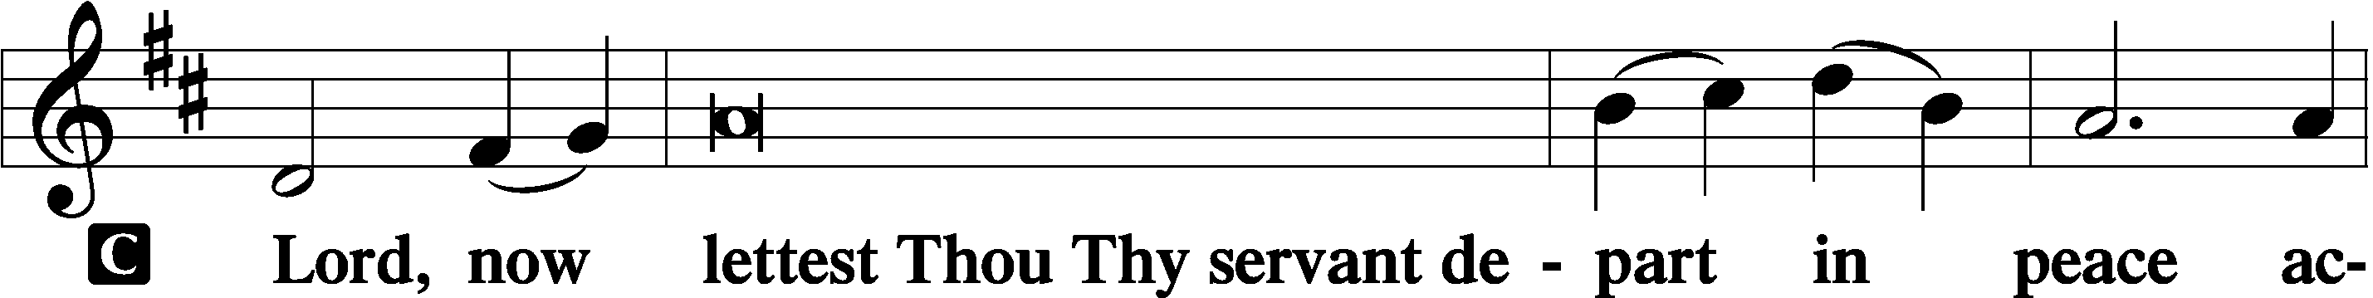
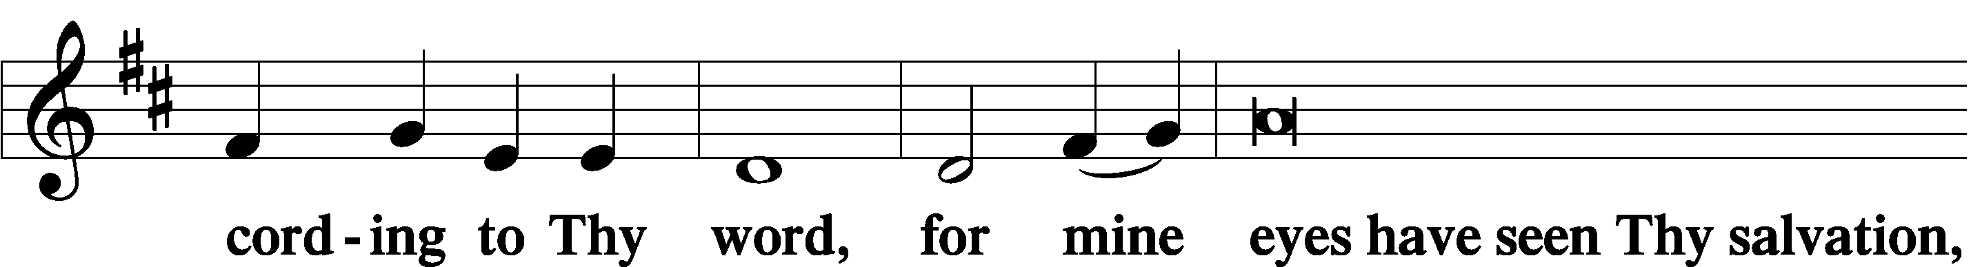
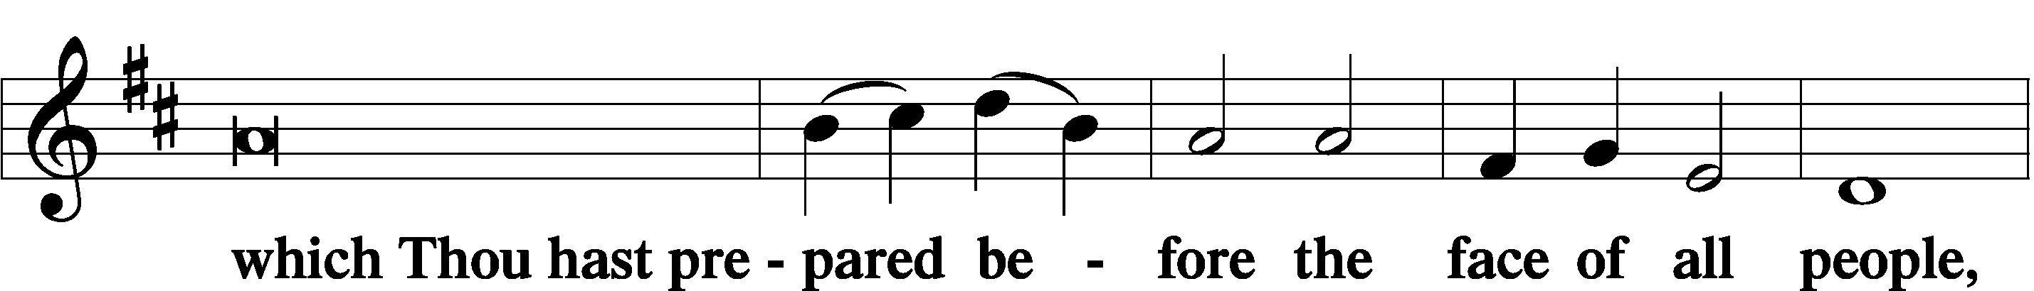
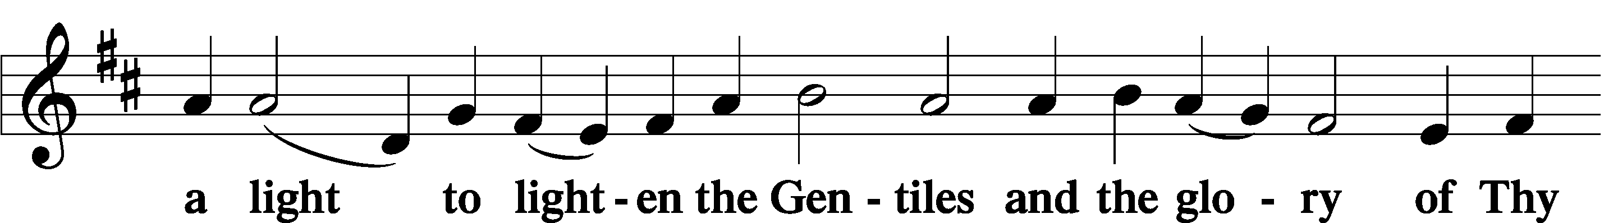
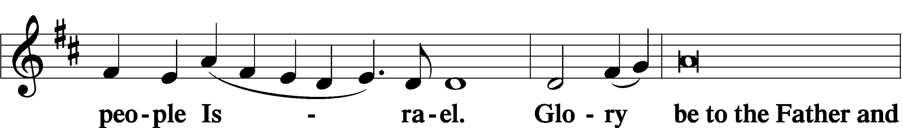
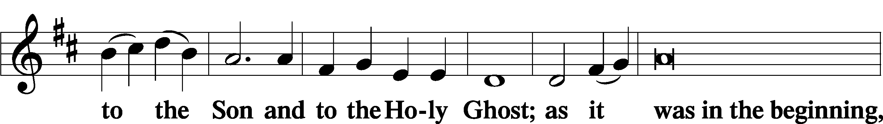
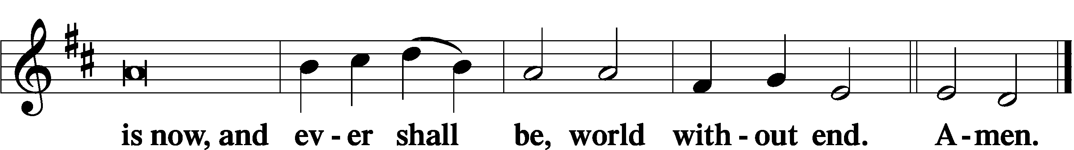

Thanksgiving Psalm 107:1
P O give thanks unto the Lord, for He is good,
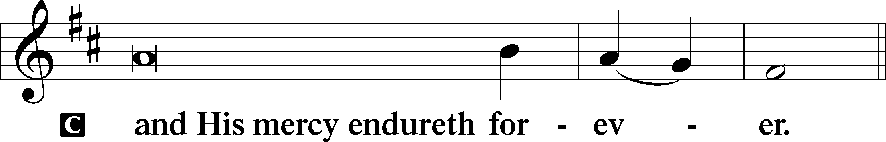

Post-Communion Collect
P Let us pray.
We give thanks to You, almighty God, that You have refreshed us through this salutary gift, and we implore You that of Your mercy You would strengthen us through the same in faith toward You and in fervent love toward one another; through Jesus Christ, Your Son, our Lord, who lives and reigns with You and the Holy Spirit, one God, now and forever.
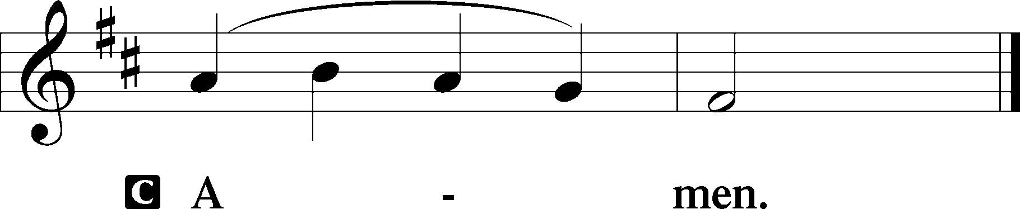

Salutation 2 Timothy 4:22
P The Lord be with you.
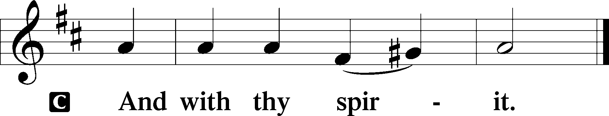

Benedicamus Psalm 103:1
P Bless we the Lord.
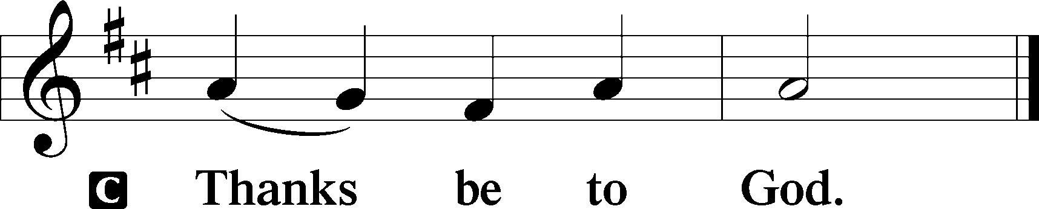

Benediction Numbers 6:24–26
P The Lord bless you and keep you.
The Lord make His face shine upon you and be gracious unto you.
The Lord lift up His countenance upon you and T give you peace.
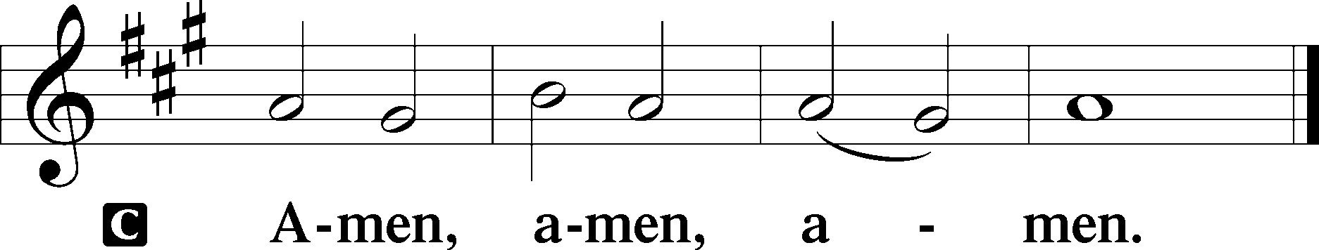

Closing Hymn: LSB #465 “Now All the Vault of Heaven Resounds”

Silent prayer after worship: Lord Jesus, grant me the enduring comfort that You are with me every day and in all circumstances. Fill me with Your Holy Spirit so that I can live joyfully in Your love and share that love with others. Amen.
fffffffffffffffffffffffffffffffffff
In Loving Memory of Cousin, Carolee Grexa: Dolores Fee (Capital Campaign),
In Loving Memory of Anson Holcroft: Catherine Carr (Capital Campaign), Mark Gabriel, and Patty Parker (Capital Campaign).
In Loving Memory of Ernie Meszaros: Mark Gabriel.
In Loving Memory of Terry Murcheck, Milan’s Son: Ruth Meszaros (Food Pantry) and Joani Rice (Food Pantry).
In Loving Memory of David Nelson: Catherine Carr (Food Pantry), Mark Gabriel, Kristy & Jeff Gibson and Family, Pat Dickson, Lori & Doug; Patty Parker (Capital Campaign), and Joani Rice (Major Repair).
In Loving Memory of Viola Sakony: Susan Bender, Catherine Carr (Capital Campaign), Dolores Fee (Capital Campaign), Mark Gabriel, Hank Holcroft (Capital Campaign), Clara Krivosh (Capital Campaign), Rev. Ed & Irene Kucera (Food Pantry), Don & Laura Maffei, Patty Parker (Capital Campaign), Michael A. Petro, Edeltraud Sulek (Capital Campaign), and Linda Tomko.
fffffffffffffffffffffffffffffffffff
The Altar Flowers this Easter morning are given to the Glory of God and in appreciation of the great sacrifice of His Son, Jesus Christ, for the remission of our sins.
Christ is Risen! He is Risen Indeed! Alleluia!
fffffffffffffffffffffffffffffffffff
Copies of the “Portals of Prayer” for April, May, and June are available in the narthex.
fffffffffffffffffffffffffffffffffff
Please note that the church office will be closed Monday of this week. It will be open Thursday from 8:30-5:00.
fffffffffffffffffffffffffffffffffff
Up-coming Meetings:
Trustees: Monday (tomorrow), April 10th at 7 pm.
Constitution/Bylaws Committee: Wednesday, April 19th at 7:15 pm.
Interior Committee: Wednesday, April 26th at 7:15 pm .
All meetings will be held in the library.
SCHEDULE THROUGH APRIL 16, 2023:

:

Today, 7 pm, Fellowship Hall: AA Meeting
Monday, 7 pm, Library: Trustees’ Meeting
Tuesday, 7-9 pm, Fellowship Hall: Penn-Ohio Singers
Wednesday, 7:30 pm, Fellowship Hall: NA Meeting
Thursday, 9 am, Downstairs: Food Pantry
Saturday, 9:30 am, All Saints~Slippery Rock: Catechism Class
1 pm, Fellowship Hall: Women’s Bible Study
4 pm, Fellowship Hall: Men’s Bible Study
Next Sunday, 8 am, Fellowship Hall: Bible Study
9 am, Sanctuary: Divine Service
Following, Fellowship Hall: Coffee Fellowship
7 pm, Fellowship Hall: AA Meeting
fffffffffffffffffffffffffffffffffff
Attendance: Monday, April 3, 2023: 4
Thursday, April 6, 2023: 28
Friday, April 7, 2023 (Tre Ore): 16
Friday, April 8, 2023 (Stations of the Cross): 13
fffffffffffffffffffffffffffffffffff
THANK YOU FOR SERVING IN APRIL: Elder: Jonathan Baisch; Ushers: Jerry Krivosh, Barry Nelson, & Jeff Sutton; Altarware: (prior) Diane Riefstahl & Marie Flaugher (04/09 & 04/30); (after) Elizabeth Haenftling (04/02 & 04/16) & Marie Flaugher (04/09, 04/23, & 04/30).
fffffffffffffffffffffffffffffffffff
April Coffee Fellowship Date Change: Please note that the date for April’s Coffee Fellowship has been changed to April 16th. April’s sponsors, Isaiah & Titus Deal, hope that you will be able to join them that day.
If interested in sponsoring a Coffee Fellowship, please sign the sheet posted in the narthex. Sponsors are asked to drop off 2-3 dozen “treats” and 1 quart of juice in the kitchen prior to worship. Set-up (including the making of coffee) and clean-up will be done for you!
fffffffffffffffffffffffffffffffffff
Bible Memory Verses ~ Week of April 9th:
For Adults: I am the resurrection and the life. Whoever believes in me, though he die, yet shall he live, and everyone who lives and believes in me shall never die.
John 11:25-26a
For Children: I am the living one. I died, and behold I am alive forevermore, and I have the keys of Death and Hades. Revelation 1:18
fffffffffffffffffffffffffffffffffff
Remember the following in Prayer…
~The Hurting and Healing: Amy, Gerald Arthur, Evelyn Baisch, Ellen Baron^{CA}, Lois Bortner^{CA}, John Burdette, Bev & Joe Chlpka, Kathleen Coughenour, Kim, Anna Mae Daris, Susan Davies, Tim Dudash, Millie Elavsky, Joseph Fleet, Judith & Eddy Furey, Tim Haenftling, Austin Hamilton, Neil Huston, Joan, Darla Krajci, Barbara Kreske, Donna Kennedy, Jess Lavoie, Joanne Lozier, Paul Lucas^{CA}, Sandy Marshall, Frank Niemeyer^{CA}, Linda Parkany, Juanita Rentschler, Richard Reuning^{CA}, Nancy Robertson^{CA}, Marty Scott, Kara, Fred Tonty, Angela Weser^{CA}, and Ruth Wolf.
~The Homebound: Rudy & Jean Tomko, Betty Wolf, and Ed & Millie Zachar.
~Celebrating: Birthday ~ Kim Revale (04.13)
~Serving in the Military: Curtis Sinewe and Joshua Solyan.
~Community & World Needs: Those suffering from or affected by the coronavirus; those suffering due to the conflict between Ukraine and Russia; those suffering from loss and dislocation because weather disasters; those suffering from addiction and their families; Local, State, and National Government Leaders; safety for all Police Officers, Firefighters, & First Responders; the unemployed; our Second Quarter Local Mission: The Support of a Concordia, Fort Wayne Seminarian.
*CA represents cancer.
fffffffffffffffffffffffffffffffffff
Sincere thanks go out to all those who assisted with the Holy Week services this past week! We are especially grateful to Jonathan Baisch, Rev. Baisch, Catherine Carr, Barry Nelson, and Jesse Riffle for all their assistance with the services and to choir director, Chris Nelson, and the members of the choir for lending their time and talents to enhance this day. Of course, a special “thank you” goes out to Pastor Deal for his dedication and faithfulness in spreading the Word of God.
fffffffffffffffffffffffffffffffffff

Our Stewardship of Treasures for the Lord:
In order to do the Lord’s work, we need $2,553.63 each week to meet our 2023 budget for general purposes and $76.92 for the SELC. Figures for Wednesday, March 22, 2023
General Fund: $63.00
Other: $112.00
Figures for Sunday, March 26, 2023
General Fund: $833.00 Behind for the week*: -$1,657.63
SELC: $0.00 Behind for the week*: -$76.92
Food Pantry: $835.00
Quarterly Missions: $30.00
Capital Campaign: $450.00 *Includes above figures.
Other: $66.00
ssssssssssssssssssssssssssssssssssssssssssssssssssssssssssssssssssssssssssssss
Figures for Wednesday, March 29, 2023
General Fund: $640.00
SELC: $10.00
Food Pantry: $25.00
Capital Campaign: $100.00
Other: $25.00
Figures for Sunday, April 2, 2023
General Fund: $1,931.00 Ahead for the week*: +$17.37
SELC: $65.00 Behind for the week*: -$1.92
Food Pantry: $65.00
Capital Campaign: $635.00 *Includes above figures.
Other: $13.00

For online giving, check out https://www.saintspeterandpaul.net/online-giving.
fffffffffffffffffffffffffffffffffff
Women’s Bible Study will take place this coming Saturday, April 15th at 1 pm. The Men’s Bible Study will occur the same afternoon at 4 pm. Both will be held in the Fellowship Hall. Attendees should use the Clover St. entrance.
fffffffffffffffffffffffffffffffffff
Acknowledgments: Unless otherwise indicated, Scripture quotations are from the ESV® Bible (The Holy Bible, English Standard Version®), copyright © 2001 by Crossway, a publishing ministry of Good News Publishers. Used by permission. All rights reserved. Created by Lutheran Service Builder © 2023 Concordia Publishing House.
We are grateful to the following for their donations towards this morning’s Easter lilies and Daffodils which adorn our sanctuary:

Catherine Carr: In Loving Memory of Timothy Carr and Otto & Millie Brillinger (1 daffodil and 1 Easter lily)

Mike & Marie Flaugher: In Loving Memory of our Daughter-in-law’s Mother, Maryann Silvidi; Viola Sakony, and Anson Holcroft (3 daffodils)

Judith Furey: In Loving Memory of Judith E. Boal, Beloved Daughter; and Dorothy Shoenberger, Beloved Friend (2 daffodils)

Mark Gabriel: In Loving Memory of Parents, Peter & Anne Gabriel, and Brother, Denny Gabriel (1 daffodil)

Hank Holcroft: In Loving Memory of Anson Holcroft (1 daffodil)

Gerald Krivosh, Jr.: In Loving Memory of Father, Gerald Krivosh, Sr. (1 Easter lily)

Elizabeth Loughan: In Loving Memory of Bill Loughan and Parents, Iris & Jim Reigelman (4 Easter lilies)

Joanne Lozier: In Honor of Rev. Ed & Irene Kucera (1 daffodil)

Barry & Chris Nelson: In Loving Memory of Bill & Margie Nelson, John & Mary Ann Krajci, John G. Krajci, Olivia Sovesky, David Nelson, & All Loved Ones (1 Easter lily)

Diane Riefstahl: In Loving Memory of Parents, Donald & Lucile Riefstahl and Brother, Don Riefstahl (2 Easter lilies)

The Sakony Family: In Loving Memory of John & Viola Sakony (1 daffodil)

Traudi Sulek: In Loving Memory of Husband, Robert Sulek and In-laws, Andrew & Bettie Sulek (2 Easter lilies)

Linda Tomko: In Loving Memory of Parents and Grandparents (2 daffodils)

