VIGIL OF EASTER
SERVICE OF LIGHT
The congregation gathers in a convenient place outside the nave of the church. Where permissible, candles are given to all, later to be lighted from the paschal candle.

In the semidarkness a fire may be kindled.

Invitation
P Beloved in the Lord, on this most holy night, in which Our Lord Jesus passed over from death into life, we are gathered here in vigil and in prayer. This is the Passover of the Lord in which, by hearing His Word and celebrating His Sacraments, we share in His victory over death.

Collect
P Let us pray. O God, You are like a refiner's fire, and Your Spirit enkindles the hearts of Your faithful people with the fire of Your love. Bless, we implore You, this new flame and those who keep this joyful Easter festival that, burning with desire for life with You, we may be found rightly prepared to share in the Feast of Light which has no end; through Jesus Christ, Your Son, our Lord, who lives and reigns with You and the Holy Spirit, one God, now and forever.
C Amen.

The cross is traced on the paschal candle.

Blessing of the Paschal Candle
P Christ Jesus, the same yesterday, today, and forever, the beginning and the ending,

The Greek letters Alpha and Omega are traced on the paschal candle.

P the Alpha and the Omega.

The year is traced on the paschal candle.

P His are time and eternity; His are the glory and dominion, now and forever.

Five wax nails are placed into the paschal candle.

P By His wounds we have healing both now and forever. Amen.

The paschal candle is lit.

P May the light of Christ, who is risen in glory from the dead, scatter all the darkness of our hearts and minds.

Collect
P Let us pray. Almighty and most merciful God, pour out on us Your abundant blessing that all who in true faith share this night in joyful celebration of the resurrection of our Lord Jesus Christ from the dead may be filled with Your heavenly benediction. Once we were in darkness, but now we are in the light, even Jesus Christ, our Lord.
C Amen.

All light their candles from the paschal candle and then follow the candle bearer in procession into the darkened church.
The bearer of the paschal candle stops at the entrance to the nave.

Lux Christi
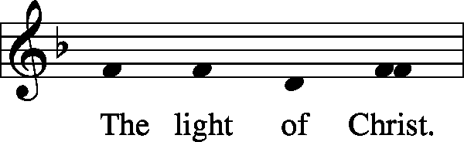
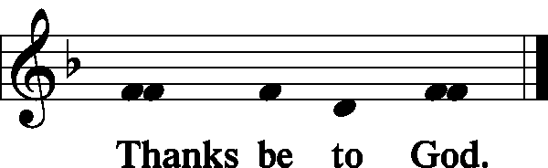

The bearer of the paschal candle stops in the middle of the nave.
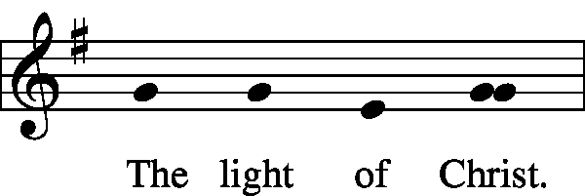
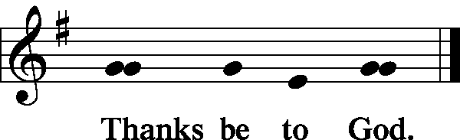

When all have processed, the bearer of the paschal candle
lifts the paschal candle high.
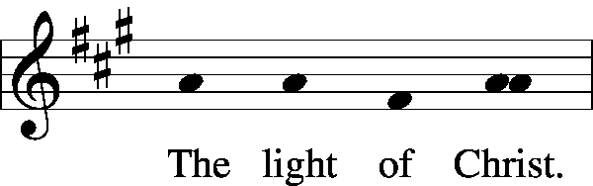
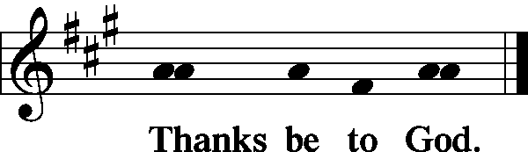

Exsultet
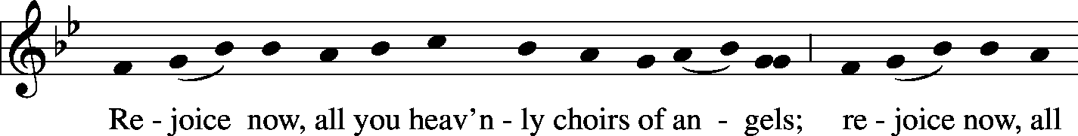
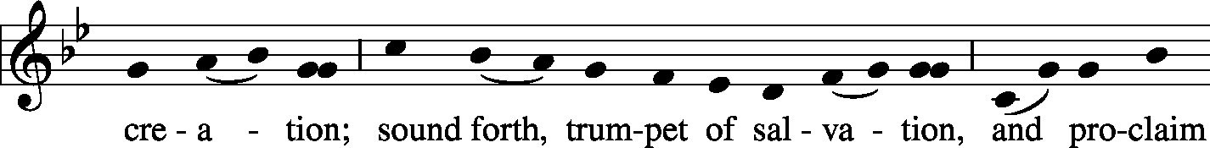
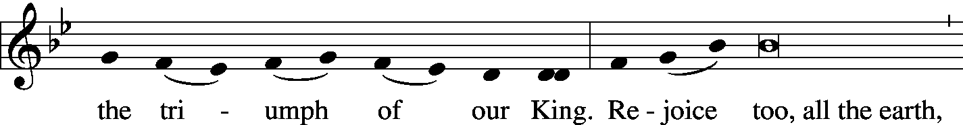
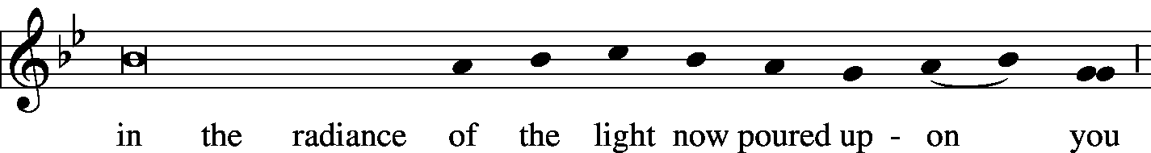
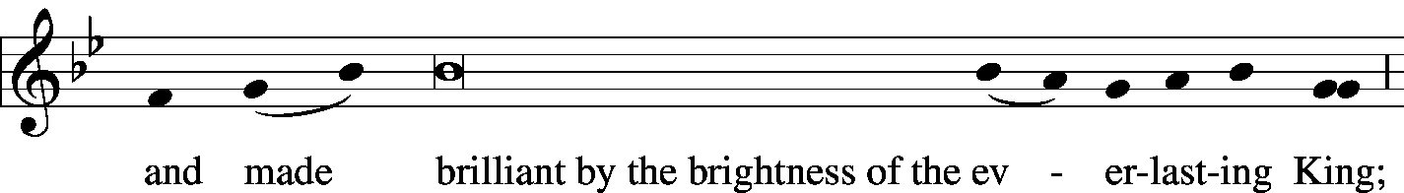
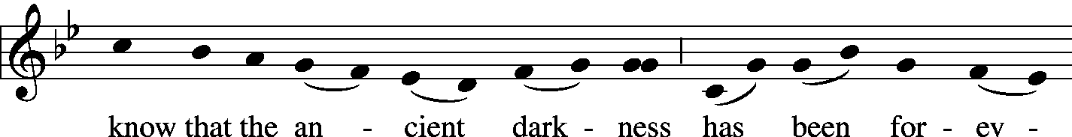
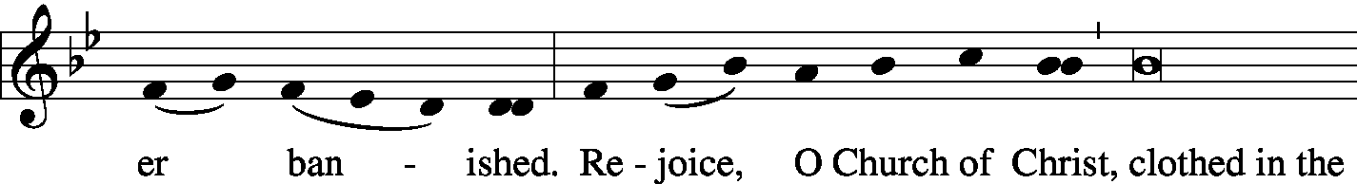
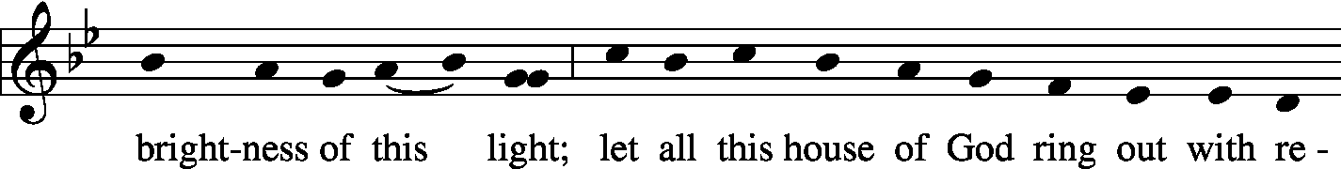
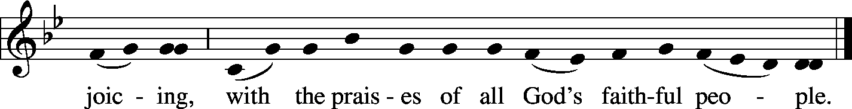

Preface
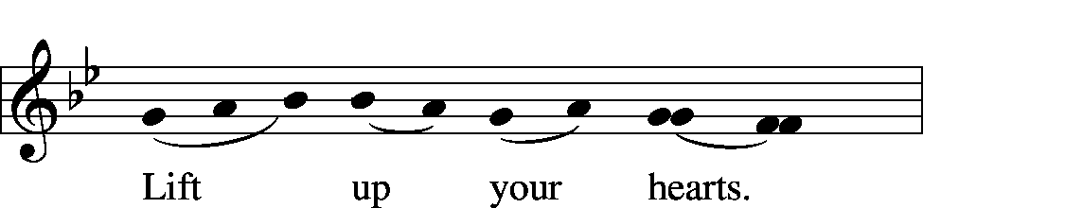
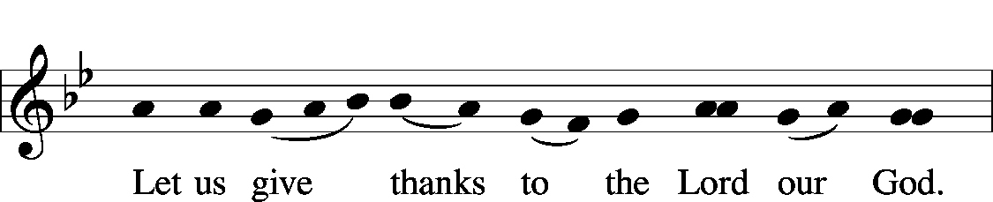
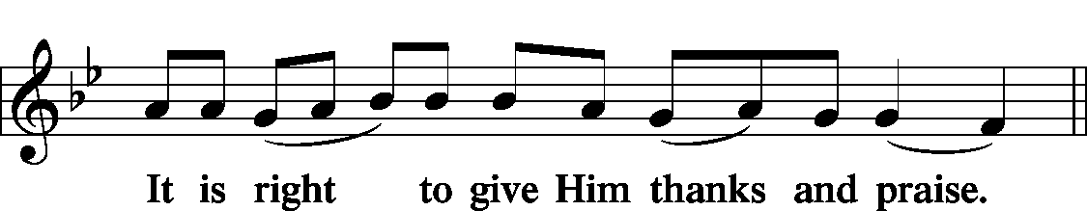

Proper Preface
P It is truly good, right, and salutary that we should at all times and in all places, with all our heart and mind and voice, praise You, O Lord, Holy Father, almighty everlasting God, and Your only-begotten Son, Jesus Christ. For He is the very Paschal Lamb who offered Himself for the sin of the world, who has cleansed us by the shedding of His precious blood. This is the night when You brought our fathers, the children of Israel, out of bondage in Egypt and led them through the Red Sea on dry ground. This is the night when all who believe in Christ are delivered from bondage to sin and are restored to life and immortality. This is the night when Christ, the Life, arose from the dead. The seal of the grave is broken and the morning of the new creation breaks forth out of night. Oh, how wonderful and beyond all telling is Your mercy toward us, O God, that to redeem a slave You gave Your Son. How holy is this night when all wickedness is put to flight and sin is washed away. How holy is this night when innocence is restored to the fallen and joy is given to those downcast. How blessed is the night when man is reconciled to God in Christ. Holy Father, accept now the evening sacrifices of our thanksgiving and praise. Let Christ, the true light and morning star, shine in our hearts, He who gives light to all creation, who lives and reigns with You and the Holy Spirit, one God, now and forever.

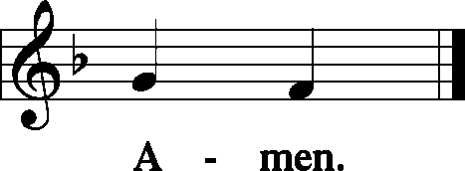

Sit
Please extinguish candles at this time.

SERVICE OF READINGS
Introduction to Readings
P In this most holy night our Savior, Christ the Lord, broke the power of death and by His resurrection brought life and salvation to all creation. Let us praise the Lord, for He truly keeps His word. The sun of righteousness has dawned upon us who have sat in darkness and in the shadow of death.

1. The Creation
A A reading from Genesis, chapters one and two.

A This is the Word of the Lord.
C Thanks be to God.

P Let us pray…
C Amen.
2. The Flood
A A reading from Genesis, chapters five, six, seven, and eight.
A This is the Word of the Lord.
C Thanks be to God.

P Let us pray…
C Amen.

3. The Testing of Abraham
A A reading from Genesis, chapter 22.

A This is the Word of the Lord.
C Thanks be to God.

P Let us pray…
C Amen.

4. Israel's Deliverance at the Red Sea
A A reading from Exodus, chapters 14 and 15.

A This is the Word of the Lord.
C Thanks be to God.

P Let us pray…
C Amen.

5. Salvation Offered Freely to All
A A reading from Isaiah, chapters 54 and 55.

A This is the Word of the Lord.
C Thanks be to God.

P Let us pray…
C Amen.

6. The Commandments of Life
A A reading from Baruch, chapter 3.
A O Lord, have mercy on us.
C Thanks be to God.
P Let us pray…
C Amen.

7. The Valley of Dry Bones
A A reading from Ezekiel, chapter 37.

A This is the Word of the Lord.
C Thanks be to God.

P Let us pray…
C Amen.

8. The Branch of the Lord
A A reading from Isaiah, chapter 4.

A This is the Word of the Lord.
C Thanks be to God.

P Let us pray…
C Amen.

9. The Lord’s Passover
A A reading from Exodus, chapter twelve.

A This is the Word of the Lord.
C Thanks be to God.

P Let us pray…
C Amen.

10. Jonah Preaches to Nineveh
A A reading from Jonah, chapter three.

A This is the Word of the Lord.
C Thanks be to God.

P Let us pray…
C Amen.

11. God’s Faithfulness to Israel
A A reading from Deuteronomy, chapter thirty-one.

A This is the Word of the Lord.
C Thanks be to God.

P Let us pray…
C Amen.

12. The Fiery Furnace
A A reading from Daniel 3:1–23 and the Prayer of Azariah 1:1

A This is the Word of the Lord.
C Thanks be to God.

P Let us pray…
C Amen.

The paschal candle is carried to the baptismal font during which the following is sung.

Hymn: LSB #931 “All You Works of the Lord” LSB 931
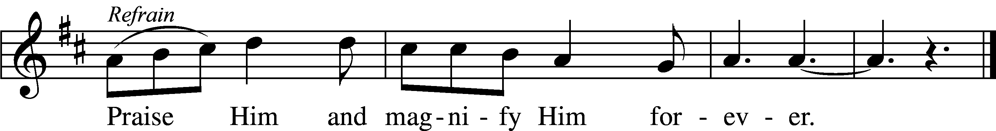

All you works of the Lord, | bless the Lord—*
praise Him and magnify Him for- | ever.*
You angels of the Lord, | bless the Lord: Refrain
You heavens, | bless the Lord;*
all you waters above the heavens, | bless the Lord;*
all you powers of the Lord, | bless the Lord: Refrain
You sun and moon, | bless the Lord;*
you stars of heaven, | bless the Lord;*
all you showers and dew, | bless the Lord: Refrain
All you winds of God, | bless the Lord;*
you fire and heat, | bless the Lord;*
you winter and summer, | bless the Lord: Refrain
You dews and frost, | bless the Lord;*
you frost and cold, | bless the Lord;*
you ice and snow, | bless the Lord: Refrain
You nights and days, | bless the Lord;*
you light and darkness, | bless the Lord;*
you lightnings and clouds, | bless the Lord: Refrain
Let the earth | bless the Lord;*
you mountains and hills, | bless the Lord;*
all you green things that grow on the earth, | bless the Lord: Refrain
You wells and springs, | bless the Lord;*
you rivers and seas, | bless the Lord;*
you whales and all who move in the waters, | bless the Lord: Refrain
All you birds of the air, | bless the Lord;*
all you beasts and cattle, | bless the Lord;*
all you children of men, | bless the Lord: Refrain
O Israel, | bless the Lord;*
you priests of the Lord, | bless the Lord;*
you servants of the Lord, | bless the Lord: Refrain
You spirits and souls of the righteous, | bless the Lord;*
you pure and humble of heart, | bless the Lord;*
let us bless the Father and the Son and the Holy | Spirit: Refrain
Text: Public domain
Tune: © 2006 Concordia Publishing House. Used by permission: LSB Hymn License no. 110004782
Stand
SERVICE OF HOLY BAPTISM

Baptismal Address
P Dearly beloved, Christ our Lord says in the last chapter of Matthew, "All authority in heaven and on earth has been given to Me. Therefore go and make disciples of all nations, baptizing them in the name of the Father and of the Son and of the Holy Spirit." In the last chapter of Mark our Lord promises, "Whoever believes and is baptized will be saved." And the apostle Peter has written, "Baptism now saves you."
The Word of God also teaches that we are all conceived and born sinful and are under the power of the devil until Christ claims us as His own. We would be lost forever unless delivered from sin, death, and everlasting condemnation. But the Father of all mercy and grace has sent His Son Jesus Christ, who atoned for the sin of the whole world, that whoever believes in Him should not perish but have eternal life.

The Flood Prayer
P Let us pray.
Almighty and eternal God, according to Your strict judgment You condemned the unbelieving world through the flood, yet according to Your great mercy You preserved believing Noah and his family, eight souls in all. You drowned hard-hearted Pharaoh and all his host in the Red Sea, yet led Your people Israel through the water on dry ground, foreshadowing this washing of Your Holy Baptism. Through the Baptism in the Jordan of Your beloved Son, our Lord Jesus Christ, You sanctified and instituted all waters to be a blessed flood and a lavish washing away of sin.

We pray that You would behold us all according to Your boundless mercy and bless us with true faith by the Holy Spirit, that through this saving flood all sin in us, which has been inherited from Adam and which we ourselves have committed since, would be drowned and die. Grant that we be kept safe and secure in the holy ark of the Christian Church, being separated from the multitude of unbelievers and serving Your name at all times with a fervent spirit and a joyful hope, so that, with all believers in Your promise, we would be declared worthy of eternal life; through Jesus Christ, our Lord.
C Amen.

Renunciation
P Do you renounce the devil?
C Yes, I renounce him.
P Do you renounce all his works?
C Yes, I renounce them.
P Do you renounce all his ways?
C Yes, I renounce them.

Profession of Faith
P Do you believe in God, the Father Almighty, maker of heaven and earth?
C Yes, I believe in God, the Father Almighty, maker of heaven and earth.

P Do you believe in Jesus Christ, His only Son?
C Yes, I believe in Jesus Christ, His only Son, our Lord, who was conceived by the Holy Spirit, born of the virgin Mary, suffered under Pontius Pilate, was crucified, died and was buried. He descended into hell. The third day He rose again from the dead. He ascended into heaven and sits at the right hand of God the Father Almighty. From thence He will come to judge the living and the dead.

P Do you believe in the Holy Spirit?
C Yes, I believe in the Holy Spirit, the holy Christian Church, the communion of saints, the forgiveness of sins, the resurrection of the body, and the life T everlasting.

The paschal candle is returned to its place.

SERVICE OF PRAYER

Litany of the Resurrection
P O Lord,
C have mercy.
P O Christ,
C have mercy.
P O Lord,
C have mercy.
P Lord Jesus Christ, Son of God,
C hear us.
P Paschal Lamb, who was offered for us and has taken away the sin of the world,
C have mercy on us.
P Who was crucified for our transgressions and raised for our justification,
C have mercy on us.
P Who foretold Your passion saying, "The Son of Man must be crucified and on the third day rise again,"
C have mercy on us.
P Who destroyed death by dying, and by rising to life again brought life and immortality to light,
C have mercy on us.
P Whose resurrection was first announced by an angel to the women,
C have mercy on us.
P Who appeared to Mary Magdalene and was worshiped by her,
C have mercy on us.
P Who revealed Yourself to the two disciples on the Emmaus road and made Yourself known to them in the Scriptures and in the breaking of the bread,
C have mercy on us.
P Who appeared to the disciples, bestowing on them Your peace and Your Spirit,
C have mercy on us.
P Who showed Your wounded hands and side to the apostle Thomas that he too might believe,
C have mercy on us.
P Who appeared to seven disciples on the Sea of Tiberias, bringing a miraculous catch of fish,
C have mercy on us.
P Who appeared to Peter and to the Twelve, to over 500 disciples, to James and to all the apostles, and to Paul on the Damascus road,
C have mercy on us.
P Who commissioned Your Church to make disciples of all nations by baptizing and teaching them,
C have mercy on us.
P By Your glorious resurrection from the dead,
C good Lord, deliver us.
P By Your victory over sin and death,
C good Lord, deliver us.
P By the majesty of Your risen body,
C good Lord, deliver us.
P We poor sinners implore You
C to hear us, Lord Jesus.
P That we may daily die and rise with You in our Baptism and walk in the freedom of Your forgiveness,
C grant us, good Lord.
P That we may set our minds on things above and not on earthly things, serving as we have been served by You,
C grant us, good Lord.
P That we may dwell with You forever in the new creation as citizens of the heavenly Jerusalem, together with all the saints,
C grant us, good Lord.
P Christ, the Lamb of God, who takes away the sin of the world,
C have mercy on us.

P Christ, the Lamb of God, who takes away the sin of the world,
C have mercy on us.
P Christ, the Lamb of God, who takes away the sin of the world,
C grant us Your peace.
P O Lord,
C have mercy.
P O Christ,
C have mercy.
P O Lord,
C have mercy. Amen.
SERVICE OF THE WORD
Easter Acclamation
P Alleluia! Christ is risen!
C He is risen indeed! Alleluia!

Sit

At this time, bells are rung. Meanwhile, the altar candles are lit, the altar is decorated for the Service of the Sacrament, and lights illuminated.

Stand
Hymn of Praise: Gloria in Excelsis
P Glory be to God on high:
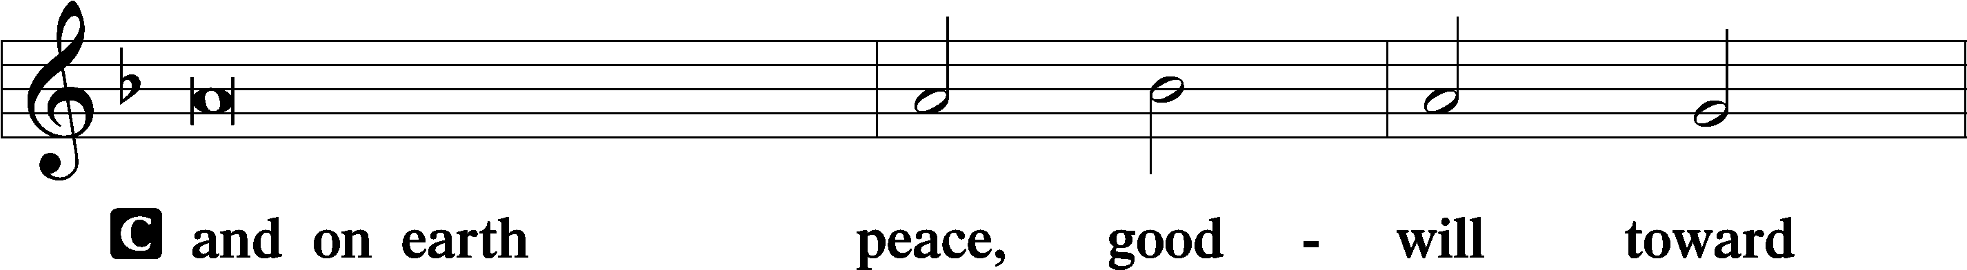
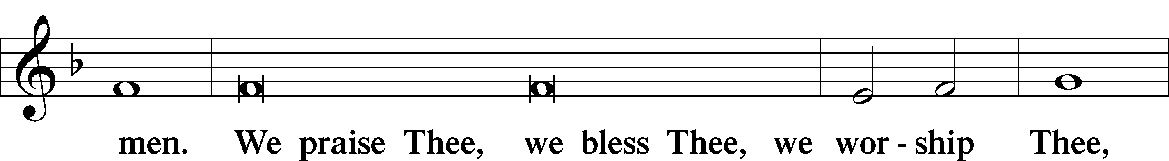
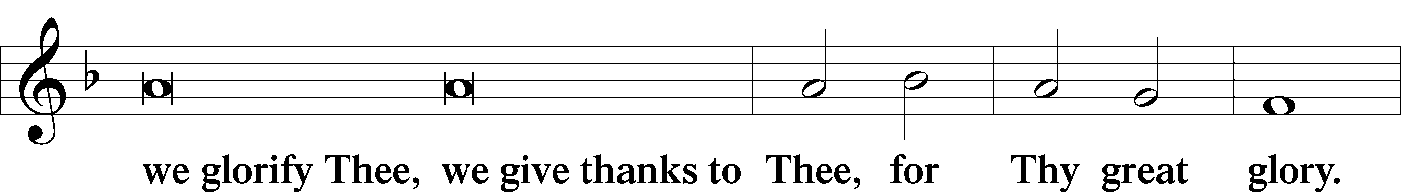
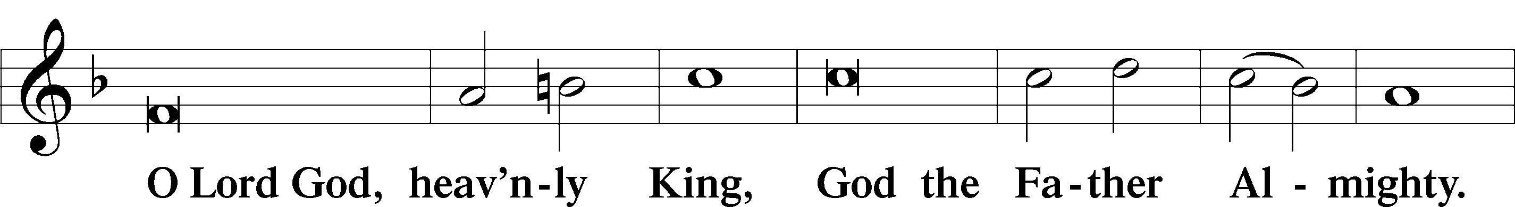
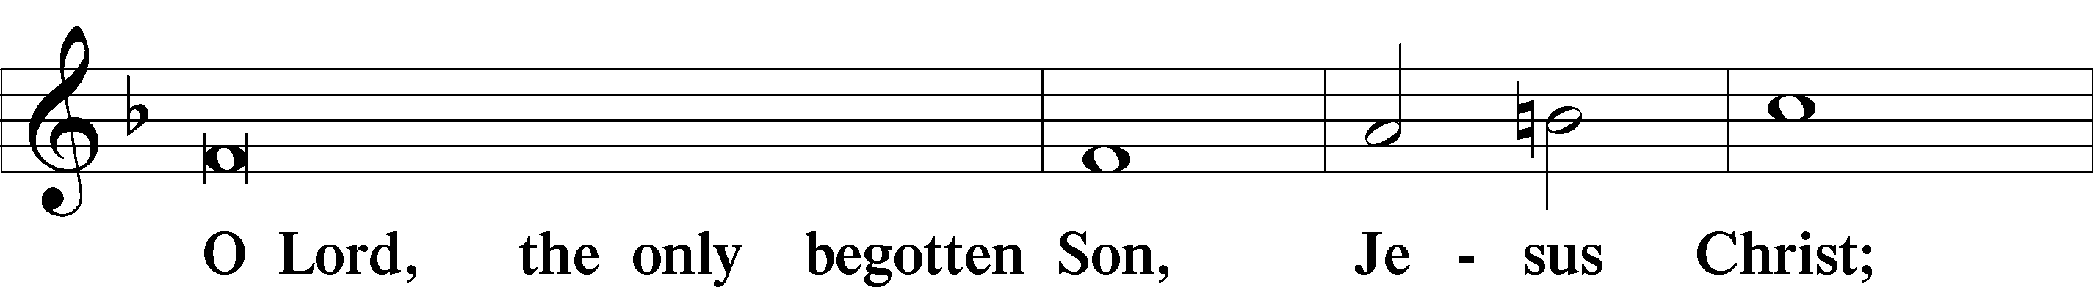
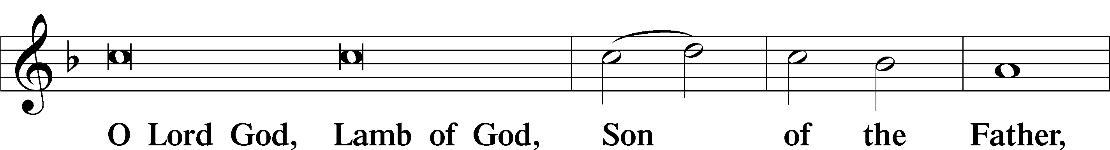
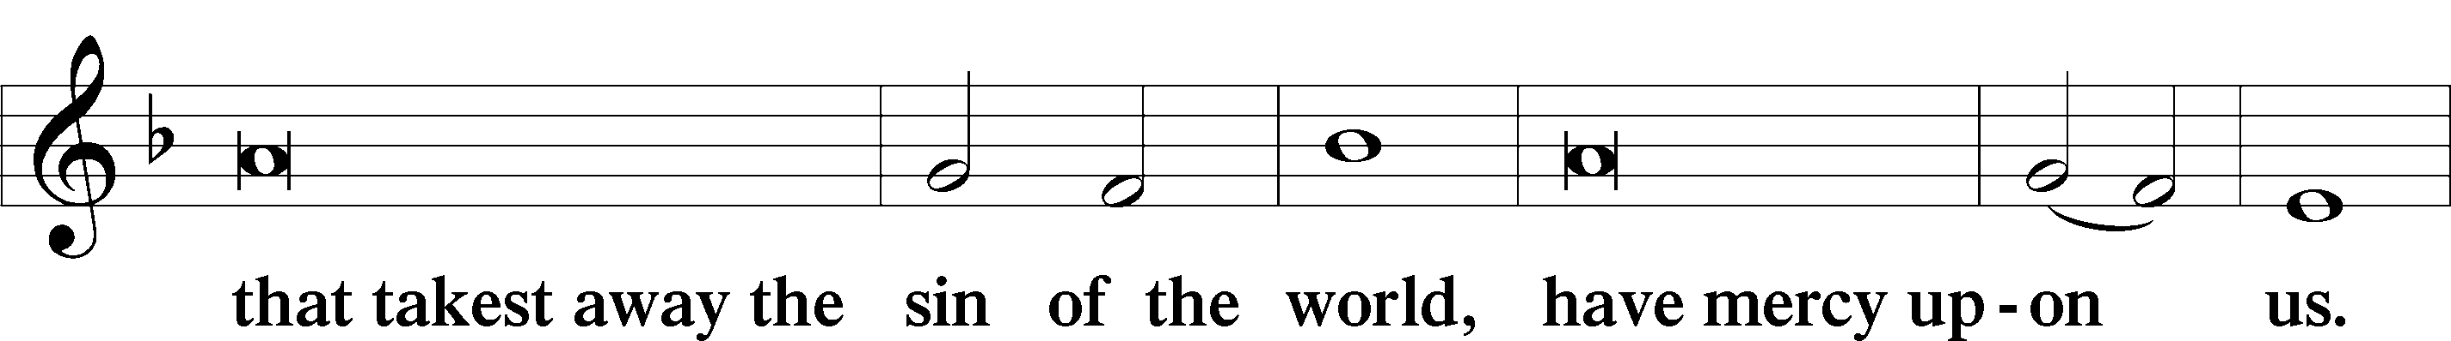
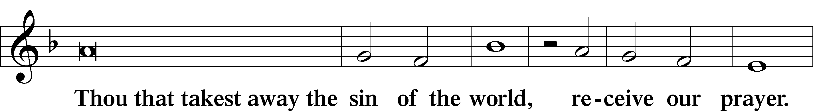
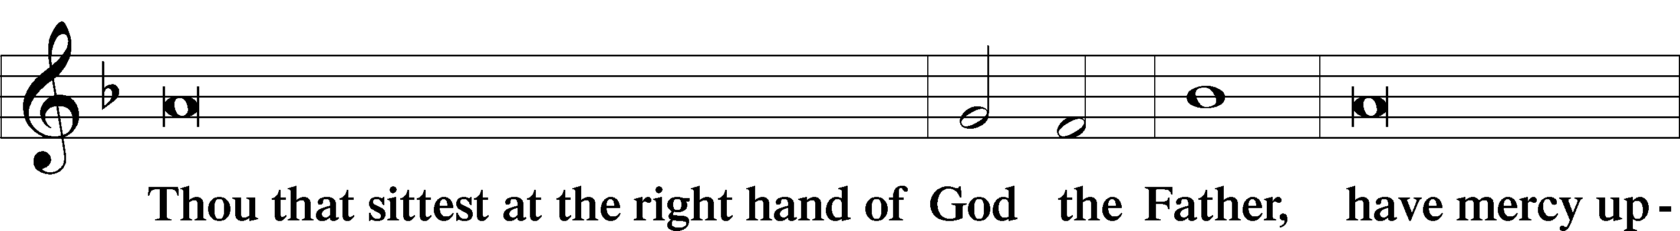
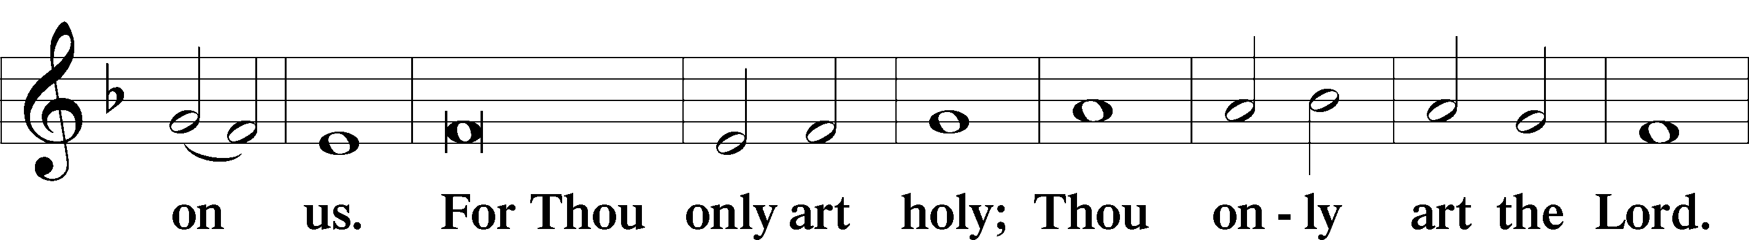
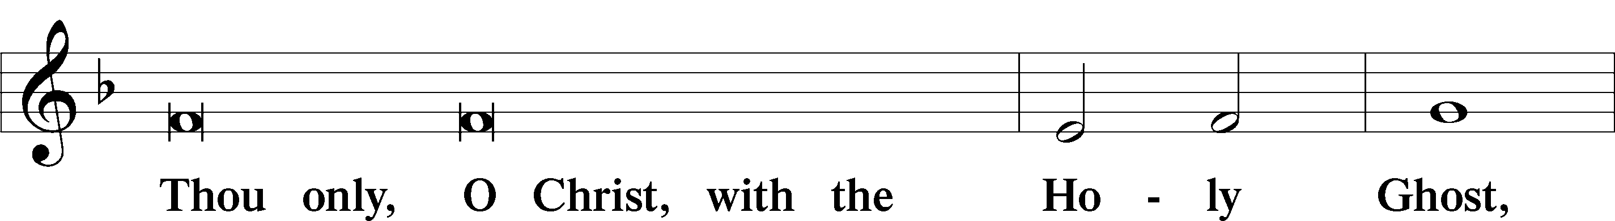
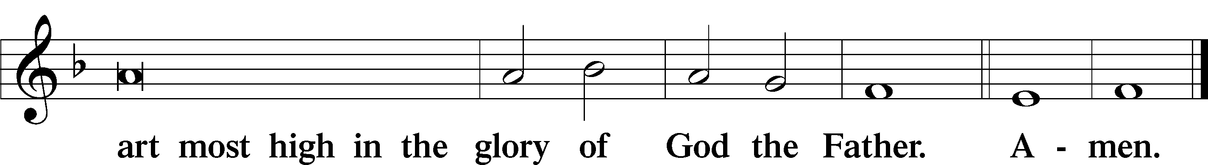

Salutation
P The Lord be with you.
C And also with you.

Collect of the Day
P Let us pray.
O God, You made this most holy night to shine with the glory of the Lord's resurrection. Preserve in us the spirit of adoption which You have given so that, made alive in body and soul, we may serve You purely; through Jesus Christ, Your Son, our Lord, who lives and reigns with You and the Holy Spirit, one God, now and forever.
C Amen.

Epistle: Colossians 3:1–4
Brethren: If you were raised with Christ, seek those things which are above, where Christ is, sitting at the right hand of God. Set your mind on things above, not on things on the earth. For you died, and your life is hidden with Christ in God. When Christ who is our life appears, then you also will appear with Him in glory.

Holy Gospel: Matthew 28:1-7
P The Holy Gospel according to St. Matthew, the 28th chapter.
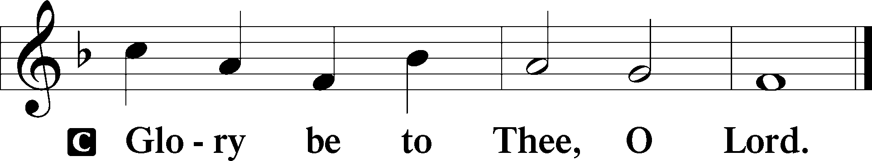

After the Sabbath, as the first day of the week began to dawn, Mary Magdalene and the other Mary came to see the tomb. And behold, there was a great earthquake; for an angel of the Lord descended from heaven, and came and rolled back the stone from the door, and sat on it. His countenance was like lightning, and his clothing as white as snow. And the guards shook for fear of him, and became like dead men. But the angel answered and said to the women, “Do not be afraid, for I know that you seek Jesus who was crucified. He is not here; for He is risen, as He said. Come, see the place where the Lord lay. And go quickly and tell His disciples that He is risen from the dead, and indeed He is going before you into Galilee; there you will see Him. Behold, I have told you.”

P This is the Gospel of the Lord.
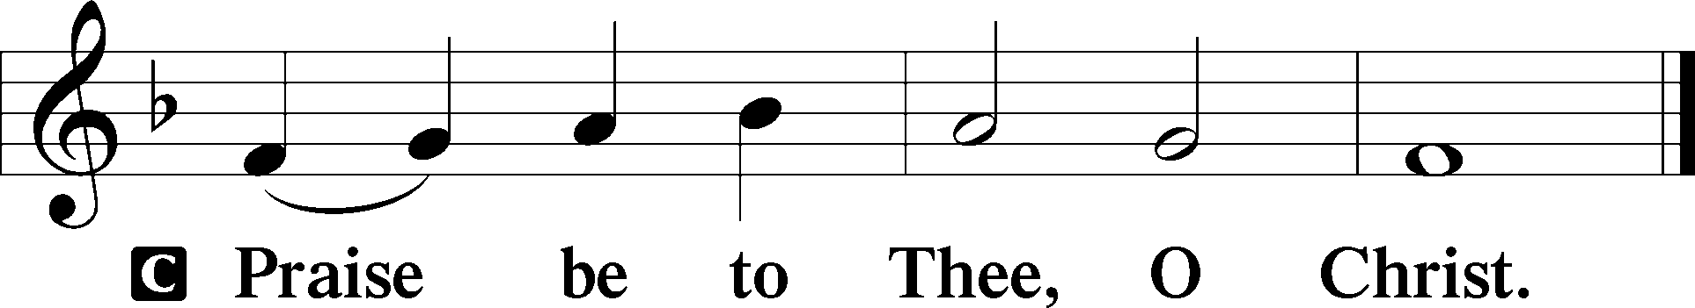
Sermon
SERVICE OF THE SACRAMENT
Stand.
Preface
P The Lord be with you.
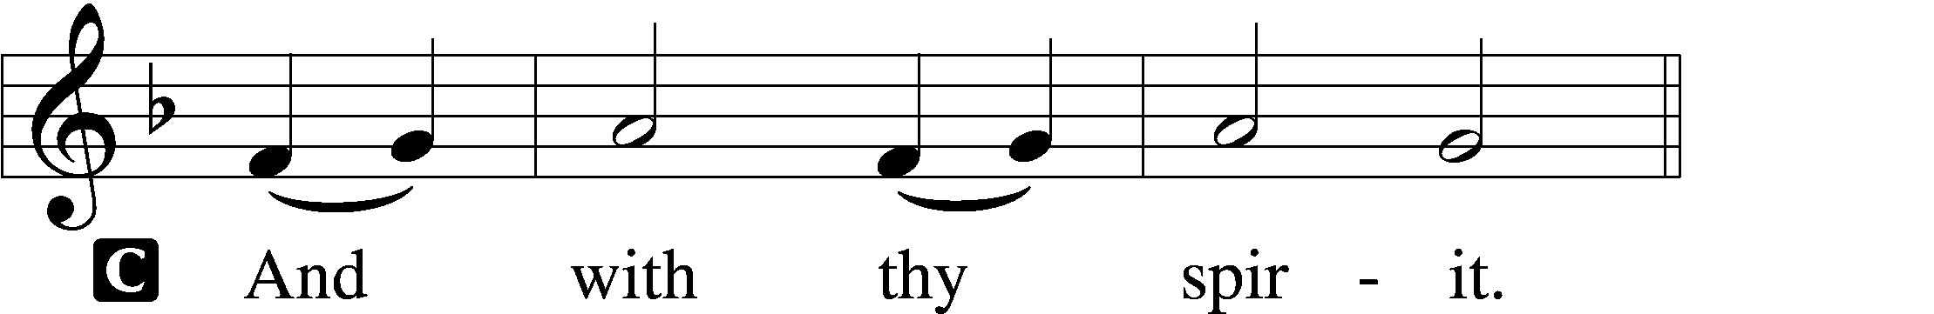

P Lift up your hearts.
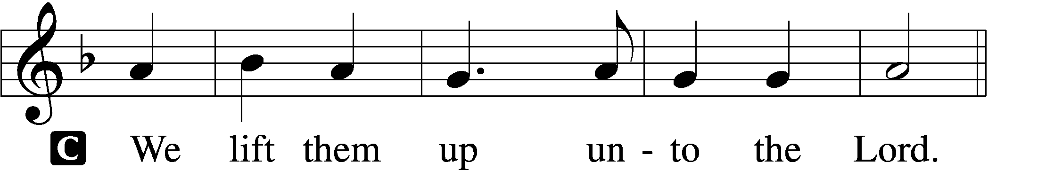

P Let us give thanks unto the Lord, our God.
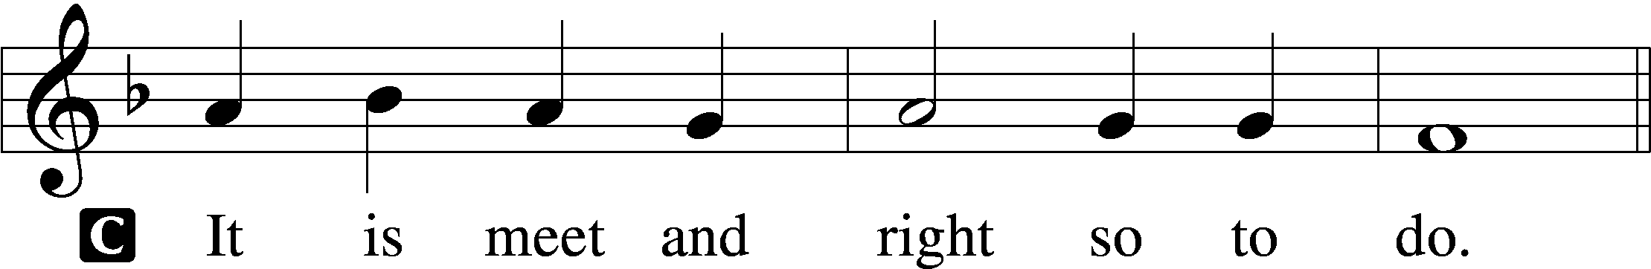

P It is truly meet, right, and salutary that we should at all times and in all places give thanks to You, holy Lord, almighty Father, everlasting God. And most especially are we bound to praise You on this day for the glorious resurrection of Your Son, Jesus Christ, the very Paschal Lamb, who was sacrificed for us and bore the sins of the world. By His dying He has destroyed death, and by His rising again He has restored to us everlasting life. Therefore with Mary Magdalene, Peter and John, and with all the witnesses of the resurrection, with angels and archangels, and with all the company of heaven we laud and magnify Your glorious name, evermore praising You and saying:

Sanctus
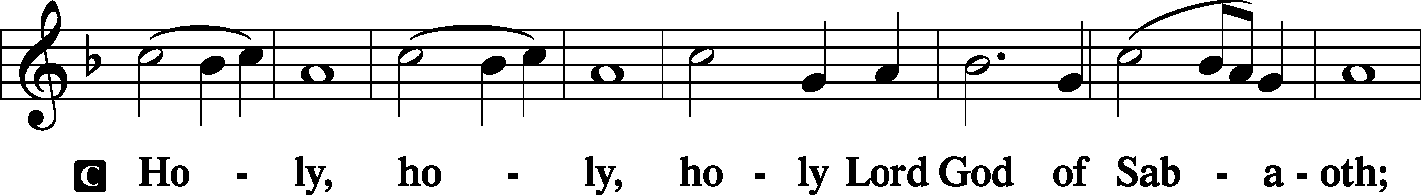
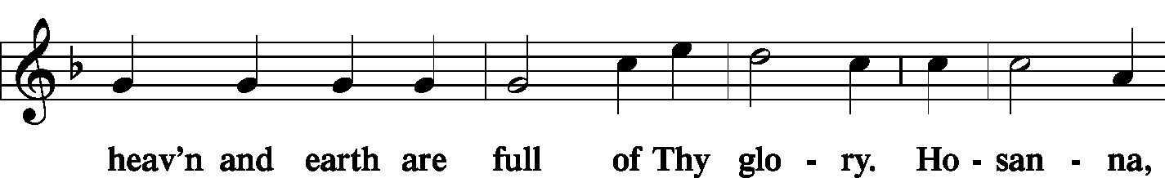
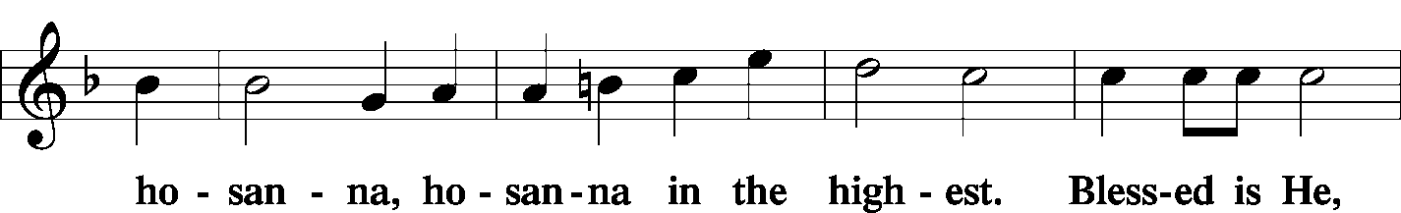
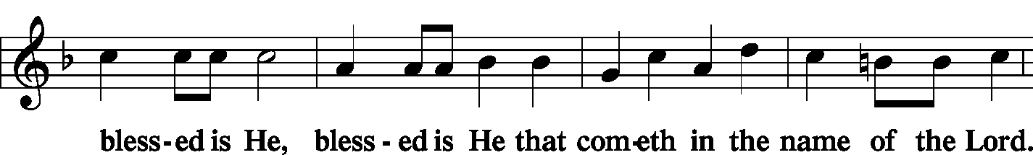
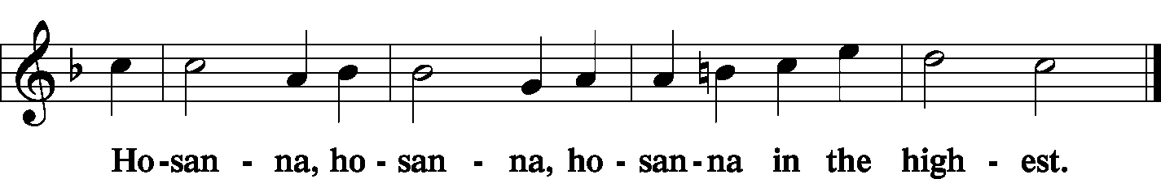

Lord's Prayer
C Our Father who art in heaven,
hallowed be Thy name,
Thy kingdom come,
Thy will be done on earth as it is in heaven;
give us this day our daily bread;
and forgive us our trespasses as we forgive those who trespass against us;
and lead us not into temptation,
but deliver us from evil.
For Thine is the kingdom and the power and the glory forever and ever. Amen.

The Words of Our Lord
P Our Lord Jesus Christ, on the night when He was betrayed, took bread, and when He had given thanks, He broke it and gave it to the disciples and said: “Take, eat; this is My T body, which is given for you. This do in remembrance of Me.”

In the same way also He took the cup after supper, and when He had given thanks, He gave it to them, saying: “Drink of it, all of you; this cup is the new testament in My T blood, which is shed for you for the forgiveness of sins. This do, as often as you drink it, in remembrance of Me.”

Pax Domini
P The peace of the Lord be with you always.
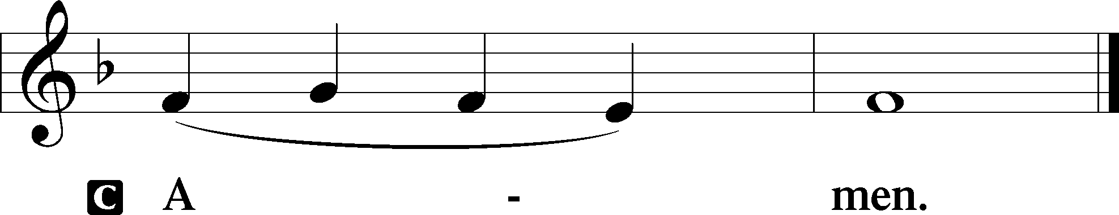

Agnus Dei
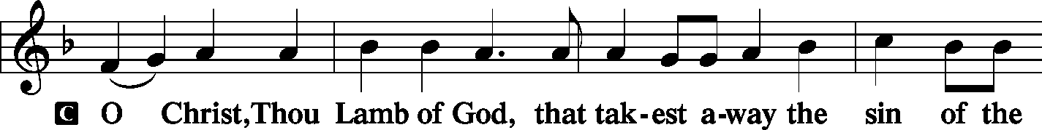
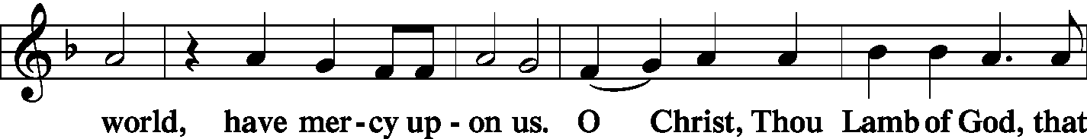
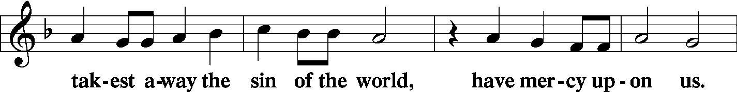
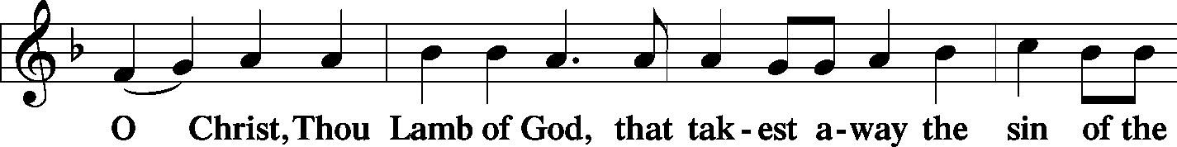
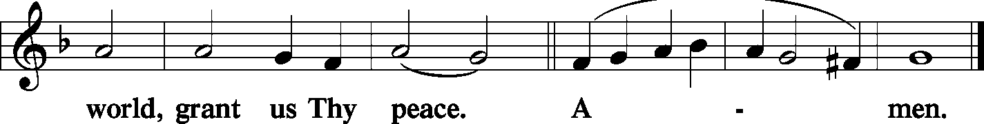
Sit

Distribution
The pastor and those who assist him receive the body and blood of Christ first and then distribute them to those who come to receive, saying:

Take, eat; this is the true body of our Lord and Savior Jesus Christ, given into death for your sins. Amen.

Take, drink; this is the true blood of our Lord and Savior Jesus Christ, shed for the forgiveness of your sins. Amen.

In dismissing the communicants, the following is said:
P The body and blood of our Lord Jesus Christ strengthen and preserve you in body and soul to life everlasting. Depart T in peace.
C Amen.

Distribution Hymn: LSB p. 155 - “This Is the Feast”
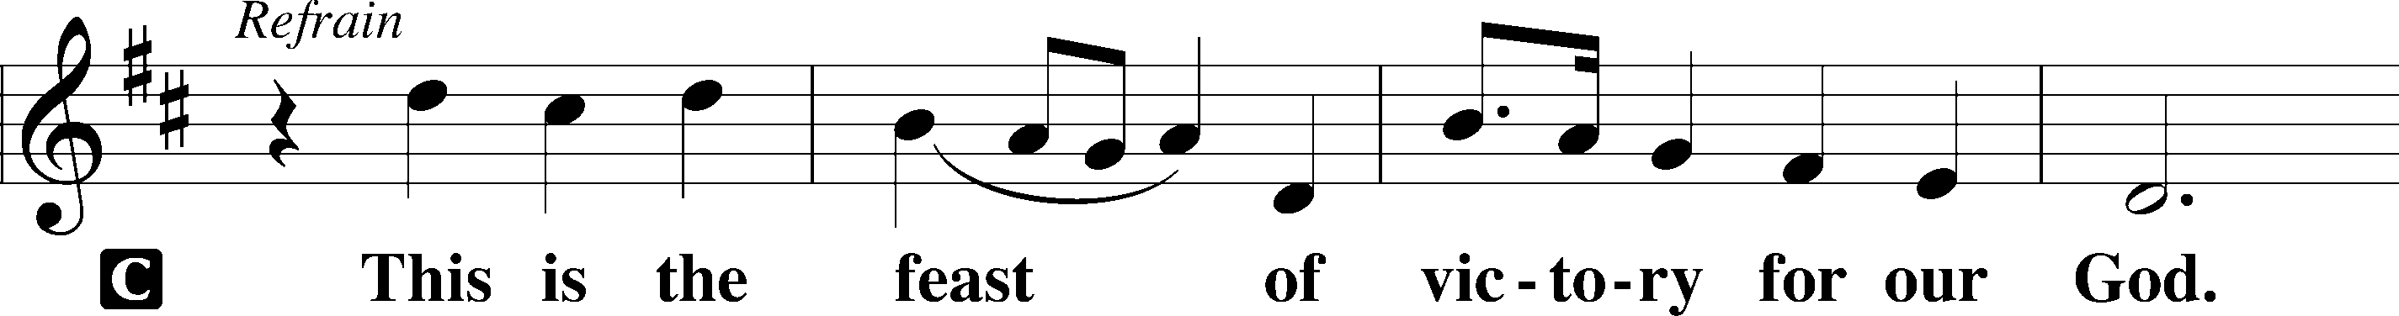
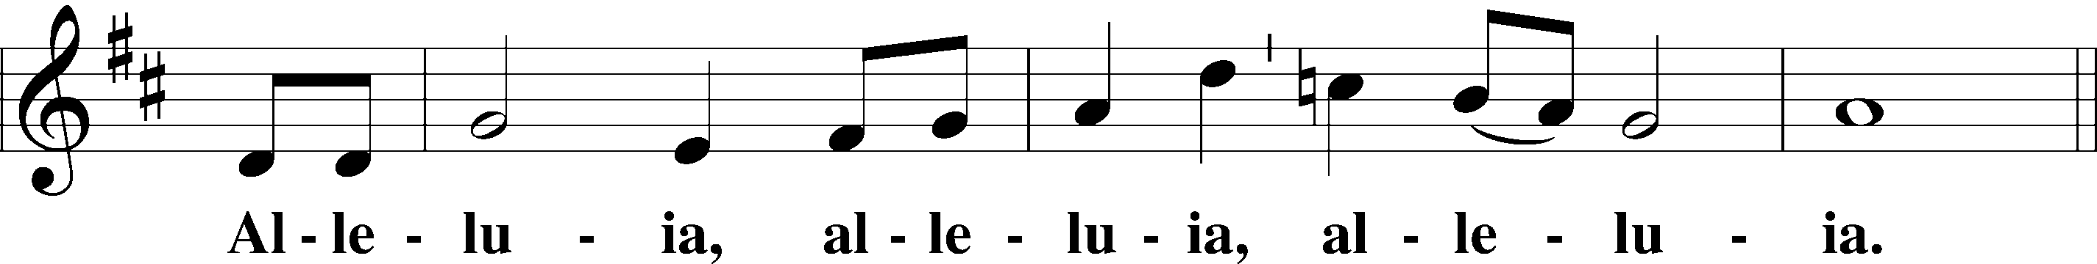
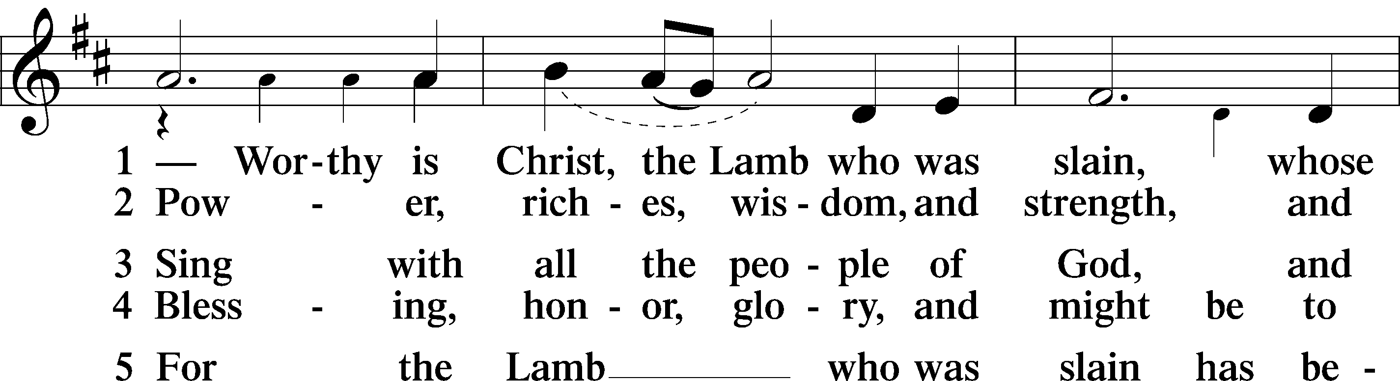
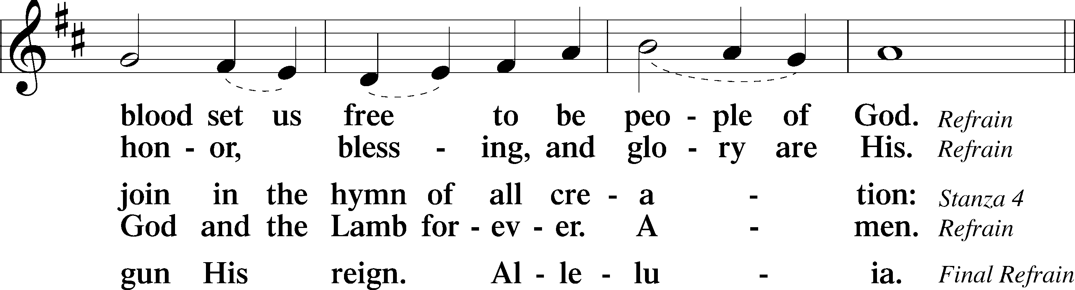
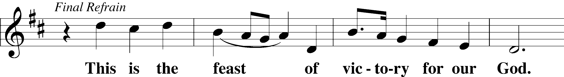
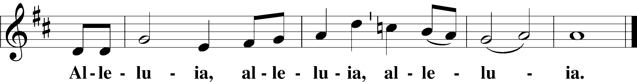

Distribution Hymn: LSB #633 “At the Lamb’s High Feast We Sing”
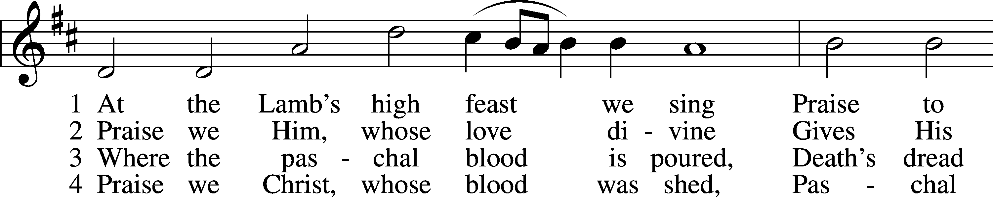
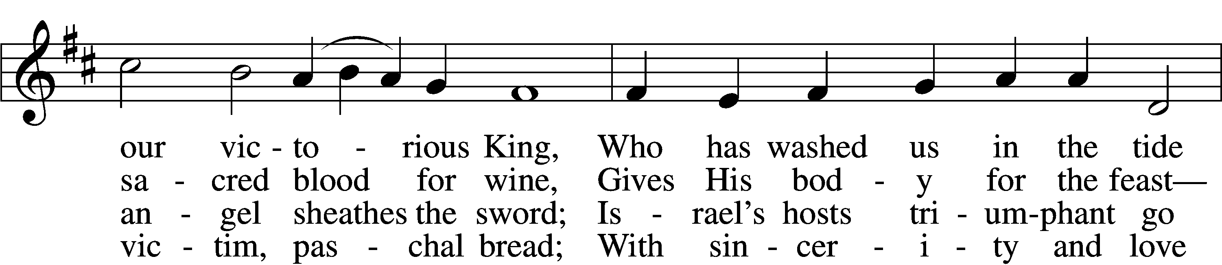
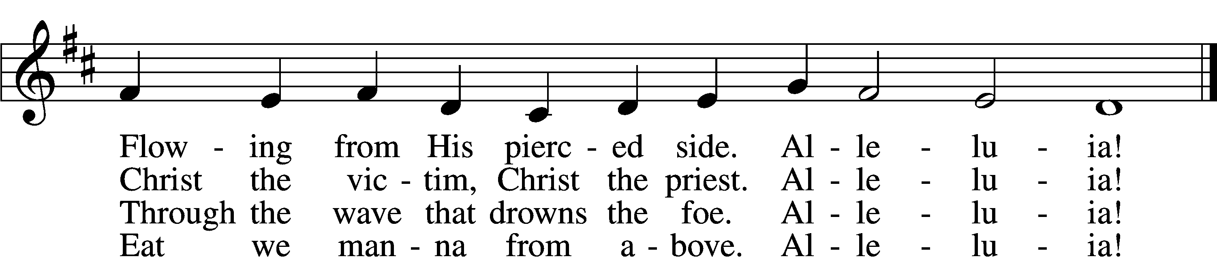

5 Mighty Victim from the sky, 6 Now no more can death appall,
Hell’s fierce pow’rs beneath You lie; Now no more the grave enthrall;
You have conquered in the fight, You have opened paradise,
You have brought us life and light. And Your saints in You shall rise.
Alleluia! Alleluia!

7 Easter triumph, Easter joy! D 8 Father, who the crown shall give,
This alone can sin destroy; Savior, by whose death we live,
From sin’s pow’r, Lord, set us free, Spirit, guide through all our days:
Newborn souls in You to be. Three in One, Your name we praise.
Alleluia! Alleluia!

Tune and text: Public domain

Stand

Nunc Dimittis
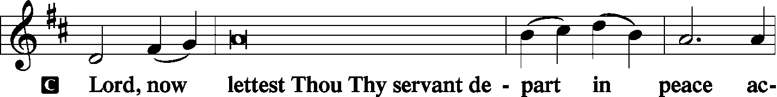
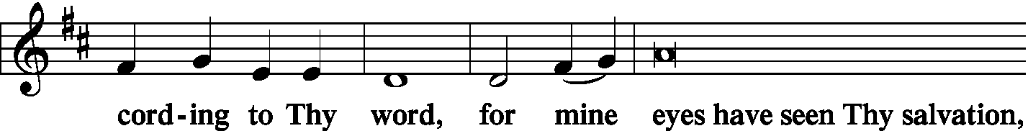
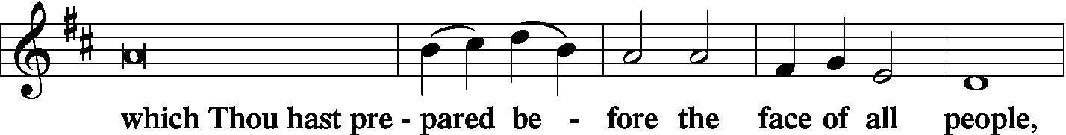
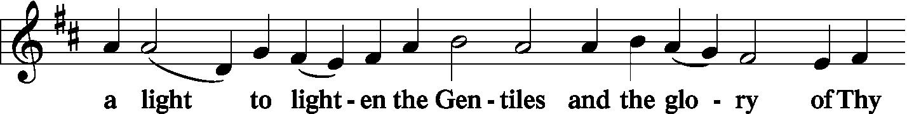
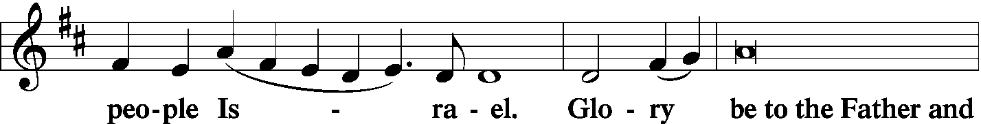
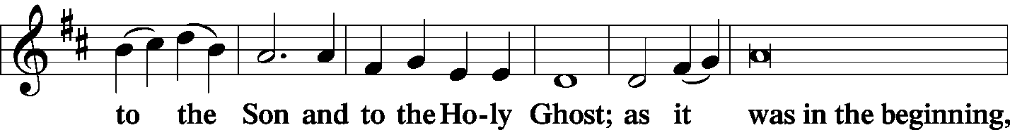
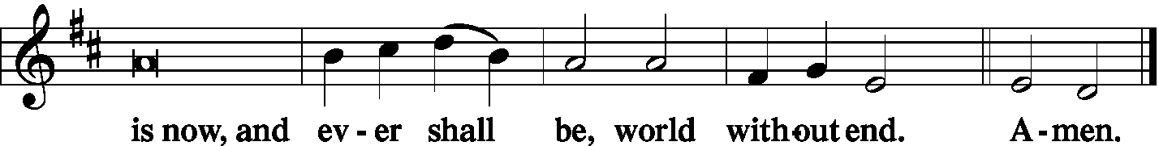

Thanksgiving
P O give thanks unto the Lord, for He is good,
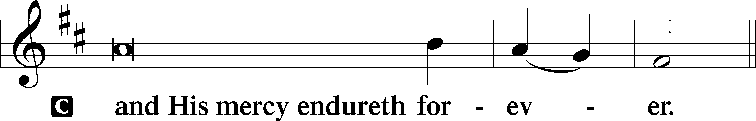

Collect
P Let us pray.
O God, for our redemption You gave Your only-begotten Son to the death of the cross and by His glorious resurrection delivered us from the power of the enemy. Grant that all our sin may be drowned through daily repentance and that day by day we may arise to live before You in righteousness and purity forever; through Jesus Christ, our Lord, who lives and reigns with You and the Holy Spirit, one God, now and forever.
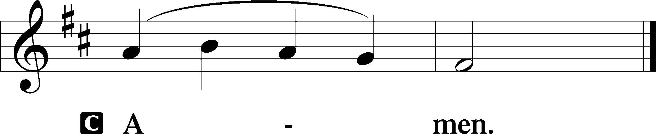

P The Lord be with you.
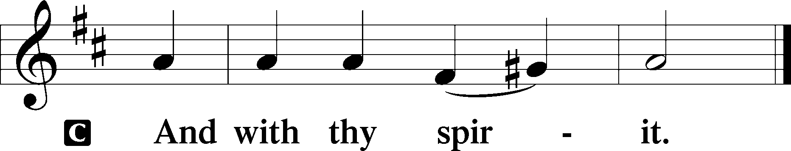

Benedicamus
P Bless we the Lord.
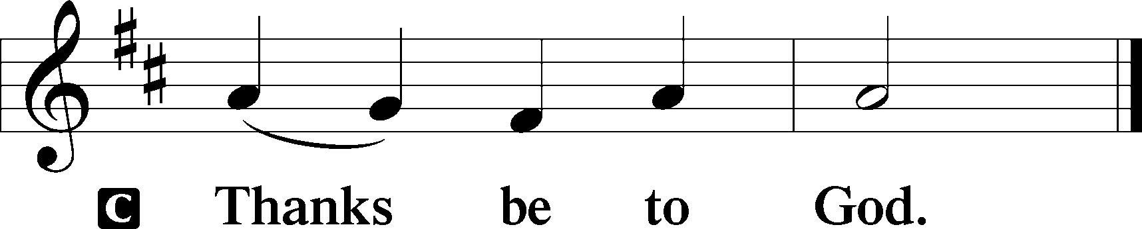

Benediction
P The Lord bless you and keep you.
The Lord make His face shine upon you and be gracious unto you.
The Lord lift up His countenance upon you and T give you peace.
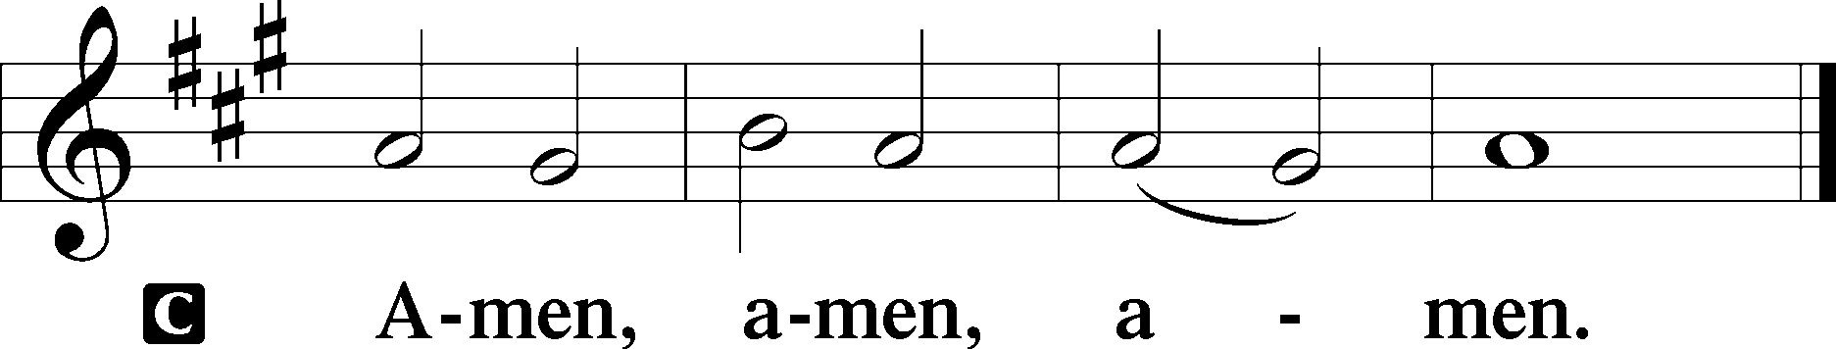

Closing Hymn: LSB #465 “Now All the Vault of Heaven Resounds”
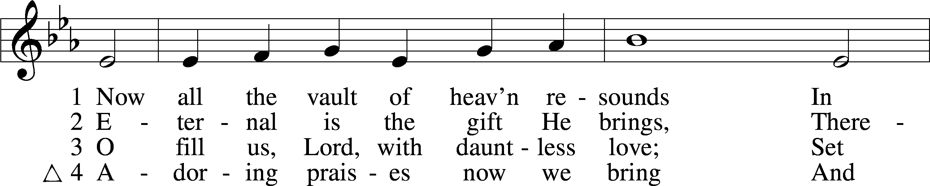
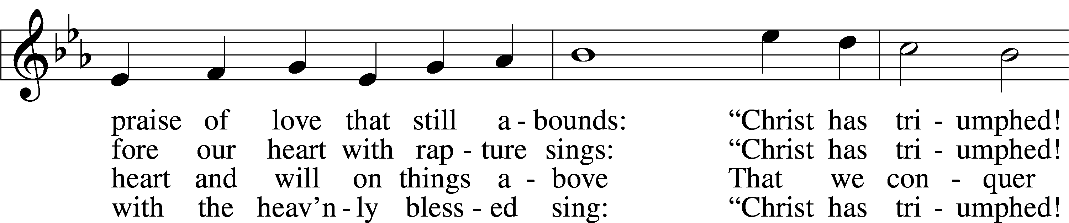
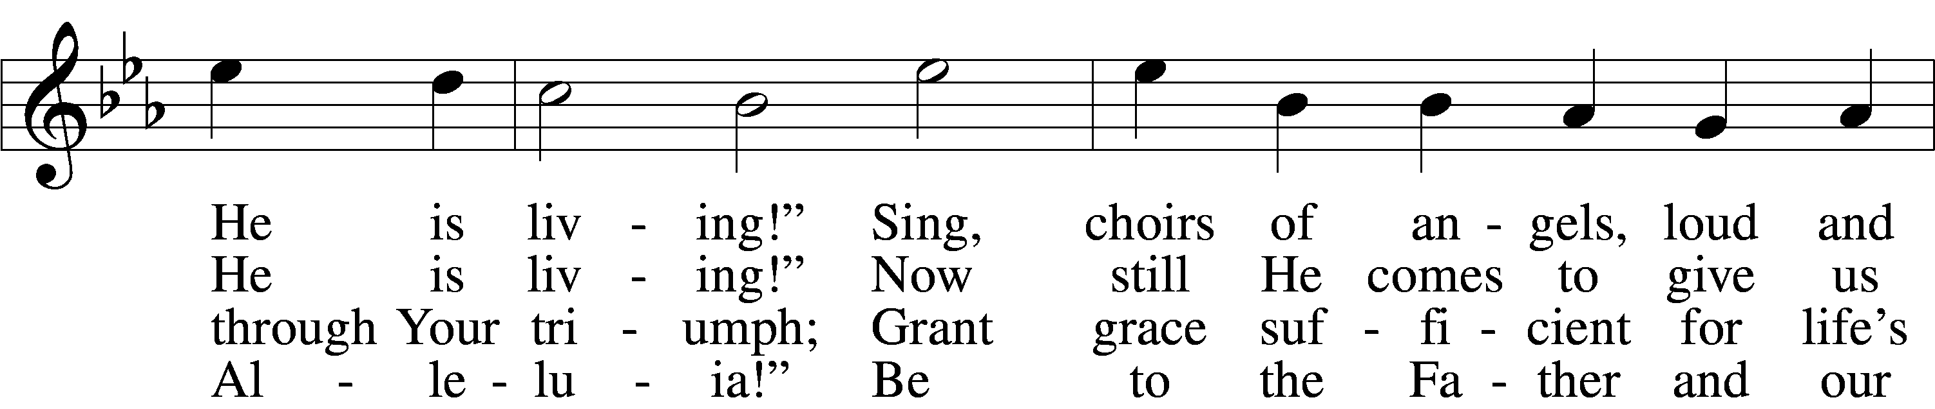
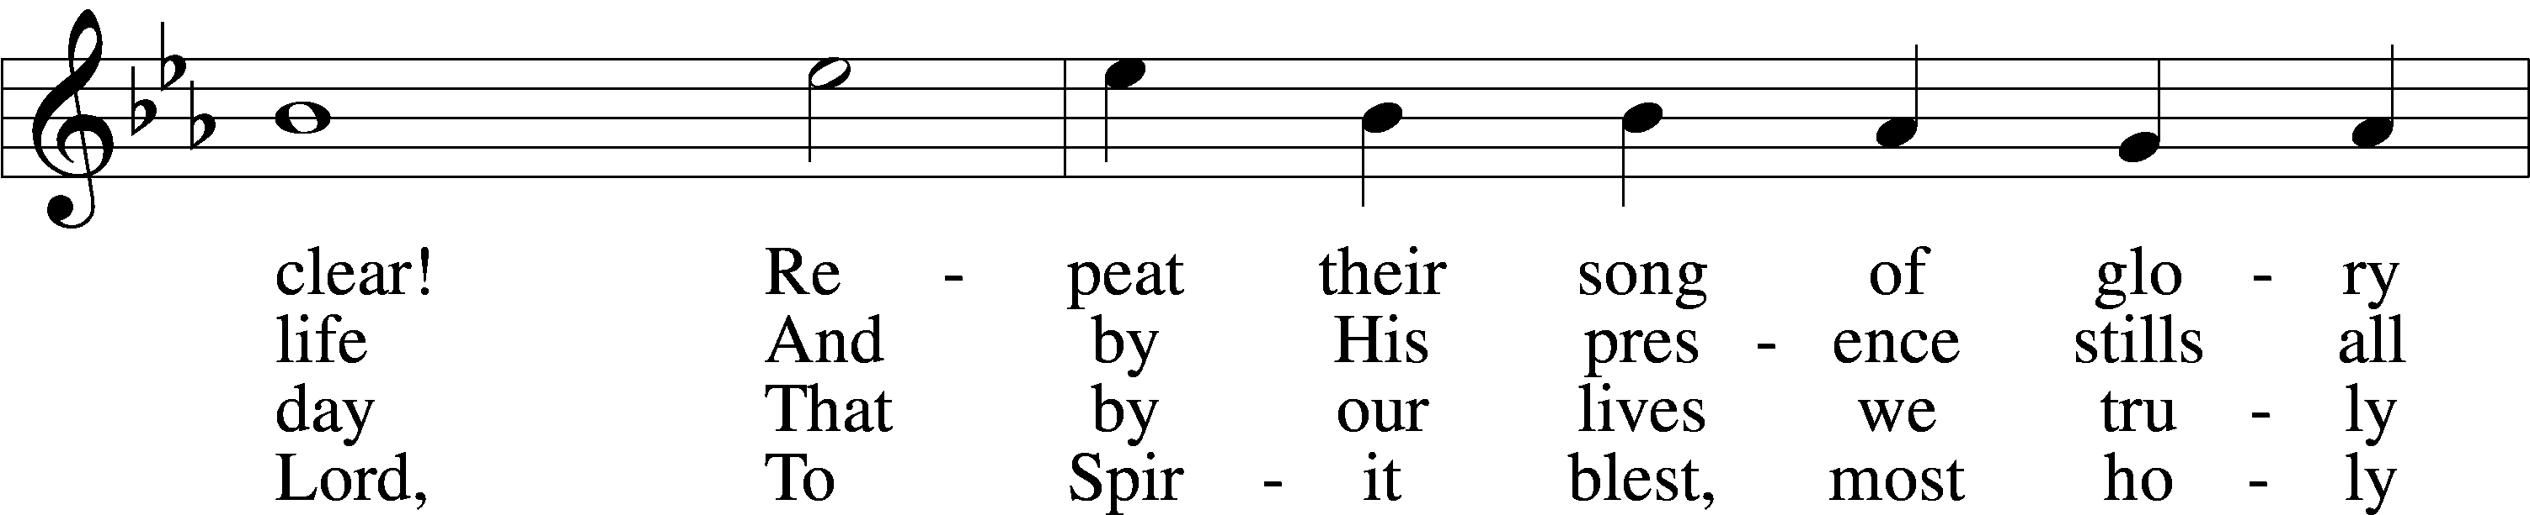
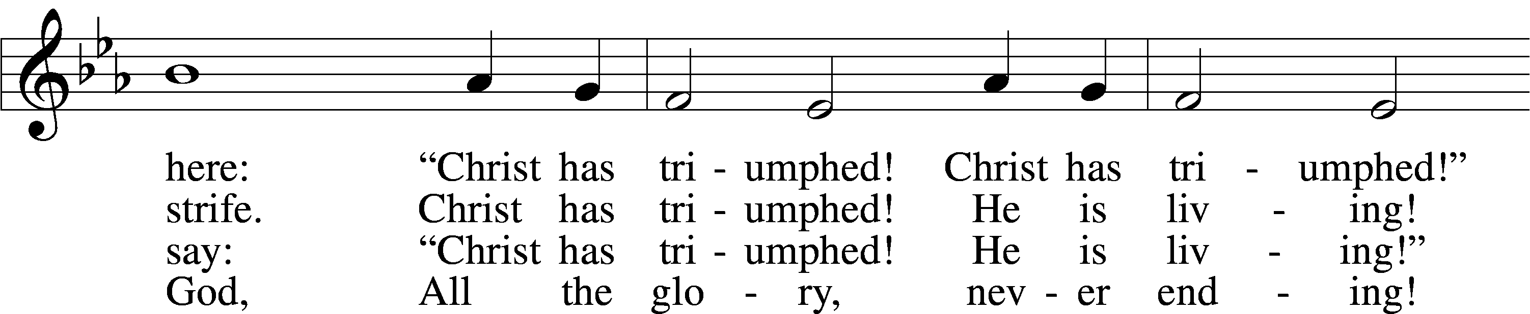
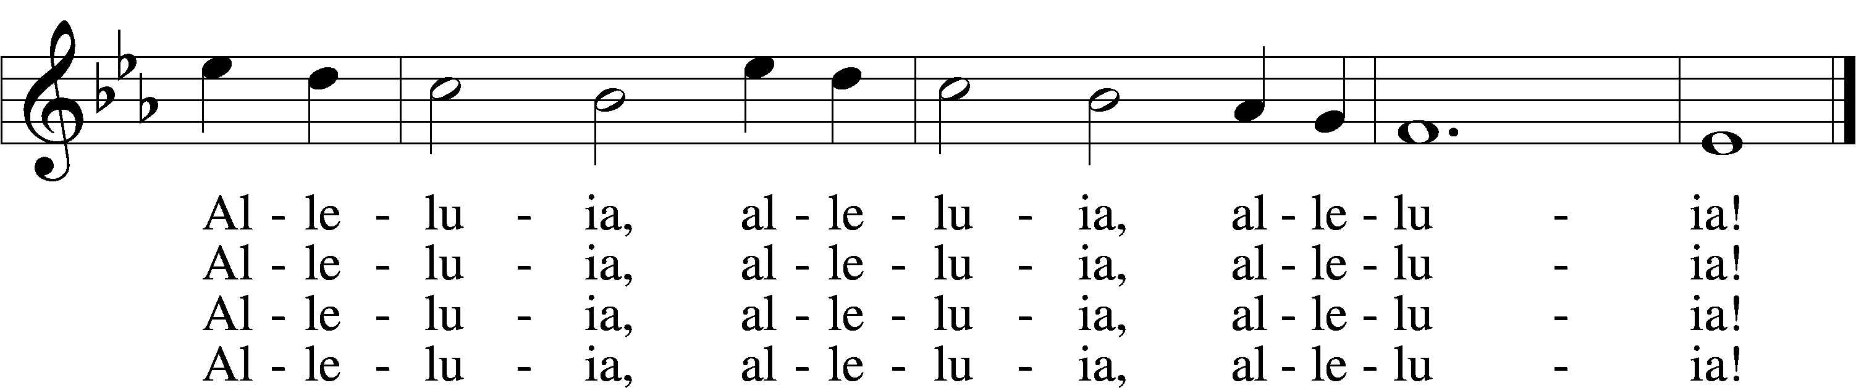

Text: © 1958 Augsburg Publishing House. Used by permission: LSB Hymn License no. 110004782 Tune: Public domain
Acknowledgments Vigil of Easter from Lutheran Service Book Unless otherwise indicated, all scripture quotations are from The Holy Bible, English Standard Version, copyright © 2001 by Crossway Bibles, a division of Good News Publishers. Used by permission. All rights reserved. Created by Lutheran Service Builder © 2006 Concordia Publishing House. CCLI License #3029-446

