Sts. Peter & Paul
Evangelical Lutheran Church
Lutheran Church-Missouri Synod
Founded-1917
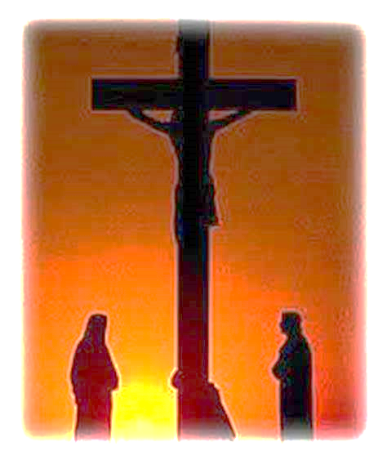
TRE ORE
Holy Friday of the Lord’s Passion and Death

APRIL 7, 2023
Noon – 3 pm

699 Stambaugh Avenue
Sharon, Pennsylvania 16146

“I was glad when they said to me,
Let us go to the house of the LORD!”
Psalm 122:1
The faithful gather in silence.
No instructions are given nor superfluous talking permitted during the Services.

MATINS
The pastor vests according to his usual custom at Matins.
The Office of Matins is said or chanted exactly as given.
All stand when the pastor enters.

Opening Hymn: LSB #440 “Jesus, I Will Ponder Now”
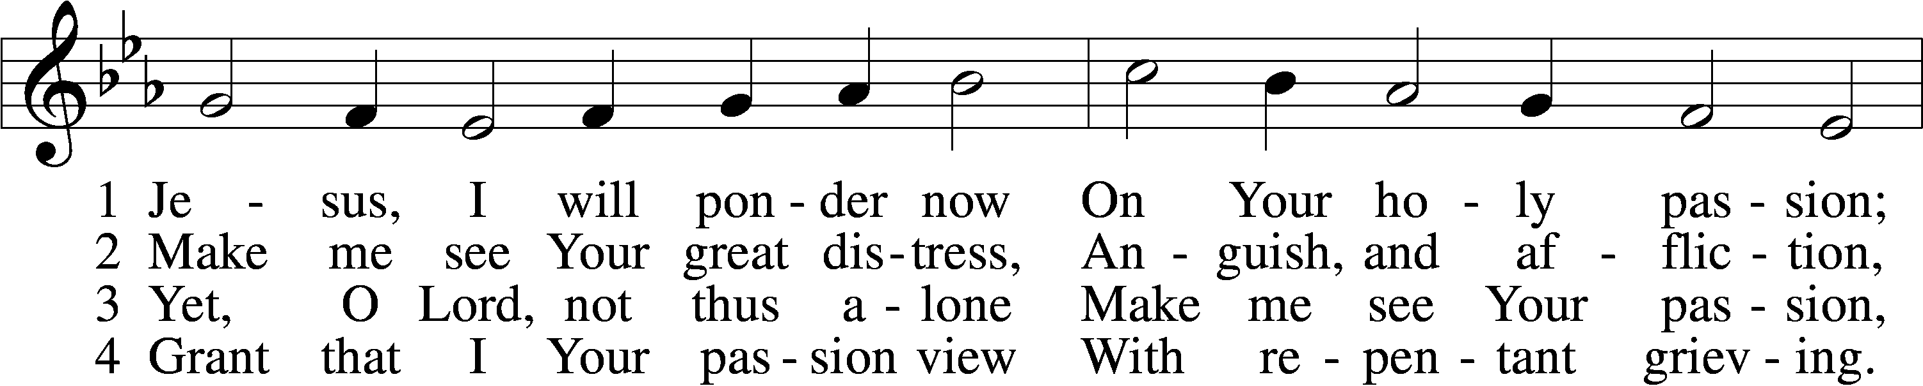
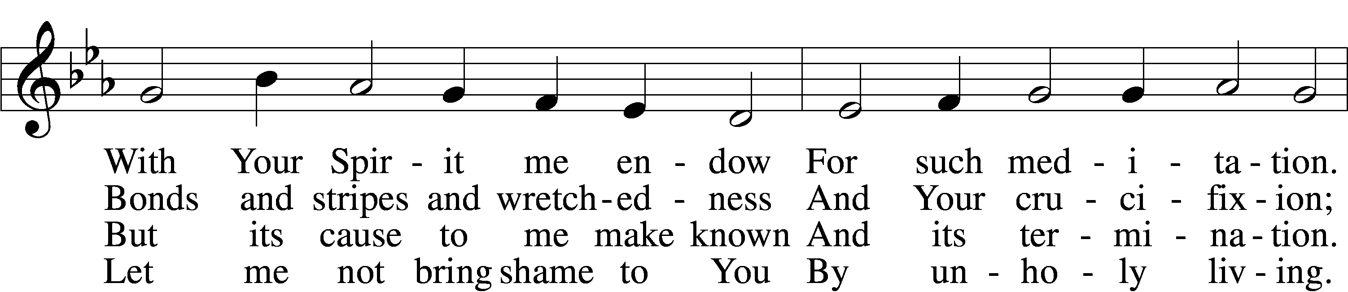
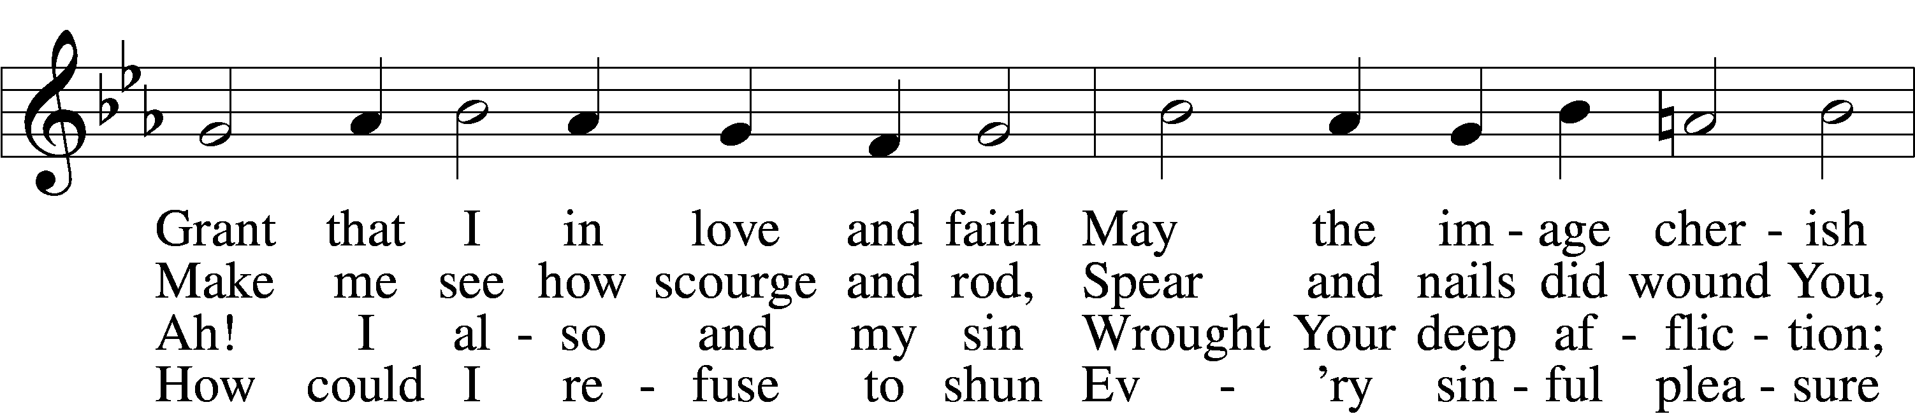
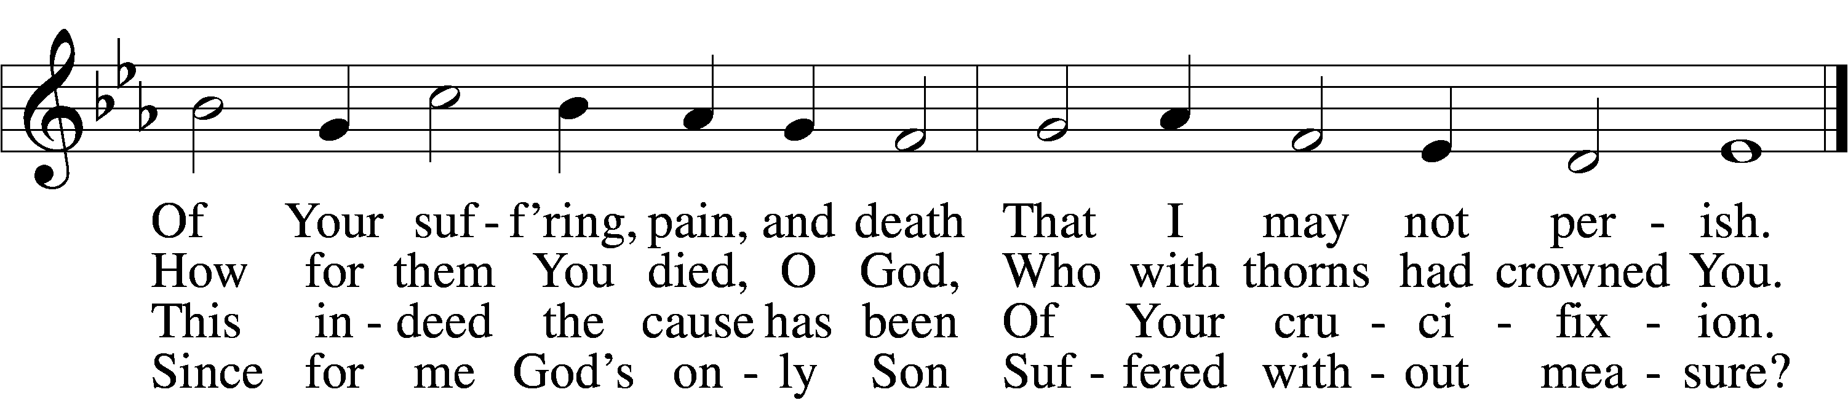

5 If my sins give me alarm
And my conscience grieve me,
Let Your cross my fear disarm;
Peace of conscience give me.
Help me see forgiveness won
By Your holy passion.
If for me He slays His Son,
God must have compassion!

6 Graciously my faith renew;
Help me bear my crosses,
Learning humbleness from You,
Peace mid pain and losses.
May I give You love for love!
Hear me, O my Savior,
That I may in heav’n above
Sing Your praise forever.
Text: Sigismund von Birken, 1626–81; tr. August Crull, 1845–1923, alt.
Tune: Melchior Vulpius, c. 1570–1615
Text and tune: Public domain

Psalm 32
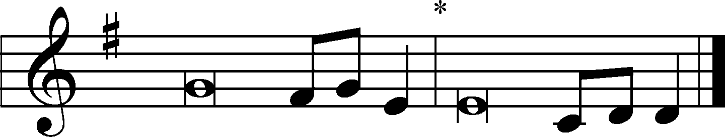
P Blessed | is the man*
To whom the Lord does not impute in-| iquity.

Blessed is he whose transgression is for- | given,*
Whose sin is | covered.
Blessed is the man to whom the LORD does not impute in- | iquity,*
And in whose spirit there is | no deceit.
When I kept silent, my | bones grew old*
Through my groaning all | the day long.
For day and night Your hand was heavy up- | on me;*
My vitality was turned into the drought of | summer.
I acknowledged my sin to You, and my iniquity I have not | hidden.*
I said, “I will confess my transgressions to the LORD.” And You forgave the
iniquity | of my sin.
For this cause everyone who is godly shall pray to You in a time when
You | may be found;*
Surely in a flood of great waters they shall not come | near him.
You are my | hiding place;*
You shall preserve me from trouble; You shall surround me with songs of de- |
liverance.
I will instruct you and teach you in the way | you should go;*
I will guide you | with My eye.
Do not be like the horse or like the mule, which have no under- | standing,*
Which must be harnessed with bit and bridle, else they will not come | near
you.
Many sorrows shall be to the | wicked;*
But he who trusts in the LORD, mercy shall sur- | round him.
Be glad in the LORD and rejoice, you | righteous;*
And shout for joy, all you up- | right in heart!

P Blessed | is the man*
To whom the Lord does not impute in-| iquity.

As we reach the culmination of this holy season, we see an increasingly stark liturgy, as more recent additions drop away, one by one. On Septuagesima Sunday, the Gloria in Excelsis and Alleluias fell silent. On Judica Sunday, the Gloria Patri and Nunc Dimittis disappeared, and the images were veiled.
On Maundy Thursday, the Agnus Dei was said without “grant us Thy peace.”
On Good Friday, the Confession, Introit, and Kyrie are not said,
and the Lessons and Passion are read without title or response.

Sit

First Reading: Hosea 5:15b-6:6 (NKJV)
“In their affliction they will earnestly seek Me, saying, ‘Come, and let us return to the Lord; for He has torn, but He will heal us; He has stricken, but He will bind us up. After two days He will revive us; on the third day He will raise us up, that we may live in His sight. Let us know, let us pursue the knowledge of the Lord. His going forth is established as the morning; He will come to us like the rain, like the latter and former rain to the earth.’ O Ephraim, what shall I do to you? O Judah, what shall I do to you? For your faithfulness is like a morning cloud, and like the early dew it goes away. Therefore I have hewn them by the prophets, I have slain them by the words of My mouth; and your judgments are like light that goes forth. For I desire mercy and not sacrifice, and the knowledge of God more than burnt offerings.”

Tract: Habakkuk 3:2-3
O Lord, I have heard Thy speech, and was afraid:
I considered Thy works and trembled.
In the midst of two beasts shalt Thou be made known:
While the years draw nigh shalt Thou be knowledged;
When the time shall come,
Thou shalt be showed.
In the time when my soul shall be troubled:
In wrath remember mercy.
God shall come from Libanus,
And the Holy One from the shady and thick-wooded mountain.
His glory covered the heavens
And the earth was full of His praise.

Stand

Collect
P Let us pray.
O God, from whom Judas received the punishment of his guilt: and the thief the reward of his confession: grant unto us the full fruit of Thy clemency, that even as in His Passion our Lord Jesus Christ gave to each retribution according to his merits, so having cleared away our former error, He may bestow on us the grace of his resurrection; who liveth and reigneth with Thee and the Holy Ghost, ever one God, world without end.
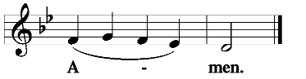
Sit

Second Reading: Exodus 12:1-11
The Lord spoke to Moses and Aaron in the land of Egypt, saying, “This month shall be your beginning of months; it shall be the first month of the year to you. Speak to all the congregation of Israel, saying: ‘On the tenth of this month every man shall take for himself a lamb, according to the house of his father, a lamb for a household. And if the household is too small for the lamb, let him and his neighbor next to his house take it according to the number of the persons; according to each man’s need you shall make your count for the lamb. Your lamb shall be without blemish, a male of the first year. You may take it from the sheep or from the goats. Now you shall keep it until the fourteenth day of the same month. Then the whole assembly of the congregation of Israel shall kill it at twilight. And they shall take some of the blood and put it on the two doorposts and on the lintel of the houses where they eat it. Then they shall eat the flesh on that night; roasted in fire, with unleavened bread and with bitter herbs they shall eat it. Do not eat it raw, nor boiled at all with water, but roasted in fire—its head with its legs and its entrails. You shall let none of it remain until morning, and what remains of it until morning you shall burn with fire. And thus you shall eat it: with a belt on your waist, your sandals on your feet, and your staff in your hand. So you shall eat it in haste. It is the Lord’s Passover.’ ”

Hymn: TLH #171 “Upon the Cross Extended” vv 1-8 (Sung to the tune of LSB #453)
- Upon the cross extended,
See, world, thy Lord suspended,
Thy Savior yields His breath.
The Prince of Life from heaven
Himself hath freely given
To shame and blows and bitter death.

- Come hither now and ponder
’Twill fill thy soul with wonder,
Blood streams from ev’ry pore.
Through grief whose depth none knoweth,
From His great heart there floweth
Sigh after sigh of anguish o’er.

- Who is it that hath bruised Thee?
Who hath so sore abused Thee
And caused Thee all Thy woe?
While we must make confession
Of sin and dire transgression,
Thou deeds of evil dost not know.

- I caused Thy grief and sighing
By evils multiplying
As countless as the sands.
I caused Thy woes unnumbered
With which Thy soul is cumbered,
Thy sorrows raised by wicked hands.

- ’Tis I who should be smitten,
My doom should here be written:
Bound hand and foot in hell.
The fetters and the scourging,
The floods around Thee surging,
‘Tis I who have deserved them well.

- The load Thou takest on Thee,
That pressed so sorely on me,
It crushed me to the ground.
The cross for me enduring,
The crown for me securing,
My healing in Thy wounds is found.

- A crown of thorns Thou wearest,
My shame and scorn Thou bearest,
That I might ransomed be.
My Bondsman, ever willing,
My place with patience filling,
From sin and guilt hast made me free.

- Into death’s jaws Thou springest,
Deliv’rance to me bringest
From such a monster dire.
My death away Thou takest,
Thy grave its grave Thou makest;
O love, O unexampled fire!

O Welt, Ich Muss Dich Lassen Paul Gerhardt, 1653 Tr. John Kelly, 1867, alt.
Source: Sts. 1–7, 9, 11–12, 14, 16, The Lutheran Hymnal, 1941, No. 171
Sts. 8, 10, 13, 15, Evangelical Lutheran Hymn-Book, 1927, No. 205

Tract: Psalm 140:1-9, 13
Deliver me, O Lord, from the evil man:
Preserve me from the violent man;
Which imagine mischiefs in their heart;
Continually are they gathered together for war.
They have sharpened their tongues like a serpent;
Adders’ poison is under their lips.
Keep me, O Lord, from the hands of the wicked;
Preserve me from the violent man; who have purposed to overthrow my goings.
The proud have hid a snare for me, and cords;
They have spread a net by the wayside; they have set traps for me.
I said unto the Lord, Thou art my God:
Hear the voice of my supplications, O Lord.
O God the Lord, the strength of my salvation,
Thou hast covered my head in the day of battle.
Grant not, O Lord, the desires of the wicked:
Further not his wicked device; lest they exalt themselves.
As for the head of those that compass me about,
Let the mischief of their own lips cover them.
Surely the righteous shall give thanks unto Thy name:
The upright shall dwell in Thy presence.

Hymn: TLH #171 “Upon the Cross Extended” vv 9-16
- Thy cords of love, my Savior,
Bind me to Thee forever,
I am no longer mine.
To Thee I gladly tender
All that my life can render
And all I have to Thee resign.

- Not much can I be giving
In this poor life I’m living,
But one thing do I say:
Thy death and sorrows ever,
Till soul from body sever,
My heart shall its remembrance pay.

- Thy cross I’ll place before me,
Its saving pow’r be o’er me,
Wherever I may be;
Thine innocence revealing,
Thy love and mercy sealing,
The pledge of truth and constancy.

- How God at our transgression
To anger gives expression,
How loud His thunders roll,
How fearfully He smiteth,
How sorely He requiteth,—
All this Thy suff’rings teach my soul.

- From them shall I be learning
How I may be adorning
My heart with quietness,
And how I still should love them
Whose malice e’er doth move them
To grieve me by their wickedness.

- When evil men revile me,
With wicked tongues defile me,
I’ll curb my vengeful heart.
The unjust wrong I’ll suffer,
Unto my neighbor offer
Forgiveness for each bitter smart.

- Upon the cross I’ll nail me
With Thee; when sins assail me
Thou shalt my Refuge be.
Forsaking sins that grieve Thee,
Lord, let me never leave Thee,
And let me find my strength in Thee.

- Thy groaning and Thy sighing,
Thy bitter tears and dying,
With which Thou wast oppressed,—
They shall, when life is ending,
Be guiding and attending
My way to Thine eternal rest.
O Welt, Ich Muss Dich Lassen Paul Gerhardt, 1653 Tr. John Kelly, 1867, alt.
Source: Sts. 1–7, 9, 11–12, 14, 16, The Lutheran Hymnal, 1941, No. 171
Sts. 8, 10, 13, 15, Evangelical Lutheran Hymn-Book, 1927, No. 205

The Passion of Our Lord Jesus Christ

All may be seated during the PASSION GOSPEL.
(N) Narrator; (T) Christ’s voice; (C) Chorus

N: When Jesus had spoken these words, He went out with His disciples over the Brook Kidron, where there was a garden, which He and His disciples entered. And Judas, who betrayed Him, also knew the place; for Jesus often met there with His disciples. Then Judas, having received a detachment of troops, and officers from the chief priests and Pharisees, came there with lanterns, torches, and weapons. Jesus therefore, knowing all things that would come upon Him, went forward and said to them,
T: “Whom are you seeking?”
N: They answered Him,
C: “Jesus of Nazareth.”
N: Jesus said to them,
T: “I am He.”
N: And Judas, who betrayed Him, also stood with them. Then –when He said to them, “I am He,” –they drew back and fell to the ground. Then He asked them again,
T: “Whom are you seeking?”
N: And they said,
C: “Jesus of Nazareth.”
N: Jesus answered,
T: “I have told you that I am He. Therefore, if you seek Me, let these go their way,”
N: that the saying might be fulfilled which He spoke, “Of those whom You gave Me I have lost none.” Then Simon Peter, having a sword, drew it and struck the high priest’s servant, and cut off his right ear. The servant’s name was Malchus. Then Jesus said to Peter,
T: “Put your sword into the sheath. Shall I not drink the cup which My Father has given Me?”

Chief Hymn: LSB #439 “O Dearest Jesus, What Law Hast Thou Broken” stanzas 1-2 Text and tune: Public domain

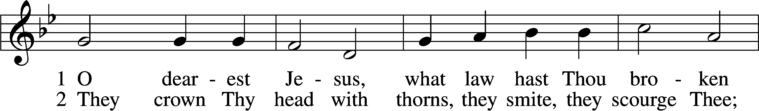
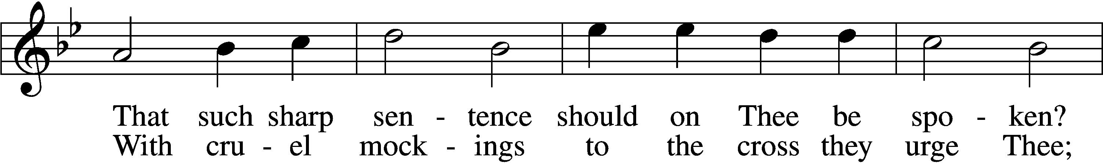
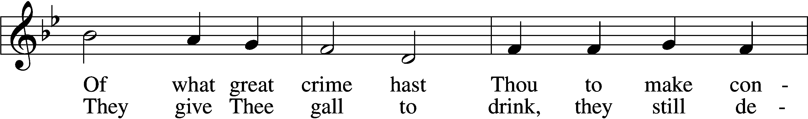
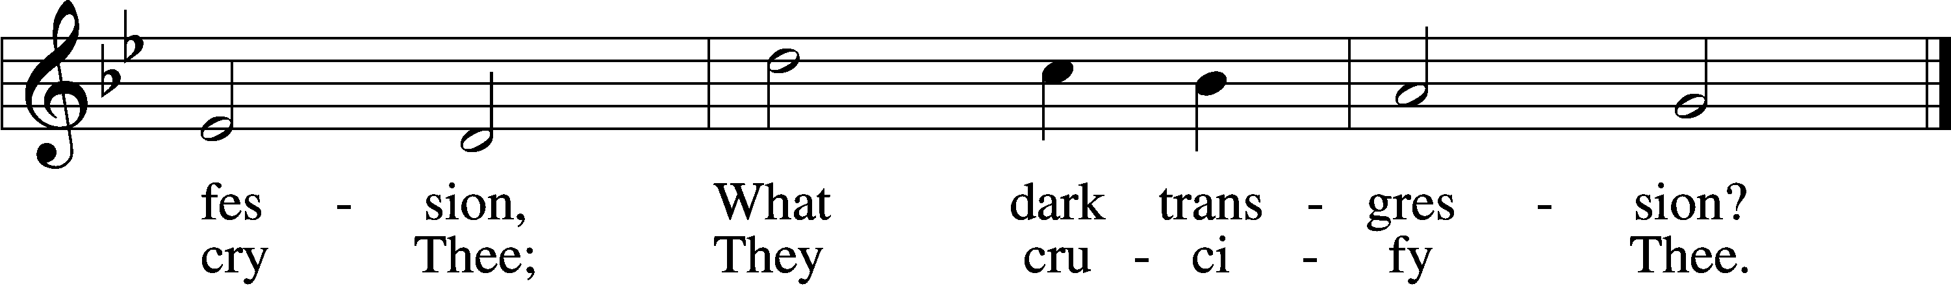
N: Then the detachment of troops and the captain and the officers of the Jews arrested Jesus and bound Him. And they led Him away to Annas first, for he was the father-in-law of Caiaphas who was high priest that year. Now it was Caiaphas who gave counsel to the Jews and it was expedient that one man should die for the people. And Simon Peter followed Jesus, and so did another disciple. Now that disciple was known to the high priest, and went with Jesus into the courtyard of the high priest. But Peter stood at the door outside. Then the other disciple, who was known to the high priest, went out and spoke to her who kept the door, and brought Peter in. Then the servant girl who kept the door said to Peter,
C: “You are not also one of the Man’s disciples, are you?”
N: He said,
C: “I am not.”
N: And the servants and officers who had made a fire of coals stood there, for it was cold, and they warmed themselves. And Peter stood with them and warmed himself. The high priest then asked Jesus about His disciples and His doctrine. Jesus answered him,
T: “I spoke openly to the world. I always taught in synagogues and in the temple, where the Jews always meet, and in secret I have said nothing. Why do you ask Me? Ask those who have heard Me what I said to them. Indeed they know what I said.”
N: And when He had said these things, one of the officers who stood by struck Jesus with the palm of his hand, saying,
C: “Do You answer the high priest like that?”
N: Jesus answered him,
T: “If I have spoken evil, bear witness of the evil; but if well, why do you strike Me?”
N: Then Annas sent Him bound to Caiaphas the high priest. Now Simon Peter stood and warmed himself. Therefore they said to him,
C: “You are not also one of His disciples, are you?”
N: He denied it and said,
C: “I am not!”
N: One of the servants of the high priest, a relative of him whose ear Peter cut off, said,
C: “Did I not see you in the garden with Him?”
N: Peter then denied again; and immediately a rooster crowed.

Chief Hymn: LSB #439 “O Dearest Jesus, What Law Hast Thou Broken” stanzas 3-4
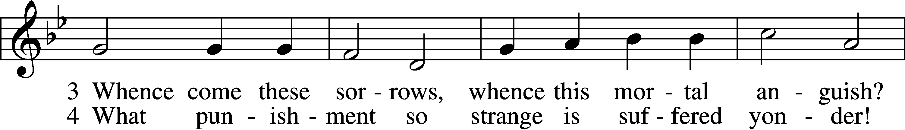
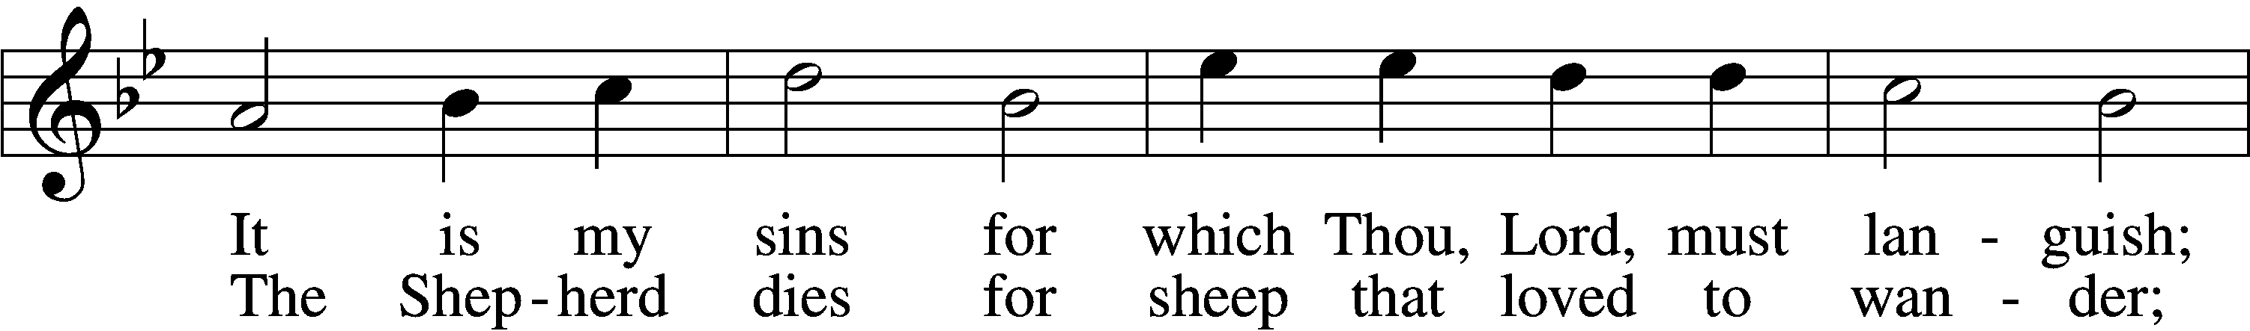
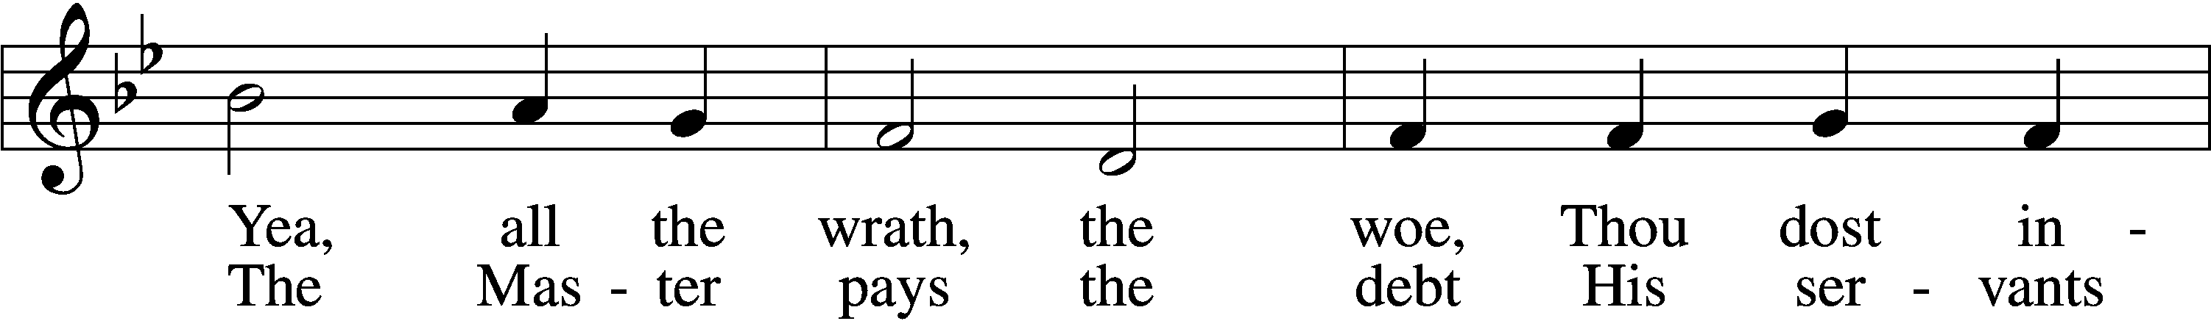
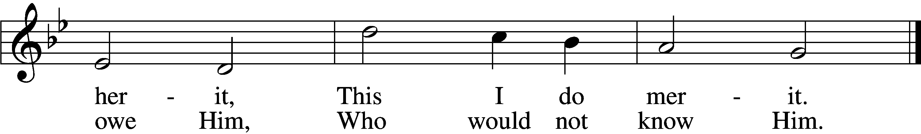
Text and tune: Public domain

N: Then they led Jesus from Caiaphas to the Praetorium, and it was early morning. But they themselves did not go into the Praetorium, lest they should be defiled, but that they might eat the Passover. Pilate then went out to them and said,
C: “What accusation do you bring against this Man?”
N: They answered and said to him,
C: “If He were not an evildoer, we would not have delivered Him up to you.”
N: Then Pilate said to them,
C: “You take Him and judge Him according to your law.”
N: Therefore the Jews said to him,
C: “It is not lawful for us to put anyone to death,”
N: that the saying of Jesus might be fulfilled which He spoke, signifying by what death He would die. Then Pilate entered the Praetorium again, called Jesus, and said to Him,
C: “Are You the King of the Jews?”
N: Jesus answered him,
T: “Are you speaking for yourself on this, or did others tell you this about Me?”
N: Pilate answered,
C: “Am I a Jew? Your own nation and the chief priests have delivered You to me. What have You done?”
N: Jesus answered,
T: “My kingdom is not of this world. If My kingdom were of this world, My servants would fight, so that I should not be delivered to the Jews; but now My kingdom is not from here.”
N: Pilate therefore said to Him,
C: “Are You a king then?”
N: Jesus answered,
T: “You say rightly that I am a king. For this cause I was born, and for this cause I have come into the world, that I should bear witness to the truth. Everyone who is of the truth hears My voice.”
N: Pilate said to Him,
C: “What is truth?”

Chief Hymn: LSB #439 “O Dearest Jesus, What Law Hast Thou Broken” stanzas 5-6 Text and tune: Public domain
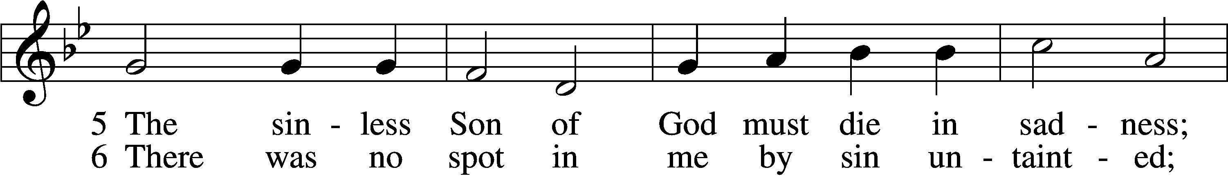
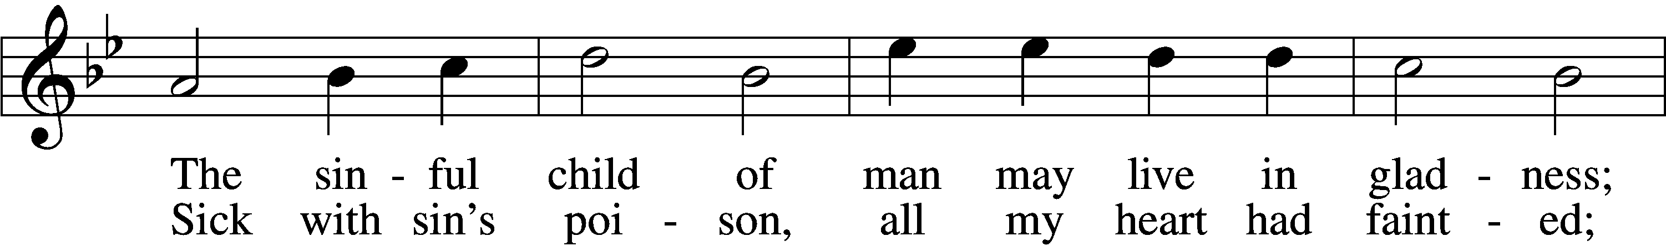
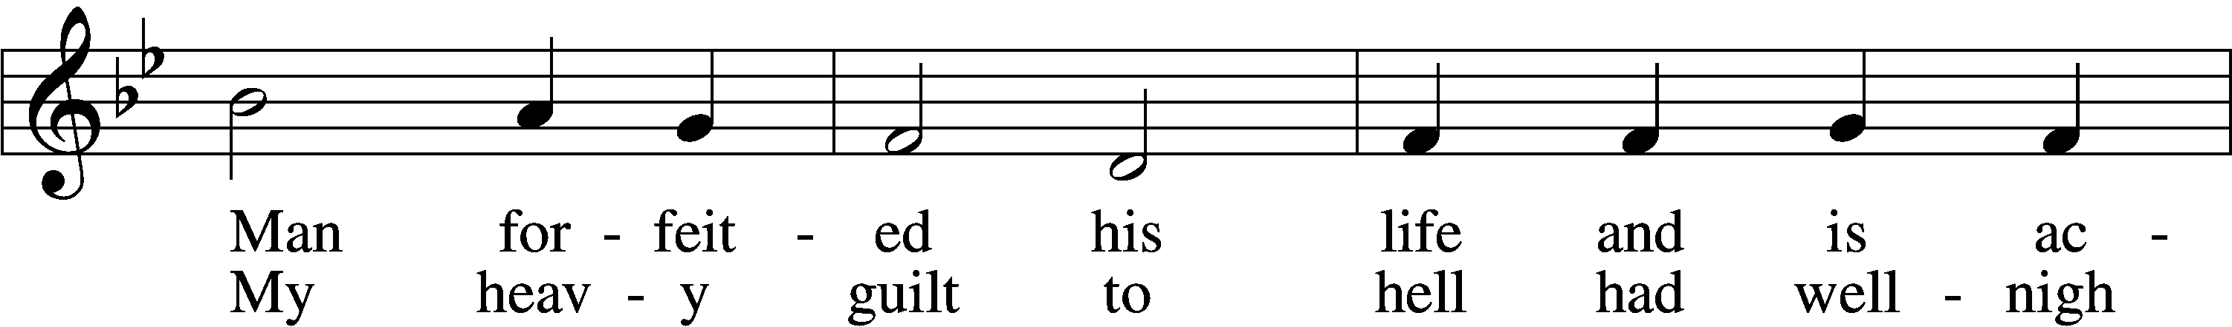
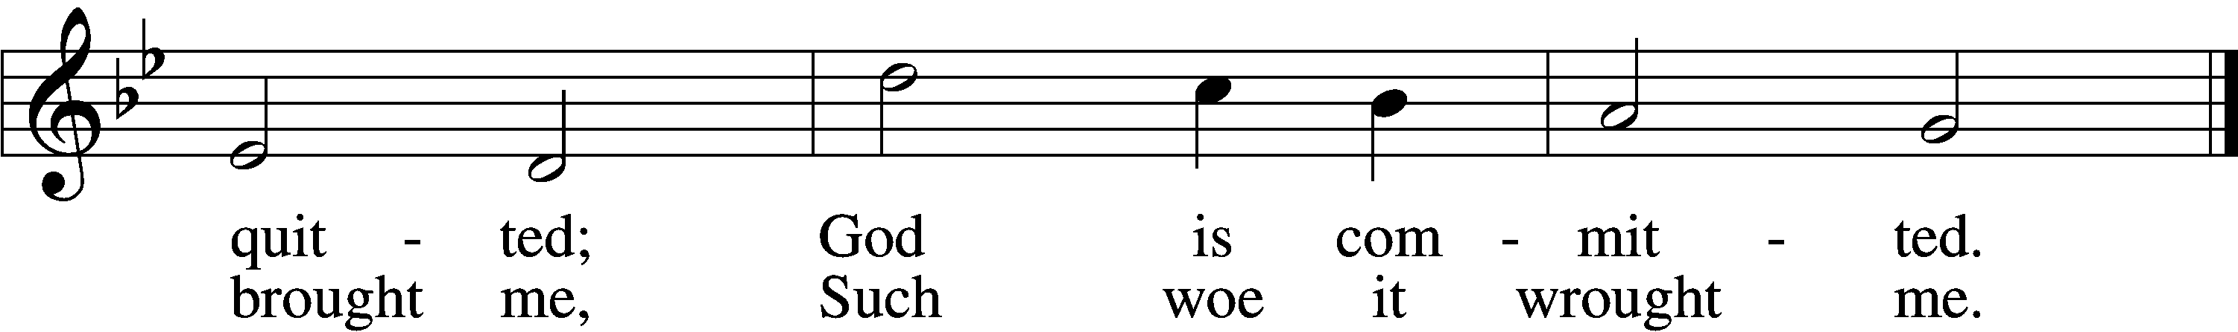
N: And when he had said this, he went out again to the Jews, and said to them,
C: “I find no fault in Him at all. But you have a custom that I should release someone to you at the Passover. Do you therefore want me to release to you the King of the Jews?”
N: Then they all cried again, saying,
C: “Not this Man, but Barabbas!”
N: Now Barabbas was a robber. So then Pilate took Jesus and scourged Him. And the soldiers twisted a crown of thorns and put it on His head, and they put on Him a purple robe. Then they said,
C: “Hail, King of the Jews!”
N: And they struck Him with their hands. Pilate then went out again, and said to them,
C: “Behold, I am bringing Him out to you, that you may know that I find no fault in Him.”
N: Then Jesus came out, wearing the crown of thorns and the purple robe. And Pilate said to them,
C: “Behold the Man!”
N: Therefore, when the chief priests and officers saw Him, they cried out, saying,
C: “Crucify Him, crucify Him!”
N: Pilate said to them,
C: “You take Him and crucify Him, for I find no fault in Him.”
N: The Jews answered him,
C: “We have a law, and according to our law He ought to die, because He made Himself the Son of God.”
N: Therefore, when Pilate heard that saying, he was the more afraid, and went again into the Praetorium, and said to Jesus,
C: “Where are You from?”
N: But Jesus gave him no answer. Then Pilate said to Him,
C: “Are You not speaking to me? Do You not know that I have power to crucify You, and power to release You?”
N: Jesus answered,
T: “You could have no power at all against Me unless it had been given you from above. Therefore the one who delivered Me to you has the greater sin.”
N: From then on Pilate sought to release Him, but the Jews cried out, saying,
C: “If you let this Man go, you are not Caesar’s friend. Whoever makes himself a king speaks against Caesar.”
N: When Pilate therefore heard that saying, he brought Jesus out and sat down in the judgment seat in a place that is called The Pavement, but in Hebrew, Gabbatha. Now it was the Preparation Day of the Passover, and about the sixth hour. And he said to the Jews,
C: “Behold your King!”
N: But they cried out,
C: “Away with Him, away with Him! Crucify Him!”
N: Pilate said to them,
C: “Shall I crucify your King?”
N: The chief priests answered,
C: “We have no king but Caesar!”
N: So he delivered Him to them to be crucified.

Chief Hymn: LSB #439 “O Dearest Jesus, What Law Hast Thou Broken” stanzas 7-9
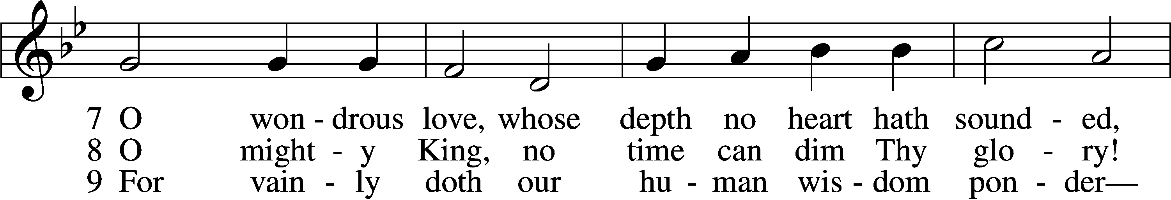
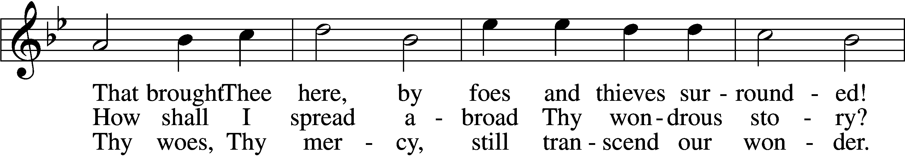
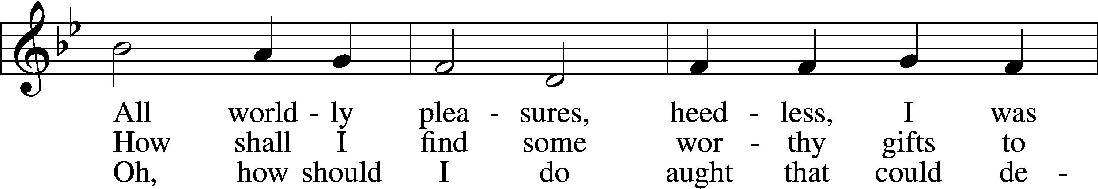
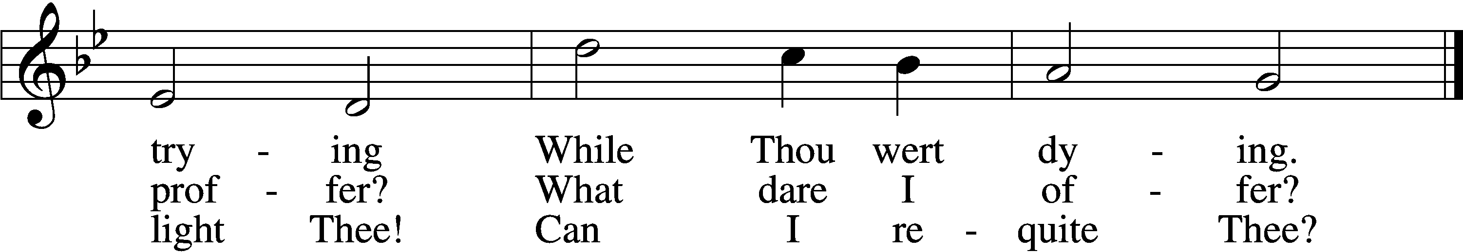
Text and tune: Public domain
N: So they took Jesus and led Him away. And He, bearing His cross, went out to a place called the Place of a Skull, which is called in Hebrew, Golgotha, where they crucified Him, and two others with Him, one on either side, and Jesus in the center. Now Pilate wrote a title and put it on the cross. And the writing was: Jesus of Nazareth, The King of the Jews. Then many of the Jews read this title, for the place where Jesus was crucified was near the city; and it was written in Hebrew, Greek, and Latin. Then the chief priests of the Jews said to Pilate,
C: “Do not write, ‘The King of the Jews,’ but, ‘He said, “I am the King of the Jews.”’”
N: Pilate answered,
C: “What I have written, I have written.”

Chief Hymn: LSB #439 “O Dearest Jesus, What Law Hast Thou Broken” stanzas 10-11
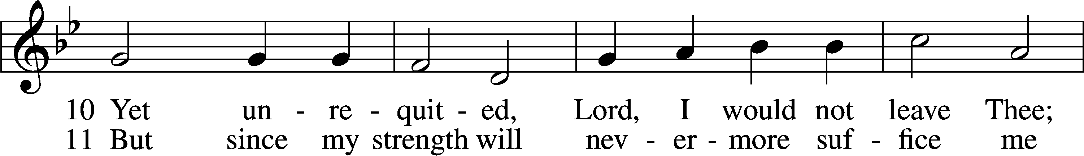
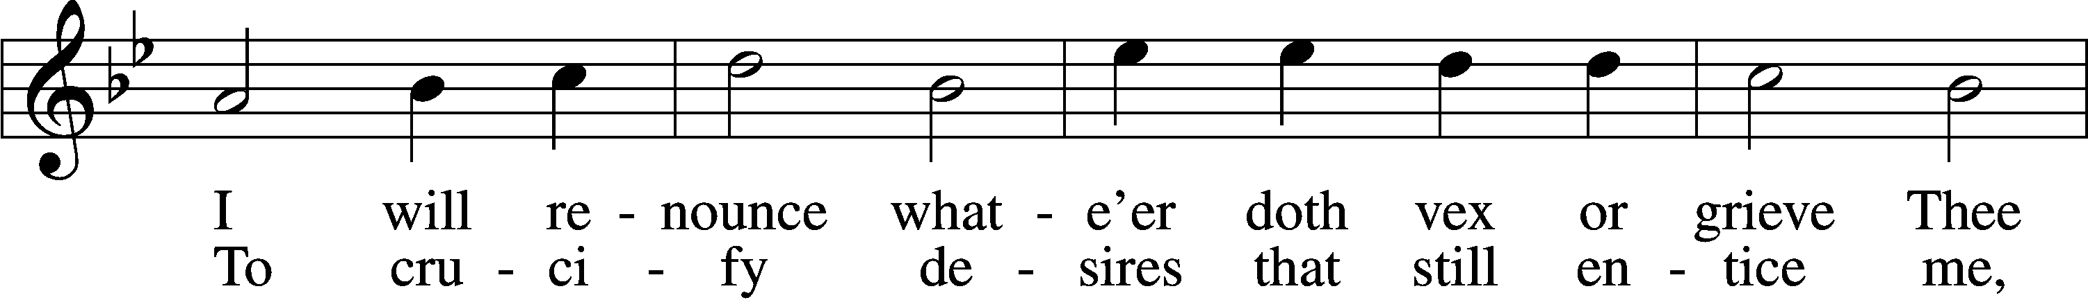
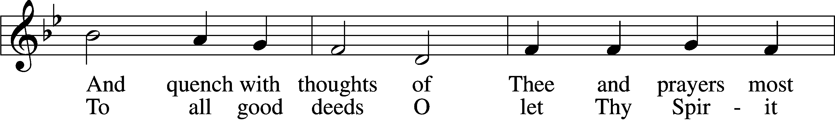
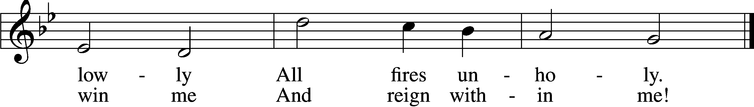
Text and tune: Public domain

N: Then the soldiers, when they had crucified Jesus, took His garments and made four parts, to each soldier a part, and also the tunic. Now the tunic was without seam, woven from the top in one piece. They said therefore among themselves,
C: “Let us not tear it, but cast lots for it, whose it shall be,”
N: that the Scripture might be fulfilled which says: “They divided My garments among them, and for My clothing they cast lots.” Therefore the soldiers did these things.

Chief Hymn: LSB #439 “O Dearest Jesus, What Law Hast Thou Broken” stanzas 12-13
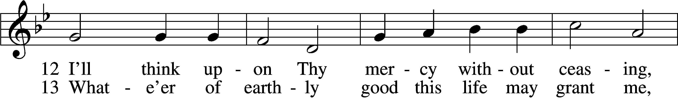
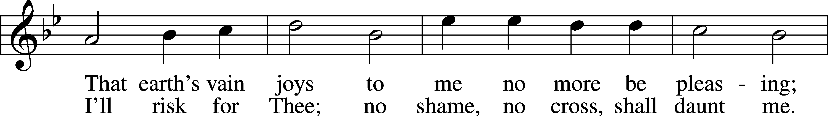
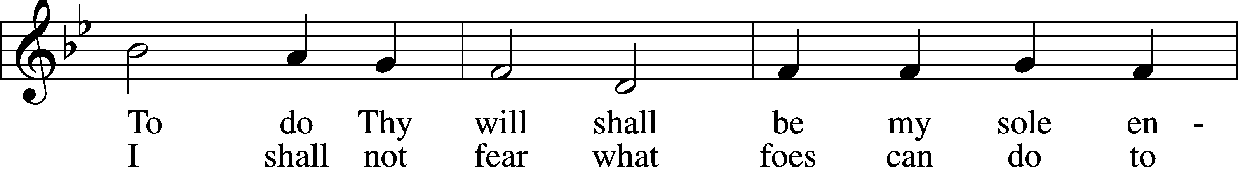
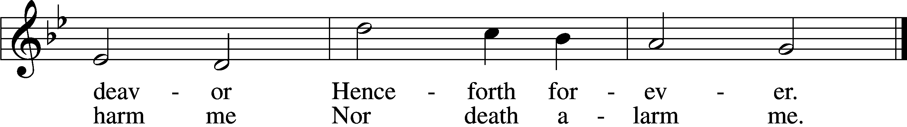
Text and tune: Public domain

N: Now there stood by the cross of Jesus His mother, and His mother’s sister, Mary the wife of Clopas, and Mary Magdalene. When Jesus therefore saw His mother, and the disciple whom He loved standing by, He said to His mother,
T: “Woman, behold your son!”
N: Then He said to the disciple,
T: “Behold your mother!”
N: And from that hour that disciple took her to his own home. After this, Jesus, knowing that all things were now accomplished, that the Scripture might be fulfilled, said,
T: “I thirst!”
N: Now a vessel full of sour wine was sitting there; and they filled a sponge with sour wine, put it on hyssop, and put it to His mouth. So when Jesus had received the sour wine, He said,
T: “It is finished!”
N: And bowing His head, He gave up His spirit.

Stand. Please silently pray the “Lord’s Prayer”.

N: Therefore, because it was the Preparation Day, the bodies should not remain on the cross on the Sabbath (for that Sabbath was a high day), the Jews asked Pilate that their legs might be broken, and that they might be taken away. Then the soldiers came and broke the legs of the first and of the other who was crucified with Him. But when they came to Jesus and saw that He was already dead, they did not break His legs. But one of the soldiers pierced His side with a spear, and immediately blood and water came out. And he who has seen has testified, and his testimony is true; and he knows that he is telling the truth, so that you may believe. For these things were done that the Scripture should be fulfilled, “Not one of His bones shall be broken.” And again another Scripture says, “They shall look on Him whom they pierced.” After this, Joseph of Arimathea, being a disciple of Jesus, but secretly, for fear of the Jews, asked Pilate that he might take away the body of Jesus; and Pilate gave him permission. So he came and took the body of Jesus. And Nicodemus, who at first came to Jesus by night, also came, bringing a mixture of myrrh and aloes, about a hundred pounds. Then they took the body of Jesus, and bound it in strips of linen with the spices, as the custom of the Jews is to bury. Now in the place where He was crucified there was a garden, and in the garden a new tomb in which no one had yet been laid. So there they laid Jesus, because of the Jews’ Preparation Day, for the tomb was nearby.

Chief Hymn: LSB #439 “O Dearest Jesus, What Law Hast Thou Broken” stanzas 14-15
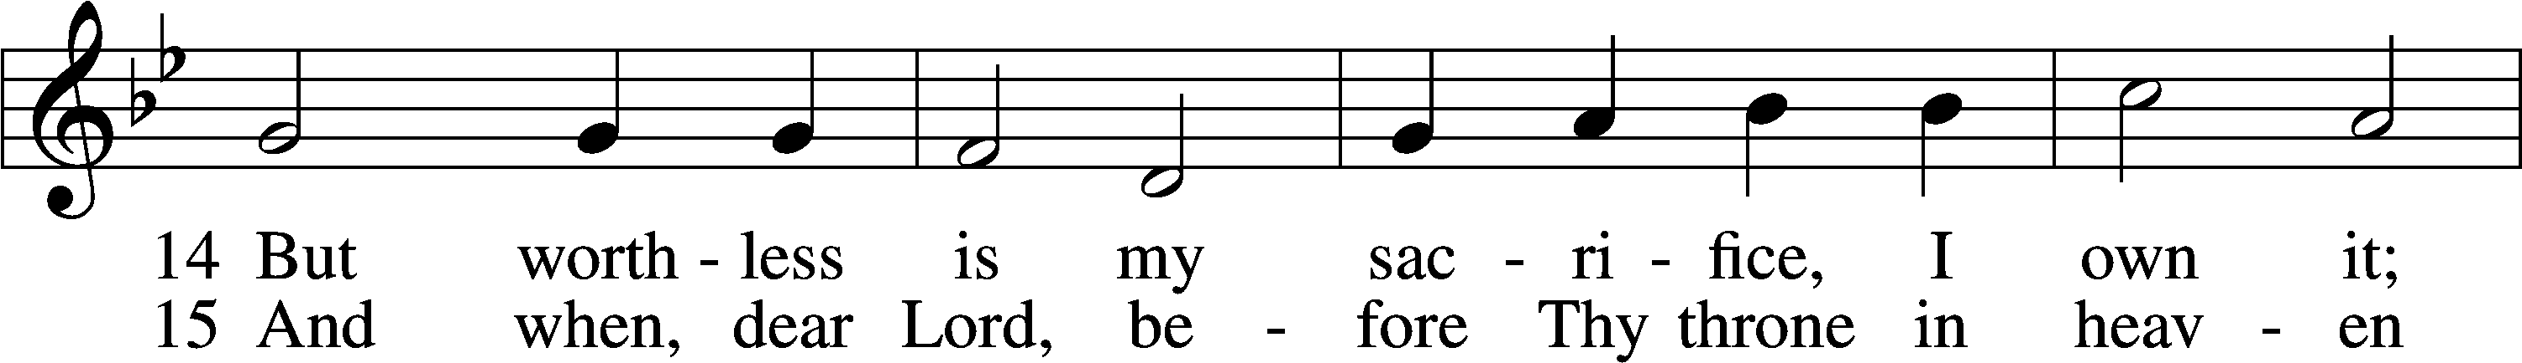
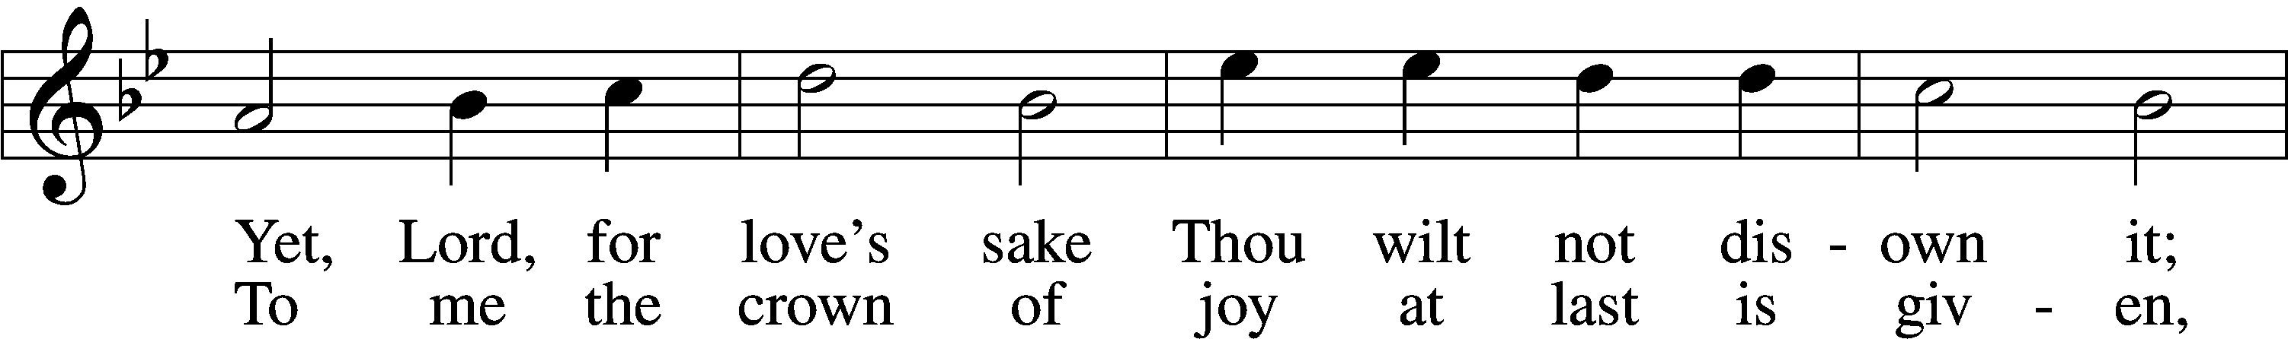
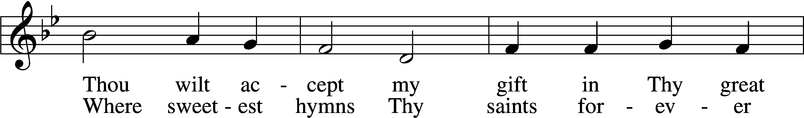
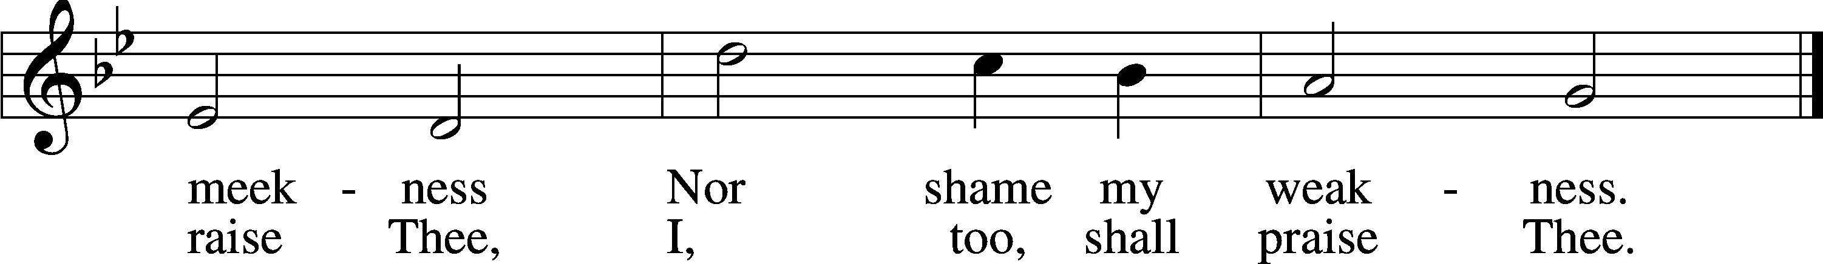
Text and tune: Public domain

Sit.

Sermon (Without introduction or conclusion)

Stand.

Bidding Prayer
For each intention, the bid is read, and a pause follows the words “Let us pray” for the People to offer their silent prayers before the Collect is sung. The “Amen” following each collect is sung on a single note.

For the Holy Church of God
A Let us pray, dearly beloved, for the Holy Church of God, that our Lord God would be pleased to give her peace in all the world, and to keep her in safety: making all the powers of evil subject to her: and that He would grant us, who live a quiet and tranquil life, to glorify God the Father Almighty.

P Let us pray.
Almighty and everlasting God, who hast revealed Thy glory to all nations in Jesus Christ and in the Word of His truth, keep, we beseech Thee, in safety the works of Thy mercy that Thy Church, spread throughout all nations, may serve Thee in true faith and persevere in the confession of Thy name, through the same Jesus Christ, Our Lord, who liveth and reigneth with Thee and the Holy Ghost, ever one God, world without end.
C Amen.

For all estates of the Church
A Let us pray for all bishops, priests, and deacons, for all other orders of clergy, and for all the holy people of God.

P Let us pray.
Almighty and everlasting God, by whose Spirit the whole body of the Church is sanctified and governed: Hear our supplications which we offer for all orders, that by the gift of Thy grace every estate may faithfully serve Thee, through Jesus Christ, Our Lord, who liveth and reigneth with Thee and the Holy Ghost, ever one God, world without end.
C Amen.
For the government

A Let us pray also for all in authority, and especially for the Government of the United States, that we may live a quiet and peaceable life in all godliness and honesty.

P Let us pray.
Almighty and everlasting God, in whose hand are the powers of all people and the laws of all nations; mercifully regard the President of the United States, the Governor of this State, our judges and magistrates, and all the rulers of the earth, that all who receive the sword may bear it according to Thy commandment, through Jesus Christ, Our Lord, who liveth and reigneth with Thee and the Holy Ghost, ever one God, world without end.
C Amen.

For catechumens

A Let us pray also for our catechumens, that our God and Lord would open the ears of their hearts, and the door of his mercy, that having received the remission of all their sins by the washing of regeneration, they may be found worthy and steadfast in Christ Jesus our Lord.

P Let us pray.
Almighty and everlasting God, who dost always multiply Thy Church: grant unto our catechumens increase both of faith and knowledge, that being renewed in the font of baptism they may be gathered into Thy Son by the adoption of grace, through the same Jesus Christ, Our Lord, who liveth and reigneth with Thee and the Holy Ghost, ever one God, world without end.
C Amen.

For those in tribulation

A Let us pray to our most beloved God, the almighty Father, that He would deliver the world from all error, take away disease, ward off famine, open the prisons, set free those in bondage, grant a safe return to the wayfarers, health to the sick, and to all mariners a harbor of security.

P Let us pray.
Almighty and everlasting God, the Consolation of the sorrowful and the Strength of the weak, may the prayers of them that in any tribulation or distress cry unto Thee graciously come before Thee, so that in all their necessities they may mark and receive Thy manifold help and comfort; through Jesus Christ, Our Lord, who liveth and reigneth with Thee and the Holy Ghost, ever one God, world without end.

C Amen.

For heretics

A Let us pray also for all heretics and schismatics, that our God and Lord may be pleased to deliver them from all their errors, and call them back to the holy Christian and apostolic Church.

P Let us pray.
Almighty and everlasting God, who savest all, and wilt that none should perish: regard the souls deceived by devilish guile: that having set aside all heretical evil, the hearts of those who err may repent, and return to the unity of Thy truth; through Jesus Christ, Our Lord, who liveth and reigneth with Thee and the Holy Ghost, ever one God, world without end.
C Amen.

For the Jews

A Let us pray also for the ancient people of God, that our God and Lord may withdraw the veil from their hearts that they may acknowledge our Lord Jesus Christ.

P Let us pray.
Almighty and everlasting God, who desirest all people to be saved and come to the knowledge of the truth: hear our prayers which we offer unto Thee for those whose hearts and blinded: that, acknowledging the Light of Thy truth, which is Christ, they may be delivered from their darkness; through the same Jesus Christ, Our Lord, who liveth and reigneth with Thee and the Holy Ghost, ever one God, world without end.
C Amen.

For all unbelievers

A Let us pray also for the unbelievers, that God Almighty would take away the iniquity of their hearts, that, quitting their idols, they may be converted to the true and living God, and His only Son, Jesus Christ, our God and Lord.

P Let us pray.
Almighty and everlasting God, who desirest not the death of sinners, but ever seekest life: mercifully receive our prayer, and free them from the worship of idols, and gather them into Thy Holy Church, to the glory of Thy Name, through Jesus Christ, Our Lord, who liveth and reigneth with Thee and the Holy Ghost, ever one God, world without end.
C Amen.

For peace

A Let us pray for peace, that we may come to the knowledge of God’s holy Word and walk before Him as becometh Christians.

P Let us pray.
Almighty and everlasting God, King of Glory and Lord of heaven and earth, by whose Spirit all things are ordered, who art the God of peace and the Author of all concord, grant us, we beseech Thee, Thy heavenly peace and concord that we may serve Thee in true fear, to the praise and glory of Thy name; through Jesus Christ, Our Lord, who liveth and reigneth with Thee and the Holy Ghost, ever one God, world without end.
C Amen.

The Celebrant goes to the narthex, removes his shoes and takes up the cross.

Solemn Respect for the Holy Cross
Behold the life-giving Cross on which was hung the salvation of the world.
Oh come, let us worship Him.

Then the Reproaches are chanted or said as follows.

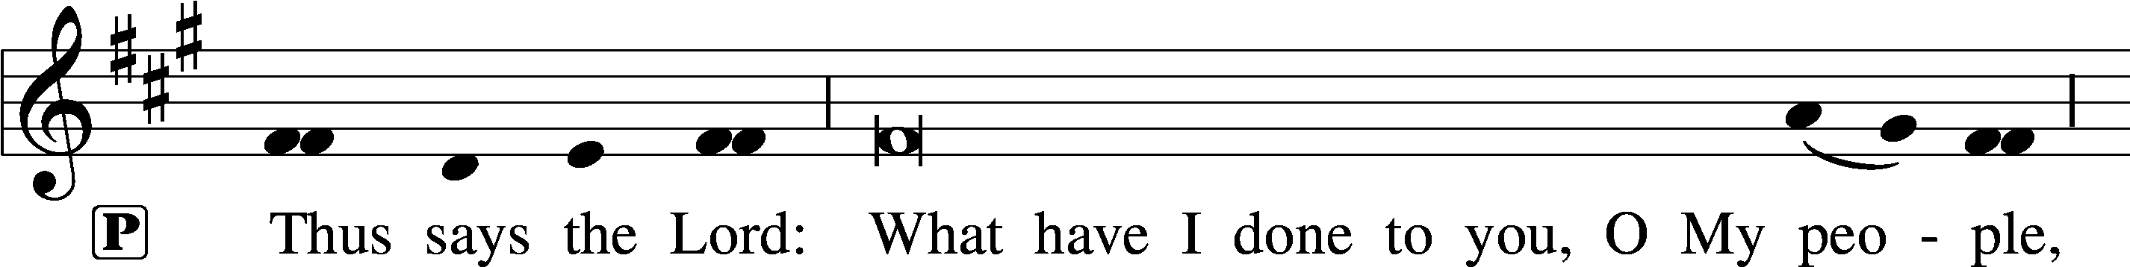
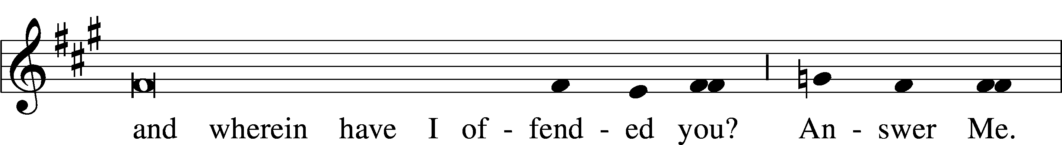
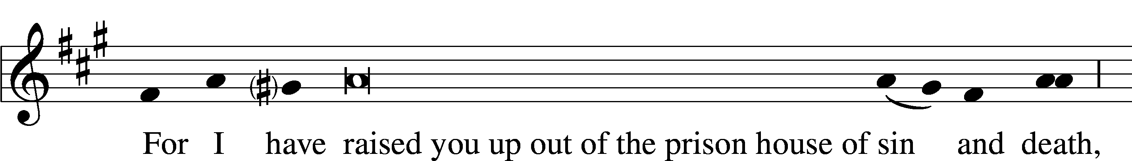
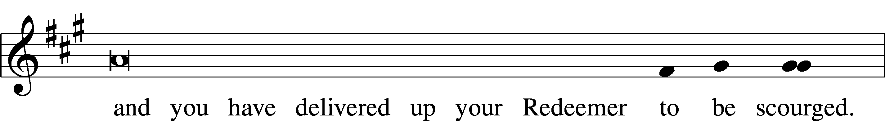
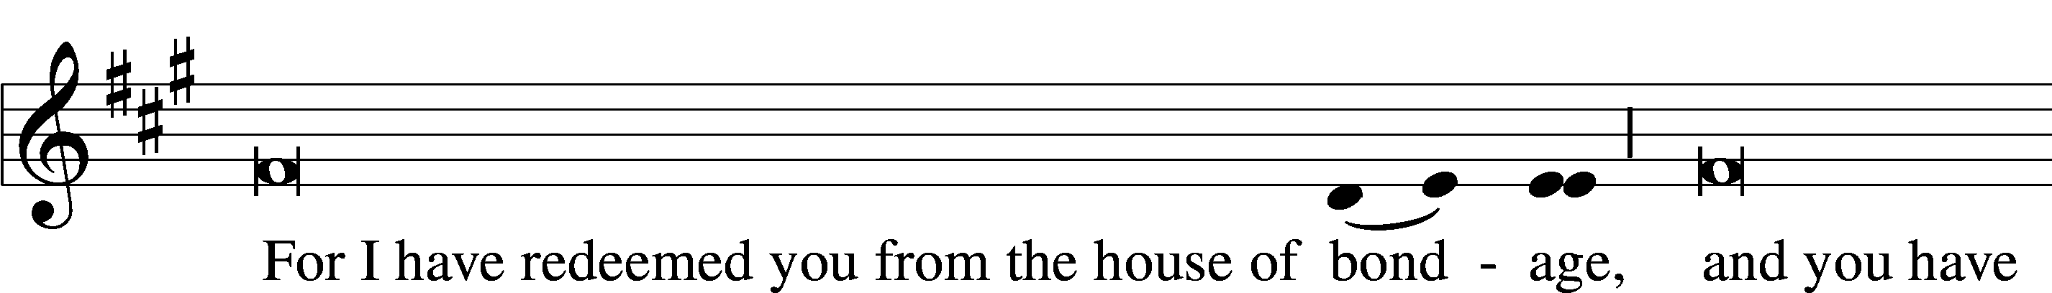
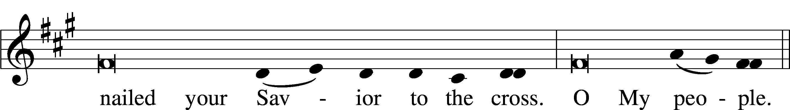
L
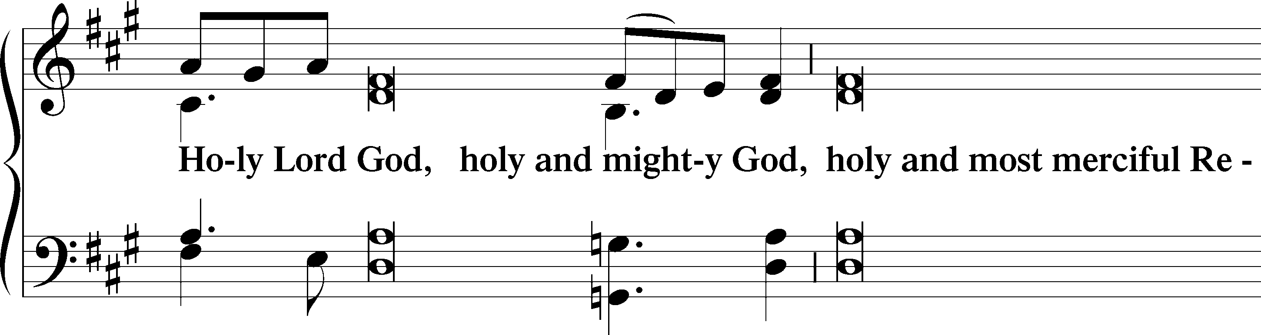
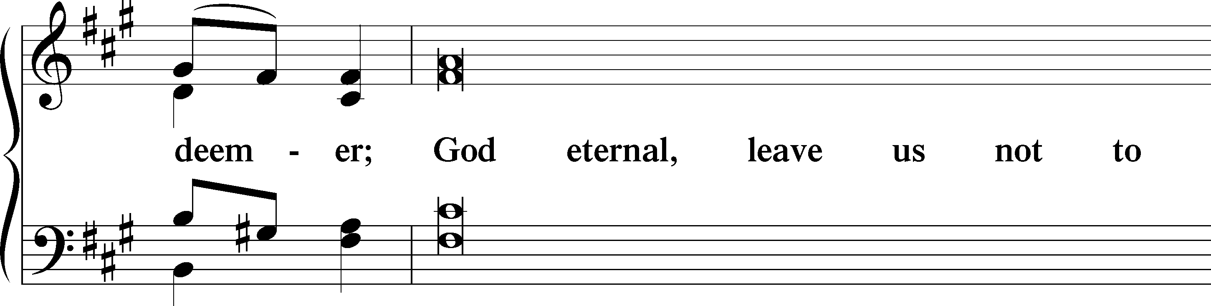
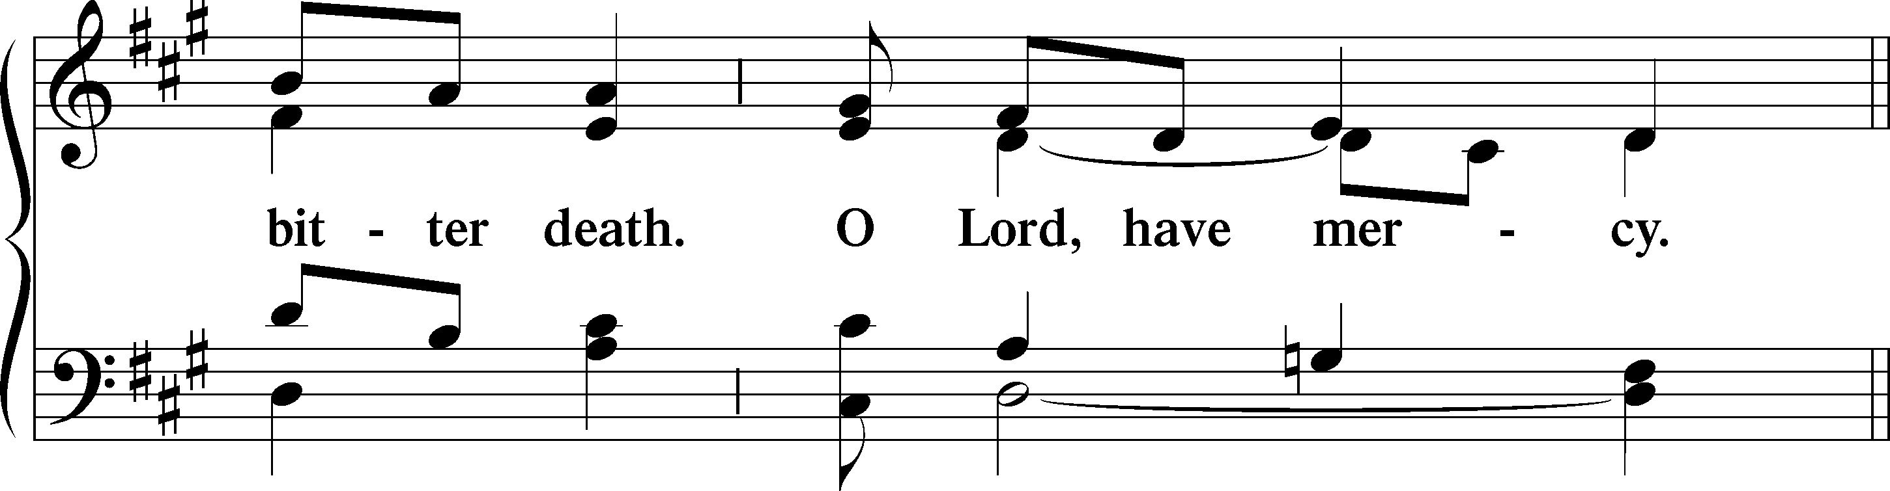

C Lamb of God, pure and holy,
Who on the cross didst suffer,
Ever patient and lowly,
Thyself to scorn didst offer.
All sins Thou borest for us,
Else had despair reigned o’er us:
Have mercy on us, O Jesus! O Jesus!
Text: tr. The Lutheran Hymnal, 1941; Nicolaus Decius, c. 1485–after 1546
Text: Public domain

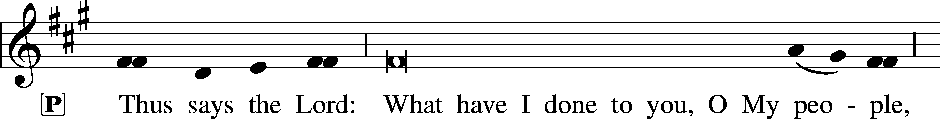
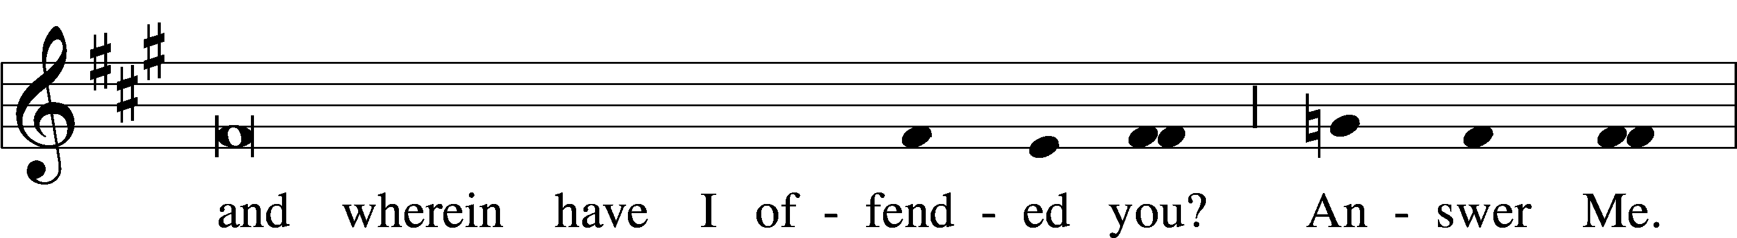
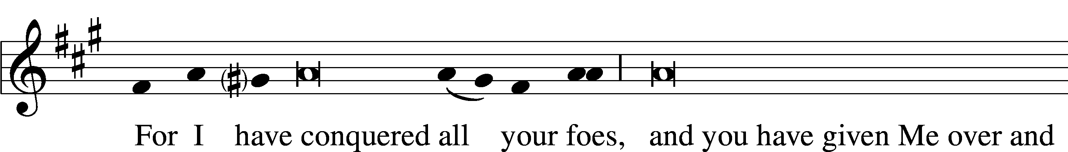
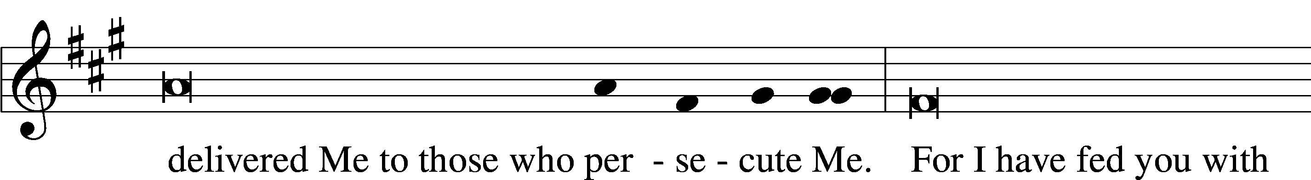
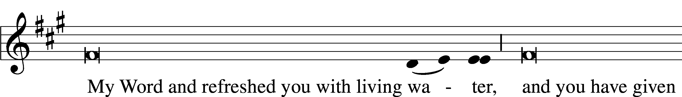
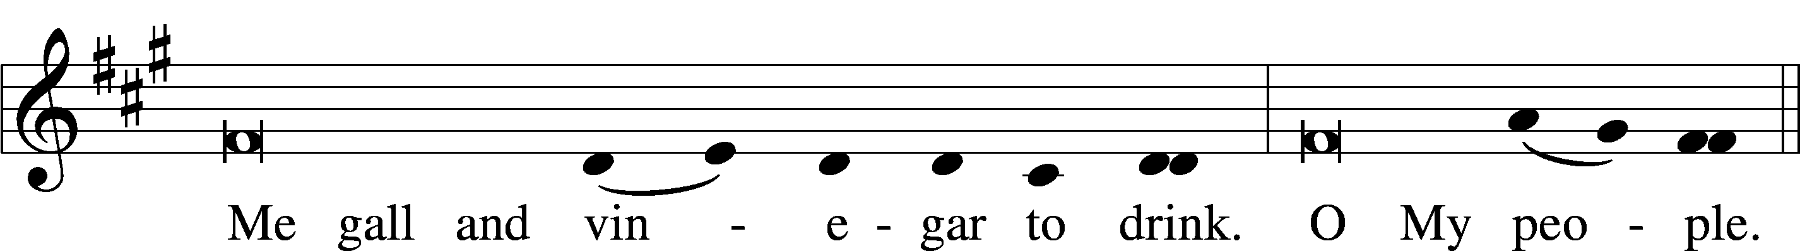
L
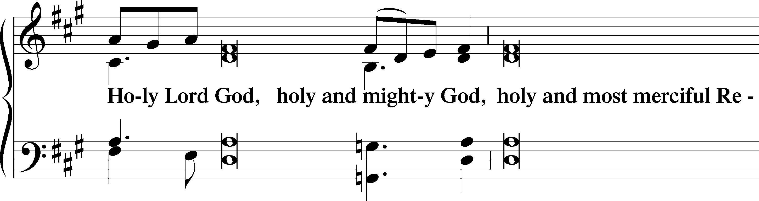
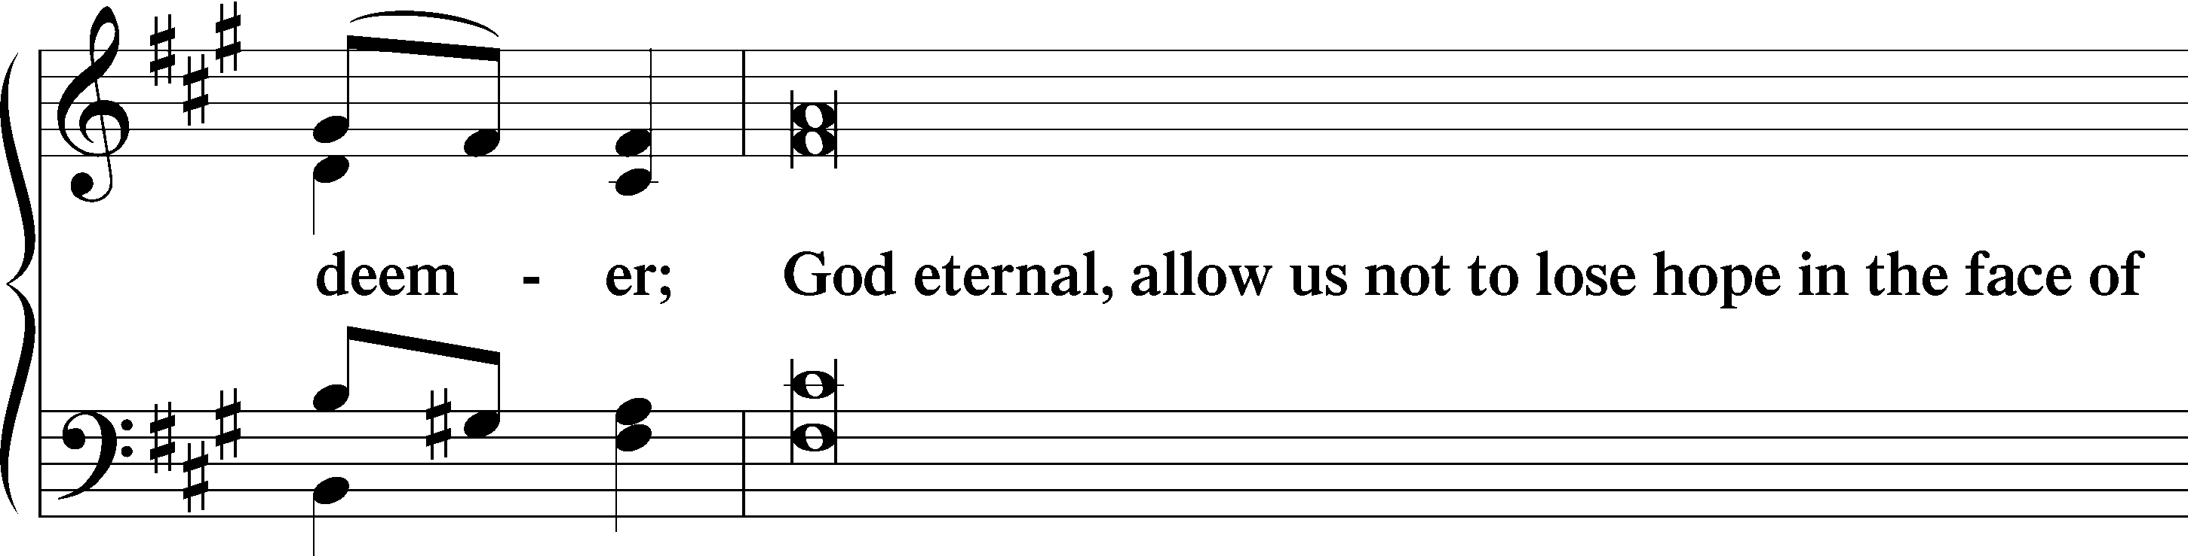
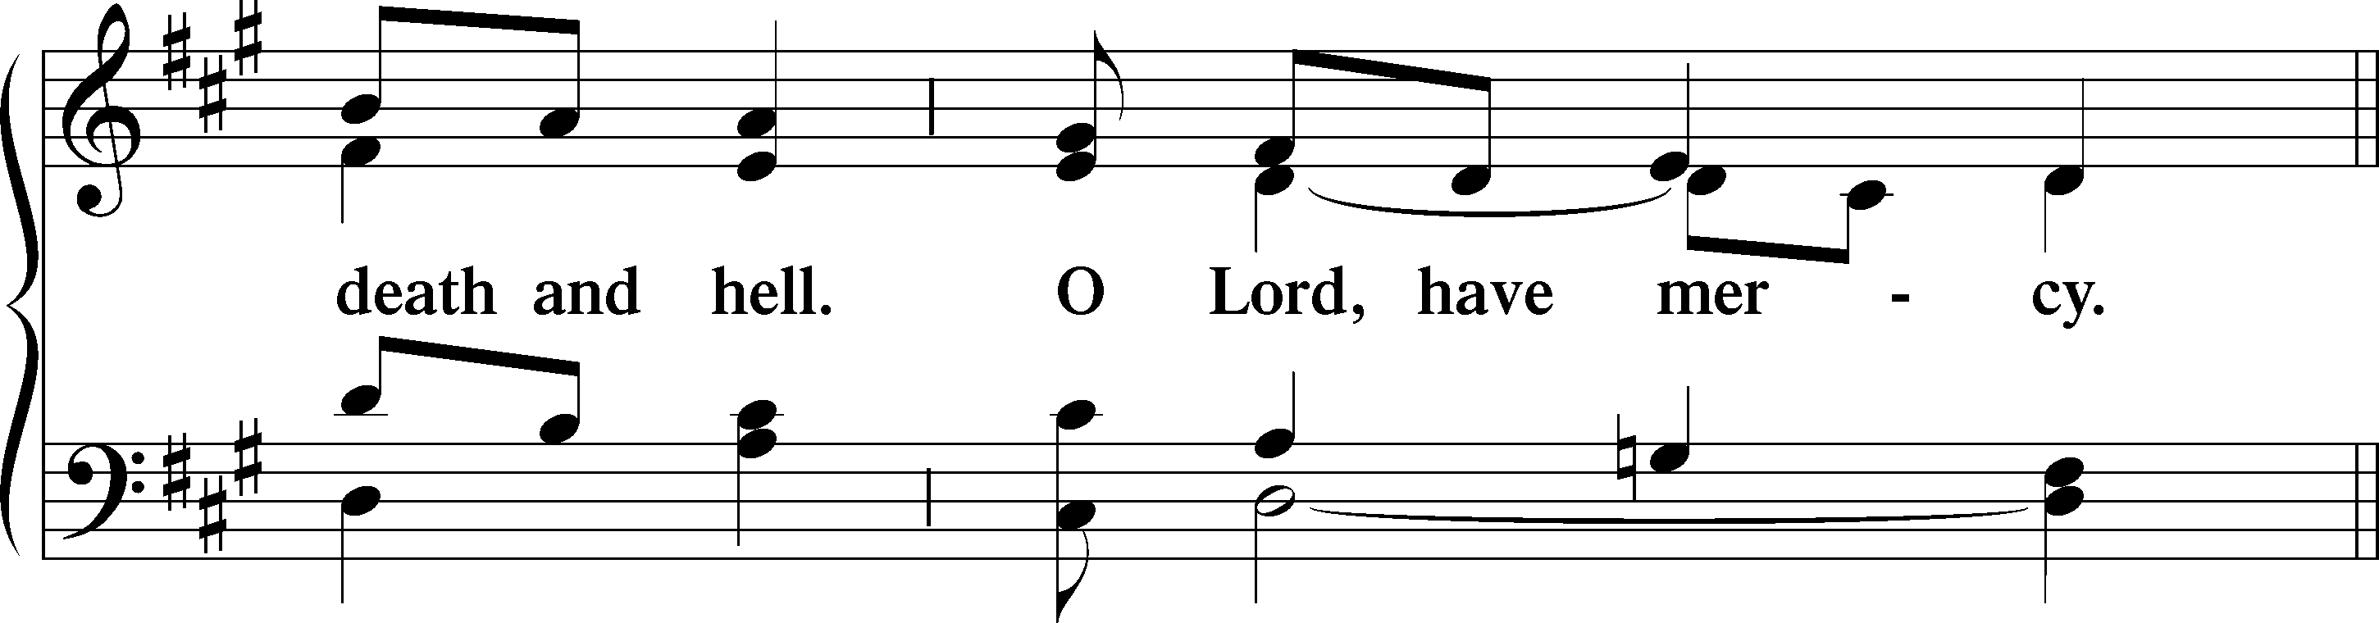
C Lamb of God, pure and holy,
Who on the cross didst suffer,
Ever patient and lowly,
Thyself to scorn didst offer.
All sins Thou borest for us,
Else had despair reigned o’er us:
Have mercy on us, O Jesus! O Jesus!
Text: tr. The Lutheran Hymnal, 1941; Nicolaus Decius, c. 1485–after 1546
Text: Public domain

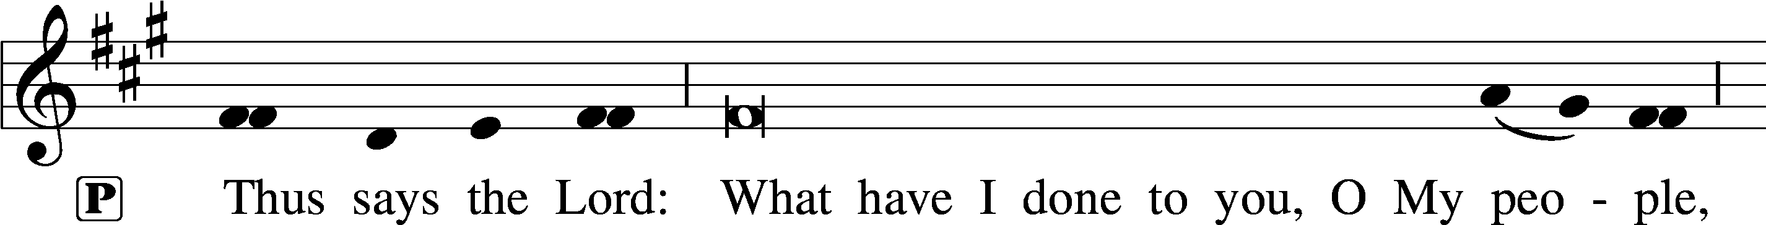
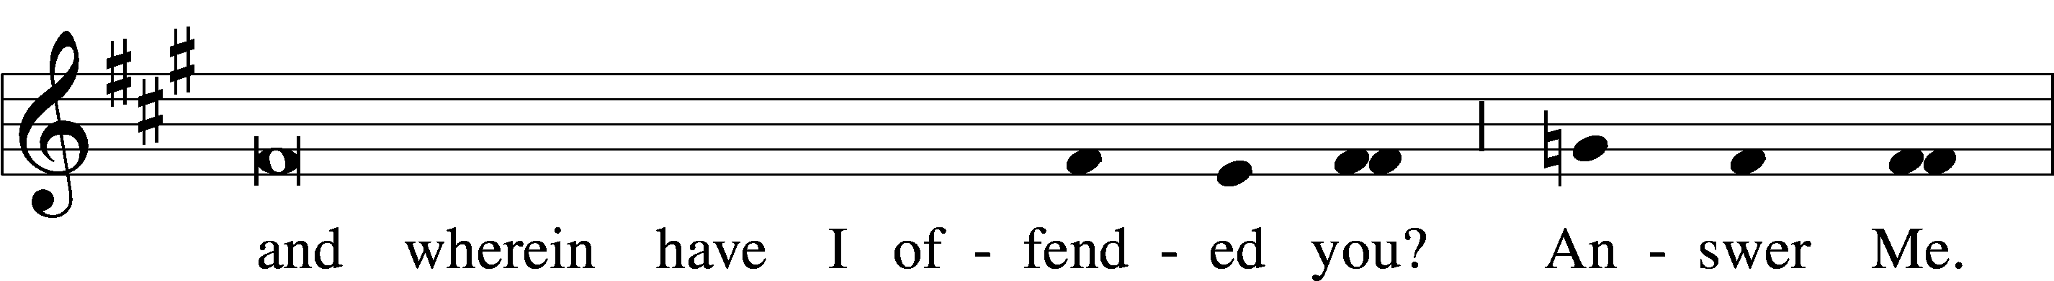
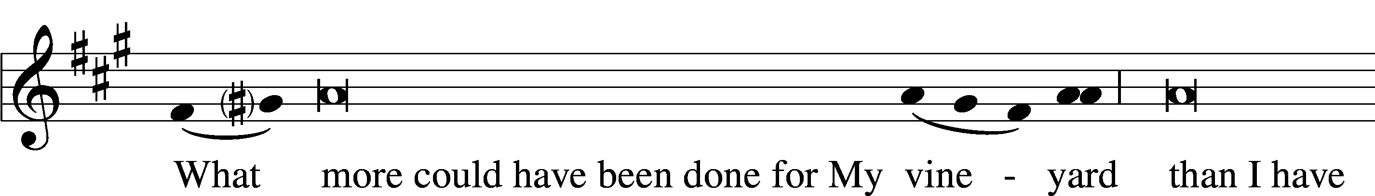
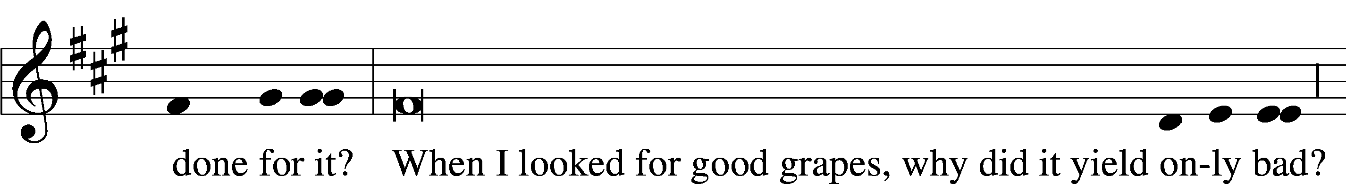
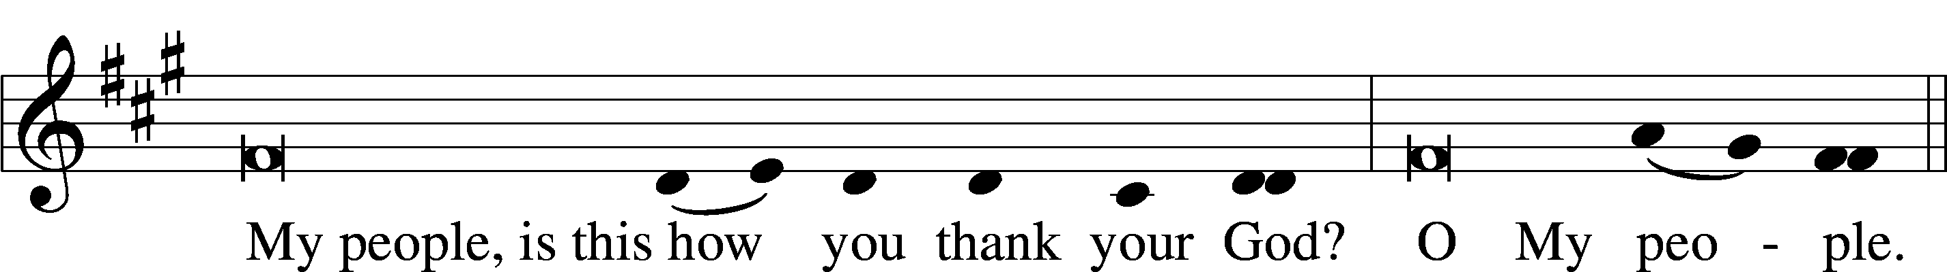
L
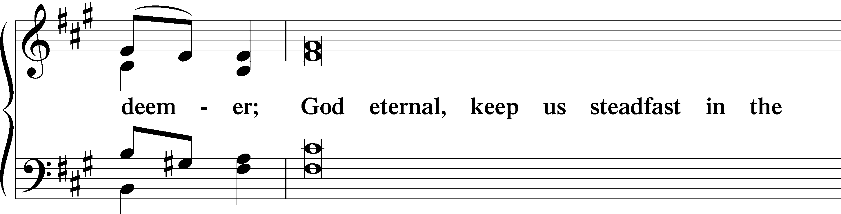
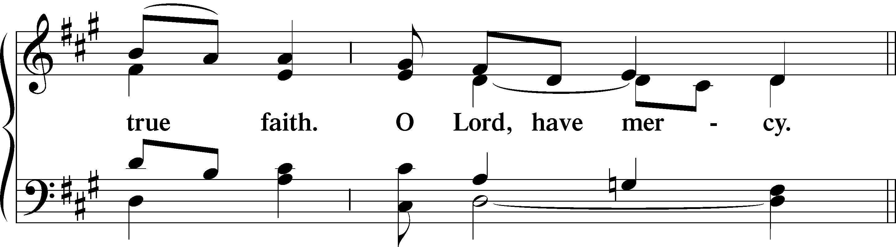
C Lamb of God, pure and holy,
Who on the cross didst suffer,
Ever patient and lowly,
Thyself to scorn didst offer.
All sins Thou borest for us,
Else had despair reigned o’er us:
Thy peace be with us, O Jesus! O Jesus!

We adore Thy cross, O Lord, and we praise and glorify Thy holy resurrection:
For by virtue of the cross, joy hath come to the whole world.
God be merciful unto us and bless us:
And show us the light of His countenance, and be merciful unto us.
We adore Thy cross, O Lord, and we praise and glorify Thy holy resurrection:
For by virtue of the cross, joy hath come to the whole world.

The following antiphon and response are sung three times as the cross is unveiled, each time at a higher pitch.
P Behold, the wood of the cross on which hung the Salvation of the world.
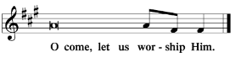
P Behold, the wood of the cross on which hung the Salvation of the world.
P Behold, the wood of the cross on which hung the Salvation of the world.

Sit.

On this day of our redemption, we greet the cross, unveiled once again, with reverence and joy. We do not adore the cross itself, but rather Christ the Crucified.

The Celebrant reverences the Cross, during which the People sing the hymn on p. 31.

P O Lord Jesus Christ, very God of very God, who for the redemption of mankind, deceived by the serpent’s persuasion, didst will to enlighten a world entangled in errors and to bear the beam of the Cross, that Thou mightiest conquer by the wood of the Tree, and by Thy most powerful death overcome the death of original sin: hear me, a poor and unworthy man prostrated before the sight of Thy most worthy Majesty and adoring Thee, and blessing Thy holy and terrible name: and grant me with a pure heart to know Thee, to praise Thee, to proclaim Thee: and by the banner of that holy Cross which I have come to adore in Thy name this day do Thou sanctify my mind and body; encompass me round about with the shield of Thy faith, put upon me the helmet of salvation, and gird upon my thigh the sword of the Spirit, that as I go forth to fight against the most wicked enemy, both I may be defended by the help of Thy mercy and the banner of the salutary Cross, and all who are marked by Thy holy name may be safe from the attack of the treacherous enemy. Through Thee, O Jesus Christ, who livest and reignest with the Father and the Holy Ghost, ever one God, world without end. Amen.

P O God, who on the way in the harsh wilderness badest Thy servant Moses lift up a brazen serpent in the midst of the multitude of the people to deliver the infected souls from the vital venom, that if any man afflicted with a mortal wound should look thereon, he should escape the deadly poison, therein signifying Thyself, who after long passage of time wouldst be lifted up on the beam of the Cross for the salvation of Thy creation: that Thy desirable Passion might call again to their native country those whom the devil had by force of arms enviously captured: grant to me, a miserable sinner, that we all, purchased by Thy blood, who this day do humbly venerate Thy Passion, may by Thy help overcome the plots of the devil and be worthy to be partakers of eternal life. Who livest and reignest with the Father and the Holy Ghost, ever one God, world without end. Amen.

P O Lord Jesus Christ, who by the Mystery of Thy Cross and Passion didst free us this day from bondage to the devil, that on the same day that Thou didst make man Thou mightest also reform him: give ear to me, a poor sinner, worshiping and imploring Thee before this token of the Cross, that secured by the protection of this venerable and life-giving wood, I may be worthy to repel the fiery darts of the most vile enemy, and escaping all wounds inflicted, to attain to life everlasting. Amen.

The Celebrant dons his chasuble and puts on again his shoes.

Hymn: “Sing My Tongue, the Glorious Battle” (sung to the following tune)
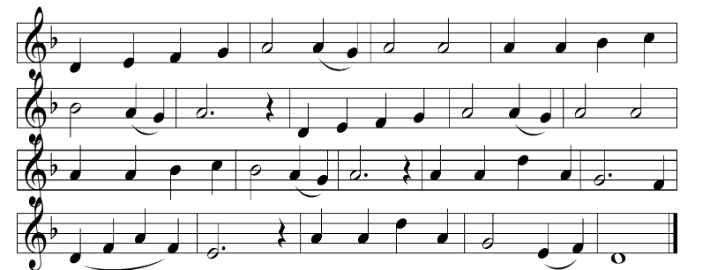

A Faithful cross above all other,
One and only noble tree!
None in foliage, none in blossom,
None in fruit thy peer may be!
Sweetest wood and sweetest iron,
Sweetest weight is hung on thee!

C Sing my tongue the glorious battle,
Sing the last, the dread affray!
O’er the cross, the victor’s trophy,
Sound the high triumphal lay,
How, the pains of death enduring,
Earth’s Redeemer won the day!

God in pity saw man fallen,
Shamed and sunk in misery,
When he fell on death by eating,
Fruit of the forbidden tree.
Then another Tree was chosen
Which the world from death should free.

Thus the scheme of our salvation
Was of old in order laid;
That the manifold deceiver’s
Art by art might be outweighed;
And the lure the foe put forward
Into means of healing made.

When at length th’ appointed fullness
Of the sacred time was come,
He was sent, the world’s Creator,
From the Father’s heav’nly home,
And was found in human fashion,
Offspring of the Virgin’s womb.

A Weeps the Infant in the manger
That in Bethl’hem’s stable stands;
And His limbs the Virgin Mother
Doth compose in swaddling bands,
Meetly thus in linen folding
Of her God the feet and hands.

C Thirty years among us dwelling,
His appointed time fulfilled.
Born for this, He meets His passion,
For that this He freely willed;
On the cross the Lamb is lifted
Where His life-blood shall be spilled.

On the Cross the offered victim
Of the sacred Body hangs—
Which the serpent sees, and straightly
Fails the venom of his fangs—
He with hissing neck is stricken
And succumbs to deadly pangs.
What now, foul, ungodly serpent,
With thy stratagem and wile
Hath it thee availed, old Adam,
First of mortals, to beguile?
God, this human frame assuming,
Wipes away what did defile.

A He endured the nails, the spitting,
Vinegar, and spear, and reed;
From that holy Body broken
Blood and water forth proceed;
Earth, and stars, and sky, and ocean,
By that flood from stain are freed.

C Bend thy boughs, O Tree of glory
Thy relaxing sinews bend;
For a while the ancient rigor
That thy birth bestowed, suspend;
And the King of heav’nly beauty
On thy bosom gently tend!

Thou alone wast counted worthy
This world’s ransom to uphold;
For a shipwrecked race preparing
Harbor, like the Ark of old;
With the sacred Blood anointed
From the smitten Lamb that rolled.

Stand.
Glory to th’eternal Father
Who made all things, God alone
With the Son, His Sole-begotten,
Who hath man’s salvation won,
And the Holy Spirit, ever
While eternal ages run.
A Faithful cross above all other,
One and only noble tree!
None in foliage, none in blossom,
None in fruit thy peer may be!
Sweetest wood and sweetest iron,
Sweetest weight is hung on thee!

As the hymn is sung, the altar is made ready for the return of the Holy Sacrament.

After the hymn concludes, the following antiphon is spoken, the same that was spoken as the Sacrament was carried away yesterday evening.

Antiphon
This is the Body which shall be delivered for you;
This is the cup of the new testament in My Blood, saith the Lord.
This do ye, as oft as ye drink it,
In remembrance of Me.

Our Father
P Let us pray. Commanded by Christ’s saving precepts and informed by His divine instruction, we are bold to say:
Our Father, who art in heaven, hallowed be Thy name, Thy kingdom come, Thy will be done on earth as it is in heaven; give us this day our daily bread; and forgive us our trespasses as we forgive those who trespass against us; and lead us not into temptation, but deliver T us from evil. For Thine is the kingdom and the power and the glory forever and ever. Amen.

Deliver us, O Lord, we beseech Thee, from every evil past, present, and to come: graciously grant peace in our days, that assisted by the aid of Thy mercy, we may ever be free from sin and safe from all affliction, through Jesus Christ, Thy Son, Our Lord, who liveth and reigneth with Thee and the Holy Ghost, ever one God, world without end.

Words of Institution
P Our Lord Jesus Christ, on the night when He was betrayed, took bread, and when He had given thanks, He broke it and gave it to the disciples and said: “Take, eat; this is My T body, which is given for you. This do in remembrance of Me.”

In the same way also He took the cup after supper, and when He had given thanks, He gave it to them, saying: “Drink of it, all of you; this cup is the new testament in My T blood, which is shed for you for the forgiveness of sins. This do, as often as you drink it, in remembrance of Me.”

The Pax Domini and Agnus Dei are not said, and the Communicants come forward to the rail after the Celebrant has communed.

VESPERS
The service concludes with a truncated form of Vespers.
Remain seated.
Psalm 142
My enemy | hath filled*
And made me drunk with | bitterness.
I cried unto the Lord with | my voice;*
With my voice unto the Lord did I make my suppli- | cation.
I poured out my complaint be- | fore Him;*
I showed before Him my | trouble.
When my spirit was overwhelmed with- | in me,
Then Thou knew- | est my path.
In the way where- | in I walked*
Have they privily laid a | snare for me.
I looked on my right hand, and beheld, but there was no man that would | know me:*
Refuge failed me; no man cared | for my soul.
I cried unto Thee, | O Lord:*
I said, Thou art my refuge and my portion in the land of the | living.
Attend unto my cry; for I am brought | very low:*
Deliver me from my persecutors; for they are strong- | er than I.
Bring my soul out of prison, that I may | praise Thy name:*
The righteous shall compass me about; for Thou shalt deal bountifully |
with me.
My enemy | hath filled*
And made me drunk with | bitterness.
Stand.
Magnificat Antiphon
P When Jesus had received the vinegar, He said: It is finished:
And He bowed His head, and gave up the ghost.

Magnificat
Magnificat Antiphon
P When Jesus had received the vinegar, He said: It is finished:
And He bowed His head, and gave up the ghost.

Verse
P Christ became obedient unto death:
C Even the death of the cross.

Our Father
Our Father, who art in heaven, hallowed be Thy name, Thy kingdom come, Thy will be done on earth as it is in heaven; give us this day our daily bread; and forgive us our trespasses as we forgive those who trespass against us; and lead us not into temptation, but deliver T us from evil. For Thine is the kingdom and the power and the glory forever and ever. Amen.
Sit.

Psalm 51
Have mercy upon me, O God, according to Thy loving | kindness:
According unto the multitude of Thy tender mercies blot out my
trans-| gressions.
Wash me thoroughly from mine in-| iquity,*
and cleanse me | from my sin.
For I acknowledge my trans-| gressions:*
and my sin is ever be-| fore me.
Against Thee, Thee only, have I sinned, and done this evil | in Thy sight:*
that Thou mightest be justified when Thou speakest, and be clear
when Thou | judgest.
Behold, I was shapen in in-| iquity;*
and in sin did my mother con-| ceive me.
Behold, Thou desirest truth in the | inward parts:*
and in the hidden part Thou shalt make me to know | wisdom.
Purge me with hyssop, and I | shall be clean:*
wash me, and I shall be whit-| er than snow.
Make me to hear joy and | gladness;*
that the bones which Thou hast broken | may rejoice.
Hide Thy face | from my sins,*
and blot out all mine in-| iquities.
Create in me a clean | heart, O God;*
and renew a right spirit with-| in me.
Cast me not away from Thy | presence;*
and take not Thy Holy Spirit | from me.
Restore unto me the joy of Thy sal-| vation;*
and uphold me with Thy free | spirit.
Then will I teach transgress-| ors Thy ways;*
And sinners shall be converted | unto Thee.
Deliver me from blood guiltiness, O God, Thou God of my sal-| vation:*
And my tongue shall sing aloud of Thy | righteousness.
O Lord, open | Thou my lips;*
And my mouth shall show | forth Thy praise.
For Thou desirest not sacrifice; else would I | give it:*
Thou delightest not in burnt | offering.
The sacrifices of God are a broken | spirit:*
a broken and a contrite heart, O God, Thou wilt | not despise.
Do good in Thy good pleasure unto | Zion:*
build Thou the walls of Je-| rusalem.
Then shalt Thou be pleased with the sacrifices of righteousness, with burnt
offering and whole burnt | offering:*
then shall they offer bullocks upon Thine | altar.
Have mercy upon me, O God, according to Thy loving | kindness:*
According unto the multitude of Thy tender mercies blot out my
trans-| gressions.

Verse
P Christ became obedient unto death:
C Even the death of the cross.

Stand.
Collect
P Almighty God, we beseech Thee graciously to behold this Thy family, for which our Lord Jesus Christ was contented to be betrayed and given up into the hands of wicked men and to suffer death upon the cross; through the same Jesus Christ, Thy Son, our Lord; who liveth and reigneth with Thee and the Holy Ghost, ever one God, world without end.
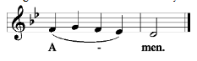

DEPOSITION OF THE CROSS
While the below responsories are spoken, the crucifix is removed from the altar and carried out of the chancel.

Responsory
He was brought as a lamb to the slaughter:
He was oppressed and He was afflicted, yet He openeth not His mouth.
He was delivered up to death:
That He might quicken His people.
His place was made in peace
And His habitation in Zion.
He was delivered up to death.

Responsory
Behold how the Righteous perisheth, and no man layeth it to heart: and merciful men are taken away, none considering that the Righteous is taken away from the evil to come.
And His memory shall be in peace.
His place was made in peace
And His habitation in Zion.
And His memory shall be in peace.

After the Crucifix is laid to rest, having been wrapped in a white cloth, as the Body of Christ was wrapped in linen before burial, the following responsory is spoken.

Responsory
The Lord being buried, they sealed the sepulcher,
Rolling a stone unto the door of the sepulcher.
They set soldiers to watch Him.
Lest His disciples come and steal Him away,
And say unto the people, He is risen from the dead.
They set soldiers to watch Him.

Closing Hymn: LSB #448 “O Darkest Woe”
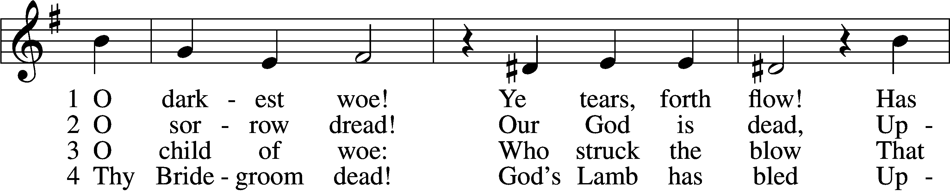
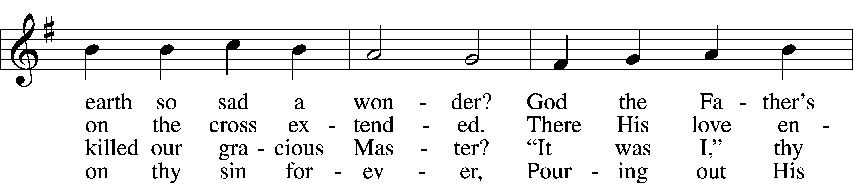
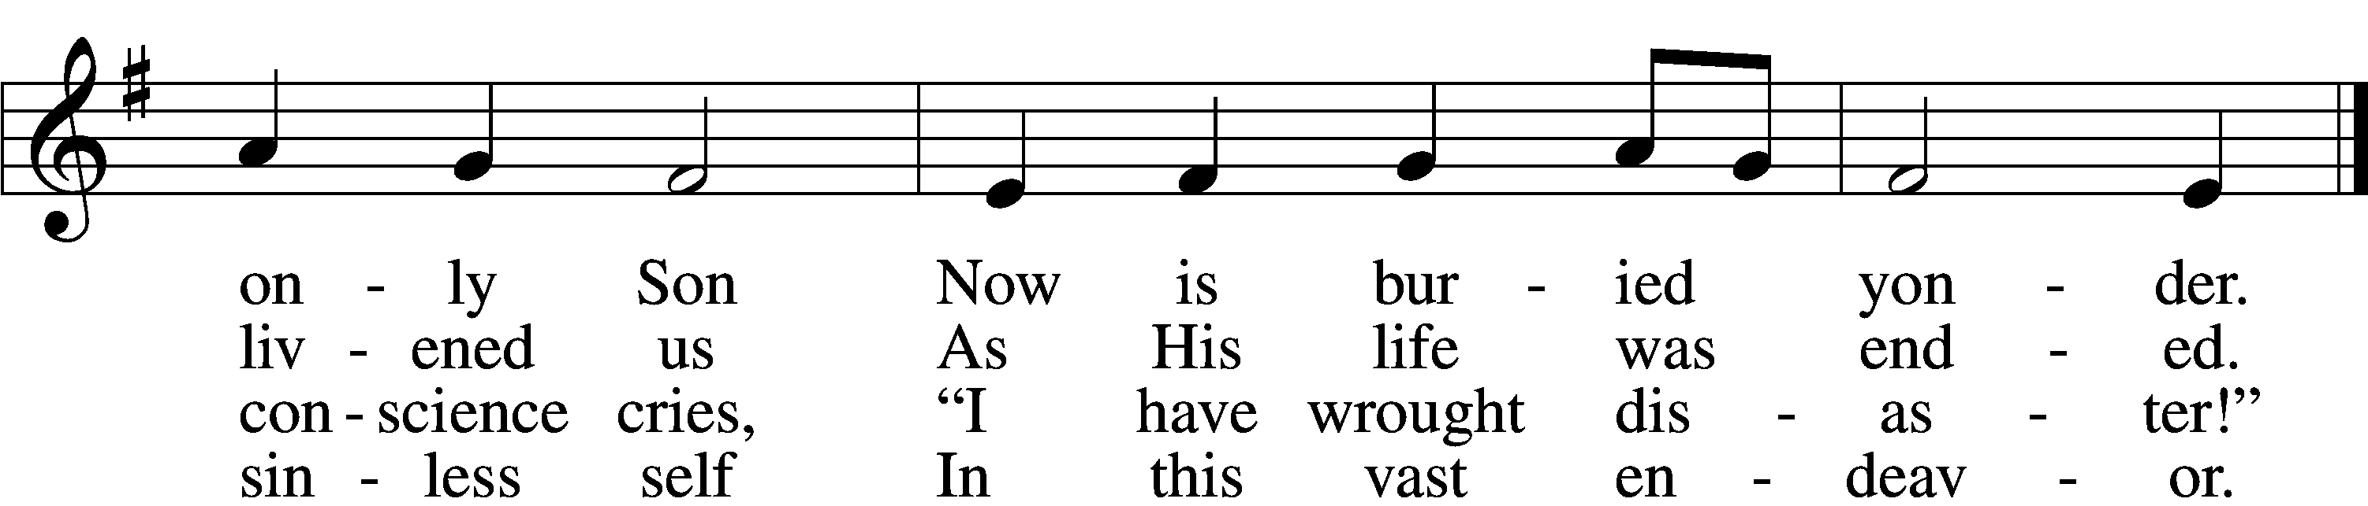

5 Such innocence!
His countenance
A fount of faith undying!
Worlds on worlds cannot contain
Grief at Him here lying.

6 O Virgin’s Son,
What Thou hast won
Is far beyond all telling:
How our God, detested, died,
Hell and devil felling.

7 O Jesus Christ,
Who sacrificed
Thy life for lifeless mortals:
Be my life in death and bring
Me to heaven’s portals!
Text (st. 1): Friedrich von Spee, 1591–1635; (st. 1): tr. Catherine Winkworth, 1827–78, alt.; (sts. 2–7): Johann Rist, 1607–67; (sts. 2–7): tr. Joseph Herl, 1959
Tune: Himmlische Harmony, 1628, Mainz
Text (sts. 2–7): © Joseph Herl. Used by permission: LSB Hymn License no. 110004782 Text (st. 1) and tune: Public domain

We return tomorrow at 7 pm for the
Great Vigil of Easter.

Here to Serve
Pastor………………………………………………...……………Rev. Jacob Deal
E-mail …………………………….……pastordeal@saintspeterandpaul.net
Phone Number……………………..…………………724-347-3620 (Option 2)
Church Office………………………..…………………724-347-3620 (Option 3)
Website …………………………………………www.saintspeterandpaul.net
Secretary…………………………………………………………Diane Riefstahl
E-mail ………………………………………church@saintspeterandpaul.net
Website …………………………………………www.saintspeterandpaul.net
Food Pantry: Please leave message……………724-347-3620 (Option 3)
AA Contact: Steve………………………………………………..…724-813-2358
NA Contact: Larry………………………………………………..724-977-8733
Choir Director………………………………………………………Chris Nelson
Congregation President……………………………………Jonathan Baisch
Church Elder …………………………………………...…… Jonathan Baisch
fffffffffffffffffffffffffffffffffff
If needing to get into the church building during the week, please phone first to make certain someone is here to let you in.

