Sts. Peter & Paul
Evangelical Lutheran Church
Lutheran Church-Missouri Synod
Founded-1917
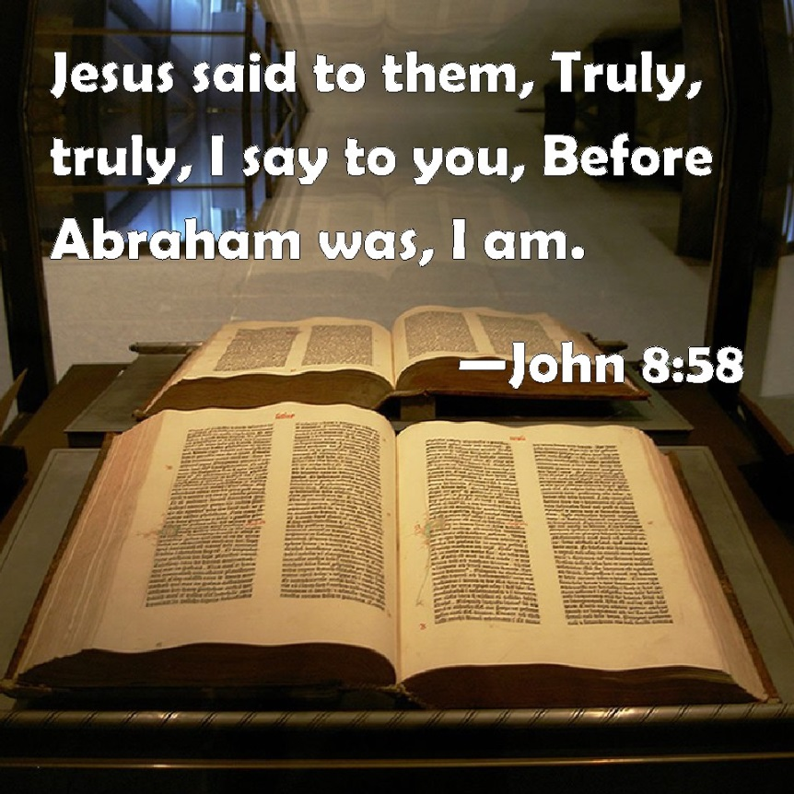

APRIL 7, 2019

699 Stambaugh Avenue
Sharon, Pennsylvania 16146

“I was glad when they said to me,
Let us go to the house of the LORD!”
Psalm 122:1
Sts. Peter & Paul Evangelical Lutheran Church, LC-MS

JUDICA: THE FIFTH SUNDAY IN LENT
April 7, 2019

Silent prayer before worship: Heavenly Father, through Your Son Jesus I have freedom from sin and death. Cause Your Word to work in my heart that I may trust in Your grace alone through Christ to save me from sin and death. Amen.

Please read Communion Statement found in pews prior to taking part in Holy Communion.
CONFESSION AND ABSOLUTION
Opening Hymn: LSB #455 “The Royal Banners Forward Go”
Stand
The sign of the cross may be made by all in remembrance of their Baptism.

P In the name of the Father and of the T Son and of the Holy Spirit.
C Amen. Matthew 28: 19b; [18:20]

P If we say we have no sin, we deceive ourselves, and the truth is not in us.
C But if we confess our sins, God, who is faithful and just, will forgive our sins and cleanse us from all unrighteousness.

Silence for reflection on God's Word and for self-examination.

P Let us then confess our sins to God our Father.
C Most merciful God, we confess that we are by nature sinful and unclean. We have sinned against You in thought, word, and deed, by what we have done and by what we have left undone. We have not loved You with our whole heart; we have not loved our neighbors as ourselves. We justly deserve Your present and eternal punishment. For the sake of Your Son, Jesus Christ, have mercy on us. Forgive us, renew us, and lead us, so that we may delight in Your will and walk in Your ways to the glory of Your holy name. Amen.
P Almighty God in His mercy has given His Son to die for you and for His sake forgives you all your sins. As a called and ordained servant of Christ, and by His authority, I therefore forgive you all your sins in the name of the Father and of the T Son and of the Holy Spirit. [John 20: 19-23]
C Amen.

Passing of the Peace.
SERVICE OF THE WORD
Introit: Ps. 43:3–5; antiphon: Ps. 43:1–2a
Vindicate me, | O God,*
and defend my cause against an ungodly | people,
from the deceitful and unjust man de- | liver me!*
For you are the God in whom I take | refuge.
Send out your light and your truth; let them | lead me;*
let them bring me to your holy hill and to your | dwelling!
Then I will go to the altar of God, to God my ex- | ceeding joy,*
and I will praise you with the lyre, O | God, my God.
Why are you cast down, O my soul, and why are you in turmoil with- | in me?*
Hope in God; for I shall again praise him, my salvation | and my God.
Vindicate me, | O God,*
and defend my cause against an ungodly | people,
from the deceitful and unjust man de- | liver me!*
For you are the God in whom I take | refuge.

Kyrie Mark 10:47
P In peace let us pray to the Lord.
C Lord, have mercy.
P For the peace from above and for our salvation let us pray to the Lord.
C Lord, have mercy.
P For the peace of the whole world, for the well-being of the Church of God, and for the unity of all let us pray to the Lord.
C Lord, have mercy.
P For this holy house and for all who offer here their worship and praise let us pray to the Lord.
C Lord, have mercy.
P Help, save, comfort, and defend us, gracious Lord.
C Amen.

Salutation and Collect of the Day
P The Lord be with you. 2 Timothy 4: 22
C And also with you.

P Let us pray.
Almighty God, by Your great goodness mercifully look upon Your people that we may be governed and preserved evermore in body and soul; through Jesus Christ, Your Son, our Lord, who lives and reigns with You and the Holy Spirit, one God, now and forever.

C Amen.

Sit

Old Testament Reading: Genesis 22:1–14
After these things God tested Abraham and said to him, “Abraham!” And he said, “Here am I.” He said, “Take your son, your only son Isaac, whom you love, and go to the land of Moriah, and offer him there as a burnt offering on one of the mountains of which I shall tell you.” So Abraham rose early in the morning, saddled his donkey, and took two of his young men with him, and his son Isaac. And he cut the wood for the burnt offering and arose and went to the place of which God had told him. On the third day Abraham lifted up his eyes and saw the place from afar. Then Abraham said to his young men, “Stay here with the donkey; I and the boy will go over there and worship and come again to you.” And Abraham took the wood of the burnt offering and laid it on Isaac his son. And he took in his hand the fire and the knife. So they went both of them together. And Isaac said to his father Abraham, “My father!” And he said, “Here am I, my son.” He said, “Behold, the fire and the wood, but where is the lamb for a burnt offering?” Abraham said, “God will provide for himself the lamb for a burnt offering, my son.” So they went both of them together.
When they came to the place of which God had told him, Abraham built the altar there and laid the wood in order and bound Isaac his son and laid him on the altar, on top of the wood. Then Abraham reached out his hand and took the knife to slaughter his son. But the angel of the Lord called to him from heaven and said, “Abraham, Abraham!” And he said, “Here am I.” He said, “Do not lay your hand on the boy or do anything to him, for now I know that you fear God, seeing you have not withheld your son, your only son, from me.” And Abraham lifted up his eyes and looked, and behold, behind him was a ram, caught in a thicket by his horns. And Abraham went and took the ram and offered it up as a burnt offering instead of his son. So Abraham called the name of that place, “The Lord will provide”; as it is said to this day, “On the mount of the Lord it shall be provided.”

P This is the Word of the Lord.
C Thanks be to God.

Gradual: Ps. 143:9a, 10a; 18:48a, c
Deliver me from my enemies, O Lord!
Teach me to do your will, for you are my God!
[You] delivered me from my enemies;
you rescued me from the man of violence.

Epistle: Hebrews 9:11–15
But when Christ appeared as a high priest of the good things that have come, then through the greater and more perfect tent (not made with hands, that is, not of this creation) he entered once for all into the holy places, not by means of the blood of goats and calves but by means of his own blood, thus securing an eternal redemption. For if the sprinkling of defiled persons with the blood of goats and bulls and with the ashes of a heifer sanctifies for the purification of the flesh, how much more will the blood of Christ, who through the eternal Spirit offered himself without blemish to God, purify our conscience from dead works to serve the living God.
Therefore he is the mediator of a new covenant, so that those who are called may receive the promised eternal inheritance, since a death has occurred that redeems them from the transgressions committed under the first covenant.

P This is the Word of the Lord.
C Thanks be to God.

Tract: Ps. 129:1– 4
“Greatly have they afflicted me from my youth”—
let Israel now say—
“Greatly have they afflicted me from my youth,
yet they have not prevailed against me.
The plowers plowed upon my back;
they made long their furrows.”
The Lord is righteous;
he has cut the cords of the wicked.

Stand
Holy Gospel: John 8:46–59
P The Holy Gospel according to St. John, the eighth chapter.
C Glory to You, O Lord.

Which one of you convicts me of sin? If I tell the truth, why do you not believe me? Whoever is of God hears the words of God. The reason why you do not hear them is that you are not of God.”
The Jews answered him, “Are we not right in saying that you are a Samaritan and have a demon?” Jesus answered, “I do not have a demon, but I honor my Father, and you dishonor me. Yet I do not seek my own glory; there is One who seeks it, and he is the judge. Truly, truly, I say to you, if anyone keeps my word, he will never see death.” The Jews said to him, “Now we know that you have a demon! Abraham died, as did the prophets, yet you say, ‘If anyone keeps my word, he will never taste death.’ Are you greater than our father Abraham, who died? And the prophets died! Who do you make yourself out to be?” Jesus answered, “If I glorify myself, my glory is nothing. It is my Father who glorifies me, of whom you say, ‘He is our God.’ But you have not known him. I know him. If I were to say that I do not know him, I would be a liar like you, but I do know him and I keep his word. Your father Abraham rejoiced that he would see my day. He saw it and was glad.” So the Jews said to him, “You are not yet fifty years old, and have you seen Abraham?” Jesus said to them, “Truly, truly, I say to you, before Abraham was, I am.” So they picked up stones to throw at him, but Jesus hid himself and went out of the temple.

P This is the Gospel of the Lord.
C Praise to You, O Christ.

Nicene Creed
C I believe in one God,
the Father Almighty,
maker of heaven and earth
and of all things visible and invisible.
And in one Lord Jesus Christ,
the only-begotten Son of God,
begotten of His Father before all worlds,
God of God, Light of Light,
very God of very God,
begotten, not made,
being of one substance with the Father,
by whom all things were made;
who for us men and for our salvation came down from heaven
and was incarnate by the Holy Spirit of the virgin Mary
and was made man;
and was crucified also for us under Pontius Pilate.
He suffered and was buried.
And the third day He rose again according to the Scriptures
and ascended into heaven
and sits at the right hand of the Father.
And He will come again with glory to judge both the living and the dead,
whose kingdom will have no end.
And I believe in the Holy Spirit,
the Lord and giver of life,
who proceeds from the Father and the Son,
who with the Father and the Son together is worshiped and glorified,
who spoke by the prophets.
And I believe in one holy Christian and apostolic Church,
I acknowledge one Baptism for the remission of sins,
and I look for the resurrection of the dead
and the life T of the world to come. Amen.
Sit

Hymn of the Day: LSB #430 “My Song Is Love Unknown”

Sermon
Stand

Prayer of the Church [Timothy 2: 1-4]

Sit

Offertory Psalm 116: 12-13, 17-19
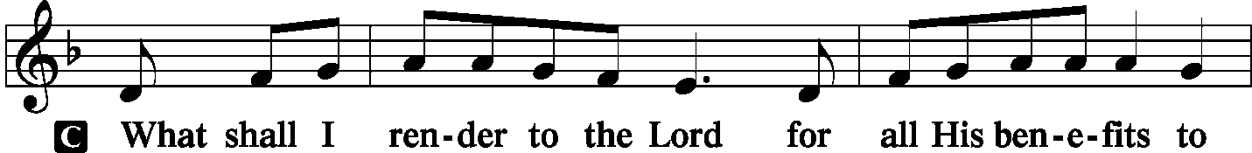
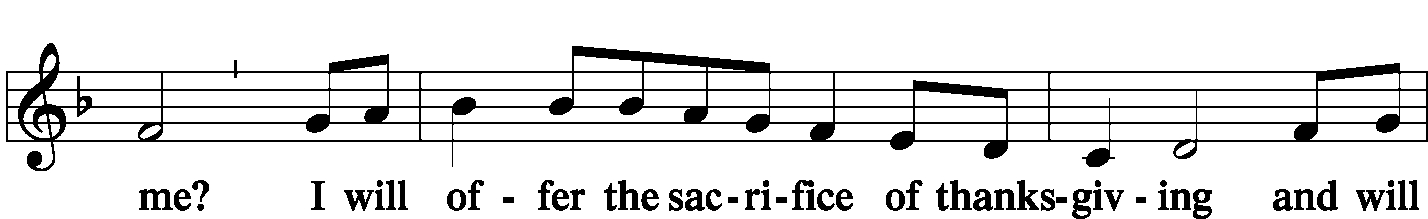
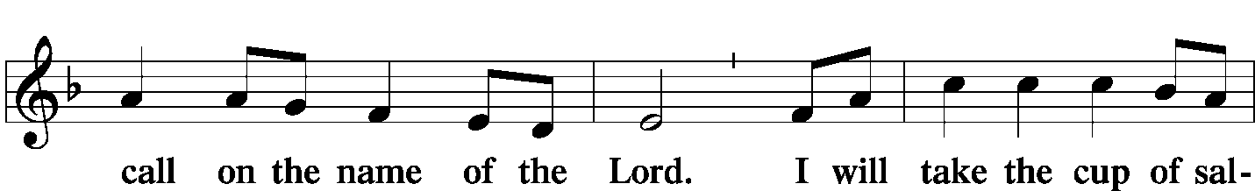
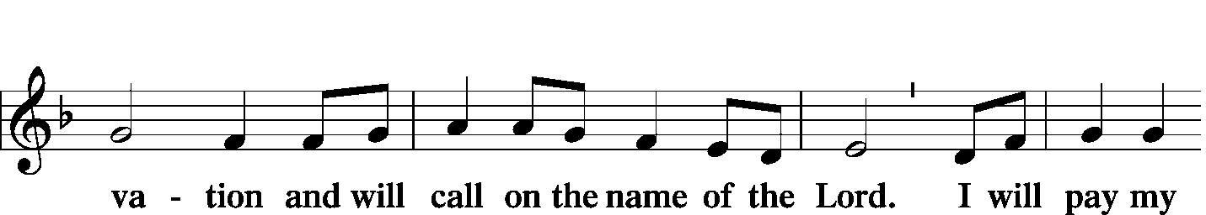
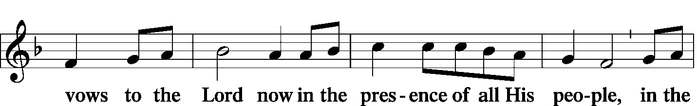
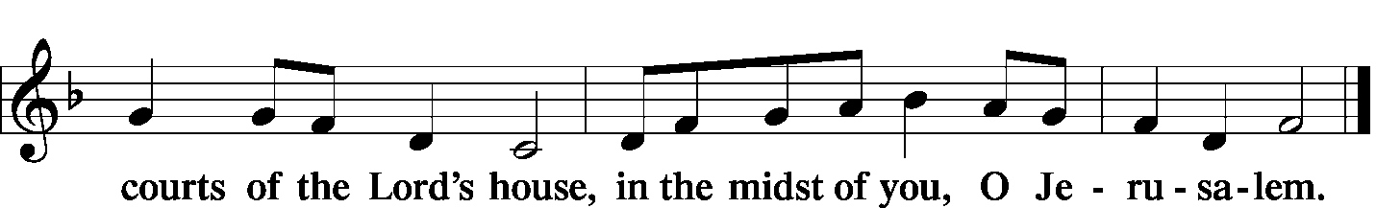

Offering/Offering Hymn: LSB #659 “Lord of Our Life”
Stand
SERVICE OF THE SACRAMENT
Preface
P The Lord be with you. 2 Timothy 4: 22
C And also with you.
P Lift up your hearts. [Colossians 3: 1]
C We lift them to the Lord.
P Let us give thanks to the Lord our God. [Psalm 136]
C It is right to give Him thanks and praise.

P It is truly meet, right, and salutary … evermore praising You and saying:

Sanctus Isaiah 6: 3; Matthew 21: 9
C Holy, holy, holy Lord, God of pow'r and might:
Heaven and earth are full of your glory.
Hosanna. Hosanna.
Hosanna in the highest.
Blessed is He who comes in the name of the Lord.
Hosanna in the highest.

Lord's Prayer Matthew 6: 9-13
P Lord, remember us in Your kingdom and teach us to pray:
C Our Father who art in heaven,
hallowed be Thy name,
Thy kingdom come,
Thy will be done on earth as it is in heaven;
give us this day our daily bread;
and forgive us our trespasses as we forgive those who trespass against us;
and lead us not into temptation,
but deliver us from evil.
For Thine is the kingdom and the power and the glory forever and ever. Amen.

The Words of Our Lord Matthew 26: 26-28; Mark 14: 22-24
Luke 22: 19-20; 1 Corinthians 11: 23-25
P Our Lord Jesus Christ, on the night when He was betrayed, took bread, and when He had given thanks, He broke it and gave it to the disciples and said: “Take, eat; this is My T body, which is given for you. This do in remembrance of Me.”

P In the same way also He took the cup after supper, and when He had given thanks, He gave it to them, saying: “Drink of it, all of you; this cup is the new testament in My T blood, which is shed for you for the forgiveness of sins. This do, as often as you drink it, in remembrance of Me.”

Pax Domini John 20: 19
P The peace of the Lord be with you always.
C Amen.

Agnus Dei John 1: 29
C Lamb of God, You take away the sin of the world; have mercy on us.
Lamb of God, You take away the sin of the world; have mercy on us.
Lamb of God, You take away the sin of the world; grant us peace.

Sit

Distribution
The pastor and those who assist him receive the body and blood of Christ first and then distribute them to those who come to receive, saying:

Take, eat; this is the true body of our Lord and Savior Jesus Christ, given into death for your sins.
Amen.

Take, drink; this is the true blood of our Lord and Savior Jesus Christ, shed for the forgiveness of your sins.
Amen.
In dismissing the communicants, the following is said:
P The body and blood of our Lord Jesus Christ strengthen and preserve you in body and soul to life everlasting. Depart T in peace.
C Amen.

Distribution Hymns: LSB #623 “Lord Jesus Christ, We Humbly Pray”
LSB #434 “Lamb of God, Pure and Holy”
Stand

Nunc Dimitti
C Lord, now You let Your servant go in peace; Your word has been fulfilled.
My own eyes have seen the salvation which You have prepared in the sight of ev'ry people:
A light to reveal You to the nations and the glory of Your people Israel.
Glory be to the Father and to the Son and to the Holy Spirit;
as it was in the beginning, is now, and will be forever. Amen.
Post-Communion Collect Let us pray.
P We give thanks to You, almighty God, that You have refreshed us through this salutary gift, and we implore You that of Your mercy You would strengthen us through the same in faith toward You and fervent love toward one another; through Jesus Christ, Your Son, our Lord, who lives and reigns with You and the Holy Spirit, one God, now and forever.
C Amen.

Benediction Numbers 6: 24-26

P The Lord bless you and keep you.
The Lord make His face shine on you
and be gracious to you.
The Lord look upon you with favor and T give you peace.
C Amen.

Closing Hymn: LSB #431 “Not All the Blood of Beasts”

Silent prayer after worship: Almighty God, lead me to honor You above all things, to cherish Your gift of salvation through Christ’s life, death and resurrection, and to share this gift with others. In Jesus’s name. Amen.

Acknowledgments: Divine Service, Setting One from Lutheran Service Book Unless otherwise indicated, all scripture quotations are from The Holy Bible, English Standard Version, copyright © 2001 by Crossway Bibles, a division of Good News Publishers. Used by permission. All rights reserved. Created by Lutheran Service Builder © 2006 Concordia Publishing House. CCLI License #3029-446

Attendance:
Sunday, March 31, 2019………………...……………………………………………44
Wednesday, April 3, 2019 (Noon: 13 ; Evening: 15 )………………………….…28

Word of Hope: 1-888-217-8679
The only 24/7 CONFIDENTIAL Hotline that is distinctly Lutheran, bringing healing found in Christ, to those whose hearts have been broken by abortion.

SCHEDULE FOR TODAY THROUGH APR. 14th:
:

:

Today, 7 pm, Downstairs….…………….…………………..…………..…………..……AA Meeting
Monday, 11 am-noon, Downstairs……………………………………………………..…Pie Pick-up
1 pm, Offices……………………………………………………….Preschool Board Meeting
Wednesday, noon & 7 pm, Sanctuary…….………………………..Midweek Lenten Service
5:30 pm, Sanctuary…………………….………………………………………...Choir Practice
Thursday, 9 am, Downstairs……………………………………………………….……..Food Pantry
Saturday, 9 am, Parking Lot……………………………..Sharon Community Clean-up Day
Next Sunday, 8:45 am, Downstairs…………………..………………………………….Bible Study
10 am, Sanctuary…......................................................................Divine Service
Following Worship, Downstairs……………….……Coffee & Donuts Fellowship
7 pm, Downstairs………………………………………………………..…....……AA Meeting

Our Stewardship of Treasures for the Lord:
In order to do the Lord’s work, we need $2,882.02* each week to meet our 2019 budget for general purposes and $38.46 for missions.
Sunday, March 31, 2019:
General Offering:…..…..……….............................................................$5215.00
Ahead this week*#: +$2,550.48
SELC Missions:……….………..…..…….....................................................$315.00 Ahead this week#: +$277.54
Quarterly Local Mission:……………………………………………………..…..$0.00
Preschool Tuition Payments:...…………………..................................….....$82.50
Other Offerings:………….…….…….....................………..……..…………...$0.00
Wednesday, March 27, 2019:
General Offering:…..…..………................................................................$135.00
SELC Missions:……….………..…..…….........................................................$1.00
*Includes preschool tuition; #Includes Wednesday’s figures.

Spring Flowering Plants order forms and payments for Easter Sunday are due to Diane TODAY.
Reminder: Next Saturday is the City of Sharon’s “Clean-up Day”. Volunteers are asked to meet here at the church at 9 am. Please wear a “church shirt” if possible.

Next Sunday will be
“Stock the Food Pantry”
Sunday.

If you ordered a pie from the Preschool fundraiser, please pick it up tomorrow (Monday) between 11 am and noon. Speak with Stacy Brandes if you should have any questions.

There are several items for you to pick up in the narthex this morning:
- April issue of “The Rock and the Sword” newsletter
- April issue of “The Lutheran Beacon”
- Portals of Prayer for April, May, and June
- Minutes from the March 24th Community Day organizational meeting

Please stop by the narthex and sign the Easter Cards for our shut-ins. Cards will be available through Sunday, April 14th.

Join us next Sunday following worship for Coffee & Donuts Fellowship. Please note that we are in need of sponsors in order to continue this fellowship opportunity.

Remember the following in Prayer…
~The Hurting and Healing: Tony², Tom Bender (Sue’s brother recovering from hip replacement surgery), Lois Bortner^{CA}, Patricia Brandes¹, Richard Brandes¹, Eileen Burns¹, Mark Chirdon², Loretta Deal², Norma Ferringer¹, Anson Holcroft², Betty Knauff^{CA}, Regis Knauff², Jess Lavoie⁴, Paul Lucas^{CA}, Barry Nelson², David Nelson³,Tom Mulligan^{CA}, Iona Oltman^{CA}, Rudy Pinal^{CA}, Richard Reuning^{CA}, Katie Sass ³, and Angela Weser^{CA}.
~Celebrating: Birthdays: Bill Nelson (04.07), Jason Parkany (04-10), and Kim Revale (04.13).
~Our Homebound: Helen Bender, Dan Davis, Edna Krajci, Mary Ann Krajci, Sophie Mihm, Marion & Gene Roberts, Barbara Vasconi, and Joanne Wolfe.
~Serving in the Military: Clayton Drnek, Curtis Sinewe, and Joshua Solyan.
~Community & World Needs: Victims of violence and terrorism; those suffering from loss and dislocation because weather disasters; those suffering from addiction and their families; safety for teachers, staff, and students; Local, State, and National Government Leaders; Safety for all Police Officers, Firefighters, & First Responders; the unemployed; our Second Quarter Local Mission: Sts. Peter & Paul’s Third Annual Community Day.
*CA represents cancer; number after other names represents weeks on the prayer list. After 4 weeks names may be resubmitted. This helps us to remember people’s specific needs and reminds us that God is providing healing as people get better and no longer need our prayers. Please submit prayer requests in writing to the church office.
Please keep those listed above in your prayers.

Bible Memory Verses: For the week of April 7th:
For Children: Christ says: “For their sake I consecrate myself, that they also may be sanctified in truth.” John 17:19
For Adults: Be angry and do not sin; do not let the sun go down on your anger, and give no opportunity to the devil. Ephesians 4:26-27

Thank You for Serving in April:
Today’s Greeters: John Dyll & Mark Gabriel. Assisting Elders: John Dyll & Bob Sulek. Ushers: John Dyll, Barry Nelson, Jerome Thomas, Gary Burns, & Bob Sulek (alternate). Altarware: Anne Colt & Joani Rice.

April Greeters: 14 ~ Rev. Ed & Irene Kucera; 20 ~ (Sat., 7 pm) Dolores Fee & Diane Riefstahl; 21 ~ Anna Mae Daris & Millie Elavsky; 28 ~ Cheryl Fedele & Clara Krivosh.

Members and guests are asked to sign the “Friendship” books found at the inside aisle of your pews. Ushers will collect signed sheets after the offering.


Here to Serve…

Pastor………………………………………………….………..…Rev. Jacob Deal
E-mail ……….…………………….…..pastordeal@saintspeterandpaul.net
Phone Number…………..……………………………724-347-3620 (Option 2)
Church Office………………………………….………724-347-3620 (Option 3)
Website ……….………………….……...…….www.saintspeterandpaul.net
Secretary………………………………………………….……. Diane Riefstahl
E-mail ……….…………………….…….…church@saintspeterandpaul.net
Food Pantry: John Dyll…………….……………………..…..…724-347-1779
Little People Preschool…………….……………….724-347-3620 (Option 4)
Teacher: Paula Ostheimer………….………………….…….....724-981-5846
Email ……….………….…………………….paula@saintspeterandpaul.net
AA Contact: Steve……………………….…………..……...……. 724-813-2358
Organist……………………………………………………..…Carrie Yasnowski
Choir Director……………..…………….…………..….….………Chris Nelson
Congregation President…………………………………………Jeff Brandes

During Lent, the secretary’s office hours will be Mondays (8:30-4:30) and Wednesdays (8:30-5:30). Pastor Deal will be in the office Monday through Thursday unless ministering off-site. If you need to enter the Church, please call ahead to be sure someone is here to let you in. Thank you.


