Sts. Peter & Paul
Evangelical Lutheran Church
Lutheran Church-Missouri Synod
Founded-1917

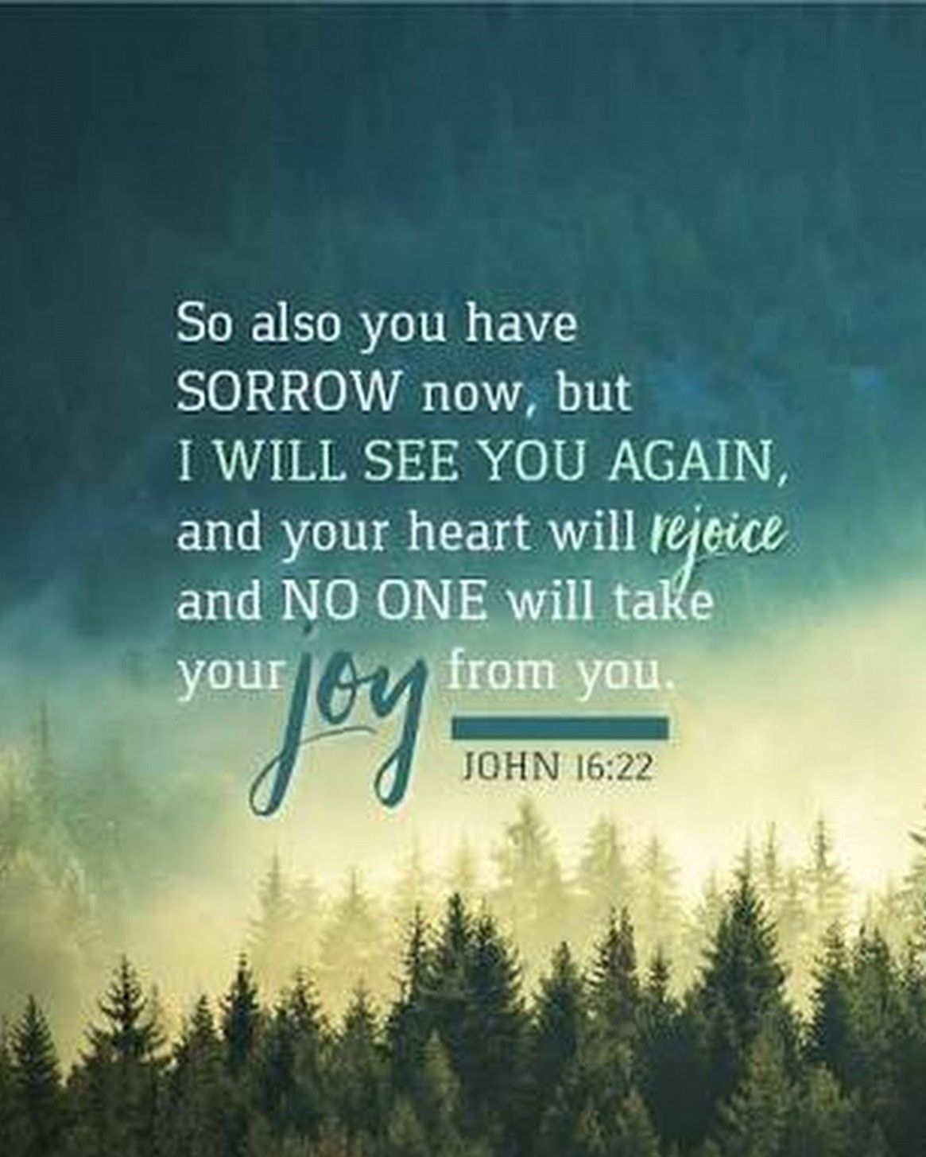

April 21, 2024

699 Stambaugh Ave.
Sharon, Pennsylvania 16146

“I was glad when they said to me,
Let us go to the house of the LORD!”
Psalm 122:1
Sts. Peter & Paul Evangelical Lutheran Church, LC-MS
JUBILATE
April 21, 2024

A special welcome to our guests this day! If you would like more information about The Lutheran Church - Missouri Synod, or this congregation, please speak with Pastor Deal or an Elder after the service.
Members & Guests: Don’t be embarrassed if your children make noise during the worship service, all children do. We encourage families to worship together but, if you feel the need, there are pews in the rear of the Church which are reserved for young families on both sides of the sanctuary. There is also a quiet room available to you, located next to the sanctuary (formerly the Pastor’s office), where you would be able to follow along with the service.

Today’s service includes the Sacrament of Holy Communion. If during this past year, you have not worshipped with us and been communed, we respectfully ask that you do not partake of this sacrament this day before first speaking with Pastor Deal.
If visiting from a sister congregation of the LC-MS and are in good standing, please inform Pastor Deal of your desire to commune prior to the service.
If wishing to receive a blessing during communion, please approach with your arms crossed.

CONTACT INFORMATION
Pastor Deal: pastordeal@saintspeterandpaul.net or 724-347-3620 (opt. 2)
Church Office: church@saintspeterandpaul.net or 724-347-3620 (opt. 3)
Office Hours: The church office will be open Monday and Thursday (8:30 am-4:30 pm).

Silent prayer before worship: Heavenly Father send Your Holy Spirit through Your Word to open my mind as I listen to Your Word. Lead me to firmly trust that Jesus died for all, and that He now lives and reigns with You forever. In Jesus’ name. Amen.

Confession and Absolution

Opening Hymn: TLH #209 “Who Is This That Comes from Edom”
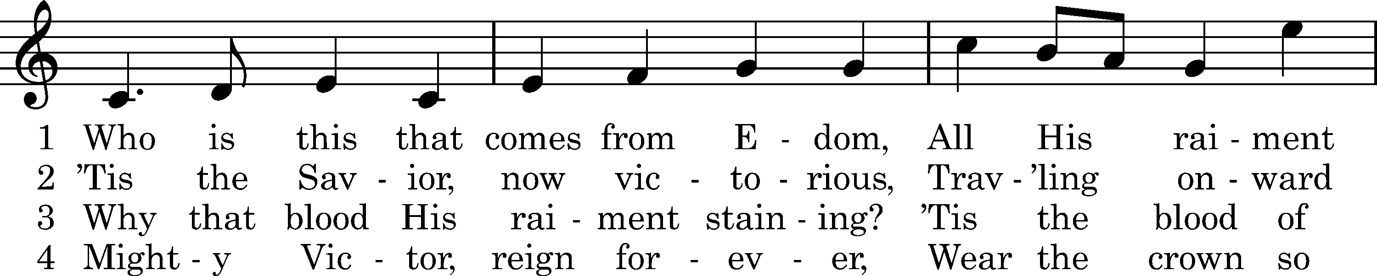
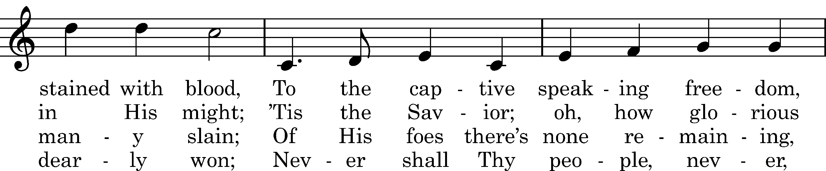
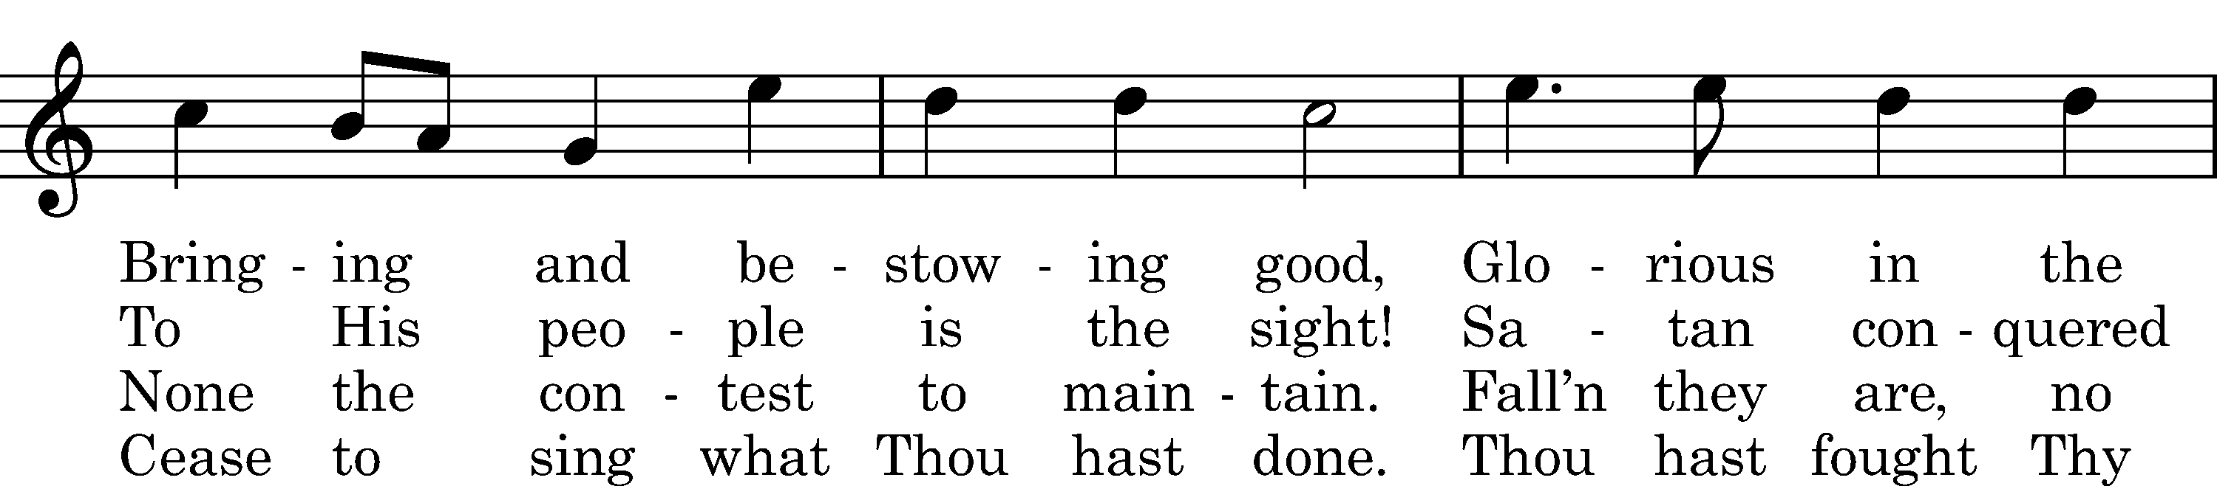
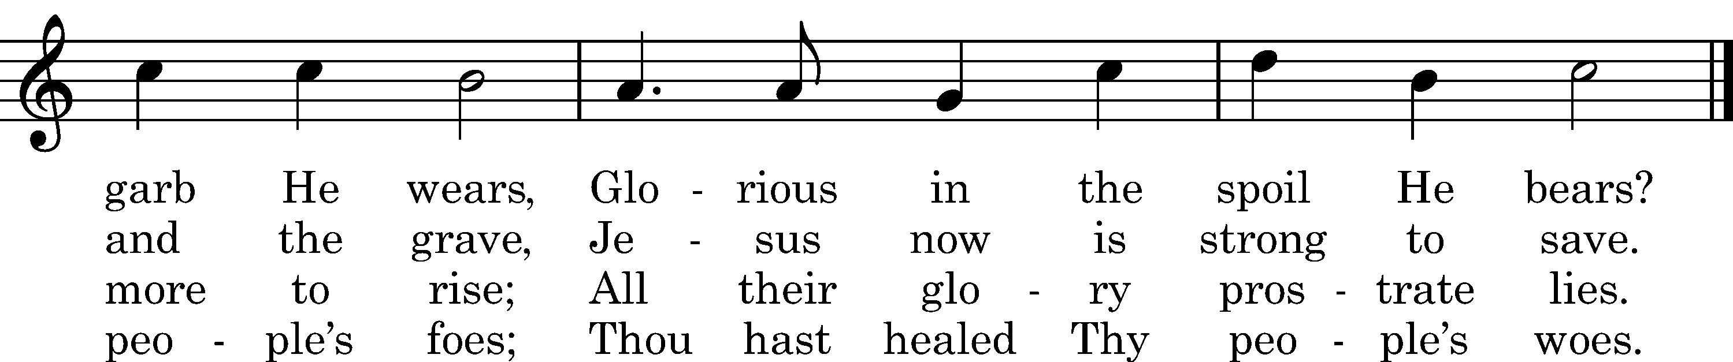

Text: Thomas Kelly, 1809, alt. Tune: Joachim Neander, 1680 Text and tune: Public domain

Stand

The sign of the cross may be made by all in remembrance of their Baptism.

Invocation
P In the name of the Father and of the T Son and of the Holy Spirit.
C Amen.

Exhortation Hebrews 10:22; Psalm 124:8; Psalm 32:5
P Beloved in the Lord! Let us draw near with a true heart and confess our sins unto God our Father, beseeching Him in the name of our Lord Jesus Christ to grant us forgiveness.
P Our help is in the name of the Lord,
C who made heaven and earth.
P I said, I will confess my transgressions unto the Lord,
C and You forgave the iniquity of my sin.

Silence for reflection on God’s Word and for self-examination.

Confession of Sins
P O almighty God, merciful Father,
C I, a poor, miserable sinner, confess unto You all my sins and iniquities with which I have ever offended You and justly deserved Your temporal and eternal punishment. But I am heartily sorry for them and sincerely repent of them, and I pray You of Your boundless mercy and for the sake of the holy, innocent, bitter sufferings and death of Your beloved Son, Jesus Christ, to be gracious and merciful to me, a poor, sinful being.

Absolution [John 20:19–23]
P Upon this your confession, I, by virtue of my office, as a called and ordained servant of the Word, announce the grace of God unto all of you, and in the stead and by the command of my Lord Jesus Christ I forgive you all your sins in the name of the Father and of the T Son and of the Holy Spirit.
C Amen.
Service of the Word

Introit Psalm 66:3, 5, 8–9; antiphon: vv. 1–2
Shout for joy to God, all the earth. Alle- | luia.*
Sing the glory of his name; give to him glorious praise! Alle- | luia.
Say to God, “How awesome | are your deeds!*
So great is your power that your enemies come cringing | to you.”
Come and see what | God has done:*
he is awesome in his deeds toward the chil- | dren of man.
Bless our God, O | peoples;*
let the sound of his | praise be heard,
who has kept our soul among the | living*
and has not let our | feet slip.
Shout for joy to God, all the earth. Alle- | luia.*
Sing the glory of his name; give to him glorious praise! Alle- | luia.

Gloria Patri
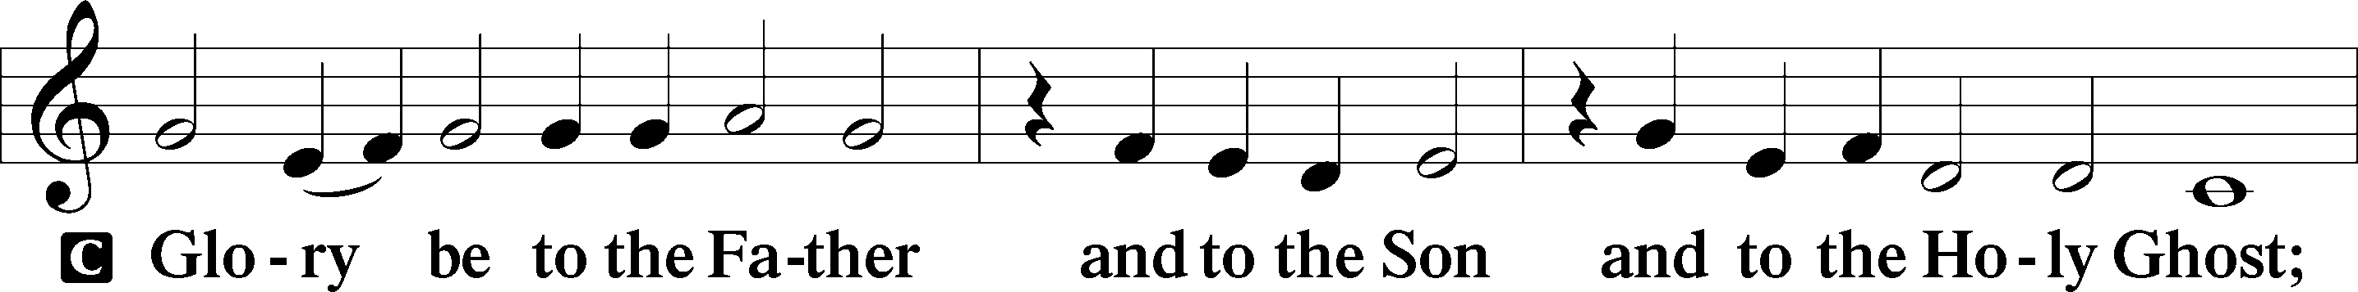
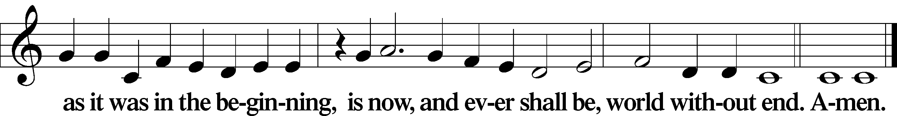

Kyrie Mark 10:47
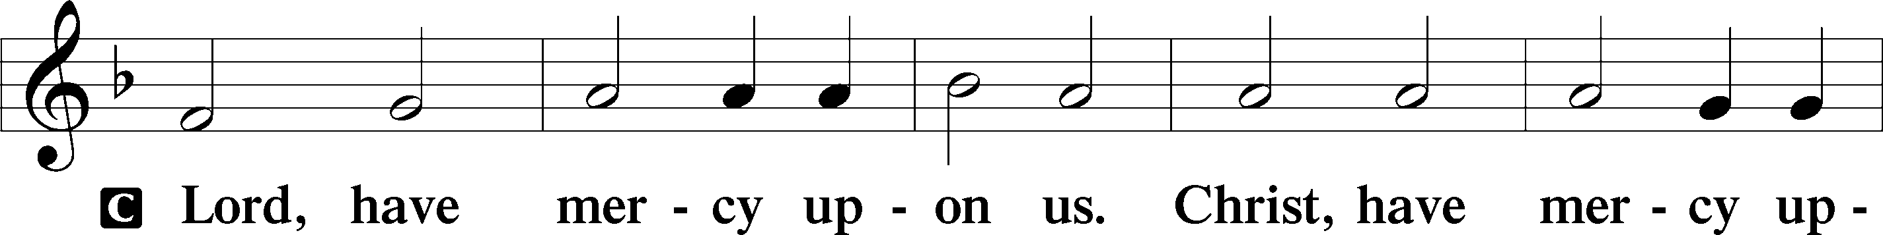
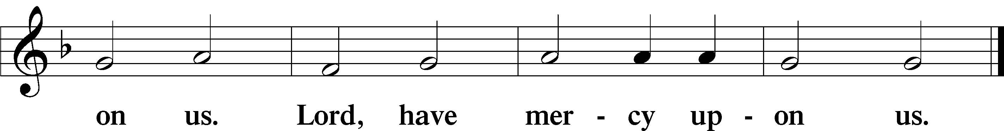
Gloria in Excelsis Luke 2:14; John 1:29
P Glory be to God on high:
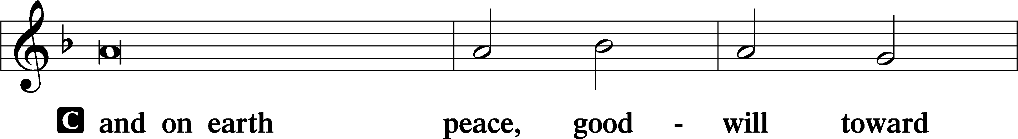
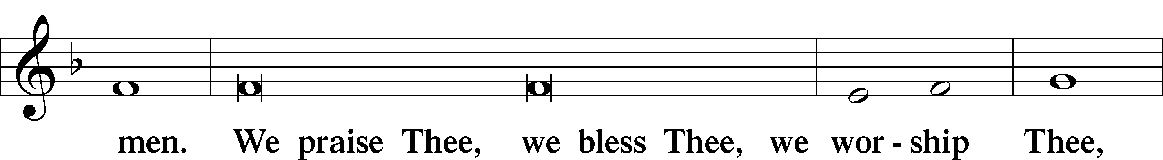
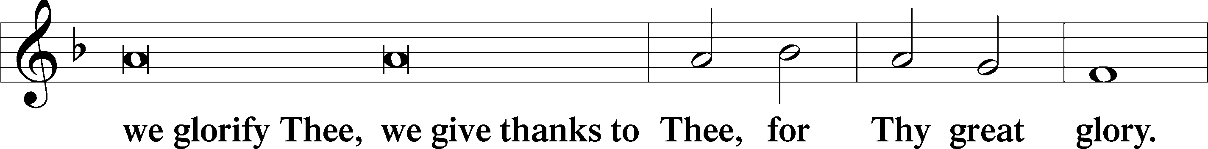
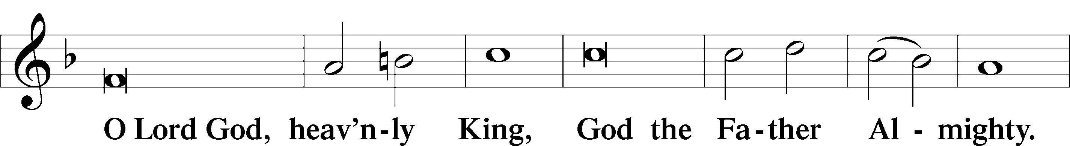
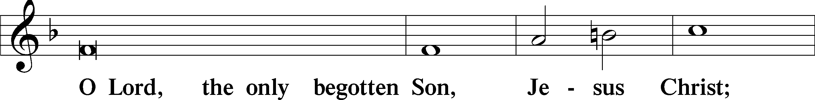
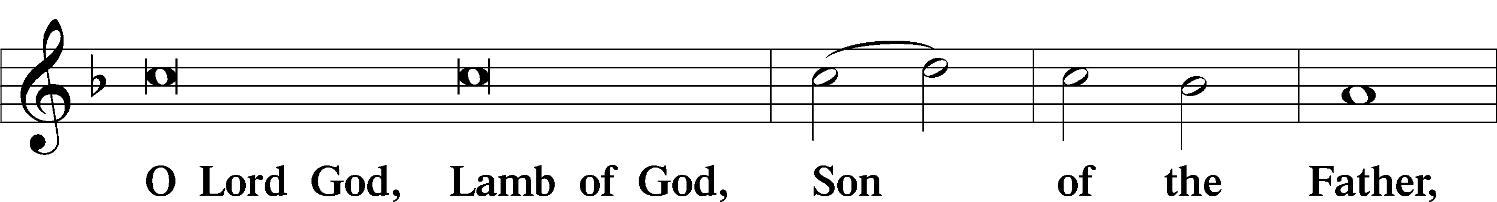
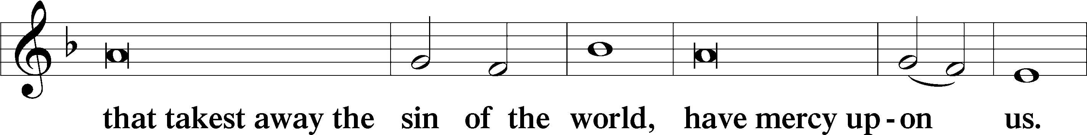
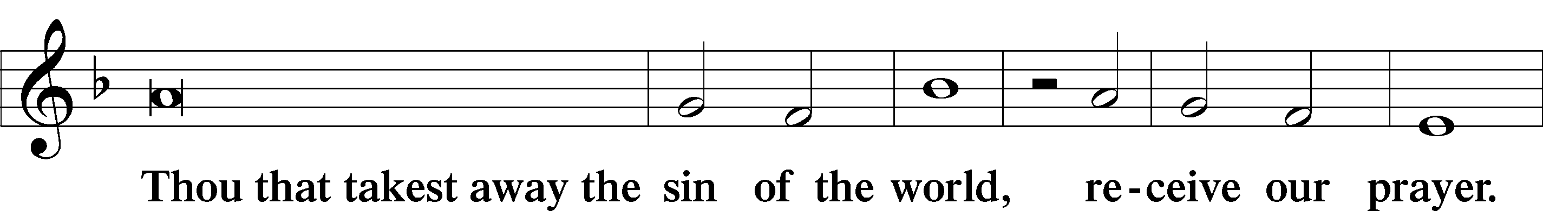
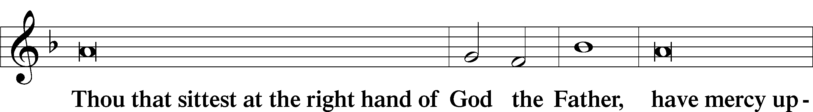
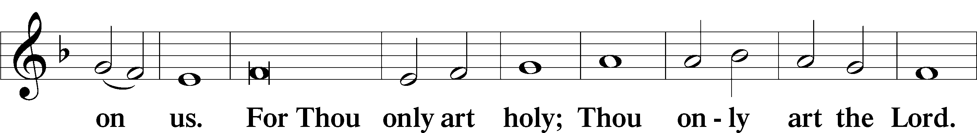
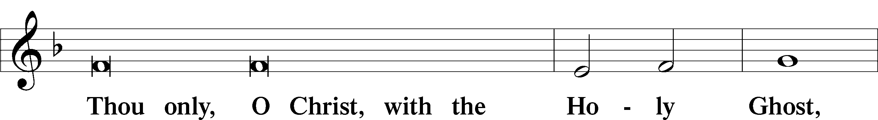
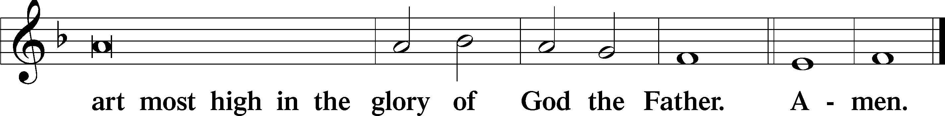

Salutation and Collect of the Day: Jubilate
P The Lord be with you.
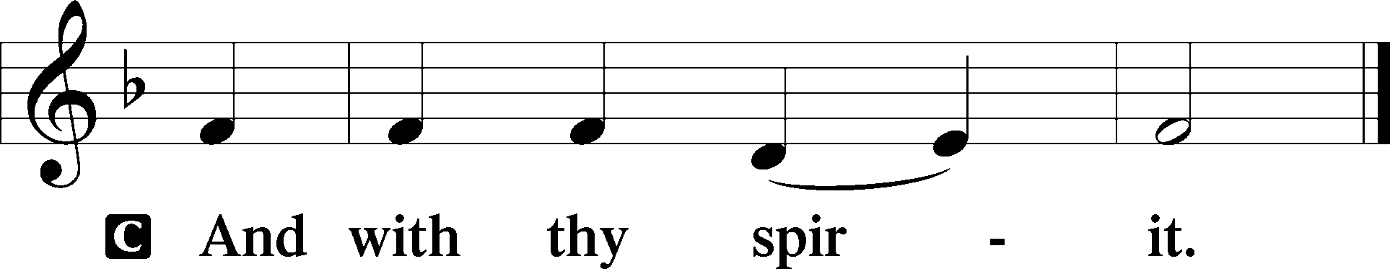

P Let us pray.
Almighty God, You show those in error the light of Your truth so that they may return to the way of righteousness. Grant faithfulness to all who are admitted into the fellowship of Christ’s Church that they may avoid whatever is contrary to their confession and follow all such things as are pleasing to You; through Jesus Christ, Your Son, our Lord, who lives and reigns with You and the Holy Spirit, one God, now and forever.
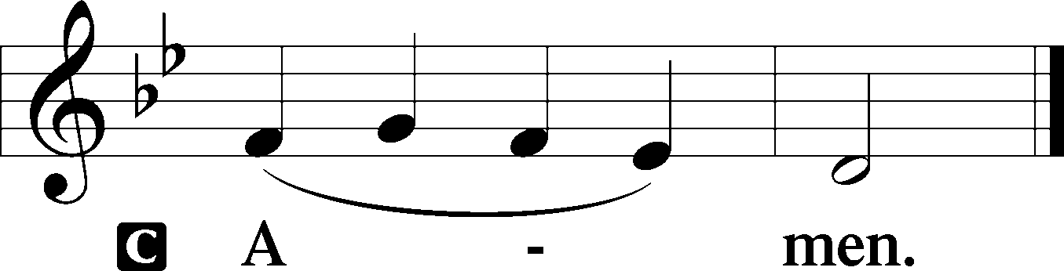
Sit

Prophecy: Isaiah 40:25–31 (NKJV)
Thus says the Lord God: “To whom will you liken Me, or to whom shall I be equal?” says the Holy One. Lift up your eyes on high, and see who has created these things, who brings out their host by number; He calls them all by name, by the greatness of His might and the strength of His power; not one is missing. Why do you say, O Jacob, and speak, O Israel: “My way is hidden from the Lord, and my just claim is passed over by my God”? Have you not known? Have you not heard? The everlasting God, the Lord, the Creator of the ends of the earth, neither faints nor is weary. His understanding is unsearchable. He gives power to the weak, and to those who have no might He increases strength. Even the youths shall faint and be weary, and the young men shall utterly fall, but those who wait on the Lord shall renew their strength; they shall mount up with wings like eagles, they shall run and not be weary, they shall walk and not faint.

P This is the Word of the Lord.
C Thanks be to God.

Psalm 147:1–11
Praise the Lord!
For it is good to sing praises to our God;
for it is pleasant, and a song of praise is fitting.
The Lord builds up Jerusalem;
he gathers the outcasts of Israel.
He heals the brokenhearted
and binds up their wounds.
He determines the number of the stars;
he gives to all of them their names.
Great is our Lord, and abundant in power;
his understanding is beyond measure.
The Lord lifts up the humble;
he casts the wicked to the ground.
Sing to the Lord with thanksgiving;
make melody to our God on the lyre!
He covers the heavens with clouds;
he prepares rain for the earth;
he makes grass grow on the hills.
He gives to the beasts their food,
and to the young ravens that cry.
His delight is not in the strength of the horse,
nor his pleasure in the legs of a man,
but the Lord takes pleasure in those who fear him,
in those who hope in his steadfast love.

Epistle: 1 Peter 2:11–20 (NKJV)
Dearly Beloved: I beg you as sojourners and pilgrims, abstain from fleshly lusts which war against the soul, having your conduct honorable among the Gentiles, that when they speak against you as evildoers, they may, by your good works which they observe, glorify God in the day of visitation. Therefore submit yourselves to every ordinance of man for the Lord’s sake, whether to the king as supreme, or to governors, as to those who are sent by him for the punishment of evildoers and for the praise of those who do good. For this is the will of God, that by doing good you may put to silence the ignorance of foolish men—as free, yet not using liberty as a cloak for vice, but as bondservants of God. Honor all people. Love the brotherhood. Fear God. Honor the king. Servants, be submissive to your masters with all fear, not only to the good and gentle, but also to the harsh. For this is commendable, if because of conscience toward God one endures grief, suffering wrongfully. For what credit is it if, when you are beaten for your faults, you take it patiently? But when you do good and suffer, if you take it patiently, this is commendable before God.
P This is the Word of the Lord.
C Thanks be to God.

Stand

Verse Psalm 111:9a; Luke 24:26
Alleluia. He sent redemption to his people. Alleluia. Was it not necessary that the Christ should suffer these things and enter into his glory? Alleluia.

Alleluia
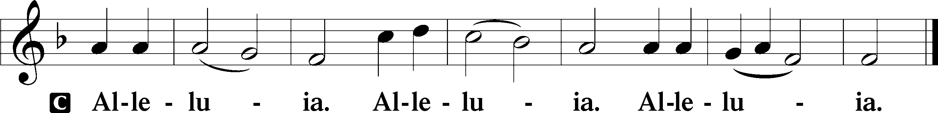

Holy Gospel: John 16:16–22 (NKJV)
P The Holy Gospel according to St. John, the sixteenth chapter.
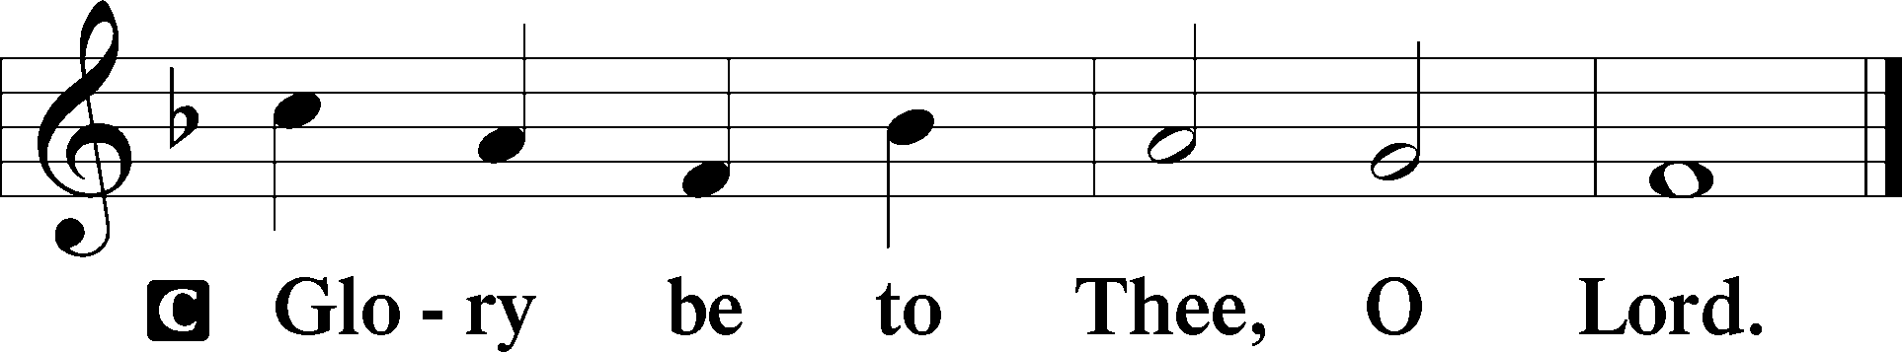

At that time Jesus said to His disciples: “A little while, and you will not see Me; and again a little while, and you will see Me, because I go to the Father.” Then some of His disciples said among themselves, “What is this that He says to us, ‘A little while, and you will not see Me; and again a little while, and you will see Me’; and, ‘because I go to the Father’?” They said therefore, “What is this that He says, ‘A little while’? We do not know what He is saying.” Now Jesus knew that they desired to ask Him, and He said to them, “Are you inquiring among yourselves about what I said, ‘A little while, and you will not see Me; and again a little while, and you will see Me’? Most assuredly, I say to you that you will weep and lament, but the world will rejoice; and you will be sorrowful, but your sorrow will be turned into joy. A woman, when she is in labor, has sorrow because her hour has come; but as soon as she has given birth to the child, she no longer remembers the anguish, for joy that a human being has been born into the world. Therefore you now have sorrow; but I will see you again and your heart will rejoice, and your joy no one will take from you.”

P This is the Gospel of the Lord.
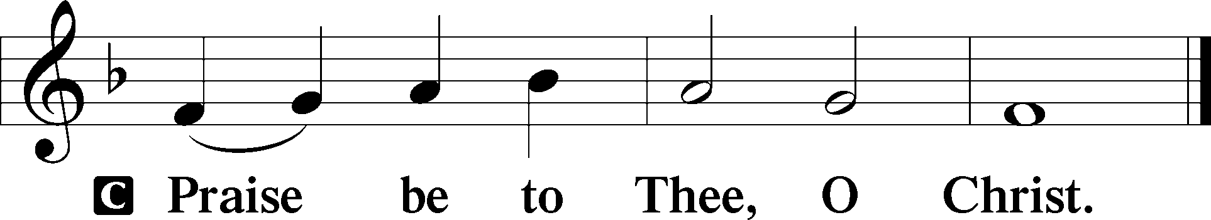

Nicene Creed
C I believe in one God,
the Father Almighty,
maker of heaven and earth
and of all things visible and invisible.

And in one Lord Jesus Christ,
the only-begotten Son of God,
begotten of His Father before all worlds,
God of God, Light of Light,
very God of very God,
begotten, not made,
being of one substance with the Father,
by whom all things were made;
who for us men and for our salvation came down from heaven
and was incarnate by the Holy Spirit of the virgin Mary
and was made man;
and was crucified also for us under Pontius Pilate.
He suffered and was buried.
And the third day He rose again according to the Scriptures
and ascended into heaven
and sits at the right hand of the Father.
And He will come again with glory to judge both the living and the dead,
whose kingdom will have no end.

And I believe in the Holy Spirit,
the Lord and giver of life,
who proceeds from the Father and the Son,
who with the Father and the Son together is worshiped and glorified,
who spoke by the prophets.
And I believe in one holy Christian and apostolic Church,
I acknowledge one Baptism for the remission of sins,
and I look for the resurrection of the dead
and the life T of the world to come. Amen.
Sit

Hymn of the Day: LSB #483 “With High Delight Let Us Unite”

Sermon

Stand

Offertory Psalm 51:10–12
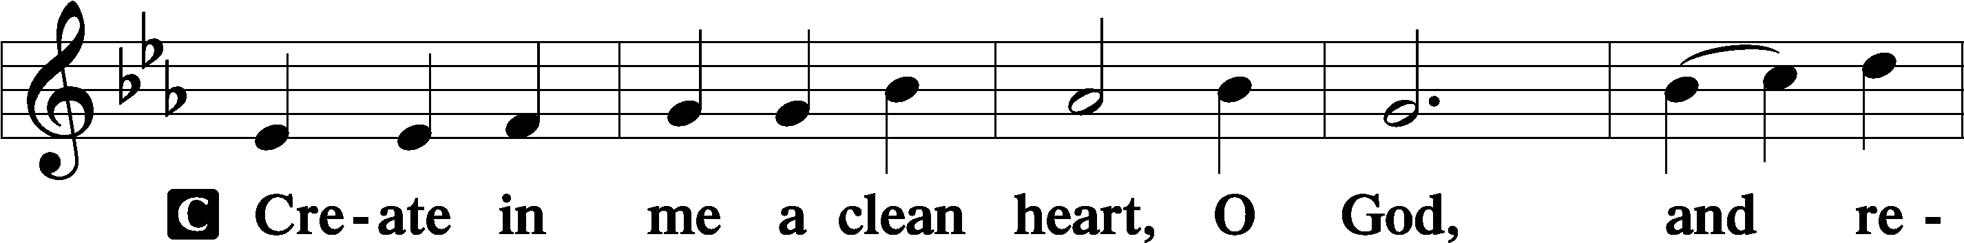
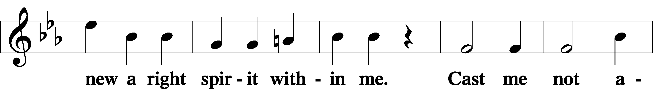
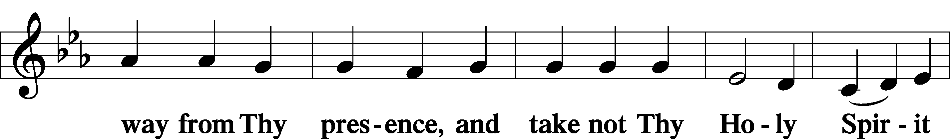
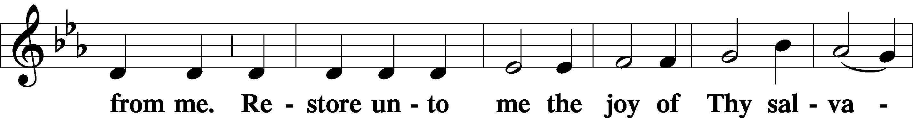
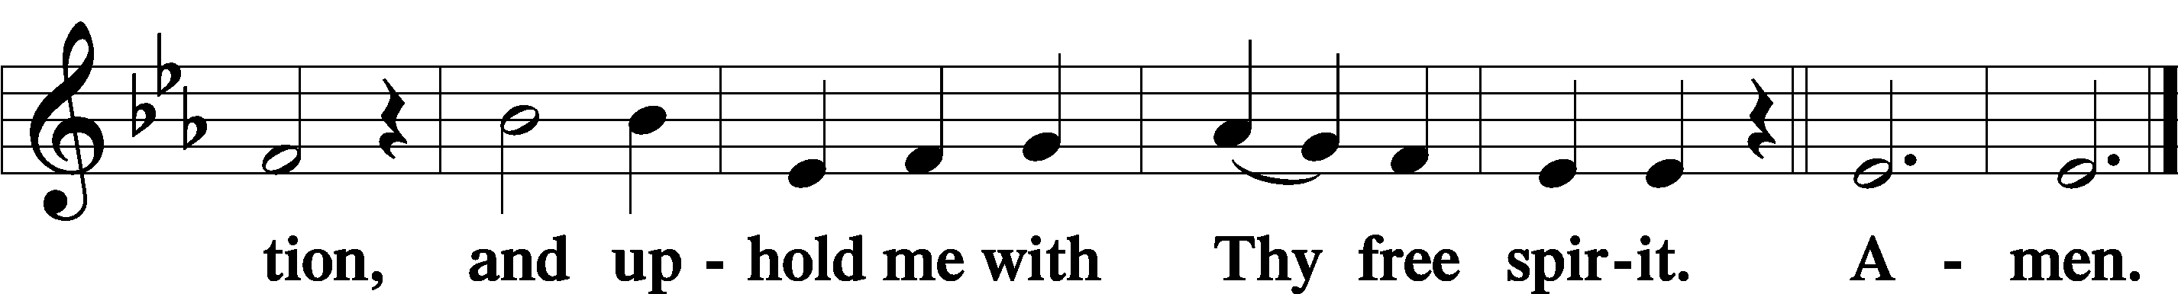

Prayer of the Church

Sit

Preparatory Hymn: LSB #684 “Come unto Me, Ye Weary”

Stand
Service of the Sacrament

Preface 2 Timothy 4:22; Colossians 3:1 Psalm 136
P The Lord be with you.
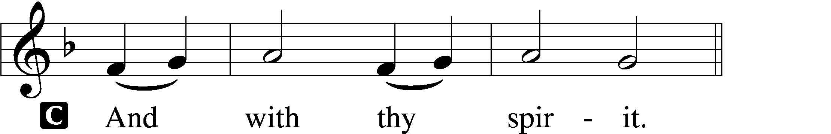

P Lift up your hearts.
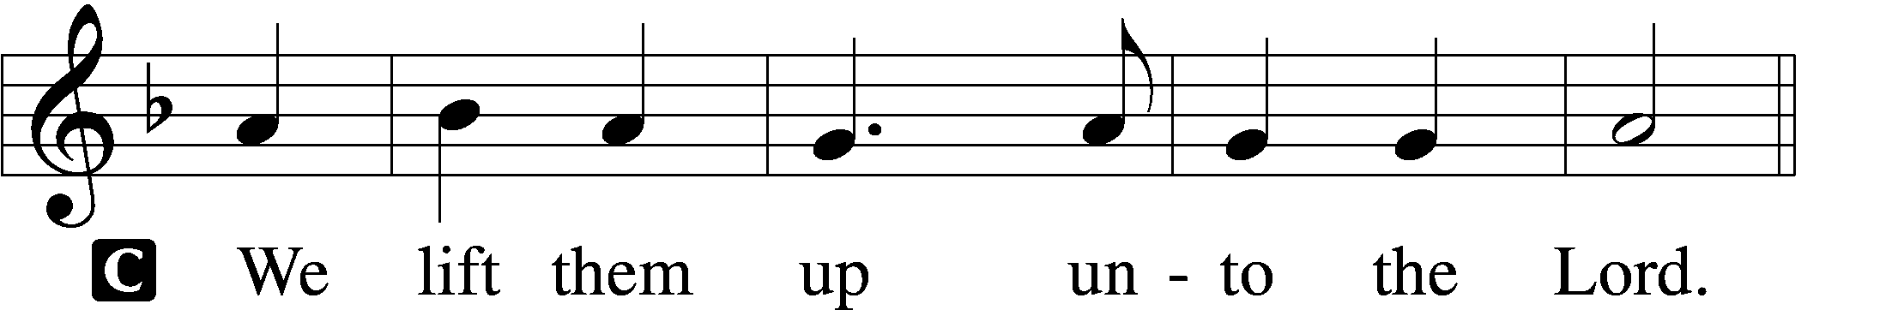

P Let us give thanks unto the Lord, our God.
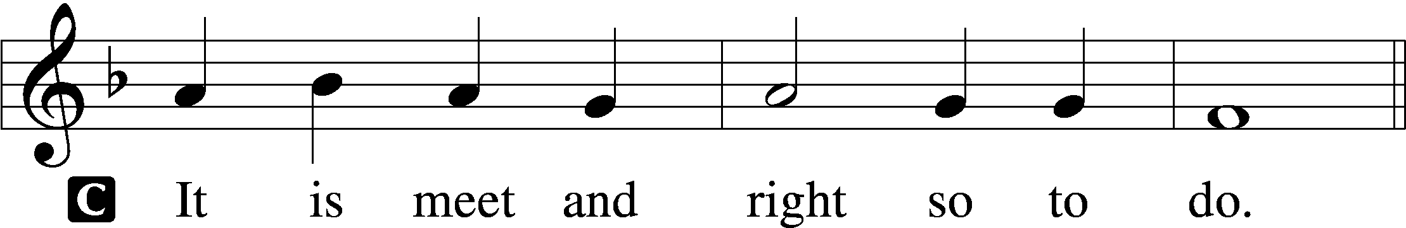

Proper Preface (Abbreviated) LSB 194
P It is truly meet, right, and salutary . . . evermore praising You and saying:

Sanctus Isaiah 6:3; Matthew 21:9
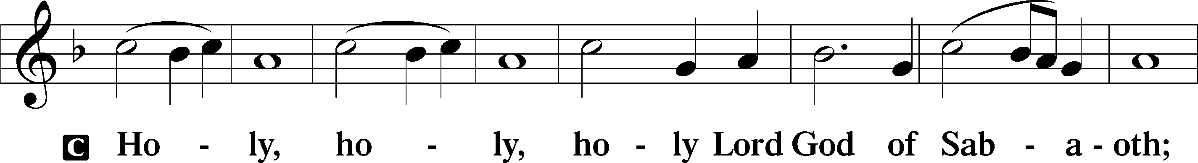
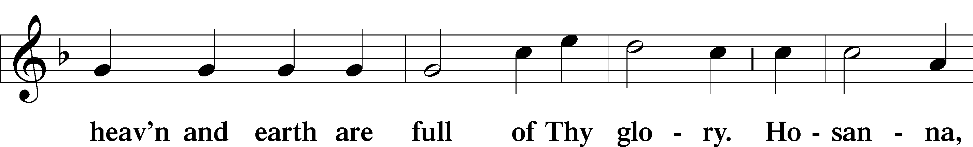
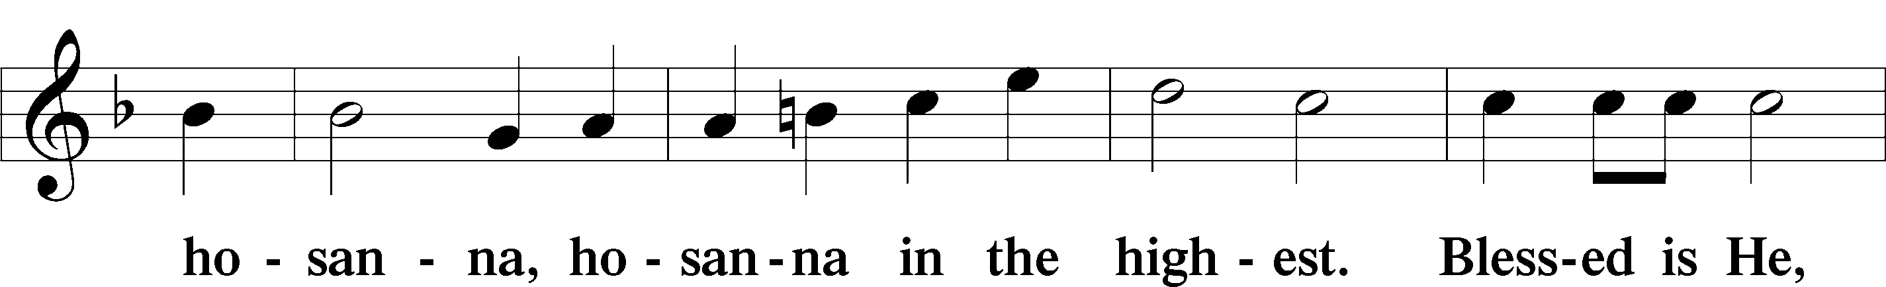
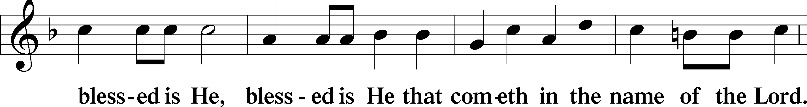
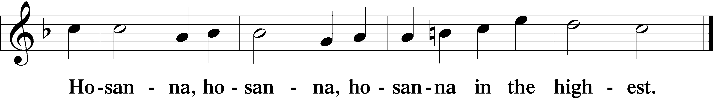

Lord’s Prayer The congregation is encouraged to silently pray the Lord’s Prayer as it is chanted. Matthew 6:9–13
P Our Father who art in heaven,
hallowed be Thy name,
Thy kingdom come,
Thy will be done on earth as it is in heaven;
give us this day our daily bread;
and forgive us our trespasses as we forgive those who trespass against us;
and lead us not into temptation,
but deliver us from evil.
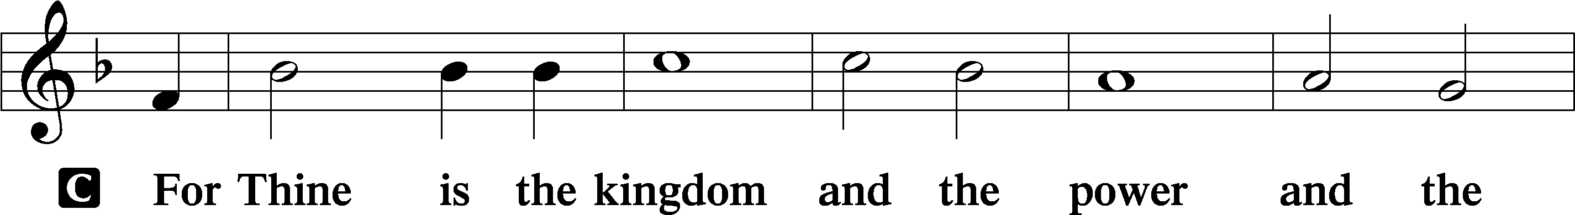
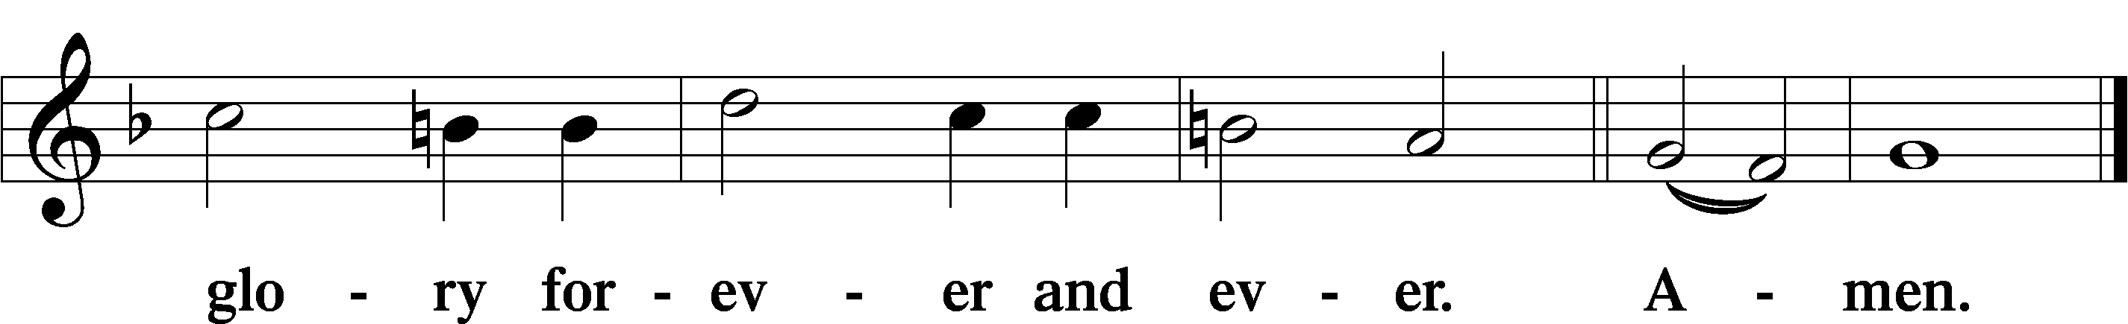

The Words of Our Lord Matthew 26:26–28; Mark 14:22–24; Luke 22:19–20; 1 Corinthians 11:23–25
P Our Lord Jesus Christ, on the night when He was betrayed, took bread, and when He had given thanks, He broke it and gave it to the disciples and said: “Take, eat; this is My T body, which is given for you. This do in remembrance of Me.”

In the same way also He took the cup after supper, and when He had given thanks, He gave it to them, saying: “Drink of it, all of you; this cup is the new testament in My T blood, which is shed for you for the forgiveness of sins. This do, as often as you drink it, in remembrance of Me.”

Pax Domini John 20:19
P The peace of the Lord be with you always.
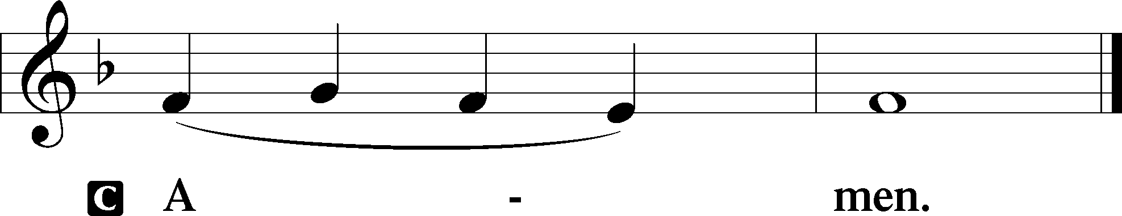

Agnus Dei John 1:29
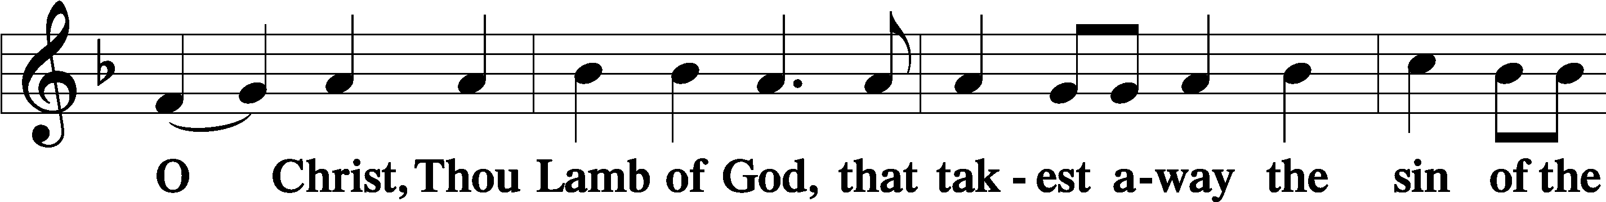
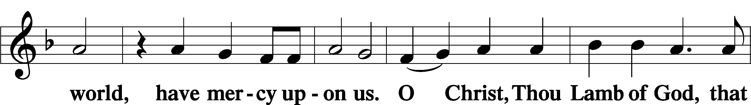
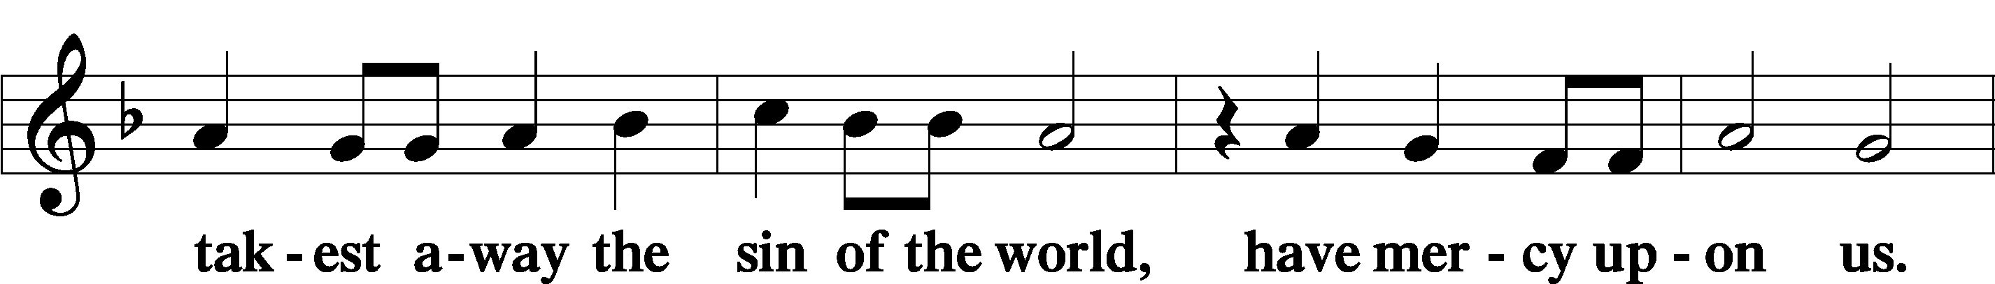
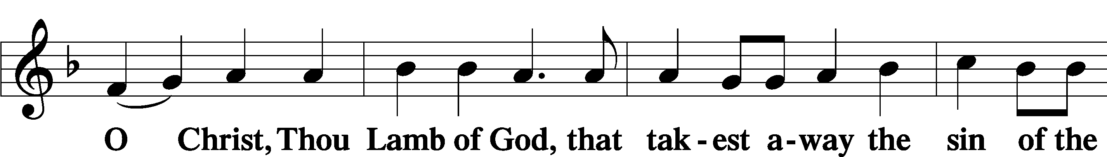
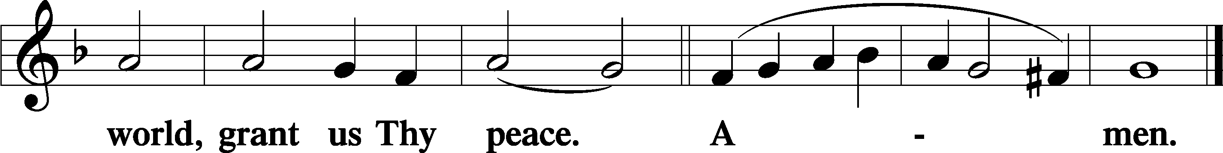
Sit

Distribution
The pastor and those who assist him receive the body and blood of Christ first and then distribute them to those who come to receive, saying:
Take, eat; this is the true body of our Lord and Savior Jesus Christ, given into death for your sins.
Amen.

Take, drink; this is the true blood of our Lord and Savior Jesus Christ, shed for the forgiveness of your sins.
Amen.

In dismissing the communicants, the following is said:
The Dismissal
P The body and blood of our Lord Jesus Christ strengthen and preserve you in body and soul to life everlasting. Depart T in peace.
C Amen.

Distribution Hymn: LSB #743 “Jesus, Priceless Treasure”

Distribution Hymn: LSB #708 “Lord, Thee I Love with All My Heart”

Distribution Hymn: LSB #490 “Jesus Lives! The Victory’s Won”

Stand

Nunc Dimittis Luke 2:29–32
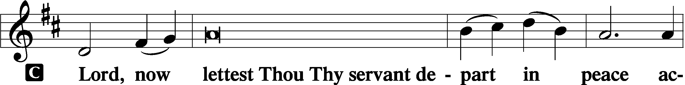
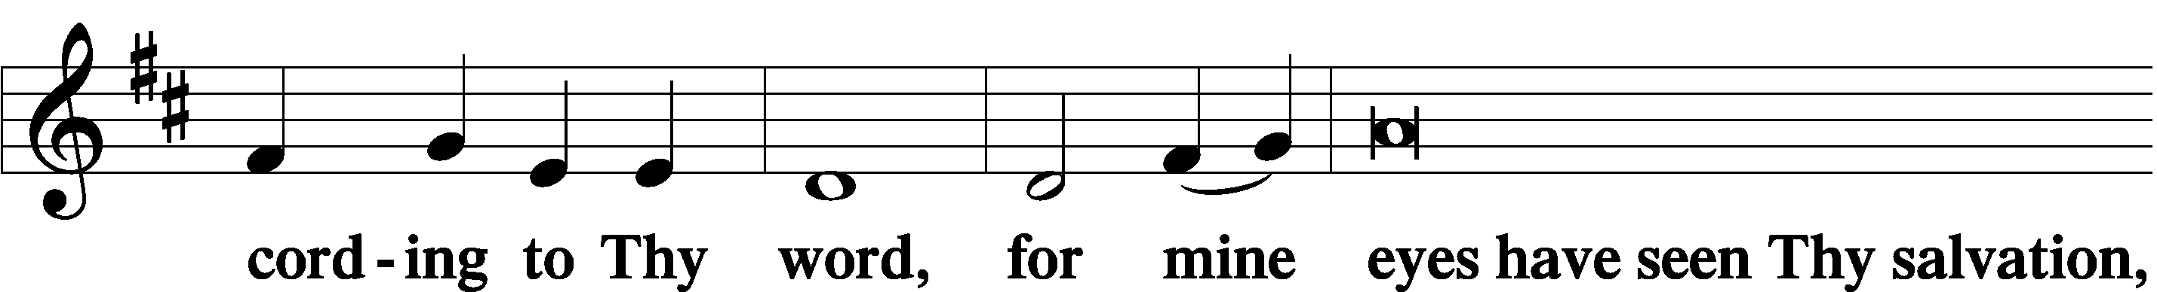
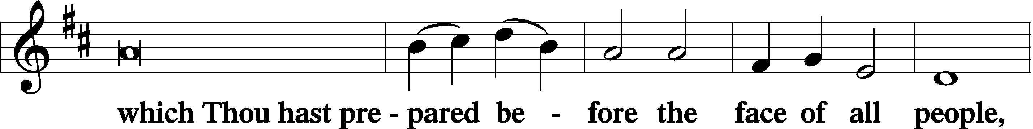
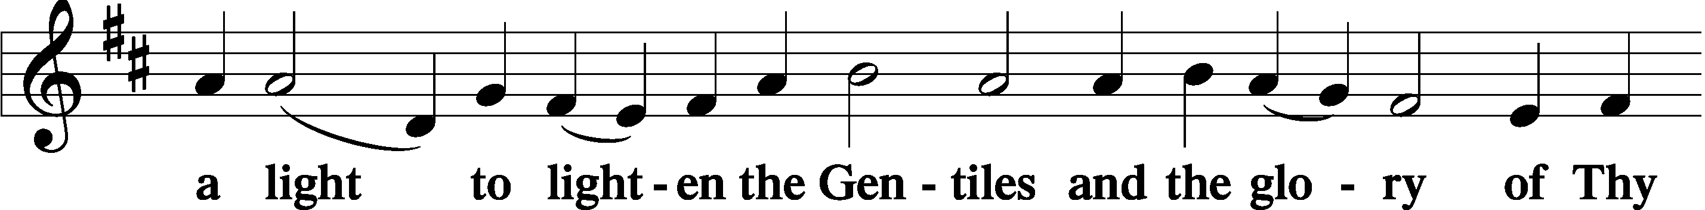
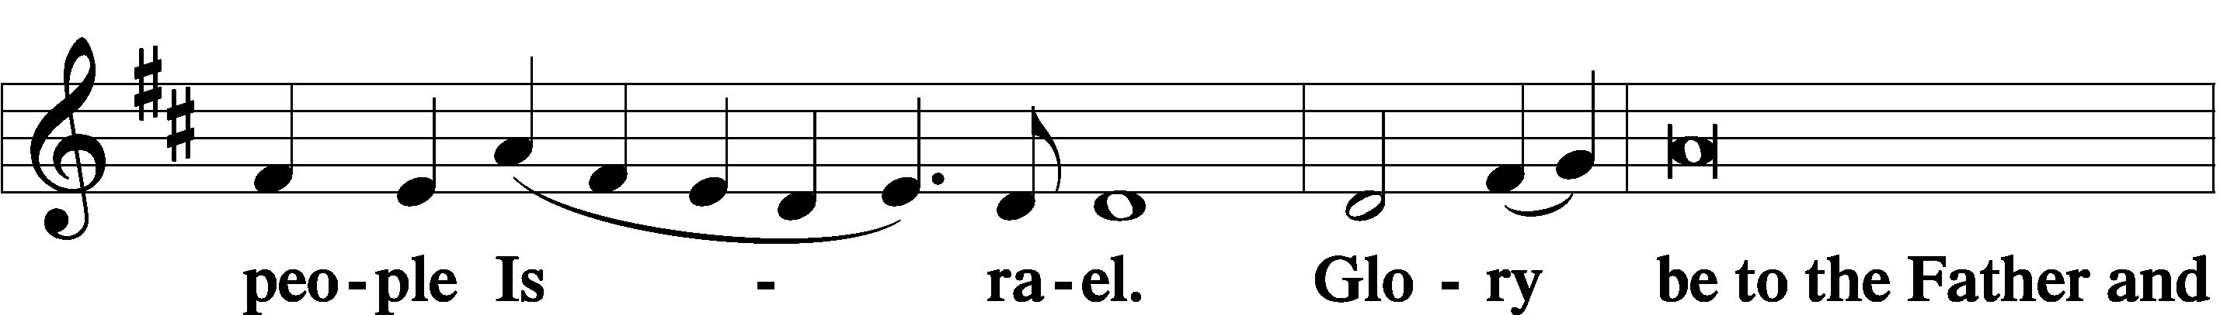
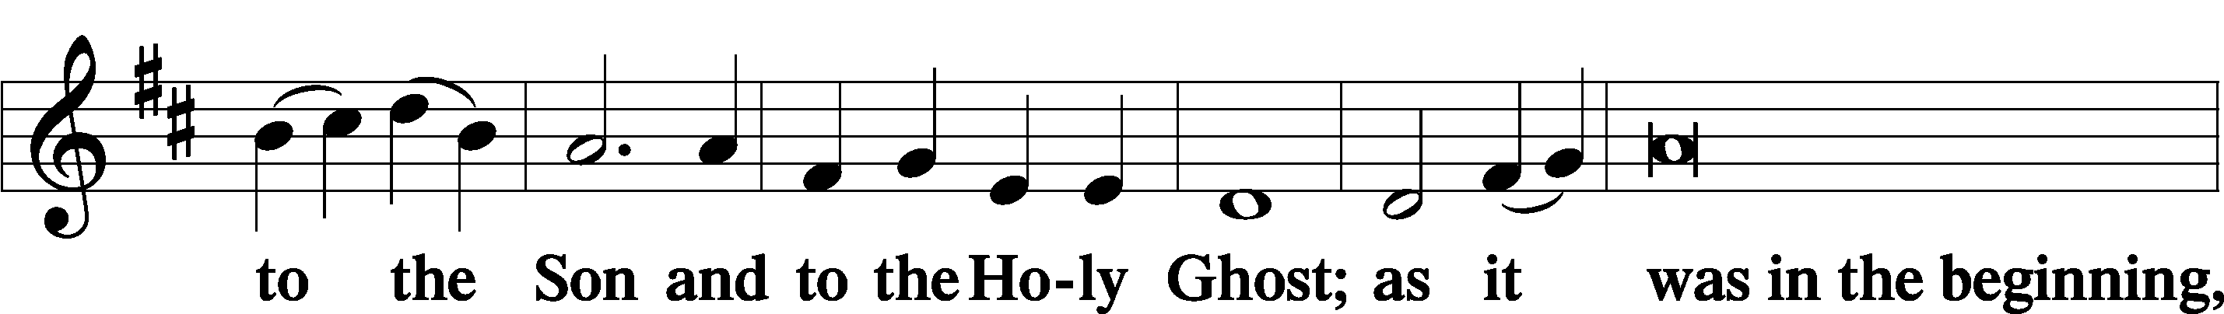
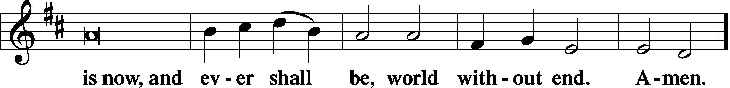

Thanksgiving Psalm 107:1
P O give thanks unto the Lord, for He is good,
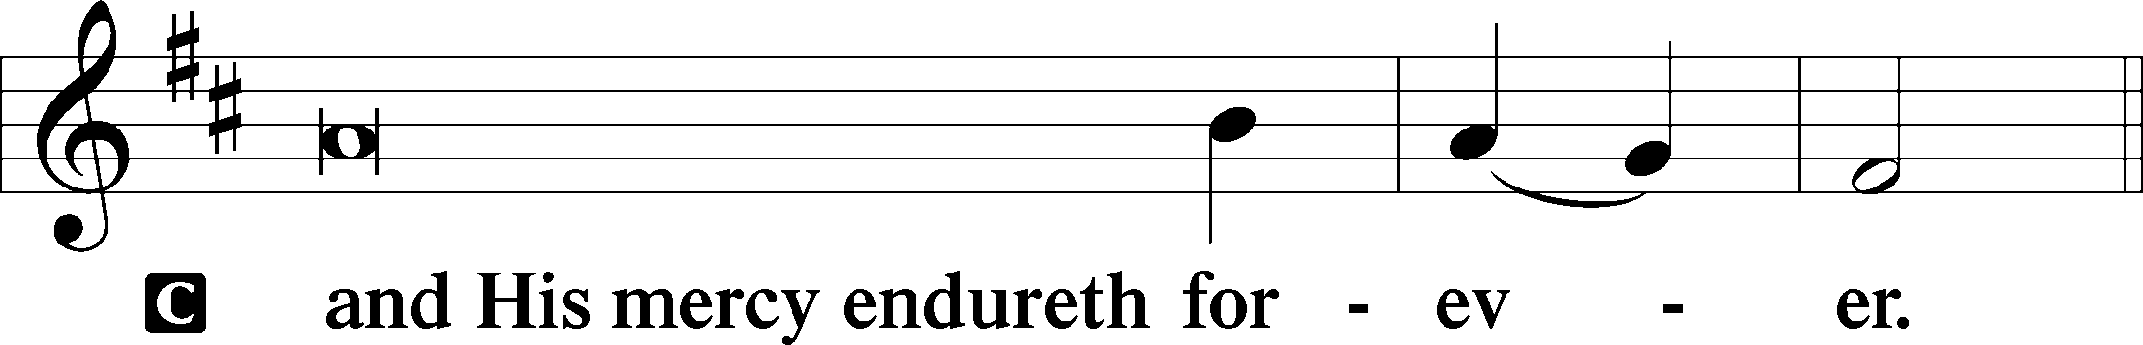

Post-Communion Collect
P Let us pray.
We give thanks to You, almighty God, … through Jesus Christ, Your Son, our Lord, who lives and reigns with You and the Holy Spirit, one God, now and forever.
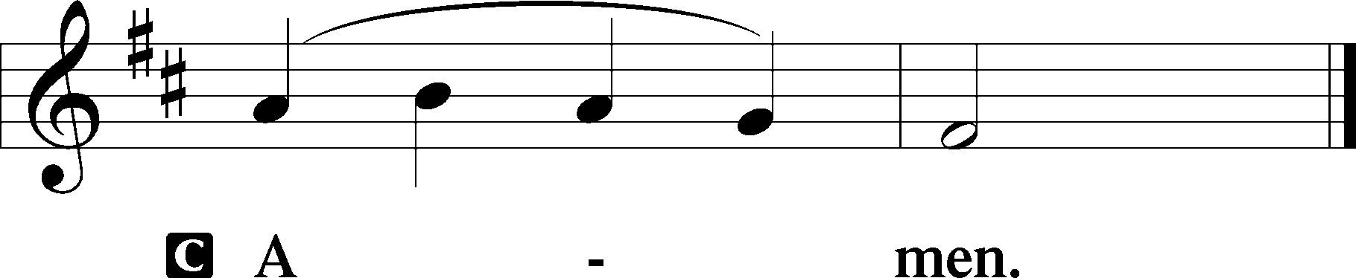

Salutation 2 Timothy 4:22
P The Lord be with you.
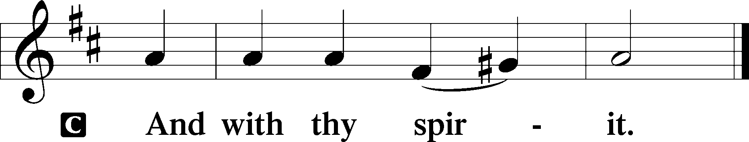

Benedicamus Psalm 103:1
P Bless we the Lord.
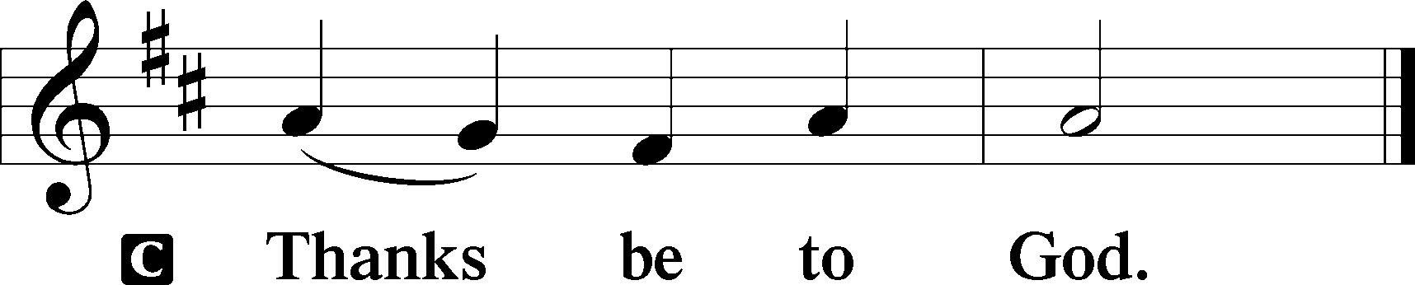

Benediction Numbers 6:24–26
P The Lord bless you and keep you.
The Lord make His face shine upon you and be gracious unto you.
The Lord lift up His countenance upon you and T give you peace.
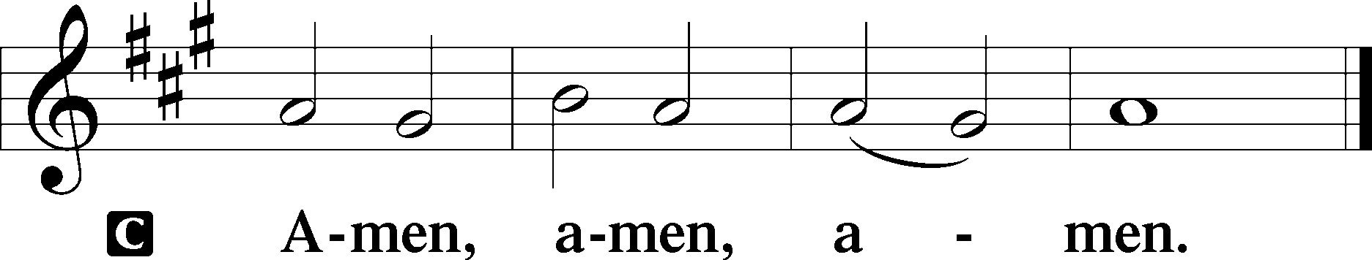

Closing Hymn: LSB #478 “The Day of Resurrection”

Silent prayer after worship: Dear Jesus, grant me the assurance that I am never alone, but that You are always with me. Lead me to be in Your Word, in prayer, and in worship regularly so that through me You might bring others to Yourself. Amen.

Acknowledgments
Unless otherwise indicated, Scripture quotations are from the ESV® Bible (The Holy Bible, English Standard Version®), copyright © 2001 by Crossway, a publishing ministry of Good News Publishers. Used by permission. All rights reserved.Created by Lutheran Service Builder © 2024 Concordia Publishing House.

fffffffffffffffffffffffffffffffffff
In Loving Memory of Uncle Rev. Paul Grexa’s and Aunt Ann Zomparelli’s Birthday, April 22nd: Dolores Fee (Capital Campaign).
In Loving Memory of Vi Sakony: Patty Parker (Altar Guild).
fffffffffffffffffffffffffffffffffff
SCHEDULE THROUGH APRIL 28, 2024:

:

Today, Following Worship, Library: Auditing
7 pm, Fellowship Hall: AA Meeting
Tuesday, 5:30 pm, All Saints (Slippery Rock): Catechesis
7-9 pm, Fellowship Hall: Penn-Ohio Singers
Wednesday, 10 am, Sanctuary: Matins Service
Following, Sanctuary: Choir Practice
7 pm, Fellowship Hall: NA Meeting
Thursday, 9 am, Downstairs: Food Pantry
6-6:45 pm, Sanctuary: Choir Practice
7 pm, Sanctuary: Vespers Service Celebrating Saint Mark, Evangelist
Friday, 10 am, Fellowship Hall: Craft Fellowship
Next Sunday, 8 am, Fellowship Hall: Bible Study
9 am, Sanctuary: Divine Service
6 pm, Deal Home: Sunday Evening Bible Study
7 pm, Fellowship Hall: AA Meeting
Our Stewardship of Treasures for the Lord:
Online Figures for April 11 & April 15, 2024
General Fund: $230.00
Capital Campaign: $200.00
Figures for Sunday, April 14, 2024
General Fund: $2,730.00
SELC: $70.00
Food Pantry: $53.00
Quarterly Missions: $35.00
Altar Guild: $100.00
Capital Campaign: $1,035.00
Other: $930.00
YTD Giving/Budget (as of April 7, 2024)
General Fund: $30,589.79/ $37,975.28
SELC: $776.00 / $1,076.88

For online giving, check out https://www.saintspeterandpaul.net/online-giving.
fffffffffffffffffffffffffffffffffff
Bible Memory Verses ~ Week of April 21st:
For Adults: In the same way, let your light shine before others, so that they may see your good works and give glory to your Father who is in heaven.
Matthew 5:16
For Children: If anyone is in Christ, he is a new creation. The old has passed away; behold, the new has come. 2 Corinthians 5:17
fffffffffffffffffffffffffffffffffff
Attendance: Sunday, April 14, 2024: 43
Wednesday, April 17, 2024: 6
fffffffffffffffffffffffffffffffffff
THANK YOU FOR SERVING IN APRIL: Elder: Jonathan Baisch; Ushers: Cheryl Fedele, Mike Flaugher, & Jesse Riffle. Altarware ~ (prior) Diane Riefstahl (04.21 & 04.28); (after) Evelyn Baisch & Traudi Sulek.
fffffffffffffffffffffffffffffffffff
Join us this Thursday evening at 7 pm for a special Vespers Service celebrating the Festival of Saint Mark, Evangelist.
Remember the following in Prayer…
~The Hurting and Healing: Amy, Ralph, Steve, Mary Jane Anderson, Steve Antolovich, Ellen Baron^{CA}, Don Baxter^{CA}, Amy Blomenberg, Lois Bortner^{CA}, Sara Brubaker and her son, Canaan; Dee Bullock, Bev & Joe Chlpka, Susan Davies, Tim Dudash, Mike Flaugher, Judith & Eddy Furey, Griffin, Pastor Charles Henrickson, Joan, Keith Jozwiakowski, Darla Krajci, Barbara Kreske, Jess Lavoie, Paul Lucas^{CA}, Sandy Marshall, Drew Martz, Augusta Mennell, Juanita Rentschler, Richard Reuning^{CA}, Nancy Robertson^{CA}, Kriss Svidro^{CA}, Rudy Tomko, Bob Usnarski, Joel & Peggy Wasson, Angela Weser^{CA}, and Ruth Wolf.
~The Homebound: Anna Mae Daris, Millie Elavsky, Jean Tomko, Betty Wolf, and Ed & Millie Zachar.
~Celebrating: Birthday: Henrietta Holcroft (04.24).
~Serving in the Military: Alex (Sasha) Carr, Duncan Vaupel, Curtis Sinewe, and Joshua Solyan.
~Community & World Needs: Those suffering due to the conflicts in the Middle East and between Ukraine and Russia; those suffering from loss and dislocation because weather disasters; those suffering from addiction and their families; Local, State, and National Government Leaders; safety for all Police Officers, Firefighters, & First Responders; the unemployed; our Second Quarter Local Mission: Support of a Concordia, Fort Wayne Seminarian. . *CA represents cancer.
fffffffffffffffffffffffffffffffffff
Items for the May calendar and newsletter are due to Diane by 9 am tomorrow, Monday, April 22nd.
fffffffffffffffffffffffffffffffffff
Church Council members are reminded of the Council meeting Monday, April 22nd at 7 pm. If responsible for a report, please email it to Diane by noon tomorrow so that packets for the meeting may be prepared.
fffffffffffffffffffffffffffffffffff
Your bulletin this morning should contain two inserts, one concerning the May 6th Vitalant blood drive and another concerning LCEF investment opportunities. Additional copies of both are available on the table in the narthex.
fffffffffffffffffffffffffffffffffff
Here to Serve
Pastor………………………………………………...……………Rev. Jacob Deal
E-mail …………………………….……pastordeal@saintspeterandpaul.net
Phone Number……………………..…………………724-347-3620 (Option 2)
Church Office………………………..…………………724-347-3620 (Option 3)
Website …………………………………………www.saintspeterandpaul.net
Secretary…………………………………………………………Diane Riefstahl
E-mail ………………………………………church@saintspeterandpaul.net
Food Pantry (phone): ……………………………….…724-347-3620 (opt. 4)
Food Pantry (email): …….………foodpantry@saintspeterandpaul.net
Congregation President………………………………….…Jonathan Baisch
Church Elder …………………………………………...……. Jonathan Baisch
Organist………………………………………………..….…Rebecca Marquette
AA Contact: Steve………………………………………………...…724-813-2358
NA Contact: Larry……………………………………..…………..724-977-8733
fffffffffffffffffffffffffffffffffff
If needing to get into the church building during the week, please phone first to make certain someone is here to let you in.

