Sts. Peter & Paul
Evangelical Lutheran Church
Lutheran Church-Missouri Synod
Founded-1917

APRIL 21, 2019

699 Stambaugh Avenue
Sharon, Pennsylvania 16146

“I was glad when they said to me,
Let us go to the house of the LORD!”
Psalm 122:1
Sts. Peter & Paul Evangelical Lutheran Church, LC-MS

EASTER SUNDAY: THE RESURRECTION OF OUR LORD
April 21, 2019

Silent prayer before worship: Heavenly Father, give me confidence to trust that through our living Savior Jesus I have a new and eternal life. Fill my heart with a joyful desire to share the wonderful news that Christ is risen. Amen.

Please read Communion Statement found in pews prior to taking part in Holy Communion.
CONFESSION AND ABSOLUTION
Opening Hymn: LSB #457 “Jesus Christ Is Risen Today”
Stand
The sign of the cross may be made by all in remembrance of their Baptism.

P In the name of the Father and of the T Son and of the Holy Spirit.
C Amen. Matthew 28: 19b; [18:20]

P If we say we have no sin, we deceive ourselves, and the truth is not in us.
C But if we confess our sins, God, who is faithful and just, will forgive our sins and cleanse us from all unrighteousness.

Silence for reflection on God's Word and for self-examination.

P Let us then confess our sins to God our Father.
C Most merciful God, we confess that we are by nature sinful and unclean. We have sinned against You in thought, word, and deed, by what we have done and by what we have left undone. We have not loved You with our whole heart; we have not loved our neighbors as ourselves. We justly deserve Your present and eternal punishment. For the sake of Your Son, Jesus Christ, have mercy on us. Forgive us, renew us, and lead us, so that we may delight in Your will and walk in Your ways to the glory of Your holy name. Amen.
P Almighty God in His mercy has given His Son to die for you and for His sake forgives you all your sins. As a called and ordained servant of Christ, and by His authority, I therefore forgive you all your sins in the name of the Father and of the T Son and of the Holy Spirit. [John 20: 19-23]
C Amen.

Passing of the Peace.
SERVICE OF THE WORD
Introit: Ps. 8:1, 5–6, 9; antiphon: Luke 24:5b–6b
He is risen! Alle- | luia!*
Why do you seek the living among the dead? Alle- | luia!
Remember how he told you, Alle- | luia,*
that the Son of Man must be crucified and on the third day rise. Alle- | luia!
O Lord, our Lord, how majestic is your name in | all the earth!*
You have set your glory above the | heavens.
Yet you have made him a little lower than the heavenly | beings*
and crowned him with glory and | honor.
You have given him dominion over the works | of your hands;*
you have put all things under | his feet.
O | Lord, our Lord,*
how majestic is your name in | all the earth!
Glory be to the Father and | to the Son*
and to the Holy | Spirit;
as it was in the be- | ginning,*
is now, and will be forever. | Amen.
He is risen! Alle- | luia!*
Why do you seek the living among the dead? Alle- | luia!
Remember how he told you, Alle- | luia,*
that the Son of Man must be crucified and on the third day rise. Alle- | luia!

Kyrie Mark 10:47
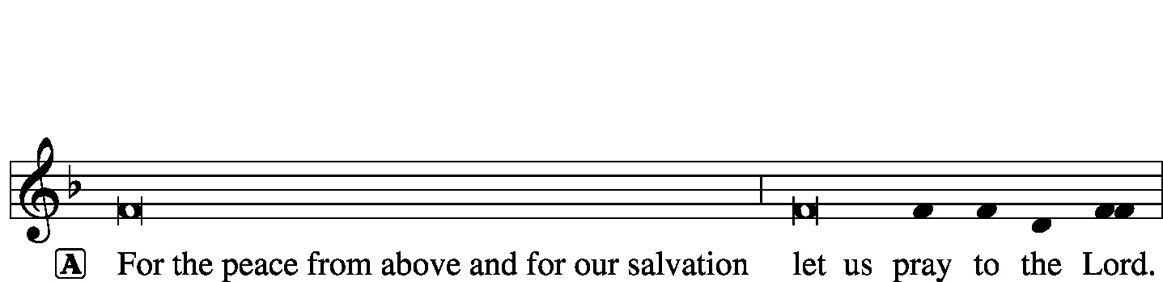
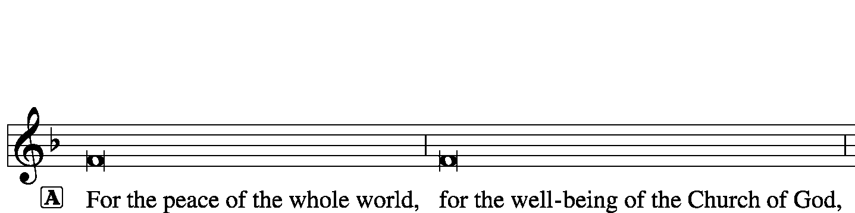
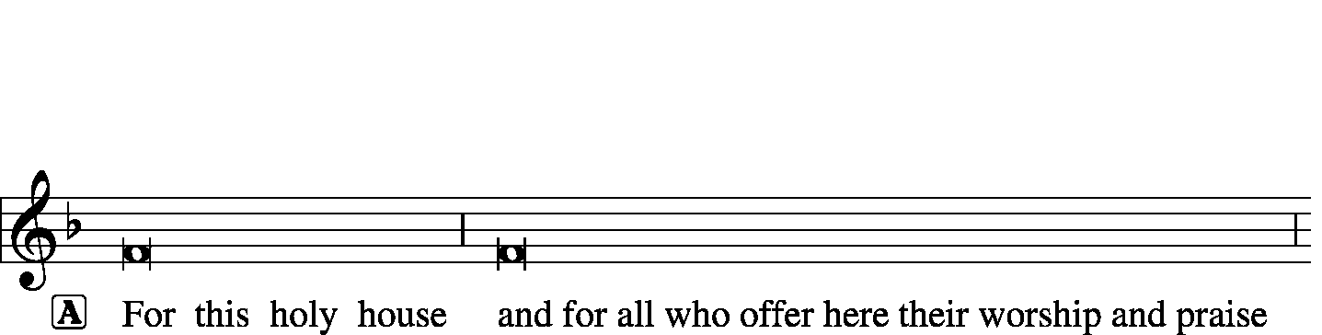
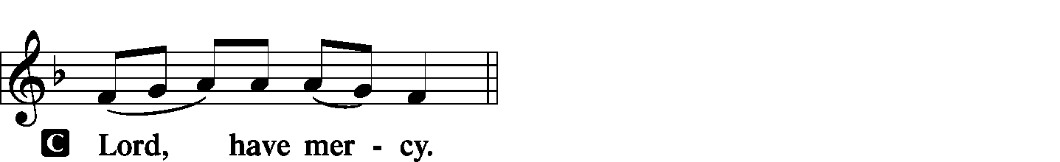
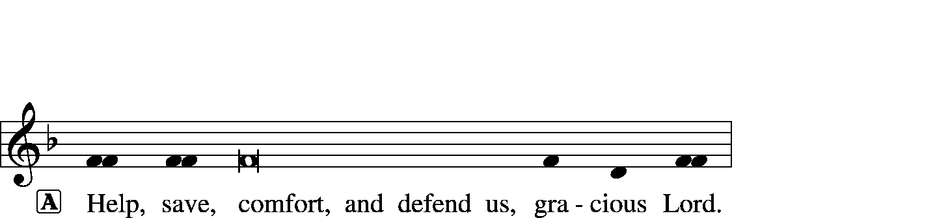

Gloria in Excelsis Luke 2: 14; John 1: 29
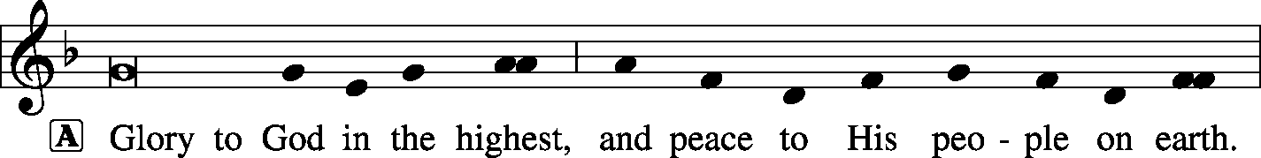
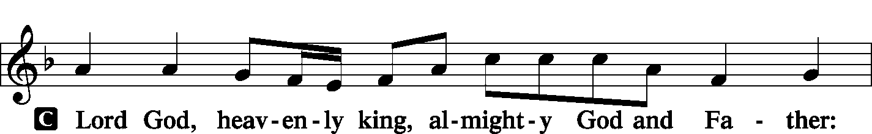
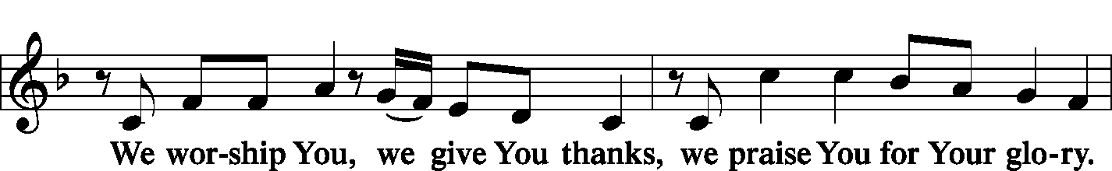
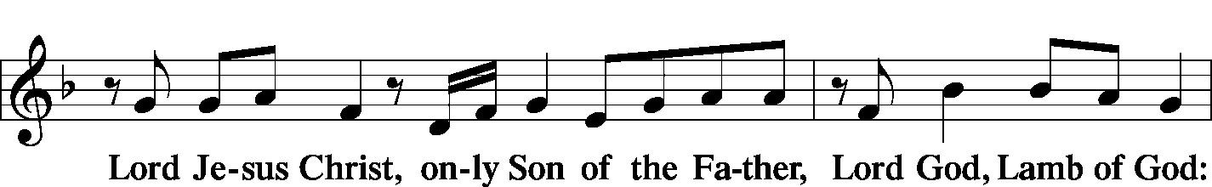
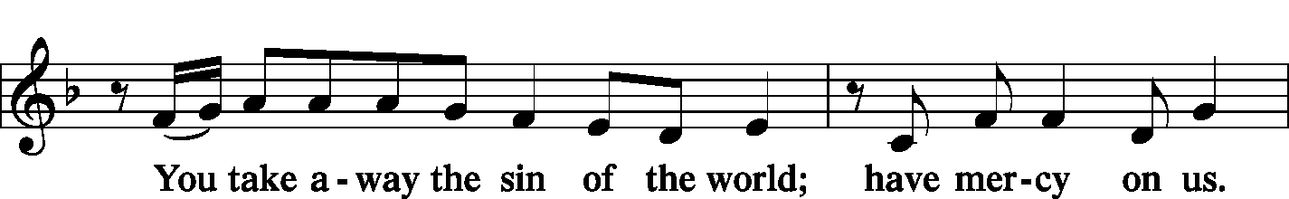
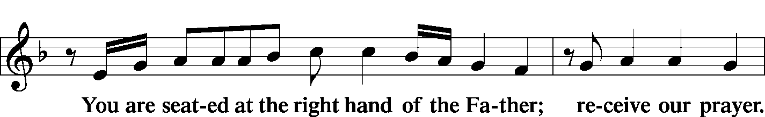
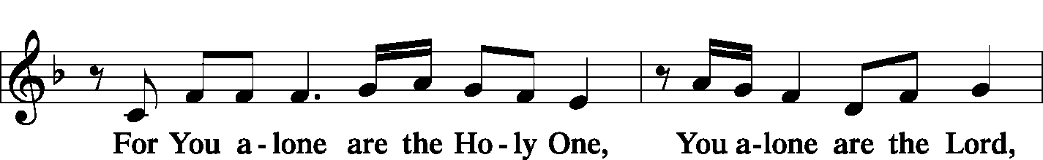
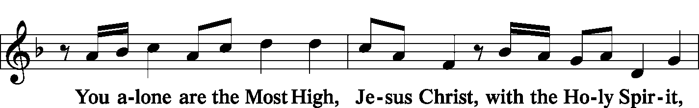
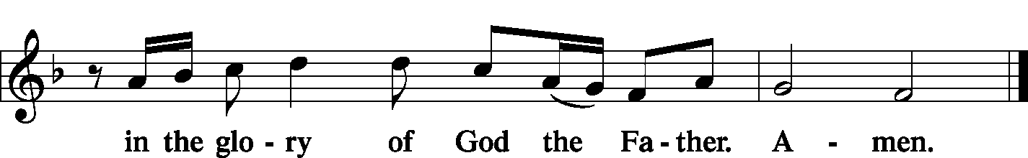

Salutation and Collect of the Day 2 Timothy 4: 22
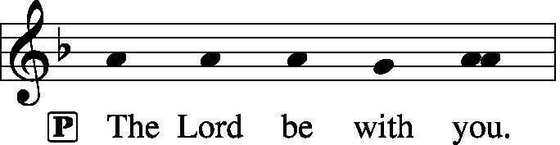
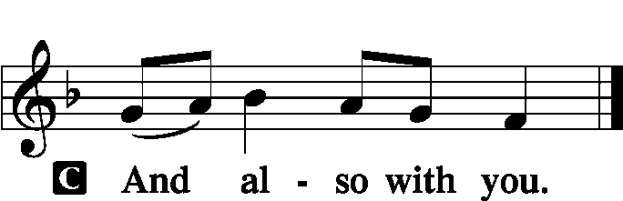

P Let us pray.
Almighty God the Father, through Your only-begotten Son, Jesus Christ, You have overcome death and opened the gate of everlasting life to us. Grant that we, who celebrate with joy the day of our Lord’s resurrection, may be raised from the death of sin by Your life-giving Spirit; through Jesus Christ, our Lord, who lives and reigns with You and the Holy Spirit, one God, now and forever.

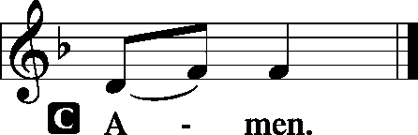

Sit

Old Testament Reading: Job 19:23–27
“Oh that my words were written!
Oh that they were inscribed in a book!
Oh that with an iron pen and lead
they were engraved in the rock forever!
For I know that my Redeemer lives,
and at the last he will stand upon the earth.
And after my skin has been thus destroyed,
yet in my flesh I shall see God,
whom I shall see for myself,
and my eyes shall behold, and not another.
My heart faints within me!”
P This is the Word of the Lord.
C Thanks be to God.

Gradual: Ps. 118:24, 1
This is the day that the Lord has made;
let us rejoice and be glad in it.
Oh give thanks to the Lord, for he is good;
for his steadfast love endures forever!
Epistle: 1 Corinthians 5:6–8
Your boasting is not good. Do you not know that a little leaven leavens the whole lump? Cleanse out the old leaven that you may be a new lump, as you really are unleavened. For Christ, our Passover lamb, has been sacrificed. Let us therefore celebrate the festival, not with the old leaven, the leaven of malice and evil, but with the unleavened bread of sincerity and truth.

P This is the Word of the Lord.
C Thanks be to God.

Choir: “Alleluia! Christ Is Risen”
Stand
Verse of the Day: 1 Cor. 5:7b–8a, c
Alleluia. Christ, our Passover lamb, has been sacrificed. Let us therefore celebrate the festival with the unleavened bread of sincerity and truth. Alleluia.

Common Alleluia
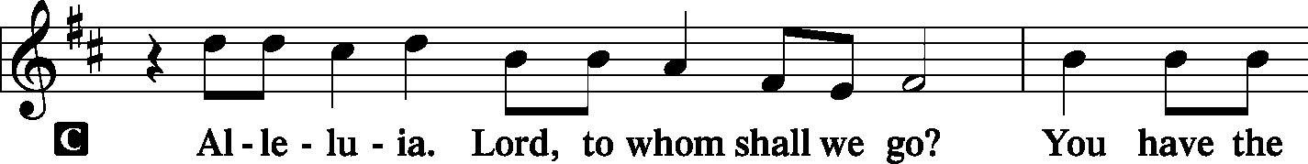
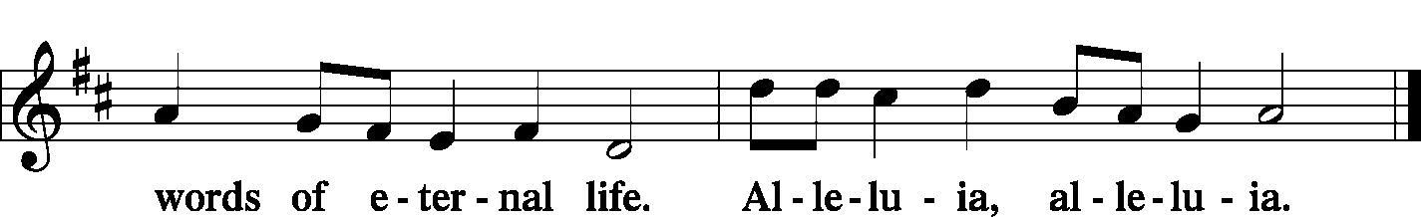

Holy Gospel: Mark 16:1–8
P The Holy Gospel according to St. Mark, the sixteenth chapter.

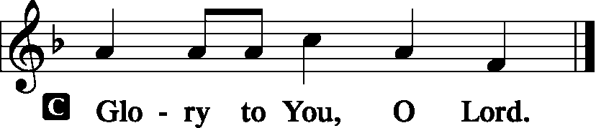

When the Sabbath was past, Mary Magdalene and Mary the mother of James and Salome bought spices, so that they might go and anoint him. And very early on the first day of the week, when the sun had risen, they went to the tomb. And they were saying to one another, “Who will roll away the stone for us from the entrance of the tomb?” And looking up, they saw that the stone had been rolled back—it was very large. And entering the tomb, they saw a young man sitting on the right side, dressed in a white robe, and they were alarmed. And he said to them, “Do not be alarmed. You seek Jesus of Nazareth, who was crucified. He has risen; he is not here. See the place where they laid him. But go, tell his disciples and Peter that he is going before you to Galilee. There you will see him, just as he told you.” And they went out and fled from the tomb, for trembling and astonishment had seized them, and they said nothing to anyone, for they were afraid.

P This is the Gospel of the Lord.

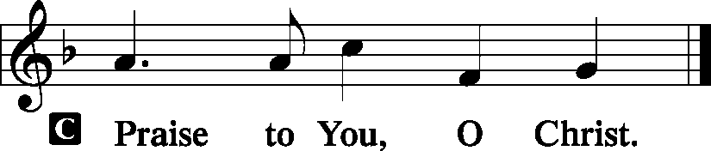

Nicene Creed
C I believe in one God,
the Father Almighty,
maker of heaven and earth
and of all things visible and invisible.
And in one Lord Jesus Christ,
the only-begotten Son of God,
begotten of His Father before all worlds,
God of God, Light of Light,
very God of very God,
begotten, not made,
being of one substance with the Father,
by whom all things were made;

who for us men and for our salvation came down from heaven
and was incarnate by the Holy Spirit of the virgin Mary
and was made man;
and was crucified also for us under Pontius Pilate.
He suffered and was buried.
And the third day He rose again according to the Scriptures
and ascended into heaven
and sits at the right hand of the Father.
And He will come again with glory to judge both the living and the dead,
whose kingdom will have no end.
And I believe in the Holy Spirit,
the Lord and giver of life,
who proceeds from the Father and the Son,
who with the Father and the Son together is worshiped and glorified,
who spoke by the prophets.
And I believe in one holy Christian and apostolic Church,
I acknowledge one Baptism for the remission of sins,
and I look for the resurrection of the dead
and the life T of the world to come. Amen.
Sit

Hymn of the Day: LSB #458 “Christ Jesus Lay in Death's Strong Bands”

Sermon
Stand

Prayer of the Church [Timothy 2: 1-4]

Sit

Offertory Psalm 116: 12-13, 17-19
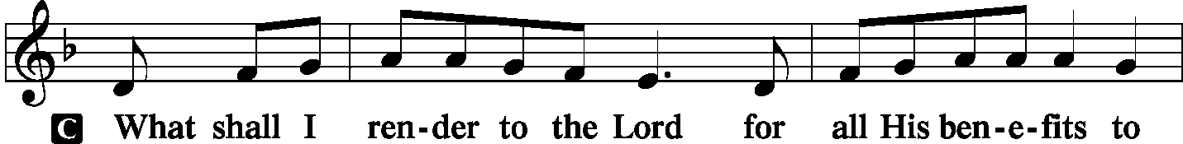
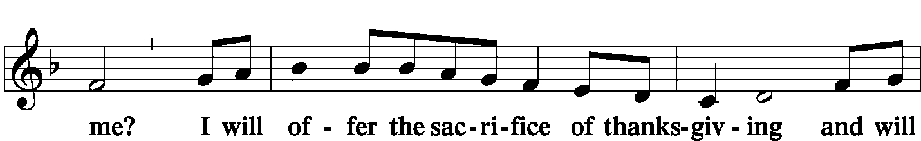
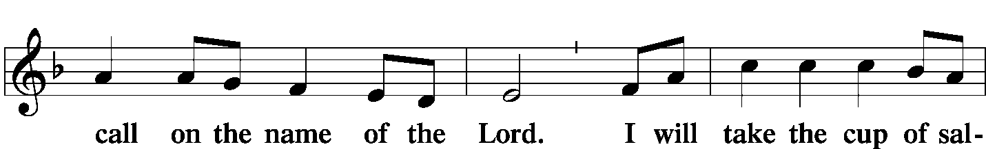
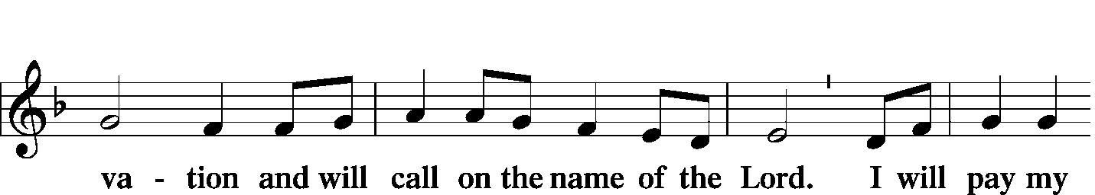
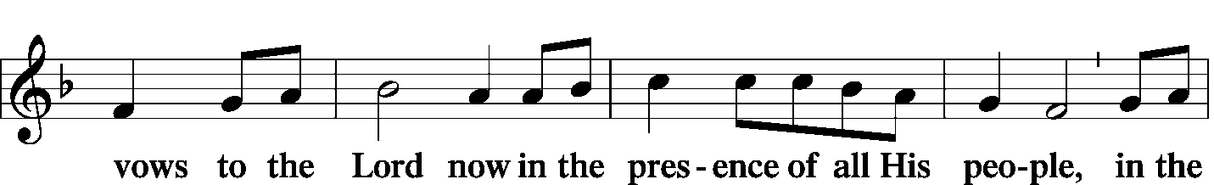
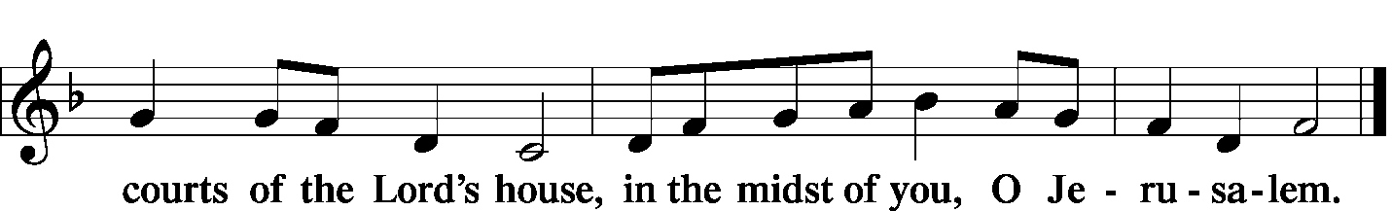

Offering
Stand
SERVICE OF THE SACRAMENT
Preface LSB 160
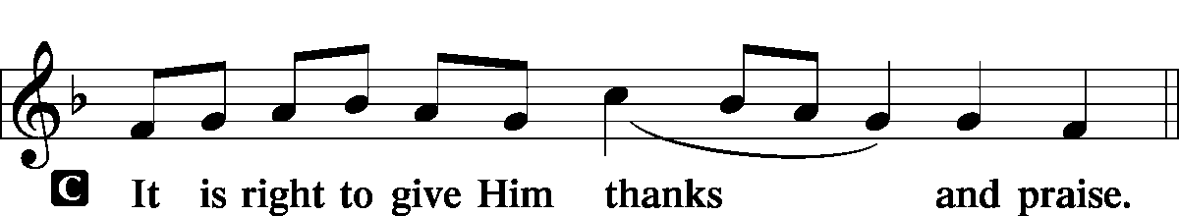

P It is truly meet, right, and salutary that we should at all times and in all places give thanks to You, holy Lord, almighty Father, everlasting God. And most especially are we bound to praise You on this day for the glorious resurrection of Your Son, Jesus Christ, the very Paschal Lamb, who was sacrificed for us and bore the sins of the world. By His dying He has destroyed death, and by His rising again He has restored to us everlasting life. Therefore with Mary Magdalene, Peter and John, and with all the witnesses of the resurrection, with angels and archangels, and with all the company of heaven we laud and magnify Your glorious name, evermore praising You and saying:

Sanctus
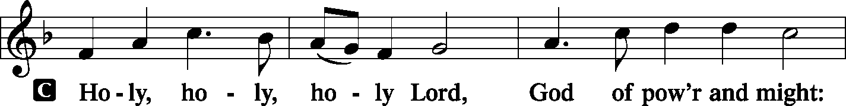
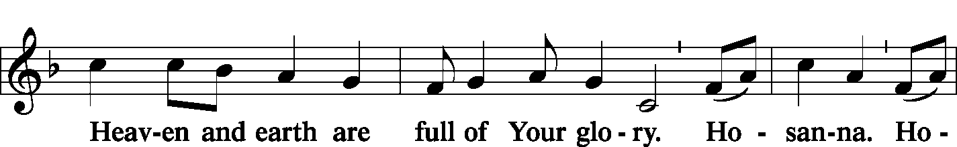
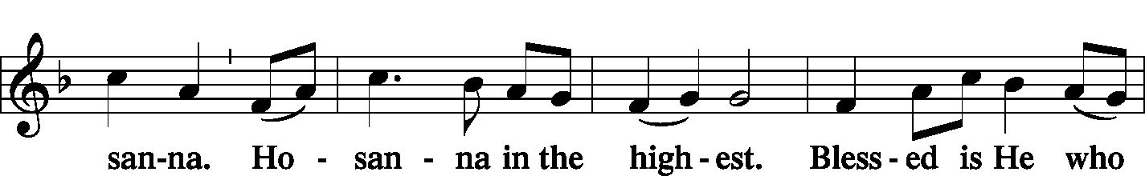
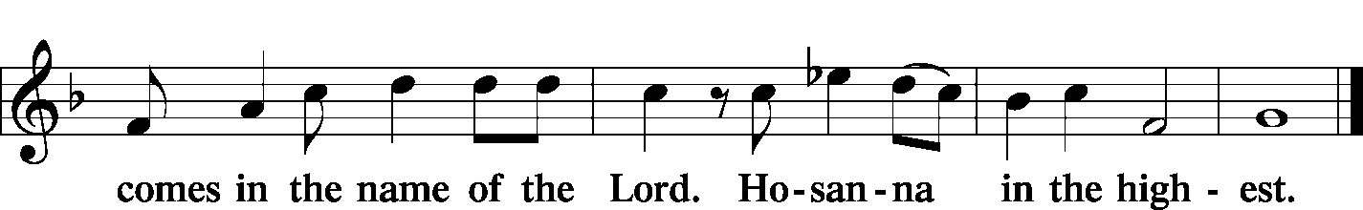

Lord's Prayer Matthew 6: 9-13
P Lord, remember us in Your kingdom and teach us to pray:
C Our Father who art in heaven,
hallowed be Thy name,
Thy kingdom come,
Thy will be done on earth as it is in heaven;
give us this day our daily bread;
and forgive us our trespasses as we forgive those who trespass against us;
and lead us not into temptation,
but deliver us from evil.
For Thine is the kingdom and the power and the glory forever and ever. Amen.

The Words of Our Lord Matthew 26: 26-28; Mark 14: 22-24
Luke 22: 19-20; 1 Corinthians 11: 23-25
P Our Lord Jesus Christ, on the night when He was betrayed, took bread, and when He had given thanks, He broke it and gave it to the disciples and said: “Take, eat; this is My T body, which is given for you. This do in remembrance of Me.”

P In the same way also He took the cup after supper, and when He had given thanks, He gave it to them, saying: “Drink of it, all of you; this cup is the new testament in My T blood, which is shed for you for the forgiveness of sins. This do, as often as you drink it, in remembrance of Me.”

Pax Domini John 20: 19
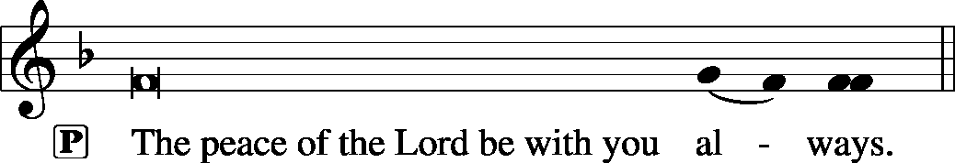

Agnus Dei John 1: 29
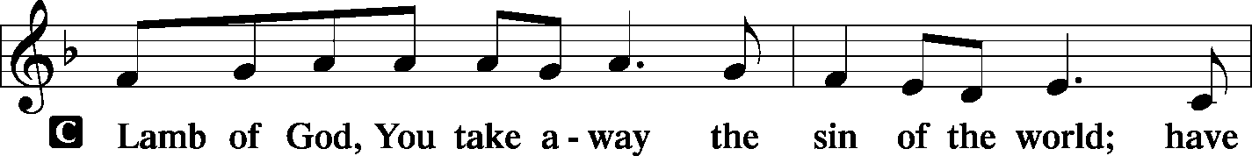
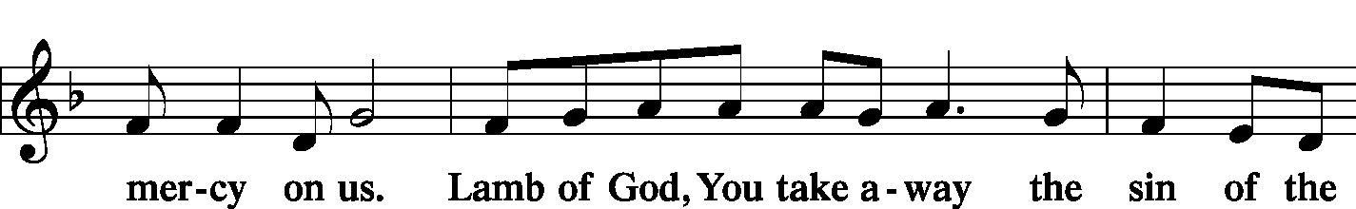
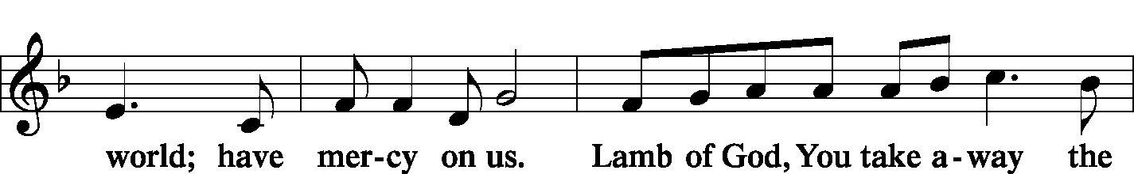
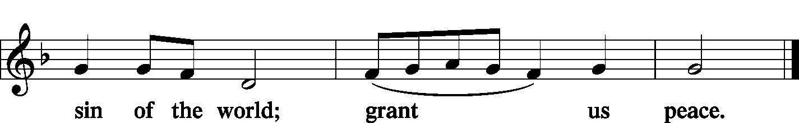

Sit

Distribution
The pastor and those who assist him receive the body and blood of Christ first and then distribute them to those who come to receive, saying:

Take, eat; this is the true body of our Lord and Savior Jesus Christ, given into death for your sins.
Amen.

Take, drink; this is the true blood of our Lord and Savior Jesus Christ, shed for the forgiveness of your sins.
Amen.
In dismissing the communicants, the following is said:
P The body and blood of our Lord Jesus Christ strengthen and preserve you in body and soul to life everlasting. Depart T in peace.
C Amen.

Distribution Hymns: LSB page 155 “This Is the Feast”
LSB #466 “Christ Has Arisen, Alleluia”
Stand

Thank the Lord
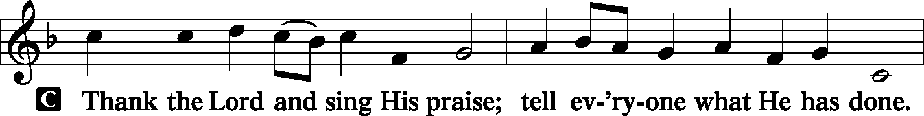
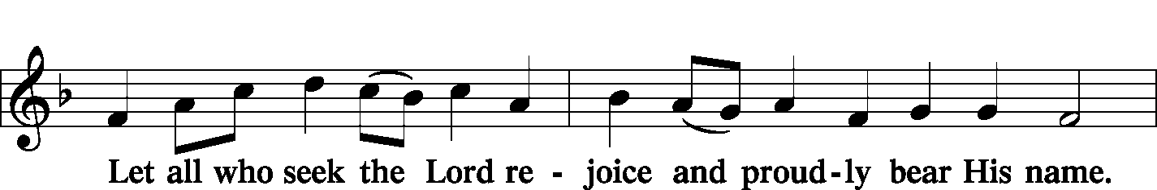
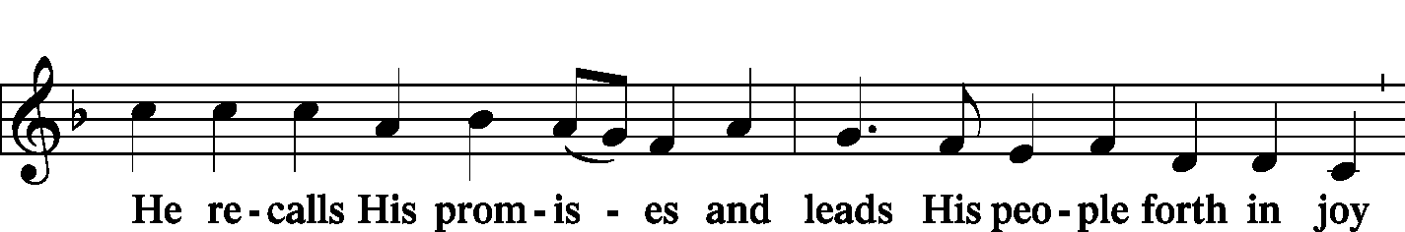
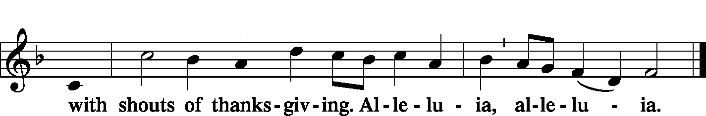

Post-Communion Collect Let us pray.
P We give thanks to You, almighty God, that You have refreshed us through this salutary gift, and we implore You that of Your mercy You would strengthen us through the same in faith toward You and fervent love toward one another; through Jesus Christ, Your Son, our Lord, who lives and reigns with You and the Holy Spirit, one God, now and forever.
C Amen.

Benediction Numbers 6: 24-26

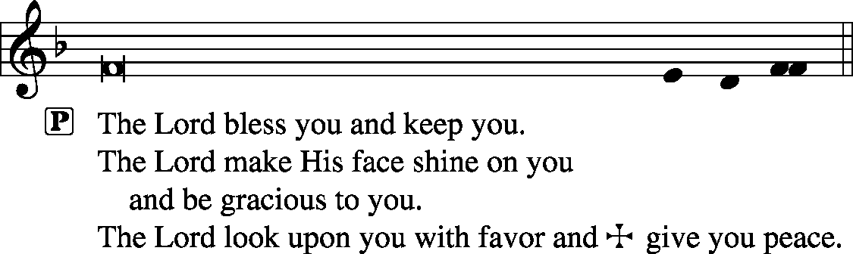

Closing Hymn: LSB #477 “Alleluia, Alleluia! Hearts to Heaven”

Silent prayer after worship: Lord Jesus, grant me the enduring comfort that You are with me every day and in all circumstances. Fill me with Your Holy Spirit so that I can live joyfully in Your love and share that love with others. Amen.

Acknowledgments: Divine Service, Setting One from Lutheran Service Book Unless otherwise indicated, all scripture quotations are from The Holy Bible, English Standard Version, copyright © 2001 by Crossway Bibles, a division of Good News Publishers. Used by permission. All rights reserved. Created by Lutheran Service Builder © 2006 Concordia Publishing House. CCLI License #3029-446

Word of Hope: 1-888-217-8679
The only 24/7 CONFIDENTIAL Hotline that is distinctly Lutheran, bringing healing found in Christ, to those whose hearts have been broken by abortion.


SCHEDULE FOR TODAY THROUGH APR. 21st:
:

:

Today, 7 pm, Downstairs….…………….…………………..…………..…………..……AA Meeting
Thursday, 9 am, Downstairs………………………………………………………..….…Food Pantry
Next Sunday, 8:45 am, Downstairs……………………………………………..………Bible Study
10 am, Sanctuary….....................................................................Divine Service
Following Worship, Library………………………………Audit Committee Meeting
3 pm, Gethsemane Lutheran………………………………………..……….MVL Meeting
7 pm, Downstairs…………………………………………..……………..…....…AA Meeting

Our Stewardship of Treasures for the Lord:
In order to do the Lord’s work, we need $2,882.02* each week to meet our 2019 budget for general purposes and $38.46 for missions.
Sunday, April 14, 2019:
General Offering:…..…..………...........................................................$2,223.25
Behind this week*#: -$328.77
SELC Missions:……….………..…..……......................................................$20.00 Behind this week#: -$18.46
Quarterly Local Mission:………………………………………………………..$10.00
Preschool Tuition Payments:...…………………...............................….....$330.00
Other Offerings:………….…….…….....................………..……..……......$166.00
Wednesday, April 10, 2019:
General Offering:…..…..………..............................................................$131.00
*Includes preschool tuition; #Includes Wednesday’s figures.

Bible Memory Verses: For the week of April 21st:
For Children: I am the living one. I died, and behold I am alive forevermore, and I have the keys of Death and Hades. Rev. 1:18
For Adults: I am the resurrection and the life. Whoever believes in me, though he die, yet shall he live, and everyone who lives and believes in me shall never die.
John 11:25-26a 

Attendance:
Sunday, April 14, 2019………………...……………………………………………58
Attendance numbers for Holy Week will be available next Sunday.
Remember the following in Prayer…
~The Hurting and Healing: Tony⁴, Tom Bender³,Lois Bortner^{CA}, Patricia Brandes³, Richard Brandes³, Eileen Burns³, Mark Chirdon⁴, Beverly Chlpka (having shoulder surgery this Thursday), Anne Colt², Loretta Deal⁴, Norma Ferringer³, Anson Holcroft⁴, Betty Knauff^{CA}, Regis Knauff⁴, Jess Lavoie², Paul Lucas^{CA}, Barry Nelson⁴, David Nelson¹,Tom Mulligan^{CA}, Iona Oltman^{CA}, Hugh Owen (having hip replacement surgery this Wednesday, Rudy Pinal^{CA}, Richard Reuning^{CA}, Katie Sass¹, and Angela Weser^{CA}.
~Our Homebound: Helen Bender, Dan Davis, Edna Krajci, Mary Ann Krajci, Sophie Mihm, Marion & Gene Roberts, Barbara Vasconi, and Joanne Wolfe.
~Celebrating: Birthday~Lillian Thurber (04.21) and Henrietta Holcroft (04.24).
~Serving in the Military: Clayton Drnek, Curtis Sinewe, and Joshua Solyan.
~Community & World Needs: Victims of violence and terrorism; those suffering from loss and dislocation because weather disasters; those suffering from addiction and their families; safety for teachers, staff, and students; Local, State, and National Government Leaders; Safety for all Police Officers, Firefighters, & First Responders; the unemployed; our Second Quarter Local Mission: Sts. Peter & Paul’s Third Annual Community Day.
*CA represents cancer; number after other names represents weeks on the prayer list. After 4 weeks names may be resubmitted. This helps us to remember people’s specific needs and reminds us that God is providing healing as people get better and no longer need our prayers. Please submit prayer requests in writing to the church office.
Please keep those listed above in your prayers.

Thank You for Serving in April:
Today’s Greeters: Anna Mae Daris & Millie Elavsky. Assisting Elders: John Dyll & Bob Sulek. Ushers: John Dyll, Barry Nelson, Jerome Thomas, Gary Burns, & Bob Sulek (alternate). Altarware: Anne Colt & Joani Rice.
April Greeters: 28 ~ Cheryl Fedele & Clara Krivosh.

Members of the Audit Committee are reminded of the Audit Committee Meeting to be held following worship next Sunday.

Special thanks is extended to Mrs. Catherine Carr, Ana Deal’s mother, who served as guest organist last evening for our Saturday Vigil and this morning for our Easter worship! We are grateful for her time and talents.

Members and guests are asked to sign the “Friendship” books found at the inside aisle of your pews. Ushers will collect signed sheets after the offering.

Sincere sympathy is extended to Viola Sakony at the passing of her sister, Caroline Swartzbeck, of Chandler, Arizona and to the friends and family of Nancy Scopic, former Thrivent representative.

Easter is a beautiful time to stop and take a moment to give thanks to God for those who work so tirelessly all year long to serve this church, maintain its property, and care for its congregation. We are especially indebted to the following:
Our Pastor and his Family
Our Elders
Our Trustees
Our Congregation Officers
Members of the Financial and Audit Staffs
Altar Guild Members and Altarware Cleaning Staff
Our Church Organist
Our Choir Director and Members of the Choir
Food Pantry Workers
Community Day Organizers and Workers
Buhl Day Organizers and Workers
Our Church Cleaning Staff
Sponsors of Monthly Coffee & Donuts Fellowships
Altar Flower Sponsors
The Little People Preschool Staff and Board
Our Church Ushers
Our Greeters
and those who give countless hours of heartfelt service.

Thank you and God Bless!
Here to Serve…

Pastor………………………………………………….………..…Rev. Jacob Deal
E-mail ……….…………………….…..pastordeal@saintspeterandpaul.net
Phone Number…………..……………………………724-347-3620 (Option 2)
Church Office………………………………….………724-347-3620 (Option 3)
Website ……….………………….……...…….www.saintspeterandpaul.net
Secretary………………………………………………….……. Diane Riefstahl
E-mail ……….…………………….…….…church@saintspeterandpaul.net
Food Pantry: John Dyll…………….……………………..…..…724-347-1779
Little People Preschool…………….……………….724-347-3620 (Option 4)
Teacher: Paula Ostheimer………….………………….…….....724-981-5846
Email ……….………….…………………….paula@saintspeterandpaul.net
AA Contact: Steve……………………….…………..……...……. 724-813-2358
Organist……………………………………………………..…Carrie Yasnowski
Choir Director……………..…………….…………..….….………Chris Nelson
Congregation President…………………………………………Jeff Brandes

For the remainder of the month, the secretary’s office hours will be Mondays and Thursdays (8:30-4:30). Pastor Deal will be in the office Monday through Thursday unless ministering off-site. If you need to enter the Church, please call ahead to be sure someone is here to let you in. Thank you.


