**From the Pastor…**

**Sts. Peter & Paul Evangelical Lutheran Church LC-MS**

Monthly Newsletter --- April 2019

699 Stambaugh Avenue, Sharon, PA 16146

Phone: 724.347.3620 Little People Pre-School: 724.347.3620 (option 4)

E-mail: church@saintspeterandpaul.net [www.saintspeterandpaul.net](http://www.saintspeterandpaul.net)

“THE ROCK and THE SWORD”

“Built upon the Rock of Christ and wielding the

Sword of the Spirit, the Word of God.”

**SELC Haiti Update**

Dear Brothers and Sisters in Christ**,**

Over the last two years I have been working in Haiti on behalf of LC-MS Disaster Response and Ministry in Mission. Rev. Ross Johnson has been working with Ministry in Mission, an RSO of the Missouri Synod, to help manage the recovery work in Haiti. They have developed a great working relationship with the Evangelical Lutheran Church in Haiti. Recovery efforts began just weeks after Hurricane Matthew struck the south western peninsula of Haiti as a category 4 hurricane. The wind and the rains stripped the trees bare, ripped the rooftops off the houses, and even leveled church buildings. Matthew destroyed everything in its path. The death toll reached over 500 people. The infrastructure was severely damaged.

The Lutheran Church Missouri Synod reached out and helped, but why? Some, I know, believe we have gone simply because we pity the poor country of Haiti. Haiti does not have the infrastructure and modern amenities that we all take for granted in the USA, but we extended the right hand of Christian fellowship and love to our brothers and sisters in Christ who live in Haiti. I am reminded of Saint Paul’s Letter to the Ephesians, “I therefore, a prisoner for the Lord, urge you to walk in a manner worthy of the calling to which you have been called,  with all humility and gentleness, with patience, bearing with one another in love, eager to maintain the unity of the Spirit in the bond of peace. There is one body and one Spirit—just as you were called to the one

hope that belongs to your call— one Lord, one faith, one baptism, one God and Father of all, who is over all and through all and in all.”

We are made anew by God to walk in a manner worthy of the calling which we have been called. We show mercy, compassion, and love to those with whom we meet, and we should do all the more for those who suffer and are of the household of faith. I work in Haiti as a brother in Christ, an extension of the local congregation that I am with at the time. These people do not need an American man to come and save them. They need Jesus Christ to rescue them in the midst of turmoil. Therefore, we build up the pastors in each community so that they are able to reach out in humility, with gentleness and patience, to help build up the kingdom of God, so that you and I, who live in the USA, may give God glory for the great multitude of believers who share the one Lord, one faith, one baptism, one God and Father of all. Though you may never see or meet them in this life, you have all eternity to share in the praises of God with them in the new creation.

It was with help of the SELC and all of you, that I was able to make my first trip to Haiti to help with pastoral care and damage assessment in November of 2016. Now, over two years later, we have put on roofs or rebuilt homes for almost 30 pastors. In addition, we have rebuilt 12 churches. The churches have been rebuilt with higher quality materials and steel roofs, in order to make them sanctuaries for the community for the soul and the body during storms. When it was recognized that clean water was extremely difficult to come by and, as a result of drinking dirty water many cholera outbreaks occurred, we set out to dig wells. We partnered with Water for Life who matched most of our funds so that we were able to successfully drill 14 deep water wells! The pastors in Haiti are extremely thankful. They give God thanks for you and for the love of Christ that you have showed them.

    I am extremely pleased to announce that, following our last two year report, the LC-MS Disaster Response has approved a new, third, and final grant in response to Hurricane Matthew recovery for $225,000. Monday, March 25, I returned to Haiti to help organize and plan the rebuilding of new churches over the next year. It is a joy and privilege to continue this work on behalf of LC-MS.

Many of you may be quite aware that Haiti has been in serious political turmoil the past 6 months. The political and social climates change frequently and, sometimes, even daily. I would ask for your constant prayers for all those who remain in the country and those who seek to help, especially those who are of the household of faith. God is faithful and continues to provide for His Church around the world. Thank you for supporting the mercy work of the LC-MS through Disaster Response and through Ministry in Mission. If you wish to continue supporting or receiving updates from these two organizations, please check out these two wonderful nonprofits by visiting their websites: <https://www.lcms.org/how-we-serve/mercy/disaster-response> or <http://www.ministryinmission.org/>.

Thank you all, again, for your support, prayers, encouragement, and donations over the past two years. I hope to bring you more updates over the next year as we draw our Hurricane Matthew recovery to an end following this grant.

In Christ,

~Pastor Jacob Deal

****

**Greeters’ Schedules for April, May, & June are available in the narthex!**

**Thank You for Serving in April:**

**Assisting Elders:** John Dyll & Bob Sulek. **Ushers:** John Dyll, Barry Nelson, Jerome Thomas, Gary Burns, & Bob Sulek (alternate). **Altarware:** Anne Colt & Joani Rice.

**April Greeters:**

7 ~ John Dyll & Mark Gabriel

14 ~ Rev. Ed & Irene Kucera

20 ~ (Sat., 7 PM) Dolores Fee & Diane Riefstahl

21 ~ Anna Mae Daris & Millie Elavsky

28 ~ Cheryl Fedele & Clara Krivosh

***New Greeters are ALWAYS needed!***

***If you would like to be added to the Greeters’ schedule, please speak with Diane. Thank you!***



**April 14th is Palm Sunday!**

Be part of our processional as we enter the front doors of our church raising our voices to the Lord while singing “All Glory, Laud, and Honor”. The worship service will begin in the hallway by the steps to the Clover St. entrance.



**“Stock the Food Pantry Sunday”**



**is April 14th!**

***Let us remember those in need!***

Please consider making a financial donation to this important function of our church. Let’s try to bring some joy into the lives of others and help them feel God’s blessings and love.

‘Truly, I say to you, as you did it to one of the least of these my brothers, you did it to me.’ Matthew 25:40



Help us spread good cheer to our shut-ins by signing Easter cards (located in the narthex) for them. Cards will be available through Palm Sunday, April 14th.

**CELEBRATING IN APRIL!**

**Birthdays:**

**Dillon Hamilton 4- 2**

**Patricia Parker 4- 3**

**Bill Nelson 4- 7**

**Jason Parkany 4- 10**

**Kim Revale 4- 13**

**Lillian Thurber 4- 21**

**Henrietta Holcroft 4- 24**

**Ryan Dougherty 4- 28**

**Anniversaries:**

**John & Shelly Gansca 4- 29**

*If birthdays or anniversaries have been omitted, please let the church office know. Thank You!



**Word of Hope: 1-888-217-8679**

The only 24/7 CONFIDENTIAL Hotline that is distinctly Lutheran bringing healing, found in Christ, to those whose hearts have been broken by abortion.





**Our Home Bound Members:**

***Please keep the following people in your prayers:***

Helen Bender

920 Pleasantview Dr.

New Castle, PA 16101



Dan Davis, Avalon Springs

745 Greenville Road

Mercer, PA 16137



Edna Krajci, **Vista Center at The Ridge**  
3379 Main St   
Mineral Ridge, Ohio 44440  
330-652-9901



Mary Ann Krajci, John XXIII

2250 Shenango Valley Freeway

Hermitage, PA 16148

724-981-3200



Sophie Mihm, John XXIII

2250 Shenango Valley Freeway

Hermitage, PA 16148

724-981-3200



Marion Roberts,

906 Orchard Rd.

Mercer, PA 16137

724-946-2236



Barbara Vasconi

880 Mayfield Rd.

Sharpsville, PA 16150

724-962-7960



Joanne Wolfe

31 North Park Ave.

Meadville, PA 16335

814-332-9301



**REMINDER:** Please let the church office know of any changes to your address, phone, cell phone or your e-mail address!



**LIKE & FOLLOW both our Church and Preschool Facebook pages.**



Remember to like, comment, and share to help us reach as many people as possible.

****

Maci James Myers



was baptized in the name

of the Lord

Sunday, March 17th.

Maci, daughter of Rachal and Jeff Myers, was born August 20, 2018. Her Baptismal sponsor was Staci Taylor and Shawn Taylor served as witness. Maci is also the granddaughter of Suellen Burns.

We were buried therefore with him by baptism into death, in order that, just as Christ was raised from the dead by the glory of the Father, we too might walk in newness of life. Romans 6: 4

******

**Mark Your Calendars!**

**April 28th:** 1st Quarter Audit Committee Mtg*

**April 29th:** Church Council Mtg (7 pm)

**May 5th:** Financial Committee Meeting (lunch provided)

**May 19th:**  Community Day Committee Mtg*

**\*after worship**

**Bible Memory Verses**

Have you ever wondered about the origin of the beautiful words which make up our liturgy? What about the basis of our hymns found in our worship hymnal? The source is the same for both: The Holy Bible.

It is to The Bible we should turn, not only to find words of comfort, but for God’s plan as to how our lives should be led. Arm yourselves with these words, and you will see God’s plan for you!

The following are the Bible verses from the month of **March:**

**FOR CHILDREN:**

***March 3:*** *See, we are going up to Jerusalem, and everything that is written about the Son of Man by the prophets will be accomplished. Luke 18:31*

***March 10:*** *The reason the Son of God appeared was to destroy the works of the devil. 1 John 3:8*

***March 17:*** *The Lord God has opened my ear, and I was not rebellious; I turned not backward.*

*Isaiah 50:4-5*

***March 24:*** *The Son of Man came not to be served but to serve, and to give his life as a ransom for many. Matt. 20:28*

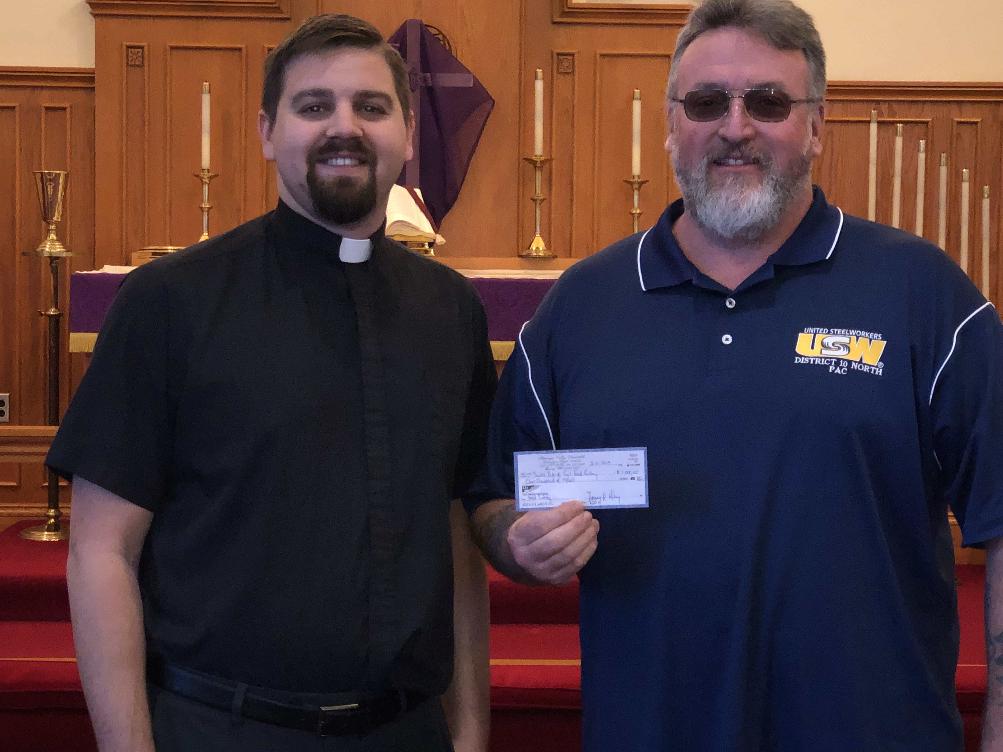

***March 31:*** *Unless a grain of wheat falls into the earth and dies, it remains alone; but if it dies, it bears much fruit. John 12:24*

**FOR ADULTS:**

***March 3:*** *You shall love your neighbor as yourself. Mark 12:31*

***March 10:*** *Above all, keep loving one another earnestly, since love covers a multitude of sins. 1 Peter 4:8*

***March 17:*** *Finally, brothers, whatever is true, whatever is honorable, whatever is just, whatever is pure, whatever is lovely, whatever is commendable, if there is any excellence, if there is anything worthy of praise, think about these things. Philippians 4:8*

***March 24:*** *Do you not know that your body is a temple of the Holy Spirit within you, whom you have from God? You are not your own, for you were bought with a price. So glorify God in your body. 1 Corinthians 6:19-20*

***March 31:*** *My son, keep your father's commandment, and forsake not your mother's teaching. Listen to your father who gave you life, and do not despise your mother when she is old. Proverbs 6:20; 23:22*

******

Fellowship Opportunity

in Jeopardy!

Currently, there are no further sponsors for Coffee & Donuts Fellowship Sundays for the remainder of this year. Perhaps this type of event has “run its course” and it’s time for it to end.

What does sponsorship involve? You are asked to simply drop off 2-1/2 dozen donuts/muffins and 1 qt. juice before Sunday worship begins. That’s all. Set-up and clean-up will be taken care of for you.

Fellowship is an important part of keeping connected with your church family. We pray that we do not lose this opportunity to catch up with one another and get to know each other better.

So, if you would like to see this opportunity continue, please sign the sponsorship sheet found on the bulletin board in the narthex. It would be a shame if this faded away.



**nlmk TO THE RESCUE!**

Each month, salaried and union workers at NLMK have the opportunity to take part in a 50-50 raffle with raffle proceeds donated to local charities. Once again, Sts. Peter & Paul’s Food Pantry was the recipient of their goodwill. On March 11th, Terry Day, who spearheads this effort, visited our church bringing with him a $1000 donation for the food pantry.

Since the inception of the 50-50 raffle, over $225,000 has been spread around to different organizations. We are grateful to those workers who donate to this cause and to our own member, Mark Gabriel, who brought our need for funds to their attention.



Did you know that our entire Sunday service bulletin can be accessed on-line the following Monday? Check out our website [www.saintspeterandpaul.net/bulletin](http://www.saintspeterandpaul.net/bulletin)!

2

******

PRESCHOOL NEWS!



As the school year winds down, the students are nearing the end of their alphabet study. The letter **V** finds them showing their creativity making **v**iolet **v**eggie prints. The letter **U** has them showing their **u**niqueness in filling plastic egg shaped containers with colorful sand. **W**acky letter **W** will elicit wacky hair and mismatched clothes. In preparation for Easter, students will be making **X**-tra special resurrection rolls. The letter **Y** will have the students learning about **y**oga.

As the students’ attention turns to Easter, God’s Time will focus on Christ’s death and resurrection for our forgiveness of sins. This will culminate in the Easter program scheduled for Monday, April 15th at 6:30 pm. All are invited to join us both for the program and dessert reception which will follow.

This month, students will be visiting the Shenango Valley Community Library and a trip to the Oh Wow Museum in Youngstown is scheduled for the beginning of May.

For more Preschool news, see the monthly newsletter posted on the bulletin board in the office hallway by the Sonshine Room.

****

Students don their leprechaun hats in celebration of St. Patrick’s Day.

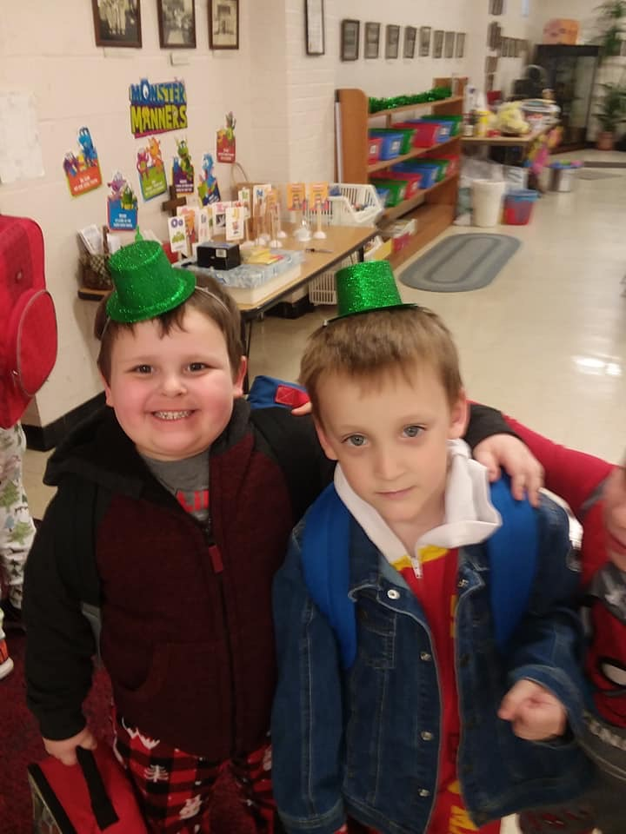

Students enjoyed participating in the Opposite Obstacle Course challenge.

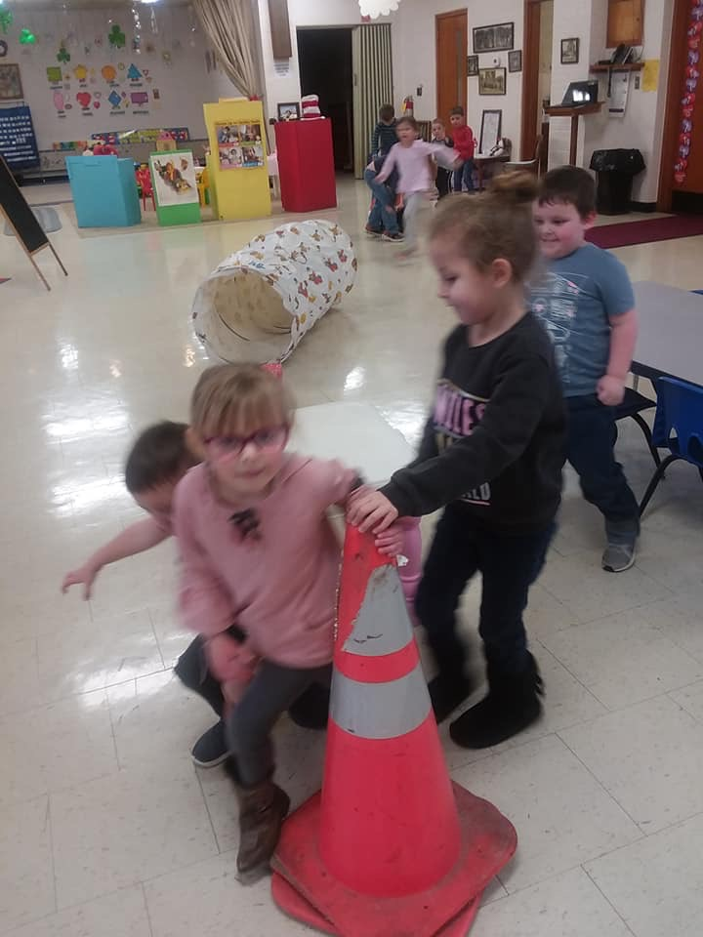

**Sts Peter & Paul**

**Little People Preschool**

**Staff and Board**

would like to thank all those who

ordered pies from their Spring fundraiser.

A total of 85 pies were sold!

Profits from the fundraiser will be applied to increased security measures for the church and school.

Those who purchased pies are reminded that pies will be delivered

Monday, April 8th and should be picked up between 11 AM and 12:30 PM from downstairs.

If you have questions, please speak with Board Member Stacy Brandes.



**Sts. Peter & Paul Little People Preschool** is now accepting registrations for the next school year. If you or someone you know are looking for a preschool that instills good Christian values and provides wonderful learning opportunities in a caring, nurturing environment, call the preschool at 724-347-3620 (Option 4) or Paula Ostheimer (724-981-5846) for more information.





**Worship Schedule**

**Wednesdays thru April 10th**

Midweek Lenten Worship Services

Noon & 7 pm

(Holy Communion will be celebrated at the evening services.)

**Thursday, April 18th at 7 pm**

Maundy Thursday Divine Service

**Friday, April 19th at 7 pm**

Good Friday Tenebrae Service

**Saturday, April 20th at 7 pm**

Saturday Vigil

**Sunday, April 21st at 10 am**

Easter Sunday Divine Service

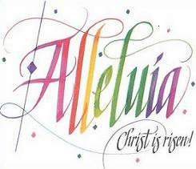

******

**Thrivent choice Dollars**

**We were recently notified that Thrivent Choice Dollars were directed to our church. We thank Gerald S. Arthur, Michael Flaugher, Lisa Jelinek, Max Jelinek, Sophia Mihm, Hugh Owen, and David Williams for making us the recipient of their giving.**

******

Make certain to pick-up the April issue of ***The Lutheran Beacon*** which is available in the narthex. You may also read the Lutheran Beacon on-line at [**www.selc.lcms.org**](http://www.selc.lcms.org/)**.**

******

Do you play a musical instrument?

Pastor Deal is looking for potential instrumentalists who may be interested in playing at the Easter Saturday Vigil or Easter Morning Divine Service.

Brass players are especially needed.

Please speak with Pastor Deal if interested.

******

Congratulations, Cathy Smith!

Cathy Rodemoyer Smith was inducted into the Mercer County Bowling Hall of Fame Saturday, March 23, 2019, at a ceremony and dinner held at The Park Inn by Radisson. Cathy’s bowling career began at the age of 10 when she participated in the Sunset Junior League program. In her teens, Cathy became part of the Tuesday Nite Ladies Trio League at Thornton Hall Bowling Lanes. An avid tournament bowler, Cathy has won honors in many local tournaments and, with her teammates, has won several league championships. Her high scoring games led her to be named “Bowler of the Month” at Thornton Hall. Currently, Cathy is a member of Thornton Hall’s PNA League where she participates with teammates Dave Kusnir, Dodie Moss, and Jeanette Telone.

To read more Cathy’s accomplishments, check out the bulletin board in the office hallway near the Sonshine Room.

Way to go, Cathy!

******

Got an eye for faces?

The church office is looking for someone to help label old photos with names of those pictured. Photos include some from church activities around the year 2000 as well as pictures from our 100th Anniversary activities. If you are interested in helping with this project, please speak with Diane.



Willow Women’s Center

Tour Scheduled

Last November, Christylee Roose from Willow Women’s Center was our guest at Coffee & Donuts and spoke to those present about the work being done at the center. Several in attendance expressed a desire to tour the facility and learn more about how what they do and how we can help.

Arrangements have been made for a tour Thursday, April 25th. If interested in joining us, please meet at the church at 10 am. We will car-pool to the site in Transfer and should finish there around noon.

Willow Women’s Center was our 2018 4th Quarter Local Mission. It is a non-profit organization which assists women facing unplanned pregnancies with quality medical services at no cost. The Center does *not* terminate pregnancies and is funded by individuals and grants.

******

The End (of the Academic Year) is Near! Help us spread some goodwill and cheer to our high school and college students as they enter the grueling part of the academic year by donating some stress relievers! Donations of snack foods, stress balls, candies, coffee, microwave popcorn, candy bars, post-its, and motivational sayings will be collected through Easter Sunday (April 21st) to be forwarded to our students. Items may be given to Diane or financial contributions placed in the offering plate (note: Stress Relief on pew envelope).

On behalf of those who will receive them, “many thanks” and “God Bless”!

******

Members of the **Audit Committee** should plan to meet after worship Sunday, April 28th for the purpose of auditing both church and food pantry accounts. Please plan accordingly.

The City of Sharon is sponsoring a **Community Clean-up Day** Saturday, April 13th. We would like to put together a team to represent the church for this endeavor. Please speak with Pastor Deal if interested in participating.

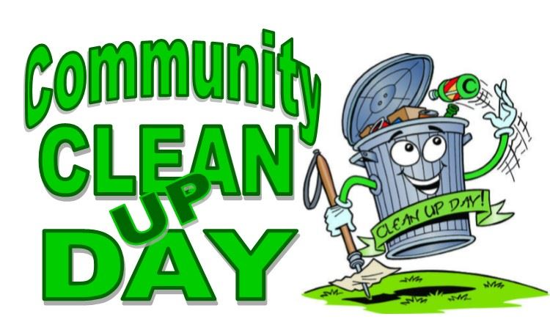

******

Order forms for flowering spring plants to adorn our altar Easter Sunday are available in the narthex. Orders and payments are due to Diane on/before Sunday, April 7th. This year, purchasers can opt to donate their plants to the church to be planted in the church gardens. Please speak with Diane if you should have any questions.

****

**Bible Study Opportunity**

**Sunday Morning Bible Study** begins at 8:45 am and is held in the Fellowship Hall. We are studying the weekly Gospel lessons. This class is open to all ages.

The **Young Adult Bible Study** continues this month and will meet at 8 pm the first and third Thursday evenings of the month. Please speak with Pastor Deal if you would like to attend.



**Sincere thanks are extended to those individuals and families who have so generously donated to our Major Repair Fund in recent weeks for potential replacement of the boiler in the “old” church. Although our plan of action has not yet been determined, please know that your donations have been greatly appreciated.**

**If anyone is interested in contributing to this effort at this time, please place your contribution in a pew envelope and check off “Major Repair Fund”.**

**Notes Concerning Holy Week Liturgies**

**Holy Thursday**, occurring on the eve of our Lord’s crucifixion, begins the celebration of the holy three days of Christ’s Passover, commonly known as the Triduum. The service on this day culminates the Lenten period of preparation for Christ’s Passion and resurrection and leads into His sacrifice on our behalf. As such, the service, like that for Good Friday, exhibits a mood of restrained joy. The Service for Holy Thursday consists of four parts:

* the Service of Corporate Confession and Absolution,
* the Service of the Word,
* the Service of the Sacrament,
* the Stripping of the Altar.

The Service of Corporate Confession and Absolution signals the end of the Lenten preparations with the absolution and peace of Christ that stand at the center of the Three Days. The Service of the Word focuses upon Christ’s sacrificial service demonstrated in His washing of His disciples’ feet, a servanthood enacted on the cross and whose benefits are bestowed in His means of grace. The service culminates with the Lord’s ministry to His people through the Sacrament of the Altar.

The depth of Christ’s servanthood is demonstrated as the altar is reverently stripped in preparation for the Church’s observance of Jesus’ death on Good Friday. On Holy Thursday, the Church and her catechumens begin the journey through the three days of Christ’s Passover from death to life and from captivity to freedom.

**Good Friday** is part of the sacred Triduum, the three-day observance of Christ’s Passion. The name may originally have been “God’s Friday,” but it is certainly also “good” because of the good gifts Christ won for us on this day.

Good Friday is not observed as a funeral for Christ. It is a day for repentance over sin and restrained joy and praise for the redemption Christ accomplished for us on the cross. In keeping with this character, music is kept to a minimum, though not silenced. Elaborate words of praise are omitted. The altar remains bare, having been stripped on Holy Thursday.

The service of Tenebrae (meaning “darkness”) consists of the extinguishing of the church lights. Historically it occurred early in the morning at the Offices of Matins and Lauds on all three days of the Triduum. In recent times, the service has been observed only on the evening of Good Friday.

As with the service for Holy Thursday, there is no benediction. Also, in both services the offering will be collected prior to, not during, the service in the narthex or outer hallway.

The service of the Triduum concludes with the **Vigil of Easter**. This year, Sts. Peter & Paul will be celebrating the Saturday Vigil beginning at 7 pm April 20th. This service ushers in the celebration of the Resurrection of Our Lord on Easter Sunday. This Vigil consists of six parts:

* the Service of Light,
* the Service of Readings,
* the Service of Holy Baptism,
* the Service of Prayer,
* the Service of the Word,
* the Service of the Sacrament.

As the Vigil of Easter marks the final day in the sacred Triduum, the service ends with the Benediction, which has not been heard since the beginning of the Triduum, and the Easter Acclamation: Christ is Risen!



**Hallelujah!**

******

**Our Second Quarter Local Mission:**

**Sts. Peter & Paul’s Third Annual**

**Community Day!**

Started in 2017, Sts. Peter & Paul’s Annual Community Day has become a fixture in our area. The purpose of Community Day is to positively cement our relationship with others who live in our neighborhood. During its first year, the event was held in October and last year it was held in August. Once again, this year’s event will be held in August which, if past events are any indicator, will prove to be a hot, hot day!

Each year Community Day becomes better and better! We hope to expand upon the 100 or so guests from last year with even more this year. Last year’s event saw free food, free raffle baskets, children’s crafts and games, face painting, and school supply giveaways. Our first organizational meeting for this year’s celebration was held March 24th with a follow-up meeting scheduled for May.

To pull off this event, both your financial support and man-power will be needed! You may place monetary donations in pew envelopes to be placed in the offering plate. Please make certain to note “Local Mission” or “Community Day” on the envelope. Please speak with either Pastor Deal or Jesse Riffle if you would like to get involved with the planning of the event. Volunteers will be needed to solicit donations, prepare raffle baskets, set-up for the gathering, work the event, and to clean- up following its conclusion.

Let’s make our third Community Day the best yet!



******

*If you have an article or news you would like to share with the congregation, email it to* [*church@saintspeterandpaul.net*](mailto:church@saintspeterandpaul.net)*.*

******



**PALM Sunday Appeal**

Pittsburgh Area Lutheran Ministries (PALM) supports regional missions that unite local congregations of The Lutheran Church–Missouri Synod. PALM supports student, homeless, blind, deaf, and children’s ministries, and others. PALM also publishes every month *via* email *The Pittsburgh Lutheran.*

PALM looks forward to bringing a vicar to the Hazelwood neighborhood THIS YEAR to touch that community with the Good News of Jesus Christ through Holy Cross Mission and the Third Annual Hazelwood Community Day. We pray this is the beginning of a growing LCMS presence in that community.

We are appealing directly to the members of our congregations to help PALM establish a solid financial base in order to impact our region with the Gospel. **Please consider a 1-time or recurring gift to support PALM. One half of all monies raised from this appeal will be directed toward Holy Cross Mission. The second half will help to establish an endowment fund to support future mission work in our region.**

Donations may be directed to PALM through your congregation on Palm Sunday, April 14. Or they may be sent directly to PALM, with “PALM Sunday Appeal” in the memo line. **THANK YOU!**

**PALM**

**535 N. Neville Street**

**Pittsburgh, PA 15213**

**Community Day Scheduled**

Saturday, August 3rd, from 5-8 PM has been selected as the date and time for our **Third Annual Community Day**. At the organizational meeting held March 24th, Jesse Riffle and Pastor Deal volunteered to chair the committee. Committee members include Matt & Cathy Berent, Jeff Brandes, Ana Deal, Marie & Mike Flaugher, Alyxis Kimmel, Kati Laird, Diane Riefstahl, and Bob & Traudi Sulek.

The committee decided to hold this year’s event in the evening to try to avoid the warmest time of the day. Weather-permitting, the parking area will be used for consumption of food/beverages as well as for different games and activities. Local schools will be notified about our event with the hopes of getting some teenagers needing community service hours to be able to help with set-up/clean-up.

Building upon the success of last-year’s “Back to School” theme, there will be plans for school item giveaways. The ever-popular free basket raffles will once again take place. Anyone wishing to contribute a raffle basket (or items to be placed in baskets) is encouraged to speak with Diane Riefstahl. A list of possible basket themes follows this article.

Key to the success of Community Day is publicity. We will again primarily rely on door-to-door contact and using our Facebook page and the church website. Please consider giving a hand if asked to participate.

**Raffle Basket Suggestions**

**FOOD BASKETS**

* Items vary depending on theme: Italian, snack basket, baking items.
* Could include recipes or cookbooks
* Could include cooking utensils

**HEALTH AND FITNESS BASKET**

* Light weights/ Stretch band
* Gatorade
* Protein bars

**DATE NIGHT BASKET**

* Movie theater/ Movie rental gift card
* Microwave popcorn / Movie candy
* Restaurant / pizza gift card

**NEW-BORN/TODDLER BASKET (AGES 2-4)**

* Age-appropriate toys/ Stuffed animals
* Books
* Blanket/ pacifiers/“sippy” cups
* Clothing
* Age-appropriate foods / drinks

**YOUTH BASKET (AGES 5-12)**

* Age-appropriate toys/ Stuffed animals
* Books
* Child’s hoodie/age-appropriate clothing

**TEEN BASKET**

* gift cards to local “activities” (bowling, etc.)
* Fast food gift card
* Store gift card (Walmart, JC Penney’s, etc.)
* Snack foods

**TEEN BASKET (GIRL)**

* Make-up/ cologne
* Nail polish remover/nail polish/ nail enhancements
* jewelry/ hair ornaments
* purse

**TEEN BASKET (BOY)**

* body spray / cologne
* wallet / money clip/ key chain
* shave cream / razor
* gum / breath mints / candy
* appropriate gift cards

**BEER & WINE BASKET**

* Variety of craft beers or wine
* Wine / beer glasses
* Beer nuts / chips /pretzels/chocolates

**GARDENING BASKET**

* Bag of tulip bulbs
* Gardening gloves/ implements
* Flower / vegetable seeds
* Whimsical “sign” for garden

**BASIC NEEDS BASKET**

* Bible!
* Toilet paper / paper towels
* Dish soap/bath soap/laundry basket
* Laundry detergent / fabric softener
* Cleaning supplies
* Sponges, dish cloths, dish towels

*Advertisement for Easter Alive*

*Redeemer Church*

*pull quote text box.]*



March 2019

**In Memory of John Berent, Matt Berent’s father:** *Anne Colt, Rev. Ed & Irene Kucera*

**In Memory of Father, Gerald Krivosh:** *Cheryl Fedele*

**In Honor of the Baptism of Granddaughter Maci James Myers:** *Suellen Burns*

*Saturday, April 13, 2019*

*11 AM*