Sts. Peter & Paul
Evangelical Lutheran Church
Lutheran Church-Missouri Synod
Founded-1917

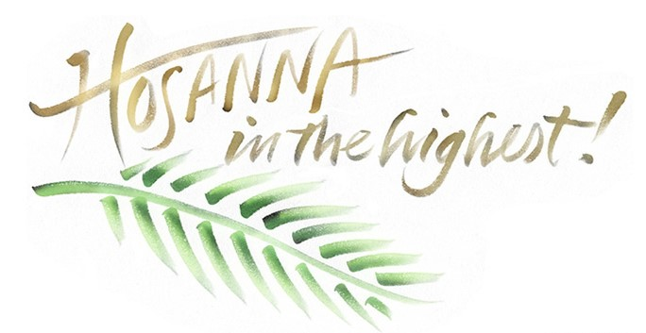

April 2, 2023

699 Stambaugh Ave.
Sharon, Pennsylvania 16146

“I was glad when they said to me,
Let us go to the house of the LORD!”
Psalm 122:1
Sts. Peter & Paul Evangelical Lutheran Church, LC-MS
PALM SUNDAY / PASSION SUNDAY
April 2, 2023

A special welcome to our guests this day! If you would like more information about The Lutheran Church - Missouri Synod, or this congregation, please speak with Pastor Deal or an Elder after the service.
Members & Guests: Don’t be embarrassed if your children make noise during the worship service, all children do. We encourage families to worship together but, if you feel the need, there are pews in the rear of the Church which are reserved for young families on both sides of the sanctuary. There is also a quiet room available to you during our service which is located down the hallway past the offices on the right side of the church as well as a children’s area in the Fellowship Hall where you are able to follow along with the service.

Today’s service includes the Sacrament of Holy Communion. If during this past year, you have not worshipped with us and been communed, we respectfully ask that you do not partake of this sacrament this day before first speaking with Pastor Deal.
If visiting from a sister congregation of the LC-MS and are in good standing, please inform Pastor Deal of your desire to commune prior to the service.
If wishing to receive a blessing during communion, please approach with your arms crossed.

CONTACT INFORMATION
Pastor Deal: pastordeal@saintspeterandpaul.net or 724-347-3620 (opt. 2)
Church Office: church@saintspeterandpaul.net or 724-347-3620 (opt. 3)

Silent prayer before worship: Lord Jesus, on this day many people praised You as King and Lord. Lead me to praise You with my heart and my lips for the gift of salvation that You won for me on the cross. Amen.

Procession of Palms

If the procession begins outside the nave, the congregation gathers around the processional cross. If the congregation is already seated in the nave, it now stands and faces the processional cross at the entrance to the nave.

Greeting
P The grace of our Lord T Jesus Christ and the love of God and the communion of the Holy Spirit be with you all.
C Amen.

P Blessed is He who comes in the name of the Lord.
C Hosanna to the Son of David.

Collect
P Let us pray.
Most merciful God, as the people of Jerusalem, with palms in their hands, gathered to greet Your dearly beloved Son when He came into His Holy City, grant that we may ever hail Him as our King and, when He comes again, may go forth to meet Him with trusting and steadfast hearts and follow Him in the way that leads to eternal life; through the same Jesus Christ, our Lord, who lives and reigns with You and the Holy Spirit, one God, now and forever.
C Amen.

Holy Gospel: John 12:12–19 (NKJV)
P The Holy Gospel according to St. John, the twelfth chapter.
C Glory to You, O Lord.

P The next day a great multitude that had come to the feast, when they heard that Jesus was coming to Jerusalem, took branches of palm trees and went out to meet Him, and cried out:
“Hosanna!
‘Blessed is He who comes in the name of the Lord!’
The King of Israel!”
Then Jesus, when He had found a young donkey, sat on it; as it is written:
“Fear not, daughter of Zion;
Behold, your King is coming,
Sitting on a donkey’s colt.”
His disciples did not understand these things at first; but when Jesus was glorified, then they remembered that these things were written about Him and that they had done these things to Him.
Therefore the people, who were with Him when He called Lazarus out of his tomb and raised him from the dead, bore witness. For this reason the people also met Him, because they heard that He had done this sign. The Pharisees therefore said among themselves, “You see that you are accomplishing nothing. Look, the world has gone after Him!”

P This is the Gospel of the Lord.
C Praise to You, O Christ.

P Let us go forth in peace,
C in the name of the Lord.

Processional Hymn: LSB #442 “All Glory, Laud, and Honor”
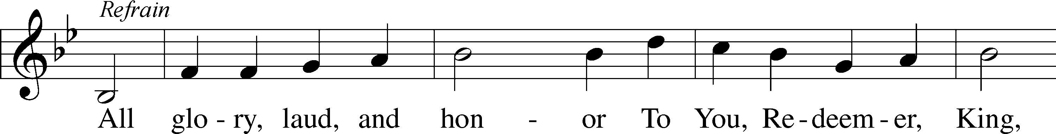
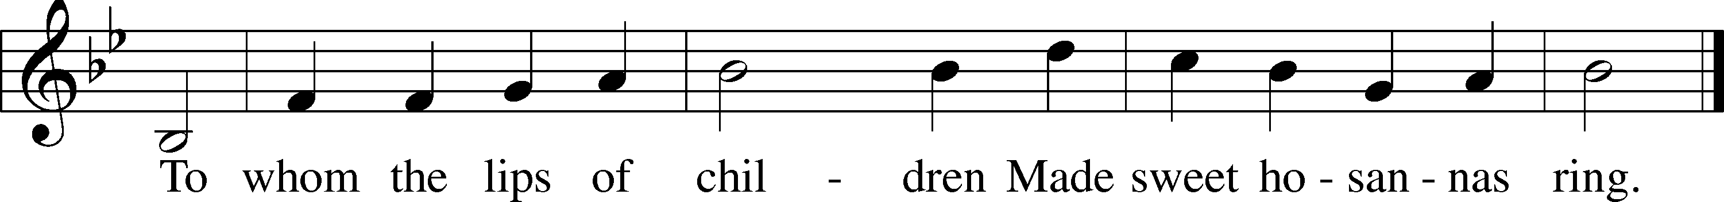
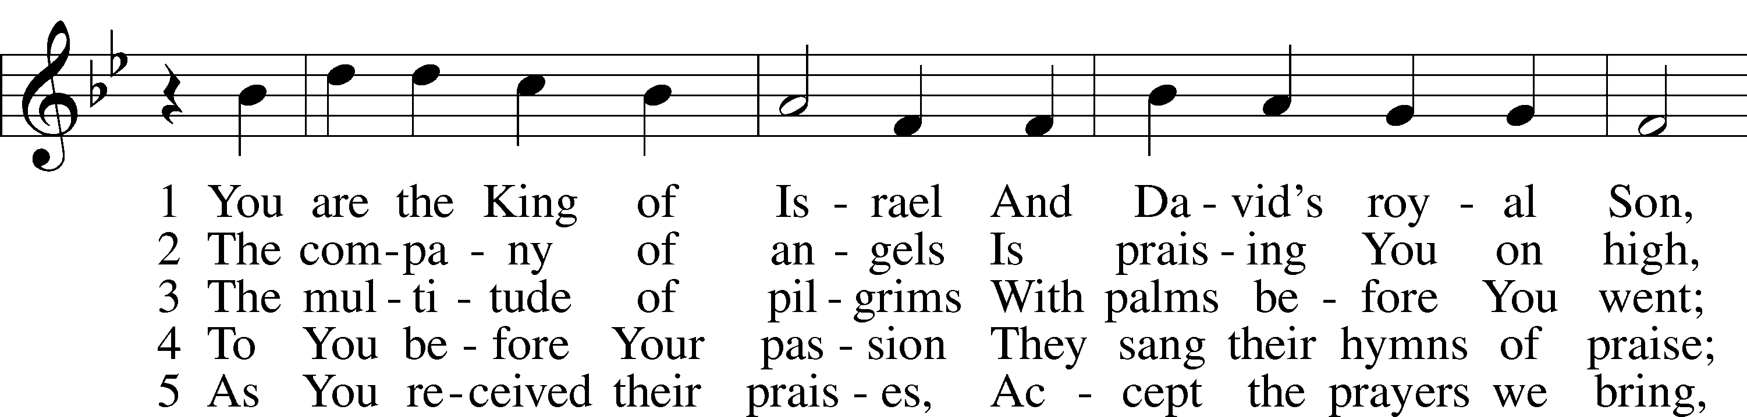
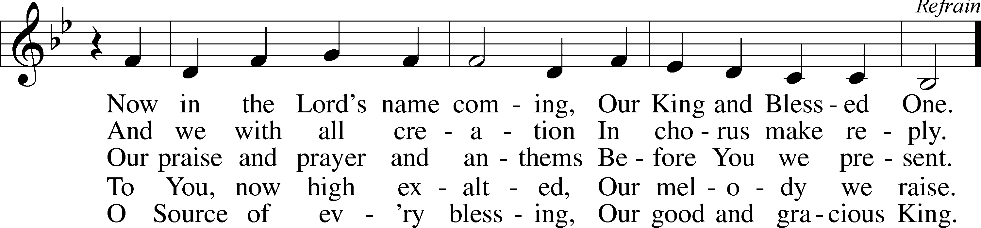
Text: Theodulf of Orléans, c. 762–821; tr. John Mason Neale, 1818–66, alt. Tune: Melchior Teschner, 1584–1635, alt. Text and tune: Public domain

When all have arrived at their places, the procession concludes with the following:
P Blessed is He who comes in the name of the Lord.
C Hosanna in the highest.

A time of silence may be observed to highlight the contrast between Jesus’ triumphal entry and His passion.

Collect: Palm Sunday / Passion Sunday
P Let us pray.
Almighty and everlasting God, who restores us by the blessed Passion of Jesus Christ, Your Son, preserve in us the works of Your mercy, that in the celebration of this mystery we may live in perpetual devotion, through the same Jesus Christ, our Lord, who lives and reigns with You and the Holy Spirit, one God, now and forever.
C Amen.
Confession and Absolution

Exhortation Hebrews 10:22; Psalm 124:8; Psalm 32:5
P Beloved in the Lord! Let us draw near with a true heart and confess our sins unto God our Father, beseeching Him in the name of our Lord Jesus Christ to grant us forgiveness.

P Our help is in the name of the Lord,
C who made heaven and earth.
P I said, I will confess my transgressions unto the Lord,
C and You forgave the iniquity of my sin.

Silence for reflection on God’s Word and for self-examination.

Confession of Sins
P O almighty God, merciful Father,
C I, a poor, miserable sinner, confess unto You all my sins and iniquities with which I have ever offended You and justly deserved Your temporal and eternal punishment. But I am heartily sorry for them and sincerely repent of them, and I pray You of Your boundless mercy and for the sake of the holy, innocent, bitter sufferings and death of Your beloved Son, Jesus Christ, to be gracious and merciful to me, a poor, sinful being.

Absolution [John 20:19–23]
P Upon this your confession, I, by virtue of my office, as a called and ordained servant of the Word, announce the grace of God unto all of you, and in the stead and by the command of my Lord Jesus Christ I forgive you all your sins in the name of the Father and of the T Son and of the Holy Spirit.
C Amen.
Service of the Word

Introit Psalm 22:1, 7–8, 11; antiphon: vv. 19, 21
But you, O Lord, do not be | far off!*
O you my help, come quickly | to my aid!
Save me from the mouth of the | lion!*
You have rescued me from the horns of the wild | oxen!
My God, my God, why have you for- | saken me?*
Why are you so far from saving me, from the words of my | groaning?
All who see me | mock me;*
they make mouths at me; they | wag their heads;
“He trusts in the Lord; let him de- | liver him;*
let him rescue him, for he de- | lights in him!”
Be not far from me, for trouble | is near,*
and there is | none to help.
But you, O Lord, do not be | far off!*
O you my help, come quickly | to my aid!
Save me from the mouth of the | lion!*
You have rescued me from the horns of the wild | oxen!

Kyrie Mark 10:47
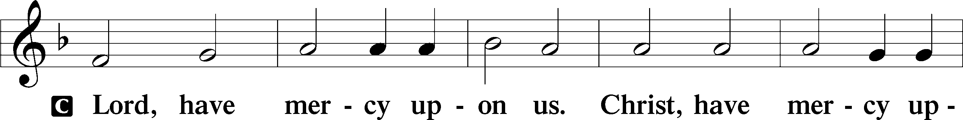
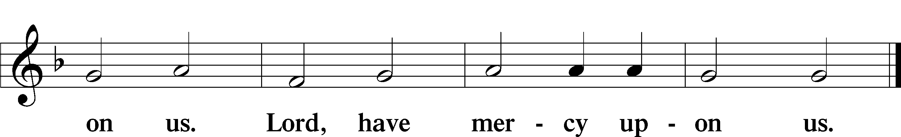

Salutation and Collect of the Day: Palm Sunday / Sunday of the Passion
P The Lord be with you.
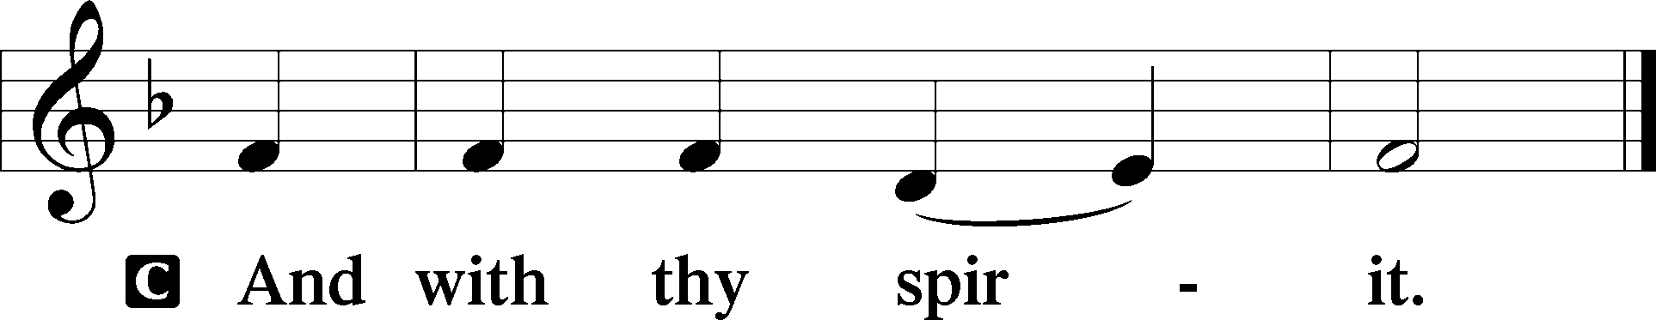

P Let us pray.
Almighty and everlasting God, You sent Your Son, our Savior Jesus Christ, to take upon Himself our flesh and to suffer death upon the cross. Mercifully grant that we may follow the example of His great humility and patience and be made partakers of His resurrection; through the same Jesus Christ, our Lord, who lives and reigns with You and the Holy Spirit, one God, now and forever.
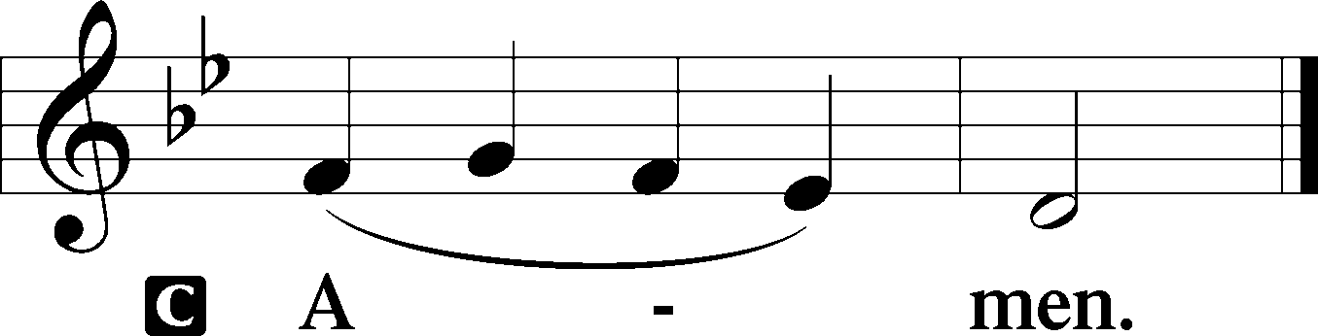
Sit

Prophecy: Zechariah 9:9–12 (NKJV)
“Rejoice greatly, O daughter of Zion!
Shout, O daughter of Jerusalem!
Behold, your King is coming to you;
He is just and having salvation,
Lowly and riding on a donkey,
A colt, the foal of a donkey.
I will cut off the chariot from Ephraim
And the horse from Jerusalem;
The battle bow shall be cut off.
He shall speak peace to the nations;
His dominion shall be ‘from sea to sea,
And from the River to the ends of the earth.’
“As for you also,
Because of the blood of your covenant,
I will set your prisoners free from the waterless pit.
Return to the stronghold,
You prisoners of hope.
Even today I declare
That I will restore double to you.

P This is the Word of the Lord.
C Thanks be to God.

Tract Psalm 22:1, 4–5
My God, my God, why have you for- | saken me?*
Why are you so far from saving me, from the words of my | groaning?
In you our fathers | trusted;*
they trusted, and you de- | livered them.
To you they cried and were | rescued;*
in you they trusted and were not | put to shame.

Epistle: Philippians 2:5–11 (NKJV)
Let this mind be in you which was also in Christ Jesus, who, being in the form of God, did not consider it robbery to be equal with God, but made Himself of no reputation, taking the form of a bondservant, and coming in the likeness of men. And being found in appearance as a man, He humbled Himself and became obedient to the point of death, even the death of the cross. Therefore God also has highly exalted Him and given Him the name which is above every name, that at the name of Jesus every knee should bow, of those in heaven, and of those on earth, and of those under the earth, and that every tongue should confess that Jesus Christ is Lord, to the glory of God the Father.

P This is the Word of the Lord.
C Thanks be to God.

Holy Gospel: Matthew 26:1—27:66 (NKJV)
P The Passion of T Our Lord Jesus Christ T according to Saint Matthew.
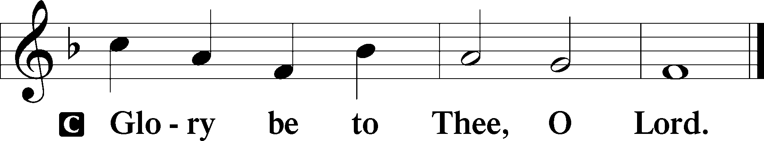

You may remain seated for the reading.

P This is the Gospel of the Lord.
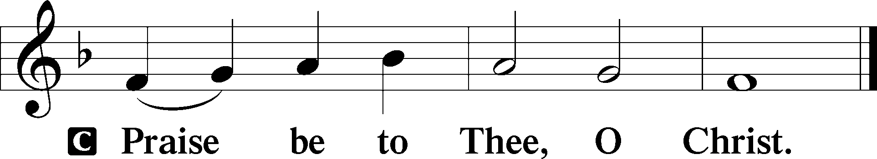

Nicene Creed
C I believe in one God,
the Father Almighty,
maker of heaven and earth
and of all things visible and invisible.

And in one Lord Jesus Christ,
the only-begotten Son of God,
begotten of His Father before all worlds,
God of God, Light of Light,
very God of very God,
begotten, not made,
being of one substance with the Father,
by whom all things were made;
who for us men and for our salvation came down from heaven
and was incarnate by the Holy Spirit of the virgin Mary
and was made man;
and was crucified also for us under Pontius Pilate.
He suffered and was buried.
And the third day He rose again according to the Scriptures
and ascended into heaven
and sits at the right hand of the Father.
And He will come again with glory to judge both the living and the dead,
whose kingdom will have no end.

And I believe in the Holy Spirit,
the Lord and giver of life,
who proceeds from the Father and the Son,
who with the Father and the Son together is worshiped and glorified,
who spoke by the prophets.
And I believe in one holy Christian and apostolic Church,
I acknowledge one Baptism for the remission of sins,
and I look for the resurrection of the dead
and the life T of the world to come. Amen.
Sit

Hymn of the Day: LSB #441 “Ride On, Ride On in Majesty”

Sermon

Stand

Prayer of the Church

Offertory Psalm 51:10–12
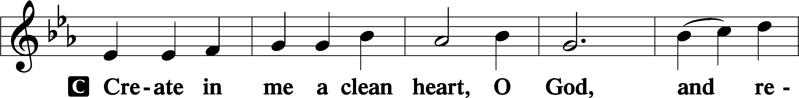
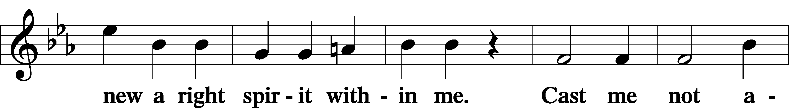
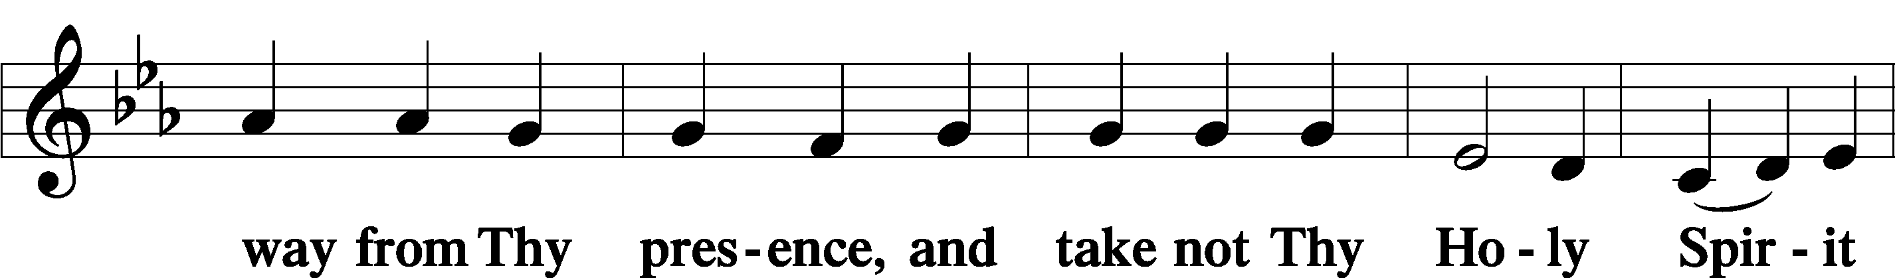
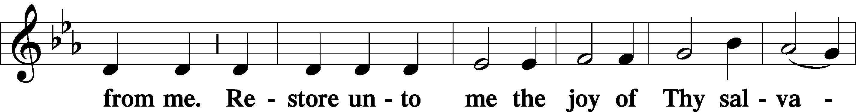
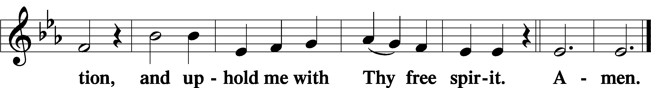
Sit

Preparatory Hymn: LSB #443 “Hosanna, Loud Hosanna”

Stand

Service of the Sacrament

Preface 2 Timothy 4:22; Colossians 3:1 Psalm 136
P The Lord be with you.
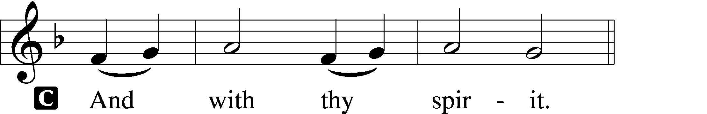

P Lift up your hearts.
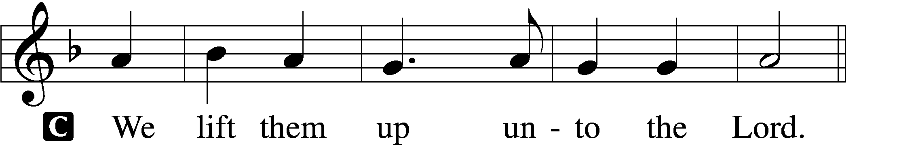

P Let us give thanks unto the Lord, our God.
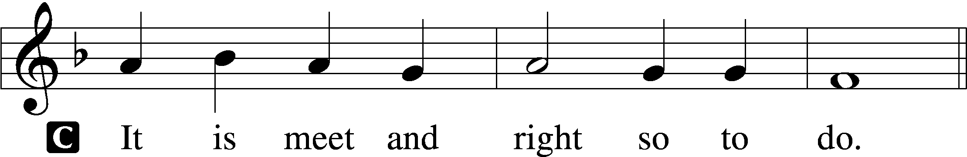

Proper Preface (Abbreviated) LSB 194
P It is truly meet, right, and salutary . . . evermore praising You and saying:

Sanctus Isaiah 6:3; Matthew 21:9
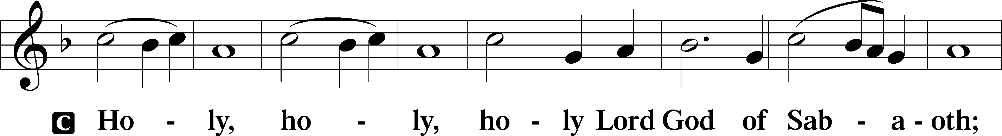
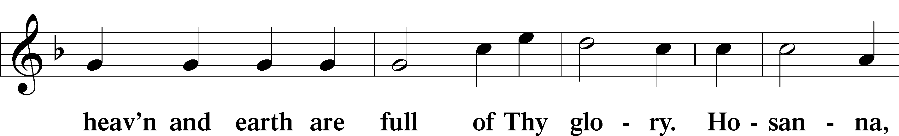
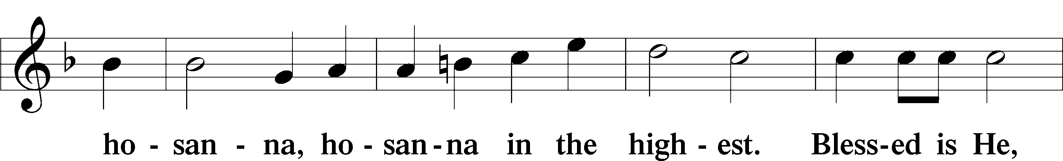
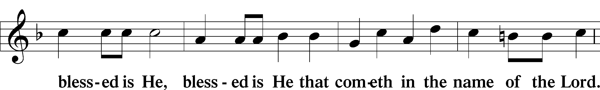
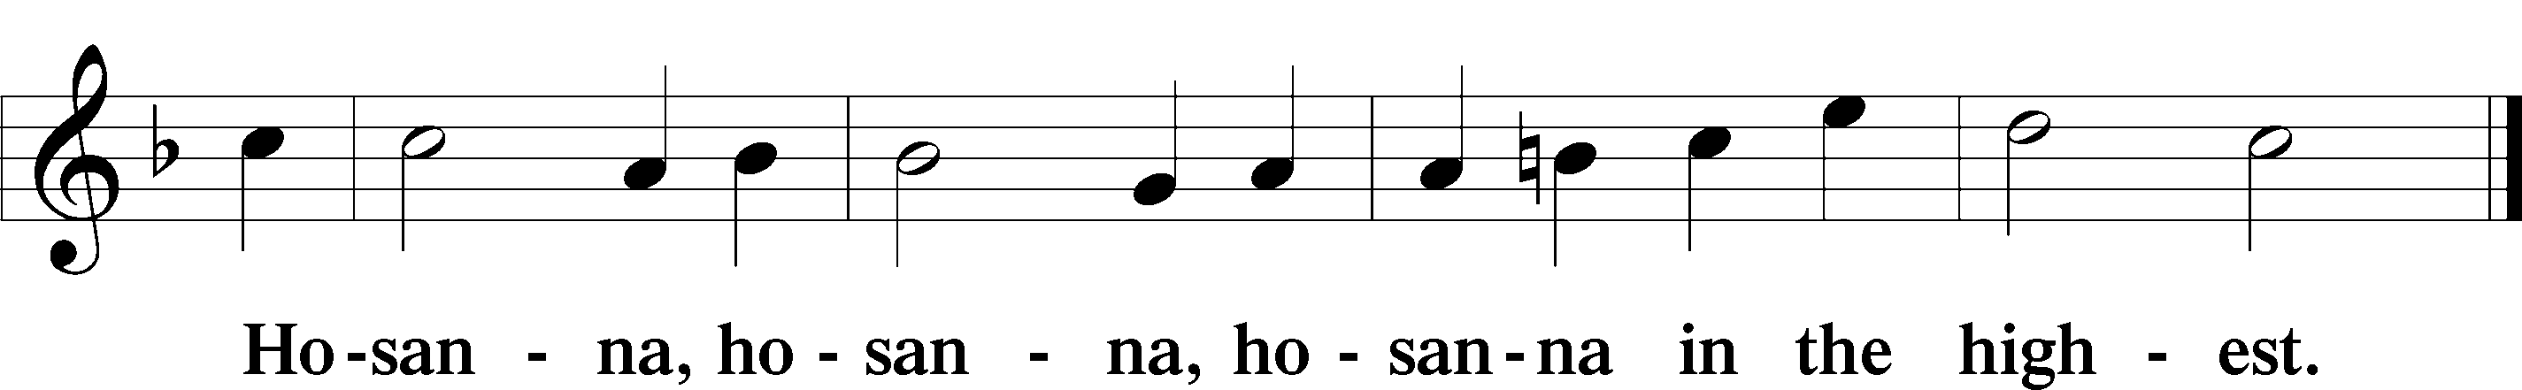

Lord’s Prayer Matthew 6:9–13
C Our Father who art in heaven,
hallowed be Thy name,
Thy kingdom come,
Thy will be done on earth as it is in heaven;
give us this day our daily bread;
and forgive us our trespasses as we forgive those who trespass against us;
and lead us not into temptation,
but deliver us from evil.
For Thine is the kingdom and the power and the glory forever and ever. Amen.

The Words of Our Lord Matthew 26:26–28; Mark 14:22–24; Luke 22:19–20; 1 Corinthians 11:23–25
P Our Lord Jesus Christ, on the night when He was betrayed, took bread, and when He had given thanks, He broke it and gave it to the disciples and said: “Take, eat; this is My T body, which is given for you. This do in remembrance of Me.”

In the same way also He took the cup after supper, and when He had given thanks, He gave it to them, saying: “Drink of it, all of you; this cup is the new testament in My T blood, which is shed for you for the forgiveness of sins. This do, as often as you drink it, in remembrance of Me.”

Pax Domini John 20:19
P The peace of the Lord be with you always.
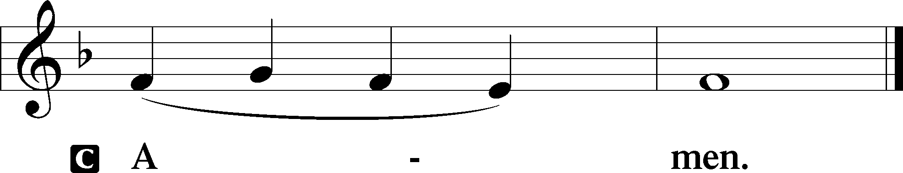

Agnus Dei John 1:29
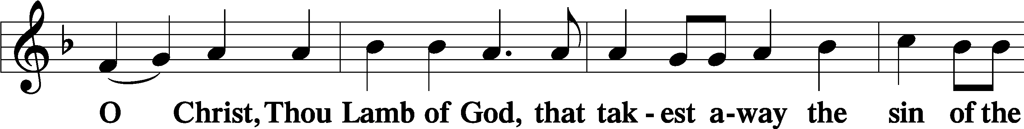
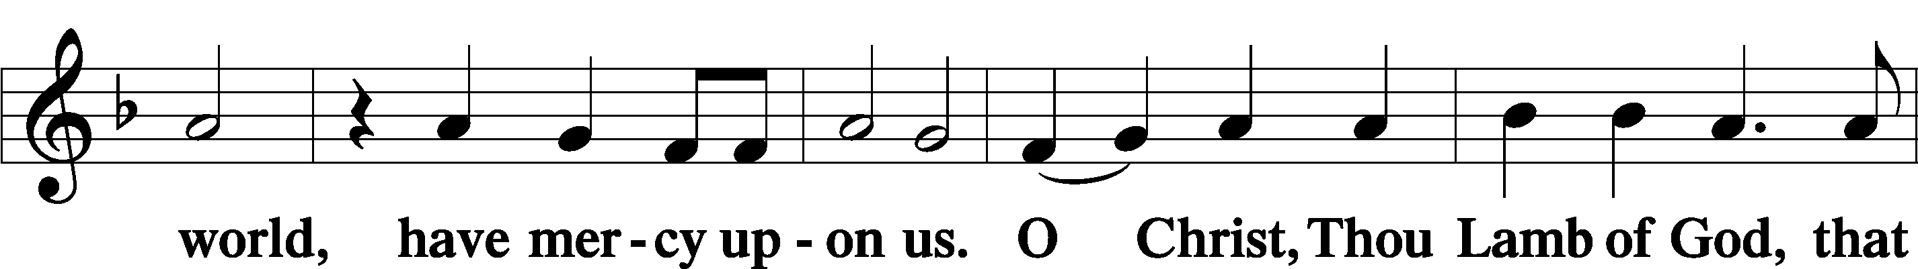
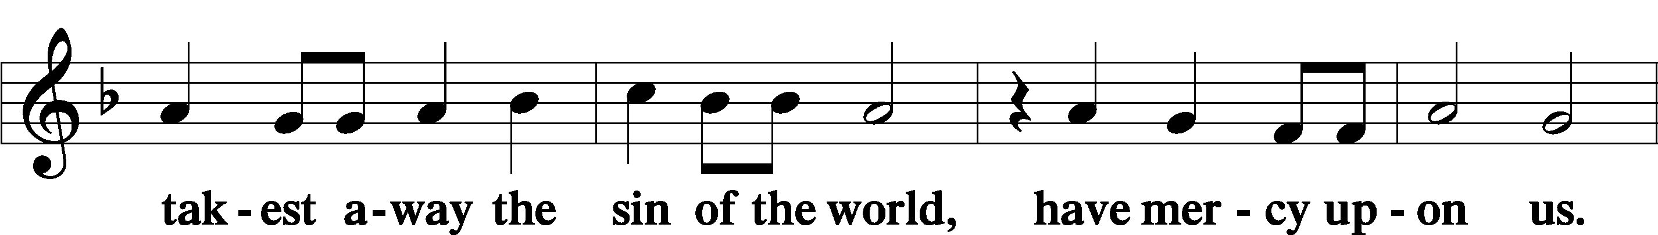
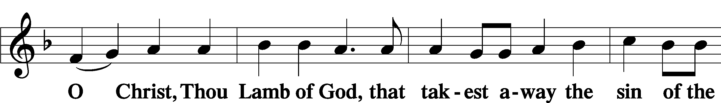
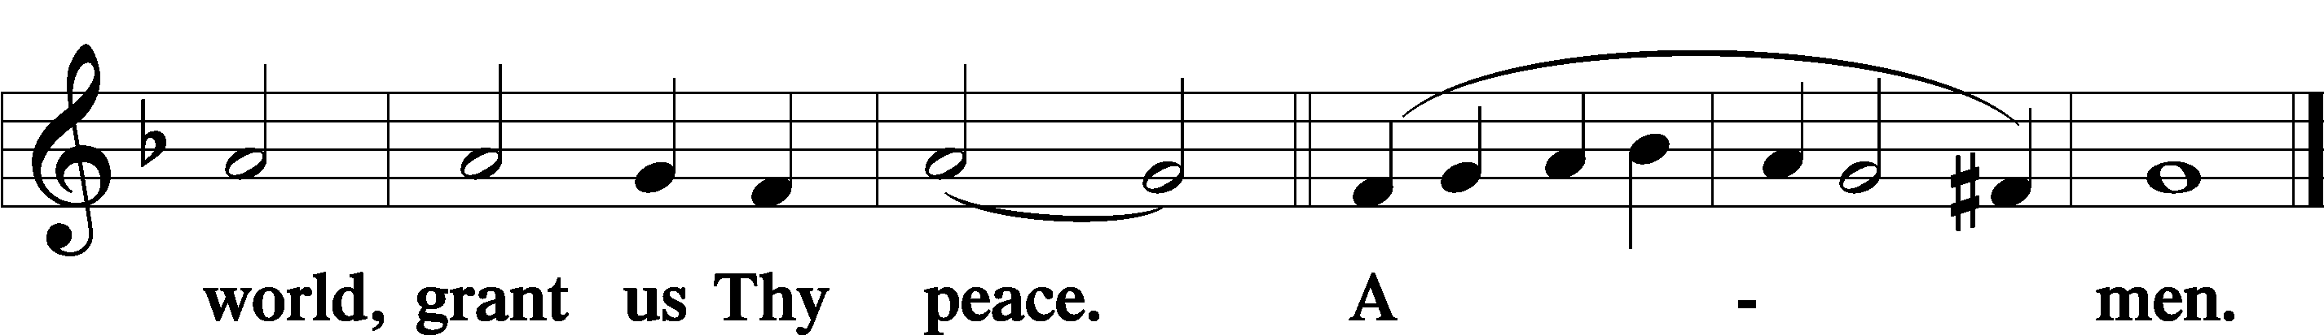
Sit
Distribution
The pastor and those who assist him receive the body and blood of Christ first and then distribute them to those who come to receive, saying:
Take, eat; this is the true body of our Lord and Savior Jesus Christ, given into death for your sins.
Amen.

Take, drink; this is the true blood of our Lord and Savior Jesus Christ, shed for the forgiveness of your sins.
Amen.

In dismissing the communicants, the following is said:
The Dismissal
P The body and blood of our Lord Jesus Christ strengthen and preserve you in body and soul to life everlasting. Depart T in peace.
C Amen.

Distribution Hymn: LSB #438 “A Lamb Goes Uncomplaining Forth”

Distribution Hymn: LSB #334 “O Lord, How Shall I Meet You”

Stand

The Nunc Dimittis continues to be omitted in Passiontide.

Thanksgiving Psalm 107:1
P O give thanks unto the Lord, for He is good,
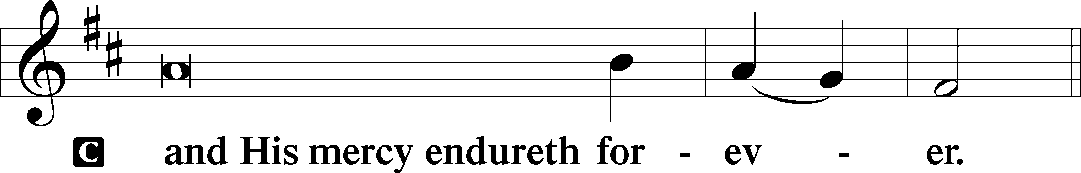

Post-Communion Collect
P Let us pray.
We give thanks to You, almighty God, that You have refreshed us through this salutary gift, and we implore You that of Your mercy You would strengthen us through the same in faith toward You and in fervent love toward one another; through Jesus Christ, Your Son, our Lord, who lives and reigns with You and the Holy Spirit, one God, now and forever.
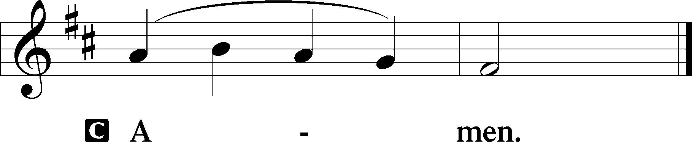

Salutation 2 Timothy 4:22
P The Lord be with you.
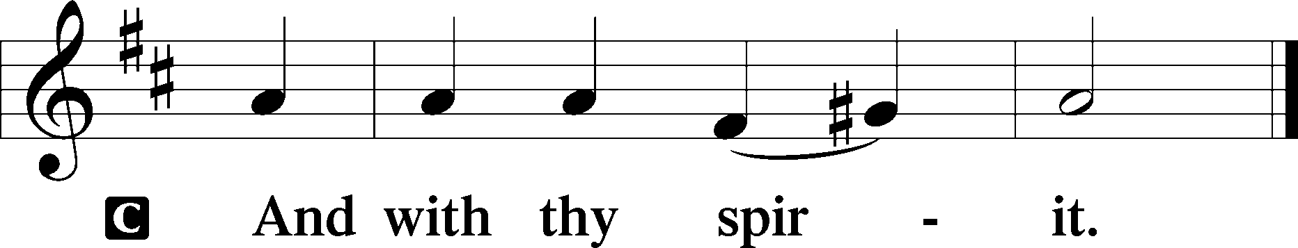
Benedicamus Psalm 103:1
P Bless we the Lord.
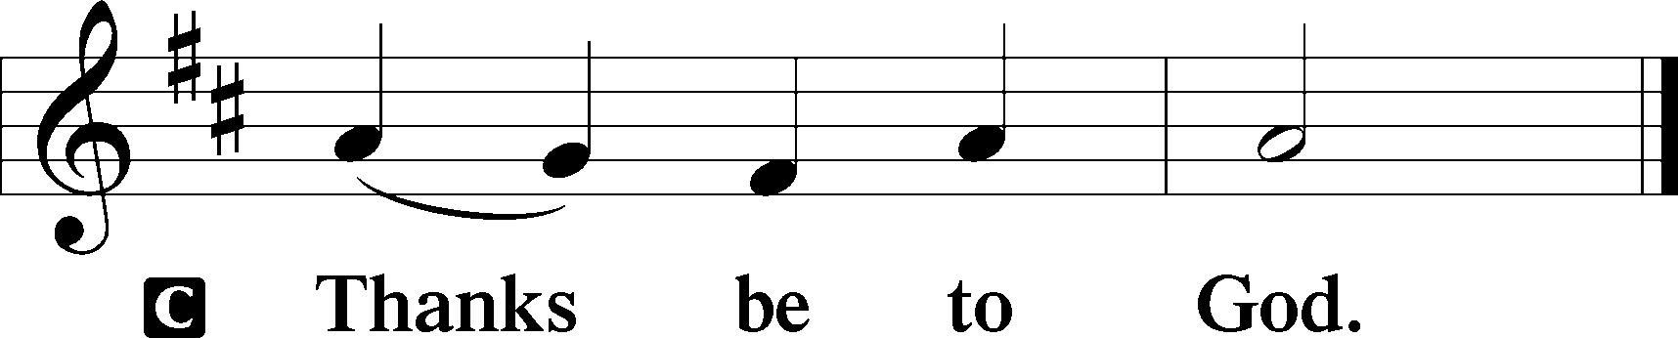

Benediction Numbers 6:24–26
P The Lord bless you and keep you.
The Lord make His face shine upon you and be gracious unto you.
The Lord lift up His countenance upon you and T give you peace.
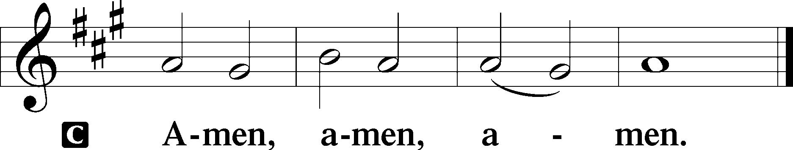

Closing Hymn: LSB #420 “Christ, the Life of All the Living”

Silent prayer after worship: Dear Jesus, help me this week to keep in mind the purpose of Your suffering, death and resurrection. Cause me to believe and proclaim the hope of salvation You won for all by Your death and resurrection. Amen.
fffffffffffffffffffffffffffffffffff
Acknowledgments: Unless otherwise indicated, Scripture quotations are from the ESV® Bible (The Holy Bible, English Standard Version®), copyright © 2001 by Crossway, a publishing ministry of Good News Publishers. Used by permission. All rights reserved. Created by Lutheran Service Builder © 2023 Concordia Publishing House.
fffffffffffffffffffffffffffffffffff
fffffffffffffffffffffffffffffffffff
In Loving Memory of John Dyll: Barry & Christine Nelson (Food Pantry).
In Loving Memory of Anson Holcroft: Barry & Christine Nelson (Food Pantry).
In Loving Memory of David Nelson: Brittany & Ian Forbis (Food Pantry), Desarae Makis (Food Pantry), Barry & Christine Nelson (Food Pantry), Bill Nelson (Food Pantry), Mark & Paul Ostheimer (Food Pantry), Edeltraud Sulek (Food Pantry), and Linda Tomko (Food Pantry).
In Loving Memory of Bob Sulek: Barry & Christine Nelson (Food Pantry).
In Loving Memory of Viola Sakony: Diane Riefstahl
SCHEDULE THROUGH APRIL 9, 2023:

:

Today, 7 pm, Fellowship Hall: AA Meeting
Monday, 10 am, Sanctuary: Holy Week Matins Service
Tuesday, 10 am, All Saints~Slippery Rock: Holy Week Matins Service
7-9 pm, Fellowship Hall: Penn-Ohio Singers
Wednesday, 10 am, All Saints~Slippery Rock: Holy Week Matins Service
7:30 pm, Fellowship Hall: NA Meeting
Thursday, 4 pm, All Saints~Slippery Rock: Maundy Thursday Service
7 pm, Sanctuary: Maundy Thursday Service
Following, Sanctuary: Choir Rehearsal
Friday, 8 am, All Saints~Slippery Rock: Stations of the Cross
Noon-3 pm, Sanctuary: Tre Ore Service
7 pm, Sanctuary: Stations of the Cross
Saturday, 7 pm, Sanctuary: Easter Vigil
Next Sunday, 9 am, Sanctuary: Divine Service
7 pm, Fellowship Hall: AA Meeting
fffffffffffffffffffffffffffffffffff
Attendance: Saturday, March 25, 2023: 4; Sunday, March 26, 2023: 37
Wednesday, March 29: 8 (7 pm service, only)
fffffffffffffffffffffffffffffffffff
THANK YOU FOR SERVING IN APRIL: Elder: Jonathan Baisch; Ushers: Jerry Krivosh, Barry Nelson, & Jeff Sutton; Altarware: (prior) Diane Riefstahl & Marie Flaugher (04/09 & 04/30); (after) Elizabeth Haenftling (04/02 & 04/16) & Marie Flaugher (04/09, 04/23, & 04/30).
fffffffffffffffffffffffffffffffffff
April Coffee Fellowship Date Change: Please note that the date for April’s Coffee Fellowship has been changed to April 16th. April’s sponsors, Isaiah & Titus Deal, hope that you will be able to join them that day.
If interested in sponsoring a Coffee Fellowship, please sign the sheet posted in the narthex. Sponsors are asked to drop off 2-3 dozen “treats” and 1 quart of juice in the kitchen prior to worship. Set-up (including the making of coffee) and clean-up will be done for you!
fffffffffffffffffffffffffffffffffff
Bible Memory Verses ~ Week of April 2nd:
For Adults: Be angry and do not sin; do not let the sun go down on your anger, and give no opportunity to the devil. Ephesians 4:26-27
For Children: Christ says: “For their sake I consecrate myself, that they also may be sanctified in truth.” John 17:19
fffffffffffffffffffffffffffffffffff
The April issue of “The Rock and the Sword” newsletter is available on the tables in the narthex and by Pastor Deal’s office along with copies of the “Portals of Prayer” for April, May, and June 2023
fffffffffffffffffffffffffffffffffff
Remember the following in Prayer…
~The Hurting and Healing: The family and friends of Viola Sakony, who passed away March 25, 2023; also, Amy, Gerald Arthur, Evelyn Baisch, Ellen Baron^{CA}, Lois Bortner^{CA}, John Burdette, Bev & Joe Chlpka, Kathleen Coughenour, Kim, Anna Mae Daris, Susan Davies, Tim Dudash, Millie Elavsky, Joseph Fleet, Judith & Eddy Furey, Tim Haenftling, Austin Hamilton, Neil Huston, Joan, Darla Krajci, Barbara Kreske, Donna Kennedy, Jess Lavoie, Paul Lucas^{CA}, Sandy Marshall, Frank Niemeyer^{CA}, Linda Parkany, Juanita Rentschler, Richard Reuning^{CA}, Nancy Robertson^{CA}, Marty Scott, Kara, Fred Tonty, Angela Weser^{CA}, and Ruth Wolf.
~The Homebound: Rudy & Jean Tomko, Betty Wolf, and Ed & Millie Zachar.
~Celebrating: Birthday ~ Dillon Hamilton (04.02), Patty Parker (04.03), and Bill Nelson (04.07).
~Serving in the Military: Curtis Sinewe and Joshua Solyan.
~Community & World Needs: Those suffering from or affected by the coronavirus; those suffering due to the conflict between Ukraine and Russia; those suffering from loss and dislocation because weather disasters; those suffering from addiction and their families; Local, State, and National Government Leaders; safety for all Police Officers, Firefighters, & First Responders; the unemployed; our First Quarter Local Mission: Sts. Peter & Paul’s Community Day 2023.
*CA represents cancer.
fffffffffffffffffffffffffffffffffff
Financial information from last week is not available at this time.

Here to Serve
Pastor………………………………………………...……………Rev. Jacob Deal
E-mail …………………………….……pastordeal@saintspeterandpaul.net
Phone Number……………………..…………………724-347-3620 (Option 2)
Church Office………………………..…………………724-347-3620 (Option 3)
Website …………………………………………www.saintspeterandpaul.net
Secretary…………………………………………………………Diane Riefstahl
E-mail ………………………………………church@saintspeterandpaul.net
Website …………………………………………www.saintspeterandpaul.net
Food Pantry: Please leave message……………724-347-3620 (Option 3)
AA Contact: Steve………………………………………………..…724-813-2358
NA Contact: Larry………………………………………………..724-977-8733
Choir Director………………………………………………………Chris Nelson
Congregation President……………………………………Jonathan Baisch
Church Elder …………………………………………...…… Jonathan Baisch
fffffffffffffffffffffffffffffffffff
If needing to get into the church building during the week, please phone first to make certain someone is here to let you in.

