Sts. Peter & Paul
Evangelical Lutheran Church
Lutheran Church-Missouri Synod
Founded-1917

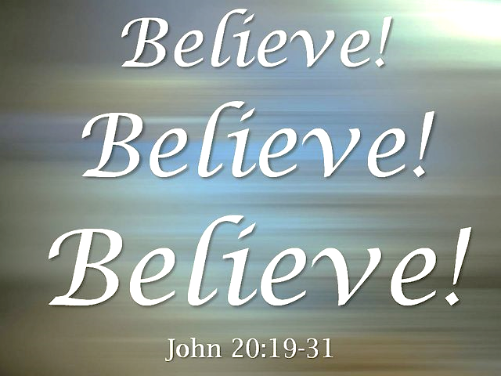

April 16, 2023

699 Stambaugh Ave.
Sharon, Pennsylvania 16146

“I was glad when they said to me,
Let us go to the house of the LORD!”
Psalm 122:1
Sts. Peter & Paul Evangelical Lutheran Church, LC-MS
QUASIMODO GENITI
April 16, 2023

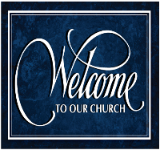
A special welcome to our guests this day! If you would like more information about The Lutheran Church - Missouri Synod, or this congregation, please speak with Pastor Deal or an Elder after the service.
Members & Guests: Don’t be embarrassed if your children make noise during the worship service, all children do. We encourage families to worship together but, if you feel the need, there are pews in the rear of the Church which are reserved for young families on both sides of the sanctuary. There is also a quiet room available to you during our service which is located down the hallway past the offices on the right side of the church as well as a children’s area in the Fellowship Hall where you are able to follow along with the service.

Today’s service includes the Sacrament of Holy Communion. If during this past year, you have not worshipped with us and been communed, we respectfully ask that you do not partake of this sacrament this day before first speaking with Pastor Deal.
If visiting from a sister congregation of the LC-MS and are in good standing, please inform Pastor Deal of your desire to commune prior to the service.
If wishing to receive a blessing during communion, please approach with your arms crossed.

CONTACT INFORMATION
Pastor Deal: pastordeal@saintspeterandpaul.net or 724-347-3620 (opt. 2)
Church Office: church@saintspeterandpaul.net or 724-347-3620 (opt. 3)
Secretary’s Office will be open Monday and Thursday of this week (8:30 am -4:30 pm)

Silent prayer before worship: I thank You, dear heavenly Father, for giving Your Son to die on the cross and rise again. Enable me to celebrate in this worship service the new life You have given me. In Jesus name. Amen.
Confession and Absolution

Opening Hymn: LSB #467 “Awake, My Heart, with Gladness”

Stand

The sign of the cross may be made by all in remembrance of their Baptism.

Invocation
P In the name of the Father and of the T Son and of the Holy Spirit.
C Amen.

Exhortation Hebrews 10:22; Psalm 124:8; Psalm 32:5
P Beloved in the Lord! Let us draw near with a true heart and confess our sins unto God our Father, beseeching Him in the name of our Lord Jesus Christ to grant us forgiveness.

P Our help is in the name of the Lord,
C who made heaven and earth.
P I said, I will confess my transgressions unto the Lord,
C and You forgave the iniquity of my sin.

Silence for reflection on God’s Word and for self-examination.

Confession of Sins
P O almighty God, merciful Father,
C I, a poor, miserable sinner, confess unto You all my sins and iniquities with which I have ever offended You and justly deserved Your temporal and eternal punishment. But I am heartily sorry for them and sincerely repent of them, and I pray You of Your boundless mercy and for the sake of the holy, innocent, bitter sufferings and death of Your beloved Son, Jesus Christ, to be gracious and merciful to me, a poor, sinful being.

Absolution [John 20:19–23]
P Upon this your confession, I, by virtue of my office, as a called and ordained servant of the Word, announce the grace of God unto all of you, and in the stead and by the command of my Lord Jesus Christ I forgive you all your sins in the name of the Father and of the T Son and of the Holy Spirit.
C Amen.

Service of the Word

Introit Psalm 81:1, 7a, 10, 16b; antiphon: 1 Peter 2:2a
Like newborn infants, Alle- | luia,*
long for the pure spiritual milk [of the Word.] Alle- | luia.
Sing aloud to | God our strength;*
shout for joy to the God of | Jacob!
In distress you called, and I de- | livered you;*
I answered you in the secret place of | thunder.
I am the | Lord your God,*
who brought you up out of the land of | Egypt.
Open your mouth wide, and I will | fill it;*
and with honey from the rock I would sat- | isfy you.
Like newborn infants, Alle- | luia,*
long for the pure spiritual milk [of the Word.] Alle- | luia.

Gloria Patri
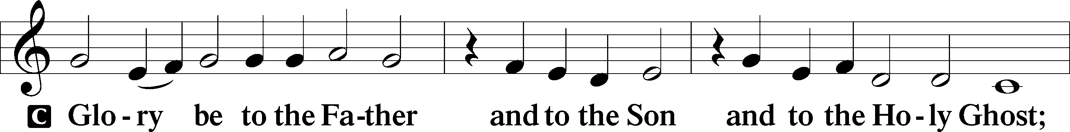
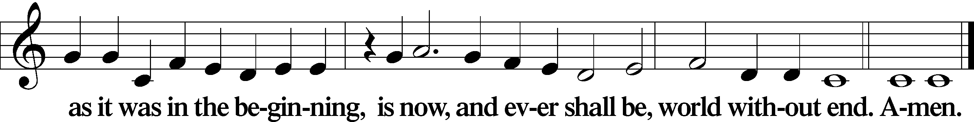
Kyrie Mark 10:47
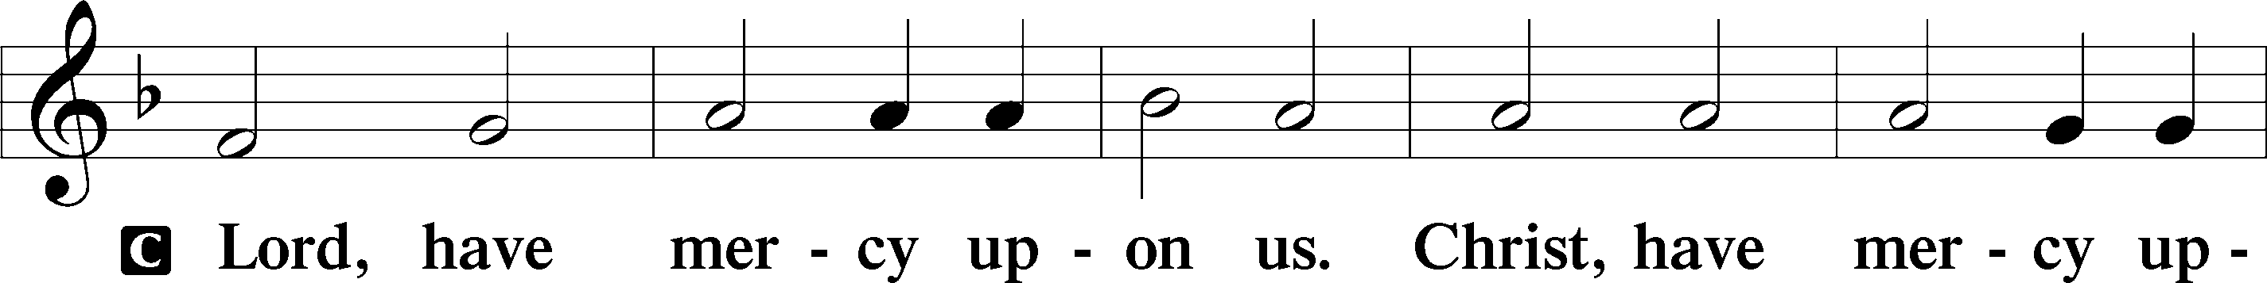
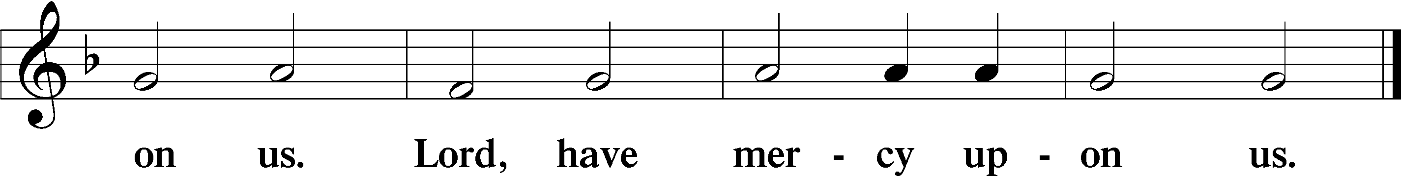

Gloria in Excelsis Luke 2:14; John 1:29
P Glory be to God on high:
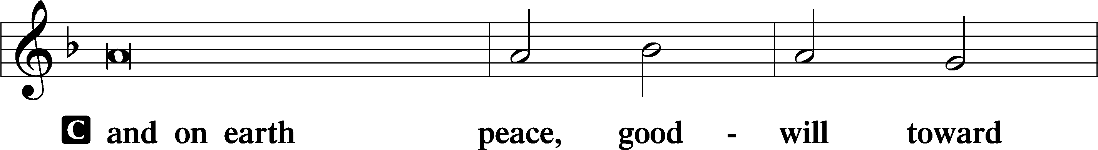
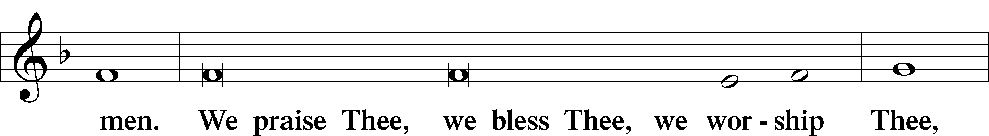
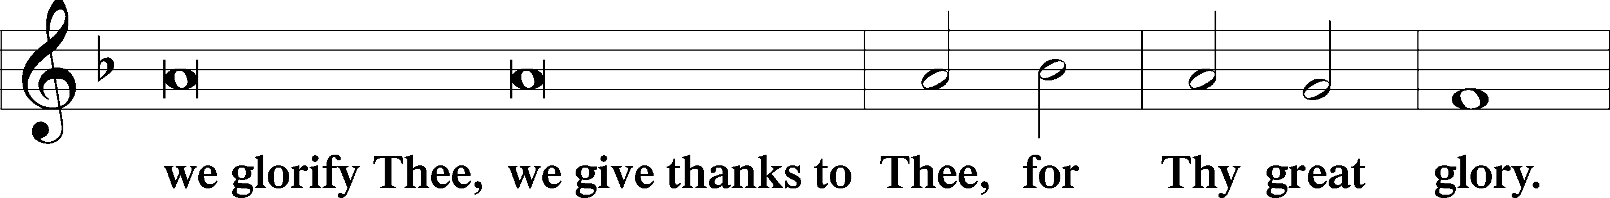
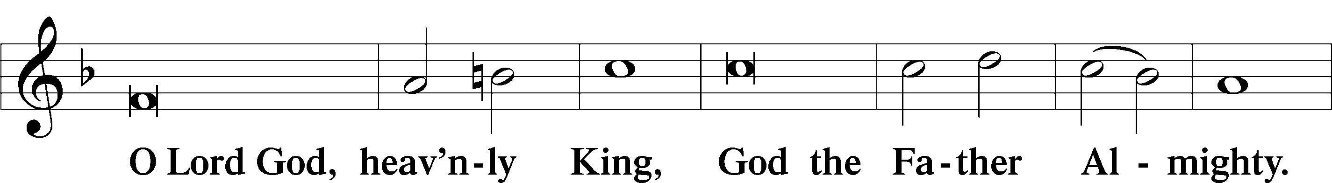
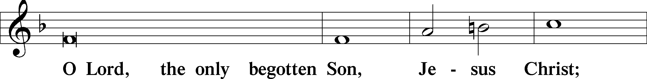
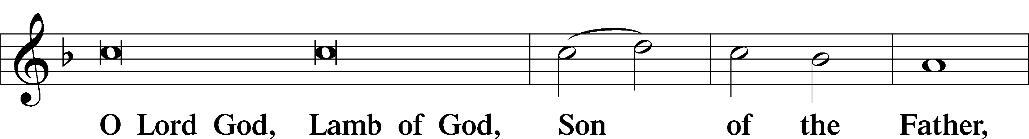
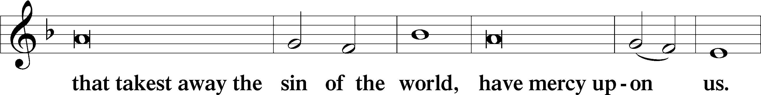
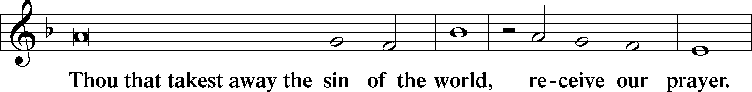
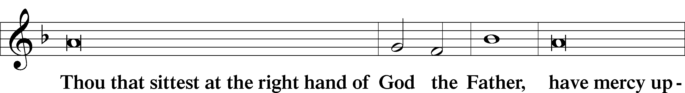
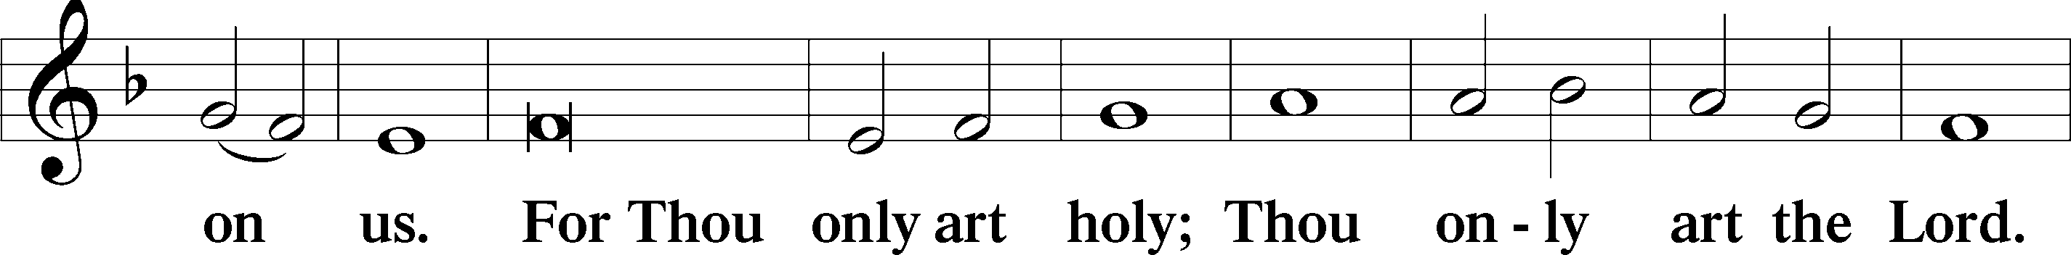
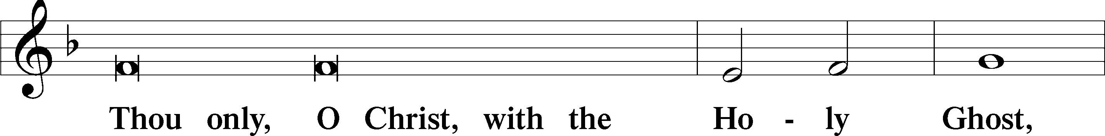
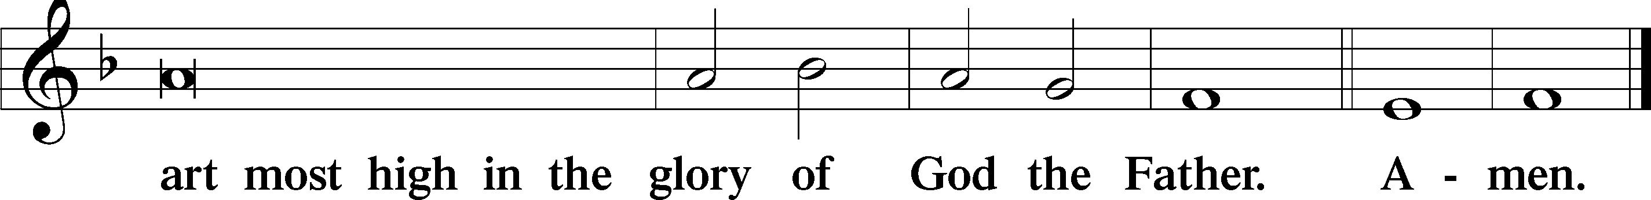

Salutation and Collect of the Day: Quasimodo Geniti
P The Lord be with you.
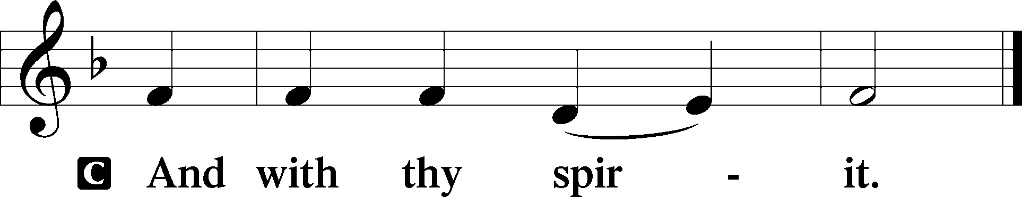

P Let us pray.
Almighty God, grant that we who have celebrated the Lord’s resurrection may by Your grace confess in our life and conversation that Jesus is Lord and God; through the same Jesus Christ, Your Son, who lives and reigns with You and the Holy Spirit, one God, now and forever.
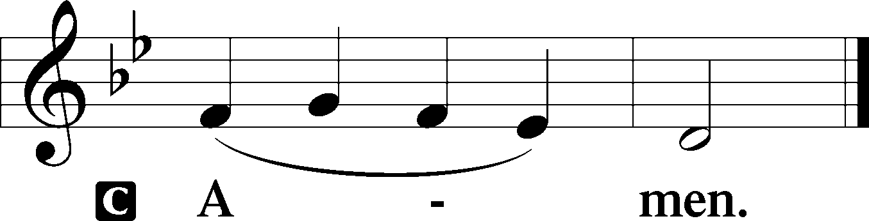
Sit

Prophecy: Ezekiel 37:1–14 (NKJV)
In those days: The hand of the Lord came upon me and brought me out in the Spirit of the Lord, and set me down in the midst of the valley; and it was full of bones. Then He caused me to pass by them all around, and behold, there were very many in the open valley; and indeed they were very dry. And He said to me, “Son of man, can these bones live?” So I answered, “O Lord God, You know.” Again He said to me, “Prophesy to these bones, and say to them, ‘O dry bones, hear the word of the Lord! Thus says the Lord God to these bones: “Surely I will cause breath to enter into you, and you shall live. I will put sinews on you and bring flesh upon you, cover you with skin and put breath in you; and you shall live. Then you shall know that I am the Lord.” ’ ” So I prophesied as I was commanded; and as I prophesied, there was a noise, and suddenly a rattling; and the bones came together, bone to bone. Indeed, as I looked, the sinews and the flesh came upon them, and the skin covered them over; but there was no breath in them. Also He said to me, “Prophesy to the breath, prophesy, son of man, and say to the breath, ‘Thus says the Lord God: “Come from the four winds, O breath, and breathe on these slain, that they may live.” ’ ” So I prophesied as He commanded me, and breath came into them, and they lived, and stood upon their feet, an exceedingly great army. Then He said to me, “Son of man, these bones are the whole house of Israel. They indeed say, ‘Our bones are dry, our hope is lost, and we ourselves are cut off!’ Therefore prophesy and say to them, ‘Thus says the Lord God: “Behold, O My people, I will open your graves and cause you to come up from your graves, and bring you into the land of Israel. Then you shall know that I am the Lord, when I have opened your graves, O My people, and brought you up from your graves. I will put My Spirit in you, and you shall live, and I will place you in your own land. Then you shall know that I, the Lord, have spoken it and performed it,” says the Lord Almighty.’ ”

P This is the Word of the Lord.
C Thanks be to God.

Psalm 33
Shout for joy in the Lord, O you righteous!
Praise befits the upright.
Give thanks to the Lord with the lyre;
make melody to him with the harp of ten strings!
Sing to him a new song;
play skillfully on the strings, with loud shouts.
For the word of the Lord is upright,
and all his work is done in faithfulness.
He loves righteousness and justice;
the earth is full of the steadfast love of the Lord.
By the word of the Lord the heavens were made,
and by the breath of his mouth all their host.
He gathers the waters of the sea as a heap;
he puts the deeps in storehouses.
Let all the earth fear the Lord;
let all the inhabitants of the world stand in awe of him!
For he spoke, and it came to be;
he commanded, and it stood firm.
The Lord brings the counsel of the nations to nothing;
he frustrates the plans of the peoples.
The counsel of the Lord stands forever,
the plans of his heart to all generations.
Blessèd is the nation whose God is the Lord,
the people whom he has chosen as his heritage!
The Lord looks down from heaven;
he sees all the children of man;
from where he sits enthroned he looks out
on all the inhabitants of the earth,
he who fashions the hearts of them all
and observes all their deeds.
The king is not saved by his great army;
a warrior is not delivered by his great strength.
The war horse is a false hope for salvation,
and by its great might it cannot rescue.
Behold, the eye of the Lord is on those who fear him,
on those who hope in his steadfast love,
that he may deliver their soul from death
and keep them alive in famine.
Our soul waits for the Lord;
he is our help and our shield.
For our heart is glad in him,
because we trust in his holy name.
Let your steadfast love, O Lord, be upon us,
even as we hope in you.

Epistle: 1 John 5:4–10a (NKJV)
Dearly Beloved: Whatever is born of God overcomes the world. And this is the victory that has overcome the world—our faith. Who is he who overcomes the world, but he who believes that Jesus is the Son of God? This is He who came by water and blood—Jesus Christ; not only by water, but by water and blood. And it is the Spirit who bears witness, because the Spirit is truth. For there are three that bear witness in heaven: the Father, the Word, and the Holy Spirit; and these three are one. And there are three that bear witness on earth: the Spirit, the water, and the blood; and these three agree as one. If we receive the witness of men, the witness of God is greater; for this is the witness of God which He has testified of His Son. He who believes in the Son of God has the witness in himself.

P This is the Word of the Lord.
C Thanks be to God.

Stand
Verse Matthew 28:7b; John 20:26a, c
Alleluia. He has risen from the dead, and behold, he is going before you to Galilee. Alleluia. Eight days later Jesus came and stood among them and said, “Peace be with you.” Alleluia.

Alleluia
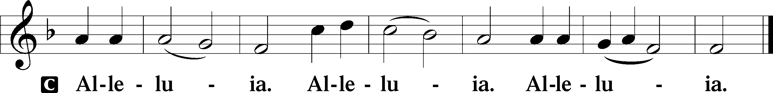

Holy Gospel: John 20:19–31 (NKJV)
P The Holy Gospel according to St. John, the twentieth chapter.
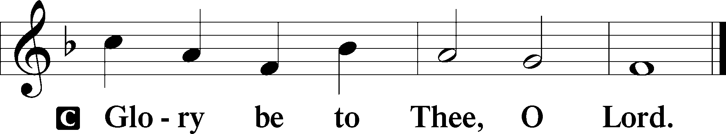

At that time: The same day at evening, being the first day of the week, when the doors were shut where the disciples were assembled, for fear of the Jews, Jesus came and stood in the midst, and said to them, “Peace be with you.” When He had said this, He showed them His hands and His side. Then the disciples were glad when they saw the Lord. So Jesus said to them again, “Peace to you! As the Father has sent Me, I also send you.” And when He had said this, He breathed on them, and said to them, “Receive the Holy Spirit. If you forgive the sins of any, they are forgiven them; if you retain the sins of any, they are retained.” Now Thomas, called the Twin, one of the twelve, was not with them when Jesus came. The other disciples therefore said to him, “We have seen the Lord.” So he said to them, “Unless I see in His hands the print of the nails, and put my finger into the print of the nails, and put my hand into His side, I will not believe.” And after eight days His disciples were again inside, and Thomas with them. Jesus came, the doors being shut, and stood in the midst, and said, “Peace to you!” Then He said to Thomas, “Reach your finger here, and look at My hands; and reach your hand here, and put it into My side. Do not be unbelieving, but believing.” And Thomas answered and said to Him, “My Lord and my God!” Jesus said to him, “Thomas, because you have seen Me, you have believed. Blessed are those who have not seen and yet have believed.” And truly Jesus did many other signs in the presence of His disciples, which are not written in this book; but these are written that you may believe that Jesus is the Christ, the Son of God, and that believing you may have life in His name.

P This is the Gospel of the Lord.
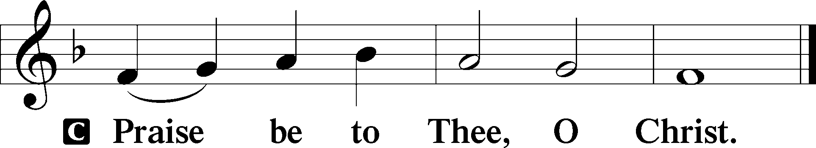

Nicene Creed
C I believe in one God,
the Father Almighty,
maker of heaven and earth
and of all things visible and invisible.

And in one Lord Jesus Christ,
the only-begotten Son of God,
begotten of His Father before all worlds,
God of God, Light of Light,
very God of very God,
begotten, not made,
being of one substance with the Father,
by whom all things were made;
who for us men and for our salvation came down from heaven
and was incarnate by the Holy Spirit of the virgin Mary
and was made man;
and was crucified also for us under Pontius Pilate.
He suffered and was buried.
And the third day He rose again according to the Scriptures
and ascended into heaven
and sits at the right hand of the Father.
And He will come again with glory to judge both the living and the dead,
whose kingdom will have no end.

And I believe in the Holy Spirit,
the Lord and giver of life,
who proceeds from the Father and the Son,
who with the Father and the Son together is worshiped and glorified,
who spoke by the prophets.
And I believe in one holy Christian and apostolic Church,
I acknowledge one Baptism for the remission of sins,
and I look for the resurrection of the dead
and the life T of the world to come. Amen.
Sit

Hymn of the Day: LSB #471 “O Sons and Daughters of the King”

Sermon

Stand

Prayer of the Church

Offertory Psalm 51:10–12
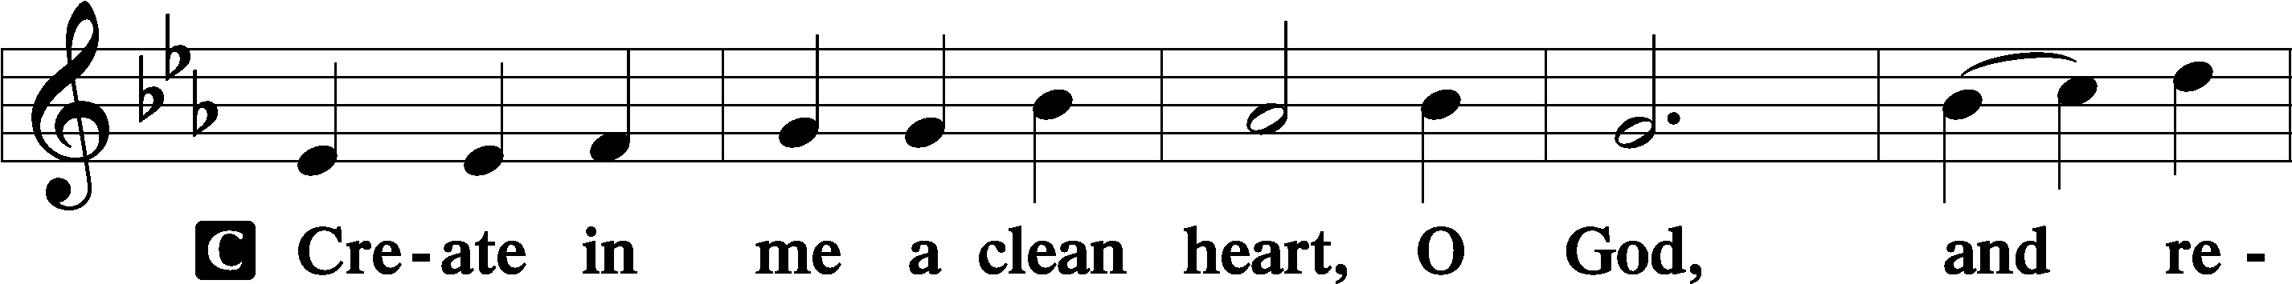
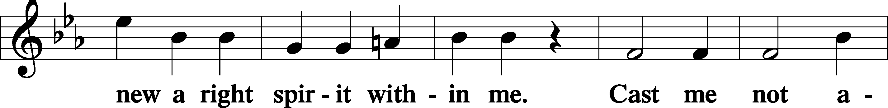
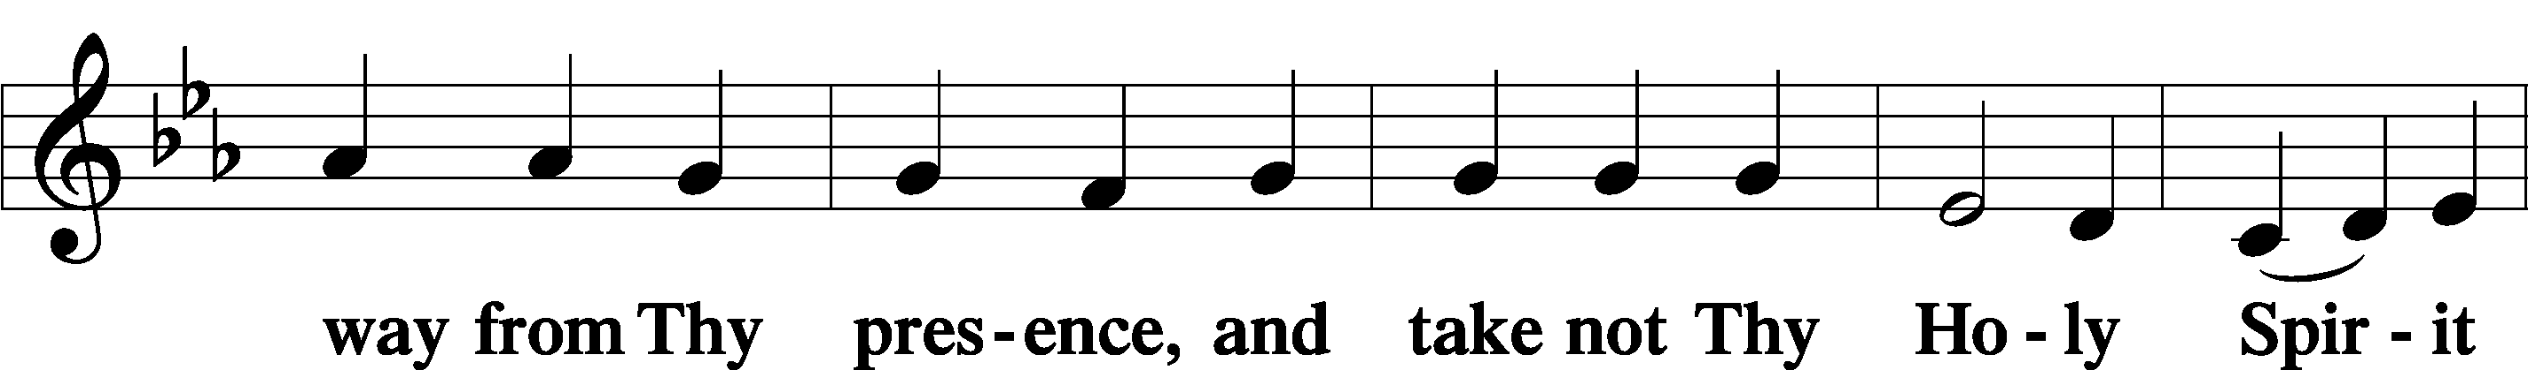
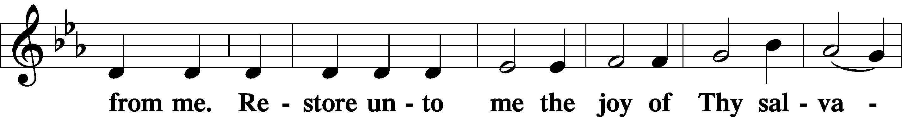
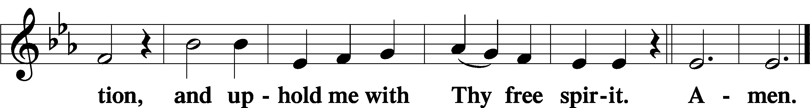
Sit

Preparatory Hymn: LSB #602 “The Gifts Christ Freely Gives”

Stand
Service of the Sacrament

Preface 2 Timothy 4:22; Colossians 3:1 Psalm 136
P The Lord be with you.
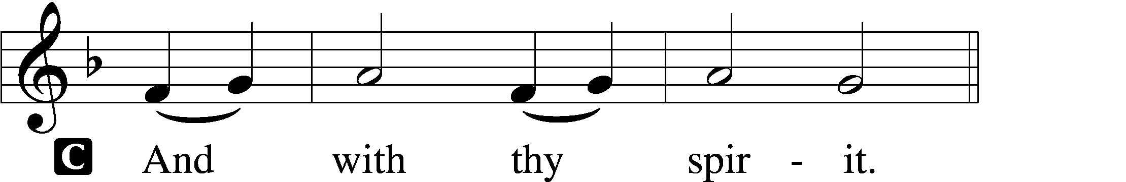

P Lift up your hearts.
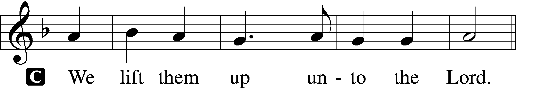

P Let us give thanks unto the Lord, our God.
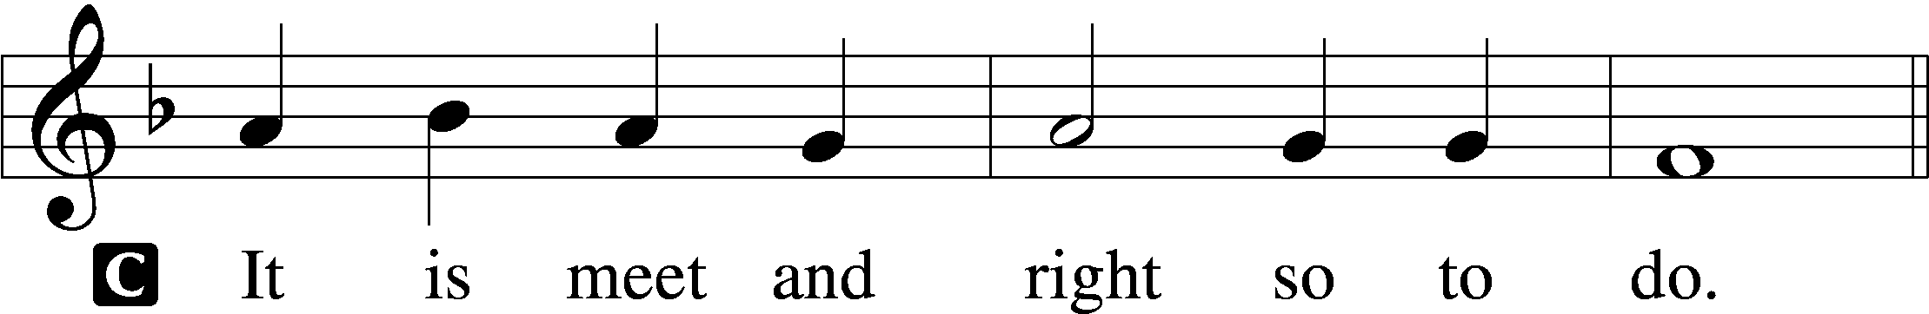
Proper Preface (Abbreviated) LSB 194
P It is truly meet, right, and salutary . . . evermore praising You and saying:

Sanctus Isaiah 6:3; Matthew 21:9
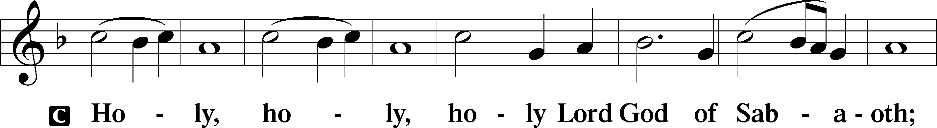
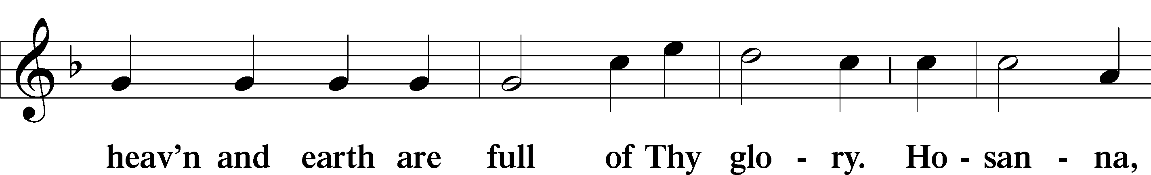
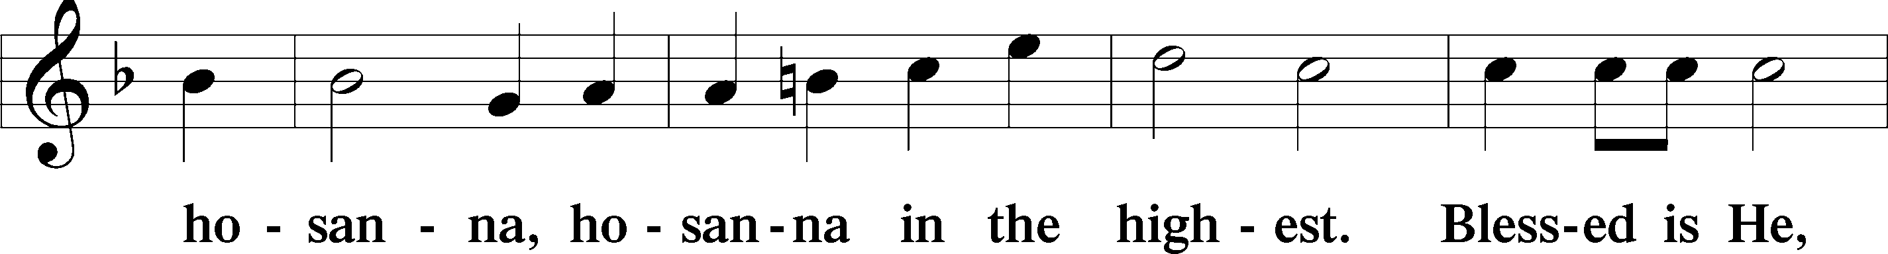
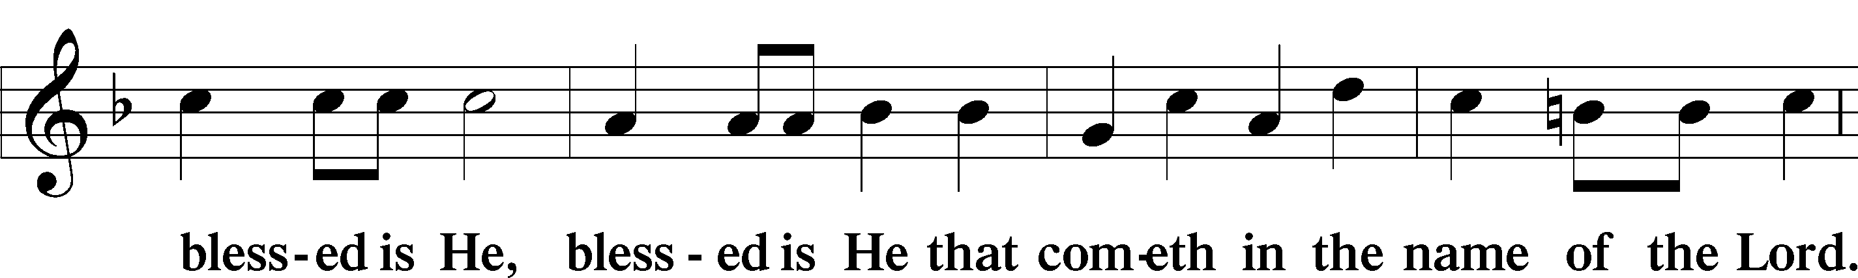
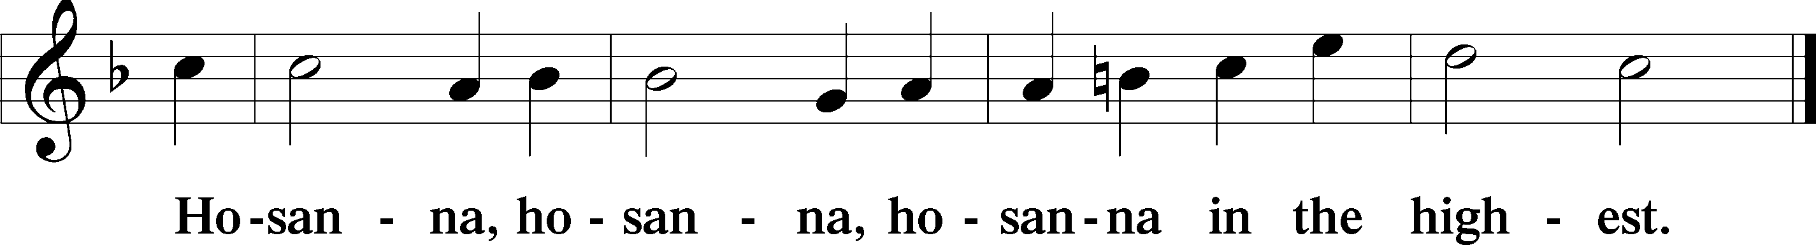

Lord’s Prayer Matthew 6:9–13
C Our Father who art in heaven,
hallowed be Thy name,
Thy kingdom come,
Thy will be done on earth as it is in heaven;
give us this day our daily bread;
and forgive us our trespasses as we forgive those who trespass against us;
and lead us not into temptation,
but deliver us from evil.
For Thine is the kingdom and the power and the glory forever and ever. Amen.

The Words of Our Lord Matthew 26:26–28; Mark 14:22–24; Luke 22:19–20; 1 Corinthians 11:23–25
P Our Lord Jesus Christ, on the night when He was betrayed, took bread, and when He had given thanks, He broke it and gave it to the disciples and said: “Take, eat; this is My T body, which is given for you. This do in remembrance of Me.”

In the same way also He took the cup after supper, and when He had given thanks, He gave it to them, saying: “Drink of it, all of you; this cup is the new testament in My T blood, which is shed for you for the forgiveness of sins. This do, as often as you drink it, in remembrance of Me.”

Pax Domini John 20:19
P The peace of the Lord be with you always.
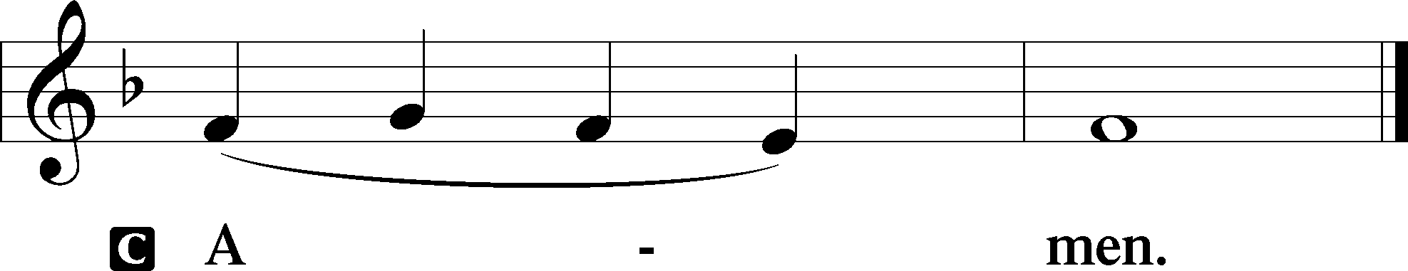

Agnus Dei John 1:29
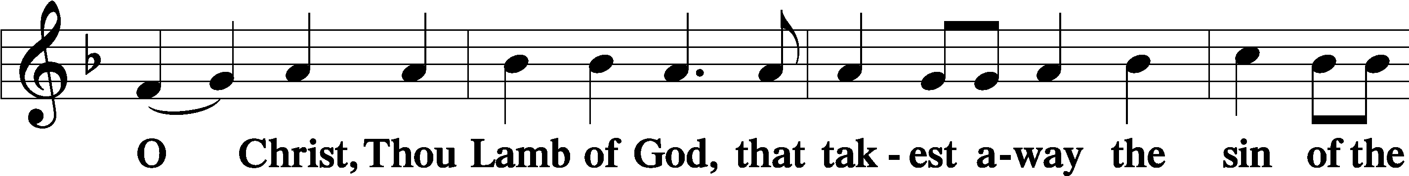
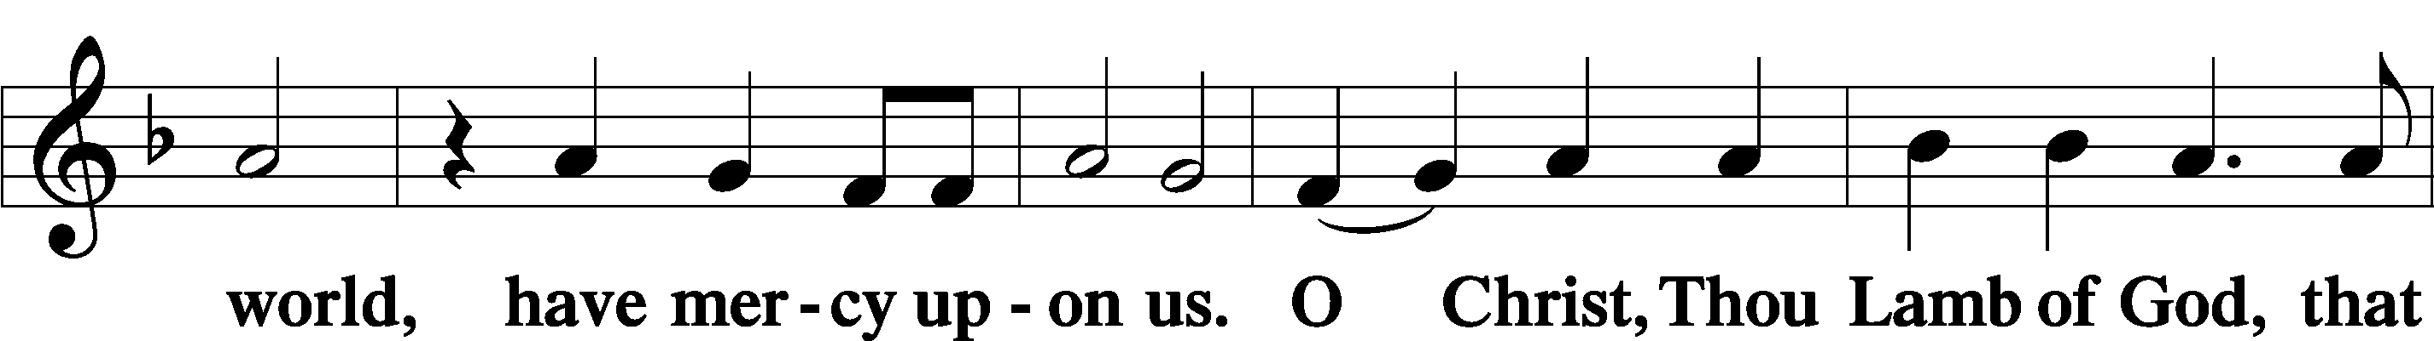
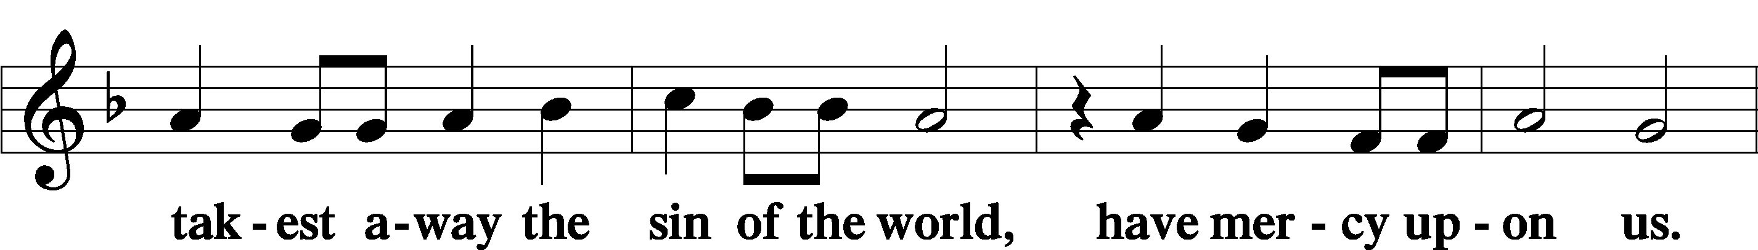
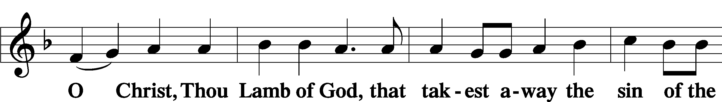
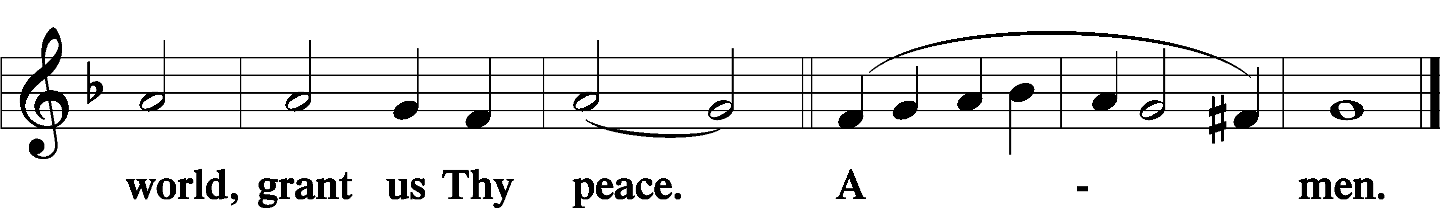
Sit
Distribution
The pastor and those who assist him receive the body and blood of Christ first and then distribute them to those who come to receive, saying:
Take, eat; this is the true body of our Lord and Savior Jesus Christ, given into death for your sins.
Amen.

Take, drink; this is the true blood of our Lord and Savior Jesus Christ, shed for the forgiveness of your sins.
Amen.

In dismissing the communicants, the following is said:
The Dismissal
P The body and blood of our Lord Jesus Christ strengthen and preserve you in body and soul to life everlasting. Depart T in peace.
C Amen.

Distribution Hymn: LSB #617 “O Lord, We Praise Thee”

Distribution Hymn: LSB #548 “Thanks to Thee, O Christ, Victorious”

Distribution Hymn: LSB #155 “This Is the Feast”

Stand
Nunc Dimittis Luke 2:29–32
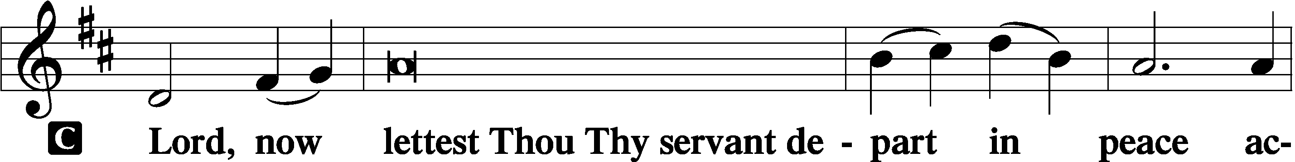
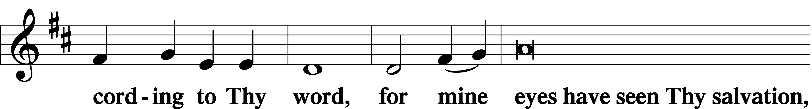
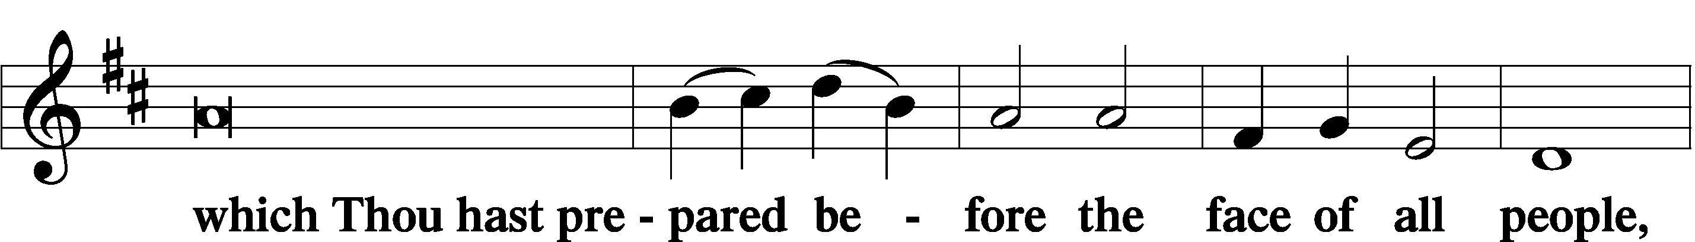
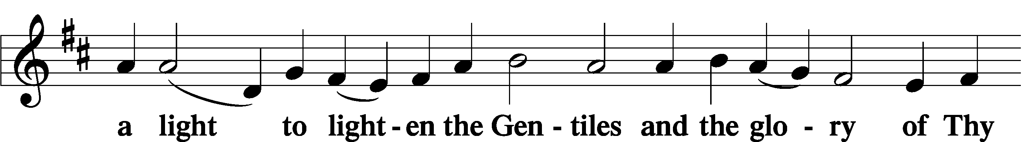
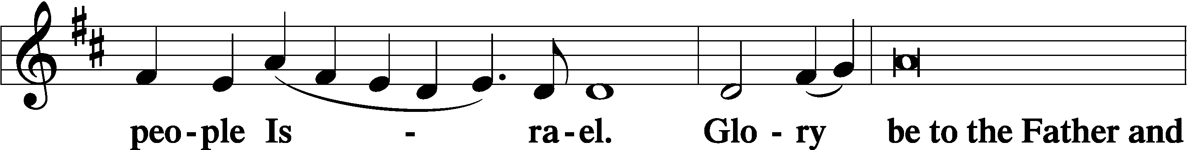
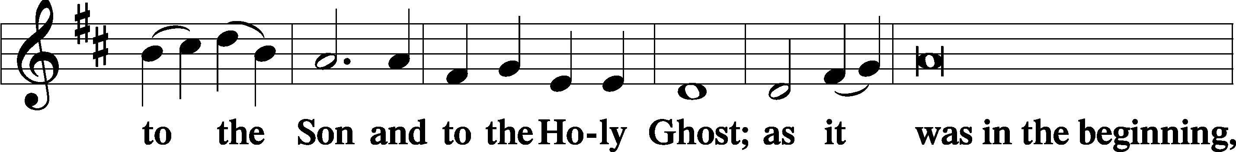
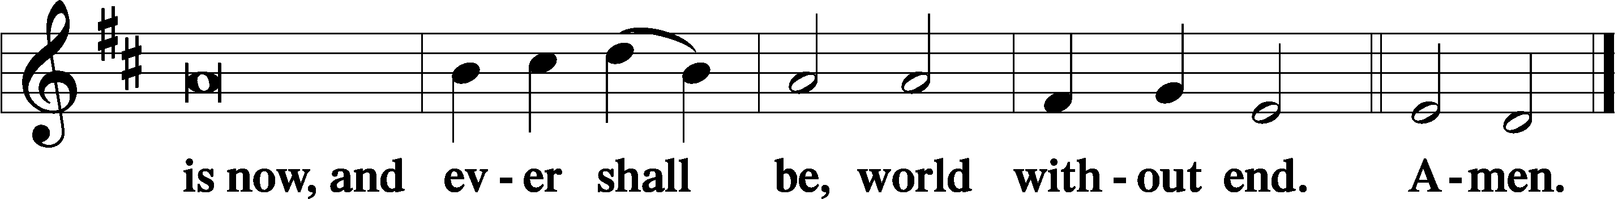

Thanksgiving Psalm 107:1
P O give thanks unto the Lord, for He is good,
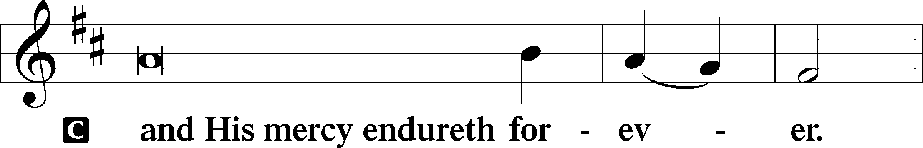

Post-Communion Collect
P Let us pray.
We give thanks to You, almighty God, that You have refreshed us through this salutary gift, and we implore You that of Your mercy You would strengthen us through the same in faith toward You and in fervent love toward one another; through Jesus Christ, Your Son, our Lord, who lives and reigns with You and the Holy Spirit, one God, now and forever.
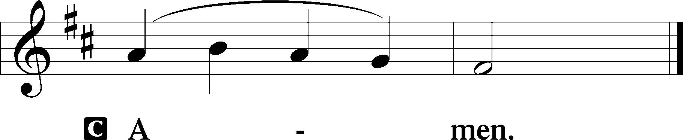

Salutation 2 Timothy 4:22
P The Lord be with you.
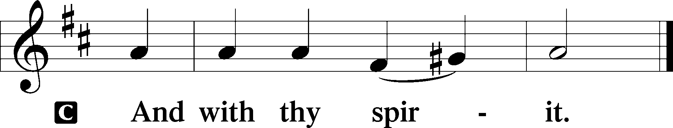

Benedicamus Psalm 103:1
P Bless we the Lord.
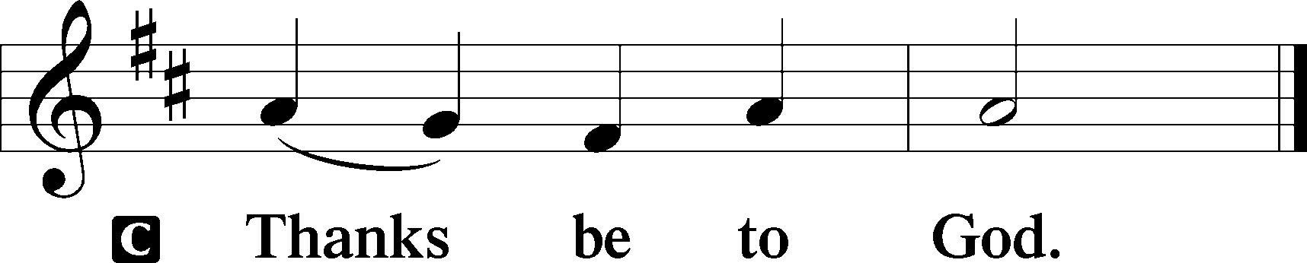

Benediction Numbers 6:24–26
P The Lord bless you and keep you.
The Lord make His face shine upon you and be gracious unto you.
The Lord lift up His countenance upon you and T give you peace.
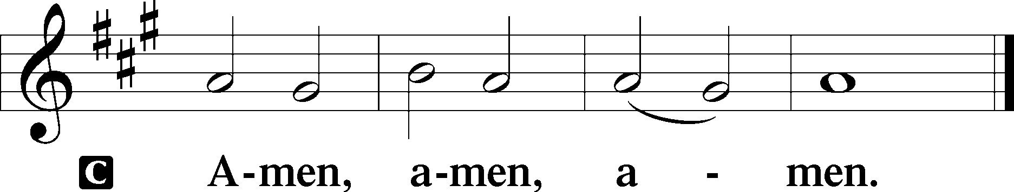

Closing Hymn: LSB #490 “Jesus Lives! The Victory’s Won”

Silent prayer after worship: Lord Jesus, by Your sacrificial death and triumphant resurrection You have given me eternal life. Give me the joy of serving You and proclaiming Your salvation until You return to take me home to You. Amen.
fffffffffffffffffffffffffffffffffff
Acknowledgments: Unless otherwise indicated, Scripture quotations are from the ESV® Bible (The Holy Bible, English Standard Version®), copyright © 2001 by Crossway, a publishing ministry of Good News Publishers. Used by permission. All rights reserved. Created by Lutheran Service Builder © 2023 Concordia Publishing House.
fffffffffffffffffffffffffffffffffff
fffffffffffffffffffffffffffffffffff
In Loving Memory of Parents, Ralph & Eleanore Haller and John & Helen Chlpka: Joseph & Beverly Chlpka (Food Pantry).
In Loving Memory of David Nelson: Dennis James (Food Pantry)
In Loving Memory of Viola Sakony: Kati & Michael L:aird (Food Pantry), Francine & Scott Sigworth (Altar Guild), and Betty & Bill Wolf.
fffffffffffffffffffffffffffffffffff
Up-coming Meetings:
Constitution/Bylaws Committee: Wednesday, April 19th at 7:15 pm.
Audit Committee: Sunday, April 23rd, following Worship
Interior Committee: Wednesday, April 26th at 7:15 pm .
Meetings will be held in the library.
SCHEDULE THROUGH APRIL 23, 2023:

:

Today, after Worship, Fellowship Hall: Coffee Fellowship
7 pm, Fellowship Hall: AA Meeting
Tuesday, 7-9 pm, Fellowship Hall: Penn-Ohio Singers
Wednesday, 7:15 pm, Library: Constitution & Bylaws Committee Meeting
7:30 pm, Fellowship Hall: NA Meeting
Saturday, 9:30 am, All Saints~Slippery Rock: Catechism Class
Next Sunday, 8 am, Fellowship Hall: Bible Study
9 am, Sanctuary: Divine Service
Following, Library: Quarterly and Monthly Audit
7 pm, Fellowship Hall: AA Meeting
fffffffffffffffffffffffffffffffffff
THANK YOU FOR SERVING IN APRIL: Elder: Jonathan Baisch; Ushers: Jerry Krivosh, Barry Nelson, & Jeff Sutton; Altarware: (prior) Diane Riefstahl & Marie Flaugher (04/09 & 04/30); (after) Elizabeth Haenftling (04/02 & 04/16) & Marie Flaugher (04/09, 04/23, & 04/30).
fffffffffffffffffffffffffffffffffff
Please note that items for the May calendar and newsletter are due to the secretary’s office by noon, Monday, April 24, 2023.
fffffffffffffffffffffffffffffffffff
Attendance: Friday, April 8, 2023 (Stations of the Cross): 22 (correction)
Saturday, April 8, 2023 (Easter Vigil): 23
Sunday, April 9, 2023: 61
fffffffffffffffffffffffffffffffffff
Please join us in the Fellowship Hall following worship this morning for Coffee Fellowship sponsored by Isaiah & Titus Deal. We are very grateful for their sponsorship.
If interested in sponsoring a Coffee Fellowship, please sign the sheet posted in the narthex. Sponsors are asked to drop off 2-3 dozen “treats” and 1 quart of juice in the kitchen prior to worship. Set-up (including the making of coffee) and clean-up will be done for you!
fffffffffffffffffffffffffffffffffff

Remember the following in Prayer…
~The Hurting and Healing: Amy, Gerald Arthur, Evelyn Baisch, Ellen Baron^{CA}, Lois Bortner^{CA}, John Burdette, Bev & Joe Chlpka, Kathleen Coughenour, Kim, Anna Mae Daris, Susan Davies, Tim Dudash, Millie Elavsky, Joseph Fleet, Judith & Eddy Furey, Tim Haenftling, Austin Hamilton, Neil Huston, Joan, Darla Krajci, Barbara Kreske, Donna Kennedy, Jess Lavoie, Joanne Lozier, Paul Lucas^{CA}, Sandy Marshall, Frank Niemeyer^{CA}, Linda Parkany, Juanita Rentschler, Richard Reuning^{CA}, Nancy Robertson^{CA}, Marty Scott, Kara, Fred Tonty, Angela Weser^{CA}, and Ruth Wolf.
~The Homebound: Rudy & Jean Tomko, Betty Wolf, and Ed & Millie Zachar.
~Serving in the Military: Curtis Sinewe and Joshua Solyan.
~Community & World Needs: Those suffering from or affected by the coronavirus; those suffering due to the conflict between Ukraine and Russia; those suffering from loss and dislocation because weather disasters; those suffering from addiction and their families; Local, State, and National Government Leaders; safety for all Police Officers, Firefighters, & First Responders; the unemployed; our Second Quarter Local Mission: The Support of a Concordia, Fort Wayne Seminarian.
*CA represents cancer.
fffffffffffffffffffffffffffffffffff
Bible Memory Verses ~ Week of April 16th:
For Adults: And when he had said this, he breathed on them and said to them, “Receive the Holy Spirit. If you forgive the sins of any, they are forgiven them; if you withhold forgiveness from any, it is withheld.” John 20:22-23
For Children: Blessed be the God and Father of our Lord Jesus Christ! According to his great mercy, he has caused us to be born again to a living hope through the resurrection of Jesus Christ from the dead. 1 Peter 1:3
fffffffffffffffffffffffffffffffffff
The Altar Flowers, from last Sunday, were given to the Glory of God and in appreciation of the great sacrifice of His Son, Jesus Christ, for the remission of our sins.
Christ is Risen! He is Risen Indeed! Alleluia!
fffffffffffffffffffffffffffffffffff
If you purchased Easter lilies or daffodils, please be certain to take them home this morning. (Two daffodils are on the window sill in the main hallway.)
Our Stewardship of Treasures for the Lord:
In order to do the Lord’s work, we need $2,553.63 each week to meet our 2023 budget for general purposes and $76.92 for the SELC. Figures for Thursday, April 6, 2023
General Fund: $865.00
SELC: $40.00
Quarterly Missions: $35.00
Other: $21.50
Figures for Friday, April 7, 2023
General Fund: $318.00
Capital Campaign: $100.00
Figures for Saturday, April 8, 2023
General Fund: $560.00
SELC: $50.00
Figures for Sunday, April 9, 2023
General Fund: $2,441.00
SELC: $5.00
Food Pantry: $115.00
Capital Campaign: $160.00
Other: $100.00
Figures for Monday, April 10, 2023
General Fund: $700.00 Ahead for the week*: +$2,330.37
SELC: $0.00 Ahead for the week*: +$18.08
*Includes above figures.

For online giving, check out https://www.saintspeterandpaul.net/online-giving.
fffffffffffffffffffffffffffffffffff
