Sts. Peter & Paul
Evangelical Lutheran Church
Lutheran Church-Missouri Synod
Founded-1917

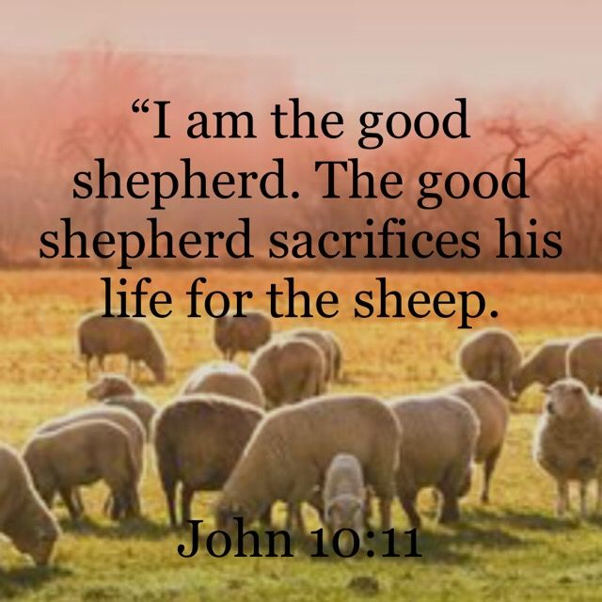

April 14, 2024

699 Stambaugh Ave.
Sharon, Pennsylvania 16146

“I was glad when they said to me,
Let us go to the house of the LORD!”
Psalm 122:1
Sts. Peter & Paul Evangelical Lutheran Church, LC-MS
MISERICORDIAS DOMINI
April 14, 2024

A special welcome to our guests this day! If you would like more information about The Lutheran Church - Missouri Synod, or this congregation, please speak with Pastor Deal or an Elder after the service.
Members & Guests: Don’t be embarrassed if your children make noise during the worship service, all children do. We encourage families to worship together but, if you feel the need, there are pews in the rear of the Church which are reserved for young families on both sides of the sanctuary. There is also a quiet room available to you, located next to the sanctuary (formerly the Pastor’s office), where you would be able to follow along with the service.

Today’s service includes the Sacrament of Holy Communion. If during this past year, you have not worshipped with us and been communed, we respectfully ask that you do not partake of this sacrament this day before first speaking with Pastor Deal.
If visiting from a sister congregation of the LC-MS and are in good standing, please inform Pastor Deal of your desire to commune prior to the service.
If wishing to receive a blessing during communion, please approach with your arms crossed.

CONTACT INFORMATION
Pastor Deal: pastordeal@saintspeterandpaul.net or 724-347-3620 (opt. 2)
Church Office: church@saintspeterandpaul.net or 724-347-3620 (opt. 3)
Office Hours: The church office will be open Monday and Thursday (8:30 am-4:30 pm).

Silent prayer before worship: Dear Heavenly Father, You sent Jesus to be my Good Shepherd. Yet, I am not always a faithful sheep. Cause me to focus on You today so I may find healing, strength and direction through Your Word. In Jesus’ name. Amen.

Confession and Absolution

Opening Hymn: LSB #709 “The King of Love My Shepherd Is”

Stand

The sign of the cross may be made by all in remembrance of their Baptism.

Invocation
P In the name of the Father and of the T Son and of the Holy Spirit.
C Amen.

Exhortation Hebrews 10:22; Psalm 124:8; Psalm 32:5
P Beloved in the Lord! Let us draw near with a true heart and confess our sins unto God our Father, beseeching Him in the name of our Lord Jesus Christ to grant us forgiveness.

P Our help is in the name of the Lord,
C who made heaven and earth.
P I said, I will confess my transgressions unto the Lord,
C and You forgave the iniquity of my sin.

Silence for reflection on God’s Word and for self-examination.

Confession of Sins
P O almighty God, merciful Father,
C I, a poor, miserable sinner, confess unto You all my sins and iniquities with which I have ever offended You and justly deserved Your temporal and eternal punishment. But I am heartily sorry for them and sincerely repent of them, and I pray You of Your boundless mercy and for the sake of the holy, innocent, bitter sufferings and death of Your beloved Son, Jesus Christ, to be gracious and merciful to me, a poor, sinful being.

Absolution [John 20:19–23]
P Upon this your confession, I, by virtue of my office, as a called and ordained servant of the Word, announce the grace of God unto all of you, and in the stead and by the command of my Lord Jesus Christ I forgive you all your sins in the name of the Father and of the T Son and of the Holy Spirit.
C Amen.

Service of the Word

Introit Psalm 33:1, 18–20; antiphon: vv. 5b, 6a
The earth is full of the steadfast love of the Lord. Alle- | luia.*
By the word of the Lord the heavens were made. Alle- | luia.
Shout for joy in the Lord, O you | righteous!*
Praise befits the | upright.
Behold, the eye of the Lord is on those who | fear him,*
on those who hope in his | steadfast love,
that he may deliver their | soul from death*
and keep them alive in | famine.
Our soul waits | for the Lord;*
he is our help | and our shield.
The earth is full of the steadfast love of the Lord. Alle- | luia.*
By the word of the Lord the heavens were made. Alle- | luia.

Gloria Patri
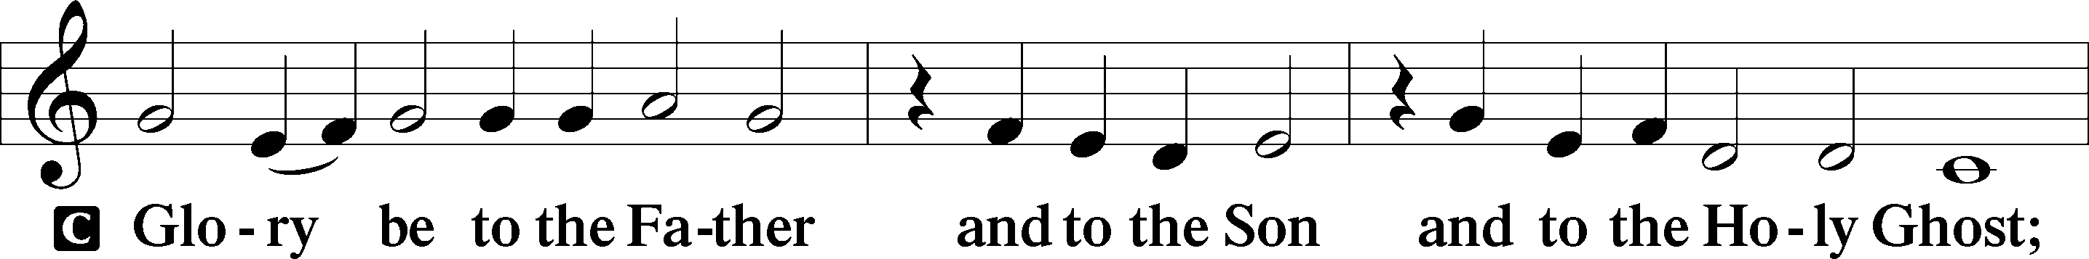
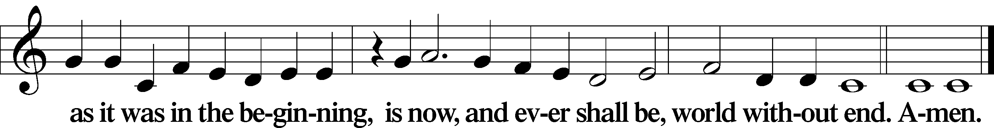
Kyrie Mark 10:47
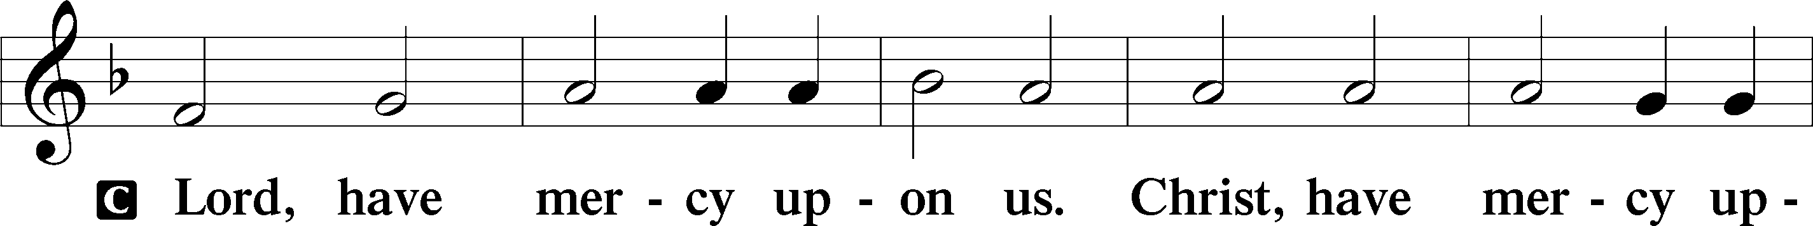
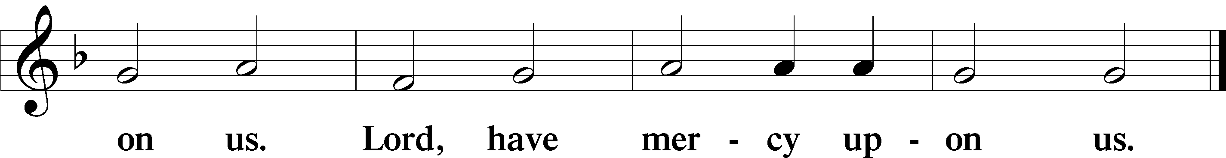

Gloria in Excelsis Luke 2:14; John 1:29
P Glory be to God on high:
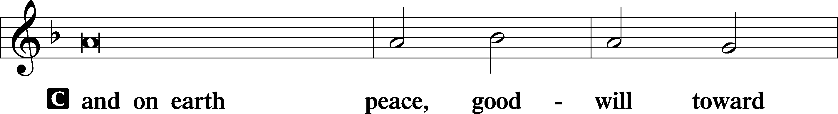
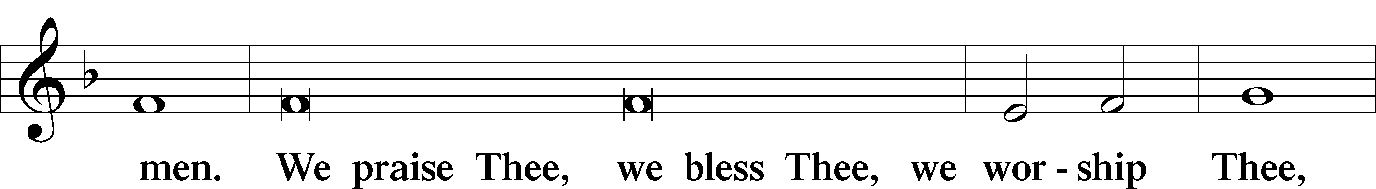
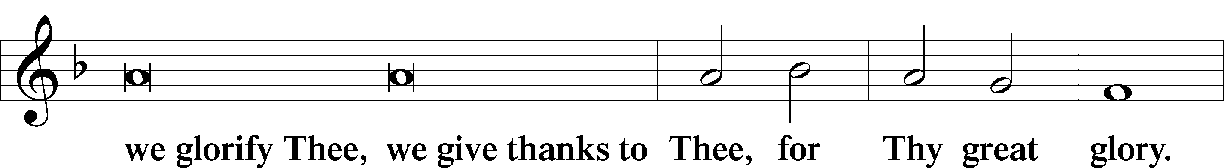
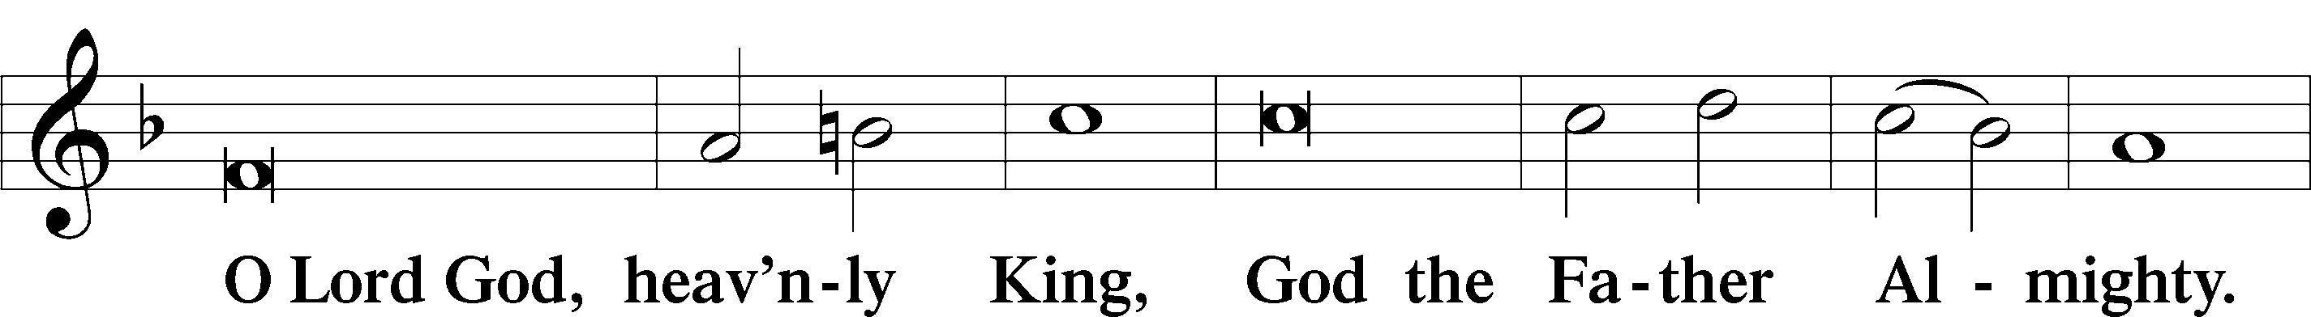
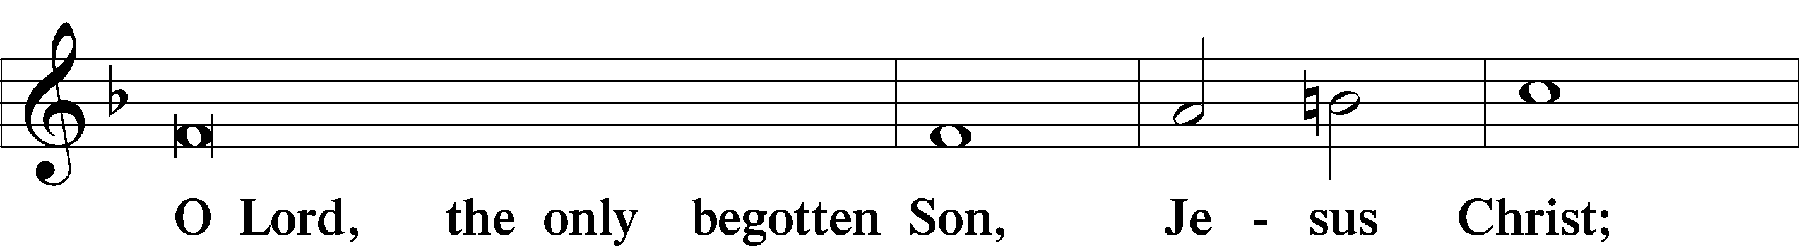
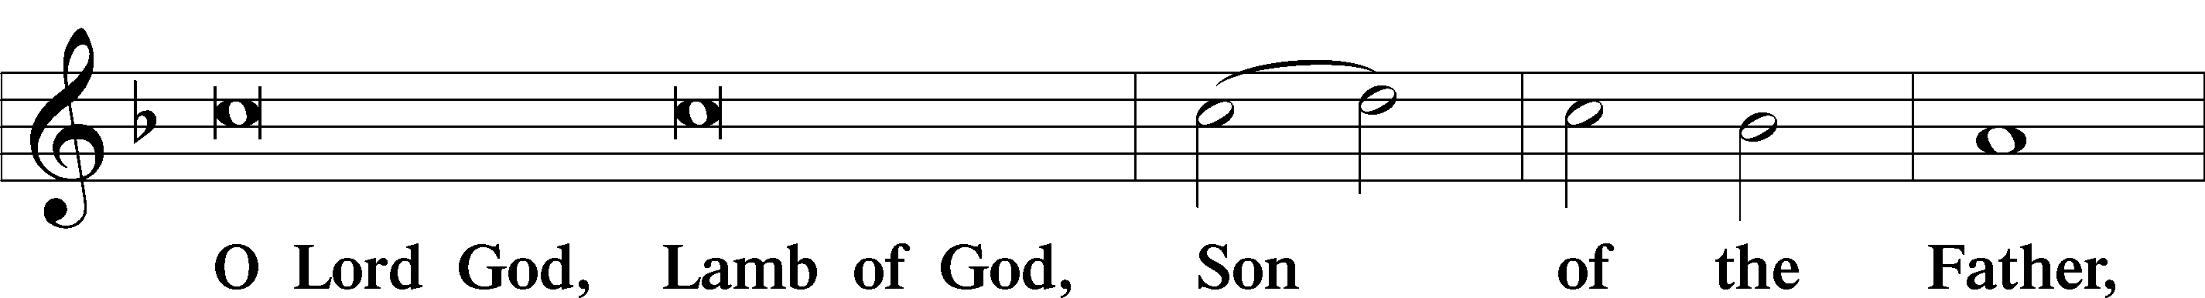
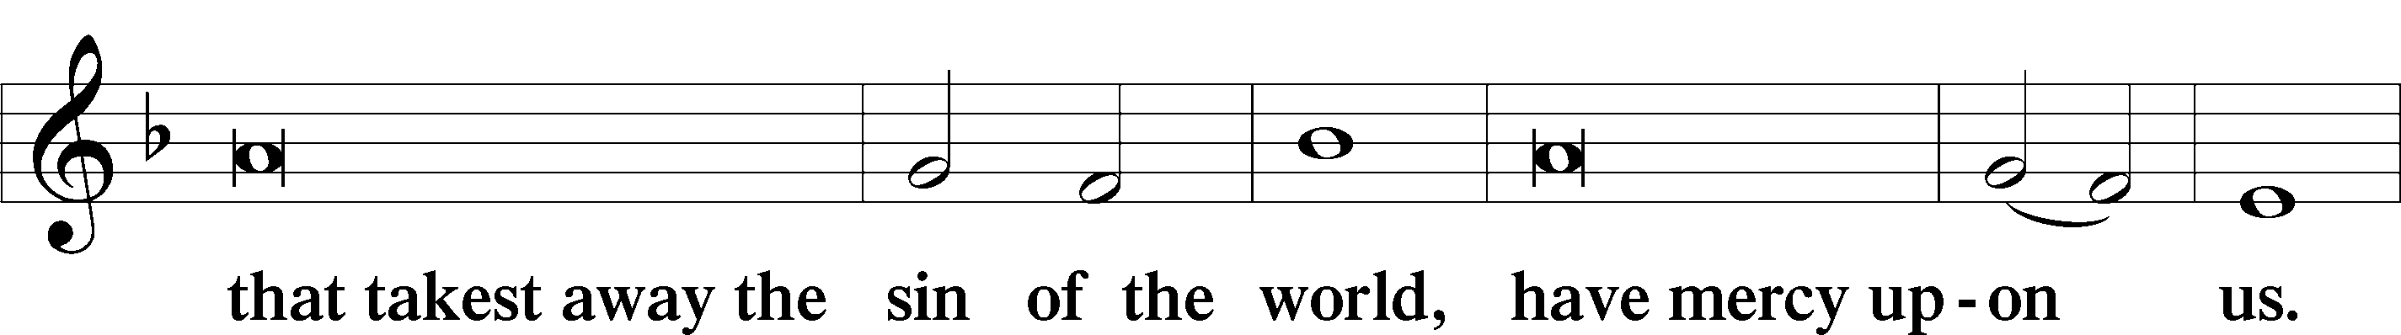
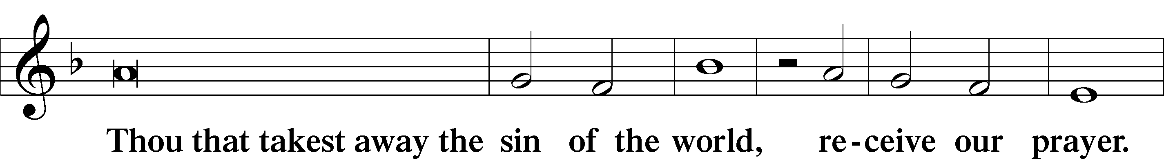
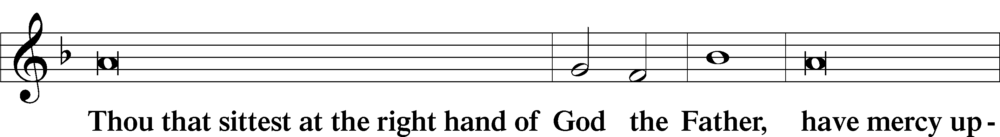
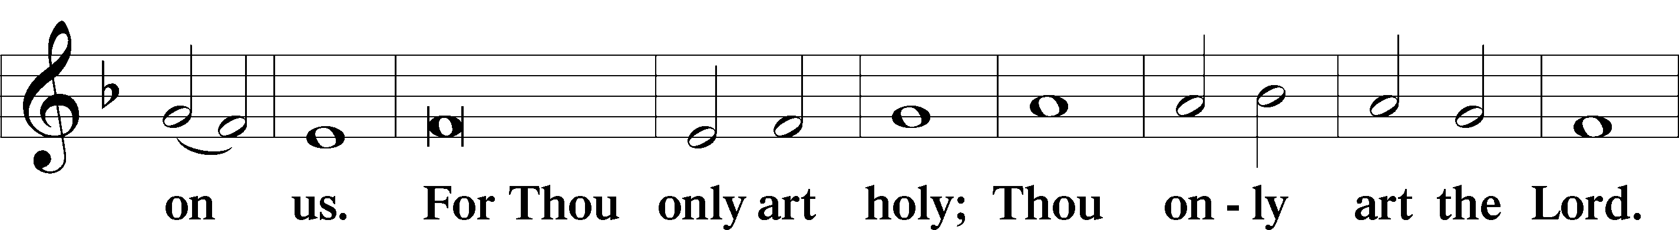
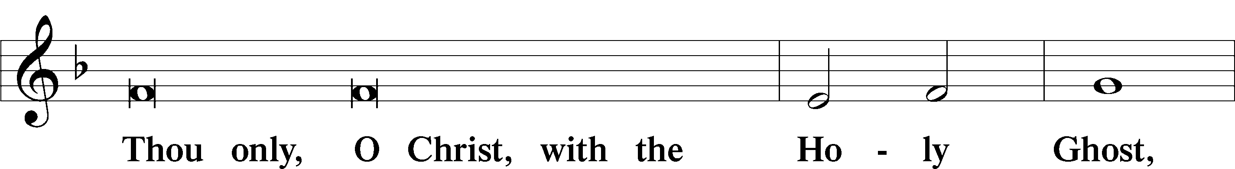
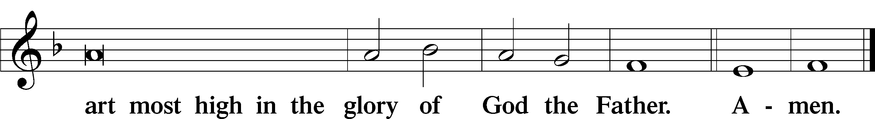

P The Lord be with you.
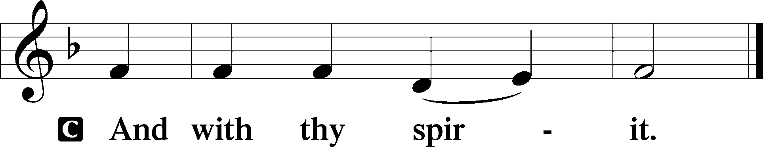

Salutation and Collect of the Day: Misericordias Domini
P Let us pray.
O God, through the humiliation of Your Son You raised up the fallen world. Grant to Your faithful people, rescued from the peril of everlasting death, perpetual gladness and eternal joys; through Jesus Christ, our Lord, who lives and reigns with You and the Holy Spirit, one God, now and forever.
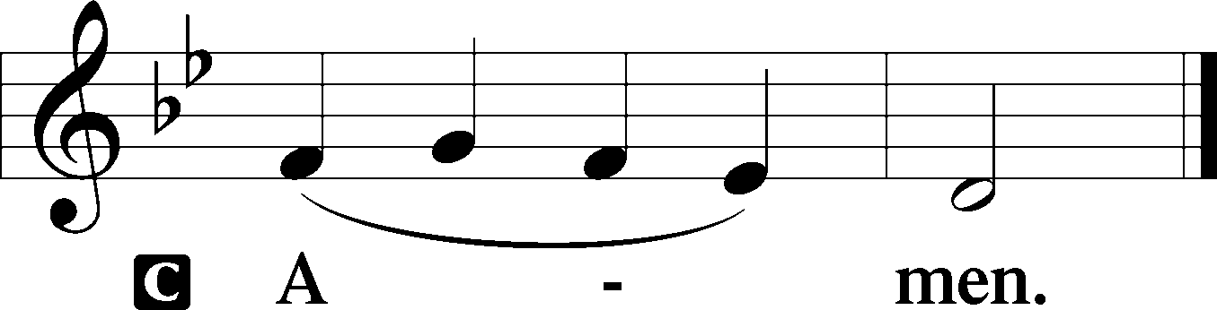
Sit

Prophecy: Ezekiel 34:11–16 (NKJV)
Thus says the Lord God: “Indeed I Myself will search for My sheep and seek them out. As a shepherd seeks out his flock on the day he is among his scattered sheep, so will I seek out My sheep and deliver them from all the places where they were scattered on a cloudy and dark day. And I will bring them out from the peoples and gather them from the countries, and will bring them to their own land; I will feed them on the mountains of Israel, in the valleys and in all the inhabited places of the country. I will feed them in good pasture, and their fold shall be on the high mountains of Israel. There they shall lie down in a good fold and feed in rich pasture on the mountains of Israel. I will feed My flock, and I will make them lie down,” says the Lord God. “I will seek what was lost and bring back what was driven away, bind up the broken and strengthen what was sick; but I will destroy the fat and the strong, and feed them in judgment,” says the Lord Almighty.

P This is the Word of the Lord.
C Thanks be to God.

Psalm 23 (NKJV)
The Lord is my shepherd; I shall not want.
He maketh me to lie down in green pastures.
He leadeth me beside the still waters.
He restoreth my soul.
He leadeth me in the paths of righteousness
for his name's sake.
Yea, though I walk through the valley of the shadow of death,
I will fear no evil,
for thou art with me;
thy rod and thy staff,
they comfort me.
Thou preparest a table before me
in the presence of mine enemies:
thou anointest my head with oil;
my cup runneth over.
Surely goodness and mercy shall follow me
all the days of my life,
and I will dwell in the house of the Lord forever.

Epistle: 1 Peter 2:21b–25 (NKJV)
Dearly Beloved: Christ suffered for us, leaving us an example, that you should follow His steps: “who committed no sin, nor was deceit found in His mouth”; who, when He was reviled, did not revile in return; when He suffered, He did not threaten, but committed Himself to Him who judges righteously; who Himself bore our sins in His own body on the tree, that we, having died to sins, might live for righteousness—by whose stripes you were healed. For you were like sheep going astray, but have now returned to the Shepherd and Overseer of your souls.

P This is the Word of the Lord.
C Thanks be to God.

Stand

Verse Luke 24:35b; John 10:14
Alleluia. [The Lord] was known to them in the breaking of the bread. Alleluia. I am the good shepherd. I know my own and my own know me. Alleluia.

Alleluia
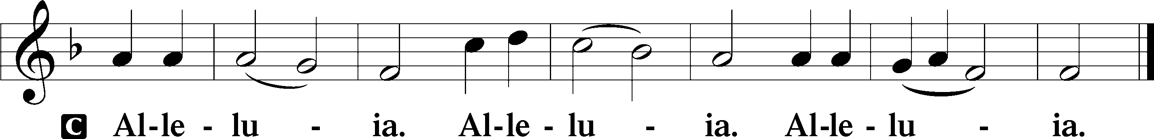

Holy Gospel: John 10:11–16 (NKJV)
P The Holy Gospel according to St. John, the tenth chapter.
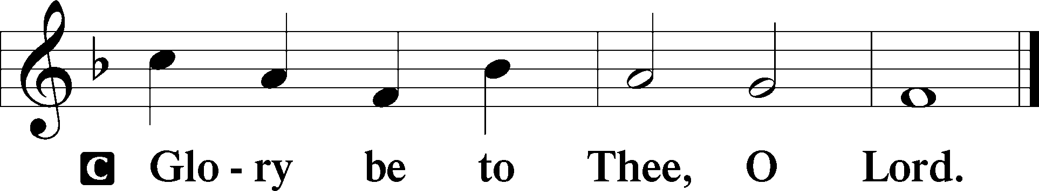

At that time Jesus said to His disciples: “I am the good shepherd. The good shepherd gives His life for the sheep. But a hireling, he who is not the shepherd, one who does not own the sheep, sees the wolf coming and leaves the sheep and flees; and the wolf catches the sheep and scatters them. The hireling flees because he is a hireling and does not care about the sheep. I am the good shepherd; and I know My sheep, and am known by My own. As the Father knows Me, even so I know the Father; and I lay down My life for the sheep. And other sheep I have which are not of this fold; them also I must bring, and they will hear My voice; and there will be one flock and one shepherd.”

P This is the Gospel of the Lord.
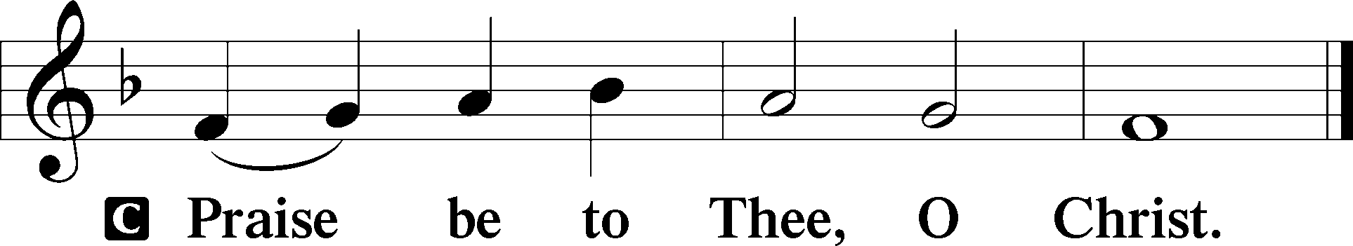

Nicene Creed
C I believe in one God,
the Father Almighty,
maker of heaven and earth
and of all things visible and invisible.

And in one Lord Jesus Christ,
the only-begotten Son of God,
begotten of His Father before all worlds,
God of God, Light of Light,
very God of very God,
begotten, not made,
being of one substance with the Father,
by whom all things were made;
who for us men and for our salvation came down from heaven
and was incarnate by the Holy Spirit of the virgin Mary
and was made man;
and was crucified also for us under Pontius Pilate.
He suffered and was buried.
And the third day He rose again according to the Scriptures
and ascended into heaven
and sits at the right hand of the Father.
And He will come again with glory to judge both the living and the dead,
whose kingdom will have no end.

And I believe in the Holy Spirit,
the Lord and giver of life,
who proceeds from the Father and the Son,
who with the Father and the Son together is worshiped and glorified,
who spoke by the prophets.
And I believe in one holy Christian and apostolic Church,
I acknowledge one Baptism for the remission of sins,
and I look for the resurrection of the dead
and the life T of the world to come. Amen.
Sit

Hymn of the Day: LSB #666 “O Little Flock, Fear Not the Foe”

Sermon

Stand

Offertory Psalm 51:10–12
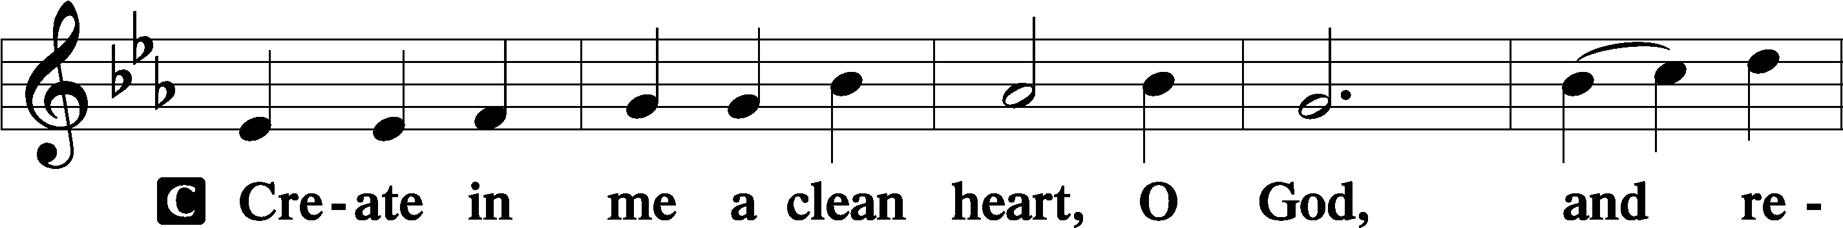
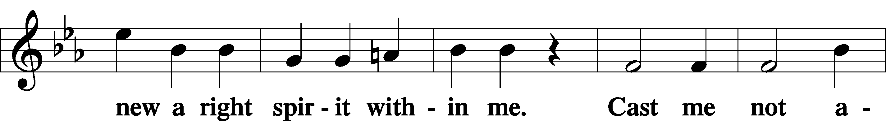
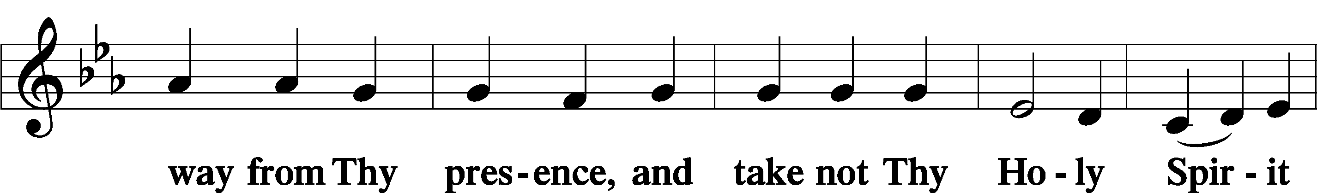
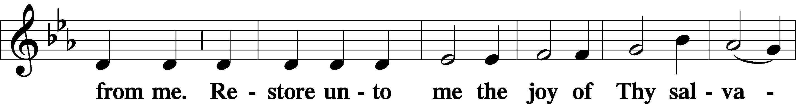
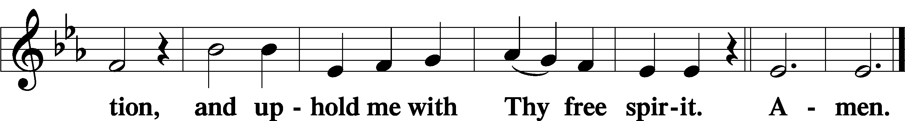

Prayer of the Church

Sit

Preparatory Hymn: LSB #633 “At the Lamb’s High Feast We Sing”

Service of the Sacrament

Preface 2 Timothy 4:22; Colossians 3:1 Psalm 136
P The Lord be with you.
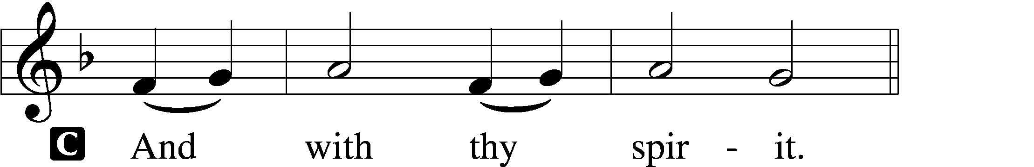

P Lift up your hearts.
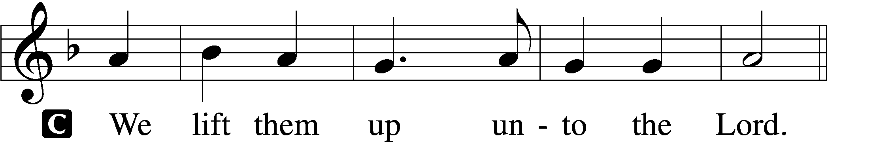

P Let us give thanks unto the Lord, our God.
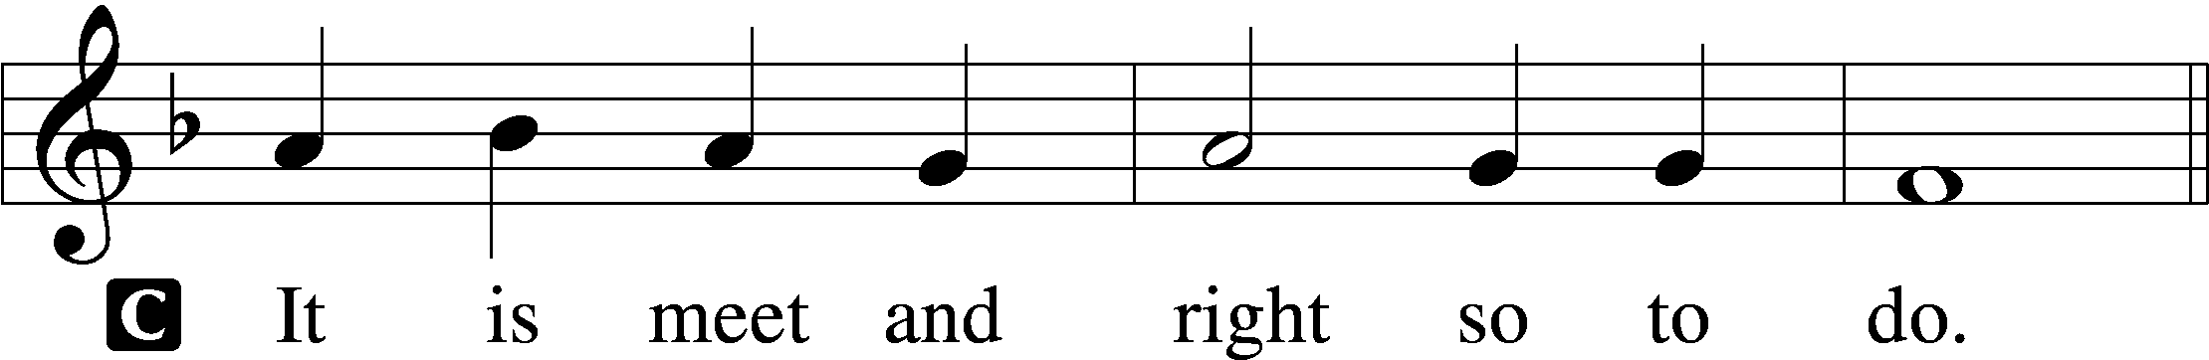

Proper Preface (Abbreviated) LSB 194
P It is truly meet, right, and salutary . . . evermore praising You and saying:

Sanctus Isaiah 6:3; Matthew 21:9
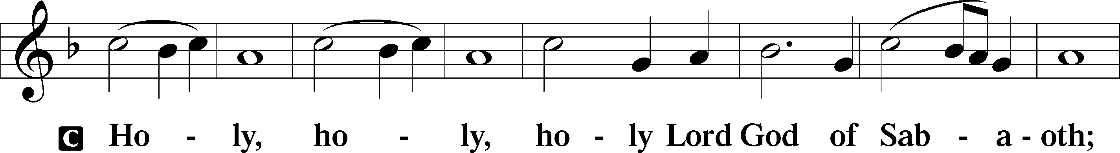
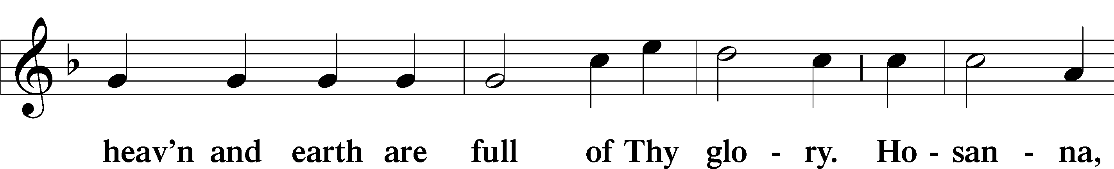
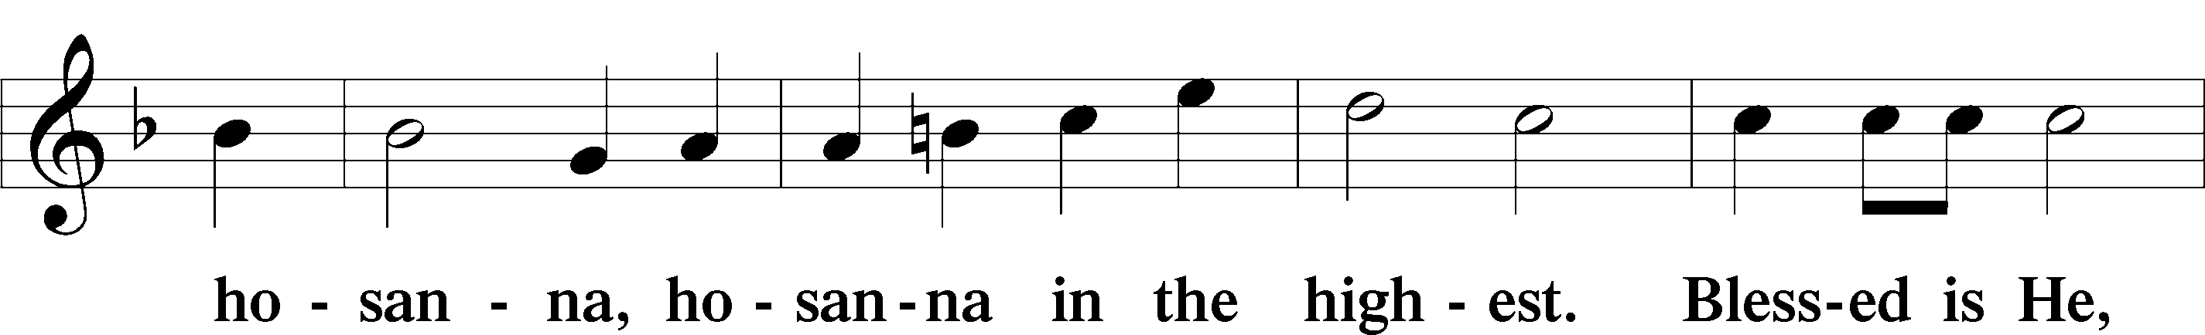
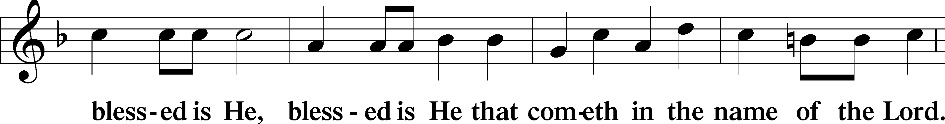
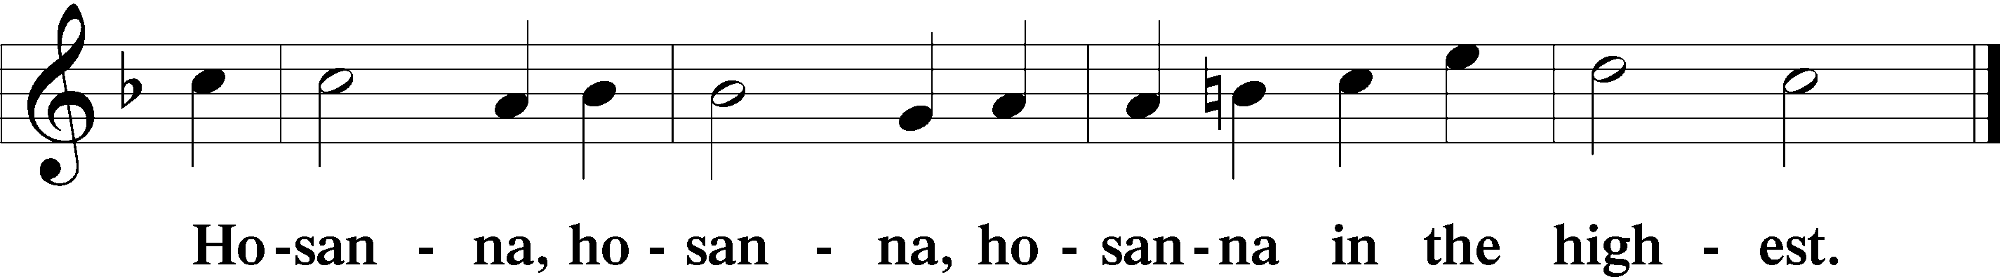

Lord’s Prayer The congregation is encouraged to silently pray the Lord’s Prayer as it is chanted. Matthew 6:9–13
P Our Father who art in heaven,
hallowed be Thy name,
Thy kingdom come,
Thy will be done on earth as it is in heaven;
give us this day our daily bread;
and forgive us our trespasses as we forgive those who trespass against us;
and lead us not into temptation,
but deliver us from evil.
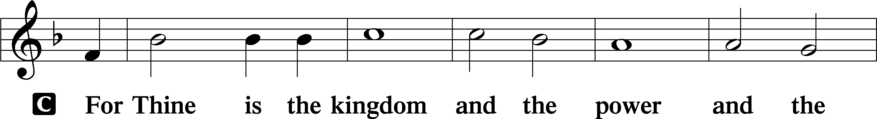
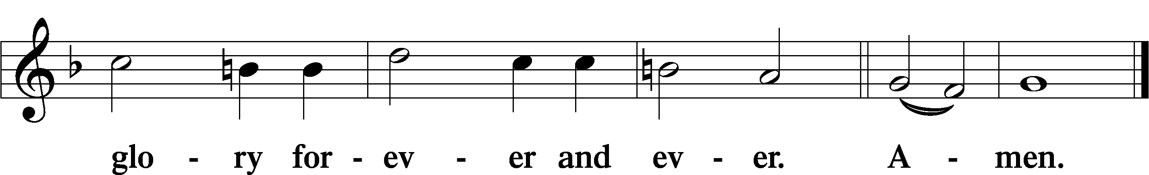

The Words of Our Lord Matthew 26:26–28; Mark 14:22–24; Luke 22:19–20; 1 Corinthians 11:23–25
P Our Lord Jesus Christ, on the night when He was betrayed, took bread, and when He had given thanks, He broke it and gave it to the disciples and said: “Take, eat; this is My T body, which is given for you. This do in remembrance of Me.”

In the same way also He took the cup after supper, and when He had given thanks, He gave it to them, saying: “Drink of it, all of you; this cup is the new testament in My T blood, which is shed for you for the forgiveness of sins. This do, as often as you drink it, in remembrance of Me.”

Pax Domini John 20:19
P The peace of the Lord be with you always.
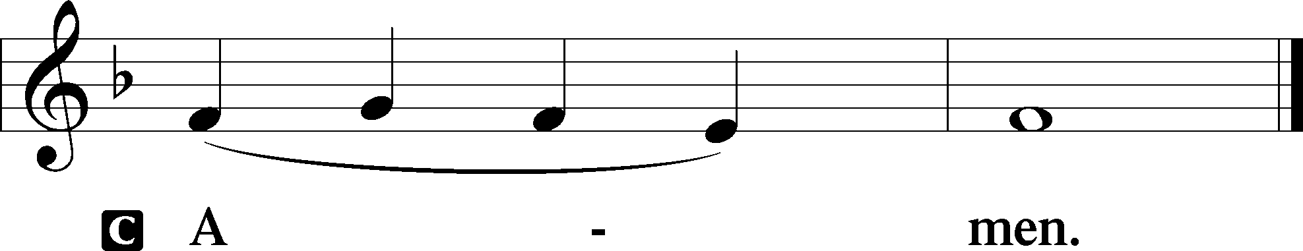

Agnus Dei John 1:29
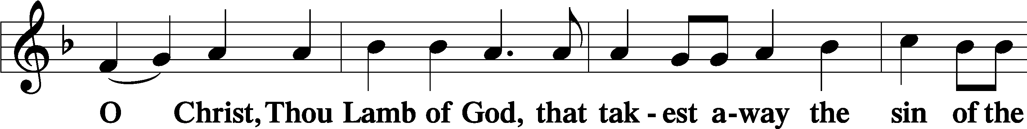
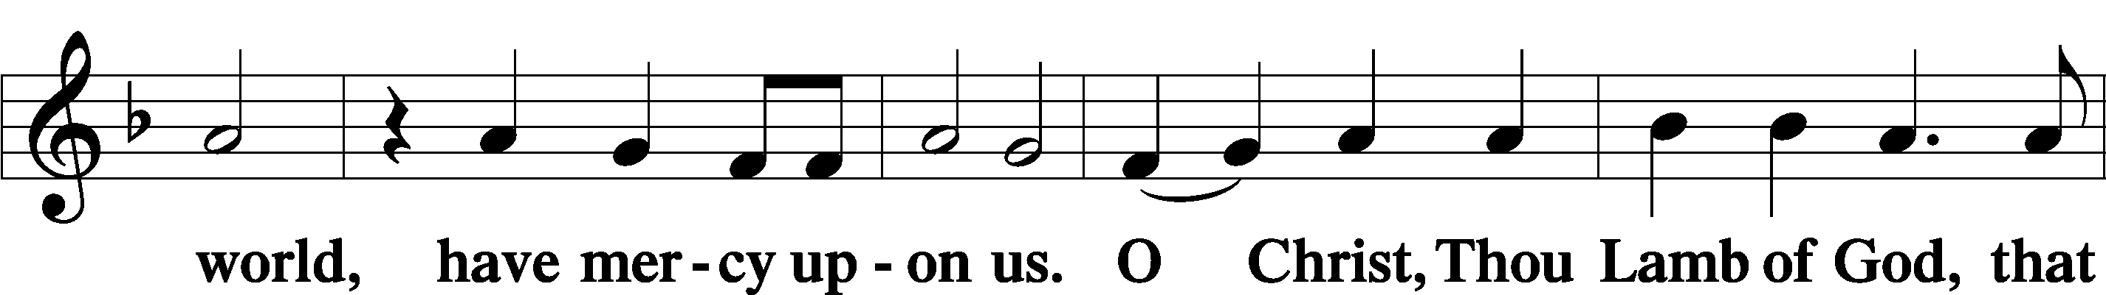
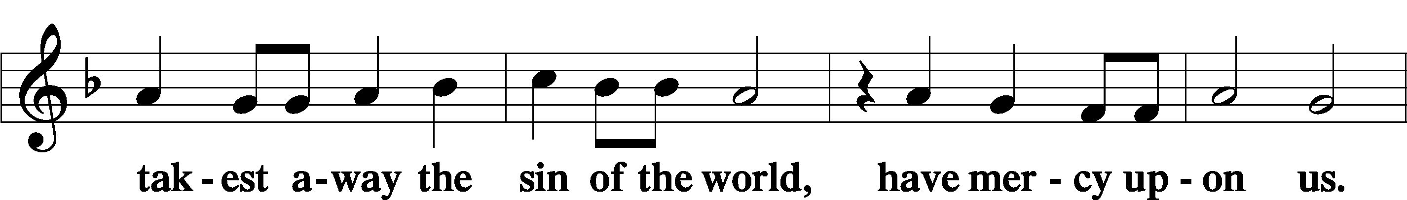
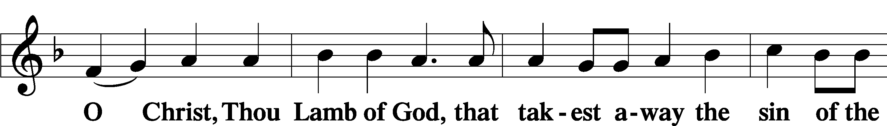
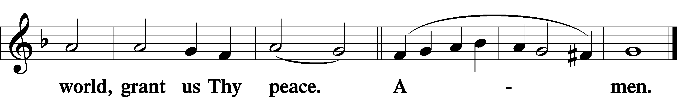
Sit

Distribution
The pastor and those who assist him receive the body and blood of Christ first and then distribute them to those who come to receive, saying:
Take, eat; this is the true body of our Lord and Savior Jesus Christ, given into death for your sins.
Amen.
Take, drink; this is the true blood of our Lord and Savior Jesus Christ, shed for the forgiveness of your sins.
Amen.

In dismissing the communicants, the following is said:
The Dismissal
P The body and blood of our Lord Jesus Christ strengthen and preserve you in body and soul to life everlasting. Depart T in peace.
C Amen.

Distribution Hymn: LSB #864 “Shepherd of Tender Youth”

Distribution Hymn: LSB p. 155 “This Is the Feast”

Distribution Hymn: LSB #548 “Thanks to Thee, O Christ, Victorious” LSB 548

Stand

Nunc Dimittis Luke 2:29–32
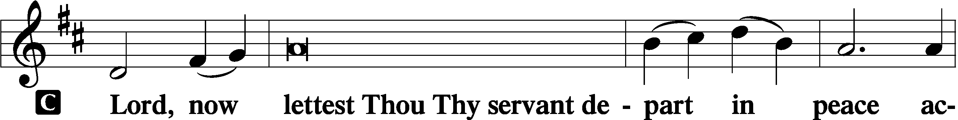
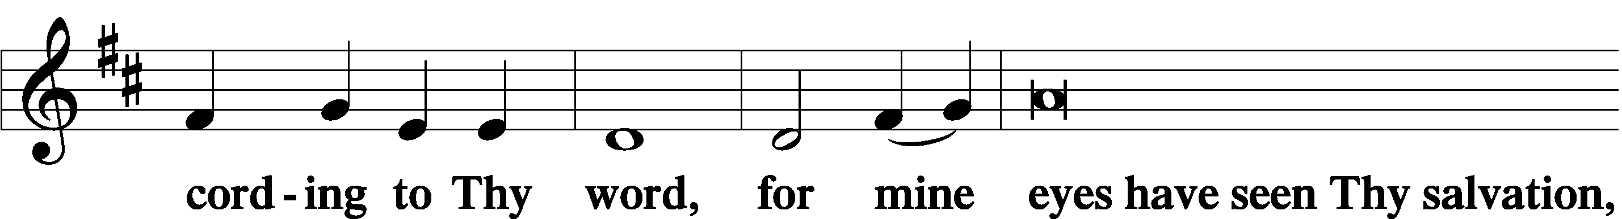
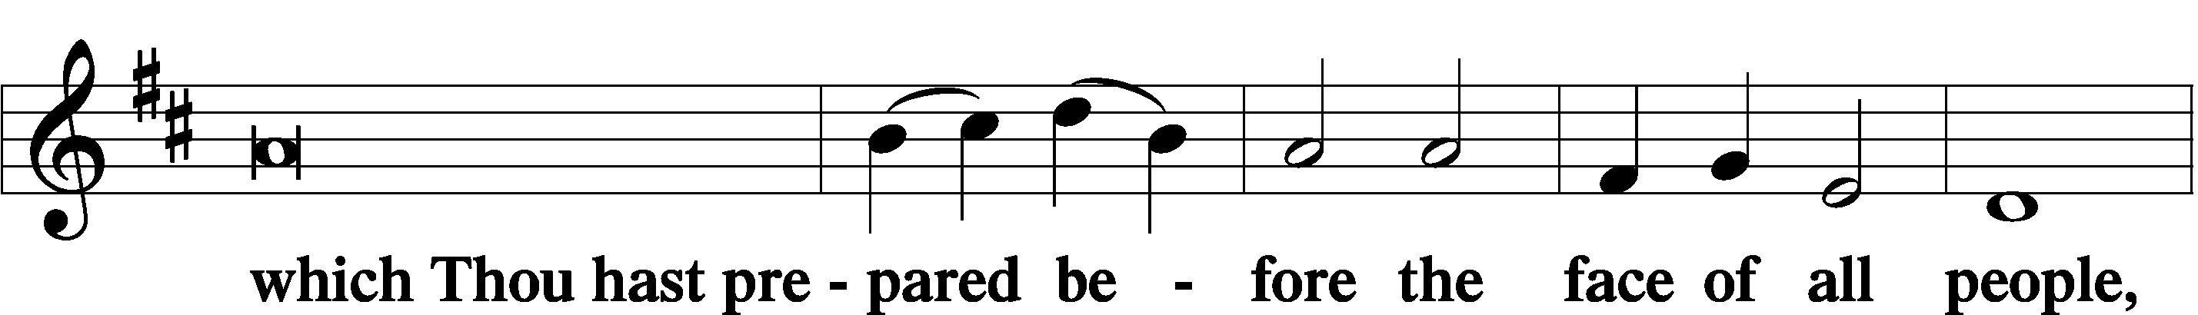
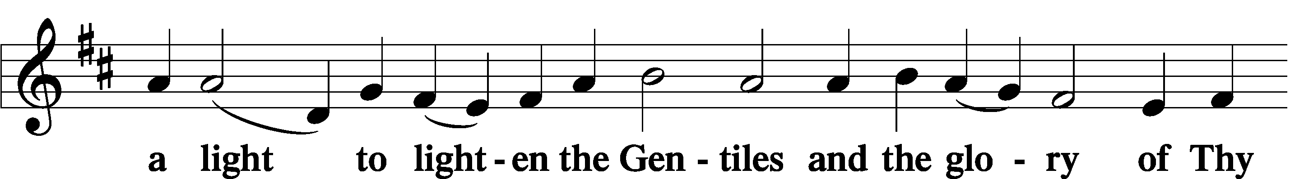
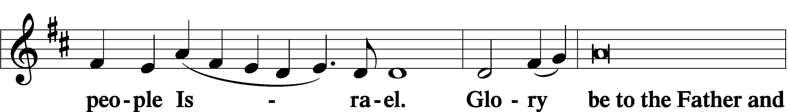
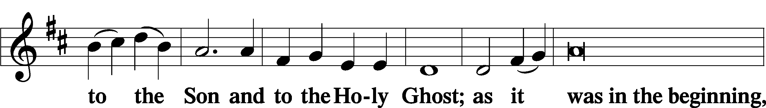
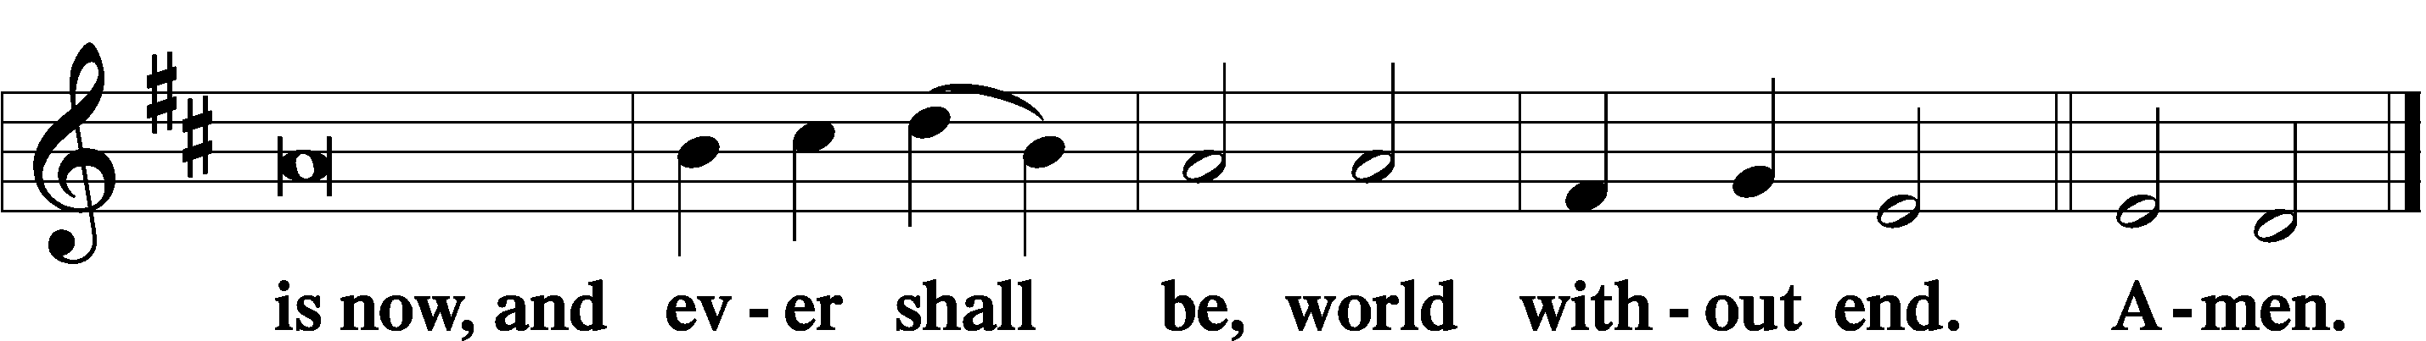

Thanksgiving Psalm 107:1
P O give thanks unto the Lord, for He is good,
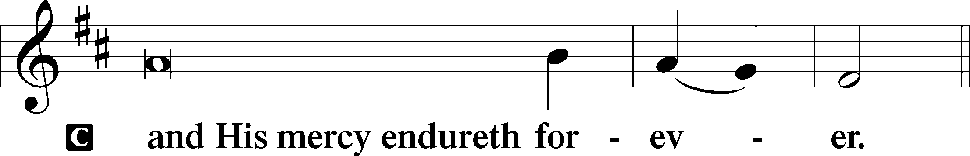

Post-Communion Collect
P Let us pray.
We give thanks to You, almighty God, that You have refreshed us through this salutary gift, and we implore You that of Your mercy You would strengthen us through the same in faith toward You and in fervent love toward one another; through Jesus Christ, Your Son, our Lord, who lives and reigns with You and the Holy Spirit, one God, now and forever.
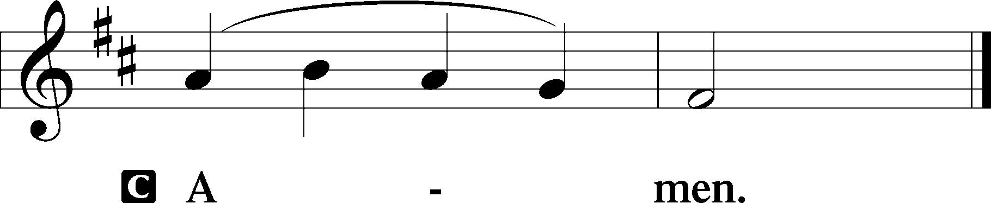

Salutation 2 Timothy 4:22
P The Lord be with you.
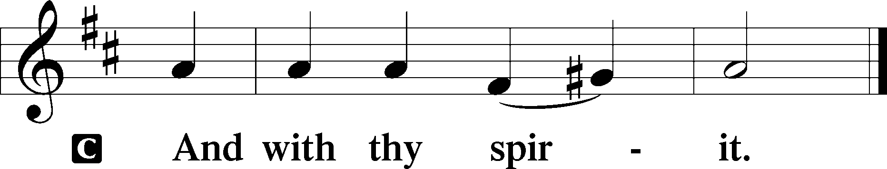

Benedicamus Psalm 103:1
P Bless we the Lord.
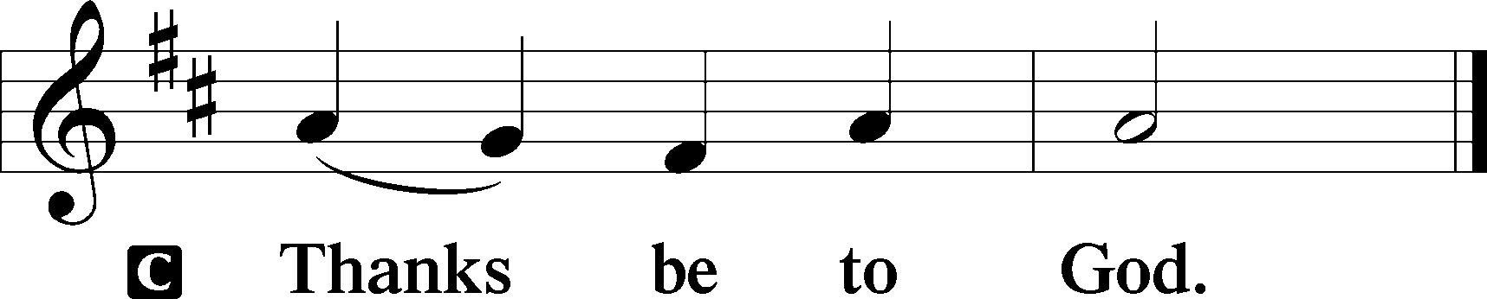
Benediction Numbers 6:24–26
P The Lord bless you and keep you.
The Lord make His face shine upon you and be gracious unto you.
The Lord lift up His countenance upon you and T give you peace.
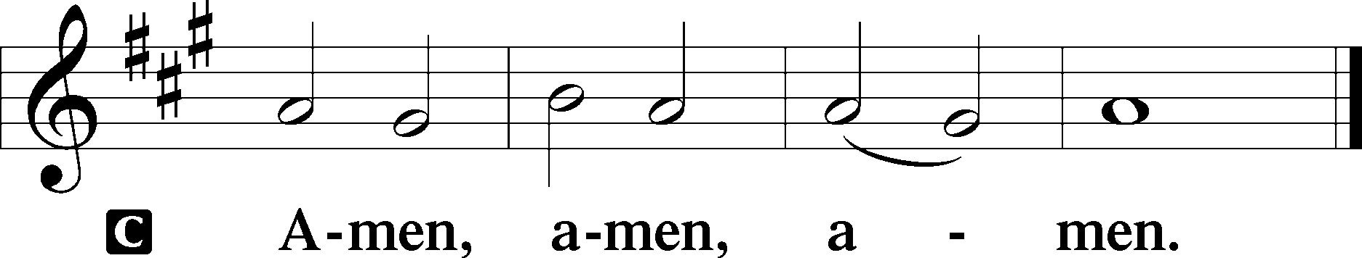

Closing Hymn: LSB #464 “The Strife Is O’er, the Battle Done”

Silent prayer after worship: Dear Jesus, as I leave Your house today, walk with me wherever I go this week. Keep me in Your Word and open my heart that I may be constantly aware of Your presence. Amen.

Acknowledgments
Unless otherwise indicated, Scripture quotations are from the ESV® Bible (The Holy Bible, English Standard Version®), copyright © 2001 by Crossway, a publishing ministry of Good News Publishers. Used by permission. All rights reserved.Created by Lutheran Service Builder © 2024 Concordia Publishing House.

SCHEDULE THROUGH APRIL 21, 2024:

:

Today, Following Worship, Fellowship Hall: Coffee Fellowship
6 pm, Deal Home: Sunday Evening Bible Study
7 pm, Fellowship Hall: AA Meeting
Tuesday, 5:30 pm, All Saints (Slippery Rock): Catechesis
7-9 pm, Fellowship Hall: Penn-Ohio Singers
Wednesday, 10 am, Sanctuary: Matins Service
Following, Sanctuary: Choir Practice
7 pm, Fellowship Hall: NA Meeting
Thursday, 10 am, Fellowship Hall: Women’s Bible Study
6-6:45 pm, Sanctuary: Choir Practice
Saturday, 11 am, Fellowship Hall: Ladies’ Spring Luncheon
Next Sunday, 8 am, Fellowship Hall: Bible Study
9 am, Sanctuary: Divine Service
Following, Library: Auditing
7 pm, Fellowship Hall: AA Meeting
Bible Memory Verses ~ Week of April 14th:
For Adults: And there is salvation in no one else, for there is no other name under heaven given among men by which we must be saved. Acts 4:12

For Children: I am the Good Shepherd…My sheep hear my voice, and I know them, and they follow me. I give them eternal life. John 10:11, 27-28
fffffffffffffffffffffffffffffffffff

This morning is “Stock the Food Pantry Sunday”. Your financial contributions will be greatly appreciated!
fffffffffffffffffffffffffffffffffff
Join us in the Fellowship Hall this morning following worship this morning for April’s Coffee Fellowship. This month’s fellowship is sponsored by Isaiah Deal in celebration of his First Communion.
fffffffffffffffffffffffffffffffffff
Attendance:
Sunday, April 7, 2024: 38
Wednesday, April 10, 2024: 8
fffffffffffffffffffffffffffffffffff
Join us in the sanctuary each Wed. at 10 am for a mid-week Matins Service.
fffffffffffffffffffffffffffffffffff
THANK YOU FOR SERVING IN APRIL: Elder: Jonathan Baisch; Ushers: Cheryl Fedele, Mike Flaugher, & Jesse Riffle. Altarware ~ (prior) Marie Flaugher (04.14), & Diane Riefstahl (04.21 & 04.28); (after) Evelyn Baisch & Traudi Sulek.
fffffffffffffffffffffffffffffffffff
Items for the May calendar and newsletter are due to Diane by 9 am Monday, April 22nd.
fffffffffffffffffffffffffffffffffff
Church Council members are reminded of their meeting Monday, April 22nd at 7 pm. If responsible for a report, please email it to Diane by noon that day so that packets for the meeting may be prepared.
Remember the following in Prayer…
~The Hurting and Healing: Amy, Ralph, Steve, Mary Jane Anderson, Steve Antolovich, Ellen Baron^{CA}, Don Baxter^{CA}, Amy Blomenberg, Lois Bortner^{CA}, Sara Brubaker and her son, Canaan; Dee Bullock, Bev & Joe Chlpka, Susan Davies, Tim Dudash, Mike Flaugher, Judith & Eddy Furey, Griffin, Pastor Charles Henrickson, Joan, Keith Jozwiakowski, Darla Krajci, Barbara Kreske, Jess Lavoie, Paul Lucas^{CA}, Sandy Marshall, Drew Martz, Augusta Mennell, Juanita Rentschler, Richard Reuning^{CA}, Nancy Robertson^{CA}, Kriss Svidro^{CA}, Rudy Tomko, Bob Usnarski, Joel & Peggy Wasson, Angela Weser^{CA}, and Ruth Wolf.
~The Homebound: Anna Mae Daris, Millie Elavsky, Jean Tomko, Betty Wolf, and Ed & Millie Zachar.
~Serving in the Military: Alex (Sasha) Carr, Duncan Vaupel, Curtis Sinewe, and Joshua Solyan.
~Community & World Needs: Those suffering due to the conflicts in the Middle East and between Ukraine and Russia; those suffering from loss and dislocation because weather disasters; those suffering from addiction and their families; Local, State, and National Government Leaders; safety for all Police Officers, Firefighters, & First Responders; the unemployed; our Second Quarter Local Mission: Support of a Concordia, Fort Wayne Seminarian. . *CA represents cancer.
fffffffffffffffffffffffffffffffffff
Our Stewardship of Treasures for the Lord:
Figures for Sunday, April 7, 2024
General Fund: $2,217.00
SELC: $170.00
Food Pantry: $120.00
Quarterly Missions: $100.00
Capital Campaign: $335.00
YTD Giving/Budget (as of March 31, 2024)
General Fund: $28,372.79/ $35,262.76
SELC: $606.00 / $999.96

For online giving, check out https://www.saintspeterandpaul.net/online-giving.
fffffffffffffffffffffffffffffffffff
The sign-up sheet for the April 20th Ladies’ Spring Luncheon is on the table in the narthex. This morning is the last opportunity to sign up if planning to attend. Bring a friend and join in the fun!
fffffffffffffffffffffffffffffffffff
Choir practices have resumed! There are two practice times offered:
Wednesdays, immediately following the Matins Service
Thursdays, from 6-6:45 pm
Please contact Rebecca Marquette at 724-761-5415 for any additional information.
fffffffffffffffffffffffffffffffffff

A special Vespers Service celebrating the Feast of Saint Mark, Evangelist will be held Thursday, April 25th at 7 pm.

fffffffffffffffffffffffffffffffffff
Vitalant will be sponsoring a blood drive in our Fellowship Hall Monday, May 6th from 1 pm – 6 pm.

Come roll up your sleeve and give the gift of life! For information as to how to pre-register, speak with Cheryl Fedele.

Please enter using the Clover St. entrance.
fffffffffffffffffffffffffffffffffff

Here to Serve
Pastor………………………………………………...……………Rev. Jacob Deal
E-mail …………………………….……pastordeal@saintspeterandpaul.net
Phone Number……………………..…………………724-347-3620 (Option 2)
Church Office………………………..…………………724-347-3620 (Option 3)
Website …………………………………………www.saintspeterandpaul.net
Secretary…………………………………………………………Diane Riefstahl
E-mail ………………………………………church@saintspeterandpaul.net
Food Pantry (phone): ……………………………….…724-347-3620 (opt. 4)
Food Pantry (email): …….………foodpantry@saintspeterandpaul.net
Congregation President………………………………….…Jonathan Baisch
Church Elder …………………………………………...……. Jonathan Baisch
Organist………………………………………………..….…Rebecca Marquette
AA Contact: Steve………………………………………………...…724-813-2358
NA Contact: Larry……………………………………..…………..724-977-8733
fffffffffffffffffffffffffffffffffff
If needing to get into the church building during the week, please phone first to make certain someone is here to let you in.

